S1 File. Search Alert (09.05.2024)

Pubmed (166)
("blood flow restriction" [Title/Abstract] OR "vascular occlusion" [Title/Abstract] OR "KAATSU" [Title/Abstract] OR "tourniquets" [Title/Abstract]) AND ("endurance" [Title/Abstract] OR "runner" [Title/Abstract] OR "marathon" [Title/Abstract] OR "triathlon" [Title/Abstract] OR "cyclist" [Title/Abstract] OR "swimmer" [Title/Abstract] OR "rower" [Title/Abstract] OR "skier" [Title/Abstract])

SCOPUS (307)
[Article title, Abstract, Keywords] ("blood flow restriction" OR "vascular occlusion" OR "KAATSU" OR "tourniquets"); AND [Article title, Abstract, Keywords] ("endurance" OR "runner" OR "marathon" OR "triathlon" OR "cyclist" OR "swimmer" OR "rower" OR "skier")

SPORTDiscus (87)
Search Alert: ("AB ("blood flow restriction" OR "vascular occlusion" OR "KAATSU" OR "tourniquets") AND AB ("endurance" OR "runner" OR "marathon" OR "triathlon" OR "cyclist" OR "swimmer" OR "rower" OR "skier")

Web of Science (438)
[Topic] ("blood flow restriction" OR "vascular occlusion" OR "KAATSU" OR "tourniquets") AND [Topic] ("endurance" OR "runner" OR "marathon" OR "triathlon" OR "cyclist" OR "swimmer" OR "rower" OR "skier")

S2 File. PEDro scale and GRADE assessment
Table S1. Physiotherapy Evidence Database (PEDro) scale ratings
References | Items* |  |  |  |  |  |  |  |  |  |  | Total  (out of 10)
References | 1 | 2 | 3 | 4 | 5 | 6 | 7 | 8 | 9 | 10 | 11 | Total  (out of 10)
Beak et al., 2022 | 1 | 1 | 0 | 0 | 0 | 0 | 0 | 1 | 1 | 1 | 1 | 5
Billaut et al., 2022 | 1 | 1 | 0 | 0 | 0 | 0 | 0 | 1 | 1 | 1 | 1 | 5
Bourgeois et al., 2024 | 1 | 1 | 1 | 1 | 0 | 0 | 0 | 1 | 1 | 1 | 1 | 7
Chen et al., 2021 | 1 | 1 | 0 | 1 | 0 | 0 | 0 | 1 | 1 | 1 | 1 | 6
Chen et al., 2022 | 1 | 1 | 0 | 1 | 0 | 0 | 0 | 1 | 1 | 1 | 1 | 6
Geng et al., 2021 | 1 | 1 | 0 | 1 | 0 | 0 | 0 | 1 | 1 | 1 | 1 | 6
Giovanna et al., 2022 | 1 | 1 | 1 | 1 | 0 | 0 | 1 | 1 | 1 | 1 | 1 | 7
Guo 2021 | 1 | 1 | 1 | 1 | 0 | 0 | 0 | 1 | 1 | 1 | 1 | 7
Held et al., 2020 | 1 | 1 | 1 | 1 | 0 | 0 | 0 | 1 | 1 | 1 | 1 | 7
Held et al., 2023 | 1 | 1 | 1 | 1 | 0 | 0 | 0 | 1 | 1 | 1 | 1 | 7
Herda et al., 2024 | 1 | 1 | 1 | 1 | 0 | 0 | 0 | 1 | 1 | 1 | 1 | 7
Liang 2023 | 1 | 1 | 0 | 1 | 0 | 0 | 0 | 1 | 1 | 1 | 1 | 6
Mitchell et al., 2019 | 1 | 1 | 0 | 1 | 0 | 0 | 0 | 1 | 1 | 1 | 1 | 6
Tang et al., 2019 | 1 | 1 | 0 | 0 | 0 | 0 | 0 | 1 | 1 | 1 | 1 | 5
Tang et al., 2022 | 1 | 1 | 0 | 0 | 0 | 0 | 0 | 1 | 1 | 1 | 1 | 5
Tangchaisuriya et al., 2021 | 1 | 1 | 1 | 1 | 0 | 0 | 0 | 1 | 1 | 1 | 1 | 7
Taylor et al., 2016 | 1 | 1 | 0 | 1 | 0 | 0 | 0 | 1 | 1 | 1 | 1 | 6
Tosun et al., 2023 | 1 | 1 | 0 | 1 | 0 | 0 | 0 | 1 | 1 | 1 | 1 | 6
Wan 2024 | 1 | 1 | 0 | 1 | 0 | 0 | 0 | 1 | 1 | 1 | 1 | 6
Wang et al.,2023 | 1 | 1 | 0 | 1 | 0 | 0 | 0 | 1 | 1 | 1 | 1 | 6
Median score = 6
Note: * Detailed explanations for PEDro scale items are available at https://pedro.org.au/English/resources/pedro-scale/ (access for this review: August 12, 2024).

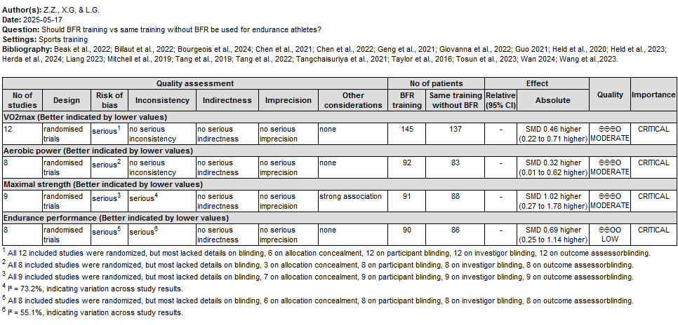
Figure S1. GradePro table summarizing grades of evidence

S3 File. Funnel plots
Figure S2. Funnel plot for VO_{2max}

Figure S3. Funnel plot for aerobic power

Figure S4. Funnel plot for maximal strength

Figure S5. Funnel plot for endurance performance

S4 File. Sensitivity analysis

Figure S6. Sensitivity analysis for VO_{2max}

Figure S7. Sensitivity analysis for aerobic power

Figure S8. Sensitivity analysis for strength

Figure S9. Sensitivity analysis for endurance performance

S5 File. Subgroup analyses

Table S2. Subgroup analyses
Covariate | k | g | 95% CI | I² (%) | p-value for subgroup
Muscle mass (k = 17)
Gender |  |  |  |  | 0.30
Male | 9 | 0.28 | -0.01, 0.57 | 0
Mixed | 5 | 0.23 | -0.16, 0.61 | 0
Female | 3 | 0.75 | 0.18, 1.31 | 0
Age |  |  |  |  | 0.10
Young adults | 11 | 0.21 | -0.06, 0.47 | 0
Older adults | 6 | 0.59 | 0.21, 0.97 | 0
Level |  |  |  |  | 0.35
Trained | 4 | 0.16 | -0.25, 0.57 | 0
Untrained | 13 | 0.39 | 0.14, 0.65 | 0
Cuff pressure |  |  |  |  | 0.86
< 180 mmHg | 6 | 0.42 | 0.05, 0.79 | 0
≥ 180 mmHg | 9 | 0.38 | 0.08, 0.68 | 0
Intensity |  |  |  |  | 0.61
Low | 10 | 0.38 | 0.09, 0.67 | 0
Moderate | 7 | 0.27 | -0.06, 0.59 | 0
Duration |  |  |  |  | 0.09
< 8 weeks | 8 | 0.14 | -0.18, 0.45 | 0
≥ 8 weeks | 9 | 0.51 | 0.21, 0.80 | 0
Frequency |  |  |  |  | 0.29
≤ 3 days/week | 9 | 0.22 | -0.07, 0.51 | 0
> 3 days/week | 8 | 0.46 | 0.14, 0.79 | 0
Maximal strength (k = 24)
Gender |  |  |  |  | 0.16
Male | 15 | 0.41 | 0.17, 0.66 | 46.8
Mixed | 6 | 0.73 | 0.30, 1.16 | 20.8
Female | 3 | 1.58 | 0.09, 3.07 | 75.3
Age |  |  |  |  | 0.001
Young adults | 17 | 0.39 | 0.16, 0.61 | 41.8
Older adults | 7 | 1.11 | 0.73, 1.49 | 39.7
Level |  |  |  |  | 0.49
Trained | 7 | 0.93 | -0.07, 1.92 | 75.1
Untrained | 17 | 0.56 | 0.33, 0.80 | 32.2
Cuff pressure |  |  |  |  | 0.72
< 180 mmHg | 13 | 0.70 | 0.34, 1.05 | 58.4
≥ 180 mmHg | 10 | 0.60 | 0.24, 0.97 | 45.4
Intensity |  |  |  |  | 0.06
Low | 11 | 0.82 | 0.49, 1.16 | 40.2
Moderate | 13 | 0.41 | 0.16, 0.66 | 55.6
Duration |  |  |  |  | 0.02
< 8 weeks | 12 | 0.32 | 0.06, 0.58 | 0
≥ 8 weeks | 12 | 1.09 | 0.49, 1.68 | 69.4
Frequency |  |  |  |  | 0.19
≤ 3 days/week | 13 | 0.46 | 0.20, 0.72 | 55.8
> 3 days/week | 11 | 0.77 | 0.40, 1.14 | 45.9
VO_{2max} (k = 16)
Gender |  |  |  |  | 0.68
Male | 8 | 0.24 | -0.08, 0.56 | 0
Mixed | 7 | 0.18 | -0.14, 0.51 | 0
Female | 1 | -0.2 | -1.13, 0.73 | --
Level |  |  |  |  | 0.49
Trained | 7 | 0.27 | -0.05, 0.59 | 0
Untrained | 9 | 0.12 | -0.19, 0.42 | 0
Cuff pressure |  |  |  |  | 0.88
< 180 mmHg | 6 | 0.20 | -0.16, 0.57 | 0
≥ 180 mmHg | 5 | 0.16 | -0.25, 0.57 | 0
Intensity |  |  |  |  | 0.71
Low | 6 | 0.13 | -0.25, 0.51 | 0
Moderate | 10 | 0.22 | -0.05, 0.49 | 0
Duration |  |  |  |  | 0.25
< 8 weeks | 12 | 0.27 | 0.01, 0.53 | 0
≥ 8 weeks | 4 | -0.03 | -0.45, 0.40 | 0
Frequency |  |  |  |  | 0.51
≤ 3 days/week | 11 | 0.23 | -0.03, 0.49 | 0
> 3 days/week | 5 | 0.07 | -0.36, 0.50 | 13.4

