SUPPLEMENTARY MATERIAL

Supplementary table 1. Search in Ovid MEDLINE
Search | Result
(("Randomized Controlled Trial"[Publication Type] OR "Controlled Clinical Trial"[Publication Type] OR randomized [Title/Abstract] OR placebo[Title/Abstract] OR "drug therapy" [MeSH Subheading] OR randomly[Title/Abstract] OR trial [Title/Abstract] OR groups [Title/Abstract]) NOT (animals[MeSH Terms] NOT humans[MeSH Terms])) AND (("Glycogen Storage Disease"[MeSH] OR "Metabolic Diseases" [MeSH]) AND "Muscular Diseases" [MeSH] OR "Muscular Dystrophies"[MeSH] OR ((metabolic OR congenital) AND myopath* [Title/Abstract]) OR inflammatory myopath*[Title/Abstract] OR "Muscular Atrophy, Spinal"[MeSH] OR "Motor Neuron Disease" [MeSH] OR ("motor neuron disease"[Title/Abstract] OR "motoneuron disease"[Title/Abstract]) OR "Amyotrophic Lateral Sclerosis"[Title/Abstract] OR (poliomyelitis OR muscular dystroph* OR myotonic dystroph* OR myasthen* OR myelopath*) [Title/Abstract] OR (dystrophy AND (becker OR duchenne OR limb girdle OR emery dreifuss OR facioscapulohumeral)) [Title/Abstract] OR "Peripheral Nervous System Diseases"[MeSH] OR (neuropathy OR neuropathies OR polyneuropathy OR polyneuropathies)[Title/Abstract] OR ("neuromuscular disease" OR "neuromuscular weakness" OR "respiratory insufficiency") [Title/Abstract]) AND ("Breathing Exercises" [MeSH] OR ((respir* OR inspirat*) AND (training OR exercise*))[Title/Abstract] OR "Chest Physiotherapy"[Title/Abstract] OR ("Physical Therapy Techniques" [Title/Abstract] OR "Physical Therapy Modalities" [MeSH]) OR ((breath* OR respir* OR inspir* OR chest) AND ("Physical Therapy Techniques"[Title/Abstract] OR "Physical Therapy Modalities"[MeSH]))) | 3066

Supplementary table 2. Search in EMBASE
Search | Result
('randomized controlled trial'/exp OR 'controlled clinical trial'/exp OR randomized:ab,ti OR placebo:ab,ti OR 'drug therapy'/exp OR randomly:ab,ti OR trial:ab,ti OR groups:ab,ti) AND ((('glycogen storage disease'/exp OR 'metabolic disease'/exp) AND 'muscular disease'/exp OR 'muscular dystrophy'/exp OR (((metabolic OR congenital) NEAR/2 myopath*):ab,ti) OR 'inflammatory myopathy'/exp OR inflammatory) AND myopath*:ab,ti OR 'spinal muscular atrophy'/exp OR 'motor neuron disease'/exp OR ((motor NEAR/1 neuron NEAR/1 disease*):ab,ti) OR 'amyotrophic lateral sclerosis'/exp OR poliomyelitis:ab,ti OR 'muscular dystrophy':ab,ti OR 'myotonic dystrophy':ab,ti OR myasthen*:ab,ti OR myelopath*:ab,ti OR ((dystrophy NEAR/3 (becker OR duchenne OR 'limb girdle' OR 'emery dreifuss' OR facioscapulohumeral)):ab,ti) OR 'peripheral nervous system disease'/exp OR neuropathy:ab,ti OR neuropathies:ab,ti OR polyneuropathy:ab,ti OR polyneuropathies:ab,ti OR 'neuromuscular disease':ab,ti OR 'neuromuscular weakness':ab,ti OR 'respiratory insufficiency':ab,ti) AND ('breathing exercise'/exp OR (((respir* OR inspirat*) NEAR/3 (training OR exercise*)):ab,ti) OR 'chest physiotherapy'/exp OR 'physical therapy techniques'/exp OR 'physical therapy modalities'/exp OR ((breath*OR respir* OR inspir* OR chest) AND (physical AND therapy AND techniques:ab,ti OR physical) AND therapyAND modalities:ab,ti)) AND [humans]/lim | 1860

Supplementary table 3. Search in the Web of Science
Search | Result
ALL=("Glycogen Storage Disease" OR "Metabolic Disease*" OR "Muscular Disease*")  AND ALL=("Muscular Dystroph*" OR "Metabolic Myopath*" OR "Congenital Myopath*" OR "Inflammatory Myopath*"  OR "Spinal Muscular Atrophy" OR "Motor Neuron Disease*" OR "Moto* Neuron* Disease*"  OR "Amyotrophic Lateral Sclerosis" OR Poliomyelitis OR "Muscular Dystroph*" OR "Myotonic Dystrophy*" OR Myasthen* OR Myelopath*  OR "Dystrophy Becker" OR "Dystrophy Duchenne" OR "Dystrophy Limb Girdle" OR "Dystrophy Emery Dreifuss" OR "Dystrophy Facioscapulohumeral"  OR "Peripheral Nervous System Disease*" OR Neuropathy OR Neuropathies OR Polyneuropathy OR Polyneuropathies  OR "Neuromuscular Weakness" OR "Respiratory Insufficiency")  AND ALL=("Breathing Exercises" OR "Respiratory Training" OR "Inspiratory Training" OR "Inspiratory Exercise*" OR "Respiratory Exercise*"  OR "Chest Physiotherapy" OR "Physical Therapy Technique*" OR "Physical Therapy Modalities"  OR Breath* OR Respir* OR Inspir* OR Chest)  AND ALL=("Randomized Controlled Trial" OR "Controlled Clinical Trial" OR Randomized OR Placebo OR "Drug Therapy" OR Randomly OR Trial OR Groups) | 65

Supplementary table 4. Search in Cochrane
ID | Search | Hits
1 | MeSH descriptor: [Glycogen Storage Disease] explode all trees | 127
2 | metabolic disease* OR muscular disease* | 30407
3 | (#1 OR #2) | 30489
4 | MeSH descriptor: [Muscular Dystrophies] explode all trees | 669
5 | (metabolic OR congenital OR inflammatory) NEAR/2 myopath* | 211
6 | MeSH descriptor: [Muscular Diseases] explode all trees | 12173
7 | MeSH descriptor: [Muscular Atrophy, Spinal] explode all trees | 150
8 | MeSH descriptor: [Motor Neuron Disease] explode all trees | 1114
9 | motor neuron disease* OR motor neurone disease* OR motoneuron disease* OR motoneurone disease* OR motorneuron disease* OR motorneurone disease* OR amyotrophic lateral sclerosis OR als:ti OR als:ab OR nmd:ti OR mnd:ab OR poliomyelitis OR muscular dystroph* OR myotonic dystroph* OR myasthen* OR myelopath* OR dystrophy NEAR/3 (Becker OR Duchenne OR 'limb girdle' OR 'emery dreifuss' OR facioscapulohumeral) OR peripheral nervous system disease* OR neuropathy OR neuropathies OR polyneuropathy OR polyneuropathies OR neuromuscular disease* OR neuromuscular weakness OR respiratory insufficiency | 31861
10 | #3 OR #4 OR #5 OR #6 OR #7 OR #8 OR #9 | 70193
11 | MeSH descriptor: [Breathing Exercises] explode all trees | 1380
12 | (respir* OR inspirat* OR expiratory OR ventilatory OR chest) NEAR/4 (training OR exercise* OR endurance) OR chest physiotherapy OR (physical therapy techni* OR physical therapy modalities) AND (breath* OR respir* OR inspir* OR chest) OR threshold NEAR/3 (load OR device*) OR resistive breathing | 17847
13 | #11 OR #12 | 18506
14 | #10 AND #13 | 2598

Supplementary table 5. Search in PEDro
Busqueda boleana | Resultados
Neuromuscular Diseases AND Exercise | 25
Neuromuscular Diseases AND Training | 27

Supplementary table 6. A search was performed in Biblioteca Virtual en Salud (Medline, IBECS, WPRIM, LILACS, Sec. Est. Saude SP)
Busqueda boleana | Resultados
((physiotherapy OR exercise OR training OR chest physiotherapy OR breathing exercise OR endurance OR threshold OR resistive breathing) OR ((intervention OR therapy) AND (respiratory OR inspiratory OR expiratory OR ventilatory OR chest)) AND (neuromuscular OR muscular disease OR muscular dystrophies OR muscular atrophy OR neuromuscular weakness OR metabolic myopathy OR congenital myopathy OR inflammatory myopathy OR motor neuron disease OR myelopathy OR nervous system diseases (or neuropathy OR neuropathies) OR respiratory insufficiency)) | 92

Supplementary table 7. Search in the ICTRP
Busqueda boleana | Resultados
Title: (neuromuscular disease OR muscular disease OR muscular dystrophies OR muscular atrophy OR neuromuscular weakness OR metabolic myopathy OR congenital myopathy OR inflammatory myopathy OR motor neuron disease OR myelopathy OR nervous system diseases OR neuropathy OR glycogen storage disease OR poliomyelitis OR myasthenia OR amyotrophic lateral sclerosis OR physiotherapy OR exercise OR training OR chest physiotherapy OR breathing exercise OR resistive breathing OR respiratory therapy OR inspiratory training OR inspiratory exercise OR respiratory training OR respiratory exercise OR expiratory training OR expiratory exercise OR expiratory endurance OR inspiratory endurance OR ventilatory training OR ventilatory exercise OR ventilatory endurance OR chest training OR chest exercise OR chest endurance OR Physical Therapy Modalities)  AND Condition: (neuromuscular disease OR muscular disease OR muscular dystrophies OR muscular atrophy OR neuromuscular weakness OR metabolic myopathy OR congenital myopathy OR inflammatory myopathy OR motor neuron disease OR myelopathy OR nervous system diseases OR neuropathy OR glycogen storage disease OR poliomyelitis OR myasthenia OR amyotrophic lateral sclerosis)  AND Intervention: (physiotherapy OR exercise OR training OR chest physiotherapy OR breathing exercise OR resistive breathing OR respiratory therapy OR inspiratory training OR inspiratory exercise OR respiratory training OR respiratory exercise OR expiratory training OR expiratory exercise OR expiratory endurance OR inspiratory endurance OR ventilatory training OR ventilatory exercise OR ventilatory endurance OR chest training OR chest exercise OR chest endurance OR Physical Therapy Modalities) | 128

Supplementary table 8. Search in CNKI.net
Boolean Search | Results
KY=(neuromuscular disease OR NMD OR muscular disease OR muscular dystrophies OR muscular atrophy OR neuromuscular weakness OR metabolic myopathy OR congenital myopathy OR inflammatory myopathy OR motor neuron disease OR myelopathy OR nervous system diseases OR neuropathy OR glycogen storage disease OR poliomyelitis OR myasthenia OR amyotrophic lateral sclerosis) AND KY(physiotherapy OR exercise OR training OR chest physiotherapy OR breathing exercise OR resistive breathing OR respiratory therapy OR inspiratory training OR inspiratory exercise OR respiratory training OR respiratory exercise OR expiratory training OR expiratory exercise OR expiratory endurance OR inspiratory endurance OR ventilatory training OR ventilatory exercise OR ventilatory endurance OR chest training OR chest exercise OR chest endurance OR Physical Therapy Modalities) | 1531

Supplementary table 9. Search in Clinical Trials
Boolean Search | Results
(neuromuscular disease OR NMD OR muscular disease OR muscular dystrophies OR muscular atrophy OR neuromuscular weakness OR metabolic myopathy OR congenital myopathy OR inflammatory myopathy OR motor neuron disease OR myelopathy OR nervous system diseases OR neuropathy OR glycogen storage disease OR poliomyelitis OR myasthenia OR amyotrophic lateral sclerosis) AND (physiotherapy OR exercise OR training OR chest physiotherapy OR breathing exercise OR resistive breathing OR respiratory therapy OR inspiratory training OR inspiratory exercise OR respiratory training OR respiratory exercise OR expiratory training OR expiratory exercise OR expiratory endurance OR inspiratory endurance OR ventilatory training OR ventilatory exercise OR ventilatory endurance OR chest training OR chest exercise OR chest endurance OR Physical Therapy Modalities) AND Adult, Older Adult | 243

Supplementary table 10. Subgroup analysis for FVC %
Variable | Subgroup | k | MD (95% CI) | I² (%) | p-value (Between Groups)
Muscle | Expiratory e inspiratory | 2 | -5.0319 (-21.0432 to 10.9793) | 68.0
 | Inspiratory | 2 | 10.4694 (-0.5913 to 21.5300) | 53.6
 | Between groups |  |  |  | 0.1185
Population | Amyotrophic Lateral Sclerosis | 2 | 8.6884 (-5.8080 to 23.1849) | 74.9
 | Multiple Sclerosis | 1 | 5.3000 (-4.3288 to 14.9288) | --
 | Slowly progressive neuromuscular diseases | 1 | -14.8000 (-31.0201 to 1.4201) | --
 | Between groups |  |  |  | 0.0676
RoBFVC | Some | 4 | 3.1395 (-8.0656 to 14.3446) | 69.9
 | Between groups |  |  |  | --

Supplementary table 11. Sensitivity analysis for FVC %
Author | Effect (95% CI: Lower; Upper) | I² | DFFITS | Cook's D | QE (del) | Is Influential
Omitting Plowman E., et al., 2023 | 5.6188 (-1.1313; 12.3689) | 0.7899 | -0.5264 | 0.2771 | 9.5202 | No
Omitting Pinto S., et al., 2012 | 0.8873 (-5.1137; 6.8882) | 0.5498 | 1.2117 | 1.4683 | 4.4422 | Yes
Omitting Fry D., et al., 2007 | 3.6922 (-2.7171; 10.1014) | 0.7981 | 0.1813 | 0.0329 | 9.9073 | No
Omitting Aslan G., et al., 2014 | 6.4893 (0.8395; 12.1390) | 0.5098 | -0.8462 | 0.7160 | 4.0798 | Yes

Supplementary table 12. Subgroup analysis for MEP
Variable | Subgroup | k | MD (95% CI) | I² (%) | p-value (Between Groups)
Muscle | Inspiratory | 3 | -7.68 (-24.77, 9.42) | 0.0
 | Expiratory & Inspiratory | 3 | 18.81 (7.47, 30.16) | 41.6
 | Expiratory | 2 | 18.02 (7.76, 28.27) | 0.0
 | p-value |  |  |  | 0.0240
Population | Myasthenia Gravis | 1 | 1.00 (-27.44, 29.44) | --
 | Pompe Disease | 1 | 14.00 (3.43, 24.57) | --
 | Amyotrophic Lateral Sclerosis | 1 | 39.20 (14.47, 63.93) | --
 | Multiple Sclerosis | 4 | 6.29 (-12.29, 24.88) | 59.1
 | Slowly Progressive Neuromuscular Disease | 1 | 15.50 (-2.11, 33.11) | --
 | p-value |  |  |  | 0.2426
RoBPes | Some | 6 | 11.06 (-3.45, 25.56) | 52.7
 | High | 1 | 8.00 (-14.64, 30.64) | --
 | Low | 1 | 20.60 (9.10, 32.10) | --
 | p-value |  |  |  | 0.4642

Supplementary table 13. Sensitivity analysis for MEP
Author | Effect (95% CI: Lower; Upper) | I² | DFFITS | Cook's D | QE (del) | Is Influential
Omitting Fregonezi G., et al., 2005 | 15.02 (8.76; 21.29) | 0.473 | -0.208 | 0.043 | 11.384 | No
Omitting Jones HN., et al., 2020 | 14.56 (7.07; 22.06) | 0.511 | -0.060 | 0.004 | 12.268 | No
Omitting Plowman E., et al., 2023 | 12.76 (6.45; 19.07) | 0.264 | 0.518 | 0.269 | 8.152 | No
Omitting Klefbeck B., et al., 2003 | 14.52 (8.39; 20.65) | 0.495 | -0.046 | 0.002 | 11.880 | No
Omitting Fry D., et al., 2007 | 16.61 (10.24; 22.97) | 0.015 | -0.715 | 0.512 | 6.091 | Yes
Omitting Gosselink R., et al., 2000 | 14.88 (8.52; 21.23) | 0.498 | -0.161 | 0.026 | 11.946 | No
Omitting Smeltzer S., et al., 1996 | 11.92 (4.70; 19.14) | 0.440 | 0.786 | 0.618 | 10.706 | Yes
Omitting Aslan G., et al., 2014 | 14.22 (7.70; 20.74) | 0.510 | 0.049 | 0.002 | 12.257 | No

Supplementary Table 14. GRADE Assessment
Certainty assessment |  |  |  |  |  |  | № of patients |  | Effect |  | Certainty | Importance
№ of studies | Study design | Risk of bias | Inconsistency | Indirectness | Imprecision | Other considerations | Respiratory Muscle Training | Standard Care | Relative  (95% CI) | Absolute  (95% CI) | Certainty | Importance
Forced Vital Capacity (%FVC)
4 | randomised trials | seriousª | serious^{b} | not serious | serious^{c} | publication bias strongly suspected  strong association^{d} | 70 | 69 | - | MD 3.14 higher  (8.07 lower to 14.34 higher) | ⨁◯◯◯  Very low^{a,b,c,d} | IMPORTANT
Maximal Expiratory Pressure (MEP)
8 | randomised trials | seriousª | not serious | not serious | not serious | publication bias strongly suspected  very strong association^{d} | 124 | 119 | - | MD 13.04 higher  (3.65 higher to 22.42 higher) | ⨁⨁⨁⨁  High^{a,d} | IMPORTANT
Forced Vital Capacity (FVC, L)
4 | randomised trials | serious^{e} | not serious | not serious | not serious | none^{d} | 56 | 58 | - | MD 0.12 lower  (0.39 lower to 0.15 higher) | ⨁⨁⨁◯  Moderate^{d,e} | IMPORTANT
Sniff Nasal Inspiratory Pressure (SNIP)
3 | randomised trials | serious^{f} | serious^{g} | not serious | serious^{c} | publication bias strongly suspected^{d} | 50 | 49 | - | MD 1.47 higher  (15.45 lower to 18.39 higher) | ⨁◯◯◯  Very low^{c,d,f,g} | IMPORTANT
Vital Capacity (VC, L)
3 | randomised trials | very serious^{h} | not serious | not serious | not serious | none | 58 | 59 | - | MD 0.1 lower  (0.31 lower to 0.11 higher) | ⨁⨁◯◯  Low^{h} | IMPORTANT
Vital Capacity (VC%)
3 | randomised trials | very serious^{i} | not serious | not serious | not serious | strong association | 44 | 45 | - | MD 5.57 higher  (2.79 lower to 13.94 higher) | ⨁⨁⨁◯  Moderate^{i} | IMPORTANT
Forced expiratory volume (FEV1)
6 | randomised trials | seriousª | not serious | not serious | serious^{c} | none | 94 | 96 | - | MD 0.02 lower  (0.17 lower to 0.13 higher) | ⨁⨁◯◯  Low^{a,c} | IMPORTANT
Maximal Inspiratory Pressure (MIP)
12 | randomised trials | seriousª | not serious | not serious | not serious | very strong association | 177 | 175 | - | MD 6.83 higher  (2.08 higher to 11.58 higher) | ⨁⨁⨁⨁  Highª | IMPORTANT
CI: confidence interval; MD: mean difference

Explanations
a. Downgraded by 1 level: Most studies had 'some concerns' in bias assessment, including unclear blinding, and deviations from intended intervention.
b. Downgraded by 1 level: High heterogeneity (I2= 69.9%). Potential differences in study design or population may explain inconsistency.
c. Downgraded by 1 level: Due to large CIs that cross clinical thresholds, limiting precise interpretation of the effect.
d. Downgraded by 1 level: Due to suspected 'publication bias' as indicated by an asymmetrical funnel plot in the Egger test.
e. Downgraded by level 1: Most studies had 'some concerns' in bias assessment, including deviation from intended intervention, measurement of outcome and selection of reported result.
f. Downgraded by level 1: Most studies had 'some concerns' in bias assessment, including deviations from intended intervention, measurement of outcome and due to missing outcome data.
g. Downgraded by 1 level: High heterogeneity (I2= 69.3%). Potential differences in study design or population may explain inconsistency.
h. Downgraded by 2 level: Most studies had 'high risk and some concerns' in bias assessment, including deviation from intended intervention and missing outcome data.
i. Downgraded by 2 level: Most studies had 'high risk and some concerns' in bias assessment, including deviation from intended intervention, selection of reported result and unclear blinding.

Supplementary figure 1. Risk of bias FVC%

Supplementary figure 2. Risk of bias MEP

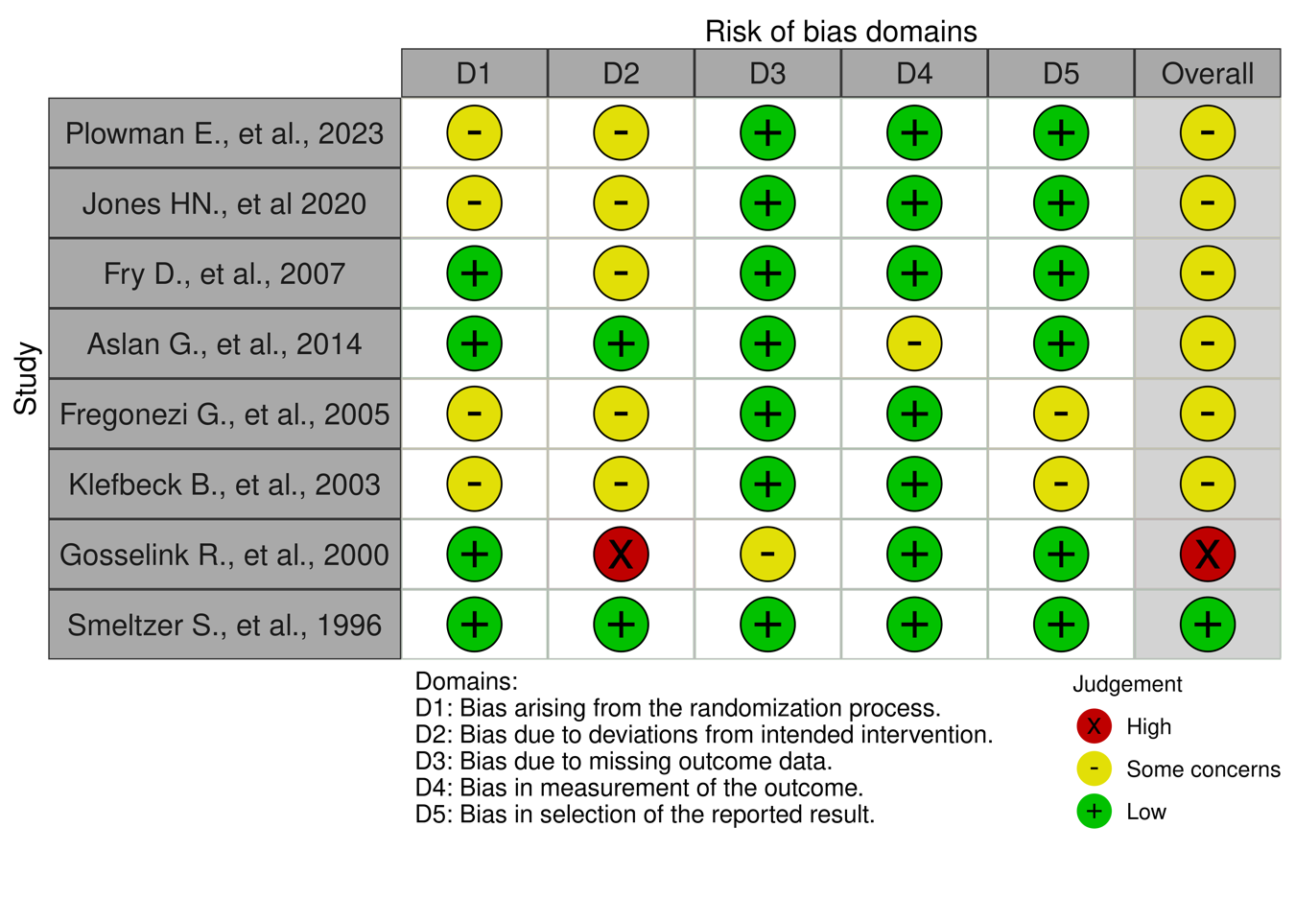

Supplementary figure 3. Risk of bias FVC L

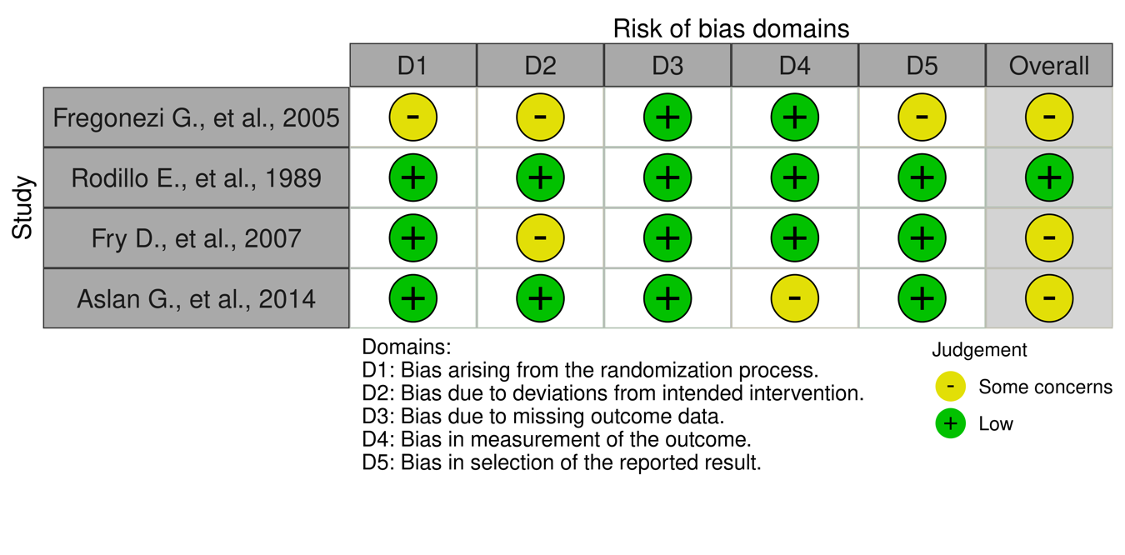

Supplementary figure 4. Risk of bias SNIP
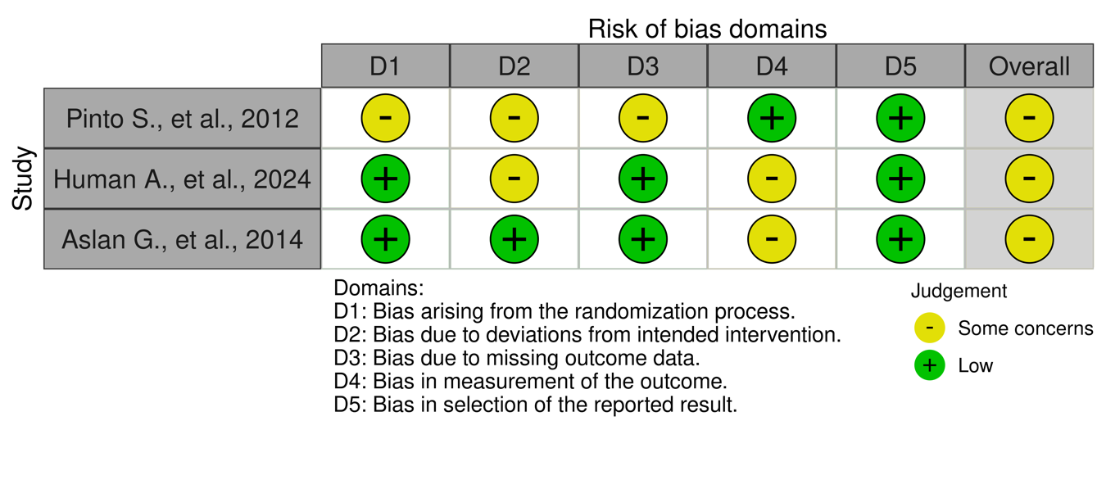

Supplementary figure 5. Risk of bias VC (L)
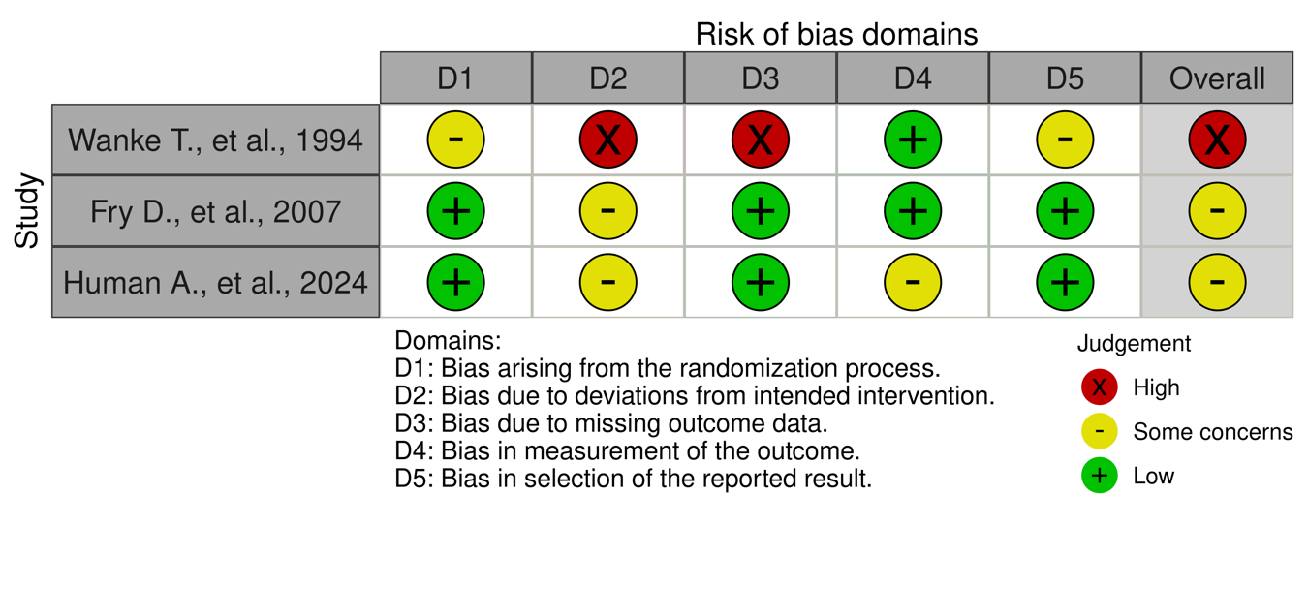
Supplementary figure 6. Risk of bias VC %

Supplementary figure 7. Risk of bias FEV1
Supplementary figure 8. Risk of bias MIP

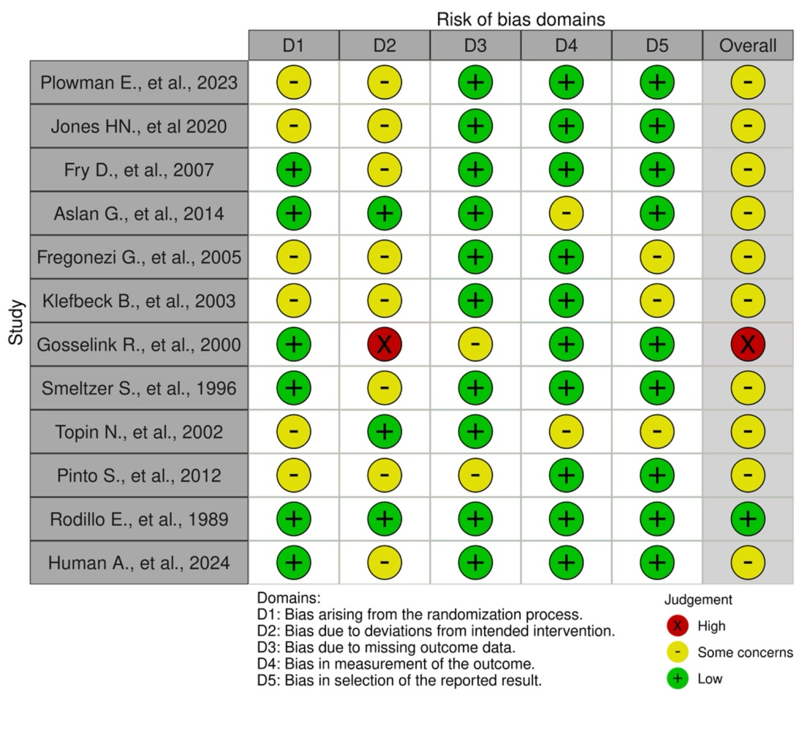
Supplementary figure 9. Forest plots (A) FVC %. (B) MEP. (C) FVC L. (D) SNIP. (E) VC L. (F) VC %. (G) FEV1 . (H) MIP.

Supplementary figure 10. Funnel plots.(A) FVC %. (B) MEP. (C) FVC L. (D) SNIP. (E) VC L. (F) VC %. (G) FEV1 . (H) MIP.

