Appendix
Table of Contents:
Supplementary 1: Search Strategy 3
Database: PubMed <inception to October 30 2024> 3
Supplementary 2: Meta-regression for pairwise meta-analysis 7
Supplementary 3: Subgroup analysis of neuromuscular training on tennis players 8
Supplementary 4: Sensitivity analysis 14
Table 4.1 Sensitivity analysis for service velocity 14
Table 4.2 Sensitivity analysis for service precision 15
Table 4.3 Sensitivity analysis for agility 16
Table 4.4 Sensitivity analysis for sprint 17
Table 4.5 Sensitivity analysis for strength 18
Table 4.6 Sensitivity analysis for power 19
Supplementary 5: Assessment of the transitivity 21
5.1 Mean age 21
5.2 Sample size 22
5.3 Sport level 23
5.4 Training period 24
5.5 Training frequency 25
5.6 Total number of training sessions 26
Supplementary 6: Network plot 27
6.1 Service velocity 27
6.2 Service precision 28
6.3 Agility 29
6.4 Sprint 30
6.5 Strength 31
6.6 Power 32
Supplementary 7: Evaluation of heterogeneity and inconsistency for network meta-analysis 33
Table 7.1 Details of SIDE splitting results 34
Supplementary 8: The pairwise comparison forest plot for network meta-analysis 36
8.1 Service velocity 36
8.2 Service precision 37
8.3 Agility 38
8.4 Sprint 39
8.5 Strength 40
8.6 Power 41
Supplementary 9: Quality of the evidence 42

Supplementary 1: Search Strategy

Database: PubMed <inception to October 30 2024>
Search Strategy:
Search number | Query | Results
61 | (Tennis[MeSH Terms]) AND (((((((((((((((((((((((((((((((((((((((((((((((((((((((((sprint training[Title/Abstract]) OR (agility training[Title/Abstract])) OR (balance training[Title/Abstract])) OR (Stretch-Shortening Cycle Exercises[Title/Abstract])) OR (Stretch Shortening Cycle Exercise[Title/Abstract])) OR (Exercises, Stretch-Shortening Cycle[Title/Abstract])) OR (Cycle Exercise, Stretch-Shortening[Title/Abstract])) OR (Cycle Exercises, Stretch-Shortening[Title/Abstract])) OR (Stretch-Shortening Cycle Exercise[Title/Abstract])) OR (Stretch-Shortening Drills[Title/Abstract])) OR (Stretch Shortening Drill[Title/Abstract])) OR (Drill, Stretch-Shortening[Title/Abstract])) OR (Drills, Stretch-Shortening[Title/Abstract])) OR (Stretch-Shortening Drill[Title/Abstract])) OR (Stretch-Shortening Exercises[Title/Abstract])) OR (Stretch Shortening Exercise[Title/Abstract])) OR (Exercise, Stretch-Shortening[Title/Abstract])) OR (Exercises, Stretch-Shortening[Title/Abstract])) OR (Stretch-Shortening Exercise[Title/Abstract])) OR (Plyometric Drills[Title/Abstract])) OR (Drills, Plyometric[Title/Abstract])) OR (Drill, Plyometric[Title/Abstract])) OR (Plyometric Drill[Title/Abstract])) OR (Trainings, Plyometric[Title/Abstract])) OR (Training, Plyometric[Title/Abstract])) OR (Plyometric Trainings[Title/Abstract])) OR (Plyometric Training[Title/Abstract])) OR (Plyometric Exercises[Title/Abstract])) OR (Exercises, Plyometric[Title/Abstract])) OR (Exercise, Plyometric[Title/Abstract])) OR (Plyometric exercise[MeSH Terms])) OR (core training[Title/Abstract])) OR (Weight-Bearing Exercise Programs[Title/Abstract])) OR (Weight Bearing Exercise Program[Title/Abstract])) OR (Exercise Program, Weight-Bearing[Title/Abstract])) OR (Exercise Programs, Weight-Bearing[Title/Abstract])) OR (Weight-Bearing Exercise Program[Title/Abstract])) OR (Weight-Bearing Strengthening Programs[Title/Abstract])) OR (Weight Bearing Strengthening Program[Title/Abstract])) OR (Strengthening Program, Weight-Bearing[Title/Abstract])) OR (Strengthening Programs, Weight-Bearing[Title/Abstract])) OR (Weight-Bearing Strengthening Program[Title/Abstract])) OR (Weight-Lifting Exercise Programs[Title/Abstract])) OR (Weight Lifting Exercise Program[Title/Abstract])) OR (Exercise Program, Weight-Lifting[Title/Abstract])) OR (Exercise Programs, Weight-Lifting[Title/Abstract])) OR (Weight-Lifting Exercise Program[Title/Abstract])) OR (Weight-Lifting Strengthening Programs[Title/Abstract])) OR (Weight Lifting Strengthening Program[Title/Abstract])) OR (Strengthening Program, Weight-Lifting[Title/Abstract])) OR (Strengthening Programs, Weight-Lifting[Title/Abstract])) OR (Weight-Lifting Strengthening Program[Title/Abstract])) OR (Training, Strength[Title/Abstract])) OR (Strength Training[Title/Abstract])) OR (Training, Resistance[Title/Abstract])) OR (Resistance Training[MeSH Terms])) OR (Neuromuscular training[Title/Abstract])) | 45
60 | ((((((((((((((((((((((((((((((((((((((((((((((((((((((((sprint training[Title/Abstract]) OR (agility training[Title/Abstract])) OR (balance training[Title/Abstract])) OR (Stretch-Shortening Cycle Exercises[Title/Abstract])) OR (Stretch Shortening Cycle Exercise[Title/Abstract])) OR (Exercises, Stretch-Shortening Cycle[Title/Abstract])) OR (Cycle Exercise, Stretch-Shortening[Title/Abstract])) OR (Cycle Exercises, Stretch-Shortening[Title/Abstract])) OR (Stretch-Shortening Cycle Exercise[Title/Abstract])) OR (Stretch-Shortening Drills[Title/Abstract])) OR (Stretch Shortening Drill[Title/Abstract])) OR (Drill, Stretch-Shortening[Title/Abstract])) OR (Drills, Stretch-Shortening[Title/Abstract])) OR (Stretch-Shortening Drill[Title/Abstract])) OR (Stretch-Shortening Exercises[Title/Abstract])) OR (Stretch Shortening Exercise[Title/Abstract])) OR (Exercise, Stretch-Shortening[Title/Abstract])) OR (Exercises, Stretch-Shortening[Title/Abstract])) OR (Stretch-Shortening Exercise[Title/Abstract])) OR (Plyometric Drills[Title/Abstract])) OR (Drills, Plyometric[Title/Abstract])) OR (Drill, Plyometric[Title/Abstract])) OR (Plyometric Drill[Title/Abstract])) OR (Trainings, Plyometric[Title/Abstract])) OR (Training, Plyometric[Title/Abstract])) OR (Plyometric Trainings[Title/Abstract])) OR (Plyometric Training[Title/Abstract])) OR (Plyometric Exercises[Title/Abstract])) OR (Exercises, Plyometric[Title/Abstract])) OR (Exercise, Plyometric[Title/Abstract])) OR (Plyometric exercise[MeSH Terms])) OR (core training[Title/Abstract])) OR (Weight-Bearing Exercise Programs[Title/Abstract])) OR (Weight Bearing Exercise Program[Title/Abstract])) OR (Exercise Program, Weight-Bearing[Title/Abstract])) OR (Exercise Programs, Weight-Bearing[Title/Abstract])) OR (Weight-Bearing Exercise Program[Title/Abstract])) OR (Weight-Bearing Strengthening Programs[Title/Abstract])) OR (Weight Bearing Strengthening Program[Title/Abstract])) OR (Strengthening Program, Weight-Bearing[Title/Abstract])) OR (Strengthening Programs, Weight-Bearing[Title/Abstract])) OR (Weight-Bearing Strengthening Program[Title/Abstract])) OR (Weight-Lifting Exercise Programs[Title/Abstract])) OR (Weight Lifting Exercise Program[Title/Abstract])) OR (Exercise Program, Weight-Lifting[Title/Abstract])) OR (Exercise Programs, Weight-Lifting[Title/Abstract])) OR (Weight-Lifting Exercise Program[Title/Abstract])) OR (Weight-Lifting Strengthening Programs[Title/Abstract])) OR (Weight Lifting Strengthening Program[Title/Abstract])) OR (Strengthening Program, Weight-Lifting[Title/Abstract])) OR (Strengthening Programs, Weight-Lifting[Title/Abstract])) OR (Weight-Lifting Strengthening Program[Title/Abstract])) OR (Training, Strength[Title/Abstract])) OR (Strength Training[Title/Abstract])) OR (Training, Resistance[Title/Abstract])) OR (Resistance Training[MeSH Terms])) OR (Neuromuscular training[Title/Abstract]) | 23,852
59 | sprint training[Title/Abstract] | 570
58 | agility training[Title/Abstract] | 103
57 | balance training[Title/Abstract] | 2,137
56 | Stretch-Shortening Cycle Exercises[Title/Abstract] | 26
55 | Stretch Shortening Cycle Exercise[Title/Abstract] | 56
54 | Exercise, Stretch-Shortening Cycle[Title/Abstract] | 432
53 | Exercises, Stretch-Shortening Cycle[Title/Abstract] | 432
52 | Cycle Exercise, Stretch-Shortening[Title/Abstract] | 454
51 | Cycle Exercises, Stretch-Shortening[Title/Abstract] | 454
50 | Stretch-Shortening Cycle Exercise[Title/Abstract] | 56
49 | Stretch-Shortening Drills[Title/Abstract] | 1
48 | Stretch Shortening Drill[Title/Abstract] | 5
47 | Drill, Stretch-Shortening[Title/Abstract] | 9
46 | Drills, Stretch-Shortening[Title/Abstract] | 9
45 | Stretch-Shortening Drill[Title/Abstract] | 3
44 | Stretch-Shortening Exercises[Title/Abstract] | 3
43 | Stretch Shortening Exercise[Title/Abstract] | 15
42 | Exercise, Stretch-Shortening[Title/Abstract] | 492
41 | Exercises, Stretch-Shortening[Title/Abstract] | 492
40 | Stretch-Shortening Exercise[Title/Abstract] | 15
39 | Plyometric Drills[Title/Abstract] | 9
38 | Drills, Plyometric[Title/Abstract] | 64
37 | Drill, Plyometric[Title/Abstract] | 64
36 | Plyometric Drill[Title/Abstract] | 2
35 | Trainings, Plyometric[Title/Abstract] | 1,115
34 | Training, Plyometric[Title/Abstract] | 16
33 | Plyometric Trainings[Title/Abstract] | 2
32 | Plyometric Training[Title/Abstract] | 618
31 | Plyometric Exercises[Title/Abstract] | 223
30 | Exercises, Plyometric[Title/Abstract] | 4
29 | Exercise, Plyometric[Title/Abstract] | 6
28 | Plyometric exercise[MeSH Terms] | 921
27 | core training[Title/Abstract] | 306
26 | Weight-Bearing Exercise Programs[Title/Abstract] | 3
25 | Weight Bearing Exercise Program[Title/Abstract] | 20
24 | Exercise Program, Weight-Bearing[Title/Abstract] | 690
23 | Exercise Programs, Weight-Bearing[Title/Abstract] | 1
22 | Weight-Bearing Exercise Program[Title/Abstract] | 20
21 | Weight-Bearing Strengthening Programs[Title/Abstract] | 1
20 | Weight Bearing Strengthening Program[Title/Abstract] | 2
19 | Strengthening Program, Weight-Bearing[Title/Abstract] | 131
18 | Strengthening Programs, Weight-Bearing[Title/Abstract] | 1
17 | Weight-Bearing Strengthening Program[Title/Abstract] | 2
16 | Weight-Lifting Exercise Programs[Title/Abstract] | 1
15 | Weight Lifting Exercise Program[Title/Abstract] | 2
14 | Exercise Program, Weight-Lifting[Title/Abstract] | 126
13 | Exercise Programs, Weight-Lifting[Title/Abstract] | 126
12 | Weight-Lifting Exercise Program[Title/Abstract] | 2
11 | Weight-Lifting Strengthening Programs[Title/Abstract] | 5
10 | Weight Lifting Strengthening Program[Title/Abstract] | 7
9 | Strengthening Program, Weight-Lifting[Title/Abstract] | 9
8 | Strengthening Programs, Weight-Lifting[Title/Abstract] | 9
7 | Weight-Lifting Strengthening Program[Title/Abstract] | 7
6 | Training, Strength[Title/Abstract] | 144
5 | Strength Training[Title/Abstract] | 7,513
4 | Training, Resistance[Title/Abstract] | 165
3 | Resistance Training[MeSH Terms] | 13,550
2 | Neuromuscular training[Title/Abstract] | 657
1 | Tennis[MeSH Terms] | 2,012

Supplementary 2: Meta-regression for pairwise meta-analysis
Variable | Coef. | Std. Err. | t | P>|t| | 95% CrI lower | 95% CrI upper
Service velocity
Level | -0.1710726 | 0.2446143 | -0.7 | 0.494 | -0.6896317 | 0.3474866
Mean age | 0.0426029 | 0.0199654 | 2.13 | 0.049 | 0.0002781 | 0.0849277
Training period | -0.0255337 | 0.1309873 | -0.19 | 0.848 | -0.3032143 | 0.252147
Training frequency | -0.3107371 | 0.5088038 | -0.61 | 0.550 | -1.389353 | 0.7678788
Total of sessions | 0.0123798 | 0.0652655 | 0.19 | 0.852 | -0.1259768 | 0.1507365
Service precision
Level | -0.0247664 | 0.3804592 | -0.07 | 0.952 | -1.235557 | 1.186024
Mean age | 0.0203453 | 0.0282774 | 0.72 | 0.524 | -0.0696459 | 0.1103365
Training period | 0.0123832 | 0.1902296 | 0.07 | 0.952 | -0.5930122 | 0.6177786
Training frequency | -0.3485036 | 0.4197269 | -0.83 | 0.467 | -1.684262 | 0.9872547
Total of sessions | -0.0576882 | 0.071817 | -0.8 | 0.481 | -0.2862421 | 0.1708656
Agility
Level | 0.2098139 | 0.1333405 | 1.57 | 0.142 | -0.0807102 | 0.5003379
Mean age | -0.0594419 | 0.0277714 | -2.14 | 0.054 | -0.1199505 | 0.0010668
Training period | 0.0371888 | 0.0119138 | 3.12 | 0.007 | 0.0119326 | 0.0624449
Training frequency | 0.407202 | 0.8078245 | 0.5 | 0.623 | -1.352896 | 2.1673
Total of sessions | 0.0187626 | 0.0062961 | 2.98 | 0.009 | 0.0054156 | 0.0321097
Sprint
Level | -0.1062599 | 0.1619641 | -0.66 | 0.521 | -0.4479742 | 0.2354544
Mean age | -0.0154301 | 0.0273881 | -0.56 | 0.581 | -0.0732139 | 0.0423537
Training period | 0.0233378 | 0.0088423 | 2.64 | 0.016 | 0.0048932 | 0.0417824
Training frequency | -0.5402652 | 0.1833321 | -2.95 | 0.008 | -0.9226893 | -0.157841
Total of sessions | 0.0106476 | 0.0046122 | 2.31 | 0.032 | 0.0010268 | 0.0202685
Muscle strength
Level | -0.2872654 | 0.2233933 | -1.29 | 0.219 | -0.7663965 | 0.1918656
Mean age | 0.0218127 | 0.0340857 | 0.64 | 0.533 | -0.0512938 | 0.0949193
Training period | 0.0101788 | 0.0078303 | 1.3 | 0.215 | -0.0066154 | 0.0269731
Training frequency | -0.2044309 | 0.243528 | -0.84 | 0.415 | -0.7267466 | 0.3178848
Total of sessions | 0.0051684 | 0.0040879 | 1.26 | 0.227 | -0.0035992 | 0.013936
Power
Level | -0.3227134 | 0.2673524 | -1.21 | 0.241 | -0.8804007 | 0.2349739
Mean age | 0.0975409 | 0.0281921 | 3.46 | 0.002 | 0.0387332 | 0.1563486
Training period | 0.0237744 | 0.0135556 | 1.75 | 0.095 | -0.0045019 | 0.0520508
Training frequency | -0.3565501 | 0.3125556 | -1.14 | 0.267 | -1.00853 | 0.2954294
Total of sessions | 0.0111402 | 0.0070276 | 1.59 | 0.129 | -0.0035192 | 0.0257996

Supplementary 3: Subgroup analysis of neuromuscular training on tennis players
Table 3.1 Subgroup analysis of neuromuscular training on the service velocity of tennis players
Covariate | Number of studies (n) | Number of Hedges g | Hedges g  (95% CI) | Heterogeneity  (I²)
Sport level
Amateur level | 4 (96) | 6 | 0.88 (0.47, 1.28) | 0.00%
Professional Level 1 | 7 (293) | 11 | 0.60 (0.27, 0.93) | 48.90%
Professional Level 2 | 3 (102) | 5 | 0.82 (0.45, 1.19) | 0.00%
Age stratification
< 12 years | - | - | - | -
12-17 years | 7 (228) | 11 | 0.43 (0.19, 0.67) | 0.00%
18-24 years | 5 (191) | 7 | 1.17 (0.87, 1.47) | 0.00%
>24 years | 2 (72) | 4 | 0.90 (0.47, 1.33) | 0.00%
Training period
< 8 weeks | 6 (207) | 8 | 0.73 (0.46, 1.00) | 5.28%
8-12 weeks | 5 (213) | 9 | 0.56 (0.16, 0.95) | 17.41%
> 12 weeks | 3 (71) | 5 | 0.97 (0.52, 1.43) | 2.22%
Training frequency
2 times/week | 7 (286) | 13 | 0.80 (0.50, 1.09) | 39.80%
3 times/week | 7 (205) | 9 | 0.59 (0.32, 0.86) | 0.00%
Total of sessions
< 12 times | - | - | - | -
12-16 times | 6 (260) | 8 | 0.60 (0.30, 0.90) | 16.80%
17-24 times | 5 (160) | 9 | 0.72 (0.37, 1.07) | 40.80%
> 24 times | 3 (71) | 5 | 0.97 (0.52, 1.43) | 0

Table 3.2 Subgroup analysis of neuromuscular training on the service precision of tennis players
Covariate | Number of studies (n) | Number of Hedges g | Hedges g  (95% CI) | Heterogeneity  (I²)
Sport level
Amateur level | - | - | - | -
Professional Level 1 | 1 (33) | 2 | 0.38 (-0.23, 0.99) | 0.00%
Professional Level 2 | 2 (72) | 3 | 0.36 (-0.08, 0.79) | 0.00%
Age stratification
< 12 years | - | - | - | -
12-17 years | 2 (63) | 3 | 0.26 (-0.20, 0.73) | 0.00%
18-24 years | - | - | - | -
>24 years | 1 (42) | 2 | 0.50 (-0.04, 1.05) | 0.00%
Training period
< 8 weeks | 2 (72) | 3 | 0.38 (-0.23, 0.99) | 0.00%
8-12 weeks | 1 (33) | 2 | 0.36 (-0.08, 0.79) | 0.00%
> 12 weeks | - | - | - | -
Training frequency
2 times/week | 2 (75) | 4 | 0.45 (0.04, 0.85) | 0.00%
3 times/week | 1 (30) | 1 | 0.10 (-0.62, 0.82) | -
Total of sessions
< 12 times | - | - | - | -
12-16 times | 2 (75) | 4 | 0.45 (0.04, 0.85) | 0.00%
17-24 times | 1 (30) | 1 | 0.10 (-0.62, 0.82) | -
> 24 times | - | - | - | -

Table 3.3 Subgroup analysis of neuromuscular training on the agility of tennis players
Covariate | Number of studies (n) | Number of Hedges g | Hedges g  (95% CI) | Heterogeneity  (I²)
Sport level
Amateur level | 4 (113) | 8 | -0.65 (-1.10, -0.19) | 17.15%
Professional Level 1 | 5 (123) | 6 | -0.74 (-1.10, -0.38) | 2.95%
Professional Level 2 | 2 (65) | 4 | -0.43 (-0.78, -0.08) | 2.45%
Age stratification
< 12 years | 1 (32) | 2 | -0.65 (-1.33, 0.02) | 43.20%
12-17 years | 7 (186) | 11 | -0.60 (-0.84, -0.36) | 0.00%
18-24 years | 3 (83) | 5 | -0.59 (-1.38, 0.20) | 74.60%
>24 years | - | - | - | -
Training period
< 8 weeks | 6 (189) | 10 | -0.65 (-0.89, -0.41) | 5.80%
8-12 weeks | 4 (85) | 6 | -0.88 (-1.27, -0.50) | 0.00%
> 12 weeks | 1 (27) | 2 | 0.43 (-0.24, 1.11) | 0.00%
Training frequency
2 times/week | 6 (147) | 10 | -0.46 (-0.82, -0.09) | 41.90%
3 times/week | 5 (154) | 8 | -0.77 (-1.03, -0.51) | 30.00%
Total of sessions
< 12 times | 1 (30) | 1 | -0.50 (-1.23, 0.23) | -
12-16 times | 4 (108) | 8 | -0.77 (-1.09, -0.46) | 16.80%
17-24 times | 5 (136) | 7 | -0.69 (-0.98, -0.40) | 40.80%
> 24 times | 1 (27) | 2 | 0.43 (-0.24, 1.11) | 0.00%

Table 3.4 Subgroup analysis of neuromuscular training on the sprint of tennis players
Covariate | Number of studies (n) | Number of Hedges g | Hedges g  (95% CI) | Heterogeneity  (I²)
Sport level
Amateur level | 2 (59) | 5 | 0.04 (-0.35, 0.43) | 0.00%
Professional Level 1 | 4 (104) | 11 | -0.38 (-0.65, -0.11) | 8.90%
Professional Level 2 | 2 (65) | 6 | -0.52 (-0.81, -0.23) | 0.00%
Age stratification
< 12 years | 1 (32) | 1 | -0.37 (-1.07, 0.33) | -
12-17 years | 5 (137) | 15 | -0.40 (-0.60, -0.19) | 0.00%
18-24 years | 2 (59) | 6 | -0.14 (-0.64, 0.36) | 49.70%
>24 years | - | - | - | -
Training period
< 8 weeks | 4 (129) | 9 | -0.54 (-0.78, -0.30) | 3.00%
8-12 weeks | 3 (72) | 9 | -0.27 (-0.57, 0.03) | 0.00%
> 12 weeks | 1 (27) | 4 | 0.23 (-0.25, 0.70) | 0.00%
Training frequency
2 times/week | 5 (129)) | 16 | -0.69 (-0.98, -0.40) | 0.00%
3 times/week | 3 (99) | 6 | -0.15 (-0.37, 0.06) | 0.00%
Total of sessions
< 12 times | - | - | - | -
12-16 times | 3 (90) | 11 | -0.22 (-0.25, 0.70) | 0.00%
17-24 times | 4 (111) | 7 | -0.70 (-0.98, -0.42) | 0.00%
> 24 times | 1 (27) | 4 | 0.23 (-0.25, 0.70) | 0.00%

Table 3.5 Subgroup analysis of neuromuscular training on the strength of tennis players
Covariate | Number of studies (n) | Number of Hedges g | Hedges g  (95% CI) | Heterogeneity  (I²)
Sport level
Amateur level | 2 (51) | 8 | 0.77 (0.41, 1.12) | 0.00%
Professional Level 1 | 4 (161) | 8 | 0.48 (0.23, 0.73) | 0.00%
Professional Level 2 | - | - | - | -
Age stratification
< 12 years | - | - | - | -
12-17 years | 3 (129) | 7 | 0.49 (0.22, 0.76) | 0.00%
18-24 years | 3 (83) | 9 | 0.69 (0.37, 1.01) | 0.00%
>24 years | - | - | - | -
Training period
< 8 weeks | 2 (92) | 2 | 0.42 (0.01, 0.83) | 0.00%
8-12 weeks | 2 (69) | 6 | 0.51 (0.19, 0.83) | 0.00%
> 12 weeks | 2 (51) | 8 | 0.77 (0.41, 1.12) | 0.00%
Training frequency
2 times/week | 2 (92) | 2 | 0.42 (0.01, 0.83) | 0.00%
3 times/week | 6 (120) | 14 | 0.62 (0.39, 0.86) | 0.00%
Total of sessions
< 12 times | - | - | - | -
12-16 times | 2 (69) | 6 | 0.51 (0.19, 0.83) | 0.00%
17-24 times | 2 (92) | 2 | 0.42 (0.01, 0.83) | 0.00%
> 24 times | 2 (51) | 8 | 0.77 (0.41, 1.12) | 0.00%

Table 3.6 Subgroup analysis of neuromuscular training on the power of tennis players
Covariate | Number of studies (n) | Number of Hedges g | Hedges g  (95% CI) | Heterogeneity  (I²)
Sport level
Amateur level | 2 (51) | 4 | 1.26 (0.28, 2.24) | 67.40%
Professional Level 1 | 7 (249) | 16 | 0.68 (0.36, 0.99) | 60.40%
Professional Level 2 | 2 (65) | 2 | 0.60 (0.10, 1.10) | 0.00%
Age stratification
< 12 years | - | - | - | -
12-17 years | 8 (182) | 15 | 0.47 (0.26, 0.69) | 0.00%
18-24 years | 3 (183) | 7 | 1.24 (0.66, 1.81) | 74.70%
>24 years | - | - | - | -
Training period
< 8 weeks | 2 (65) | 2 | 0.60 (0.10, 1.10) | 0.00%
8-12 weeks | 7 (249) | 16 | 0.68 (0.36, 0.99) | 60.40%
> 12 weeks | 2 (51) | 4 | 1.26 (0.28, 2.24) | 67.40%
Training frequency
2 times/week | 7 (253) | 17 | 0.82 (0.50, 1.15) | 62.80%
3 times/week | 4 (112) | 5 | 0.49 (0.12, 0.86) | 0.00%
Total of sessions
< 12 times | - | - | - | -
12-16 times | 3 (90) | 9 | 0.49 (0.23, 0.75) | 0.00%
17-24 times | 5 (192) | 8 | 0.74 (0.47, 1.01) | 75.40%
> 24 times | 3 (83) | 5 | 1.12 (0.41, 1.83) | 58.90%

Supplementary 4: Sensitivity analysis

Table 4.1 Sensitivity analysis for service velocity
Studlab | TE | seTE | P-val | lower | upper | Weight
Omitting Behringer et al. (2013) | 0.70366892 | 0.09640119 | 4.66072E-07 | 0.50257957 | 0.90475828 | 85.3906699
Omitting Behringer et al. (2013) | 0.72402593 | 0.09875522 | 4.36732E-07 | 0.51802615 | 0.93002571 | 83.747894
Omitting Fernandez-Fernandez et al. (2013) | 0.72983474 | 0.0992563 | 4.18167E-07 | 0.52278972 | 0.93687976 | 81.9925363
Omitting Mont et al. (1994) | 0.72534485 | 0.09872765 | 4.23351E-07 | 0.51940259 | 0.93128711 | 83.7820921
Omitting Mont et al. (1994) | 0.73445499 | 0.09803538 | 3.16486E-07 | 0.52995678 | 0.9389532 | 84.3569176
Omitting Kara et al. (2015) | 0.70320258 | 0.09569182 | 4.21908E-07 | 0.50359295 | 0.90281221 | 86.1631731
Omitting Egesoy et al. (2021) | 0.76201012 | 0.09468642 | 1.06319E-07 | 0.56449771 | 0.95952252 | 87.7514226
Omitting Egesoy et al. (2021) | 0.76153784 | 0.09480254 | 1.09402E-07 | 0.5637832 | 0.95929247 | 87.5916894
Omitting Genevois et al. (2013) | 0.70774529 | 0.09758412 | 5.12391E-07 | 0.50418839 | 0.9113022 | 84.2680183
Omitting Genevois et al. (2013) | 0.69507115 | 0.09513664 | 4.59839E-07 | 0.4966196 | 0.8935227 | 86.0710195
Omitting Canós et al. (2022) | 0.74125958 | 0.09626871 | 2.09351E-07 | 0.54044656 | 0.9420726 | 86.239126
Omitting Canós et al. (2022) | 0.73954195 | 0.09666069 | 2.30616E-07 | 0.53791128 | 0.94117262 | 85.9460277
Omitting Kraemer et al. (2000) | 0.71211212 | 0.09735545 | 4.51971E-07 | 0.50903222 | 0.91519202 | 85.5274601
Omitting Kraemer et al. (2000) | 0.73776962 | 0.09702491 | 2.53113E-07 | 0.53537921 | 0.94016003 | 85.679454
Omitting Kraemer et al. (2003) | 0.70618987 | 0.09596298 | 4.13176E-07 | 0.50601461 | 0.90636513 | 86.304295
Omitting Kraemer et al. (2003) | 0.70616337 | 0.0961617 | 4.26291E-07 | 0.50557359 | 0.90675315 | 86.0687476
Omitting Terraza-Rebollo et al. (2017) | 0.7354506 | 0.09698047 | 2.63591E-07 | 0.53315288 | 0.93774831 | 86.1713295
Omitting Terraza-Rebollo et al. (2017) | 0.74278336 | 0.09511496 | 1.68868E-07 | 0.54437703 | 0.9411897 | 87.3318976
Omitting Malliou et al. (2011) | 0.74808174 | 0.09925231 | 2.89043E-07 | 0.54104506 | 0.95511843 | 80.8978905
Omitting Treiber et al. (1998) | 0.72906981 | 0.09893223 | 4.04598E-07 | 0.5227008 | 0.93543882 | 82.916998
Omitting Liu et al. (2022) | 0.70973473 | 0.0974555 | 4.82139E-07 | 0.50644613 | 0.91302333 | 84.8528155
Omitting Huangsheng et al. (2023) | 0.63543943 | 0.08844863 | 5.88951E-07 | 0.45093881 | 0.81994005 | 112.494212

Table 4.2 Sensitivity analysis for service precision
Studlab | TE | seTE | statistic | P-val | lower | upper | Weight
Omitting Behringer et al. (2013) | 0.37479695 | 0.10315607 | 3.63329997 | 0.03591014 | 0.04650829 | 0.70308561 | 25.3747966
Omitting Behringer et al. (2013) | 0.34746303 | 0.09972653 | 3.48415825 | 0.039935 | 0.03008869 | 0.66483737 | 26.0992589
Omitting Fernandez-Fernandez et al. (2013) | 0.44859653 | 0.04401516 | 10.1918652 | 0.00201307 | 0.30852066 | 0.58867239 | 23.4559427
Omitting Genevois et al. (2013) | 0.3314822 | 0.09497433 | 3.49022961 | 0.03976024 | 0.02923151 | 0.6337329 | 25.1651939
Omitting Genevois et al. (2013) | 0.32277492 | 0.09578761 | 3.36969388 | 0.04342066 | 0.017936 | 0.62761385 | 23.6856972

Table 4.3 Sensitivity analysis for agility
Studlab | TE | seTE | statistic | P-val | lower | upper | Weight
Omitting Ziagkas et al. (2019) | -0.5942747 | 0.12172155 | -4.8822468 | 0.00016608 | -0.8523128 | -0.3362365 | 73.3862549
Omitting Ziagkas et al. (2019) | -0.5814871 | 0.11559767 | -5.0302667 | 0.00012312 | -0.8265432 | -0.336431 | 80.8131987
Omitting Salonikidis et al. (2008) | -0.5819266 | 0.11921119 | -4.8814764 | 0.00016634 | -0.834643 | -0.3292102 | 77.5484995
Omitting Bashir et al. (2019) | -0.627715 | 0.12612626 | -4.9768775 | 0.00013712 | -0.8950907 | -0.3603392 | 67.3481533
Omitting Canós et al. (2022) | -0.6002891 | 0.12140158 | -4.9446563 | 0.00014635 | -0.8576489 | -0.3429292 | 74.0056067
Omitting Canós et al. (2022) | -0.6239642 | 0.12451597 | -5.0111178 | 0.00012797 | -0.8879262 | -0.3600021 | 70.8272113
Omitting Kraemer et al. (2003) | -0.6687344 | 0.10553084 | -6.3368622 | 9.8751E-06 | -0.8924498 | -0.445019 | 91.9657396
Omitting Kraemer et al. (2003) | -0.6611329 | 0.11299852 | -5.85081 | 2.4592E-05 | -0.900679 | -0.4215867 | 83.815746
Omitting Mengyao et al. (2022) | -0.5894032 | 0.12157032 | -4.848249 | 0.00017796 | -0.8471208 | -0.3316856 | 73.7743855
Omitting Mengyao et al. (2022) | -0.6021026 | 0.12483196 | -4.823305 | 0.00018722 | -0.8667346 | -0.3374707 | 69.1773584
Omitting Wang et al. (2022) | -0.6411942 | 0.12468389 | -5.1425584 | 9.8281E-05 | -0.9055122 | -0.3768761 | 69.35471
Omitting Wang et al. (2022) | -0.5929778 | 0.12308822 | -4.8175024 | 0.00018945 | -0.8539132 | -0.3320424 | 71.6373193
Omitting Sinkovic et al. (2023) | -0.6424113 | 0.12486223 | -5.1449612 | 9.781E-05 | -0.9071074 | -0.3777152 | 69.0819507
Omitting Sinkovic et al. (2023) | -0.5987737 | 0.12489511 | -4.7942128 | 0.00019866 | -0.8635395 | -0.3340079 | 68.9594595
Omitting Novak et al. (2023) | -0.6425069 | 0.12414336 | -5.1755237 | 9.2015E-05 | -0.9056791 | -0.3793347 | 70.1755305
Omitting Novak et al. (2023) | -0.6507234 | 0.12219181 | -5.3254259 | 6.831E-05 | -0.9097585 | -0.3916884 | 73.219847
Omitting Mainer-Pardos et al. (2024) | -0.6264982 | 0.12361705 | -5.0680566 | 0.00011411 | -0.8885546 | -0.3644418 | 72.4189823
Omitting Arslan et al. (2022) | -0.6196868 | 0.12579295 | -4.9262447 | 0.0001519 | -0.886356 | -0.3530177 | 68.2423052

Table 4.4 Sensitivity analysis for sprint
Studlab | TE | seTE | statistic | P-val | lower | upper | Weight
Omitting Salonikidis et al. (2008) | -0.3005137 | 0.08708816 | -3.4506836 | 0.00252762 | -0.4821764 | -0.118851 | 122.653103
Omitting Salonikidis et al. (2008) | -0.3463926 | 0.0989226 | -3.5016526 | 0.00224651 | -0.5527415 | -0.1400437 | 102.877342
Omitting Egesoy et al. (2021) | -0.3619306 | 0.09782616 | -3.699732 | 0.0014181 | -0.5659924 | -0.1578688 | 106.040066
Omitting Egesoy et al. (2021 | -0.3629653 | 0.0976665 | -3.7163743 | 0.00136418 | -0.566694 | -0.1592365 | 106.548595
Omitting Canós et al. (2022) | -0.3250913 | 0.09362615 | -3.4722273 | 0.00240481 | -0.520392 | -0.1297906 | 114.513053
Omitting Canós et al. (2022) | -0.3471304 | 0.09730205 | -3.567555 | 0.00192826 | -0.5500989 | -0.1441619 | 109.140682
Omitting Canós et al. (2022) | -0.3296428 | 0.09546433 | -3.4530468 | 0.00251386 | -0.5287779 | -0.1305077 | 111.88492
Omitting Canós et al. (2022) | -0.3561784 | 0.09602479 | -3.7092337 | 0.00138707 | -0.5564826 | -0.1558742 | 111.383402
Omitting Canós et al. (2022) | -0.3389862 | 0.09724914 | -3.4857505 | 0.00233074 | -0.5418444 | -0.1361281 | 109.164737
Omitting Canós et al. (2022) | -0.3631555 | 0.09407631 | -3.8602225 | 0.00097531 | -0.5593953 | -0.1669157 | 114.761608
Omitting Kraemer et al. (2003) | -0.3562337 | 0.09617745 | -3.7039214 | 0.00140433 | -0.5568563 | -0.1556111 | 110.981193
Omitting Kraemer et al. (2003) | -0.3671644 | 0.09318846 | -3.9400205 | 0.00080942 | -0.5615522 | -0.1727767 | 116.521625
Omitting Kraemer et al. (2003) | -0.3603396 | 0.09518947 | -3.7854987 | 0.00116115 | -0.5589014 | -0.1617779 | 112.781985
Omitting Kraemer et al. (2003) | -0.373012 | 0.09060567 | -4.1168719 | 0.00053528 | -0.5620121 | -0.1840118 | 121.317414
Omitting Wang et al. (2022) | -0.3410892 | 0.09896227 | -3.4466584 | 0.00255124 | -0.5475208 | -0.1346575 | 102.705831
Omitting Sinkovic et al. (2023) | -0.3000477 | 0.08843044 | -3.3930367 | 0.00288734 | -0.4845104 | -0.1155851 | 121.846493
Omitting Sinkovic et al. (2023) | -0.3227656 | 0.09712368 | -3.3232429 | 0.0033905 | -0.525362 | -0.1201691 | 107.252091
Omitting Sinkovic et al. (2023) | -0.3209678 | 0.09669232 | -3.3194754 | 0.00341997 | -0.5226644 | -0.1192711 | 108.45053
Omitting Novak et al. (2023) | -0.3495294 | 0.09858678 | -3.5453986 | 0.00202995 | -0.5551779 | -0.143881 | 103.990789
Omitting Novak et al. (2023) | -0.3521744 | 0.09838109 | -3.5796956 | 0.00187468 | -0.5573937 | -0.146955 | 104.550993
Omitting Novak et al. (2023) | -0.349849 | 0.09856546 | -3.5494071 | 0.00201117 | -0.5554529 | -0.144245 | 104.049125
Omitting Mainer-Pardos et al. (2024) | -0.3309168 | 0.09477236 | -3.4917021 | 0.00229886 | -0.5286085 | -0.1332252 | 113.432691

Table 4.5 Sensitivity analysis for strength
Studlab | TE | seTE | statistic | P-val | lower | upper | Weight
Omitting Behringer et al. (2013) | 0.57583967 | 0.06570345 | 8.76422232 | 4.6619E-07 | 0.43491978 | 0.71675956 | 84.8946494
Omitting Behringer et al. (2013) | 0.5660534 | 0.06479686 | 8.73581519 | 4.8466E-07 | 0.42707795 | 0.70502884 | 85.6796655
Omitting Behringer et al. (2013) | 0.59073961 | 0.06322568 | 9.34334857 | 2.152E-07 | 0.455134 | 0.72634522 | 84.7428543
Omitting Behringer et al. (2013) | 0.58021099 | 0.06510019 | 8.9125858 | 3.8112E-07 | 0.44058498 | 0.719837 | 85.4713225
Omitting Salonikidis et al. (2008) | 0.59068556 | 0.06490868 | 9.1002554 | 2.9639E-07 | 0.45147029 | 0.72990083 | 82.4869532
Omitting Egesoy et al. (2021) | 0.58254017 | 0.06662905 | 8.74303606 | 4.7989E-07 | 0.43963507 | 0.72544527 | 81.60723
Omitting Egesoy et al. (2021 | 0.57517316 | 0.06700692 | 8.58378775 | 5.9761E-07 | 0.43145761 | 0.7188887 | 81.6916463
Omitting Kraemer et al. (2000) | 0.54425962 | 0.04817786 | 11.2968829 | 2.0222E-08 | 0.44092839 | 0.64759085 | 87.3192909
Omitting Kraemer et al. (2000) | 0.57455503 | 0.06511857 | 8.82321359 | 4.3017E-07 | 0.4348896 | 0.71422047 | 86.5057675
Omitting Kraemer et al. (2000) | 0.57469402 | 0.06511639 | 8.8256437 | 4.2875E-07 | 0.43503326 | 0.71435478 | 86.5037018
Omitting Kraemer et al. (2000) | 0.58613913 | 0.06323667 | 9.26897479 | 2.3719E-07 | 0.45050995 | 0.7217683 | 86.3724939
Omitting Kraemer et al. (2003) | 0.5584618 | 0.06187868 | 9.02510816 | 3.2764E-07 | 0.42574523 | 0.69117838 | 86.5927502
Omitting Kraemer et al. (2003) | 0.5536049 | 0.05959063 | 9.29013392 | 2.307E-07 | 0.42579572 | 0.68141408 | 86.5016076
Omitting Kraemer et al. (2003) | 0.56607521 | 0.06439226 | 8.79104415 | 4.4943E-07 | 0.42796755 | 0.70418288 | 86.4232068
Omitting Kraemer et al. (2003) | 0.56625927 | 0.06454698 | 8.77282391 | 4.6074E-07 | 0.42781977 | 0.70469876 | 86.2116567
Omitting Malliou et al. (2011) | 0.60099856 | 0.06723687 | 8.93852715 | 3.6802E-07 | 0.45678982 | 0.7452073 | 75.6949802

Table 4.6 Sensitivity analysis for power
Studlab | TE | seTE | statistic | P-val | lower | upper | Weight
Omitting Salonikidis et al. (2008) | 0.73795162 | 0.13330902 | 5.53564674 | 2.0326E-05 | 0.45987389 | 1.01602936 | 52.6558187
Omitting Egesoy et al. (2021) | 0.76803685 | 0.1312133 | 5.8533462 | 1.0007E-05 | 0.49433071 | 1.04174299 | 54.0934551
Omitting Egesoy et al. (2021) | 0.75645576 | 0.13280519 | 5.69598038 | 1.4195E-05 | 0.47942899 | 1.03348253 | 52.8691664
Omitting Egesoy et al. (2021) | 0.77012004 | 0.13083355 | 5.88625787 | 9.305E-06 | 0.49720602 | 1.04303405 | 54.3945498
Omitting Egesoy et al. (2021) | 0.76220568 | 0.13212525 | 5.76881174 | 1.207E-05 | 0.48659725 | 1.03781412 | 53.3832782
Omitting Canós et al. (2022) | 0.73300874 | 0.13183779 | 5.55992905 | 1.9247E-05 | 0.45799994 | 1.00801754 | 54.4907903
Omitting Canós et al. (2022) | 0.72782147 | 0.13116752 | 5.54879342 | 1.9734E-05 | 0.45421082 | 1.00143212 | 54.8781417
Omitting Canós et al. (2022) | 0.74401143 | 0.13223576 | 5.62640094 | 1.6582E-05 | 0.46817246 | 1.0198504 | 54.1893574
Omitting Canós et al. (2022) | 0.74354489 | 0.13224499 | 5.62248052 | 1.6728E-05 | 0.46768667 | 1.01940311 | 54.1880129
Omitting Kraemer et al. (2000) | 0.72966701 | 0.13144482 | 5.5511277 | 1.9631E-05 | 0.45547791 | 1.00385611 | 54.721716
Omitting Kraemer et al. (2000) | 0.76745394 | 0.12894453 | 5.9518144 | 8.0529E-06 | 0.49848035 | 1.03642752 | 55.8943027
Omitting Kraemer et al. (2002) | 0.69552998 | 0.11406468 | 6.09768052 | 5.8493E-06 | 0.45759523 | 0.93346473 | 61.3663193
Omitting Kraemer et al. (2002) | 0.70966737 | 0.1262779 | 5.61988586 | 1.6826E-05 | 0.44625629 | 0.97307845 | 57.2441747
Omitting Terraza-Rebollo et al. (2017) | 0.76004686 | 0.13002731 | 5.84528639 | 1.0187E-05 | 0.48881465 | 1.03127908 | 55.4864176
Omitting Terraza-Rebollo et al. (2017) | 0.74749721 | 0.13174464 | 5.67383384 | 1.4914E-05 | 0.4726827 | 1.02231172 | 54.7218414
Omitting Sinkovic et al. (2023) | 0.74117707 | 0.13349546 | 5.55207699 | 1.9589E-05 | 0.46271042 | 1.01964372 | 52.4173637
Omitting Novak et al. (2023) | 0.75772461 | 0.13233123 | 5.7259698 | 1.3277E-05 | 0.48168651 | 1.03376271 | 53.3556565
Omitting Mainer-Pardos et al. (2024) | 0.75007955 | 0.13140724 | 5.70805336 | 1.3818E-05 | 0.47596885 | 1.02419026 | 54.9653312
Omitting Mainer-Pardos et al. (2024) | 0.74070792 | 0.13180918 | 5.61954715 | 1.6839E-05 | 0.46575878 | 1.01565706 | 54.8707788
Omitting Arslan et al. (2022) | 0.78418422 | 0.12573973 | 6.23656695 | 4.3248E-06 | 0.52189575 | 1.0464727 | 58.0772272
Omitting Huangsheng et al. (2023) | 0.62754686 | 0.09359342 | 6.70503197 | 1.5904E-06 | 0.43231441 | 0.82277931 | 125.827037
Omitting Huangsheng et al. (2023) | 0.73188929 | 0.1345431 | 5.4398128 | 2.5224E-05 | 0.4512373 | 1.01254129 | 50.9083753

Supplementary 5: Assessment of the transitivity
Different trials need to ensure that their baseline levels or intervention specific variables (period, frequency, or total times) are consistent. If the baseline levels are inconsistent, the results cannot be transitive. Therefore, the transitivity assumption was evaluated by comparing the distribution of potential effect modifiers (mean age, sample size, sports level, period, frequency, or total times) across studies grouped before analyzing the results, and we use the R ggplot2 package to draw boxplots between the above potential influencing factors and various types of neuromuscular training.

5.1 Mean age
We checked the mean age distribution of the included study participants. The range is from 7.2 to 27.6, with a median of 15.5. The results of one-way ANOVA showed that there was no statistical difference in the mean age between the types of neuromuscular training (F = 0.750, P = 0.522).
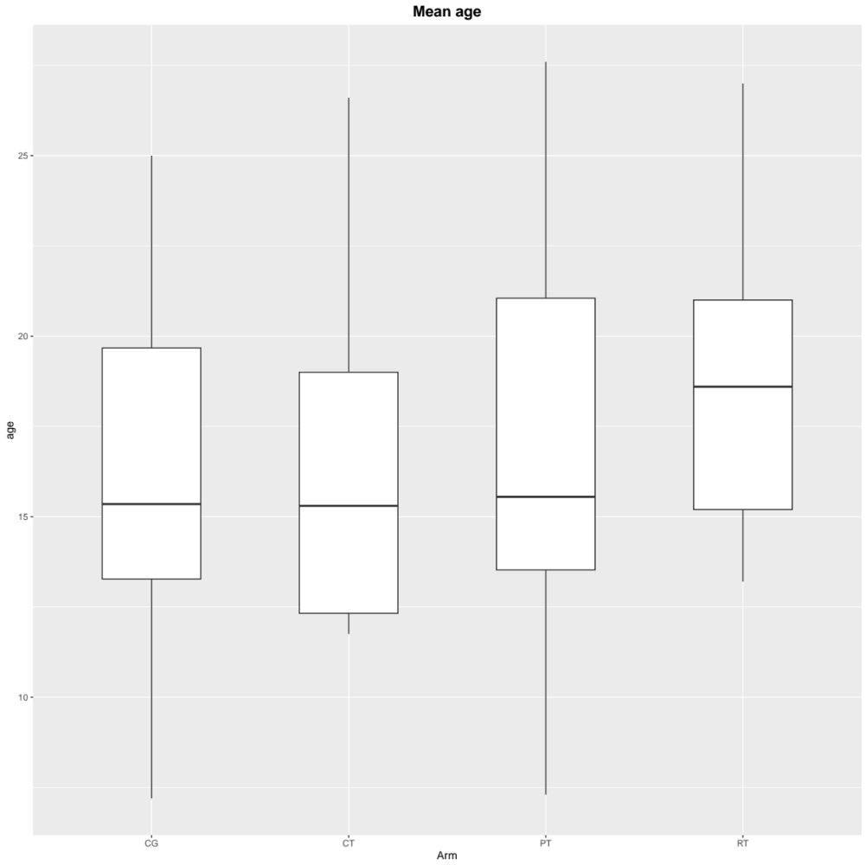

5.2 Sample size
We checked the sample size distribution of the included study. The range is from 6 to 50, with a median of 12. The results of one-way ANOVA showed that there was no statistical difference in the sample size between the types of neuromuscular training (F = 0.784, P = 0.508).
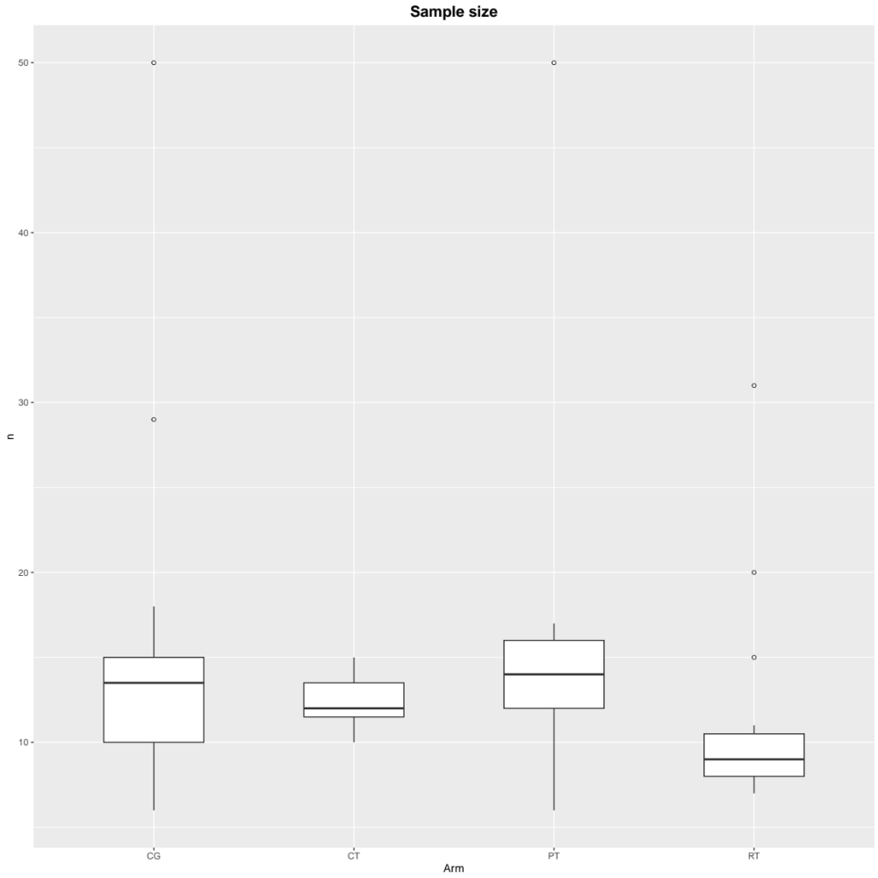

5.3 Sport level
We checked the sport level distribution of the included study participants. The range is from 1 to 3, with a median of 2. The results of one-way ANOVA showed that there was no statistical difference in the sport level between the types of neuromuscular training (F = 0.258, P = 0.855).
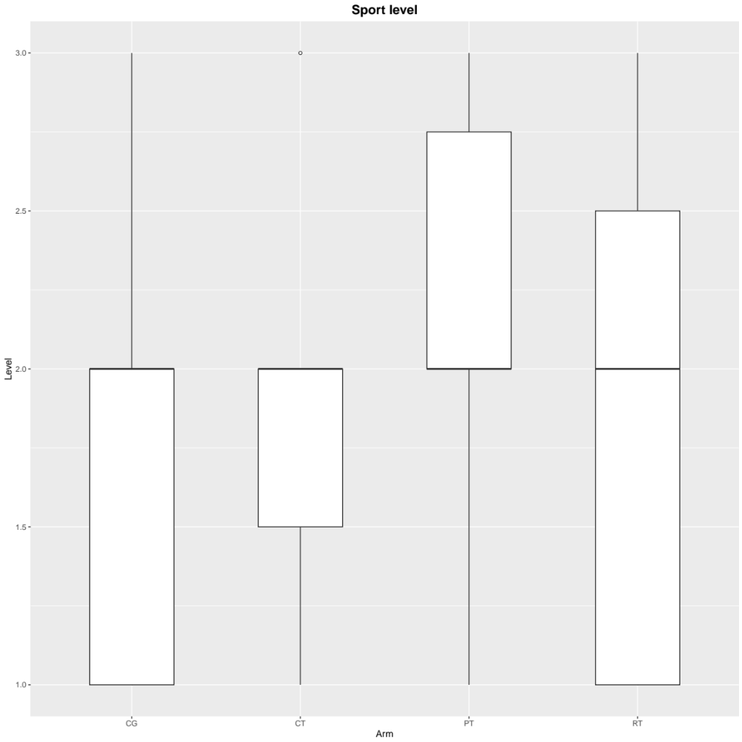

5.4 Training period
We checked the training period distribution of the included study. The range is from 4 to 36, with a median of 8. The results of one-way ANOVA showed that there was no statistical difference in the training period between the types of neuromuscular training (F = 1.884, P = 0.171).
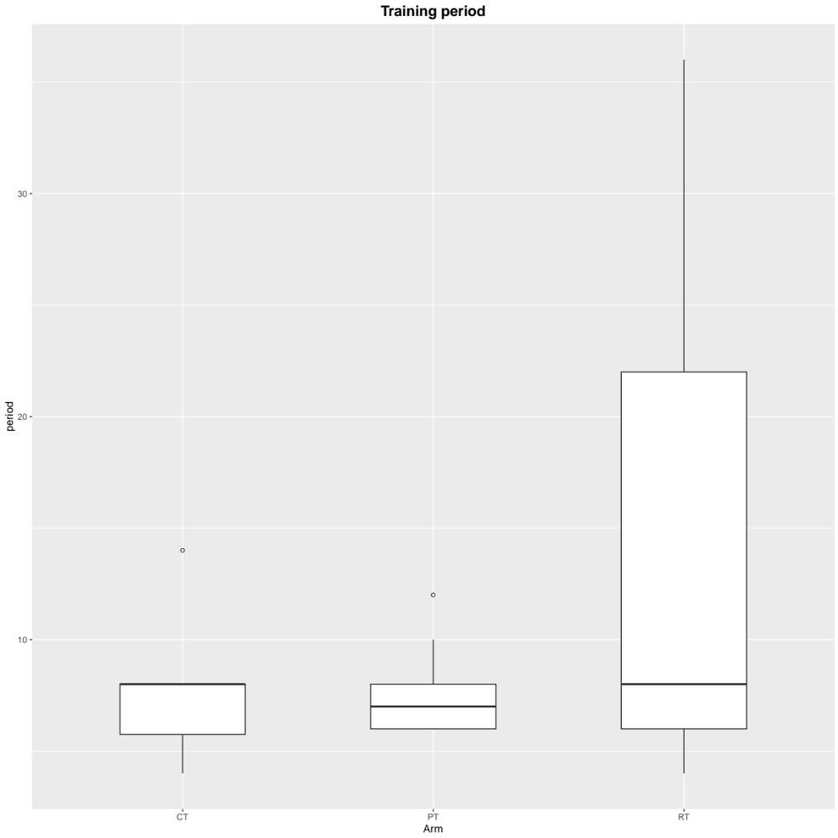

5.5 Training frequency
We checked the training frequency distribution of the included study. The range is from 2 to 3, with a median of 2. The results of one-way ANOVA showed that there was no statistical difference in the training frequency between the types of neuromuscular training (F = 0.081, P = 0.923).

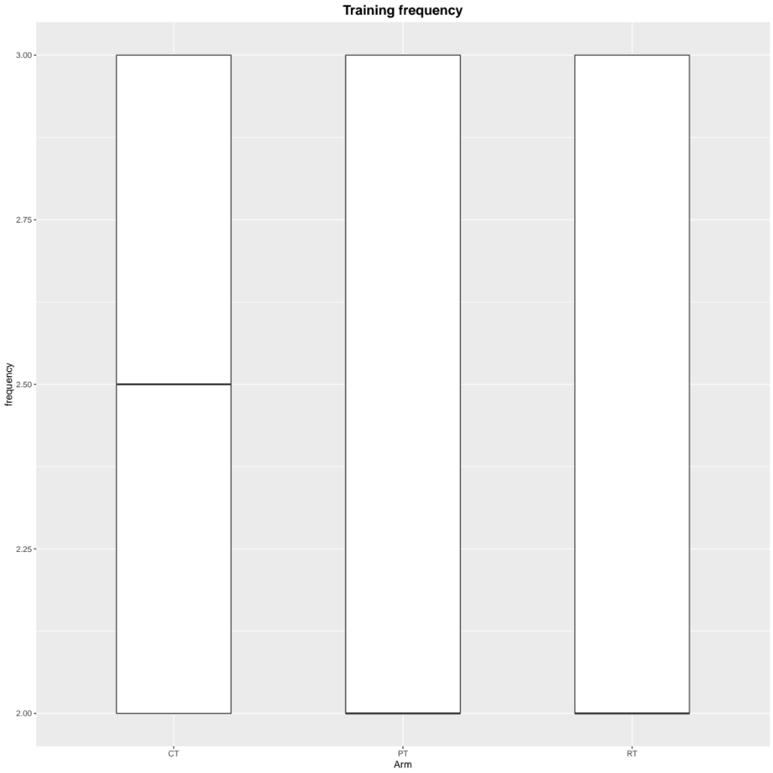

5.6 Total number of training sessions
We checked the training times distribution of the included study. The range is from 10 to 72, with a median of 18. The results of one-way ANOVA showed that there was no statistical difference in the training times between the types of neuromuscular training (F = 1.948, P = 0.161).
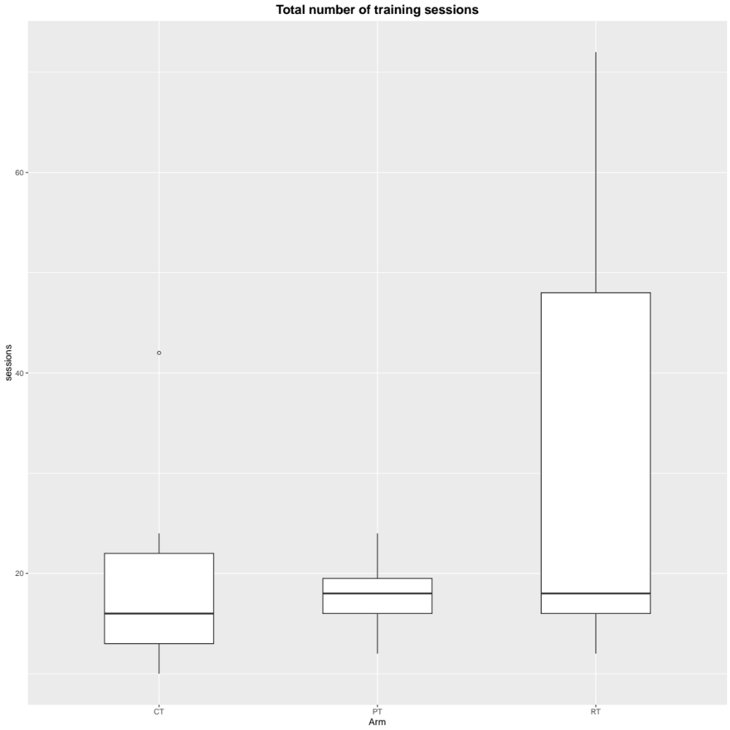

Supplementary 6: Network plot

6.1 Service velocity
The size of the dots represents the sample size, and the thickness of the line represents the number of studies that directly compared different types of neuromuscular training. PT, Plyometric training; RT, resistance training; CT, core strength training; CG, Conventional training program.

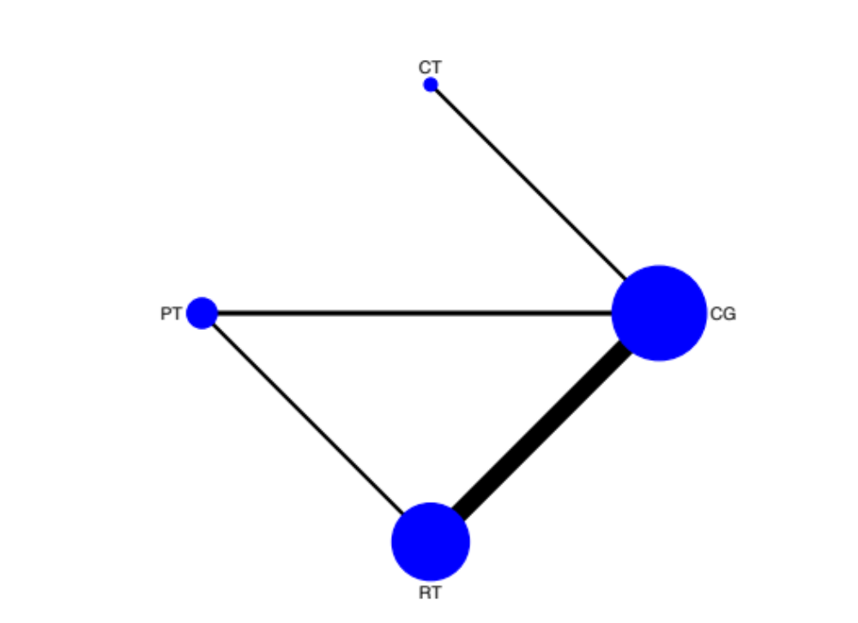

6.2 Service precision

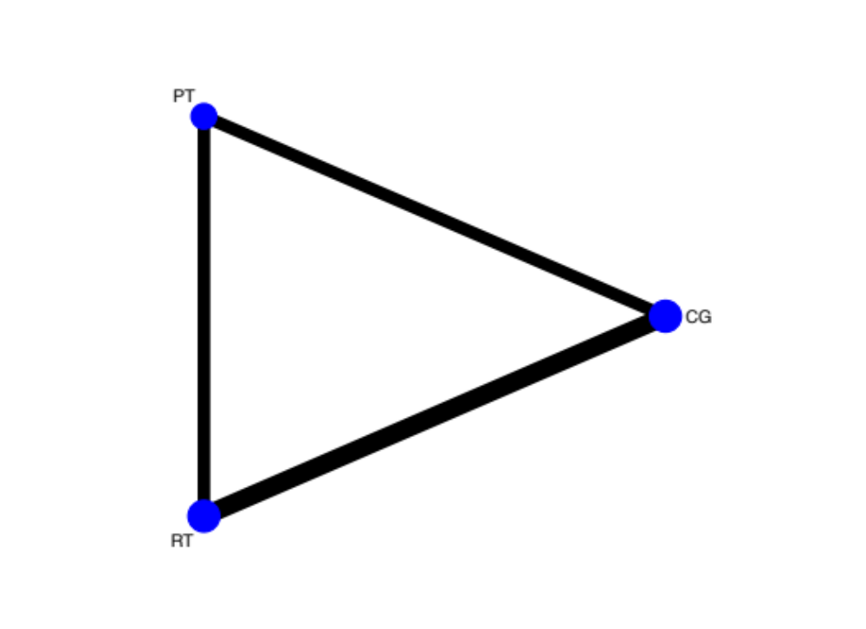

6.3 Agility

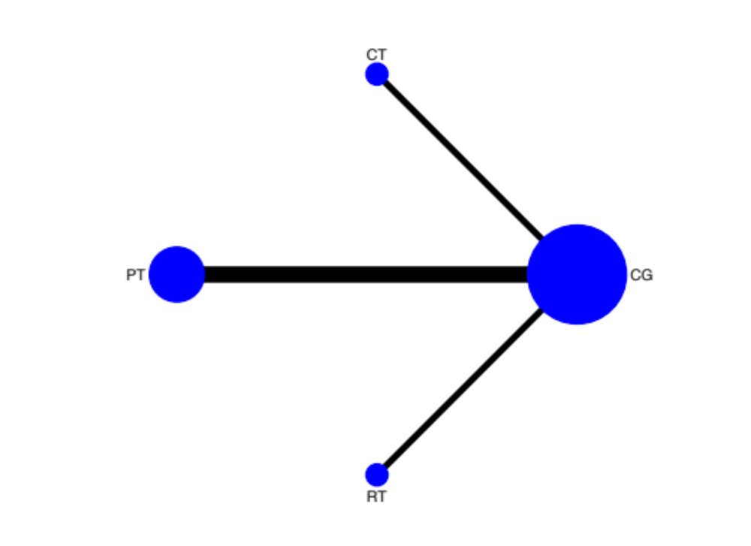

6.4 Sprint

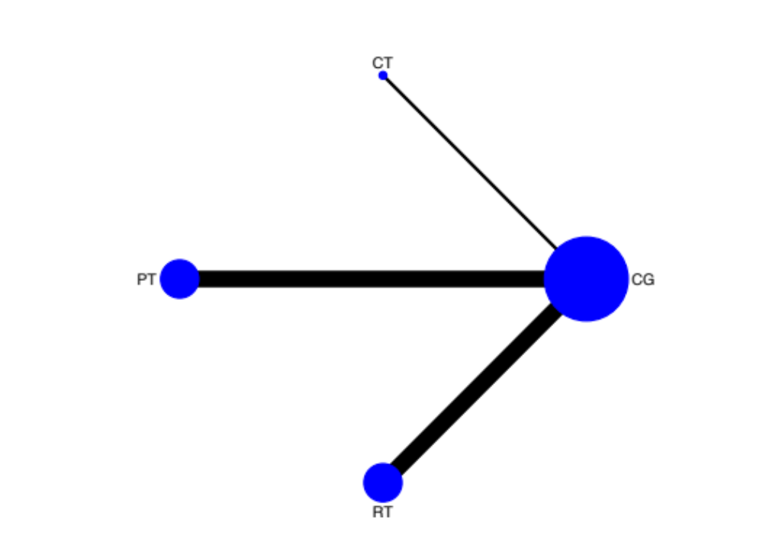

6.5 Strength
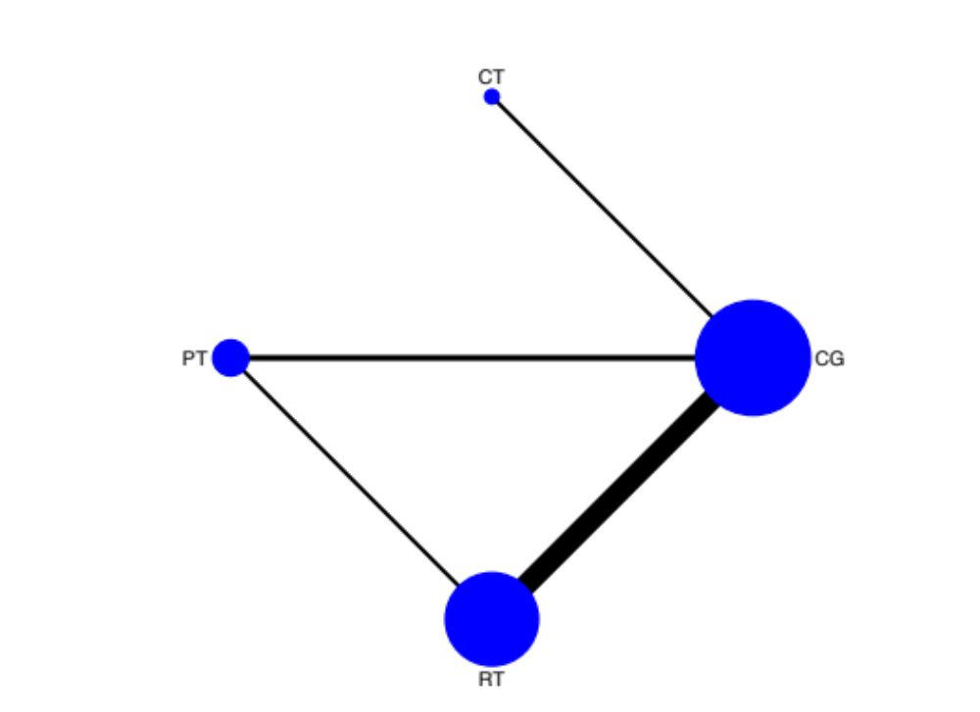

6.6 Power

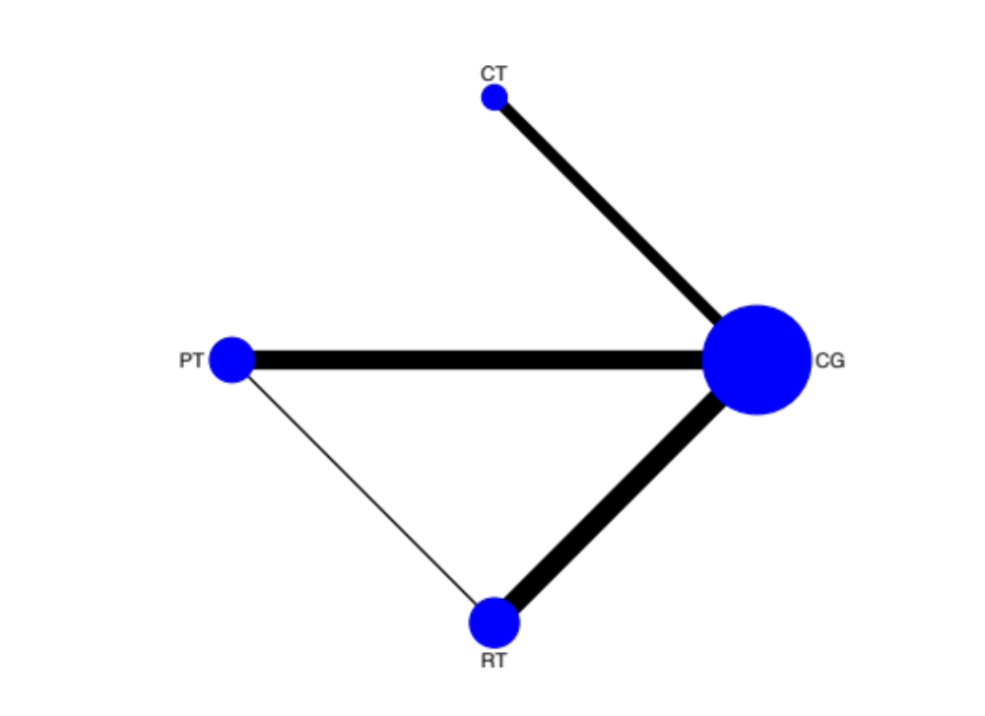

Supplementary 7: Evaluation of heterogeneity and inconsistency for network meta-analysis
We use the tau square (τ²) test and p-value to qualitatively analyze the statistical heterogeneity between the studies. The larger the τ² and the smaller the p-value, the greater the possibility of heterogeneity; on the contrary, the smaller the existence heterogeneity. In addition, I² is a parameter for quantitative analysis of the heterogeneity between the results of each study. It’ s value is distributed from 0-100%. When I² is less than 25%, it means that the heterogeneity is low; 25%-50% means that the heterogeneity is moderate; I² > 75% means high heterogeneity. In summary, when I² > 50%, it means that there is substantial heterogeneity.
Outcomes | Quantifying heterogeneity |  |  |  |  |  | Global inconsistency
Outcomes | τ² | Q | df | P | I² | Heterogeneity  assessment | The Design-by-Treatment test
Service velocity | 0 | 15.57 | 19 | 0.6854 | 0% | Low | 0.3163
Service precision | 0 | 0.63 | 3 | 0.8901 | 0% | Low | 0.5286
Agility | 0.0538 | 19.83 | 15 | 0.1786 | 24.4% | Low | 0.6075
Sprint | 0 | 16.66 | 19 | 0.6128 | 0% | Low | 0.5237
Strength | 0 | 4.21 | 13 | 0.9888 | 0% | Low | 0.9829
Power | 0.1316 | 34.38 | 19 | 0.0166 | 44.7% | Moderate | 0.5355

Table 7.1 Details of SIDE splitting results
Comparison | k | prop | nma | direct | indir. | Diff | z | p-value
Service velocity
CT vs CG | 3 | 1 | 0.3507 | 0.3507 | NA | NA | NA | NA
PT vs CG | 4 | 0.87 | 1.1295 | 1.1995 | 0.6567 | 0.5429 | 1.13 | 0.2576
RT vs CG | 15 | 0.95 | 0.7053 | 0.6745 | 1.3399 | -0.6654 | -1.26 | 0.2063
CT vs PT | 0 | 0 | -0.7788 | NA | -0.7788 | NA | NA | NA
CT vs RT | 0 | 0 | -0.3546 | NA | -0.3546 | NA | NA | NA
PT vs RT | 3 | 0.51 | 0.4242 | 0.183 | 0.6718 | -0.4888 | -1.39 | 0.163
Service precision
PT vs CG | 2 | 0.88 | 0.3831 | 0.4498 | -0.1238 | 0.5736 | 0.66 | 0.508
RT vs CG | 3 | 1 | 0.2819 | 0.2879 | -1.3886 | 1.6766 | 0.45 | 0.6543
PT vs RT | 2 | 0.92 | 0.1012 | 0.0596 | 0.5536 | -0.4939 | -0.52 | 0.6038
Agility
CT vs CG | 4 | 1 | -0.769 | -0.769 | NA | NA | NA | NA
PT vs CG | 10 | 1 | -0.6871 | -0.6871 | NA | NA | NA | NA
RT vs CG | 4 | 1 | -0.1426 | -0.1426 | NA | NA | NA | NA
CT vs PT | 0 | 0 | -0.082 | NA | -0.082 | NA | NA | NA
CT vs RT | 0 | 0 | -0.6264 | NA | -0.6264 | NA | NA | NA
PT vs RT | 0 | 0 | -0.5444 | NA | -0.5444 | NA | NA | NA
Sprint
CT vs CG | 2 | 1 | -0.0749 | -0.0749 | NA | NA | NA | NA
PT vs CG | 10 | 1 | -0.5506 | -0.5506 | NA | NA | NA | NA
RT vs CG | 10 | 1 | -0.1008 | -0.1008 | NA | NA | NA | NA
CT vs PT | 0 | 0 | 0.4757 | NA | 0.4757 | NA | NA | NA
CT vs RT | 0 | 0 | 0.0259 | NA | 0.0259 | NA | NA | NA
PT vs RT | 0 | 0 | -0.4498 | NA | -0.4498 | NA | NA | NA
Strength
CT vs CG | 2 | 1 | 0.5262 | 0.5262 | NA | NA | NA | NA
PT vs CG | 3 | 0.84 | 0.4184 | 0.4018 | 0.5072 | -0.1055 | -0.18 | 0.8556
RT vs CG | 11 | 0.98 | 0.6445 | 0.6462 | 0.5762 | 0.07 | 0.08 | 0.9362
CT vs PT | 0 | 0 | 0.1078 | NA | 0.1078 | NA | NA | NA
CT vs RT | 0 | 0 | -0.1183 | NA | -0.1183 | NA | NA | NA
PT vs RT | 2 | 0.57 | -0.2261 | -0.1918 | -0.271 | 0.0792 | 0.17 | 0.8611
Power
CT vs CG | 5 | 1 | 0.2828 | 0.2828 | NA | NA | NA | NA
PT vs CG | 8 | 0.97 | 0.9547 | 0.9267 | 2.042 | -1.1153 | -0.95 | 0.3441
RT vs CG | 9 | 0.96 | 0.9255 | 0.9219 | 1.0221 | -0.1002 | -0.09 | 0.9305
CT vs PT | 0 | 0 | -0.6719 | NA | -0.6719 | NA | NA | NA
CT vs RT | 0 | 0 | -0.6427 | NA | -0.6427 | NA | NA | NA
PT vs RT | 1 | 0.18 | 0.0292 | 0.3146 | -0.033 | 0.3476 | 0.49 | 0.6272
CT vs CG | 5 | 1 | 0.2828 | 0.2828 | NA | NA | NA | NA
Legend:
comparison - Treatment comparison
k - Number of studies providing direct evidence
prop - Direct evidence proportion
nma - Estimated treatment effect (SMD) in network meta-analysis
direct - Estimated treatment effect (SMD) derived from direct evidence
indir. - Estimated treatment effect (SMD) derived from indirect evidence
Diff - Difference between direct and indirect treatment estimates
z - z-value of test for disagreement (direct versus indirect)
p-value - p-value of test for disagreement (direct versus indirect)
NA - No available

Supplementary 8: The pairwise comparison forest plot for network meta-analysis

8.1 Service velocity
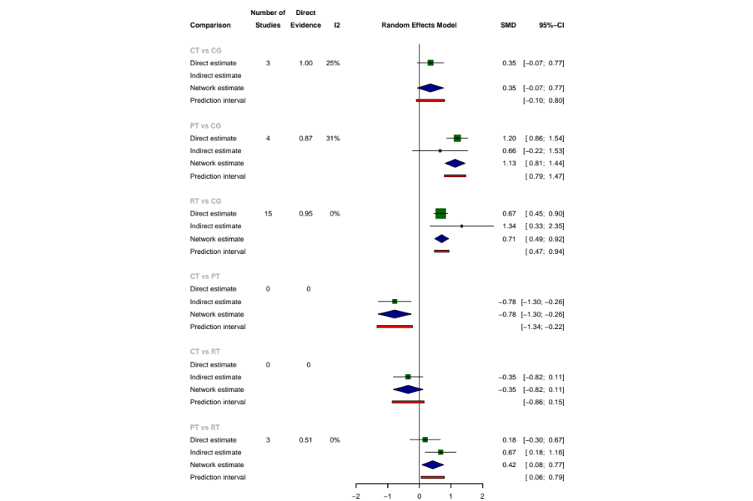

8.2 Service precision
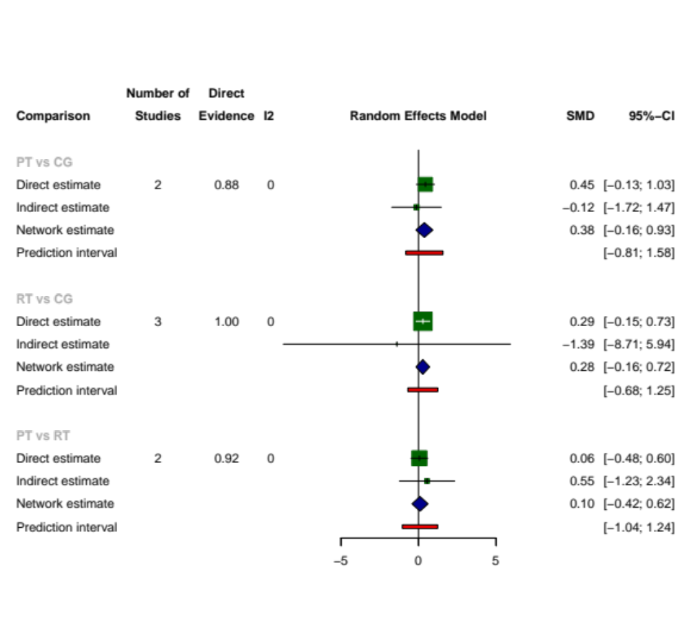

8.3 Agility
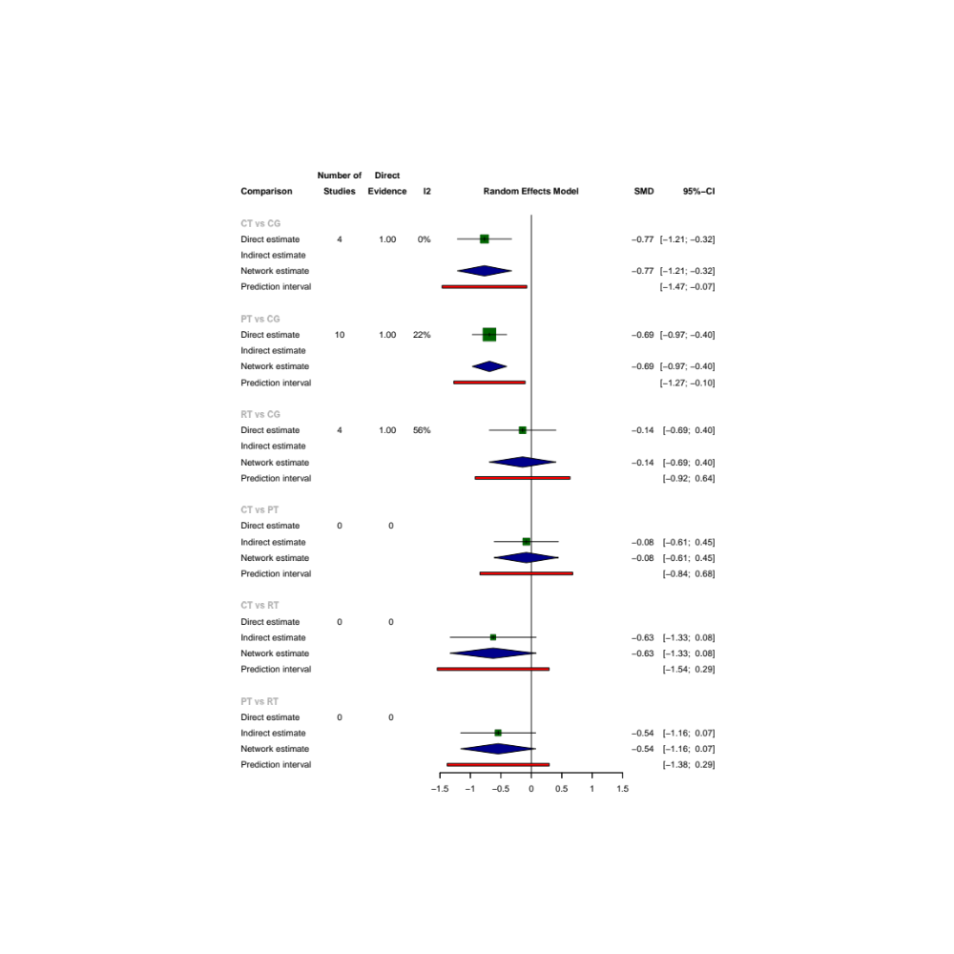

8.4 Sprint
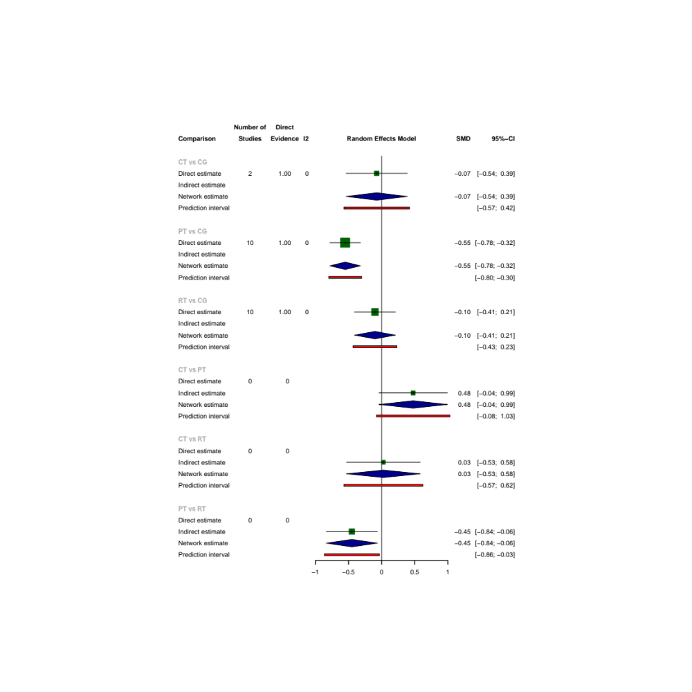

8.5 Strength
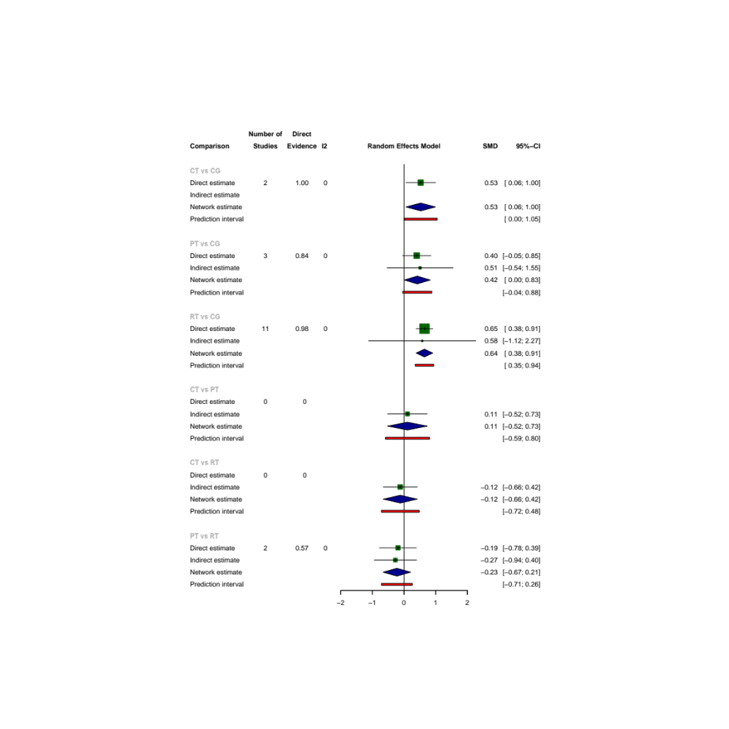

8.6 Power
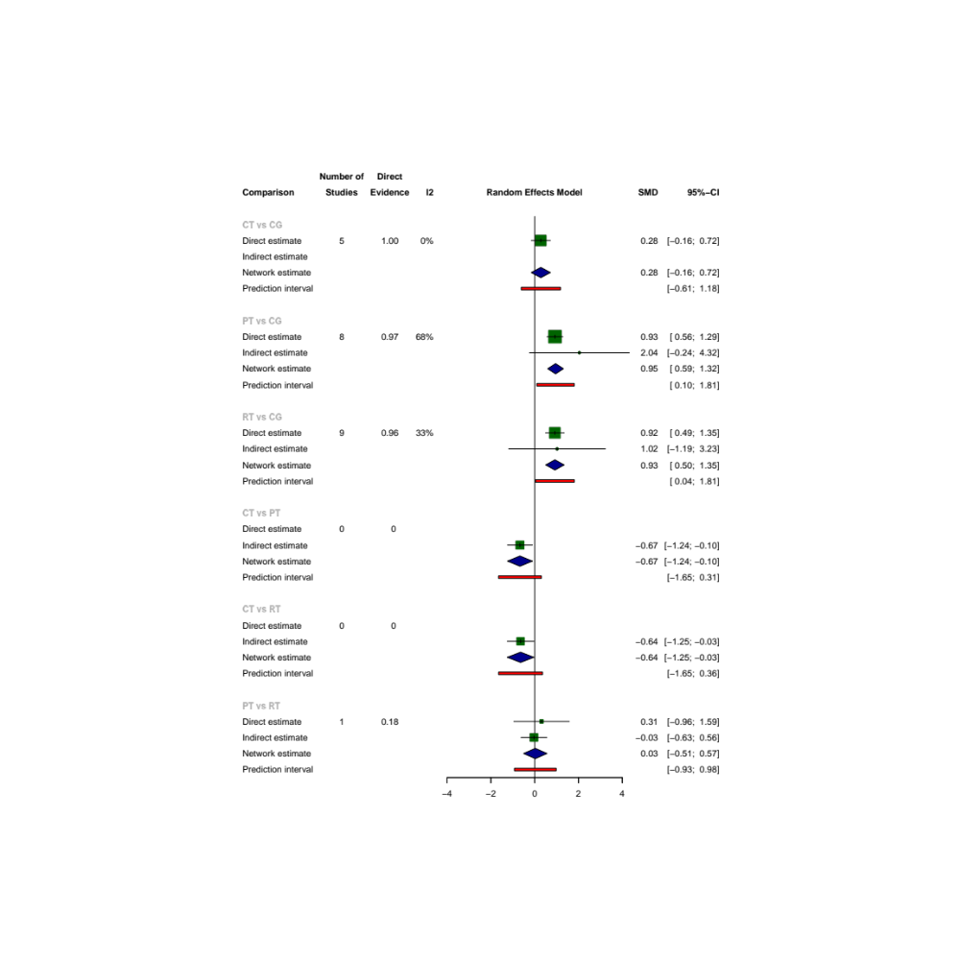

Supplementary 9: Quality of the evidence
Author(s):
Question: [Neuromuscular training] compared to [Conventional training program] for [Special skills and functional performance]
Setting:
Bibliography:
 | Certainty assessment |  |  |  |  |  |  | № of patients |  | Effect | Certainty
 | № of studies | Study design | Risk of bias | Inconsistency | Indirectness | Imprecision | Other considerations | [Neuromuscular training] | [Conventional training program] | Absolute  (95% CI)
Service velocy | 14 | randomised trials | seriousª | not serious | not serious | not serious | none | 299 | 192 | SMD 0.72 (0.47 to 0.99) | ⨁⨁⨁◯  Moderateª
Service precision | 3 | randomised trials | seriousª | not serious | not serious | very serious^{b} | none | 70 | 35 | SMD 0.36 (-0.13 to 0.86) | ⨁◯◯◯  Very low^{a,b}
Agility | 11 | randomised trials | seriousª | not serious | not serious | serious^{b} | none | 158 | 143 | SMD -0.64 (-0.92 to -0.35) | ⨁⨁◯◯  Low^{a,b}
Sprint | 8 | randomised trials | seriousª | not serious | not serious | serious^{b} | none | 129 | 99 | SMD -0.33 (-0.6 to -0.07) | ⨁⨁◯◯  Low^{a,b}
Strength | 6 | randomised trials | seriousª | not serious | not serious | serious^{b} | none | 128 | 84 | SMD 0.57 (0.35 to 0.8) | ⨁⨁◯◯  Low^{a,b}
Power | 11 | randomised trials | seriousª | not serious | not serious | serious^{b} | none | 204 | 161 | SMD 0.74 (0.41 to 1.08) | ⨁⨁◯◯  Low^{a,b}
CI: confidence interval; SMD: standardised mean difference
Explanations
a. The results of literature quality evaluation generally have some concern
b. the meta-analysis included fewer than 400 subjective

