S1.BMI-Funnel plot of meta-analysis results.
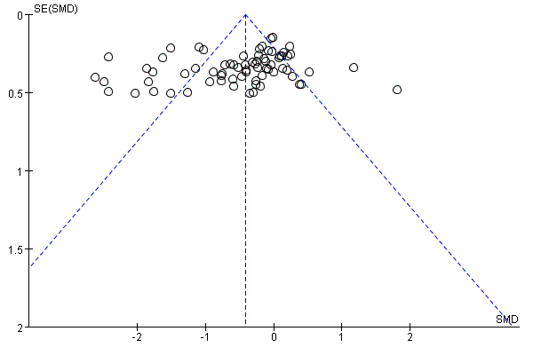

S2.TC-Funnel plot of meta-analysis results.
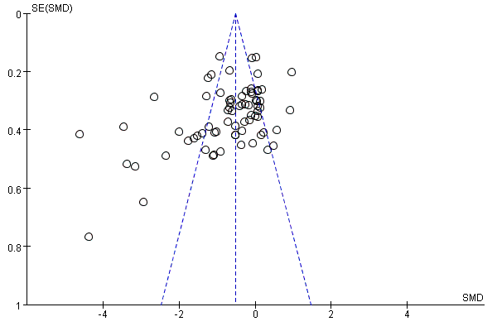

S3.TG-Funnel plot of meta-analysis results.
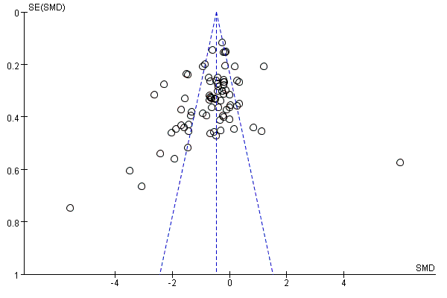

S4.LDL-Funnel plot of meta-analysis results.
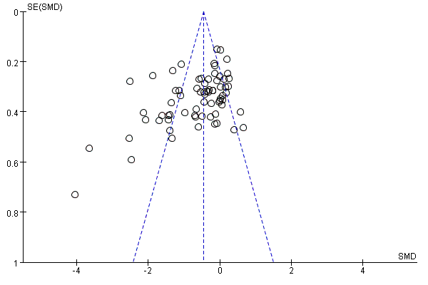

S5.HDL-Funnel plot of meta-analysis results.
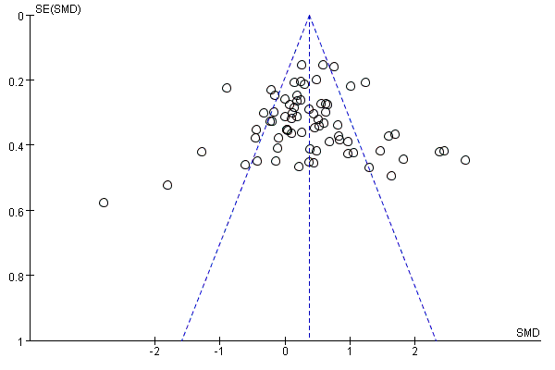

S6.FPG-Funnel plot of meta-analysis results.

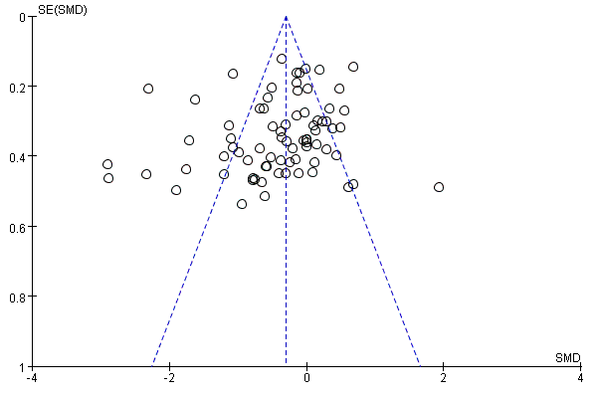

S7.FIN-Funnel plot of meta-analysis results.
