S1.TC-Forest plot of intervention duration subgroups.
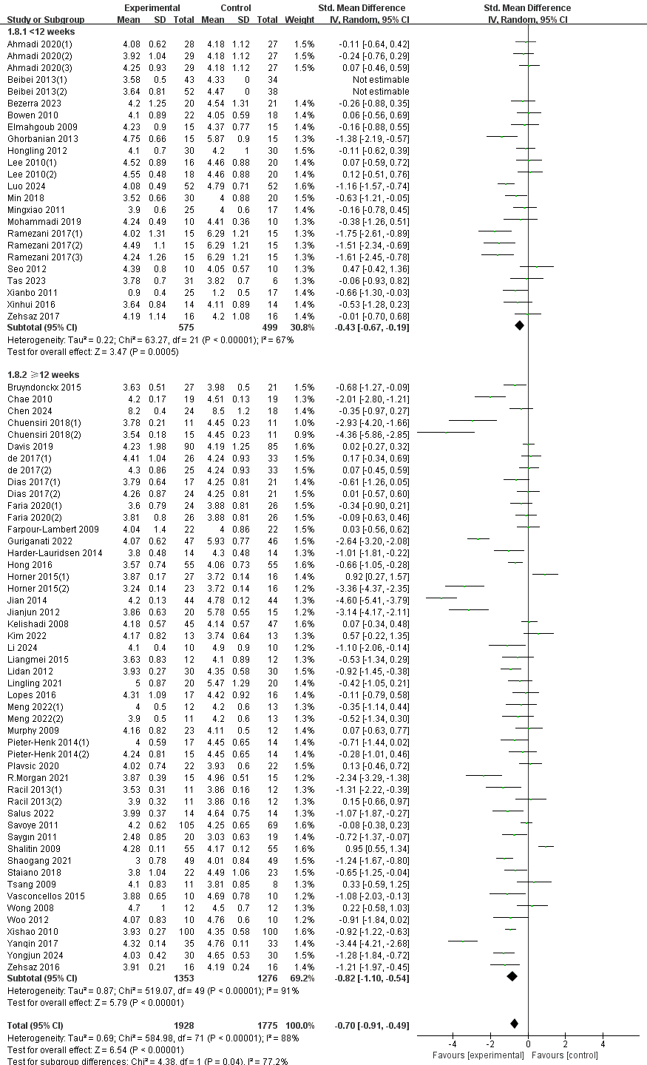
S2.TC-Forest plot of exercise mode subgroups.
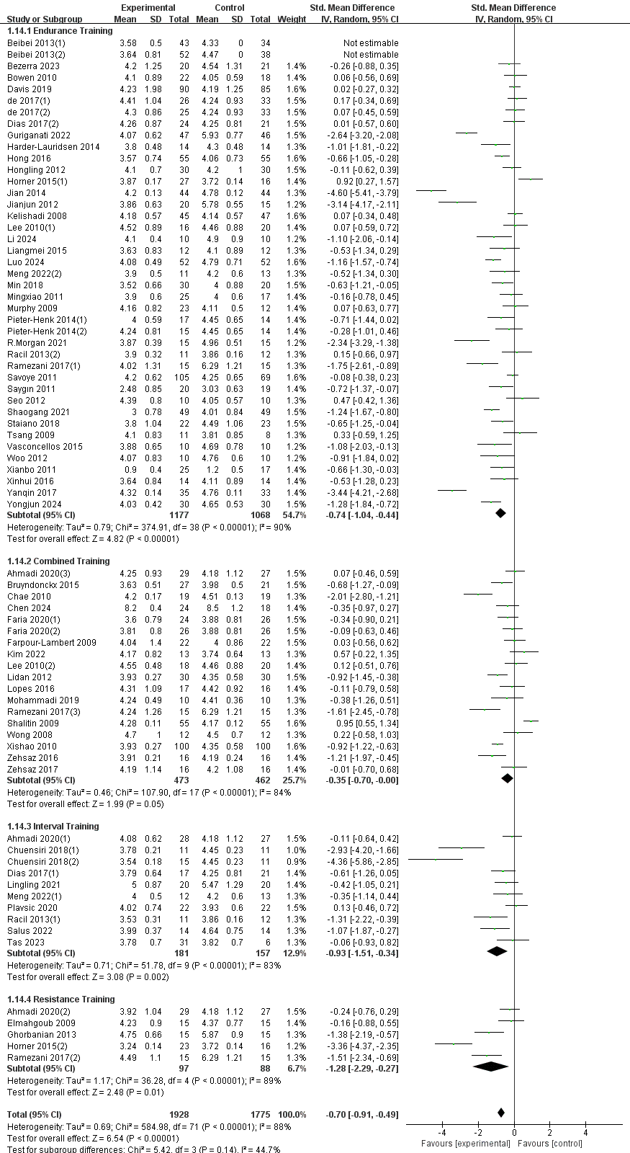
S3.TC-Forest plot of duration of a single intervention subgroups.(＜60 minutes or ≥60 minutes)
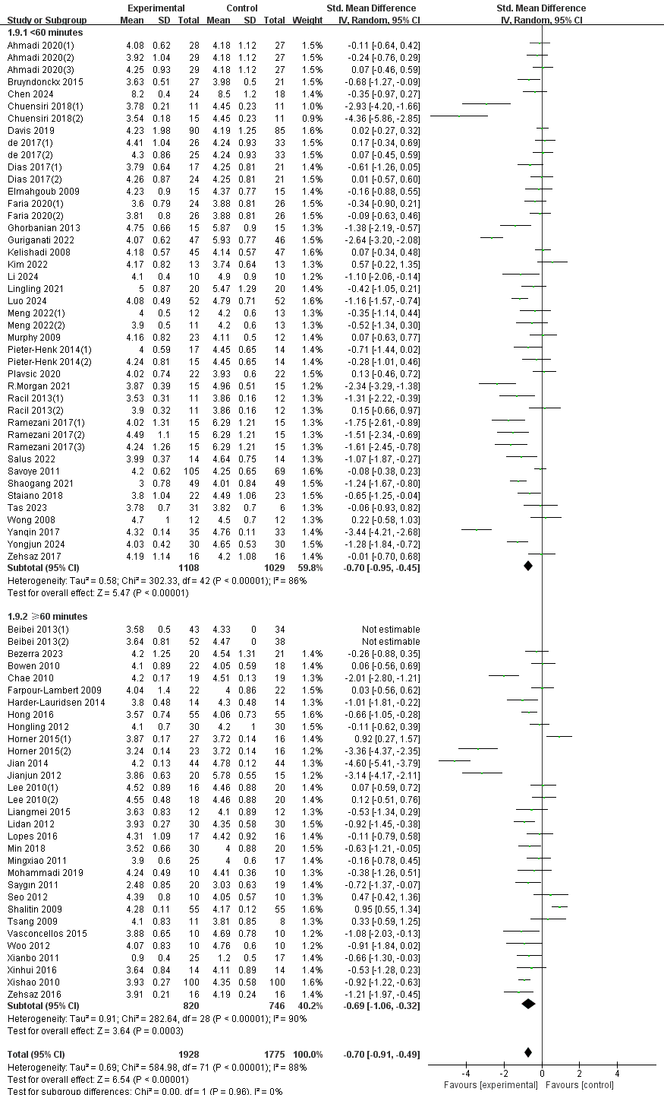
S4.TC-Forest plot of duration of a single intervention subgroups.(＜60 minutes 、=60 minutes or＞60 minutes)
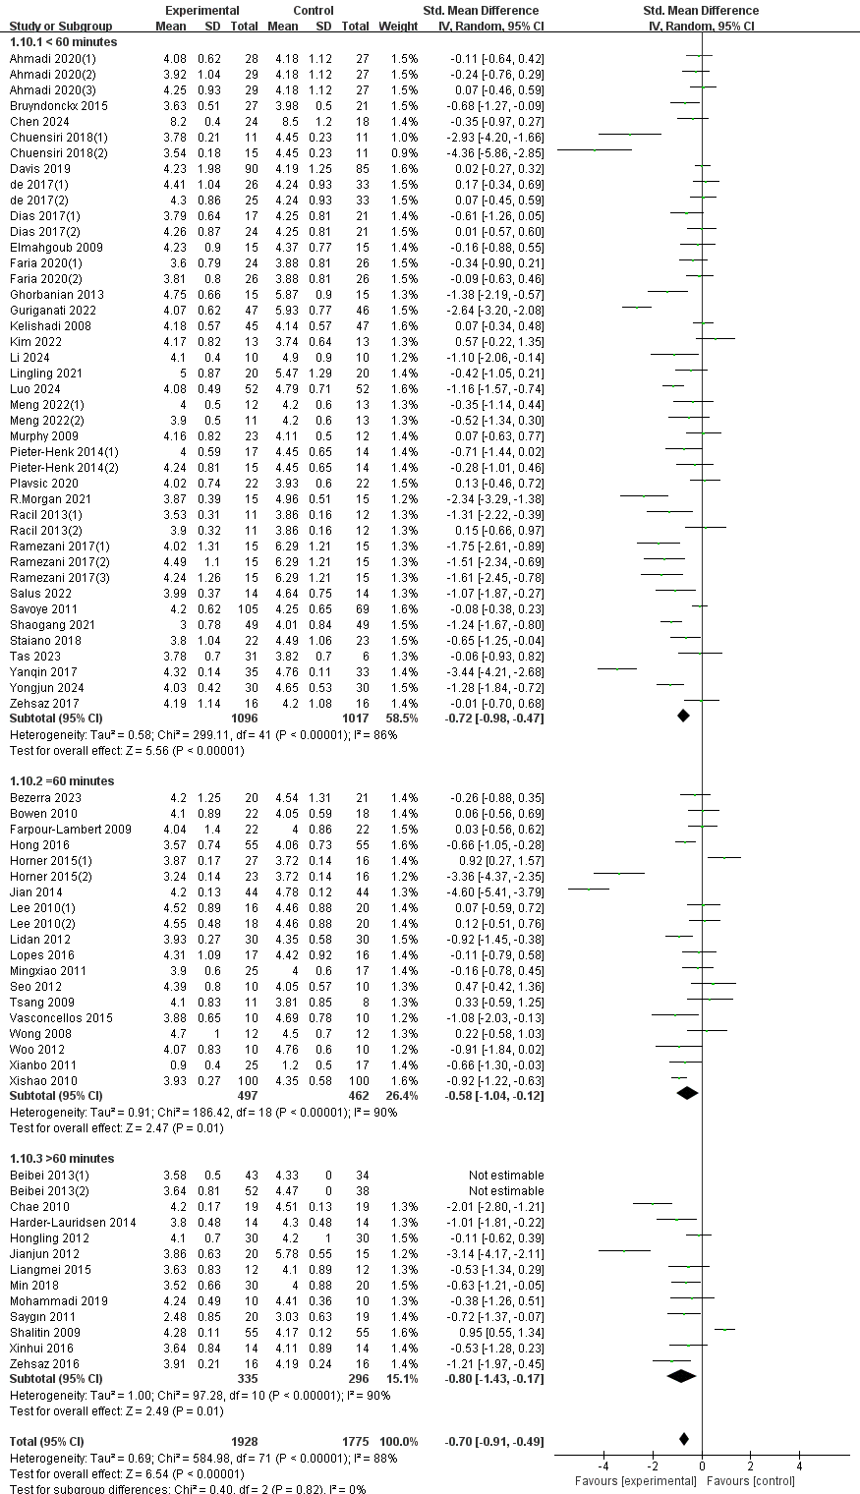
S5.TC-Forest plot of duration of a single intervention subgroups.( ＜40 minutes or ≥40 minutes)
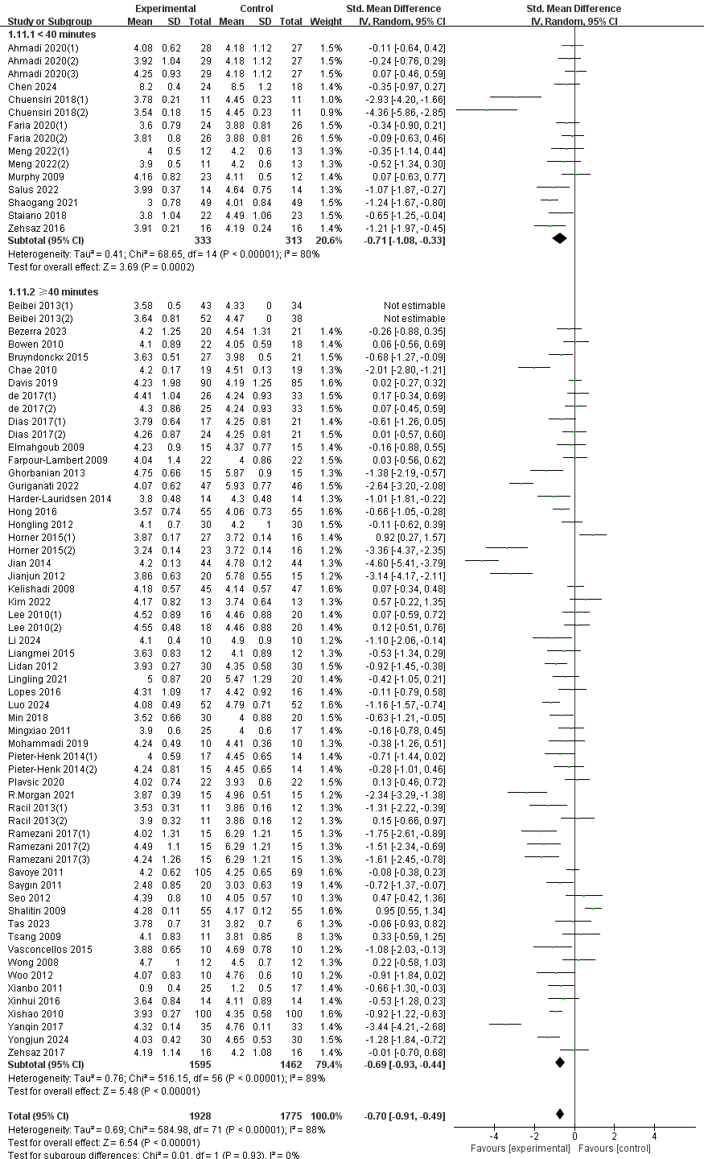

S6.TC-Forest plot of duration of a single intervention subgroups.( ＜50 minutes or ≥50 minutes)
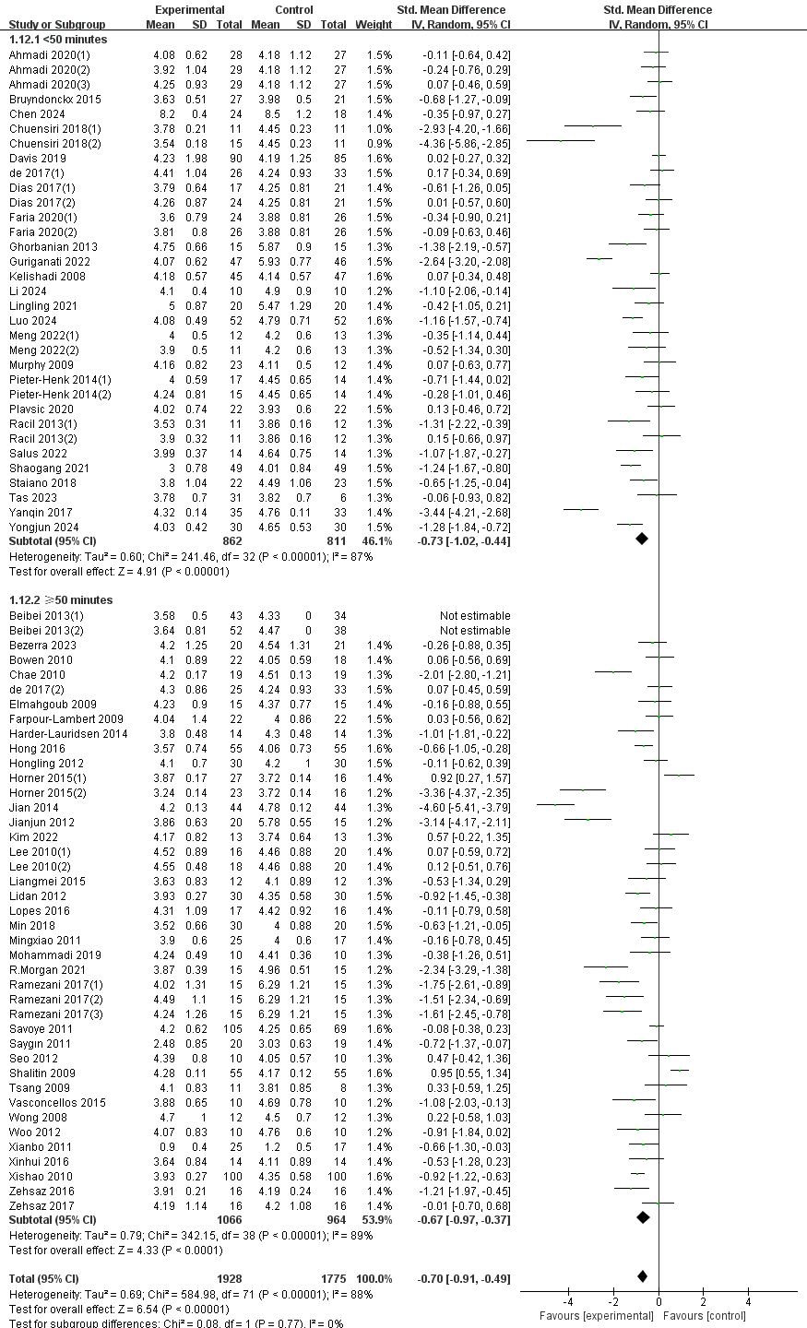
S7.TC-Forest plot of intervention frequency subgroups.
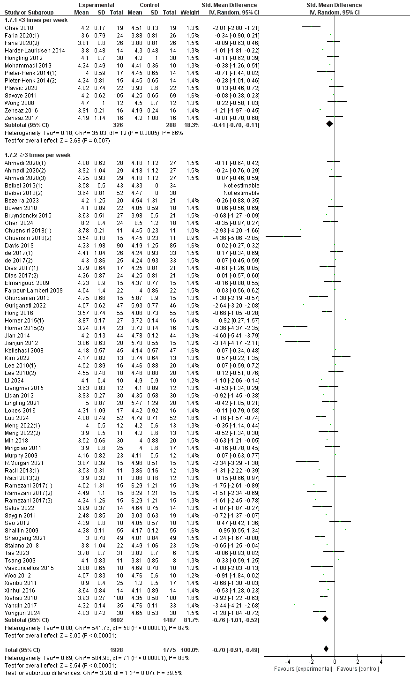
S8.TC-Forest plot of intervention intensity subgroups.
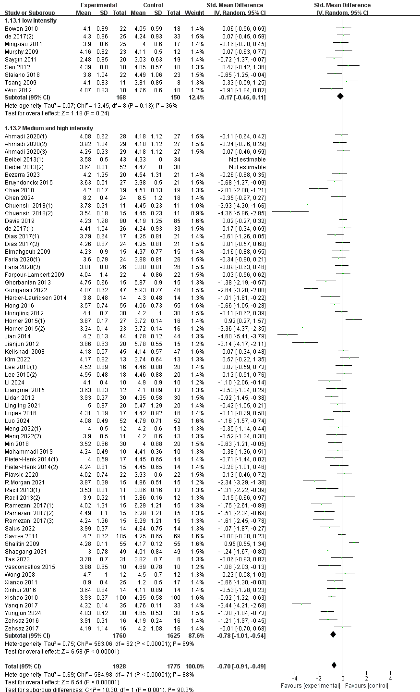
S9.TC-Forest plot of Gender inclusion subgroups.
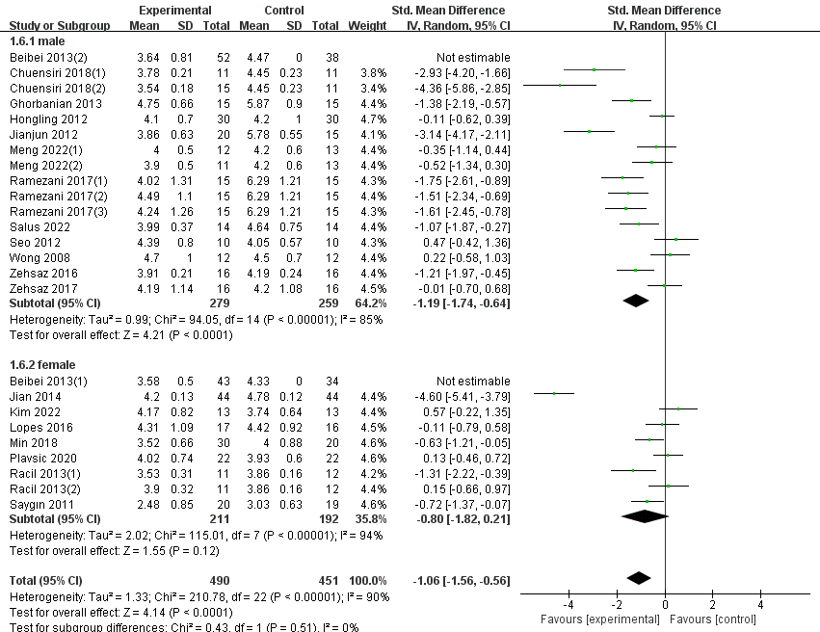

S10.TC-Forest plot of region subgroups.
