S1.TG-Forest plot of intervention duration subgroups.
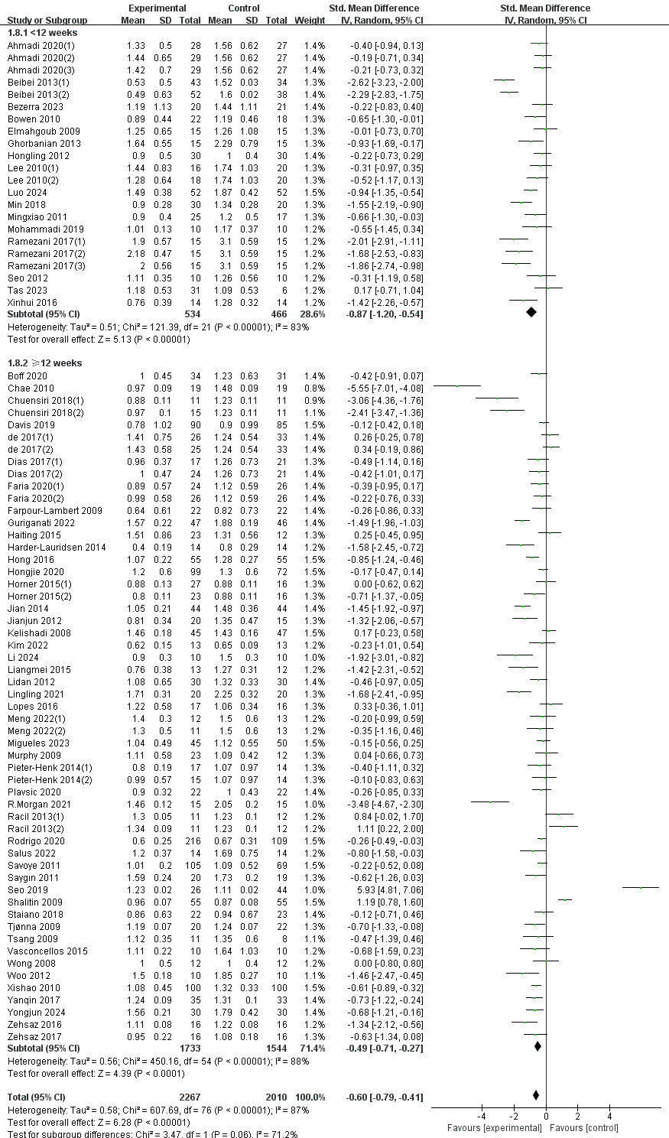

S2.TG-Forest plot of exercise mode subgroups.
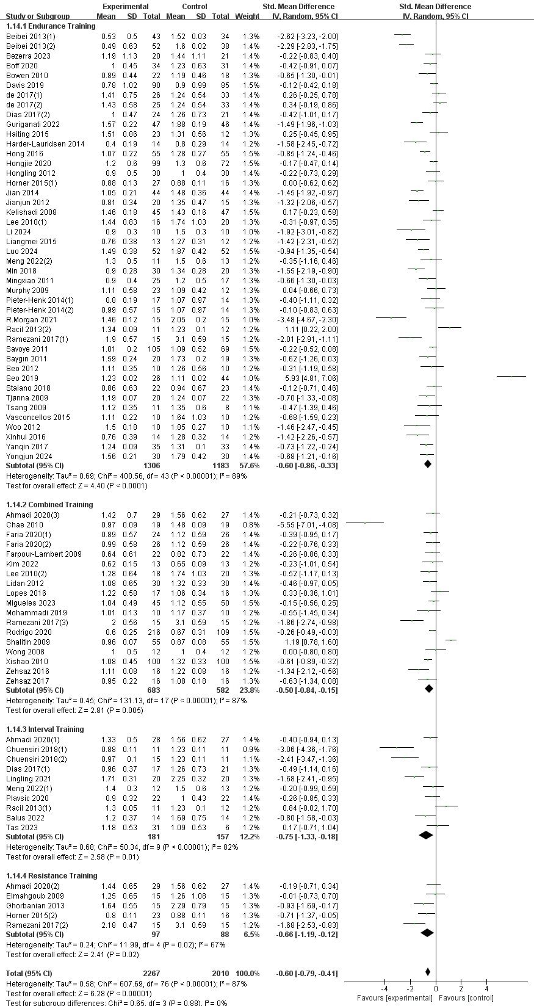
S3.TG-Forest plot of duration of a single intervention subgroups.(＜60 minutes or ≥60 minutes)
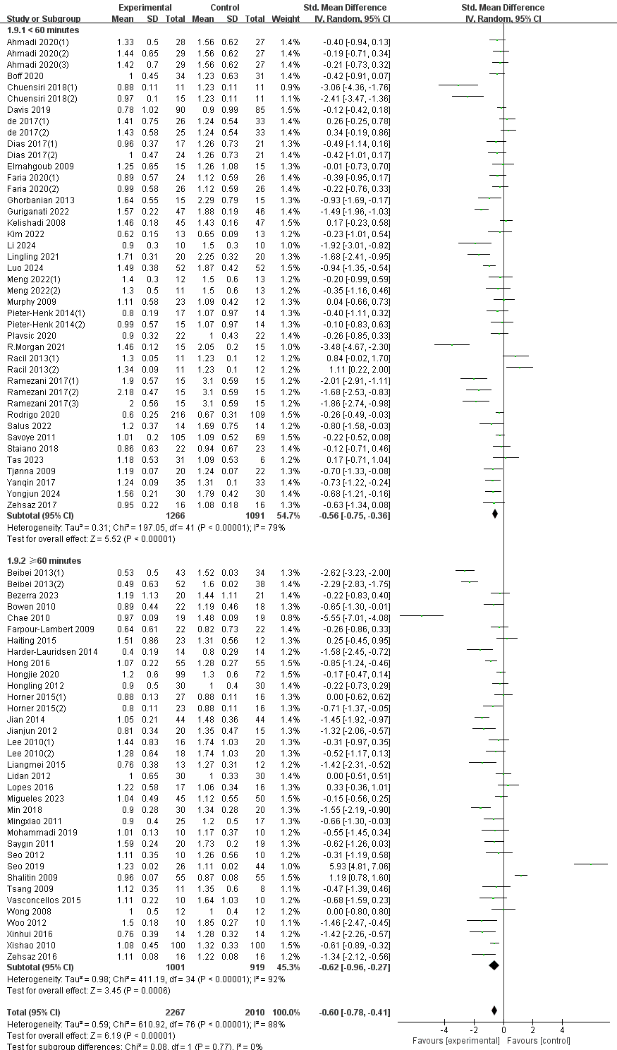
S4.TG-Forest plot of duration of a single intervention subgroups.(＜60 minutes 、=60 minutes or＞60 minutes)
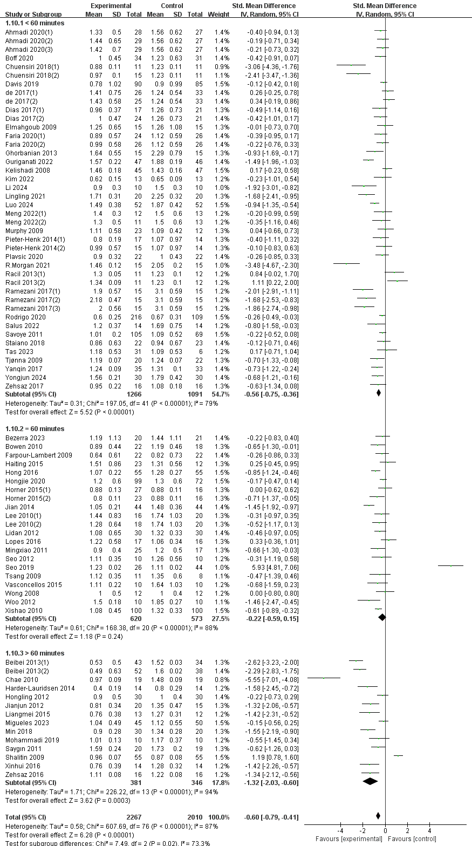
S5.TG-Forest plot of duration of a single intervention subgroups.( ＜40 minutes or ≥40 minutes)
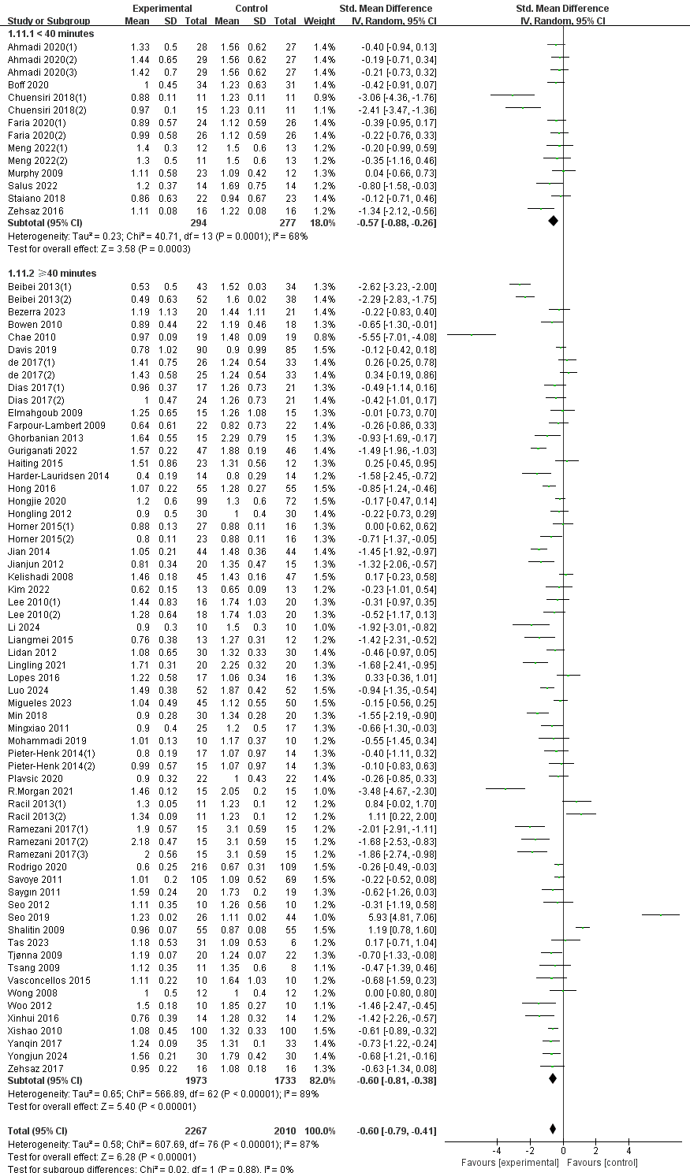

S6.TG-Forest plot of duration of a single intervention subgroups.( ＜50 minutes or ≥50 minutes)
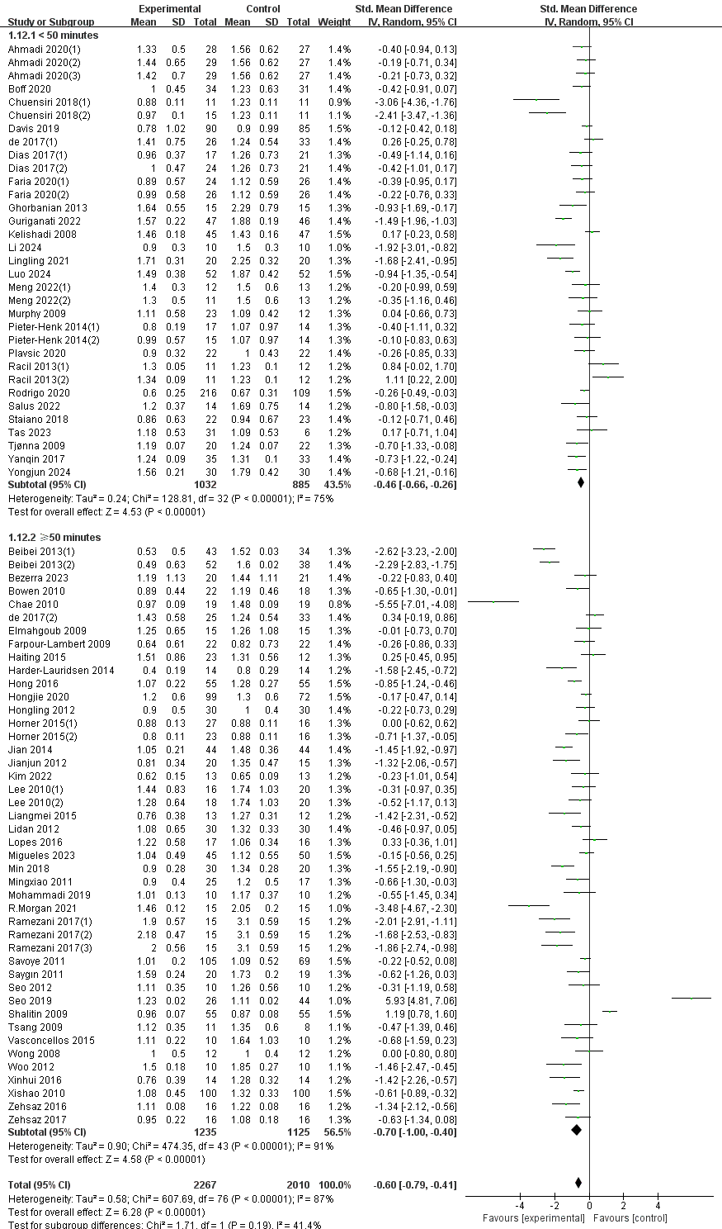
S7.TG-Forest plot of intervention frequency subgroups.
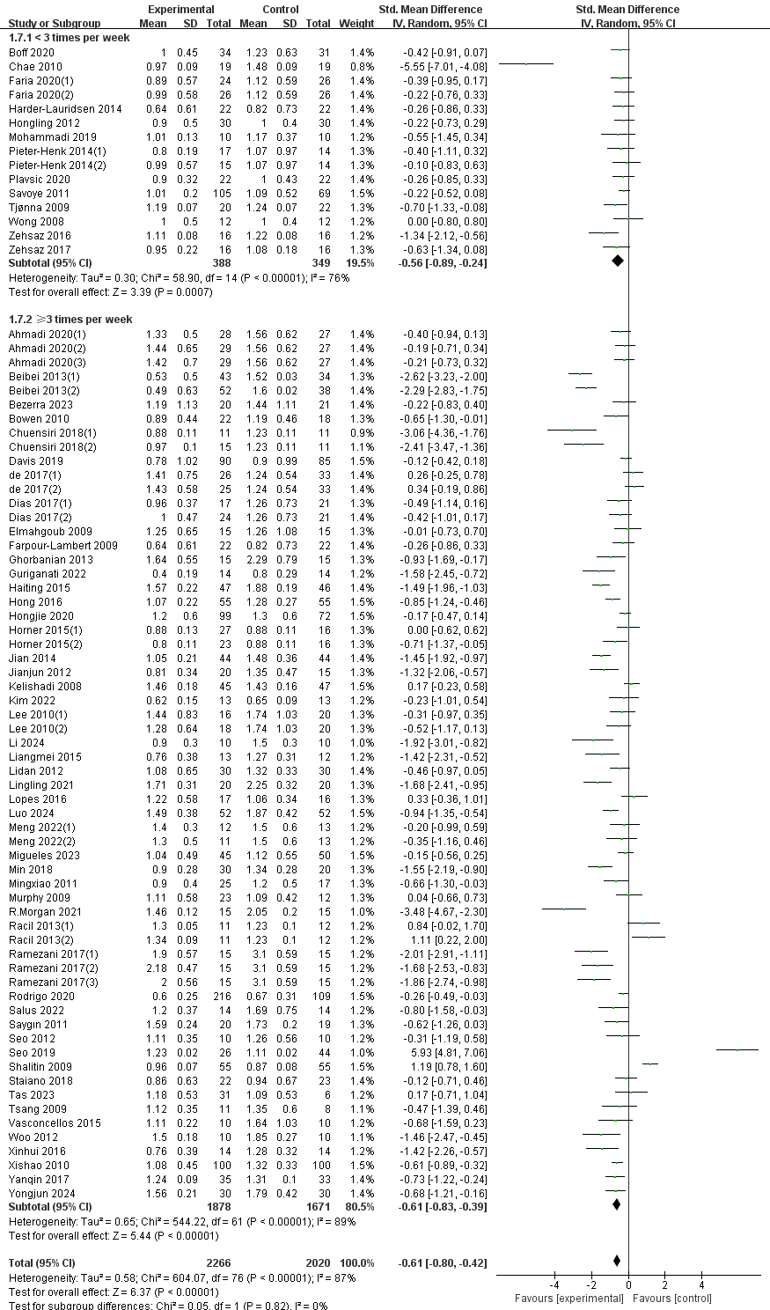
S8.TG-Forest plot of intervention intensity subgroups.
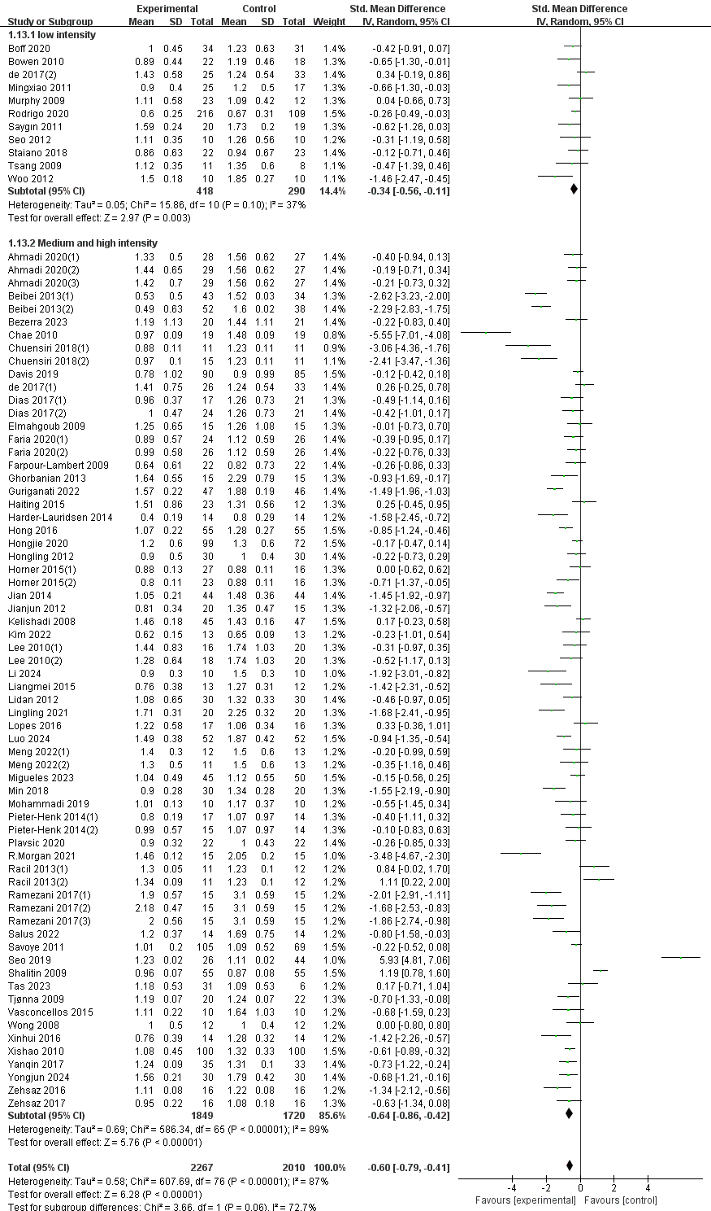
S9.TG-Forest plot of Gender inclusion subgroups.
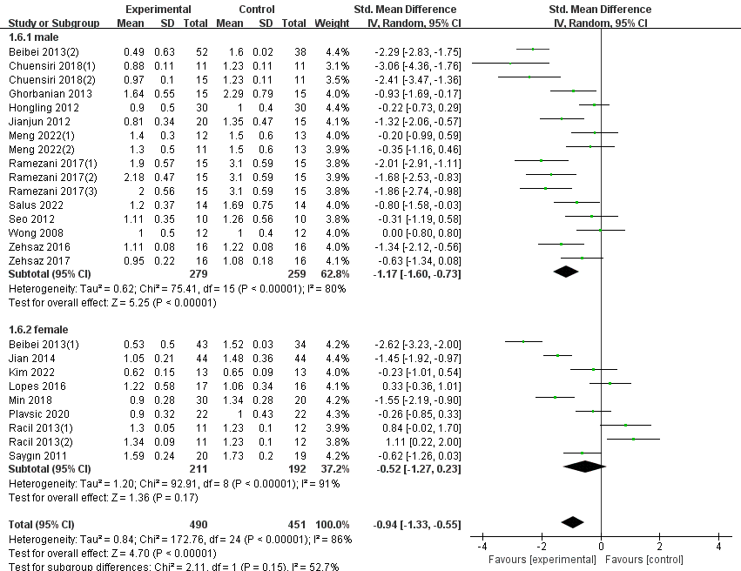

S10.TG-Forest plot of region subgroups.
