SUPPLEMENTARY FIGURES AND TABLES

Supplementary Appendix I: Socio-demographic and medical questionnaire

Socio-demographic and medical questionnaire :
Socio-demographic questionnaire
  - 1. Are you male or female? (circle the correct answer)
          - Male
          - Female
          - Other: ……………………………………………………………………………………
  - 2. What is your age?
  - ….….. years
  - 3. To which of the following population groups do you belong? (circle the correct answer)
  - White / Eastern and Western European
  - White / Southern European Mediterranean or Arab
  - Black / African descent
  - Asian
  - Other population group
  - 4. Religion: what is your religion? (circle the correct answer)
  - Atheism (no specific faith)
  - Buddhism
  - Christianity
  - Hinduism
  - Islam
  - Judaism
  - Other (please specify): ………………………………………………………………………
  - 5. Describe your living situation (circle the correct answer)
  - Living alone
  - Living together with someone (partner, family, friends)
  - Assisted living (nursing home, service flat, short stay)
  - Other (please specify): ………………………………………………………………………
  - 6. Suppose you were in need of long-term care, would you have someone who would regularly help you? (circle the correct answer)
  - No, I would not have anyone
  - Yes, but I’m not sure
  - Yes, I’m certain
  - 7. How many children do you have? (circle the correct answer)
  - No children
  - 1 child
  - 2 children
  - 3 children
  - 4 children
  - 5 or more children
  - 8. Do you currently spend a lot of time and energy caring for others?
  - No, hardly at all
  - Yes, I spend a moderate amount of energy caring for others
  - Yes, I spend a great deal of energy caring for others
  - 9. What is the highest level of education you have completed or the highest degree you have obtained?
  - Uneducated – No diploma or certificate
  - Primary education (regular or special)
  - Secondary education (general, technical, vocational, arts, or special education)
  - Post-secondary (i.e. successful completion of the seventh year or the third year of the third stage of regular secondary education (general – technical – arts – vocational) or of special secondary education, or the fourth stage of vocational education (including entrepreneurial training))
  - Higher non-university education (College / University of Applied Sciences)
  - Higher university education (University)
  - Other (please specify): ………………………………………………………………………………
  - 10. Describe your employment situation in the months before your transplant:
  - I was in school, I was studying
  - I was employed, for …… %
  - I was self-employed, for …… %
  - I was a full-time homemaker (housewife/househusband)
  - I was unemployed
  - I was retired
  - 11. Describe your employment situation at this moment (3–5 months after transplant):
  - I am in school, I am studying
  - I am employed, for …… %
  - I am self-employed, for …… %
  - I am a full-time homemaker (housewife/househusband)
  - I am unemployed
  - I am unable to work, for …… %
  - 12. Which of the following categories best describes your net monthly income?
  - <500 € per month
  - 500–1000 € per month
  - 1000–1500 € per month
  - 1500–2000 € per month
  - 2000–2500 € per month
  - 2500–3000 € per month
  - 3000 € per month
  - Other (please specify): ………………………………………………………………………………
  - 13. Are you able to set some money aside at the end of the month?
  - No
  - Yes: on average between 0–100 € per month
  - Yes: on average between 100–400 € per month
  - Yes: on average >400 € per month
  - 14. Smoking behavior: Which of the following statements applies to you?
  - I do not smoke
  - I quit smoking more than 3 months ago
  - I quit smoking within the past 3 months
  - I smoke
  - 15. Alcohol consumption:
  - 15a. How often do you drink alcoholic beverages?
  - Never
  - 1–3 days per month
  - 1 day per week
  - 2–4 days per week
  - 5–6 days per week
  - Every day
  - 15b. On the days when you drink alcoholic beverages, how many units do you consume on average? Please use the following classification:
  - 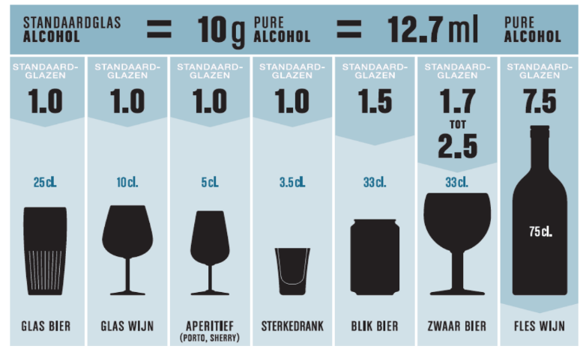
  - 1 unit
  - 2 units
  - 3 units
  - 4 units
  - 5 units
  - 6 units
  - 7 units or more
  - 16. Have you experienced problems in the past in maintaining a healthy body weight?
  - Yes
  - No

  - Medical Questionnaire
  - 1. Body weight: …… Kg
  - 2. Height: …… cm
  - 3. Date of liver transplantation: …… / …… / …….
  - 4. Cause of liver failure: …………………………………………………………………………..
  - 5. Other conditions, comorbidities, and risk factors (tick all that apply):
  - Pregnancy (trimester:…………..)
  - Type 1 diabetes
  - Type 2 diabetes
  - Hypertension
  - Cardiac arrhythmias
  - Heart failure
  - Chronic lung disease
  - Chronic kidney disease
  - Chronic neurological or neuromuscular disease
  - Cognitive disorder (e.g., dementia, Alzheimer’s, persistent encephalopathy, etc.)
  - Cancer (except for liver cancer leading to transplantation)
  - Amputations
  - Persistent infections/wounds
  - Other illness, please specify:…………………………………………………….
  - 6. Did you undergo physical therapy before your liver transplantation?
  - Yes
  - No
  - 7. Did you undergo physical therapy after your liver transplantation?
  - Yes
  - No

Supplementary Appendix II: Physical Activity Vital Sign
Before transplantation
- In your opinion, were you physically active before liver failure?
  - Yes
  - No
- In your opinion, were you physically active in the last month before the transplantation?
  - Yes
  - No
After transplantation
- On average, how many days per week do you engage in moderate to vigorous physical activity (such as brisk walking)?
_______ days
- On average, how many minutes do you engage in physical activity at this level?
_______ minutes
→ Total number of minutes of physical activity per week (question 1 × question 2) =
_______ minutes
- How many days per week do you perform muscle-strengthening exercises, such as bodyweight exercises or strength training?
_______ days

What is moderate intensity?
- You can talk, but not sing, while performing the activity.
- Examples: brisk walking, slow cycling, doubles tennis, various forms of dancing, active housework and gardening, etc.
What is vigorous intensity?
- You cannot talk while performing the activity and may be out of breath.
- Examples: jogging, fast cycling, singles tennis, aerobic workouts, swimming, etc.

Supplementary Appendix III: Barriers and Motivators Questionnaire
Barriers to Physical Activity

Below are reasons mentioned by other transplant patients that hinder them from being physically active or exercising. For each statement, please indicate to what extent this is also a reason for you not to be physically active or exercise. Check the answer that best applies to you.
Barriers | Not at all | Somewhat | Quite a lot | Strongly
- I lack motivation | □ | □ | □ | □
- I am too fatigued | □ | □ | □ | □
- When I exercise or play sports, I experience unpleasant feelings or body signals | □ | □ | □ | □
- I am too short of breath / lack of air | □ | □ | □ | □
- I am afraid that exercising or playing sports will harm my health | □ | □ | □ | □
- I prefer to spend my time on other things | □ | □ | □ | □
- While exercising or playing sports, I am self-conscious about my appearance, which I find a barrier | □ | □ | □ | □
- I have no interest in being physically active or exercising | □ | □ | □ | □
- I am afraid of falling | □ | □ | □ | □
- I have depression that prevents me from being physically active or exercising | □ | □ | □ | □
- I am afraid of getting injured | □ | □ | □ | □
- I do not have enough knowledge about the benefits of exercise or sports | □ | □ | □ | □
- I have physically demanding work that prevents me from exercising or playing sports on top of it | □ | □ | □ | □
- I have low expectations of my own performance in exercise or sports | □ | □ | □ | □
- My healthcare providers expect little of me regarding exercise or sports | □ | □ | □ | □
- There is no place to sit when I am outside exercising or playing sports | □ | □ | □ | □
- I am afraid of experiencing more pain | □ | □ | □ | □
- Poor sidewalks or road surfaces prevent me from being physically active or exercising | □ | □ | □ | □
- Anxiety is a barrier for me to be physically active or exercise | □ | □ | □ | □
- Health problems from other diseases (comorbidities) | □ | □ | □ | □
- There is a lack of access to exercise or sports facilities (e.g., gym, sports hall) | □ | □ | □ | □
- I lack time | □ | □ | □ | □
- I do not want to become even more fatigued | □ | □ | □ | □
- I worry that I will get too thirsty while exercising or playing sports | □ | □ | □ | □
- Bad weather | □ | □ | □ | □
- My family and/or friends have low expectations of me | □ | □ | □ | □
- I experience a lack of encouragement to be physically active or exercise | □ | □ | □ | □
- I do not have sufficient financial resources to exercise or play sports | □ | □ | □ | □
- I am afraid of crime on the streets while exercising or playing sports | □ | □ | □ | □
- I experience a lack of support from family and/or friends | □ | □ | □ | □
- I have received negative advice from my doctor regarding exercise or sports | □ | □ | □ | □

Facilitators of Physical Activity

Below are reasons mentioned by other transplant patients that motivate them to be physically active or exercise. For each statement, please indicate to what extent this is also a reason for you to be physically active or exercise. Check the answer that best applies to you.
Facilitators | Not at all | Somewhat | Quite a lot | Strongly
- I want to feel better | □ | □ | □ | □
- By exercising or being physically active, I experience less pain | □ | □ | □ | □
- I want to improve my health | □ | □ | □ | □
- I want to control my weight | □ | □ | □ | □
- Having a supportive exercise/physical activity coach motivates me | □ | □ | □ | □
- I know the added value of increasing my activity level | □ | □ | □ | □
- I enjoy the feeling that physical activity gives me | □ | □ | □ | □
- I want to feel healthy | □ | □ | □ | □
- I believe in my physical abilities | □ | □ | □ | □
- My healthcare providers have encouraged me to exercise or be physically active | □ | □ | □ | □
- I feel encouraged by family and/or friends | □ | □ | □ | □
- My family and/or friends have high expectations of me | □ | □ | □ | □
- I want to become stronger, improve my strength | □ | □ | □ | □
- The information I have received about how to exercise or be physically active has motivated me | □ | □ | □ | □
- I want to experience less pain | □ | □ | □ | □
- Exercising or being physically active with others stimulates me | □ | □ | □ | □
- My healthcare providers have high expectations of me | □ | □ | □ | □
- I want to reduce my depressive feelings | □ | □ | □ | □
- I want to be more physically mobile, move more | □ | □ | □ | □
- I want to improve my energy level | □ | □ | □ | □
- I want to reduce my anxiety | □ | □ | □ | □
- Attending group classes motivates me | □ | □ | □ | □
- Having sufficient financial resources motivates me

Supplementary Appendix IV: The main reason for unwilling to participate in the study
What is the main reason that you are not participating in this study?
- Lack of motivation
- Lack of transportation
- Lack of time
- Afraid that this program will be too demanding
- Afraid of injuries
- Fatigue
- I do not enjoy exercise/sports
- I prefer not to give a reason
- Other: …………………………………………………………………………………………………

Supplementary Appendix V: Distribution of motivator domain scores for physical activity among participants (ICF-A) and non-participants (ICF-B)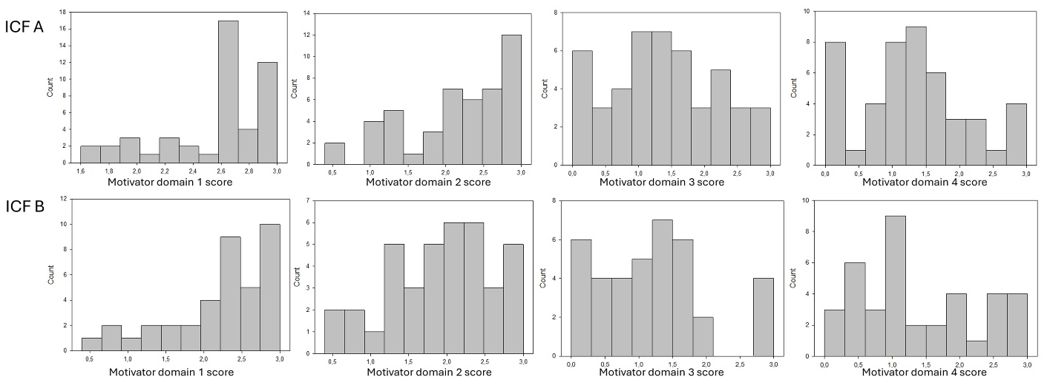

Supplementary Appendix VI: Distribution of barrier domain scores for physical activity among participants (ICF-A) and non-participants (ICF-B)
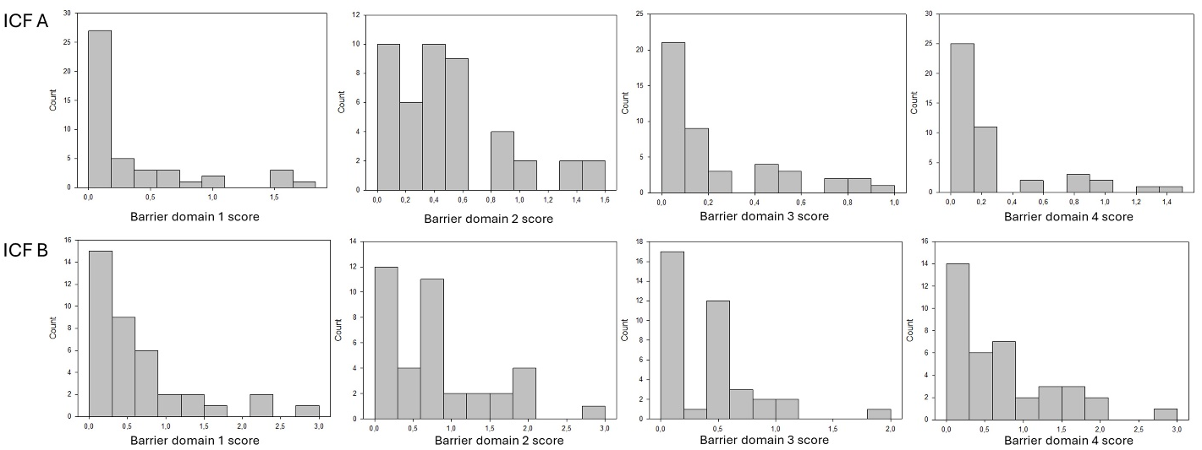

Supplementary Appendix VII: Multiple logistic regression analysis to identify factors associated with willingness to participate in the exercise study
 | Participation in the study
Variable | AOR [95%CI] | p-value
Home-to-site distance (km)  Education  Motivator: Health & physical outcomes (score: 0-4 scale)  Barrier: lack of motivation or time (score: 0-4 scale) | 0.988 [0.976-1.000]  7.295 [0.777-68.500]  1.953 [0.595-6.413]  0.304 [0.084-1.108] | 0.056  0.082  0.270  0.071
Abbreviations: AOR, adjusted odd ratio; CI, confidence interval PA, physical activity; WHO, world health organization

