Table S1 Detailed search strategy for each database
Pubmed
#1 | "athlet*"[Title/Abstract] OR "college athlet*"[Title/Abstract] OR "elite athlete*"[Title/Abstract] OR "professional athlet*"[Title/Abstract] OR "sportman"[Title/Abstract] OR "sportmen"[Title/Abstract] OR "sports playe*"[Title/Abstract] OR "sportsman"[Title/Abstract] OR "sportsmen"[Title/Abstract] OR "sportspeople"[Title/Abstract] OR "sportsperso*"[Title/Abstract] OR "sportsplayers"[Title/Abstract] OR "sportswoman"[Title/Abstract] OR "sportswomen"[Title/Abstract] OR "sportwomen"[Title/Abstract]
#2 | "athletes"[MeSH Terms]
#3 | "anti oxidant effec*"[Title/Abstract] OR "Antioxidant Activity"[Title/Abstract] OR "antioxidant agent"[Title/Abstract] OR "antioxidant effec*"[Title/Abstract] OR "antioxidant nutrient"[Title/Abstract] OR "antioxidation agent"[Title/Abstract] OR "antioxidative"[Title/Abstract] OR "antoxidant"[Title/Abstract] OR "endogenous antioxidan*"[Title/Abstract] OR "phenolic antioxidant"[Title/Abstract]
#4 | "antioxidants"[MeSH Terms]
#5 | "diet additive"[Title/Abstract] OR "diet supplement"[Title/Abstract] OR "dietary supplemen*"[Title/Abstract] OR "food supplemen*"[Title/Abstract] OR "herbal supplemen*"[Title/Abstract] OR "neutraceutica*"[Title/Abstract] OR "nutraceutica*"[Title/Abstract] OR "nutriceutica*"[Title/Abstract] OR "supplementary diet"[Title/Abstract]
#6 | "dietary supplements"[MeSH Terms]
#7 | (#1 OR #2) AND (#3 OR #4) AND (#5 OR #6)
#9 | (#1 OR #2) AND (#3 OR #4) AND (#5 OR #6) AND "randomizedcontrolledtrial"[Filter]
Scopus
#1 | (ALL (athlet) OR TITLE-ABS-KEY (college AND athlet) OR TITLE-ABS-KEY (elite AND athlete) OR TITLE-ABS-KEY (professional AND athlet) OR TITLE-ABS-KEY (sportman) OR TITLE-ABS-KEY (sportmen) OR TITLE-ABS-KEY (sports AND playe) OR TITLE-ABS-KEY (sportsman) OR TITLE-ABS-KEY (sportsmen) OR TITLE-ABS-KEY (sportspeople) OR TITLE-ABS-KEY (sportsperso) OR TITLE-ABS-KEY (sportsplayers) OR TITLE-ABS-KEY (sportswoman) OR TITLE-ABS-KEY (sportswomen) OR TITLE-ABS-KEY (sportwomen))
#2 | ALL (athletes)
#3 | (TITLE-ABS-KEY ("anti oxidant effect") OR TITLE-ABS-KEY (antioxidant AND activity) OR TITLE-ABS-KEY (antioxidant AND agent) OR TITLE-ABS-KEY (antioxidant AND effect) OR TITLE-ABS-KEY ('antioxidant AND nutrient') OR TITLE-ABS-KEY ('antioxidation AND agent') OR TITLE-ABS-KEY ('antioxidation AND product') OR TITLE-ABS-KEY ('antioxidative') OR TITLE-ABS-KEY (antioxidant) OR TITLE-ABS-KEY ('endogenous AND antioxidan') OR TITLE-ABS-KEY ('phenolic AND antioxidant'))
#4 | ALL (antioxidants)
#5 | (TITLE-ABS-KEY ('diet AND additive') OR TITLE-ABS-KEY ('diet AND supplement') OR TITLE-ABS-KEY ("dietary supplemen") OR TITLE-ABS-KEY ("food supplemen") OR TITLE-ABS-KEY (herbal AND supplemen) OR TITLE-ABS-KEY (neutraceutica) OR TITLE-ABS-KEY (nutraceutica) OR TITLE-ABS-KEY (nutriceutica) OR TITLE-ABS-KEY (supplementary AND diet))
#6 | ALL (dietary AND supplements)
#7 | ( ( ( ALL ( athlet ) OR TITLE-ABS-KEY ( college AND athlet ) OR TITLE-ABS-KEY ( elite AND athlete ) OR TITLE-ABS-KEY ( professional AND athlet ) OR TITLE-ABS-KEY ( sportman ) OR TITLE-ABS-KEY ( sportmen ) OR TITLE-ABS-KEY ( sports AND playe ) OR TITLE-ABS-KEY ( sportsman ) OR TITLE-ABS-KEY ( sportsmen ) OR TITLE-ABS-KEY ( sportspeople ) OR TITLE-ABS-KEY ( sportsperso ) OR TITLE-ABS-KEY ( sportsplayers ) OR TITLE-ABS-KEY ( sportswoman ) OR TITLE-ABS-KEY ( sportswomen ) OR TITLE-ABS-KEY ( sportwomen ) ) ) OR ( ALL ( athletes ) ) ) AND ( ( ( TITLE-ABS-KEY ( "anti oxidant effect" ) OR TITLE-ABS-KEY ( antioxidant AND activity ) OR TITLE-ABS-KEY ( antioxidant AND agent ) OR TITLE-ABS-KEY ( antioxidant AND effect ) OR TITLE-ABS-KEY ( 'antioxidant AND nutrient' ) OR TITLE-ABS-KEY ( 'antioxidation AND agent' ) OR TITLE-ABS-KEY ( 'antioxidation AND product' ) OR TITLE-ABS-KEY ( 'antioxidative' ) OR TITLE-ABS-KEY ( antoxidant ) OR TITLE-ABS-KEY ( 'endogenous AND antioxidan' ) OR TITLE-ABS-KEY ( 'phenolic AND antioxidant' ) ) ) OR ( ALL ( antioxidants ) ) ) AND ( ( ( TITLE-ABS-KEY ( 'diet AND additive' ) OR TITLE-ABS-KEY ( 'diet AND supplement' ) OR TITLE-ABS-KEY ( "dietary supplemen" ) OR TITLE-ABS-KEY ( "food supplemen" ) OR TITLE-ABS-KEY ( herbal AND supplemen ) OR TITLE-ABS-KEY ( neutraceutica ) OR TITLE-ABS-KEY ( nutraceutica ) OR TITLE-ABS-KEY ( nutriceutica ) OR TITLE-ABS-KEY ( supplementary AND diet ) ) ) OR ( ALL ( dietary AND supplements ) ) )
Web of Science (WOS)
#1 | (TI=(("Athlet*") OR ("College Athlet*") OR ("Elite Athlete*") OR ("Professional Athlet*") OR ("sportman") OR ("sportmen") OR ("sports playe*") OR ("sportsman") OR ("sportsmen") OR ("sportspeople") OR ("sportsperso*") OR ("sportsplayers") OR ("sportswoman") OR ("sportswomen") OR ("Sportwomen")) OR AB=(("Athlet*") OR ("College Athlet*") OR ("Elite Athlete*") OR ("Professional Athlet*") OR ("sportman") OR ("sportmen") OR ("sports playe*") OR ("sportsman") OR ("sportsmen") OR ("sportspeople") OR ("sportsperso*") OR ("sportsplayers") OR ("sportswoman") OR ("sportswomen") OR ("Sportwomen")) OR AK=(("Athlet*") OR ("College Athlet*") OR ("Elite Athlete*") OR ("Professional Athlet*") OR ("sportman") OR ("sportmen") OR ("sports playe*") OR ("sportsman") OR ("sportsmen") OR ("sportspeople") OR ("sportsperso*") OR ("sportsplayers") OR ("sportswoman") OR ("sportswomen") OR ("Sportwomen"))) AND (TI=(("Anti Oxidant Effec*") OR ("Antioxidant Activity") OR ("antioxidant agent") OR ("AntiOxidant Effec*") OR ("antioxidant nutrient") OR ("antioxidation agent") OR ("antioxidation product") OR ("antioxidative") OR ("antoxidant") OR ("Endogenous Antioxidan*") OR ("phenolic antioxidant")) OR AB=(("Anti Oxidant Effec*") OR ("Antioxidant Activity") OR ("antioxidant agent") OR ("AntiOxidant Effec*") OR ("antioxidant nutrient") OR ("antioxidation agent") OR ("antioxidation product") OR ("antioxidative") OR ("antoxidant") OR ("Endogenous Antioxidan*") OR ("phenolic antioxidant")) OR AK=(("Anti Oxidant Effec*") OR ("Antioxidant Activity") OR ("antioxidant agent") OR ("AntiOxidant Effec*") OR ("antioxidant nutrient") OR ("antioxidation agent") OR ("antioxidation product") OR ("antioxidative") OR ("antoxidant") OR ("Endogenous Antioxidan*") OR ("phenolic antioxidant"))) AND (TI=(("diet additive") OR ("diet supplement") OR ("Dietary Supplemen*") OR ("Food Supplemen*") OR ("Herbal Supplemen*") OR ("Neutraceutica*") OR ("Nutraceutica*") OR ("Nutriceutica*") OR ("supplementary diet")) OR AB=(("diet additive") OR ("diet supplement") OR ("Dietary Supplemen*") OR ("Food Supplemen*") OR ("Herbal Supplemen*") OR ("Neutraceutica*") OR ("Nutraceutica*") OR ("Nutriceutica*") OR ("supplementary diet")) OR AK=(("diet additive") OR ("diet supplement") OR ("Dietary Supplemen*") OR ("Food Supplemen*") OR ("Herbal Supplemen*") OR ("Neutraceutica*") OR ("Nutraceutica*") OR ("Nutriceutica*") OR ("supplementary diet"))) and Preprint Citation Index (Exclude – Database)
Cochrane Library
#1 | ('Athlet*' OR 'College Athlet*' OR 'Elite Athlete*' OR 'Professional Athlet*' OR 'sportman' OR 'sportmen' OR 'sports playe*' OR 'sportsman' OR 'sportsmen' OR 'sportspeople' OR 'sportsperso*' OR 'sportsplayers' OR 'sportswoman' OR 'sportswomen' OR 'sportwomen'):ti,ab,kw
#2 | "Athlete"
#3 | ('Anti Oxidant Effec*' OR 'Antioxidant Activity' OR 'antioxidant agent' OR 'AntiOxidant Effec*' OR 'antioxidant nutrient' OR 'antioxidation agent' OR 'antioxidation product' OR 'antioxidative' OR 'antoxidant' OR 'Endogenous Antioxidan*' OR 'phenolic antioxidant'):ti,ab,kw
#4 | "Antioxidants"
#5 | ('diet additive' OR 'diet supplement' OR 'Dietary Supplemen*' OR 'Food Supplemen*' OR 'Herbal Supplemen*' OR 'Neutraceutica*' OR 'Nutraceutica*' OR 'Nutriceutica*' OR 'supplementary diet'):ti,ab,kw
#6 | "Dietary Supplements"
#7 | (#1 OR #2) AND (#3 OR #4) AND (#5 OR #6)
Embase
#1 | 'athlet*':ti,ab,kw OR 'college athlet*':ti,ab,kw OR 'elite athlete*':ti,ab,kw OR 'professional athlet*':ti,ab,kw OR 'sportman':ti,ab,kw OR 'sportmen':ti,ab,kw OR 'sports playe*':ti,ab,kw OR 'sportsman':ti,ab,kw OR 'sportsmen':ti,ab,kw OR 'sportspeople':ti,ab,kw OR 'sportsperso*':ti,ab,kw OR 'sportsplayers':ti,ab,kw OR 'sportswoman':ti,ab,kw OR 'sportswomen':ti,ab,kw OR 'sportwomen':ti,ab,kw
#2 | 'athlete'/exp
#3 | 'anti oxidant effec*':ti,ab,kw OR 'antioxidant activity':ti,ab,kw OR 'antioxidant agent':ti,ab,kw OR 'antioxidant effec*':ti,ab,kw OR 'antioxidant nutrient':ti,ab,kw OR 'antioxidation agent':ti,ab,kw OR 'antioxidation product':ti,ab,kw OR 'antioxidative':ti,ab,kw OR 'antoxidant':ti,ab,kw OR 'endogenous antioxidan*':ti,ab,kw OR 'phenolic antioxidant':ti,ab,kw
#4 | 'antioxidant'/exp
#5 | 'diet additive':ti,ab,kw OR 'diet supplement':ti,ab,kw OR 'dietary supplemen*':ti,ab,kw OR 'food supplemen*':ti,ab,kw OR 'herbal supplemen*':ti,ab,kw OR 'neutraceutica*':ti,ab,kw OR 'nutraceutica*':ti,ab,kw OR 'nutriceutica*':ti,ab,kw OR 'supplementary diet':ti,ab,kw
#6 | 'dietary supplement'/exp
#7 | (#1 OR #2) AND (#3 OR #4) AND (#5 OR #6)

Table S2 Basic characteristics of included studies.
Author/Year | Intervention Measures | Dose | Region | Continents | Number of Participants | Male/Female | Athlete Type | Professional/Amateur | Supplementation Duration | Average Age | Outcome | Study design
Schröder 2000 | Vitamin C + Vitamin E + Beta-Carotene | Four times a day, 150mg of vitamin E+250mg of vitamin C+8mg of beta carotene each time (total dose: 600mg of E+1000mg of C+32mg of beta carotene/d), lasting for 32 days. | Spain | Europe | 16 | 16/0 | Basketball player | Professional | 32 days | 23.45 ± 3.56 | ① | Parallel RCT
Pilaczynska-Szczesniak 2005 | Anthocyanins | Total 150 mL/d, containing 23 mg/100 mL anthocyanin | Poland | Europe | 19 | 19/0 | Rower | Professional | 28 days | 21 ± 0.8/ 22 ± 1.7 | ③④⑤⑨ | Parallel RCT
Tauler 2006 | Vitamin C + Vitamin E + Beta-Carotene | Take 2 capsules daily for 90 days (containing 250mg vitamin E+15mg β - carotene), and add 2 500mg vitamin C capsules for the last 15 days (total dose: 500mg E+30mg β - carotene+1g C/d). | Spain | Europe | 15 | 15/0 | 3 cyclists, 12 triathletes | Amateur | 105 days | 23.3±2.0 | ③④ | Parallel RCT
Aguilo 2007 | Vitamin E + Beta-Carotene | Each capsule contains 250 mg of vitamin E and 15 mg of beta-carotene | Spain | Europe | 15 | 15/0 | 3 cyclists, 12 athletes participating in the running and cycling biathlon | Amateur | 90 days | 23.7±1.7/25.3±1.7 | ⑤ | Parallel RCT
Tauler 2008 | Coenzyme Q10 | Take one compound capsule per day (Coenzyme Q ₁₀ 100mg, Vitamin C 60mg, E 10mg, β - carotene 6mg, etc.) | Spain | Europe | 19 | 19/0 | Footballer | Professional | 90 days | NA | ③④ | Parallel RCT
Ferre 2009 | Coenzyme Q10 + Multivitamins | During the study period, adolescents maintained regular physical activity with 100mg of coenzyme Q ₁₀ and a combination of vitamins (including 60mg of vitamin C, 10mg of E, etc.) per day. | Spain | Europe | 19 | 19/0 | Footballer | Professional | 90 days | 20.0 ± 0.2/ 19.5 ± 0.4 | ③④ | Parallel RCT
Skarpanska-Stejnborn 2009 | Rhodiola Rosea | 100mg Rhodiola extract (containing 5mg zinc) each time for 4 weeks | Poland | Europe | 22 | 22/0 | Rower | Professional | 28 days | 20.4 ± 1.2/ 21.0 ± 0.9 | ①②③④ | Parallel RCT
Parisi 2010 | Rhodiola Rosea | 170mg/d | Italy | Europe | 14 | 14/0 | Competitive sports primarily focused on aerobic metabolism, such as athletics, triathlon, roller skating, and running | Professional | 28 days | 25±5 | ①⑤⑥⑦⑨ | Cross-Over RCT
Jówko 2012 | Green Tea Polyphenols | Single intake of 640mg green tea polyphenols (containing 500mg catechins, including 176mg EGCG) | Poland | Europe | 16 | 16/0 | Footballer | Professional | 8 days | 22.9 ± 5.5/ 22.4 ± 3.4 | ①②④ | Parallel RCT
Djordjevic 2012 | Astaxanthin | 4mg astaxanthin daily (sourced from Heathcock’s pluvialis) | Serbia | Europe | 32 | 32/0 | Footballer | Professional | 90 days | 18.1±0.7/ 17.7±0.6 | ①②④⑥ | Parallel RCT
Basta 2013 | Aloe Vera Extract (Biostimine) | Take 1 ml of Biostimine (containing aloe vera leaf water extract) orally daily for 4 weeks | Poland | Europe | 18 | 18/0 | Rower | Professional | 28 days | 20.5±1.41/21.2±0.71 | ③④⑨ | Parallel RCT
Nieman 2013 | Polyphenol-Enriched Soy Protein Complex | Take 40 g of PSPC daily (containing 2,136 mg of gallic acid equivalent polyphenols, from blueberry and green tea extracts, mixed in a 3:1 ratio), divided into two doses (dissolved in 237 ml of water in the morning and at lunch). | USA | America | 31 | 18/13 | Runner | Professional | 17 days | 33.7±6.8/35.2±8.7 | ⑥ | Parallel RCT
Łowińska-Lisowska 2014 | L-Carnosine | Take 2 g twice a day (a total of 4 g/ day) | Poland | Europe | 14 | 14/0 | Rower | Professional | 14 days | 20.7±1.1/21.7±1.60 | ④⑤⑧ | Cross-Over RCT
Trinity 2014 | Polyphenolic Antioxidants | Take 500 mL of Polyphenolic Antioxidants twice a day for 7 consecutive days. Take the last dose 30 minutes before the test. | USA | America | 12 | 12/0 | Endurance training athlete | Professional | 7 days | 26.8±5.0 | ⑤ | Cross-Over RCT
Verazaluce 2015 | Phlebodium decumanum / Phlebodium decumanum + Coenzyme Q10 | Experimental Group 1 (GE1), training + Phlebodium decumanum (4 capsules per day, 400mg per capsule); Experimental Group 2 (GE2), training + Phlebodium decumanum (the same as GE1) + Coenzyme Q10 (4 capsules per day, 30mg per capsule) | | Spain | Europe | 30 | 30/0 | Volleyball player | Professional | 28 days | 26.6±2.37/25.5±2.55/25.2±/2.15 | ⑤⑦ | Parallel RCT
Busquets-Cortés 2016 | Docosahexaenoic Acid (DHA, 1.14g/day) | 1 L/day almond beverage (containing 0.2% DHA-S+0.6% olive oil, with the remaining ingredients being the same as placebo. | Spain | Europe | 16 | 16/0 | Footballer | Professional | 56 days | 26.6±2.37/ 25.5±2.55 | ⑥ | Parallel RCT
Jastrzebski 2016 | Vitamin D | 10 drops of Vigantol (about 5000 IU of vitamin D) daily | Poland | Europe | 16 | 16/0 | Rower | Professional | 28 days | 23.1±2.7/23.1±3.2 | ① | Parallel RCT
Leonardo-Mendonça 2017 | Melatonin | Take 100 mg of melatonin capsules orally 30 to 60 minutes before going to bed every day. | Spain | Europe | 24 | 24/0 | Resistance training athlete | Professional | 28 days | 20.3±0.71/19.2±0.33 | ①③⑧⑨ | Parallel RCT
Ortiz-Franco 2017 | Melatonin | Take one capsule containing 20 mg of melatonin orally before each exercise (Acofarma, Barcelona, Spain) | Spain | Europe | 14 | 14/0 | NA | Professional | 14 days | 28.43±4.39/26±6.03 | ①③④ | Parallel RCT
Toscano 2019 | Purple Grape Juice | Take 10 milliliters per kilogram per day within 2 hours | Brazil | America | 14 | 14/0 | Runner | Amateur | 7 days | 39±9.2 | ①⑥⑨ | Parallel RCT
Lydiane 2020 | Purple Grape Juice | The supplements were divided into equal parts and taken before training (200 milliliters) and at the end of training (200 milliliters) | Brazil | America | 15 | 15/0 | Beach handball player | Professional | 3 days | 28.7±3.5/24.8±2.7 | ⑥⑧⑨ | Cross-Over RCT
Drobnic 2021 | Krill Oil | 2.5g/d krill oil (containing 550mg EPA/DHA, 150mg choline, 1.7mg astaxanthin) | Spain | Europe | 35 | 27/8 | NA | Professional | 84 days | 32.5 ± 9.6/ 33.7 ± 8.0 | ① | Cross-Over RCT
Stankiewicz 2021 | Chokeberry Juice | 200ml chokeberry juice daily (twice a day, in the morning and evening) | Poland | Europe | 20 | 20/0 | Footballer | Professional | 49 days | 15.8 ± 0.7 | ①②⑤⑦ | Parallel RCT
Chaouachi 2022 | Spirulina | 5.7g of spirulina daily (containing 24.9mg of beta-carotene, 61.3μg of vitamin B12, etc.) | France | Europe | 17 | 17/0 | Rugby player | Professional | 49 days | 26.0 ± 3.8 | ③④⑨ | Parallel RCT
Fernández-Lázaro 2022 | Tribulus Terrestris | Obtain 2 TT capsules daily from Quamtrax® Pharmaceuticals (Quamtrax® Nutrition Europe S.L., Madrid, Spain) at a daily dose of 770 mg; TT extract accounted for 72.64% (385 mg/granule), among which the saponin content was 40% | Spain | Europe | 30 | 30/0 | NA | Amateur | 42 days | 32.9 ± 6.3/ 33.1 ± 5.7 | ①⑦⑨ | Parallel RCT
Esen 2023 | Beetroot Juice | 140 mL of concentrated beetroot juice (containing 12.8 mmol nitrate) | UK | Europe | 12 | 12/0 | Rugby player | Professional | 7 days | 20±4 | ⑤⑧ | Parallel RCT
Number: ①TAS, ②TBARS, ③GPx, ④SOD, ⑤LA, ⑥MDA, ⑦IL-6, ⑧NOx, ⑨CK

Table S3 Training Plan
Author/Year | Training Plan
Schröder 2000 | During the last third part of the competition season 1996/97 of the ACB, a period of heavier load and activity
Pilaczynska-Szczesniak 2005 | The study population consisted of 19 male members of the Polish rowing team participating in a 1-month training camp between the preparation period and the competition period
Tauler 2006 | During this study all sportsmen continued their training sessions and participated in several competitions. After the three months of supplementation all the athletes performed a maximal and a submaximal prolonged exercise test. Subjects were in-  structed to refrain from strenuous exercise the day before the exercise test
Aguilo 2007 | Maximal incremental exercise tests were performed on an electromagnetically braked cycle ergometer (Ergometrics 900, MedGraphicsTM, St. Paul, MN). This maximal test was performed after a gradual protocol until exhaustion. Participants were familiarized with the exercise protocol. Participants warmed up for 3 min at 30 W before starting the test. The test began at 50 W and the participants’ work rate was increased by 30 W every 3 min. The participants were asked to maintain a pedaling cadence between 50 and 60 rev/min⁻¹. A pedal frequency meter was used to maintain this cadence. Each test finished when the increased work did not increase or decrease the oxygen consumption; this value was recorded as maximal oxygen up take VO₂ max. A heart rate above 90% of the predicted maximum for age and a respiratory quotient higher than 1.15 were also considered criteria for the maximal exercise end-point. All the tests were performed at the same time, in the same room, and at the same temperature (208C) and humidity (70%).
Tauler 2008 | After three months of supplementation, the athletes played a 60-minute friendly football match and collected samples before and after the match to determine the same parameters
Ferre 2009 | Four 120-minute football training sessions, two 90-minute physical training sessions, and one game per week for a period of three months
Skarpanska-Stejnborn 2009 | On the first day (before supplementation) and at the end of the training camp (after supplementation), the athletes performed a controlled 2,000m rowing exercise. Each participant had to cover the distance on a rowing ergometer (Concept II, USA) in as short a time as possible. Because the results of both tests were taken into consideration during selection of athletes to the championship team, the athletes were well motivated to perform both tests with all-out effort. Before each test, participants performed a 5-min individual warm-up.
PARISI 2010 | All subjects underwent a preliminary test to evaluate their maximal oxygen uptake (VO_{2 max}) through cardio-pulmonary maximal stress test at increasing loads (40 Watt × 2 min) on a cycloergometer (Ergocard II, ESAOTE BIOMEDICA®) linked to an ergospirometer (Cardio2 MEDICAL GRAPHICS®). Before the beginning of any test, metabolimeter was carefully calibrated. During the test, heart rate (HR) was monitored through 12 leads electrocardiogram, oxygen consumption was monitored through metabolimeter and blood pressure was assessed through a mercury sphygmomanometer. The subject was monitored during recovering period, after the effort, for five minutes through electrocardiogram and blood pressure measurement. According to the international literature 32 the test was stopped when one of these situations occurred: Symptoms onset; Complicated arrhythmias onset; Significant ST segment anomalies; Muscular exhaustion; Reaching of Maximal oxygen uptake; According to the classical notion of Maximal oxygen uptake, we considered it was reached when:The subject reached a plateau, i.e. when VO₂increases less than 150 mlxmin⁻¹, rising from a step to  the next one; Respiratory exchange quotient exceeded 1.08-1.1; The subject had more than 10 beats over HR max  for the age; During this test sport eligibility of these athletes was evaluated
Jówko 2012 | 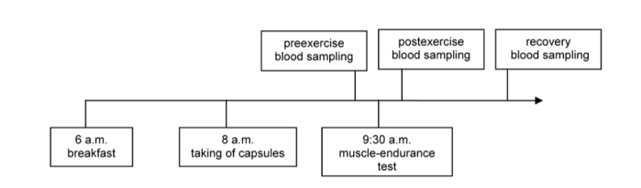
Djordjevic 2012 | Subjects had 5 to7 training sessions per week with an average weekly training of 10 to 15 hours and took participation in National championship during training season. They had different aspects of trainings, including strength, resistance, cardio, fexibility and proprioceptive training. The participation in the study did not have any effect on previously determined training and competition schedule
Basta 2013 | Training volumes (expressed in min per day) during the week preceding the first term of assessment (Trial I) and during the week preceding the second term of assessment (Trial II)—specific to extensive rowing, intensive rowing, kilometers, and extensive nonspecific training—are shown in Table 3. In the load training phase (before the first assessment), the training volume amounted to 1425 min·wk⁻¹ , of which approximately 58% were extensive rowing, 34% was nonspecific training such as power training, and the rest was intensive rowing. Total training volume before the second assessment was1119 min·wk⁻¹ and comprised approximately 60% extensive rowing, 12% intensive rowing, and 28% land training.  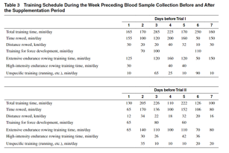
Nieman 2013 | Subjects trained normally during the 2-week supplementation, and then participated in a 3-day period of intensified exercise. In the morning of the first exercise session, subjects consumed the normal supplement portion (one tablespoon of PSPC or placebo in one cup of water) and breakfast (ad libitum). A standardized meal consisting of Boost Plus at 10 kcal/kg was ingested at 12:00 noon. The normal lunch-time PSPC or placebo supplement was delayed until after the blood draw at 2:30 pm. Subjects reported to the Human Performance Laboratory at 2:30 pm and provided blood samples in a rested, seated position. Subjects next ingested the PSPC or placebo supplement dose. At 3:00 pm, subjects ran on treadmills for 2.5h at approximately 70% VO_{2 max}. Water was given ad libitum throughout the 2.5-h exercise bouts, with no other beverage or food allowed. Subjects ingested another 1 tablespoon dose of PSPC or placebo mixed in water after one hour of exercise. Heart rate, rating of perceived exertion (RPE), and distance run were recorded every 30 minutes during the bout, with oxygen consumption and ventilation measured after one hour of exercise. Subjects repeated this schedule for the next two days, but without pre-exercise blood draws. Blood samples were taken immediately following the third exercise bout on the third day, and 14-h post-exercise the following morning. A symptom log was administered during the final blood draw session.
Łowińska-Lisowska 2014 | 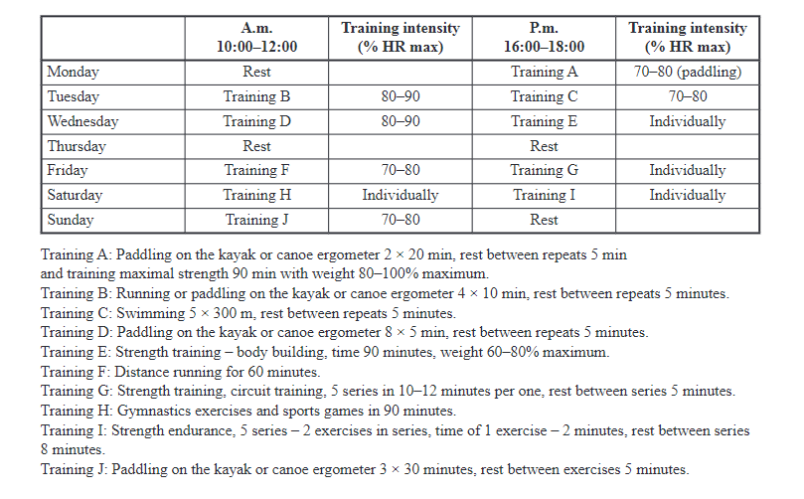
Trinity 2014 | 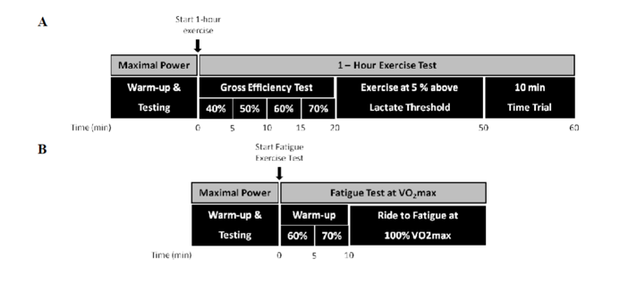
Verazaluce 2015 | El programa de entrenamiento físico, común a todos los grupos, se llevó a cabo en las Instalaciones Deportivas del Campus Universitario de Fuentenueva de Granada, tuvo una duración total de cuatro semanas, y se planificó como sesiones de 3 horas de duración al día, realizadas con una frecuencia de 5 días a la semana con competición 1 día del fin de semana. Dicho programa, incluyó ejercicios técnicos propios del voleibol con una intensidad; realizándose 3 series de 10 repeticiones de cada fundamento técnico de este deporte (voleo, remate, golpe bajo, saque y bloqueo) de 5 minutos de tiempo efectivo con 1 minuto de descanso entre series. Se utilizó una variante en los ejercicios técnicos que consistió en trabajo individual y grupal, incluyendo en ambos casos desplazamientos, con balón y sin balón.
Busquets-Cortés 2016 | The training during the experiment included six physical activities and ten official competitions per week. The exercise includes two hours of regular football training
Jastrzebski 2016 | All participants completed the same training plan during the preparation period. The 4-week training consists of 45 units and a total of approximately 60 hours of effective exercise, such as the rowing goniometer (Concept II), running, swimming and strength training. During the training program, no rowing athlete participated in rowing competitions.
Leonardo-Mendonça 2017 | Physical training during the study consisted of 8 sessions per week lasting approximately 1-1.5 hours each (10 hours/week), comprising resistance training (5 sessions), weight training (2 sessions) and aerobic running (1 session). All subjects were instructed to avoid training during the 24 hours prior to the days of blood sample (S1 and S2). The study prioritized resistance over strength. Weekly routine of resistance consisted in 3 sessions between 60%-75% of maximal strength, with higher volume than intensity, and 2 sessions between 80%-90% of maximal strength, with a volume constant and increasing the intensity. A combination of distances and profiles using both race and bike were used for these purposes. Regarding the strength, after calculating the one-repetition maximum (1RM) for each subject, the usual training in the 2 sessions was focused on the strength pyramid, i.e., performing 3 sessions of 8-12 repetitions at 75% of maximal weight, and with rest periods of stretch.
Ortiz-Franco 2017 | The training program was carried out combining strength and HIIT over a 2-week period. An adaptation-training period was performed after the athletes’ selection procedure. The athletes followed the exercise training over 2 weeks, with six sessions per week, lasting 60–75 min per day. Each session was divided into three components: 20–25 min of HIIT exercise, 35–40 min of strength exercise (exercises performed were: bench press, leg press, high pulley rowing, military press, quadriceps extensions and leg curls), and 10 min of stretching and cool down. The HIIT component was divided into 7 periods of 2 min at high intensity above the anaerobic threshold (90 % VO2max) and interspersed with 6 periods of 1 min at moderate intensity within the aerobic threshold (70 % VO2max). All training sessions were performed with a Polar heart rate monitor (RS300X). The strength exercises consisted of 3 sets of 10 repetitions at 70–80 % of 1RM. More than 75 % of assiduity was obligatory to assure the physical exercise training effects.
Toscano 2019 | Initially, athletes performed a 3200-m run test to estimate aerobic capacity. In the following 2 weeks, they participated in the experimental procedures by performing the test run to exhaustion after supplementation (10 ml/kg/day of whole grape juice) or the placebo drink, and the two tests were separated by a week. As demonstrated in Fig. 2, after 48 h without training and overnight fast (10 h), the athletes were submitted to nutritional, sleep and recovery assessment. Blood samples were collected before the ingestion of the grape juice or placebo drink, 2 h after ingestion, and immediately after the test run to exhaustion for further analysis of biomarkers of oxidative stress, inflammation and muscle injury.
Lydiane 2020 | The study protocol did not modify the training program prepared by the technical committee. The team was in training camp phase, characterized by the accumulation of training loads in a short time recovery (three daily training sessions lasting 120 minutes each session and 180 minutes intervals between sessions. Experimental procedures occurred at third day of training camp, in the first session of this day. The training was done in half the morning (8:00 am), and the athletes had trained until 06:00 pm the previous day. The team was in concentration regime, so that everyone fed and went into the rooms to sleep around 9:00 pm in previous day. The training lasted 120 minutes and was characterized as technical and tactical, started with stretching / warm up and finished with a collective game. In the next three hours post-training, the athletes were rested, and in the end, they had the last collections done
Drobnic 2021 | In the interest of performing a similar training session, typical of a PT facility, the same instructor performed all sessions with the same exercise model with the same progression and structure. Six to eight individuals participated in the sessions that were always performed at the same time in the day, i.e., in the morning, with the same breakfast and dinner the day before the session. The training sessions were scheduled on a Thursday, having done moderate training on Monday and Tuesday and no training on Wednesday. That means that the athletes had at least 24 h of rest from the last training session, which was at low intensity. The work session protocol included 10 min of oriented warm-up, and then two series with various stations of intense work lasting 20 min with 10 min of rest in between. Heart rate was monitored in each athlete using the Polar RS800CXTM HR monitor. At the end of each series, lactate was measured by micromethod in arteriolarized blood (lactate analyzer LACTATE PRO 2, Arkray KDK, Japan) at 3 and 5 min and the internal load session rating of perceived exertion (RPE) was assessed through the Borg CR-10 scale adapted from
Stankiewicz 2021 | 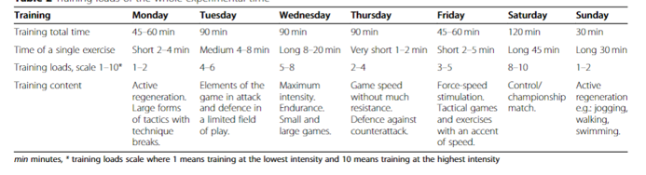
Chaouachi 2022 | Players performed the YYIRT-2 as described by Krustrup et al. The YYIRT-2 examines the ability to perform repeated high-intensity exercise bout with an almost maximum aerobic energy production and a high anaerobic energy contribution. It consists of repeated 40 m (2 × 20 m) runs between markers set 20 m apart, at a progressively increased speed starting from 13 km/h and controlled by audio bleeps from a tape recorder. Between each running bout, the participants had 10 s of active recovery, consisting of a 10 m (2 × 5 m) walk. When the participant failed to reach the finishing line in time twice or felt unable to continue, the total distance covered (m) was recorded and represented the test result.
Fernández-Lázaro 2022 | Participants trained in 3 sessions on alternate weekdays (Monday, Wednesday, and Friday) for a total of 4.5 h/week. The start of all CrossFit® training sessions was between 6:00 p.m. and 8:00 p.m. Each 1.5 h CrossFit® training session consisted of 3 sections such as specific warm-up, WODs, and cool-down. Each workout was performed in the participants ‘own gym, supervised by a certified CrossFit® Degree 1- or 2-certified instructor (each). All subjects completed the same physical activity routines to ensure that they performed the same prescribed workout during the study. In addition, CrossFit® athletes were specifically asked not to perform CrossFit routines outside of the structured training program.
Esen 2023 | The Prone Yo-Yo IR1 test was performed as described elsewhere (Dobbin et al., 2018a). In brief, it consists of repeated shuttle (2 × 20 m) runs, separated by a 10 s active recovery period (5 m jog, 180° change in direction and walk to the line), at progressively increasing speeds controlled by audio bleeps from a portable audio system. Each running bout was started from a proneposition in which participants’ head were behind the start line, legs were straight, and chest were in contact with the ground. The speed of the shuttles was 10–13 km·h⁻¹ at first four (0–160 m), at 13.5 km·h⁻¹ next three (200–280 m), and at 14.0 km·h⁻¹ at next four (320–440 m). After that, the speed increased 0.5 km·h⁻¹ every eight shuttles (i.e. 760, 1080, 1400 m, etc.). When participants failed twice to reach the start/finish line in the allocated, distance covered was recorded as the final distance. The coefficient of variation (CV) and intra-class correlation coefficient of the prone Yo-Yo IR1 has been reported as 9.9% and 0.98, respectively. Participants performed three CMJ to assess jump height (cm) using optojump system (Optojump, Microgate, Bolzano, Italy), which calculates height (cm) via flight time. Participants were instructed to stand in upright position, squatted down to a 90° knee angle, then immediately jumped upwards as fast and high as they can. Three repetitions were separated by 30 sec standing rest. The highest jump heights (cm) recorded as result measures. Test-retest measurements revealed a CV of 2.1%.

Table S4 Time points for outcome indicator measurement
Author/Year | Time points for outcome indicator measurement
Schröder 2000 | Collected immediately after the daily supplementation/placebo intervention for 32 consecutive days ended
Pilaczynska-Szczesniak 2005 | One minute after exercise (collected immediately after the test ends)
Tauler 2006 | After completing 105 days of antioxidant supplementation (90 days of vitamin E+β -carotene, and vitamin C added in the last 15 days), the resting blood samples collected before the exercise test were used to analyze the effects of long-term supplementation on the activities of basal antioxidant enzymes and plasma vitamin concentrations. Blood was collected immediately after exhaustive exercise to evaluate the effects of acute high-intensity exercise on antioxidant enzymes in red blood cells and lymphocytes.
Aguilo 2007 | Immediately after exercise: Draw blood immediately after the maximum test is completed.
Tauler 2008 | Blood will be drawn immediately after the 60-minute game
Ferre 2009 | One hour after the competition: Collect post-exercise samples
Skarpanska-Stejnborn 2009 | One minute after the test: Collect blood samples immediately after exercise
PARISI 2010 | Peak Exercise (Acme): Blood is drawn immediately at the moment of exhaustion
Jówko 2012 | Five minutes after exercise (Post): Blood is drawn immediately after exercise to test for immediate oxidative damage and muscle damage indicators
Djordjevic 2012 | After exercise: Blood will be drawn 15 minutes after the 2-hour football training
Basta 2013 | One minute after exercise: Blood is drawn immediately after the 2000-meter test
Nieman 2013 | Immediately after exercise: Draw blood immediately after the exercise on the third day
Łowińska-Lisowska 2014 | 30 minutes after exercising
Trinity 2014 | After the time trial (TT)
Verazaluce 2015 | Collected after the completion of 4 weeks of training and supplement intervention, it was used to evaluate the impact of the intervention measures on each indicator. The collection conditions were a fasting state in the morning, and the subjects had undergone approximately 36 hours of physical rest before collection to ensure consistent collection conditions and avoid the influence of recent exercise or diet on the test results.
Busquets-Cortés 2016 | Collected at the end of the nutritional intervention
Jastrzebski 2016 | Collected after completing a 4-week vitamin D supplementation and training program.  The collection conditions were an empty stomach in the morning. Immediately after collection, the samples were stored at 4℃. Within 10 minutes, they were centrifuged at 3000g for 10 minutes. After separating the plasma, they were stored at -80 ℃
Leonardo-Mendonça 2017 | Blood samples (10 ml) were collected from the antecubital vein between 7-8 am after 8-10 hours of fasting, using vacutainer CPT tubes (ref. 362782, Beckton Dickinson, Madrid, Spain). Blood was centrifuged at 3000 g for 10 min at 4 ºC, plasma was collected, the buffy coat was discarded and the erythrocytes were washed with cold saline thrice. Aliquots of plasma and erythrocytes were either maintained at 4 °C or frozen at -80 ºC until the assays were performed. A total of two blood samples pre and post-treatment (S1 and S2) were taken during the study period as mention above.
Ortiz-Franco 2017 | Immediately after the training, 10 mL of blood samples were collected from each subject
Toscano 2019 | Immediate Post-exercise: Collected immediately after the exhaustion run test is completed
Lydiane 2020 | Collect immediately after the training is completed
Drobnic 2021 | Collect immediately after the training is completed
Stankiewicz 2021 | Collect immediately after the training is completed
Chaouachi 2022 | Collect immediately after the training is completed
Fernández-Lázaro 2022 | Forty-two days after the end of the study
Esen 2023 | Collect immediately after the training is completed

Figure S1 Subgroup results of TAS

Figure S2 Subgroup results of TBARS

Figure S3 Subgroup results of SOD

Figure S4 Subgroup results of GPx

Figure S5 Subgroup results of LA
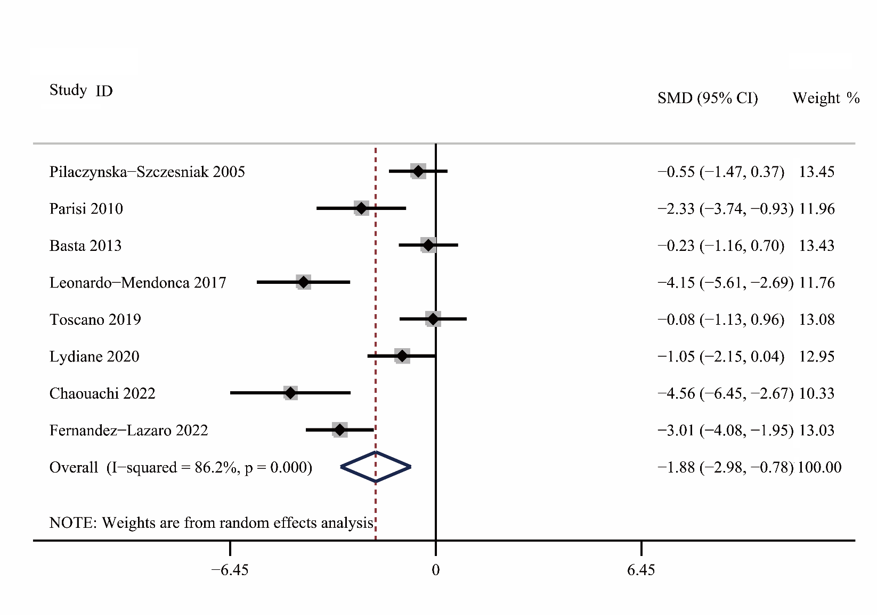Figure S6 Meta-analytic forest plot for the effect of antioxidant supplementation on post-exercise CK in athletes
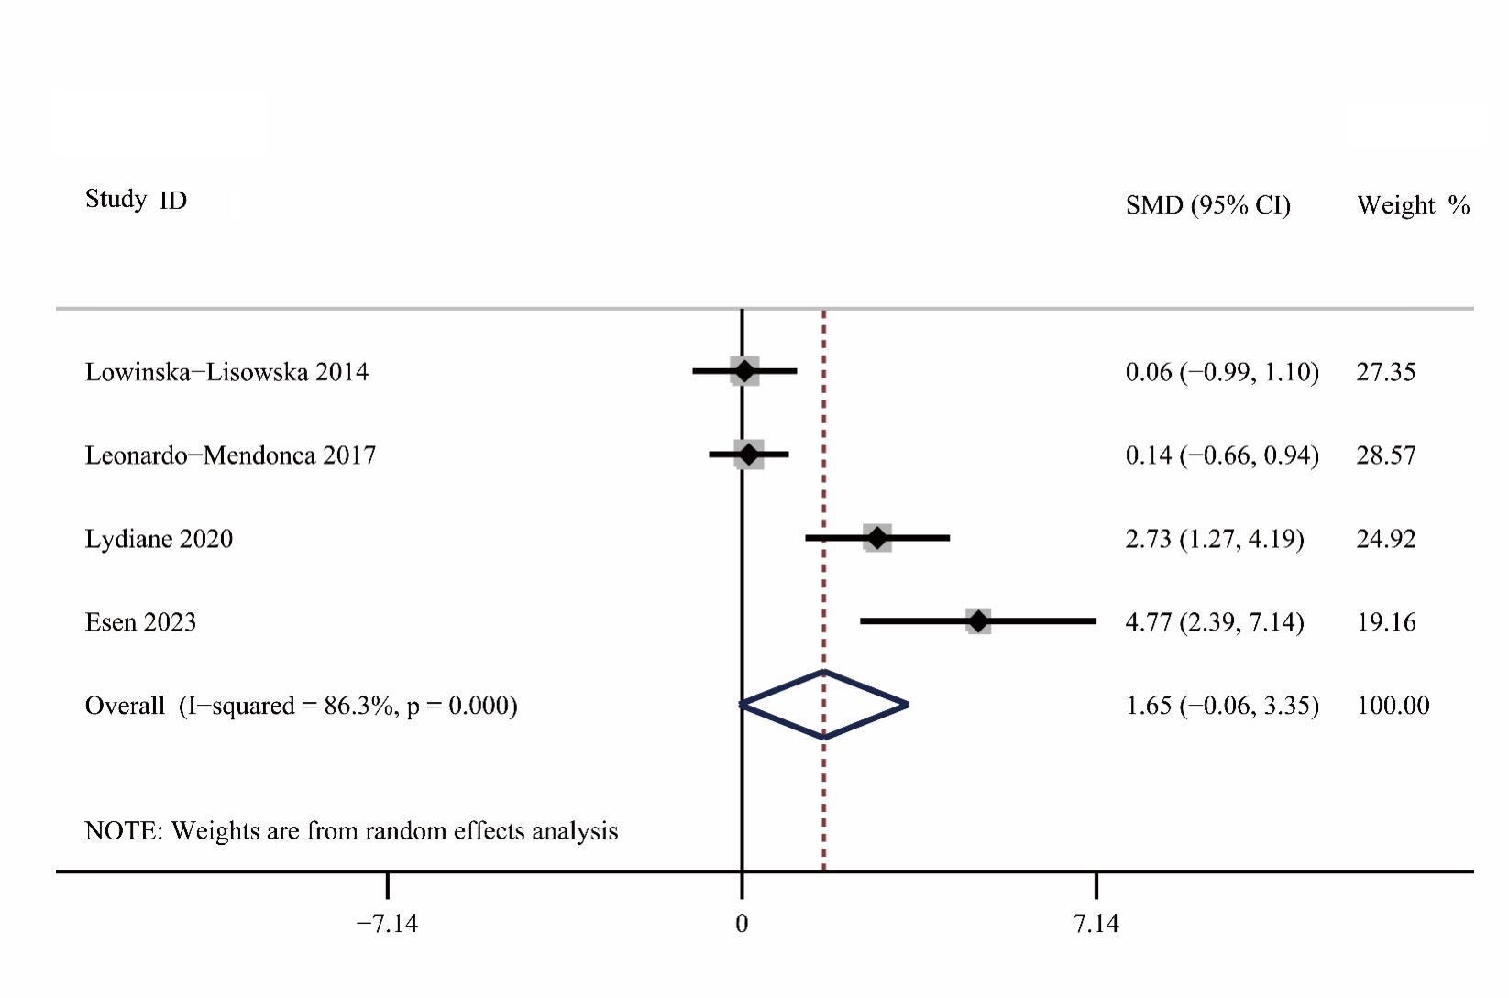Figure S7 Meta-analytic forest plot for the effect of antioxidant supplementation on post-exercise NOX in athletes

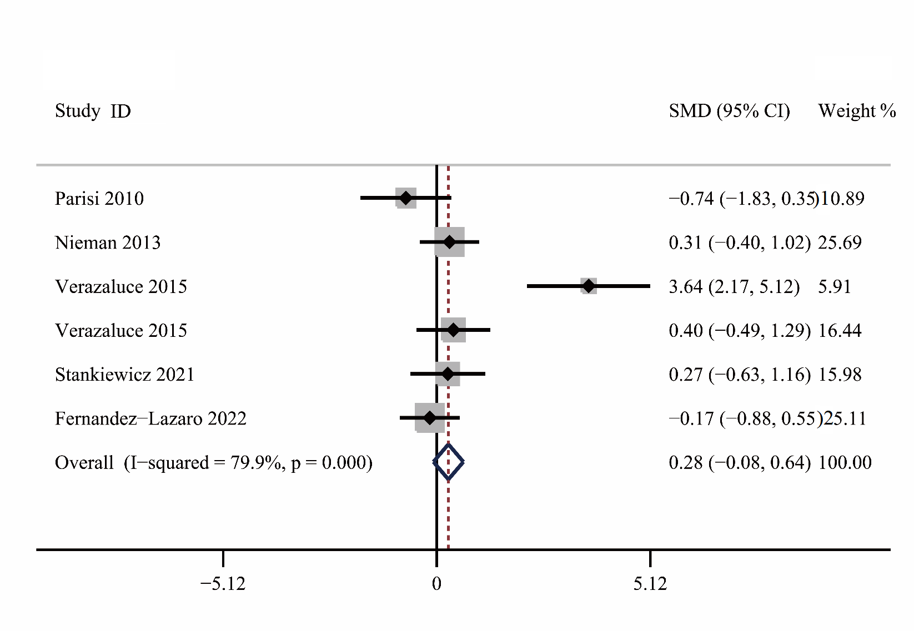
Figure S8 Meta-analytic forest plot for the effect of antioxidant supplementation on post-exercise IL-6 in athletes

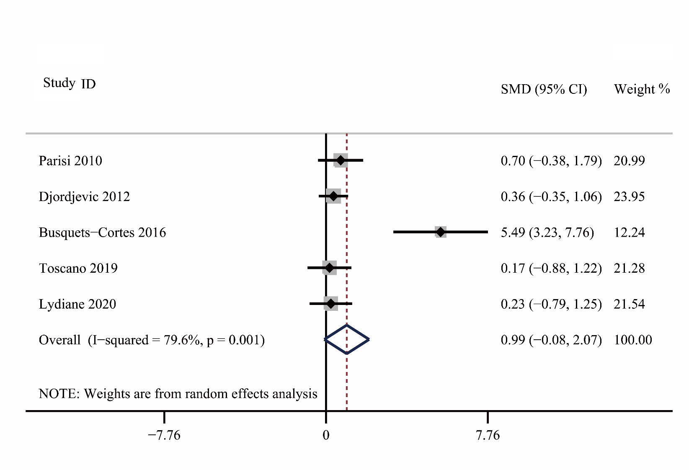
Figure S9 Meta-analytic forest plot for the effect of antioxidant supplementation on post-exercise MDA in athletes

Figure S10 Funnel plot analysis results

Figure S11 Funnel plot analysis results of MDA

Figure S12 Literature quality evaluation

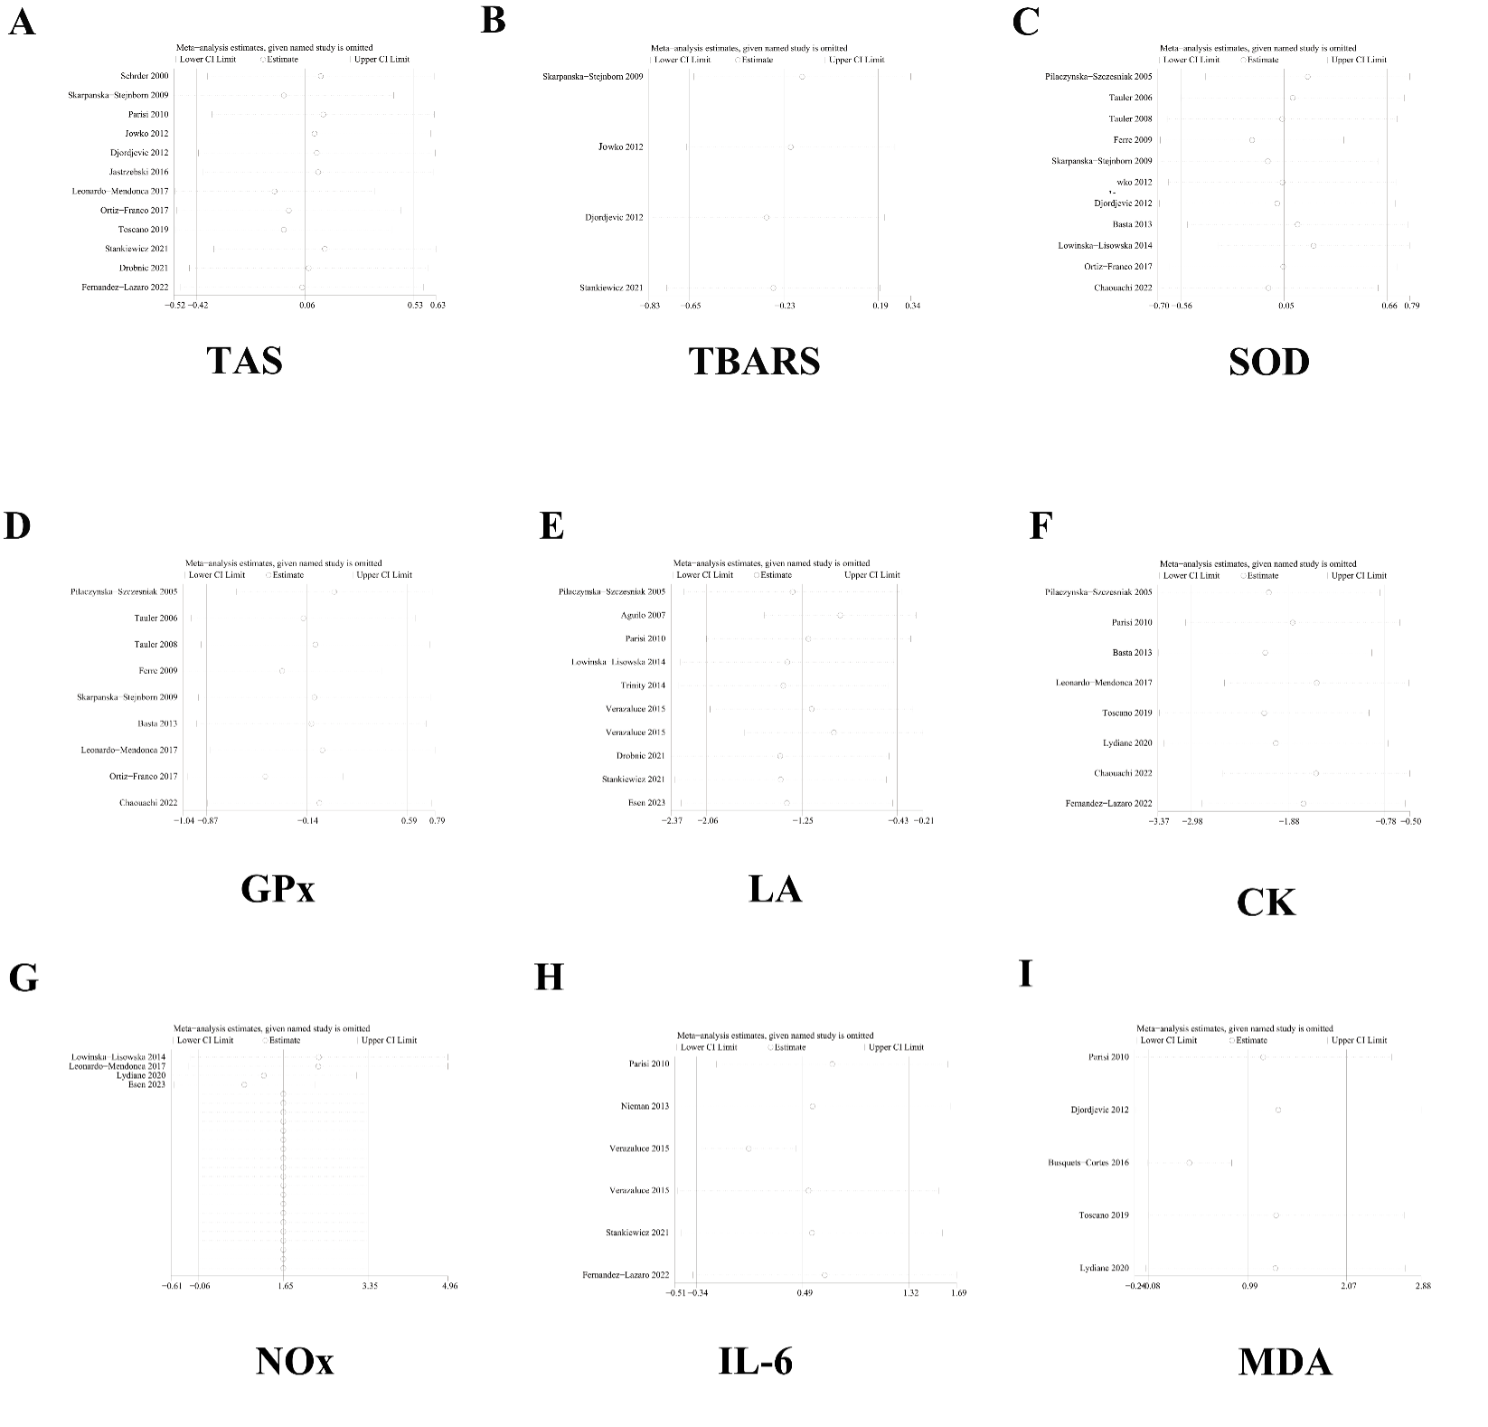
Figure S13 Sensitivity analysis results

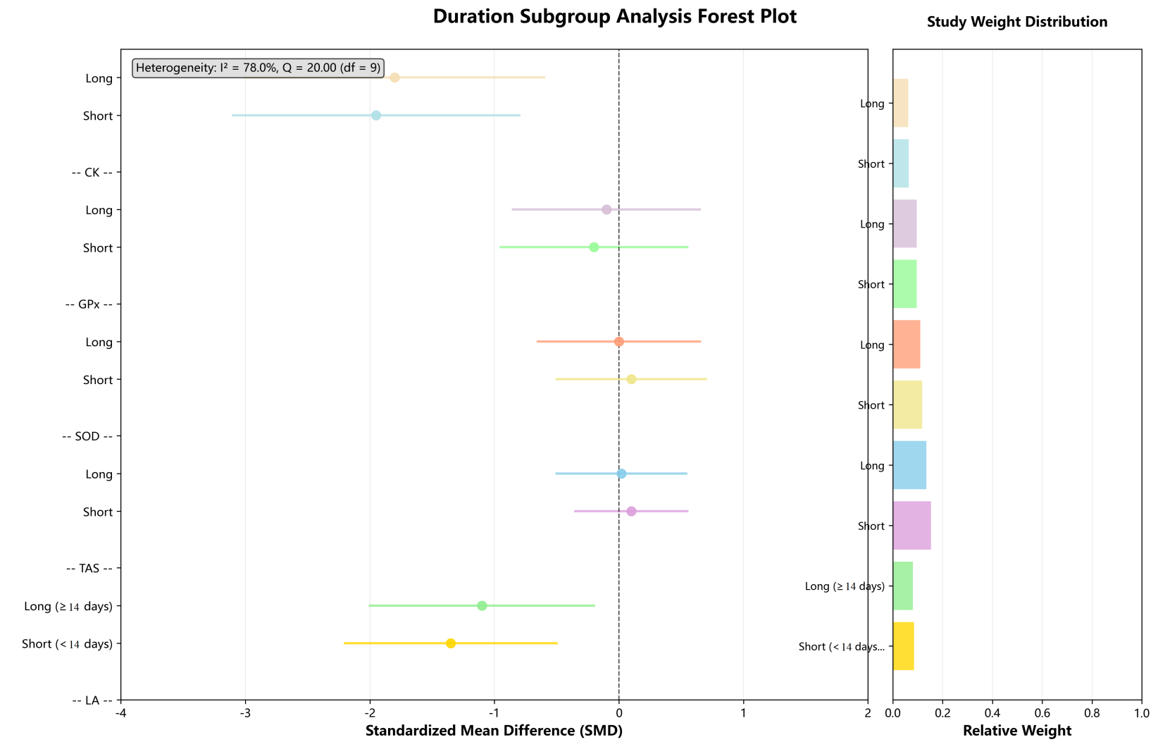
Figure S14 Duration subgroup analysis forest plot

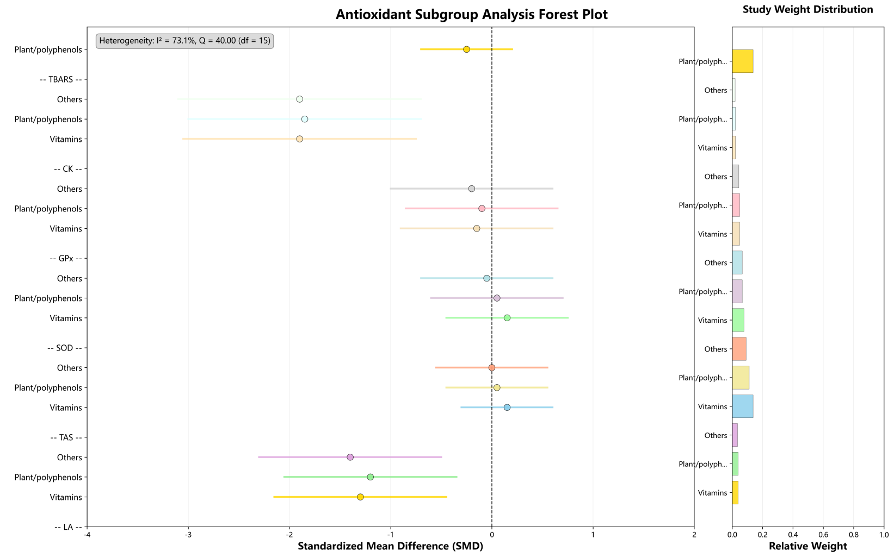
Figure S15 Antioxidant subgroup analysis forest plot

