Table of contents

Appendix 1 Search expression 1
Appendix 2 Subgroup analysis of forest maps 3
Cmj Subgroup 3
linear sprint Subgroup 4
Appendix 3 funnel plot 5
Appendix 4 Sensitivity Analysis 6

Appendix 1 Search expression
Table S1. Search strategy of Pubmed
# | Searches
1 | (flywheel training[Title/Abstract] )OR (flywheel overload training[Title/Abstract]) OR (flywheel resistance training[Title/Abstract] ) OR (eccentric exercise[Title/Abstract]) OR (FRT[Title/Abstract])
2 | (((athlete*[Title/Abstract]) OR (player*[Title/Abstract]) OR (sportsman*[Title/Abstract])
3 | (((((randomized controlled trial"[Publication Type]) OR (randomized[Publication Type]) OR (placeb [Publication Type]) OR (randomly [Publication Type]) OR (trial"[Publication Type])
4 | #1 AND #2 AND #3

Table S2. Search strategy of Web of Science
# | Searches
1 | TS=(“flywheel training” OR “flywheel overload training” OR “flywheel resistance training” OR “eccentric exercise”OR“FRT”)
2 | TS=(”athlete*” OR “player*” OR “sportsman* ”)
3 | TS=(" randomized controlled trial” OR “randomized” OR “placeb” OR “randomly”OR “trial”)
4 | #1 AND #2 AND #3

Table S3. Search strategy of Cochrane Library
# | Searches
1 | All text=(“flywheel training” OR “flywheel overload training” OR “flywheel resistance training” OR “eccentric exercise”OR“FRT”)
2 | All text=(”athlete*” OR “player*” OR “sportsman* ”)
3 | Publication Type=(" randomized controlled trial” OR “randomized” OR “placeb” OR “randomly ”OR “trial”)
4 | #1 AND #2 AND #3

Table S4. Search strategy of SPORTDiscus
# | Searches
1 | AB=(“flywheel training” OR “flywheel overload training” OR “flywheel resistance training” OR “eccentric exercise”OR“FRT”)
2 | AB=(”athlete*” OR “player*” OR “sportsman* ”)
3 | AB=(" randomized controlled trial” OR “randomized” OR “placeb” OR “randomly ”OR “trial”)
4 | #1 AND #2 AND #3

Table S5. Search strategy of proquest Central
# | Searches
1 | SUMMARY=(“flywheel training” OR “flywheel overload training” OR “flywheel resistance training” OR “eccentric exercise”OR“FRT”)
2 | SUMMARY=(“athlete*” OR “player*” OR “sportsman* ”)
3 | SUMMARY=(" randomized controlled trial” OR “randomized” OR “placeb” OR “randomly ”OR “trial”)
4 | #1 AND #2 AND #3

Appendix 2 Subgroup analysis of forest maps

Cmj Subgroup
Figure 1 Subgroup analysis of FRT training sessions(CMJ)
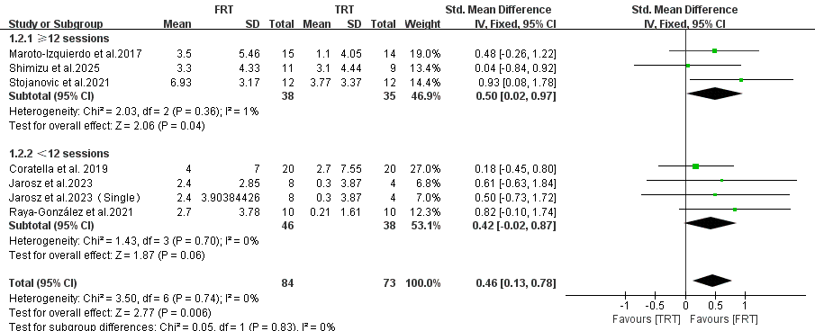
Figure 2 Subgroup analysis of the training frequency of FRT(CMJ)
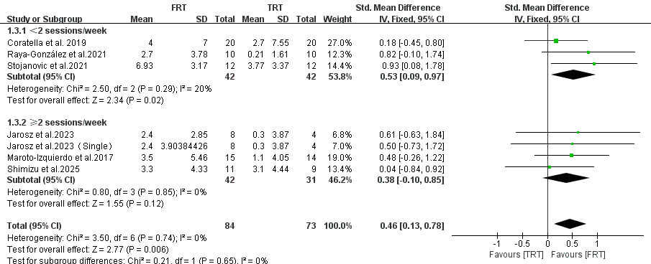
Figure 3 Subgroup analysis of the training duration of FRT(CMJ)
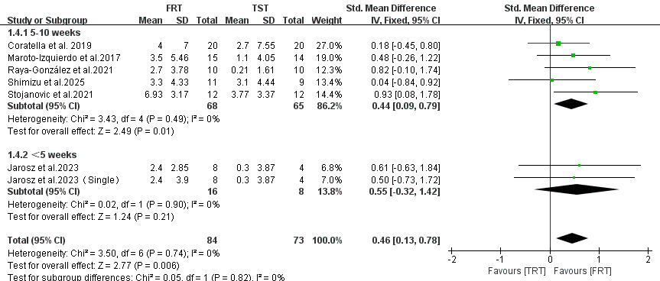
Figure 4 Subgroup analysis of the training load time of FRT(CMJ)
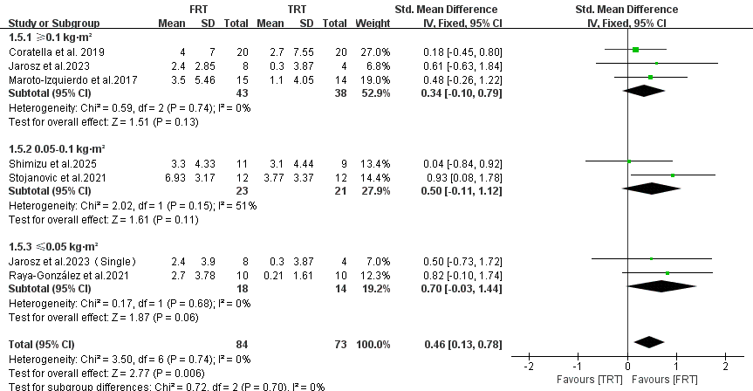

linear sprint Subgroup
Figure 5Subgroup analysis of FRT training sessions (linear sprint)
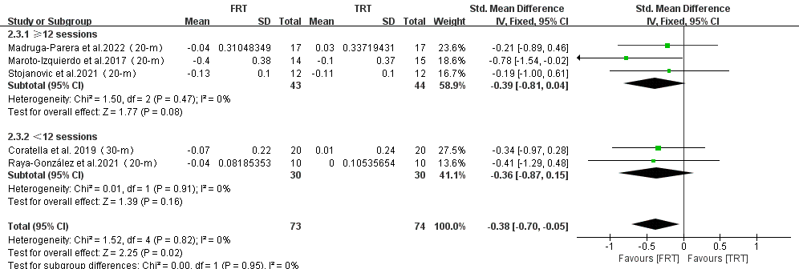
Figure6 Subgroup analysis of the training frequency of FRT(linear sprint)
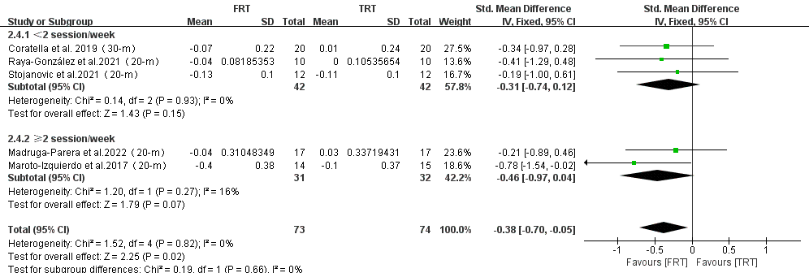

Appendix 3 funnel plot

Figure7 Publication bias plot(cmj)
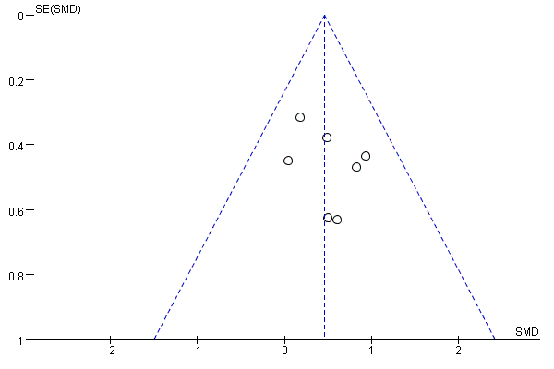

Figure8 Publication bias plot(linear sprint)
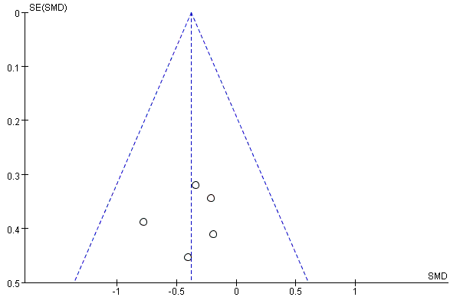

Appendix 4 Sensitivity Analysis
Figure 9 One-by-one Study Exclusion Sensitivity Analysis for CMJ
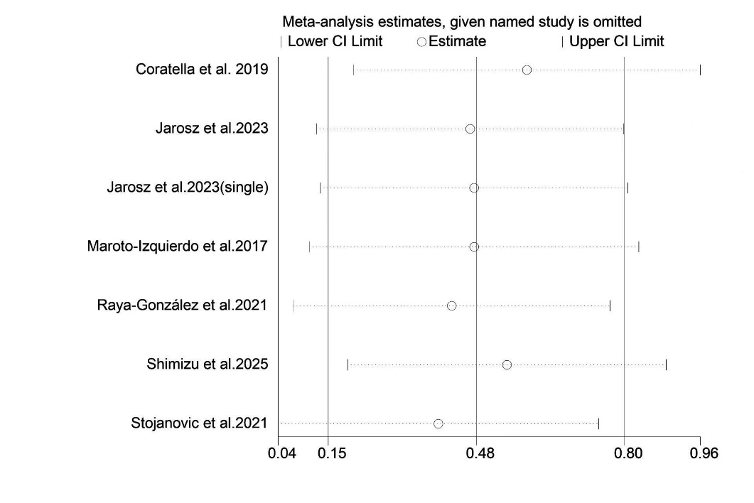

Figure 10 One-by-one Study Exclusion Sensitivity Analysis for linear sprint

