The Effects of Aerobic Exercise on Quality of Life and Motor Function in Patients with Parkinson's Disease: A Systematic Review and Meta-Analysis
Bing Zeng¹, Zhihai Lu¹, Xianyang Xin¹, Zhe Kong¹, Jun Xie²*
1 Capital University of Physical Education and Sports, Beijing, China
2 Shenzhen University of Advanced Technology, Shenzhen, China
corresponding author: Jun Xie, e-mail address: xiejun@suat-sz.edu.cn

Supplementary materials | Page
Appendix 1 Search strategy | P1-P4
Appendix 2 Basic characteristics of the included studies | P5-P7
Appendix 3 List of Included Studies | P8-P10
Appendix 4 Funnel plot | P11
Appendix 5 PRISMA 2020 Checklist | P12-P15

Appendix 1 Search strategy
Table S1. Search strategy for PubMed database
Search procedure | Query | Results
#11 | Search: (((("Parkinson Disease"[Mesh]) OR (((((((((((Idiopathic Parkinson Disease[Title/Abstract]) OR (Idiopathic Parkinson's Disease[Title/Abstract])) OR (Lewy Body Parkinson Disease[Title/Abstract])) OR (Lewy Body Parkinson's Disease[Title/Abstract])) OR (Paralysis Agitans[Title/Abstract])) OR (Parkinson Disease, Idiopathic[Title/Abstract])) OR (Parkinson's Disease[Title/Abstract])) OR (Parkinson's Disease, Idiopathic[Title/Abstract])) OR (Parkinson's Disease, Lewy Body[Title/Abstract])) OR (Primary Parkinsonism[Title/Abstract])) OR (Parkinsonism, Primary[Title/Abstract]))) AND (((("Quality of Life"[Mesh]) OR ((((Life Quality[Title/Abstract]) OR (Health-Related Quality Of Life[Title/Abstract])) OR (Health Related Quality Of Life[Title/Abstract])) OR (HRQOL[Title/Abstract]))) OR ("Motor Skills"[Mesh])) OR ((((((((Motor Skill[Title/Abstract]) OR (Skill, Motor[Title/Abstract])) OR (Skills, Motor[Title/Abstract])) OR (motor ability[Title/Abstract])) OR (motor performance[Title/Abstract])) OR (movement performance[Title/Abstract])) OR (physical performance[Title/Abstract])) OR (motor function[Title/Abstract])))) AND (((randomized controlled trial[Title/Abstract]) OR (randomized[Title/Abstract])) OR (placebo[Title/Abstract]))) AND ((((((((Aerobic Exercise[Title/Abstract]) OR (Aerobic Exercises[Title/Abstract])) OR (Exercises, Aerobic[Title/Abstract])) OR (treadmill[Title/Abstract])) OR (cycling[Title/Abstract])) OR (walking[Title/Abstract])) OR (dance[Title/Abstract])) OR (Qigong[Title/Abstract])) Sort by: Publication Date | 170
#10 | Search: ((randomized controlled trial[Title/Abstract]) OR (randomized[Title/Abstract])) OR (placebo[Title/Abstract]) Sort by: Publication Date | 915280
#9 | Search: ((("Quality of Life"[Mesh]) OR ((((Life Quality[Title/Abstract]) OR (Health-Related Quality Of Life[Title/Abstract])) OR (Health Related Quality Of Life[Title/Abstract])) OR (HRQOL[Title/Abstract]))) OR ("Motor Skills"[Mesh])) OR ((((((((Motor Skill[Title/Abstract]) OR (Skill, Motor[Title/Abstract])) OR (Skills, Motor[Title/Abstract])) OR (motor ability[Title/Abstract])) OR (motor performance[Title/Abstract])) OR (movement performance[Title/Abstract])) OR (physical performance[Title/Abstract])) OR (motor function[Title/Abstract])) Sort by: Publication Date | 424505
#8 | Search: (((((((Motor Skill[Title/Abstract]) OR (Skill, Motor[Title/Abstract])) OR (Skills, Motor[Title/Abstract])) OR (motor ability[Title/Abstract])) OR (motor performance[Title/Abstract])) OR (movement performance[Title/Abstract])) OR (physical performance[Title/Abstract])) OR (motor function[Title/Abstract]) Sort by: Publication Date | 67891
#7 | Search: "Motor Skills"[Mesh] Sort by: Most Recent | 27892
#6 | Search: (((Life Quality[Title/Abstract]) OR (Health-Related Quality Of Life[Title/Abstract])) OR (Health Related Quality Of Life[Title/Abstract])) OR (HRQOL[Title/Abstract]) Sort by: Publication Date | 83786
#5 | Search: "Quality of Life"[Mesh] Sort by: Most Recent | 313113
#4 | Search: (((((((Aerobic Exercise[Title/Abstract]) OR (Aerobic Exercises[Title/Abstract])) OR (Exercises, Aerobic[Title/Abstract])) OR (treadmill[Title/Abstract])) OR (cycling[Title/Abstract])) OR (walking[Title/Abstract])) OR (dance[Title/Abstract])) OR (Qigong[Title/Abstract]) Sort by: Publication Date | 249053
#3 | Search: ("Parkinson Disease"[Mesh]) OR (((((((((((Idiopathic Parkinson Disease[Title/Abstract]) OR (Idiopathic Parkinson's Disease[Title/Abstract])) OR (Lewy Body Parkinson Disease[Title/Abstract])) OR (Lewy Body Parkinson's Disease[Title/Abstract])) OR (Paralysis Agitans[Title/Abstract])) OR (Parkinson Disease, Idiopathic[Title/Abstract])) OR (Parkinson's Disease[Title/Abstract])) OR (Parkinson's Disease, Idiopathic[Title/Abstract])) OR (Parkinson's Disease, Lewy Body[Title/Abstract])) OR (Primary Parkinsonism[Title/Abstract])) OR (Parkinsonism, Primary[Title/Abstract])) Sort by: Publication Date | 147350
#2 | Search: ((((((((((Idiopathic Parkinson Disease[Title/Abstract]) OR (Idiopathic Parkinson's Disease[Title/Abstract])) OR (Lewy Body Parkinson Disease[Title/Abstract])) OR (Lewy Body Parkinson's Disease[Title/Abstract])) OR (Paralysis Agitans[Title/Abstract])) OR (Parkinson Disease, Idiopathic[Title/Abstract])) OR (Parkinson's Disease[Title/Abstract])) OR (Parkinson's Disease, Idiopathic[Title/Abstract])) OR (Parkinson's Disease, Lewy Body[Title/Abstract])) OR (Primary Parkinsonism[Title/Abstract])) OR (Parkinsonism, Primary[Title/Abstract]) Sort by: Publication Date | 127068
#1 | Search: "Parkinson Disease"[Mesh] Sort by: Most Recent | 91938

Table S2. Search strategy for Embase database
Search procedure | Query | Results
#13 | #3 AND #6 AND #11 AND #12 | 618
#12 | 'randomized controlled trial':ab,ti OR 'randomized':ab,ti OR 'placebo':ab,ti | 1509389
#11 | #7 OR #8 OR #9 OR #10 | 1020882
#10 | 'motor ability':ab,ti OR 'motor control':ab,ti OR 'motor skills':ab,ti OR 'movement performance':ab,ti OR 'physical performance':ab,ti OR 'neuromuscular performance':ab,ti OR 'motor function':ab,ti | 111315
#9 | 'motor performance'/exp | 111423
#8 | 'life quality':ab,ti OR 'health-related quality of life':ab,ti OR 'health related quality of life':ab,ti OR 'hrqol':ab,ti | 128927
#7 | 'quality of life'/exp | 839863
#6 | #4 OR #5 | 615903
#5 | 'exercise, physical':ab,ti OR 'exercises, physical':ab,ti OR 'physical exercise':ab,ti OR 'physical exercises':ab,ti OR 'exercise, aerobic':ab,ti OR 'aerobic exercises':ab,ti OR 'exercises, aerobic':ab,ti OR 'acute exercise':ab,ti OR 'acute exercises':ab,ti OR 'exercise, acute':ab,ti OR 'exercises, acute':ab,ti OR 'exercise training':ab,ti OR 'exercise trainings':ab,ti OR 'training, exercise':ab,ti OR 'trainings, exercise':ab,ti OR 'physical activity':ab,ti OR 'activities, physical':ab,ti OR 'activity, physical':ab,ti OR 'physical activities':ab,ti OR 'endurance training':ab,ti OR 'physical fitness':ab,ti OR 'exercise therapy':ab,ti OR 'remedial exercise':ab,ti OR 'exercise therapies':ab,ti OR 'treadmill':ab,ti OR 'cycling':ab,ti OR 'walking':ab,ti OR 'dance':ab,ti OR 'qigong':ab,ti | 602817
#4 | 'aerobic exercise'/exp | 30535
#3 | #1 OR #2 | 229173
#2 | 'idiopathic parkinson disease':ab,ti OR 'lewy body parkinson disease':ab,ti OR 'paralysis agitans':ab,ti OR 'parkinson disease, idiopathic':ab,ti OR 'primary parkinsonism':ab,ti OR 'parkinsonism, primary':ab,ti | 792
#1 | 'parkinson disease'/exp | 229090

Table S3. Search strategy for Cochrane Library database
Search procedure | Query | Results
#9 | #3 and #4 and #8 | 1829
#8 | #5 or #6 or #7 | 247058
#7 | (motor function):ti,ab,kw or (motor ability):ti,ab,kw or (motor control):ti,ab,kw or (motor skills):ti,ab,kw or (movement performance):ti,ab,kw or (physical performance):ti,ab,kw or (neuromuscular performance):ti,ab,kw | 65831
#6 | (Life Quality):ti,ab,kw or (Health-Related Quality Of Life):ti,ab,kw or (Health Related Quality Of Life):ti,ab,kw or (HRQOL):ti,ab,kw | 192274
#5 | MeSH descriptor: [Quality of Life] explode all trees | 45919
#4 | (Exercise, Physical):ti,ab,kw or (Exercises, Physical):ti,ab,kw or (Physical Exercise):ti,ab,kw or (Physical Exercises):ti,ab,kw or (Exercise, Aerobic):ti,ab,kw or (Aerobic Exercise):ti,ab,kw or (Aerobic Exercises):ti,ab,kw or (Exercises, Aerobic):ti,ab,kw or (Acute Exercise):ti,ab,kw or (Acute Exercises):ti,ab,kw or (Exercises, Acute):ti,ab,kw or (Exercise, Acute):ti,ab,kw or (Exercise Training):ti,ab,kw or (Exercise Trainings):ti,ab,kw or (Training, Exercise):ti,ab,kw or (Trainings, Exercise):ti,ab,kw or (Physical Activity):ti,ab,kw or (Activities, Physical):ti,ab,kw or (Activity, Physical):ti,ab,kw or (Physical Activities):ti,ab,kw or (Endurance Training):ti,ab,kw or (Physical Fitness):ti,ab,kw or (Exercise Therapy):ti,ab,kw or (Remedial Exercise):ti,ab,kw or (Exercise Therapies):ti,ab,kw or (treadmill):ti,ab,kw or (cycling):ti,ab,kw or (walking):ti,ab,kw or (dance):ti,ab,kw or (Qigong):ti,ab,kw | 187367
#3 | #1 or #2 | 14249
#2 | (Idiopathic Parkinson Disease):ti,ab,kw or (Idiopathic Parkinson's Disease):ti,ab,kw or (Lewy Body Parkinson Disease):ti,ab,kw or (Lewy Body Parkinson's Disease):ti,ab,kw or (Paralysis Agitans):ti,ab,kw or (Parkinson Disease, Idiopathic):ti,ab,kw or (Parkinson's Disease):ti,ab,kw or (Parkinson's Disease, Idiopathic):ti,ab,kw or (Parkinson's Disease, Lewy Body):ti,ab,kw or (Primary Parkinsonism):ti,ab,kw or (Parkinsonism, Primary):ti,ab,kw | 14249
#1 | MeSH descriptor: [Parkinson Disease] explode all trees | 6377

Table S4. Search strategy for Web of Science database
Search procedure | Query | Results
#5 | #1 AND #2 AND #3 AND #4 and Preprint Citation Index (Exclude – Database) and Research Commons (Exclude – Database) | 1068
#4 | randomized controlled trial (Topic) or randomized (Topic) or placebo (Topic) and Preprint Citation Index (Exclude – Database) and Research Commons (Exclude – Database) | 1782697
#3 | Quality of Life (Topic) or Life Quality (Topic) or Health-Related Quality Of Life (Topic) or Health Related Quality Of Life (Topic) or HRQOL (Topic) or motor function (Topic) or motor ability (Topic) or motor control (Topic) or motor skills (Topic) or movement performance (Topic) or physical performance (Topic) or neuromuscular performance (Topic) and Preprint Citation Index (Exclude – Database) and Research Commons (Exclude – Database) | 3261730
#2 | Aerobic Exercise (Topic) or Aerobic Exercises (Topic) or Exercises, Aerobic (Topic) or treadmill (Topic) or cycling (Topic) or walking (Topic) or dance (Topic) or Qigong (Topic) and Preprint Citation Index (Exclude – Database) and Research Commons (Exclude – Database) | 3784796
#1 | Parkinson Disease (Topic) or Idiopathic Parkinson Disease (Topic) or Idiopathic Parkinson's Disease (Topic) or Lewy Body Parkinson Disease (Topic) or Lewy Body Parkinson's Disease (Topic) or Paralysis Agitans (Topic) or Parkinson Disease, Idiopathic (Topic) or Parkinson's Disease (Topic) or Parkinson's Disease, Idiopathic (Topic) or Parkinson's Disease, Lewy Body (Topic) or Primary Parkinsonism (Topic) or Parkinsonism, Primary (Topic) and Preprint Citation Index (Exclude – Database) and Research Commons (Exclude – Database) | 289048

Appendix 2 Basic characteristics of the included studies
study | country | characteristic of subjects |  |  |  | intervention information |  | outcome measures
study | country | number | age | disease stage | disease duration | type of exercise | characteristics of intervention | outcome measures
Duncan¹  (2014) | America | IG:5 | 69.6 ± 6.6 | H&Y 2.5 ± 0.5 | 6.6 ± 7.5 | Dance | 104 weeks, 2 times/week, 60 minutes | ①②③④
Duncan¹  (2014) | America | CG:5 | 66.0 ± 11.0 | H&Y 2.5 ± 0.5 | 11.0 ± 3.9 | CON | usual care and usual daily activities | ①②③④
Li²  （2022） | China | IG:20 | 67.6 ± 4.0 | Total: H&Y stage 1-3 | 6.8 ± 4.1 | Qigong | 30–70% HRmax (RPE 6–12), 12 weeks, 2 times/week, 90 minutes | ①②④⑥
Li²  （2022） | China | CG:20 | 70.0 ± 5.6 | Total: H&Y stage 1-3 | 7.8 ± 4.6 | CON | stretching exercises(12 weeks, 2 times/week, 90 minutes) | ①②④⑥
Carvalho³  （2015） | Brazil | IG:5 | 64.8 ± 11.9 | H&Y 2.6 ± 0.5 | 6.6 ± 1.5 | TT | 60% VO₂max or 70% HRmax, 12 weeks, 2 times/week, 40 minutes | ①
Carvalho³  （2015） | Brazil | CG:9 | 62.1 ± 11.7 | H&Y 2.3 ± 0.5 | 4.3 ± 2.8 | CON | conventional physiotherapy | ①
Sage⁴  (2009) | Canada | IG:13 | 65.1 ± 9.3 | NR | 3.2 ± 2.9 | AE | 60–75% HRmax (RPE <5/10), 12 weeks, 3 times/week, 30 minutes | ①④
Sage⁴  (2009) | Canada | CG:15 | 68.6 ± 8.7 | NR | 2.5 ± 2.2 | CON | usual care and usual daily activities | ①④
Shanahan⁵  （2017） | Ireland | IG:20 | 69.0 ± 10.0 | H&Y 1.3 ± 1.0 | 5.5 ± 6.0 | Dance | 10 weeks, 1 time/week, 90 minutes | ①②③⑥
Shanahan⁵  （2017） | Ireland | CG:21 | 69.0 ± 8.0 | H&Y 2.0 ± 1.0 | 6.0 ± 5.8 | CON | usual care and usual daily activities | ①②③⑥
Tollár⁶  （2018） | Netherlands | IG:25 | 70.6 ± 4.1 | H&Y 2.4 ± 0.5 | 7.5 ± 2.2 | Cycling | 80% HRmax, 5 weeks, 5 times/week, 60 minutes | ③⑤
Tollár⁶  （2018） | Netherlands | CG:24 | 67.5 ± 4.3 | H&Y 2.4 ± 0.5 | 7.3 ± 2.2 | CON | usual care and usual daily activities | ③⑤
CHANG⁷  （2024） | China | IG:14 | 64.4 ± 7.4 | NR | 6.6 ± 7.9 | Cycling | 70–75% HRR, 12 weeks, 3 times/week, 30 minutes | ①
CHANG⁷  （2024） | China | CG:13 | 63.2 ± 8.0 | NR | 6.8 ± 6.7 | CON | usual care and usual daily activities | ①
Sacheli⁸  (2019) | Canada | IG:20 | 66.8 ± 6.0 | Total: H&Y stage 1-3 | 3.9 ± 2.9 | Cycling | 60–80% VO₂max, 12 weeks, 3 times/week, 40–60 minutes | ①④
Sacheli⁸  (2019) | Canada | CG:15 | 67.9 ± 8.5 | Total: H&Y stage 1-3 | 5.2 ± 4.3 | CON | usual care and usual daily activities | ①④
Cakit⁹  (2007) | Turkey | IG:20 | 71.8 ± 6.4 | Total: H&Y stage 2-3 | 5.6 ± 2.9 | TT | 8 weeks, 2 times/week, 25–35 minutes | ⑤
Cakit⁹  (2007) | Turkey | CG:10 | 71.8 ± 6.4 | Total: H&Y stage 2-3 | 5.6 ± 2.9 | CON | usual care and usual daily activities | ⑤
van der Kolk¹⁰  (2019) | Netherlands | IG:61 | 59.3 ± 8.3 | Total: H&Y stage 1-2 | 3.4 ± 1.5 | Cycling | 50–80% HRR, 24 weeks,≥ 3 times/week, 30–45 minutes | ①②③⑥
van der Kolk¹⁰  (2019) | Netherlands | CG:64 | 59.4 ± 9.3 | Total: H&Y stage 1-2 | 3.2 ± 1.3 | CON | stretching exercises(24 weeks, 3 times/week, 30 minutes) | ①②③⑥
Nadeau¹¹  （2014） | Canada | IG:12 | 64.0 ± 6.6 | H&Y 1.9 ± 0.2 | NR | TT | ≤ 75% HRmax, 24 weeks, 3 times/week, 60 minutes | ①③⑥
Nadeau¹¹  （2014） | Canada | CG:11 | 64.3 ± 5.6 | H&Y 1.9 ± 0.2 | NR | CON | usual care and usual daily activities | ①③⑥
Shen¹²  (2021) | China | IG:15 | 68.7 ± 4.3 | H&Y 1.9 ± 0.8 | 6.3 ± 4.5 | Qigong | 12 weeks, 2 times/week, 90 minutes | ①④
Shen¹²  (2021) | China | CG:15 | 66.9 ± 3.4 | H&Y 2.2 ± 0.7 | 7.0 ± 3.9 | CON | stretching exercises(12 weeks, 2 times/week, 90 minutes) | ①④
Volpe¹³  (2013) | Italy | IG:12 | 61.6 ± 4.5 | H&Y 2.2 ± 0.4 | 9.0 ± 3.6 | Dance | 24 weeks, 1 time/week, 90 minutes | ①⑤⑥
Volpe¹³  (2013) | Italy | CG:12 | 65.0 ± 5.3 | H&Y 2.2 ± 0.4 | 8.9 ± 2.5 | CON | conventional physiotherapy | ①⑤⑥
Ventura¹⁴  (2016) | America | IG:8 | 71.8 ± 3.6 | Total: H&Y stage 1-2 | 6.1 ± 3.1 | Dance | 10 weeks, 1 time/week, 75 minutes | ④⑥
Ventura¹⁴  (2016) | America | CG:7 | 70.4 ± 5.5 | Total: H&Y stage 1-2 | 4.3 ± 2.6 | CON | usual care and usual daily activities | ④⑥
Duncan¹⁵  (2012) | America | IG:26 | 69.3 ± 1.9 | H&Y 2.6 ± 0.1 | 5.8 ± 1.1 | Dance | 52 weeks, 2 times/week, 60 minutes | ①②③
Duncan¹⁵  (2012) | America | CG:26 | 69.0 ± 1.5 | H&Y 2.5 ± 0.1 | 7.0 ± 1.0 | CON | usual care and usual daily activities | ①②③
Wang¹⁶  (2020) | China | IG:23 | 67.0 ± 5.6 | Total: H&Y stage 1-3 | 5.0 ± 3.1 | Qigong | 12 weeks, 2 times/week, 60 minutes | ⑥
Wang¹⁶  (2020) | China | CG:23 | 67.1 ± 6.1 | Total: H&Y stage 1-3 | 5.3 ± 3.8 | CON | stretching exercises(12 weeks, 2 times/week, 60 minutes) | ⑥
Canning¹⁷  (2011) | Australia | IG:9 | 60.7 ± 5.9 | Total: H&Y stage 1-2 | 6.1 ± 4.0 | TT | 60–80% 6MWT speed, 6 weeks, 4 times/week, 30–40 minutes | ①③⑥
Canning¹⁷  (2011) | Australia | CG:9 | 62.9 ± 9.9 | Total: H&Y stage 1-2 | 5.2 ± 4.1 | CON | usual care and usual daily activities | ①③⑥
Romenets¹⁸  (2015) | Canada | IG:18 | 64.3 ± 8.1 | Total: H&Y stage 1-3 | 7.7 ± 4.6 | Dance | 12 weeks, 2 times/week, 60 minutes | ①②④⑥
Romenets¹⁸  (2015) | Canada | CG:15 | 63.2 ± 9.9 | Total: H&Y stage 1-3 | 5.5 ± 4.4 | CON | usual care and usual daily activities | ①②④⑥
Ganesan¹⁹  (2014) | India | IG:20 | 57.6 ± 9.1 | Total: H&Y stage 2-2.5 | 5.7 ± 3.9 | TT | 4 weeks, 4 times/week, 30 minutes | ①⑤
Ganesan¹⁹  (2014) | India | CG:20 | 59.1 ± 6.8 | Total: H&Y stage 2-2.5 | 5.5 ± 3.4 | CON | conventional physiotherapy | ①⑤
Cugusi²⁰  (2015) | Italy | IG:10 | 68.1 ± 8.7 | Total: H&Y stage 1-3 | 7.0 ± 2.0 | NW | 60–80% HRR, 12 weeks, 2 times/week, 60 minutes | ①③④⑤
Cugusi²⁰  (2015) | Italy | CG:10 | 66.6 ± 7.3 | Total: H&Y stage 1-3 | 7.0 ± 4.0 | CON | usual care and usual daily activities | ①③④⑤
Altmann²¹  (2016) | America | IG:11 | 62.8 ± 8.6 | Total: H&Y stage 1-3 | NR | TT | 50–75% HRR, 16 weeks, 3 times/week, 20–45 minutes | ①
Altmann²¹  (2016) | America | CG:10 | 67.8 ± 9.8 | Total: H&Y stage 1-3 | NR | CON | usual care and usual daily activities | ①
Hackney²²  (2009) | America | IG:31 | 67.4 ± 8.1 | H&Y 2.0 ± 0.7 | 8.2 ± 5.7 | Dance | 13 weeks, 2 times/week, 60 minutes | ①③④⑤
Hackney²²  (2009) | America | CG:17 | 66.5 ± 11.5 | H&Y 2.2 ± 0.8 | 5.9 ± 4.1 | CON | usual care and usual daily activities | ①③④⑤
Lee²³  (2017) | Korea | IG:25 | 65.8 ± 7.2 | Total: H&Y stage 1-3 | 4.5 ± 3.3 | Dance | 8 weeks, 2 times/week, 60 minutes | ①⑤
Lee²³  (2017) | Korea | CG:16 | 65.7 ± 6.4 | Total: H&Y stage 1-3 | 4.4 ± 3.0 | CON | usual care and usual daily activities | ①⑤
Wan²⁴  (2021) | China | IG:20 | 65.0 ± 7.8 | Total: H&Y stage 1-4 | 3.6 ± 1.5 | Qigong | 12 weeks, 4 times/week, 60 minutes | ④
Wan²⁴  (2021) | China | CG:20 | 67.0 ± 7.5 | Total: H&Y stage 1-4 | 3.3 ± 1.7 | CON | conventional physiotherapy | ④
Hashimoto²⁵  (2015) | Japan | IG:15 | 67.9 ± 7.0 | Total: H&Y stage 2-4 | 6.3 ± 4.6 | Dance | 12 weeks, 1 time/week, 60 minutes | ④⑤
Hashimoto²⁵  (2015) | Japan | CG:14 | 69.7 ± 4.0 | Total: H&Y stage 2-4 | 6.9 ± 4.0 | CON | usual care and usual daily activities | ④⑤
Solla²⁶  (2019) | Italy | IG:10 | 67.8 ± 5.9 | H&Y 2.1 ± 0.6 | 4.4 ± 4.5 | Dance | 12 weeks, 2 times/week, 90 minutes | ①③④⑤
Solla²⁶  (2019) | Italy | CG:9 | 67.1 ± 6.3 | H&Y 2.3 ± 0.4 | 5.0 ± 2.9 | CON | usual care and usual daily activities | ①③④⑤
Arfa-FAEollahkhan²⁷  (2018) | Iran | IG:11 | 60.6 ± 9.4 | H&Y 2.1 ± 0.3 | 8.9 ± 5.1 | TT | 60% HRR (RPE 11–13), 10 weeks, 2 times/week, 30 minutes | ③④
Arfa-FAEollahkhan²⁷  (2018) | Iran | CG:9 | 61.6 ± 8.6 | H&Y 2.0 ± 0.4 | 8.5 ± 6.3 | CON | usual care and usual daily activities | ③④
①UPDRS-Ⅲ = Unified Parkinson’s Disease Rating Scale Part III, ②Mini-BESTest = Mini-Balance Evaluation Systems Test, ③6MWT = Six-Minute Walk Test, ④TUG = Timed Up and Go, ⑤BBS = Berg Balance Scale, ⑥PDQ-39 = 39-item Parkinson’s Disease Questionnaire, ⑦TT = Treadmill Training, ⑧NW = Nordic Walking, ⑨AE = Aerobic Exercise, ⑩NR = Not Reported, ⑪IG = Intervention Group, ⑫CG = Control Group, ⑬HRR = heart rate reserve, ⑭VO₂max = maximal oxygen uptake, ⑮RPE = rating of perceived exertion, ⑯HRmax = maximal heart rate, ⑰H&Y=Hoehn and Yahr

Appendix 3 List of Included Studies
1. Duncan, R. P., & Earhart, G. M. (2014). Are the effects of community-based dance on parkinson disease severity, balance, and functional mobility reduced with time? A 2-year prospective pilot study. The Journal of Alternative and Complementary Medicine, 20(10), 757–763. https://doi.org/10.1089/acm.2012.0774
2. Li, Z., Wang, T., Shen, M., Song, T., He, J., Guo, W., Wang, Z., & Zhuang, J. (2022). Comparison of wuqinxi qigong with stretching on single- and dual-task gait, motor symptoms and quality of life in parkinson’s disease: A preliminary randomized control study. International Journal of Environmental Research and Public Health, 19(13), 8042. https://doi.org/10.3390/ijerph19138042
3. Alessandro Carvalho, A., Barbirato, D., Santos, T., Coutinho, E., Laks, J., Deslandes, A., Araujo, N., Martins, J., & Cavalcanti, J. (2015). Comparison of strength training, aerobic training, and additional physical therapy as supplementary treatments for parkinson&rsquo;s disease: Pilot study. Clinical Interventions in Aging, 183. https://doi.org/10.2147/CIA.S68779
4. Sage, M. D., & Almeida, Q. J. (2009). Symptom and gait changes after sensory attention focused exercise vs aerobic training in parkinson’s disease. Movement Disorders, 24(8), 1132–1138. https://doi.org/10.1002/mds.22469
5. Shanahan, J., Morris, M. E., Bhriain, O. N., Volpe, D., Lynch, T., & Clifford, A. M. (2017). Dancing for parkinson disease: A randomized trial of irish set dancing compared with usual care. Archives of Physical Medicine and Rehabilitation, 98(9), 1744–1751. https://doi.org/10.1016/j.apmr.2017.02.017
6. Tollár, J., Nagy, F., & Hortobágyi, T. (2019). Vastly different exercise programs similarly improve parkinsonian symptoms: A randomized clinical trial. Gerontology, 65(2), 120–127. https://doi.org/10.1159/000493127
7. Chang, C.-L., Lin, T.-K., Pan, C.-Y., Wang, T.-C., Tseng, Y.-T., Chien, C.-Y., & Tsai, C.-L. (2024). Distinct effects of long-term tai chi chuan and aerobic exercise interventions on motor and neurocognitive performance in early-stage parkinson’s disease: A randomized controlled trial. European Journal of Physical and Rehabilitation Medicine, 60(4). https://doi.org/10.23736/S1973-9087.24.08166-8
8. Sacheli, M. A., Neva, J. L., Lakhani, B., Murray, D. K., Vafai, N., Shahinfard, E., English, C., McCormick, S., Dinelle, K., Neilson, N., McKenzie, J., Schulzer, M., McKenzie, D. C., Appel‐Cresswell, S., McKeown, M. J., Boyd, L. A., Sossi, V., & Stoessl, A. J. (2019). Exercise increases caudate dopamine release and ventral striatal activation in parkinson’s disease. Movement Disorders, 34(12), 1891–1900. https://doi.org/10.1002/mds.27865
9. Cakit, B. D., Saracoglu, M., Genc, H., Erdem, H. R., & Inan, L. (2007). The effects of incremental speed-dependent treadmill training on postural instability and fear of falling in parkinson’s disease. Clinical Rehabilitation, 21(8), 698–705. https://doi.org/10.1177/0269215507077269
10. Van Der Kolk, N. M., De Vries, N. M., Kessels, R. P. C., Joosten, H., Zwinderman, A. H., Post, B., & Bloem, B. R. (2019). Effectiveness of home-based and remotely supervised aerobic exercise in parkinson’s disease: A double-blind, randomised controlled trial. The Lancet Neurology, 18(11), 998–1008. https://doi.org/10.1016/S1474-4422(19)30285-6
11. Nadeau, A., Pourcher, E., & Corbeil, P. (2014). Effects of 24 wk of treadmill training on gait performance in parkinson’s disease. Medicine & Science in Sports & Exercise, 46(4), 645–655. https://doi.org/10.1249/MSS.0000000000000144
12. Shen, M., Pi, Y.-L., Li, Z., Song, T., Jie, K., Wang, T., Guo, W., Zhuang, J., & Wang, Z. (2021). The feasibility and positive effects of wuqinxi exercise on the cognitive and motor functions of patients with parkinson’s disease: A pilot study. Evidence-Based Complementary and Alternative Medicine, 2021, 1–7. https://doi.org/10.1155/2021/8833736
13. Volpe, D., Signorini, M., Marchetto, A., Lynch, T., & Morris, M. E. (2013). A comparison of Irish set dancing and exercises for people with Parkinson’s disease: A phase II feasibility study. BMC Geriatrics, 13(1), 54. https://doi.org/10.1186/1471-2318-13-54
14. Ventura, M. I., Barnes, D. E., Ross, J. M., Lanni, K. E., Sigvardt, K. A., & Disbrow, E. A. (2016). A pilot study to evaluate multi-dimensional effects of dance for people with parkinson’s disease. Contemporary Clinical Trials, 51, 50–55. https://doi.org/10.1016/j.cct.2016.10.001
15. Duncan, R. P., & Earhart, G. M. (2012). Randomized controlled trial of community-based dancing to modify disease progression in parkinson disease. Neurorehabilitation and Neural Repair, 26(2), 132–143. https://doi.org/10.1177/1545968311421614
16. Wang, T., Xiao, G., Li, Z., Jie, K., Shen, M., Jiang, Y., Wang, Z., Shi, X., & Zhuang, J. (2020). Wuqinxi exercise improves hand dexterity in patients with parkinson’s disease. Evidence-Based Complementary and Alternative Medicine, 2020(1), 8352176. https://doi.org/10.1155/2020/8352176
17. Canning, C. G., Allen, N. E., Dean, C. M., Goh, L., & Fung, V. S. (2012). Home-based treadmill training for individuals with parkinson’s disease: A randomized controlled pilot trial. Clinical Rehabilitation, 26(9), 817–826. https://doi.org/10.1177/0269215511432652
18. Rios Romenets, S., Anang, J., Fereshtehnejad, S.-M., Pelletier, A., & Postuma, R. (2015). Tango for treatment of motor and non-motor manifestations in parkinson’s disease: A randomized control study. Complementary Therapies in Medicine, 23(2), 175–184. https://doi.org/10.1016/j.ctim.2015.01.015
19. Ganesan, M., Sathyaprabha, T. N., Gupta, A., & Pal, P. K. (2014). Effect of partial weight–supported treadmill gait training on balance in patients with parkinson disease. PM&R, 6(1), 22–33. https://doi.org/10.1016/j.pmrj.2013.08.604
20. Cugusi, L., Solla, P., Serpe, R., Carzedda, T., Piras, L., Oggianu, M., Gabba, S., Di Blasio, A., Bergamin, M., Cannas, A., Marrosu, F., & Mercuro, G. (2015). Effects of a nordic walking program on motor and non-motor symptoms, functional performance and body composition in patients with parkinson’s disease. NeuroRehabilitation: An International, Interdisciplinary Journal, 37(2), 245–254. https://doi.org/10.3233/NRE-151257
21. Altmann, L. J. P., Stegemöller, E., Hazamy, A. A., Wilson, J. P., Bowers, D., Okun, M. S., & Hass, C. J. (2016). Aerobic exercise improves mood, cognition, and language function in parkinson’s disease: Results of a controlled study. Journal of the International Neuropsychological Society, 22(9), 878–889. https://doi.org/10.1017/S135561771600076X
22. Hackney, M., & Earhart, G. (2009). Effects of dance on movement control in parkinson’s disease: A comparison of argentine tango and American ballroom. Journal of Rehabilitation Medicine, 41(6), 475–481. https://doi.org/10.2340/16501977-0362
23. Lee, H.-J., Kim, S.-Y., Chae, Y., Kim, M.-Y., Yin, C., Jung, W.-S., Cho, K.-H., Kim, S.-N., Park, H.-J., & Lee, H. (2018). Turo (qi dance) program for parkinson’s disease patients: Randomized, assessor blind, waiting-list control, partial crossover study. EXPLORE, 14(3), 216–223. https://doi.org/10.1016/j.explore.2017.11.002
24. Wan, Z., Liu, X., Yang, H., Li, F., Yu, L., Li, L., Wang, Y., Jiang, H., Zou, J., & Du, J. (2021). Effects of health qigong exercises on physical function on patients with parkinson’s disease. Journal of Multidisciplinary Healthcare, Volume 14, 941–950. https://doi.org/10.2147/JMDH.S303945
25. Hashimoto, H., Takabatake, S., Miyaguchi, H., Nakanishi, H., & Naitou, Y. (2015). Effects of dance on motor functions, cognitive functions, and mental symptoms of parkinson’s disease: A quasi-randomized pilot trial. Complementary Therapies in Medicine, 23(2), 210–219. https://doi.org/10.1016/j.ctim.2015.01.010
26. Solla, P., Cugusi, L., Bertoli, M., Cereatti, A., Della Croce, U., Pani, D., Fadda, L., Cannas, A., Marrosu, F., Defazio, G., & Mercuro, G. (2019). Sardinian folk dance for individuals with parkinson’s disease: A randomized controlled pilot trial. The Journal of Alternative and Complementary Medicine, 25(3), 305–316. https://doi.org/10.1089/acm.2018.0413
27. Arfa-Fatollahkhani, P., Safar Cherati, A., Habibi, S. A. H., Shahidi, G. A., Sohrabi, A., & Zamani, B. (2020). Effects of treadmill training on the balance, functional capacity and quality of life in parkinson’s disease: A randomized clinical trial. Journal of Complementary and Integrative Medicine, 17(1), 20180245. https://doi.org/10.1515/jcim-2018-0245

Appendix 4 Funnel plot
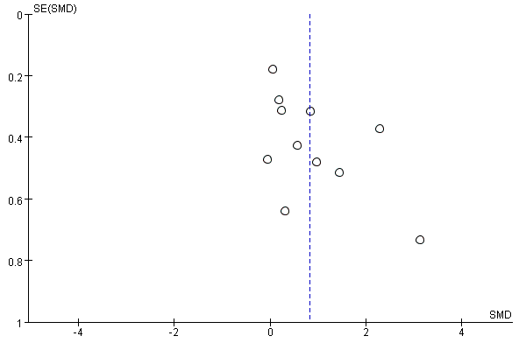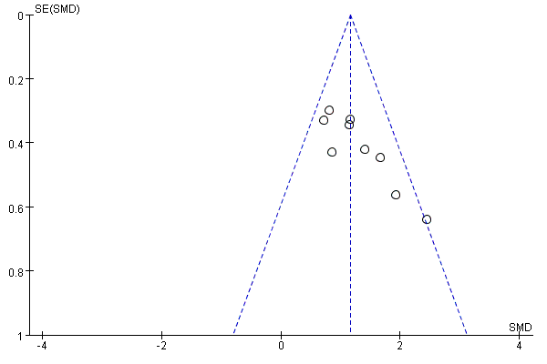
A B
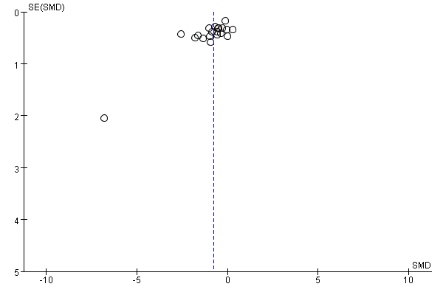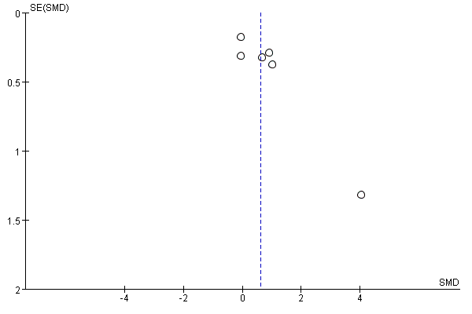
C D
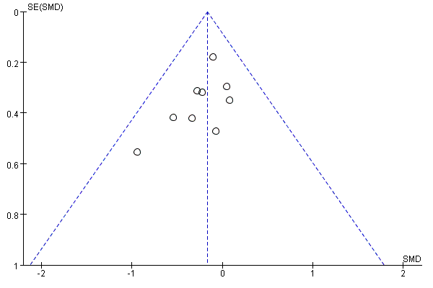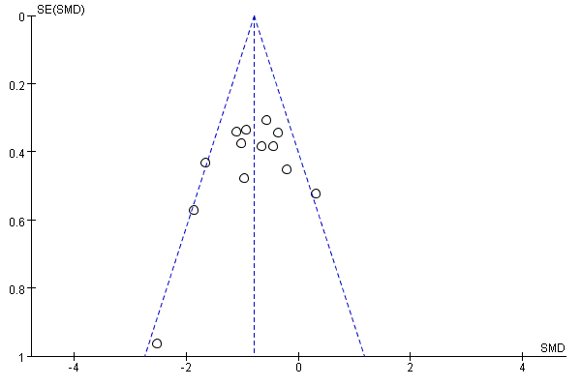
E F
(A: 6MWT, B: BBS, C: UPDRS-Ⅲ, D: Mini-BESTest, E: PDQ-39, F: TUG)

Appendix 5 PRISMA 2020 Checklist
Section and Topic | Item # | Checklist item | Location where item is reported
TITLE
Title | 1 | Identify the report as a systematic review. | P1
ABSTRACT
Abstract | 2 | See the PRISMA 2020 for Abstracts checklist. | P1-P2
INTRODUCTION
Rationale | 3 | Describe the rationale for the review in the context of existing knowledge. | P2-P3
Objectives | 4 | Provide an explicit statement of the objective(s) or question(s) the review addresses. | P2-P3
METHODS
Eligibility criteria | 5 | Specify the inclusion and exclusion criteria for the review and how studies were grouped for the syntheses. | P3-P4
Information sources | 6 | Specify all databases, registers, websites, organisations, reference lists and other sources searched or consulted to identify studies. Specify the date when each source was last searched or consulted. | P3
Search strategy | 7 | Present the full search strategies for all databases, registers and websites, including any filters and limits used. | P3  Appendix1  Table S1-S4
Selection process | 8 | Specify the methods used to decide whether a study met the inclusion criteria of the review, including how many reviewers screened each record and each report retrieved, whether they worked independently, and if applicable, details of automation tools used in the process. | P4-P5
Data collection process | 9 | Specify the methods used to collect data from reports, including how many reviewers collected data from each report, whether they worked independently, any processes for obtaining or confirming data from study investigators, and if applicable, details of automation tools used in the process. | P4-P5
Data items | 10a | List and define all outcomes for which data were sought. Specify whether all results that were compatible with each outcome domain in each study were sought (e.g. for all measures, time points, analyses), and if not, the methods used to decide which results to collect. | P4-P5
Data items | 10b | List and define all other variables for which data were sought (e.g. participant and intervention characteristics, funding sources). Describe any assumptions made about any missing or unclear information. | P4-P5
Study risk of bias assessment | 11 | Specify the methods used to assess risk of bias in the included studies, including details of the tool(s) used, how many reviewers assessed each study and whether they worked independently, and if applicable, details of automation tools used in the process. | P5
Effect measures | 12 | Specify for each outcome the effect measure(s) (e.g. risk ratio, mean difference) used in the synthesis or presentation of results. | P5
Synthesis methods | 13a | Describe the processes used to decide which studies were eligible for each synthesis (e.g. tabulating the study intervention characteristics and comparing against the planned groups for each synthesis (item #5)). | P5
Synthesis methods | 13b | Describe any methods required to prepare the data for presentation or synthesis, such as handling of missing summary statistics, or data conversions. | P5
Synthesis methods | 13c | Describe any methods used to tabulate or visually display results of individual studies and syntheses. | P5
Synthesis methods | 13d | Describe any methods used to synthesize results and provide a rationale for the choice(s). If meta-analysis was performed, describe the model(s), method(s) to identify the presence and extent of statistical heterogeneity, and software package(s) used. | P5
Synthesis methods | 13e | Describe any methods used to explore possible causes of heterogeneity among study results (e.g. subgroup analysis, meta-regression). | P5
Synthesis methods | 13f | Describe any sensitivity analyses conducted to assess robustness of the synthesized results. | P5
Reporting bias assessment | 14 | Describe any methods used to assess risk of bias due to missing results in a synthesis (arising from reporting biases). | P5
Certainty assessment | 15 | Describe any methods used to assess certainty (or confidence) in the body of evidence for an outcome. | P5
RESULTS
Study selection | 16a | Describe the results of the search and selection process, from the number of records identified in the search to the number of studies included in the review, ideally using a flow diagram. | P5-P6,Figure 1
Study selection | 16b | Cite studies that might appear to meet the inclusion criteria, but which were excluded, and explain why they were excluded. | P5
Study characteristics | 17 | Cite each included study and present its characteristics. | P6,  Appendix2
Risk of bias in studies | 18 | Present assessments of risk of bias for each included study. | P6-P8,Figure2,  Figure 3
Results of individual studies | 19 | For all outcomes, present, for each study: (a) summary statistics for each group (where appropriate) and (b) an effect estimate and its precision (e.g. confidence/credible interval), ideally using structured tables or plots. | P8-P11,Figure4,  Figure5,Figure6,  Figure7,Figure8,  Figure9
Results of syntheses | 20a | For each synthesis, briefly summarise the characteristics and risk of bias among contributing studies. | P8-P11
Results of syntheses | 20b | Present results of all statistical syntheses conducted. If meta-analysis was done, present for each the summary estimate and its precision (e.g. confidence/credible interval) and measures of statistical heterogeneity. If comparing groups, describe the direction of the effect. | P8-P11
Results of syntheses | 20c | Present results of all investigations of possible causes of heterogeneity among study results. | P8-P11
Results of syntheses | 20d | Present results of all sensitivity analyses conducted to assess the robustness of the synthesized results. | P8-P10
Reporting biases | 21 | Present assessments of risk of bias due to missing results (arising from reporting biases) for each synthesis assessed. | P8-P11
Certainty of evidence | 22 | Present assessments of certainty (or confidence) in the body of evidence for each outcome assessed. | P8-P11
DISCUSSION
Discussion | 23a | Provide a general interpretation of the results in the context of other evidence. | P11-P12
Discussion | 23b | Discuss any limitations of the evidence included in the review. | P14
Discussion | 23c | Discuss any limitations of the review processes used. | P14
Discussion | 23d | Discuss implications of the results for practice, policy, and future research. | P13
OTHER INFORMATION
Registration and protocol | 24a | Provide registration information for the review, including register name and registration number, or state that the review was not registered. | P3
Registration and protocol | 24b | Indicate where the review protocol can be accessed, or state that a protocol was not prepared. | Not Applicable
Registration and protocol | 24c | Describe and explain any amendments to information provided at registration or in the protocol. | unchanged
Support | 25 | Describe sources of financial or non-financial support for the review, and the role of the funders or sponsors in the review. | None
Competing interests | 26 | Declare any competing interests of review authors. | no conflicts
Availability of data, code and other materials | 27 | Report which of the following are publicly available and where they can be found: template data collection forms; data extracted from included studies; data used for all analyses; analytic code; any other materials used in the review. | Supplementary file 1

