Reporting checklist for randomised trial.
Based on the CONSORT guidelines.

 |  | Reporting Item | Page Number
Title and Abstract
Title | #1a | Study on the Effect of Aquatic Exercise Combined with Hot Spring Bathing for Patients with Chronic Low Back Pain: A Randomized Controlled Trial | 1
Abstract | #1b | Background Chronic low back pain (CLBP) is a common musculoskeletal symptom associated with spinal disorders, impairing quality of life while imposing significant medical and socioeconomic burdens. Traditional land-based rehabilitation training is often limited by pain, whereas aquatic exercise utilizes water's buoyancy, hydrostatic pressure, and viscosity to reduce spinal loading and provide a stable environment. This study aims to evaluate the effects of combining hot spring bathing with aquatic exercise alongside conventional physical therapy on clinical symptoms and functional outcomes in CLBP patients.  Methods A randomized controlled clinical trial was conducted with blinding of outcome assessors; participants were not masked to the intervention group, in which 36 participants were randomly distributed into control and intervention groups. The control group received conventional physical therapy, while the intervention group additionally underwent aquatic exercise combined with hot spring bathing. The primary (subjective pain intensity, degree of functional impairment) and secondary outcomes (motor Balance Ability, lower back muscle strength) were evaluated before and after the session using the Visual Analogue Scale (VAS), Oswestry Disability Index (ODI), Functional Movement Screen scale (FMS), and BCS-400 electronic back dynamometer. For all outcomes, multiple mixed 2 (group) × 2 (time) ANOVAs were performed.  Results After intervention, the outcome measures of VAS, ODI, FMS and back muscle strength were improved significantly in intervention groups. There was a significant difference in the VAS change in the control group, while no significant differences were observed in ODI, FMS, or lumbar back muscle strength. It was noteworthy that the intervention group showed greater improvement after intervention than the control group: △VAS: 2.56 ± 0.92 & 0.94 ± 0.54; △ODI: 9% ± 6% & 4% ± 5%; △FMS: 3.44 ± 2.20 & 1.44 ± 1.62; △back muscle strength: 18.50 ± 8.52 & 12.44 ± 7.69 kg, all the changes showed significant difference between two groups.  Conclusions Aquatic exercise combined with hot spring bathing can significantly enhance the therapeutic effect of conventional physical therapy in CLBP patients, alleviating the subjective pain intensity and functional impairment, and improving motor function and lumbar and back strength. | 2
Introduction
Background and objectives | #2a | CLBP is defined by the International Association for the Study of Pain as pain or discomfort occurring between the lower edge of the ribs and the gluteal crease, persisting for more than 12 weeks ^{[1]}. It may be accompanied by radiating pain to the buttocks or lower limbs, impacting daily activities and quality of life. Its occurrence is influenced by multiple factors, including work and lifestyle habits, physiological conditions, psychosocial factors, genetics, and environment ^{[2]}. High-risk populations primarily include individuals engaged in occupations requiring frequent bending, the elderly, those with prolonged sedentary lifestyles, manual laborers, individuals experiencing significant psychological stress, and obese individuals. As a vital component of the spine, abnormalities in the structure or function of the lumbar spine，such as lumbar disc degeneration, facet joint dysfunction, or lumbar instability constitute the core pathological factors underlying chronic low back pain. Approximately 80% to 90% of nonspecific chronic low back pain can be traced to functional imbalances within the spine and surrounding soft tissues. Additionally, weakness in the back and abdominal core muscles is a common contributing factor. These muscles are prone to functional decline when chronically inactive, while excessive use can lead to overuse injuries ^{[3-5]}.  CLBP represents a global health challenge, affecting individuals across all age groups from childhood to old age ^{[6-7]}. Global data indicates that the prevalence of low back pain among the working-age population has risen to 452.8 million cases, reflecting a 52.66% increase since 1990 ^{[8]} and underscoring the significant burden this condition imposes on public health worldwide. To enhance public awareness of low back pain prevention and management, the 2024 World Physical Therapy Day adopted the theme “Low Back Pain and Rehabilitation: The Power of Physical Therapy” ^{[9]}, emphasizing the critical role of physical therapy in low back pain management and rehabilitation while promoting deeper societal understanding of this issue. | 2-4
Background and objectives | #2b | A literature search revealed no studies combining aquatic exercise with hot spring bathing for CLBP. Therefore, this study aims to integrate both modalities to further investigate their combined intervention effects on patients with CLBP. | 4
Methods
Trial design | #3a | This study employed a randomized controlled trial design, with subjects randomly assigned to either the intervention or control group, to compare the therapeutic effects of aquatic exercise combined with hot spring bathing and conventional physical therapy. | 4
Participants | #4a | Inclusion criteria:① Age 18 years ≤ age ≤ 65 years; ② Low back pain lasting over 12 weeks; ③ Pain symptoms affecting normal daily activities; ④ Visual Analog Scale (VAS) pain score of 1–6; ⑤ Voluntary participation with signed informed consent; ⑥ Acceptance of random assignment. | 5
Participants | #4b | Exclusion criteria: ① Patients with psychiatric disorders or cognitive impairment; ② Open wounds such as abrasions, lacerations, cuts, or punctures; ③ Patients with severe, unstable cardiovascular, renal, or hepatic disease; ④ Chlorine allergy or hydrophobia; ⑤ Concurrent use of medications affecting sensory perception; ⑥ History of joint dislocation or high-risk patients. | 5-6
Interventions | #5 | Control Group: Received conventional rehabilitation therapy (40 min/session) comprising 20 min of magnetic thermal therapy and 20 min of medium-frequency electrotherapy, administered 3 times/week over a 4-week course.  Intervention Group: Received conventional rehabilitation therapy plus aquatic rehabilitation training (60 min/session, 3 times/week over 4 weeks). Training pool parameters: water temperature 30°C, depth 1.2 m, excellent water quality; Room temperature: 26–28°C (79–82°F), with adequate ventilation. Pre-training health education was provided. Rehabilitation technicians conducted physical assessments and instructed patients to immediately cease training and signal the therapist if discomfort arose during any movement. Therapists closely monitored patients throughout training to provide guidance and assistance. Emergency personnel were stationed poolside, with emergency equipment and medications available in the treatment room. Aquatic training is comprised of the following 12 exercises.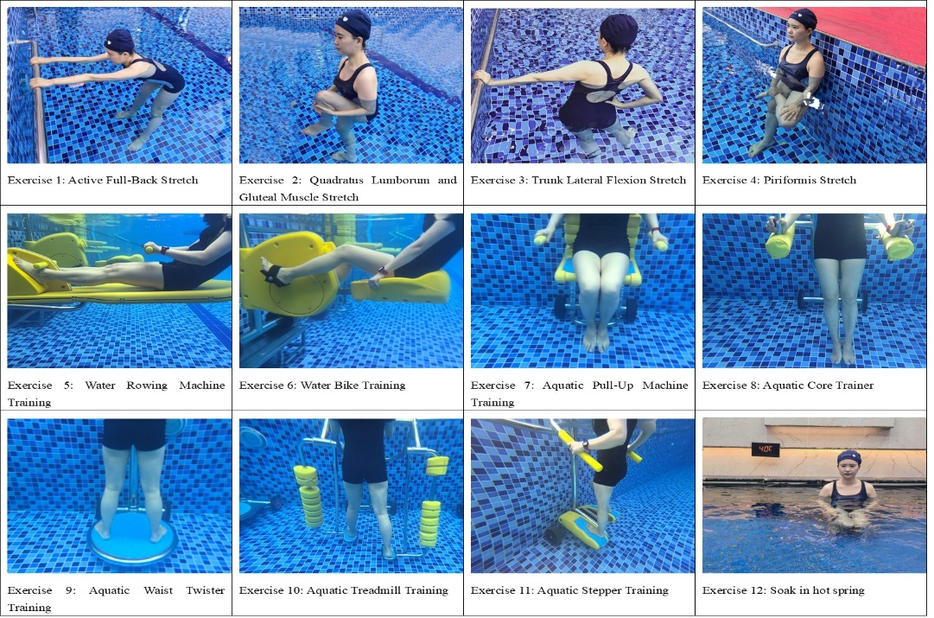 Fig. 1 The 12 training programs of aquatic rehabilitation | 6-7
Outcomes | #6a | Primary outcome  Pain intensity was assessed using the Visual Analogue Scale (VAS). This scale ranges from 0 to 10, where 0 indicates no pain; scores below 3 indicate mild, tolerable pain; scores between 4 and 6 indicate pain affecting sleep but still tolerable; scores between 7 and 10 indicate progressively severe, intolerable pain affecting appetite and sleep.  Secondary Outcomes  Functional impairment was assessed using the Oswestry Disability Index (ODI) . This scale evaluates 10 domains: pain intensity, activities of daily living, lifting objects, walking, sitting, standing, sleep, sexual activity, social life, and travel. Each question offers 6 response options. with a maximum score of 5 points per item. Selecting the first option scores 0 points, while selecting the last option scores 5 points. If all 10 items are answered, the score is calculated as: Actual Score / 50 (maximum possible score) × 100%. If one item is unanswered, the score is calculated as: Actual Score / 45 (maximum possible score) × 100%. Higher scores indicate more severe functional impairment.  The Functional Movement Screen (FMS) instrument is used to assess motor function. The test includes seven items: Overhead Squat, Hurdle Step, Straight-Leg Deadlift, Shoulder Flexibility, Straight-Leg Raise, Trunk Stability Push-Up, and Rotational Stability (Fig 2). Each item is scored out of 3 points. A higher total score indicates better motor function. FMS scores are categorized into four grades ranging from 0 to 3, with 3 being the highest. 0 points: Pain occurs in any body part during testing. 1 point: The subject cannot complete the entire movement or maintain the starting position. 2 points: The subject can complete the movement but with poor quality. 3 points: The subject performs the movement with high quality. 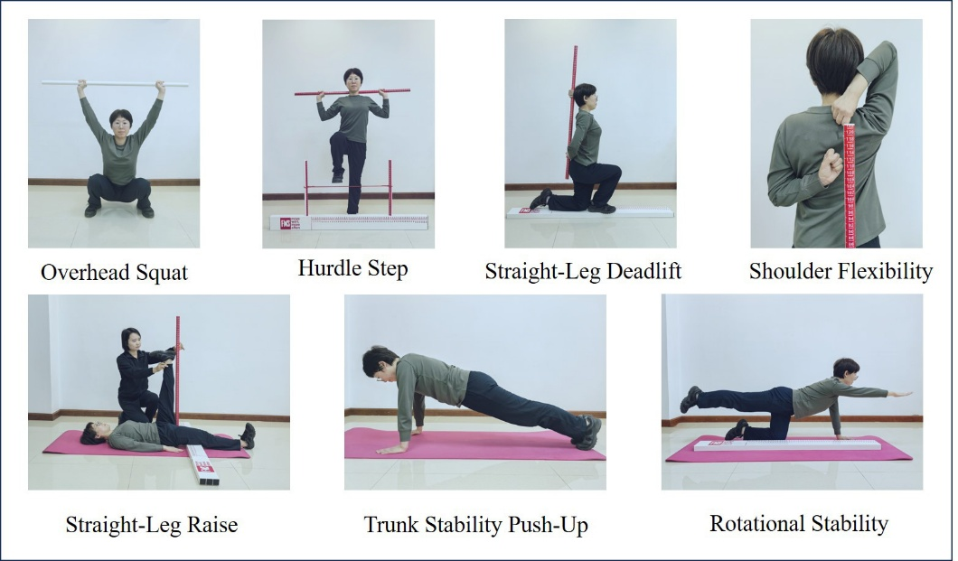  Fig. 2 The test items of the Functional Movement Screen  The BCS-400 electronic back dynamometer is used to assess lumbar and back muscle strength (Fig 3). The procedure involves the patient standing at the base of the dynamometer with feet positioned as indicated. Arms and hands are extended straight, hanging down in front of the thighs on the same side, with fingertips touching the handles. The chain length is adjusted to this height. During testing, the patient keeps legs straight, leaning the upper body forward approximately 30 degrees. With arms fully extended and palms facing inward, the patient grips the handles and pulls upward with maximum force, engaging the abdominal muscles while avoiding leg assistance. Three trials are conducted with 30-second intervals between each， The highest value result.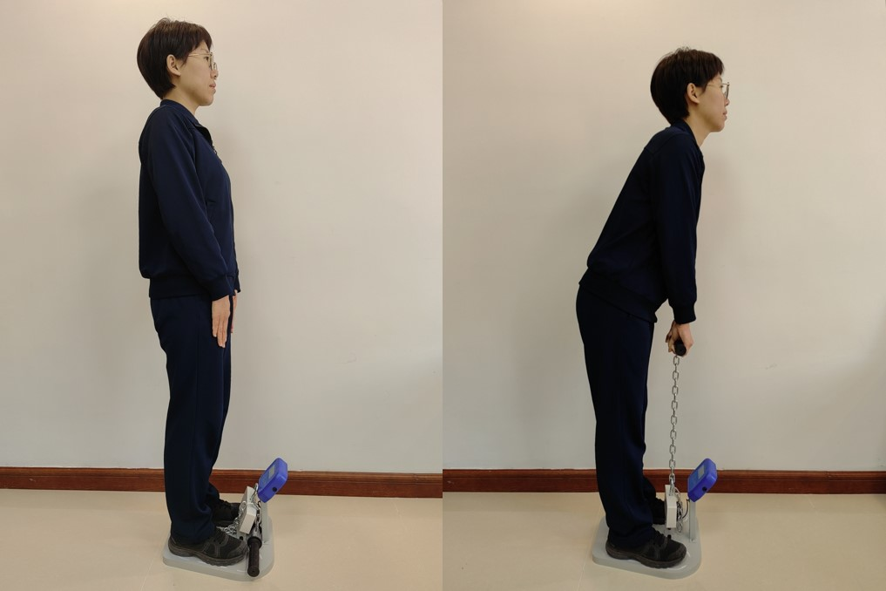  Fig. 3 Testing Method of the back muscle strength | 7-10
Sample size | #7a | Of the first 40 patients who sought treatment and agreed to participate, 4 were excluded, because they met the exclusion criteria. Therefore, 36 patients were included, 18 were assigned to the intervention group and 18 to the control group, with no participants losses during the study. | 11
Sample size | #7b | The sample size was calculated based on the study of Borges et al. (2025 May), who compared the aquatic exercise group and the control group (land exercise) ^{[15]}. Considering the probability of loss during follow-up (20%), with an effect size of 1.079, 𝛼=0.05, and a power of 80%, the total sample size was calculated to be 36 participants (18 per group). | 10
Randomization - Sequence generation | #8a | A researcher who did not participate in the subsequent study stage selected 36 numbers from a certain position in the random number table and randomly divided them into the intervention Group and control groups. Then, the papers with numbers were placed into sealed opaque envelopes, to be scrambled and numbered in turn. The same researcher distributed the envelopes to the included participants consecutively, respecting the numbering on each label. | 10
Randomization - Sequence generation | #8b | All assessments at baseline and after 4 weeks of treatment were conducted by a single investigator who remained blinded to group assignments and interventions throughout the study. | 10-11
Randomization - Allocation concealment mechanism | #9 | The same researcher distributed the envelopes to the included participants consecutively, respecting the numbering on each label. They were randomly assigned to an intervention group (n=18) and a control group (n=18). | 10
Blinding | #11a | This study is evaluator-blinded. | 11
Blinding | #11b | All assessments at baseline and after 4 weeks of treatment were conducted by a single investigator who remained blinded to group assignments and interventions throughout the study. | 10-11
Statistical methods | #12a | All data underwent double-entry verification before system input. SPSS 22.0 statistical software was used to analyze the data. The descriptive variables were presented as the mean and standard deviation (mean ± SD) with a confidence interval of 95%, Kolmogorov–Smirnov test was used to test normality, multiple mixed two-way ANOVAs were performed for all outcomes, with the group (intervention group or control group) as the independent factor and time (pre- intervention or post-intervention) as the repeated factor. The statistical significance level was determined as P< 0.05. | 11
Results
Participant flow diagram (strongly recommended) | #13a | 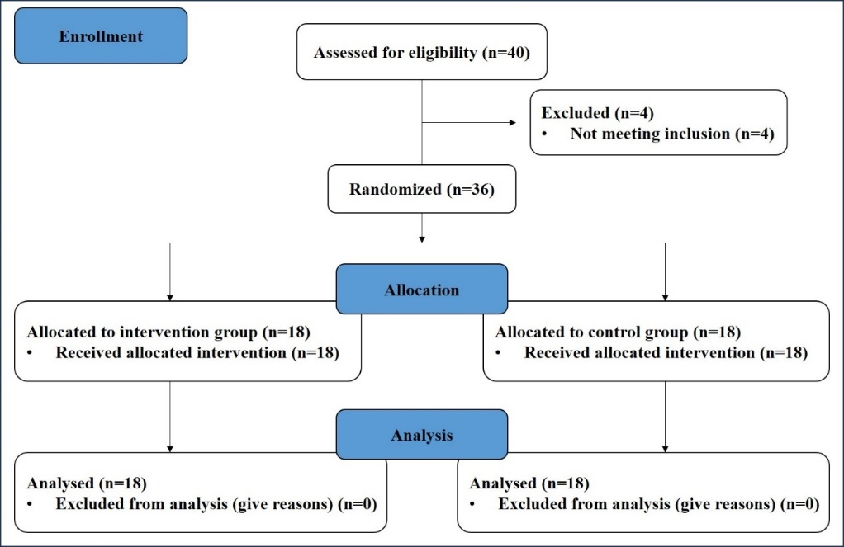 | 12
Participant flow | #13b | Of the first 40 patients who sought treatment and agreed to participate, 4 were excluded, because they met the exclusion criteria. Therefore, 36 patients were included, 18 were assigned to the intervention group and 18 to the control group, with no participants losses during the study. | 11
Recruitment | #14a | Thirty-six patients with a history of low back pain who sought treatment at the author's institution were randomly allocated to one of two groups: the intervention group (18-men) and the control group (18-men). | 5
Baseline data | #15 | There were no significant differences between the two groups in terms of age, disease duration, height, weight, body mass index (BMI), and the scores of VAS, ODI, FMS and back strength at baseline (Table 1).  Table 1 Demographic and clinical characteristics of patients | 11
  Item | Intervention group | Control group | P
  Demographic
  Age (years) | 36.56±7.87 | 32.94±9.67 | 0.227
  duration(months) | 30.5±22.36 | 27.17±17.80 | 0.624
  Height (cm) | 174.28±3.46 | 176.56±3.91 | 0.073
  Weight (Kg) | 71.78±8.26 | 72.89±7.13 | 0.668
  BMI | 23.61±2.43 | 23.37±1.97 | 0.738
  Clinical
  VAS | 4.00±0.91 | 3.83±0.86 | 0.575
  ODI | 23%±10% | 23%±12% | 0.964
  FMS | 11.06±1.95 | 12.17±2.07 | 0.107
  back strength | 112.39±23.38 | 124.67±21.76 | 0.112
Outcomes and estimation | #17a | The pain intensity (VAS) was analyzed a significant effect on time (F = 92.050; P = 0.000) and interaction between group and time (F = 19.505; P = 0.000), and also for group (F = 12.269; P = 0.001)，and VAS was significantly reduced after the treatment in both groups, and the intervention group was significantly lower than that in the control group (Table 2). Furthermore, the intervention group exhibited significantly greater score reduction (△VAS: 2.56±0.92) of VAS than the control group (△VAS: 0.94±0.54) (Table 3).  The assessment of functional impairment (ODI) (Table 2) showed a significant time main effect (F = 8.381; P = 0.005), and there was no significant effect for the group factor (F = 0.885; P = 0.350) and interaction between group and time (F =1.028; P = 0.314). There was significantly improved in ODI with the intervention group , but no significantly changed with the control group, to compared with the baseline. Especially, the intervention group showed a significantly greater improvement (△ODI: 9%±6%) than the control group (△ODI: 4%±5%) (Table 3).  The assessment of motor function (FMS) (Table 2) also showed a significant time main effect (F =18.839; P = 0.000), and no significant effect for the group factor (F = 0.039; P = 0.844) and interaction between group and time (F =3.153; P = 0.080). It showed FMS was significantly improved in the intervention group, but no significantly changed in the control group, to compared with the baseline. Furthermore, the intervention group showed a significantly greater improvement (△FMS: 3.44±2.20) than the control group (△FMS: 1.44±1.62) for motor function (Table 3).  The results of the lumbar and back muscle strength test (Table 2) showed a significant time main effect (F =8.185; P = 0.006), and there was also no significant effect for the group factor (F = 2.926; P = 0.092) and interaction between group and time (F =0.313; P = 0.577). The back strength was significantly improved after the treatment in the intervention group, and the muscle strength of intervention group was increased more significantly (△Back strength: 18.50±8.52) than the control group (△Back strength: 12.44±7.69) (Table 3).  Table 2 Comparison of the scores of VAS, ODI, FMS and back strength between 2 groups ($\overline{x}±s$ )  Table 3 Comparison of the difference between post-and pre-treatment in VAS, ODI, FMS and back strength ($\overline{x}±s$)  △: The absolute value of the value before the intervention minus that after the intervention. | 12-15
  Item | Intervention group | Control group | t | P
  VAS | 4.00±0.91 | 3.83±0.86 | 0.566 | 0.575
  ODI | 23%±10% | 23%±12% | 0.046 | 0.964
  FMS | 11.06±1.95 | 12.17±2.07 | -1.658 | 0.107
  back strength | 112.39±23.38 | 124.67±21.76 | -1.631 | 0.112
  Item | Intervention group | Control group | F | P
  △VAS | 2.56±0.92 | 0.94±0.54 | 40.966 | 0.000
  △ODI | 9%±6% | 4%±5% | 5.700 | 0.023
  △FMS | 3.44±2.20 | 1.44±1.62 | 9.646 | 0.004
  △Back strength | 18.50±8.52 | 12.44±7.69 | 5.007 | 0.032
Harms | #19 | During the intervention period of this study, none of the 18 subjects in the intervention group or the 18 subjects in the control group experienced any adverse events related to or unrelated to the study intervention. All subjects tolerated the intervention protocol and the entire evaluation process well.
Discussion
Limitations | #20 | This trial has limitations. First, the 4-week study period is relatively short, reflecting only short-term efficacy without long-term follow-up data. Its effects on sustained pain relief and functional improvement require further validation. Second, no control group receiving only hydrotherapy or hot spring bathing was established. Future studies should design a three-group controlled trial (aquatic exercise intervention group, hot spring bath intervention group, and control group) to more precisely distinguish the efficacy of different intervention | 17-18
Interpretation | #22 | Aquatic exercise combined with hot spring bathing can significantly enhance the therapeutic effect of conventional physical therapy in CLBP patients, and can have positive and promising effects for alleviating the subjective pain intensity and functional impairment, and improving motor function and lumbar and back strength. Therefore, in order to examine the effects of this intervention in more detail and to compare with other common treatments, more studies with larger sample sizes are necessary. | 18
Registration | #23 | This study has been prospectively registered with the China Clinical Trial Registry (ChiCTR) (Registration Number: ChiCTR2500106741/29. 07. 2025, https://www.chictr.org.cn/bin/project/edit?pid=280890) | 2
Other information
Registration | #23 | This research protocol has been approved by the Ethics Committee of Jinzhou Medical University (Approval No.: JZMULL2025003). | 19
Protocol | #24 | All research participants provided written informed consent prior to enrollment. All participants in this study were adults who voluntarily signed informed consent forms. | 19

