Table S1. Search strategy for HIIT-related terms
Database | Complete Search Strategy | Hits
Web of Science | TS=(HIIT OR "high-intensity interval training*" OR "high-intensity interval exercise*" OR "high-intensity interval activit*" OR "high-intensity intermittent training*" OR "high-intensity intermittent exercise*" OR "high-intensity intermittent activit*" OR "high-intensity training*" OR "high-intensity exercise*" OR "high-intensity activit*" OR "sprint interval training*") AND TS=( basketball OR soccer OR football OR handball OR volleyball OR rugby OR hockey OR "flag football" OR "team sport*") | 1309
Scopus | TITLE-ABS-KEY (HIIT OR "high-intensity interval training" OR "high-intensity interval exercise" OR "high-intensity interval activity" OR "high-intensity intermittent training" OR "high-intensity intermittent exercise" OR "high-intensity intermittent activity" OR "high-intensity training" OR "high-intensity exercise" OR "high-intensity activity" OR "sprint interval training") AND TITLE-ABS-KEY (basketball OR soccer OR football OR handball OR volleyball OR rugby OR hockey OR "flag football" OR "team sport”) | 1360
PubMed | ( HIIT[Title/Abstract] OR "high-intensity interval training"[Title/Abstract] OR "high-intensity interval exercise"[Title/Abstract] OR "high-intensity interval activity"[Title/Abstract] OR "high-intensity intermittent training"[Title/Abstract] OR "high-intensity intermittent exercise"[Title/Abstract] OR "high-intensity intermittent activity"[Title/Abstract] OR "high-intensity training"[Title/Abstract] OR "high-intensity exercise"[Title/Abstract] OR "high-intensity activity"[Title/Abstract] OR "sprint interval training"[Title/Abstract] ) AND ( basketball[Title/Abstract] OR soccer[Title/Abstract] OR football[Title/Abstract] OR handball[Title/Abstract] OR volleyball[Title/Abstract] OR rugby[Title/Abstract] OR hockey[Title/Abstract] OR "flag football"[Title/Abstract] OR "team sport"[Title/Abstract]) | 668
Embase | (HIIT: ti,ab OR 'high-intensity interval training’: ti,ab OR 'high-intensity interval exercise’: ti,ab OR 'high-intensity interval activity’: ti,ab OR 'high-intensity intermittent training’: ti,ab OR 'high-intensity intermittent exercise’: ti,ab OR 'high-intensity intermittent activity’: ti,ab OR 'high-intensity training’: ti,ab OR 'high-intensity exercise’: ti,ab OR 'high-intensity activity’: ti,ab OR 'sprint interval training’: ti,ab) AND ( basketball:ti,ab OR soccer:ti,ab OR football:ti,ab OR handball:ti,ab OR volleyball:ti,ab OR rugby:ti,ab OR 'team sport':ti,ab OR hockey:ti,ab OR "flag football":ti,ab OR 'team sports':ti,ab ) | 697

Table S2. Search strategy for SSG-related terms
Database | Complete Search Strategy | Hits
Web of Science | TS= ( "small-sided game" OR "medium-sided game" OR "large-sided game" OR SSG OR SSGs OR "drill-based game" OR "conditioned game" ) AND ("basketball" OR "soccer" OR "football" OR "handball" OR "volleyball" OR "rugby" OR hockey OR "flag football" OR "team sport" ) | 818
Scopus | TITLE-ABS-KEY("small-sided game*" OR "medium-sided game*" OR "large-sided game*" OR SSG OR SSGs OR "drill-based game*" OR "conditioned game*") AND ( basketball OR soccer OR football OR handball OR volleyball OR rugby OR hockey OR "flag football" OR "team sport") | 1439
PubMed | ( "small-sided game"[Title/Abstract] OR "medium-sided game"[Title/Abstract] OR "large-sided game"[Title/Abstract] OR SSG[Title/Abstract] OR SSGs[Title/Abstract] OR "drill-based game"[Title/Abstract] OR "conditioned game"[Title/Abstract] ) AND ( basketball[Title/Abstract] OR soccer[Title/Abstract] OR football[Title/Abstract] OR handball[Title/Abstract] OR volleyball[Title/Abstract] OR rugby[Title/Abstract] OR hockey[Title/Abstract] OR "flag football"[Title/Abstract]OR "team sport"[Title/Abstract] ) | 530
Embase | ( "small-sided game*":ti,ab OR "medium-sided game*":ti,ab OR "large-sided game*":ti,ab OR SSG:ti,ab OR SSGs:ti,ab OR "drill-based game*":ti,ab OR "conditioned game*":ti,ab ) AND ( basketball:ti,ab OR soccer:ti,ab OR football:ti,ab OR handball:ti,ab OR volleyball:ti,ab OR rugby:ti,ab OR hockey:ti,ab OR "flag football":ti,ab OR "team sport":ti,ab ) | 622

Table S3. Within-group effect sizes of HIIT on physical fitness outcomes
Outcome | K | SMD | 95% CI | I² (%) | P  (overall effect)
VO₂max | 8 | 1.34 | 0.54 to 2.14 | 82.2 | 0.001
VIFT (30–15 IFT final velocity) | 5 | 1.31 | 0.84 to 1.77 | 40.2 | 0.000
Yo-Yo IR1 | 6 | 1.68 | 0.93 to 2.44 | 71.9 | 0.000
Countermovement jump | 8 | 0.80 | 0.26 to 1.34 | 72.0 | 0.003
≤10-m sprint | 8 | -0.45 | −1.15 to 0.25 | 82.4 | 0.204
≥20-m sprint | 10 | -0.54 | −0.99 to −0.09 | 66.5 | 0.020
Change-of-direction | 8 | -0.82 | −1.28 to −0.35 | 61.9 | 0.001

Table S4. Within-group effect sizes of SSG on physical fitness outcomes.
Outcome | K | SMD | 95% CI | I² (%) | P  (overall effect)
VO₂max | 8 | 0.93 | 0.51 to 1.36 | 46 | 0.000
VIFT (30–15 IFT final velocity) | 5 | 1.48 | 0.49 to 2.46 | 85.1 | 0.003
Yo-Yo IR1 | 6 | 1.00 | 0.56 to 1.45 | 39 | 0.000
Countermovement jump | 8 | 0.70 | 0.25 to 1.16 | 62.6 | 0.002
≤10-m sprint | 8 | -0.27 | −0.76 to 0.21 | 66 | 0.269
≥20-m sprint | 10 | -0.31 | −0.58 to −0.04 | 13.5 | 0.026
Change-of-direction | 8 | -0.75 | −1.20 to −0.30 | 59.1 | 0.001

Table S5. Exploratory subgroup analysis results.
Subgroup | Type | K | n | SMD (95%CI) | I²  (%) | p  (Subgroup Difference)
VO₂max
Age | 13-15.99 | 6 | 137 | −0.02 (−0.46, 0.43) | 40.4 | 0.522
Age | 16-18.99 | 2 | 49 | 0.22 (−0.35, 0.78) | 0 | 0.522
Training duration | <8 | 4 | 91 | 0.45 (0.03, 0.87) | 0 | 0.010
Training duration | ≥8 | 4 | 95 | −0.32 (−0.72, 0.09) | 0 | 0.010
Total sessions | ≤16 | 5 | 105 | −0.16 (−0.62, 0.30) | 27.8 | 0.095
Total sessions | >16 | 3 | 81 | 0.34 (−0.10, 0.78) | 0 | 0.095
Change-of-direction
Age | 13-15.99 | 5 | 116 | 0.27 (−0.21, 0.75) | 39.3 | 0.108
Age | 16-18.99 | 3 | 83 | −0.39 (−1.05, 0.26) | 61.9 | 0.108
Total sessions | ≤12 | 4 | 103 | −0.24 (−0.83, 0.36) | 61.2 | 0.258
Total sessions | >12 | 4 | 96 | 0.25 (−0.36, 0.87) | 54.4 | 0.258
Note. These analyses were exploratory and were based partly on categorized study-level continuous variables. The results should therefore be interpreted cautiously.
Figure S1. Leave-one-out sensitivity analysis for VO₂max.
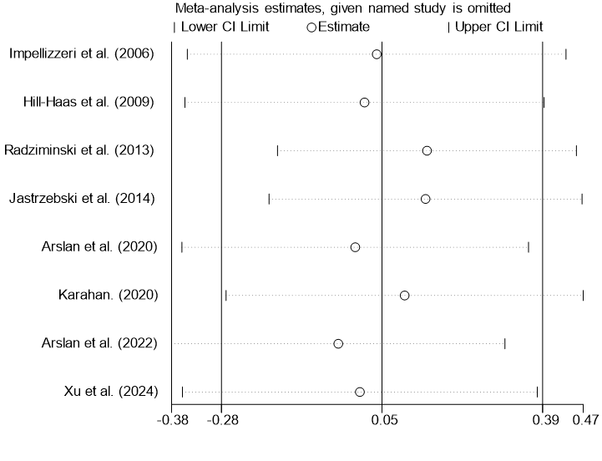

Figure S2. Leave-one-out sensitivity analysis for VIFT.
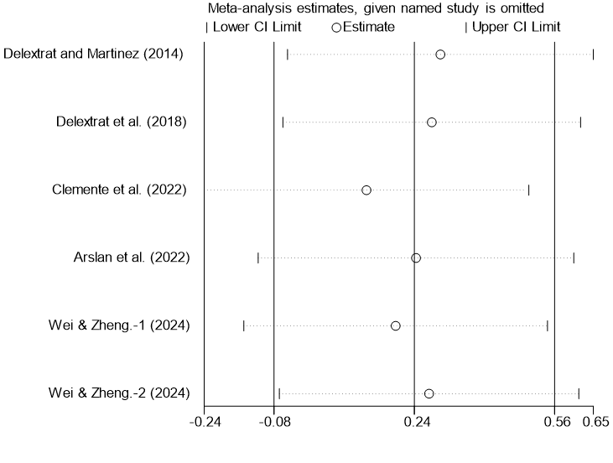

Figure S3. Leave-one-out sensitivity analysis for Yo-Yo IR1.
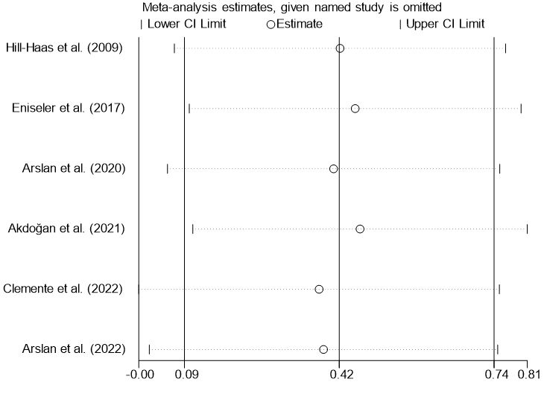

Figure S4. Leave-one-out sensitivity analysis for CMJ.
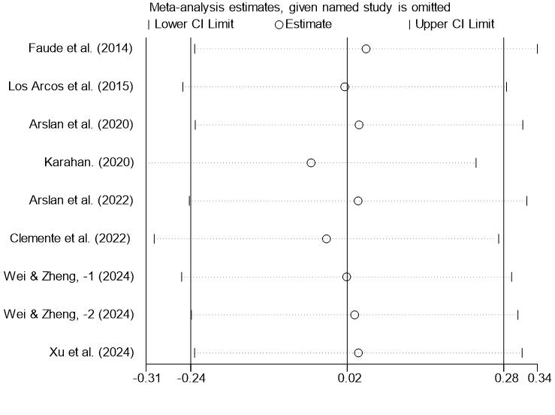

Figure S5. Leave-one-out sensitivity analysis for ≤10-m.
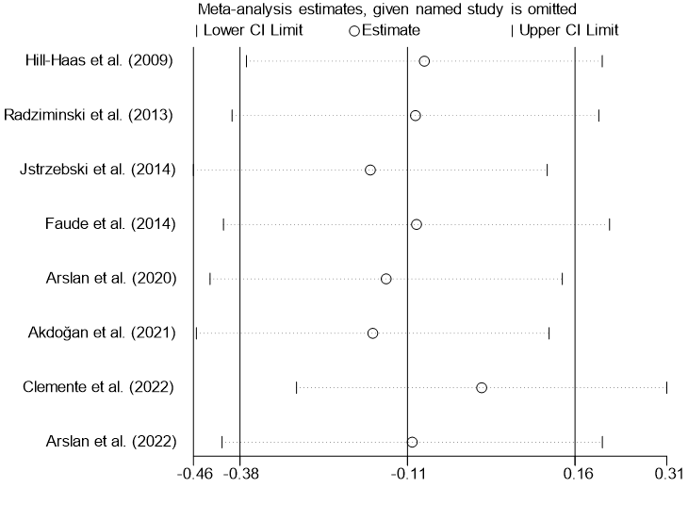

Figure S6. Leave-one-out sensitivity analysis for ≥20-m.
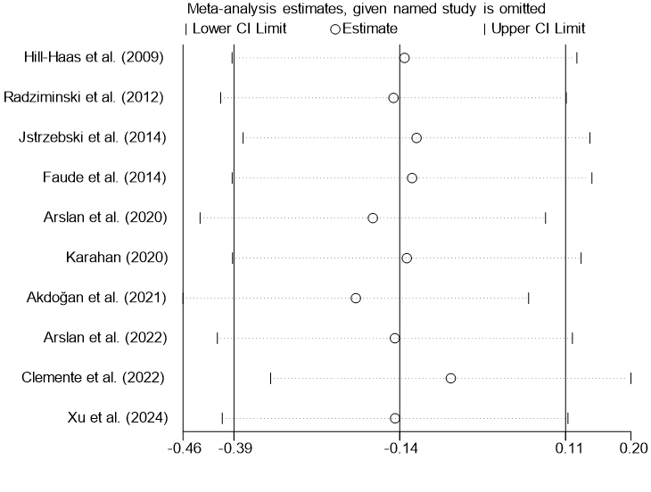

Figure S7. Leave-one-out sensitivity analysis for COD.
