Retrieval formula
PubMed

(
(
"Chronic Ankle Instability"[Mesh] OR "Chronic Ankle Instability" OR CAI
OR "recurrent ankle sprain*" OR "ankle instability"
)
AND
(
"Athletes"[Mesh] OR athlete* OR "sports participants" OR "competitive athlete*"
)
AND
(
"Balance Training"[Mesh] OR "Postural Balance"[Mesh]
OR "Proprioceptive Training" OR "Neuromuscular Training"
OR "Functional Training"[Mesh] OR "Functional Training"
OR "CrossFit" OR "Self-Mobilization" OR "Joint Mobilization"
OR "Dynamic Balance" OR "Star Excursion Balance Test" OR SEBT
OR "Y Balance Test" OR YBT
)
AND
(
"Randomized Controlled Trial"[Publication Type]
OR "Controlled Clinical Trial"[Publication Type]
OR RCT OR "randomized trial" OR "controlled trial"
)
)
NOT ("Animals"[Mesh] NOT "Humans"[Mesh])

Web of Science​​
TS=(
("Chronic Ankle Instability" OR CAI OR "recurrent ankle sprain*")
AND (athlete* OR "sports participants" OR "competitive athlete*")
AND (
"Balance Training" OR "Proprioceptive Training"
OR "Neuromuscular Training" OR "Functional Training"
OR CrossFit OR "Self-Mobilization" OR "Joint Mobilization"
OR "Dynamic Balance" OR "Star Excursion Balance Test" OR SEBT
OR "Y Balance Test" OR YBT
)
AND ("randomized controlled trial" OR RCT)
)
Refined by:
[excluding NON-HUMAN]

Cochrane Library​​：
(
("Chronic Ankle Instability" OR CAI OR "recurrent ankle sprain*")
AND (athlete* OR "sports participants" OR "competitive athlete*")
AND (
"Balance Training" OR "Proprioceptive Training"
OR "Neuromuscular Training" OR "Functional Training"
OR CrossFit OR "Self-Mobilization" OR "Joint Mobilization"
OR "Dynamic Balance" OR "Star Excursion Balance Test" OR SEBT
OR "Y Balance Test" OR YBT
)
AND (trial OR "randomized controlled trial" OR RCT)
)
in Title, Abstract, Keywords

Diagnostic characteristics of CAI/FAI definitions across included studies
Study | Original population label | Extracted diagnostic information | Laterality reported | Suggested classification for sensitivity analysis
Cruz-Diaz 2015 | CAI athletes | Accessible original/secondary excerpt indicates previous unilateral ankle sprain with self-reported instability; article also assessed CAIT, but the full diagnostic threshold was not fully retrievable from the accessible original methods excerpt. | Yes | Unclear / borderline
Chang 2021 | Female athletes with CAI | History of at least one ankle sprain, dominant-leg lateral ankle instability, CAIT ≤ 24, and persistent sensation of ankle “giving way”. | Yes | Validated criteria: Yes
Jiang 2022 | College soccer players with CAI | Accessible methods excerpt indicates players had experienced lateral ankle sprain within the previous month; a clear standardized CAI threshold was not retrievable from the accessible original text. This definition appears less consistent with established chronic-instability criteria. | Not clearly reported | No / questionable
Naderi 2025 | Athletes with CAI | Significant ankle sprain history, symptoms lasting >3 months, at least two episodes of instability/giving way or recurrent sprain, and CAIT ≤ 24; additional clinical exclusion criteria were reported. | Yes | Validated criteria: Yes
Sierra-Guzmán 2018 | Recreational athletes with CAI | At least one substantial ankle sprain, most recent sprain >3 months before enrollment, ≥2 episodes of giving way in the previous 6 months, and CAIT ≤ 24. | Yes | Validated criteria: Yes
Pengsri 2024 | Athletes with chronic ankle sprains / chronic ankle instability screening | CAIT was used for screening; participants with CAIT < 25 were classified as having chronic ankle instability in the accessible report. Other standardized instability-history criteria were not clearly visible in the accessible original text. | Not clearly reported | Borderline / partial
Cain 2020 | Adolescent athletes with CAI | Accessible original snippet indicates CAIT-based inclusion (≤24). Full diagnostic history criteria were not fully retrievable from the accessible original text. | Yes | Borderline / partial
Cain 2017 | High school athletes with CAI | Accessible excerpt indicates repeated inversion injury with residual symptoms and at least two moderate ankle sprains to the same ankle; however, a full standardized questionnaire threshold was not clearly retrievable from accessible original text. | Yes | Borderline / partial
Mohammadi 2022 | Professional male soccer players with CAI | Diagnosis based on International Ankle Consortium-style criteria: prior significant ankle sprain, first sprain ≥12 months earlier, most recent injury ≥3 months earlier, episodes of giving way/recurrent sprain, and CAIT < 27. | Yes | Validated criteria: Yes
Melam 2018 | University-level competitive athletes with CAI | Original accessible abstract confirms CAI population, but detailed diagnostic thresholds were not fully retrievable from the accessible original report. | Not clearly reported | Unclear
Naderi 2024 | Athletes with functional ankle instability (FAI) | Original report clearly used an FAI population rather than a strictly labeled CAI population; CAIT was measured, but full standardized eligibility thresholds were not fully retrievable from the accessible original excerpt. | Yes | Unclear / not strict CAI
Cruz-Díaz 2020 | Recreational athletes with CAI | Original accessible abstract confirms recreational athletes with CAI and reports CAIT as an outcome, but detailed eligibility thresholds were not fully retrievable from the accessible original report. | Yes | Unclear / borderline
Taghavi Asl 2022 | Men with CAI | At least one significant unilateral lateral ankle sprain, ≥2 reports of giving way within 6 months, last injury >6 weeks earlier, FADI < 90% and FADI-S < 80%. | Yes | Validated criteria: Yes

Operational definitions and study-level assignment of intervention-modality categories
Study | Experimental intervention (as extracted) | Mode 1: Primary intervention modality | Mode 2: Comparator type | Mode 3: Training environment / delivery emphasis | Coding rationale
Cruz-Diaz 2015 | Balance Training vs. Control Group | CBT | PC | SST | General balance-training program without vibration, aquatic delivery, explicit strength combination, or function-oriented whole-body task emphasis
Chang 2021 | Whole-Body Vibration + Balance vs. Control Group | WBT+BT | PC | UST | Experimental intervention combined vibration-platform exposure with balance exercise; unstable/perturbation-based stimulus was central
Jiang 2022 | Balance Training vs. Pilates Training | CBT | AC | SST | Experimental arm was conventional balance training; comparator was another active exercise program
Naderi 2025 | Water-Based vs. Land-Based Balance Exercises | WBBE | AC | SST | Experimental arm was delivered in an aquatic environment; comparator was another active balance-oriented exercise condition
Sierra-Guzmán 2018 | Whole-Body Vibration + Balance vs. Balance Training | WBT+BT | AC | UST | Experimental intervention combined vibration-platform exposure with balance training; comparator was active balance training
Pengsri 2024 | Balance Board vs. Jump Rope Training | CBT | AC | SST | Experimental arm was coded as conventional balance-oriented training in the primary-modality framework; comparator was another active exercise program
Cain 2020 | BAPS Board Training vs. Control Group | CBT | PC | SST | Experimental arm was coded as a clinic-style balance rehabilitation program rather than vibration-, water-, strength-, or function-dominant training
Cain 2017 | BAPS Balance Training vs. Control Group | CBT | PC | SST | Experimental arm was coded as conventional balance rehabilitation; comparator was passive control
Mohammadi 2022 | Balance + Strength vs. Conventional Training | BST | AC | SST | Experimental program explicitly combined balance and strength components
Melam 2018 | Elastic Tubing Balance Training vs. Control Group | BST | PC | SST | Experimental program combined balance work with resistance/overload elements using elastic tubing
Naderi 2024 | Mind-Body Balance (Tai Chi) vs. Control Group | FBT | PC | FBT | Tai Chi was coded as function-oriented, whole-body, task-integrated balance training rather than a purely surface-based protocol
Cruz-Díaz 2020 | CrossFit + Self-Mobilization vs. Control Group | FBT | PC | FBT | CrossFit plus self-mobilization was coded as function-oriented balance training because of its multijoint, task-based, kinetic-chain emphasis
Taghavi Asl 2022 | Wobble Board ± Cognitive Intervention vs. Wobble Board | CBT | AC | UST | Experimental arm was coded as balance training in the primary-modality framework, and as unstable-surface training in Mode 3 because wobble-board perturbation was central
Note: BT, conventional balance training; WBT+BT, whole-body vibration plus balance training; WBBE, water-based balance exercise; BST, balance plus strength training; FBT, functional balance training; CBT: Conventional Balance Training; PC, passive control; AC, active control; SST, stable-surface/conventional-surface training; UST, unstable-surface/perturbation-device training. Some categories defined in the coding framework (e.g., WBBE) may not appear in the final pooled subgroup table if only one study met that category and single-study subgroup estimates were omitted from the revised Table 2.

Handling of potentially multi-arm trials and multiple outcome domains
Study | Potential source of non-independence | Study design feature | Decision used in this review | Rationale
Cain 2020 | Multi-arm trial | Three-arm rehabilitation design | Only one eligible pairwise comparison was retained in each pooled analysis; the comparison entered into the review was BAPS board training vs control | To avoid double-counting participants and shared control data
Naderi 2025 | Active-versus-active comparison | Water-based balance exercise vs land-based balance exercise | The study was treated as a single pairwise comparison in the active-control framework | Participants contributed only once to each pooled analysis
Mohammadi 2022 | Multi-arm trial | More than one active intervention reported in the original trial | Only the balance-plus-strength vs conventional-training comparison was retained for the primary synthesis | To match the prespecified intervention framework and avoid duplicate use of participants
Taghavi Asl 2022 | Parallel active arms | Wobble board with versus without cognitive intervention | The study was entered as one active-comparator comparison | To ensure that only one comparison from the same participant pool entered a given pooled model
All included studies | Multiple dynamic-balance outcomes | Composite and direction-specific outcomes (anterior, posteromedial, posterolateral) | Each outcome domain was synthesized in a separate meta-analysis | To avoid entering multiple correlated outcomes from the same study into a single pooled analysis

GRADE certainty of evidence for the main outcomes
Outcome | Pooled effect | Risk of bias | Inconsistency | Indirectness | Imprecision | Publication bias | Overall certainty | Main reason(s) for downgrading
Composite score | SMD = 1.316 (95% CI: 0.08 to 2.55) | Serious | Very serious | Not serious | Serious | Serious | Very low | Downgraded for risk-of-bias concerns across several included trials, very high heterogeneity (I² = 94.1%), a wide confidence interval, the CR2-adjusted sensitivity analysis in which the effect no longer remained statistically significant, and trim-and-fill evidence suggesting possible missing studies.
Anterior direction | SMD = 0.671 (95% CI: 0.29 to 1.06) | Serious | Serious | Not serious | Not serious | Serious | Low | Downgraded for methodological limitations, substantial heterogeneity (I² = 76.6%), and possible small-study effects suggested by trim-and-fill.
Posteromedial direction | SMD = 0.591 (95% CI: 0.16 to 1.02) | Serious | Serious | Not serious | Not serious | Not serious | Low | Downgraded for methodological limitations and substantial heterogeneity (I² = 80.5%). No clear publication-bias signal was identified.
Posterolateral direction | SMD = 0.74 (95% CI: 0.12 to 1.36) | Serious | Serious | Not serious | Not serious | Not serious | Low | Downgraded for methodological limitations and substantial heterogeneity (I² = 88.4%). No clear publication-bias signal was identified.

Cluster-robust (CR2) sensitivity analyses for the primary three-level meta-analytic models
Outcome | Estimate | Robust SE (CR2) | t-stat | df (Satt) | p-value | Interpretation
Composite score | 1.32 | 0.628 | 2.10 | 4.98 | 0.0903 | Not statistically significant after CR2 adjustment
Anterior direction | 0.671 | 0.196 | 3.42 | 10.1 | 0.00644 | Remained significant
Posteromedial direction | 0.591 | 0.220 | 2.69 | 10.7 | 0.0216 | Remained significant
Posterolateral direction | 0.736 | 0.316 | 2.33 | 8.97 | 0.0450 | Remained significant
Note: CR2-adjusted cluster-robust variance estimation was conducted using the clubSandwich package with study ID as the clustering variable. Satterthwaite degrees of freedom were used for inference. These analyses were performed as a sensitivity check for dependence among effect sizes and small-sample uncertainty.

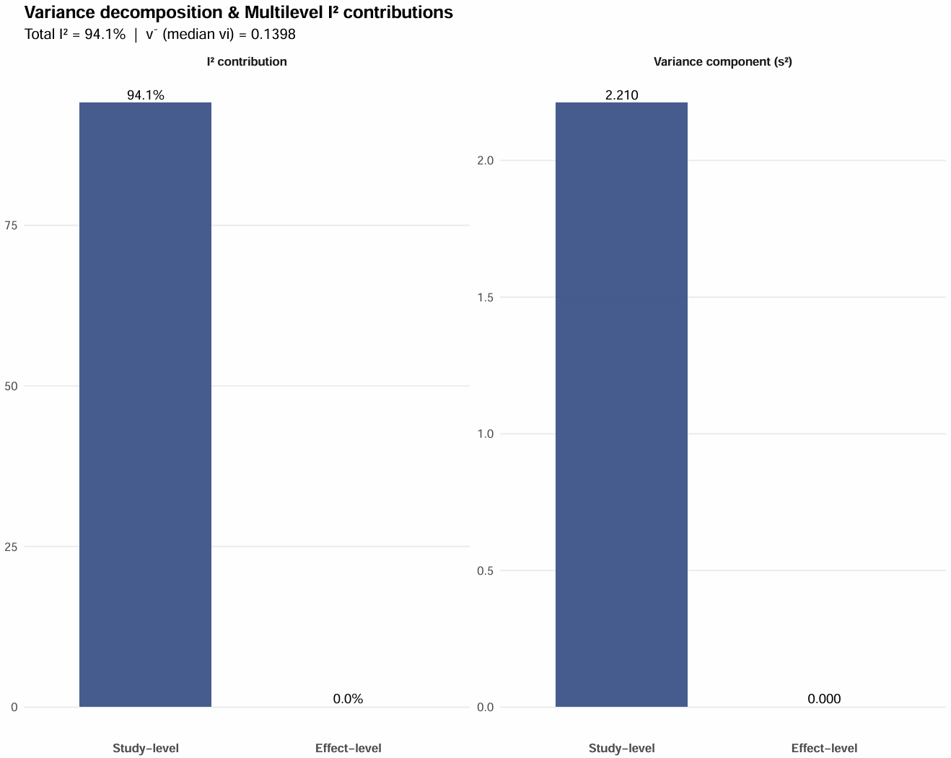
CR2-adjusted cluster-robust sensitivity analysis for the composite dynamic balance score

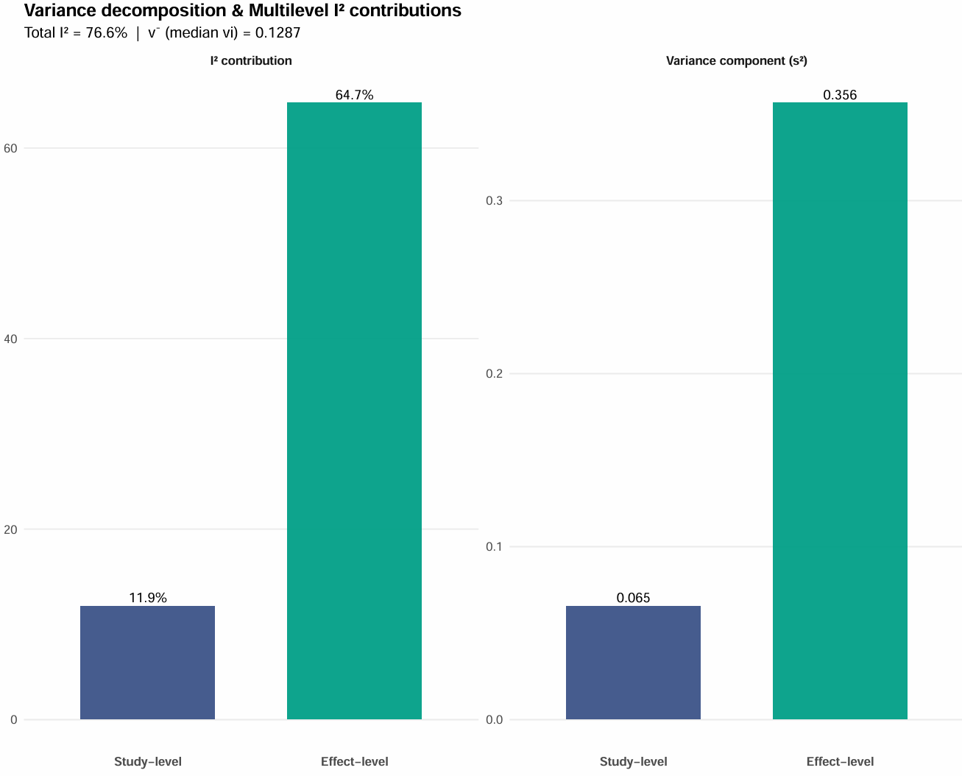
CR2-adjusted cluster-robust sensitivity analysis for the anterior direction

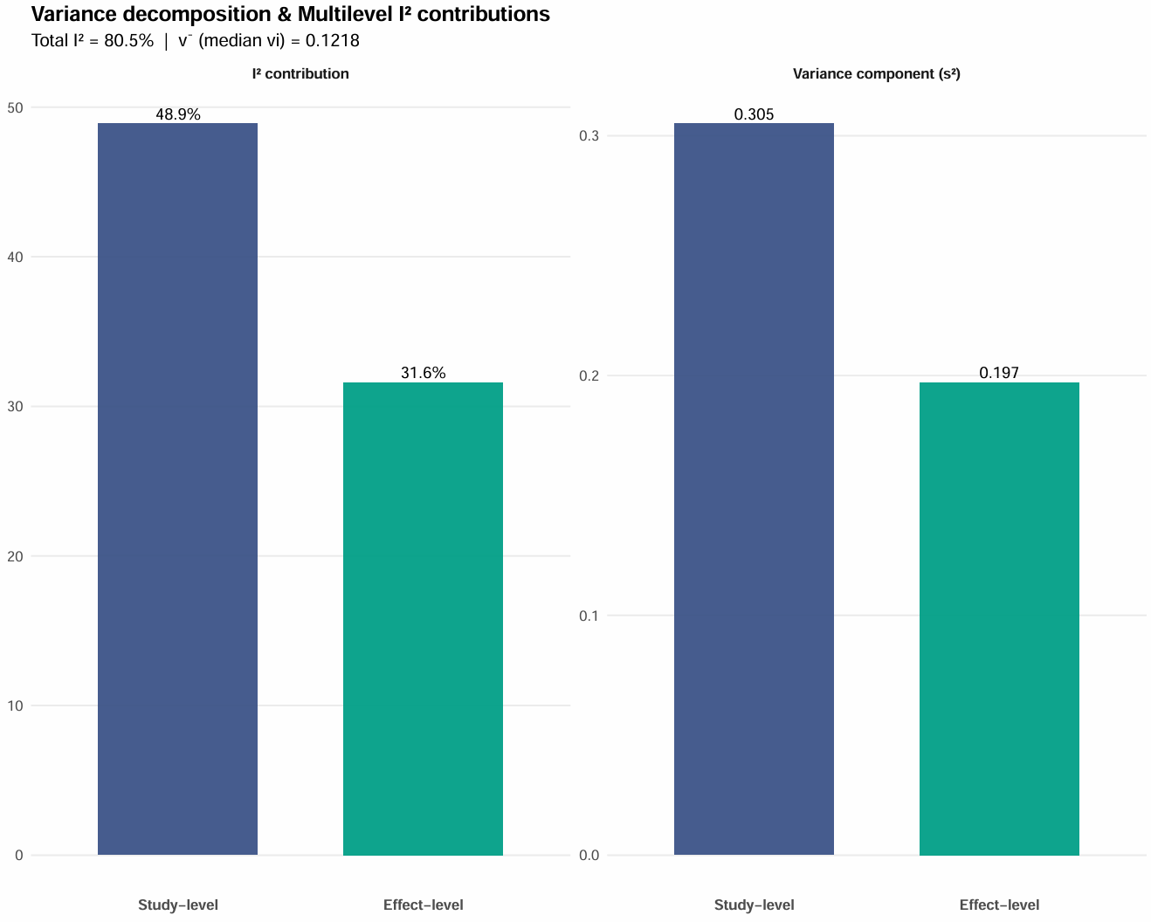
CR2-adjusted cluster-robust sensitivity analysis for the posteromedial direction

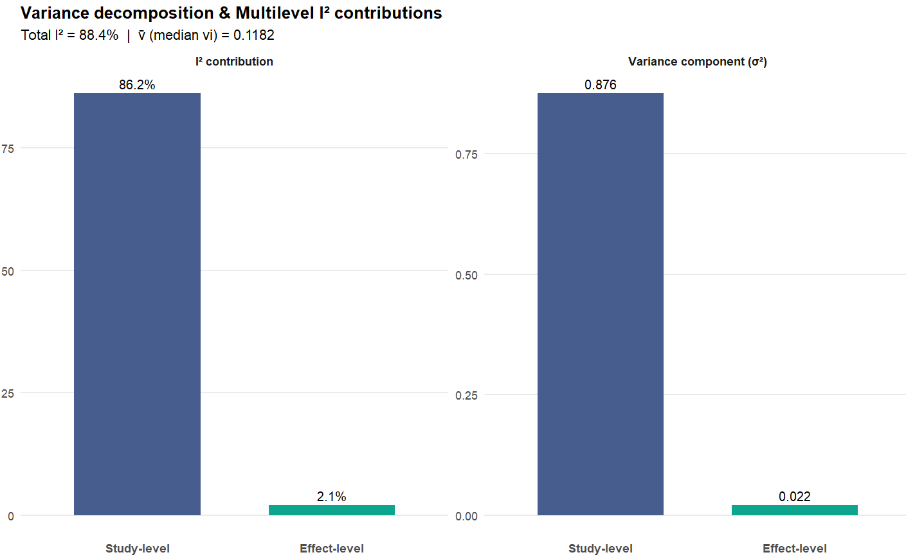
CR2-adjusted cluster-robust sensitivity analysis for the posterolateral direction

