Appendix 3: Trunk muscle strength training with their estimated activation intensities and progressions
Overview of activations performed on session 1
Isolated muscle to be tested | Activation test used
m. transversus abdominus | Abdominal drawing in maneuver in crook lying¹
m. multifidus | Prone posterior pelvic tilting²
mm. gluteus medius and maximus | Prone isolated contraction by squeezing of the buttocks³

General therapeutic principles used during these activations⁴:
- Oral feedback on movement by the therapist
- breathing pattern optimization
- palpation feedback (assisted by therapist + introspective by participant)
- symmetry and co-contraction evaluation
Note: These activation exercises were also repeated in sit and while standing.

Overview of primary muscles trained, starting exercises and progressions performed
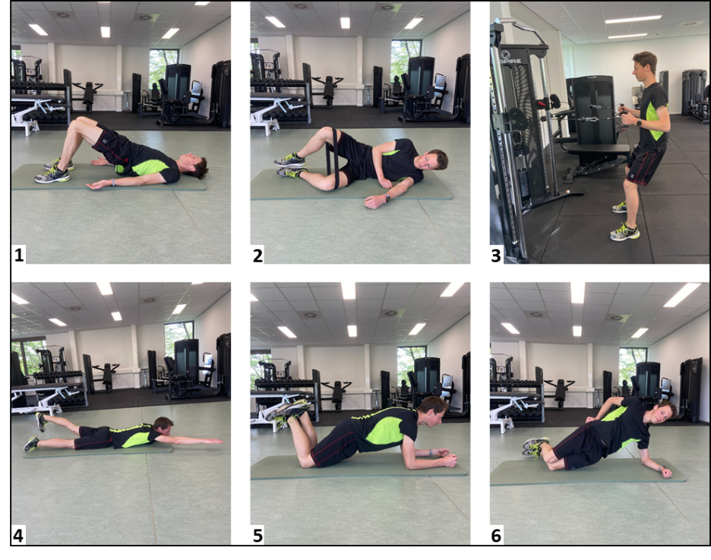
1: glute bridge; 2: glute clam with elastic band; 3: shoulder retraction with hip hinge; 4: superman back extension; 5: adapted knee plank; 6: adapted knee side plank.

Exercise number | Primary muscle trained | Starting exercise | %MVC activation | Progressions (Activation %MVC) | %MVC activation
1 | m. Gluteus Maximus | Glute bridge | 17⁵ | 1. Quadruped hip extension with knee extended  2. Unilateral glute bridge  3. Unilateral squat + wall squat | 1. 28⁵  2. 35⁵  3. 57 + 86⁵
2 | m. Gluteus Medius | Resistance band glute clam | 47⁶ | 1. Resistance band side lying hip abduction | 1. 81⁷
3 | mm. Multifidi + m. Erector Spinae (lumbar part) | Lying diagonal extension | 36 + 46⁸ | 1. Prone extension on bosuball  2. Lying superman extension  3. Weighted superman extension | 1. 56 + 50⁸  2. 81 + 77⁸
4 | m. Rectus Abdominus | Adapted knee plank (with posterior tilt) | >27⁹ | 1. Adapted whole body plank  2. Long lever whole body plank | 1. 54^{9,10}  2. >100⁹
5 | mm. Obliqui | Adapted knee side  plank | 37¹⁰ | 1. Whole body side plank | 69¹⁰
6 | m. Erector Spinae (thoracic part) | Elastic band  shoulder retraction with hip hinge | No data | 1. Resistance pulley shoulder retraction with hip hinge | 60¹¹

Progression of exercises when 60%MVC is reached
Participants were trained to achieve the exercises with a minimal MVC of >60% as soon as possible. Thereafter, exercises were made more difficult intrinsically by:
- Increasing the static hold time from ten to twelve seconds
- increasing the body weight bearing (e.g. full plank position instead of kneeling position)
- using different kinds of elastic resistance bands (e.g. clam exercise)¹²
- performing unilateral positions (e.g. unilateral bridge exercise)¹³
- adding additional weights (e.g. weight supported superman exercise)¹⁴
References
1. Kaping K, Äng BO, Rasmussen-Barr E. The abdominal drawing-in manoeuvre for detecting activity in the deep abdominal muscles: is this clinical tool reliable and valid? BMJ open. 2015;5(12):e008711.
2. Takaki S, Kaneoka K, Okubo Y, et al. Analysis of muscle activity during active pelvic tilting in sagittal plane. Physical therapy research. 2016;19(1):50-57.
3. Comerford M, Mottram S. Kinetic control. The Management of Uncontrolled Movement; Elsevier: Chatswood, Australia. 2012;
4. Hodges PW, Cholewicki J, Van Dieën JH. Spinal control: the rehabilitation of back pain: state of the art and science. 2013;
5. Selkowitz DM, Beneck GJ, Powers CM. Which exercises target the gluteal muscles while minimizing activation of the tensor fascia lata? Electromyographic assessment using fine-wire electrodes. journal of orthopaedic & sports physical therapy. 2013;43(2):54-64.
6. Boren K, Conrey C, Le Coguic J, Paprocki L, Voight M, Robinson TK. Electromyographic analysis of gluteus medius and gluteus maximus during rehabilitation exercises. International journal of sports physical therapy. 2011;6(3):206.
7. Distefano LJ, Blackburn JT, Marshall SW, Padua DA. Gluteal muscle activation during common therapeutic exercises. Journal of orthopaedic & sports physical therapy. 2009;39(7):532-540.
8. Ekstrom RA, Osborn RW, Hauer PL. Surface electromyographic analysis of the low back muscles during rehabilitation exercises. journal of orthopaedic & sports physical therapy. 2008;38(12):736-745.
9. Schoenfeld BJ, Contreras B, Tiryaki-Sonmez G, Willardson JM, Fontana F. An electromyographic comparison of a modified version of the plank with a long lever and posterior tilt versus the traditional plank exercise. Sports biomechanics. 2014;13(3):296-306.
10. Ekstrom RA, Donatelli RA, Carp KC. Electromyographic analysis of core trunk, hip, and thigh muscles during 9 rehabilitation exercises. Journal of orthopaedic & sports physical therapy. 2007;37(12):754-762.
11. Fenwick CM, Brown SH, McGill SM. Comparison of different rowing exercises: trunk muscle activation and lumbar spine motion, load, and stiffness. The Journal of Strength & Conditioning Research. 2009;23(5):1408-1417.
12. Macadam P, Cronin J, Contreras B. An examination of the gluteal muscle activity associated with dynamic hip abduction and hip external rotation exercise: a systematic review. International journal of sports physical therapy. 2015;10(5):573.
13. Feldwieser FM, Sheeran L, Meana-Esteban A, Sparkes V. Electromyographic analysis of trunk-muscle activity during stable, unstable and unilateral bridging exercises in healthy individuals. European Spine Journal. 2012;21:171-186.
14. Kim M-J, Oh D-W, Park H-J. Integrating arm movement into bridge exercise: Effect on EMG activity of selected trunk muscles. Journal of electromyography and kinesiology. 2013;23(5):1119-1123.

