Supplement 1. Foot and Ankle Exercises Program
Exercises | Description | Progression
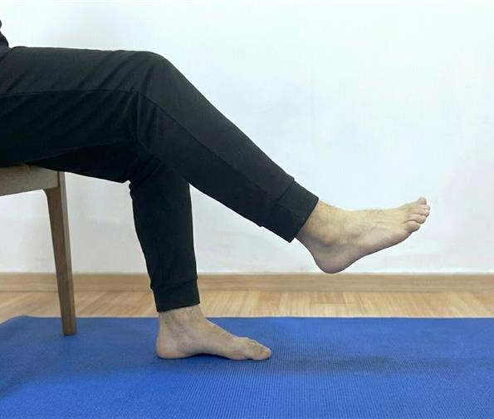  Alphabet exercises | The participant was asked to write the letters of the alphabet with their foot for warm-up purposes. | 1: sitting position 10 letters  2: sitting position 20 letters  3: standing position 10 letters
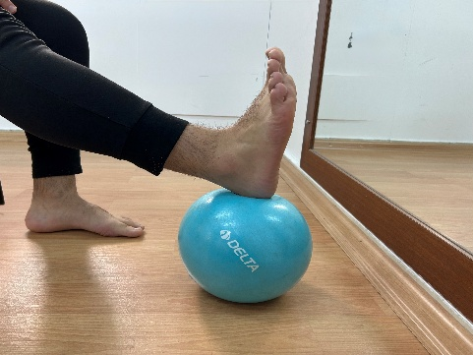 Unilateral Posterior compartment stretching | While seated with the hip and knee flexed at 90°, the participant was instructed to perform knee extension while pressing the heel downward, and to hold the end position for 10 seconds. | 1: 1x10 rep;  2: 2x10 rep;  3: 3x10 rep;
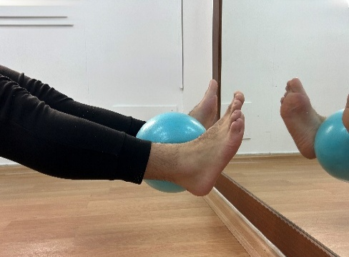  Bilateral Posterior compartment stretching | While seated with the hip and knee flexed at 90°, the participants were instructed to perform knee extension while squeezing a ball placed between their feet and maintaining maximum dorsiflexion, holding the end position for 5 seconds. | 1: 1x10 rep;  2: 2x10 rep;  3: 3x10 rep;
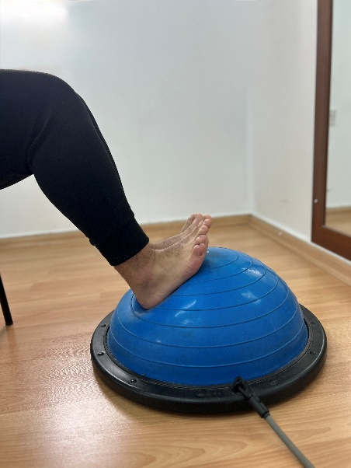  Soleus muscle stretching | While seated with the hip and knee flexed at 90 degrees, the participants were instructed to perform maximum dorsiflexion on a Bosuball, holding the end position for 10 seconds. | 1: 1x10 rep;  2: 2x10 rep;  3: 3x10 rep;
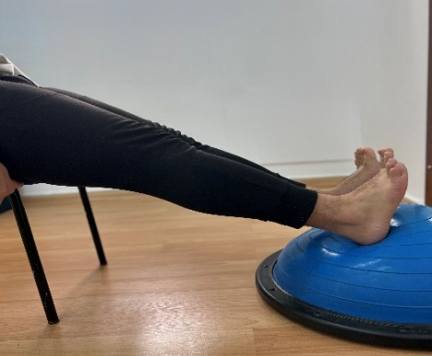  Gastrocnemius muscle stretching | While seated with the knees extended, the participant was instructed to perform dorsiflexion and to hold the end position for 10 seconds. | 1: 1x10 rep;  2: 2x10 rep;  3: 3x10 rep;
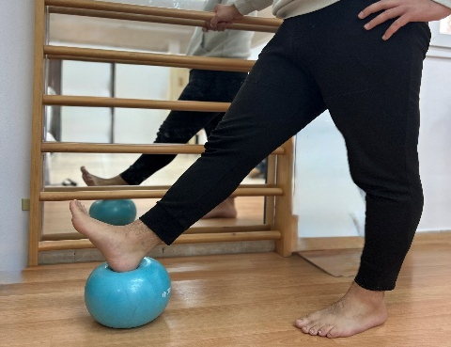  Myofascial release | While standing, the participant was instructed to roll a ball using the plantar surface of the foot, followed by dorsiflexion at the end range, and to hold the final position while pressing on the ball for 10 seconds. | 1: 1x10 rep;  2: 2x10 rep;  3: 3x10 rep;
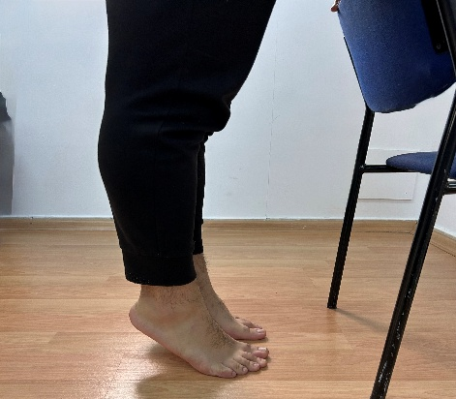  Gastrocnemius–soleus strengthening | Using a chair for support, the participants were instructed to rise onto their toes, hold the position for 5 seconds, and return to the starting position in a slow and controlled manner. | 1: 1x10 rep;  2: 2x10 rep;  3: 3x10 rep;
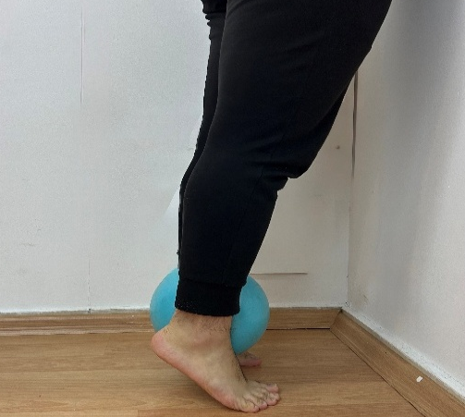  Tibialis posterior strengthening | With a ball placed between their feet, the participants were instructed to rise onto their toes while keeping the feet parallel and to squeeze the ball as the heels were lifted. | 1: 1x10 rep;  2: 2x10 rep;  3: 3x10 rep;
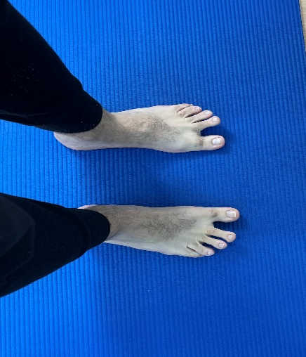  Toes spread out | The participants were instructed to perform a toe-spreading movement and to hold the position for 5 seconds. | 1: sitting position  1x10 rep  2: : sitting position  2x10 rep  3: standing position  1x15 rep
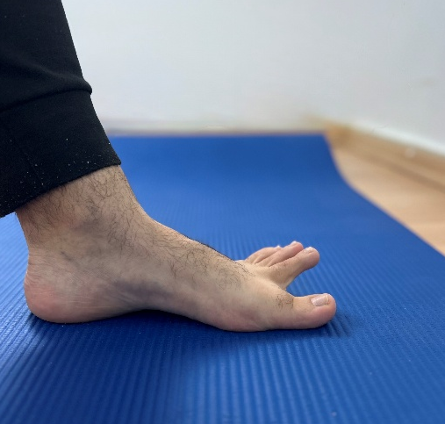  First-toe extension and second-to fifth-toes extension | The participants were instructed to keep the great toe in extension while the other toes remained on the ground, holding the position for 5 seconds. | 1: sitting position  1x10 rep  2: sitting position  2x10 rep  3: standing position  1x15 rep
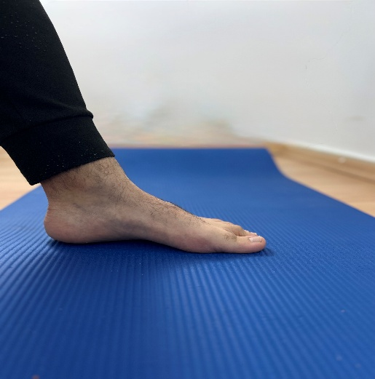  Short foot exercises | The participants were instructed to shorten the foot length without allowing toe flexion and to hold the position for 5 seconds. | 1: sitting position  2x10 rep  2: standing position  2x10 rep  3: one leg-standing position  1x15 rep
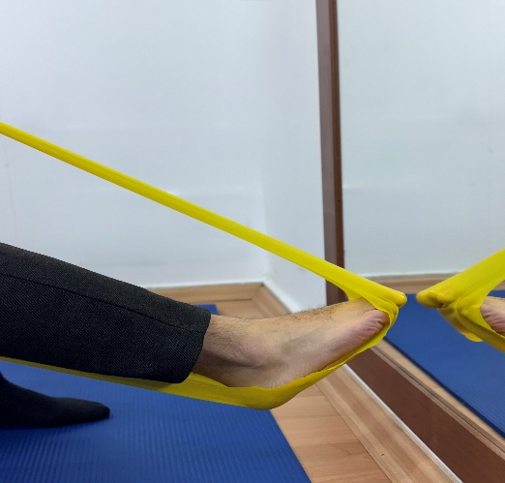  Toe fleksion with theraband | While seated, the participants were instructed to perform toe flexion against the resistance of an exercise band and to hold the end position for 5 seconds. | The resistance of the exercise band was increased monthly according to the participant’s condition.  1: 2x10 rep;  2: 2x10 rep;  3: 2x10 rep;
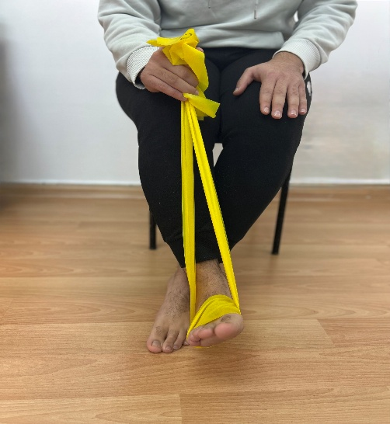  Plantar flexor strengthening | The participant was instructed to perform ankle plantar flexion against elastic exercise band resistance in a standing position and to hold the end position for 5 seconds. | The resistance of the exercise band was increased monthly according to the participant’s condition.  1: 2x10 rep;  2: 2x10 rep;  3: 2x10 rep;
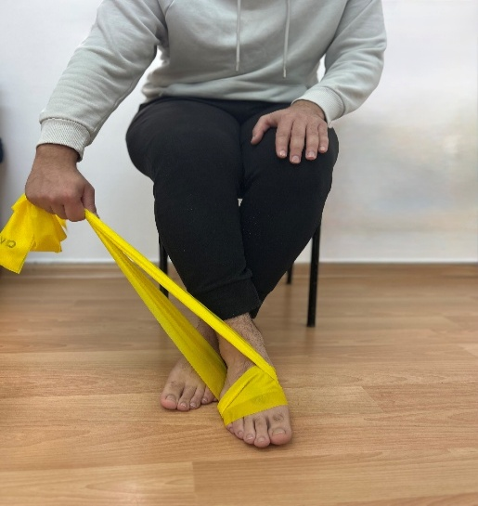  Invertor muscle strengthening | The participant was instructed to perform ankle inversion against elastic exercise band resistance in a seated position and to hold the end position for 5 seconds. | The resistance of the exercise band was increased monthly according to the participant’s condition.  1: 2x10 rep;  2: 2x10 rep;  3: 2x10 rep;
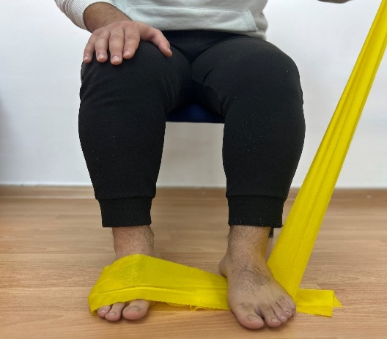  Evertor mucle strengthening | The participant was instructed to perform ankle eversion against elastic exercise band resistance in a seated position and to hold the end position for 5 seconds. | The resistance of the exercise band was increased monthly according to the participant’s condition.  1: 2x10 rep;  2: 2x10 rep;  3: 2x10 rep;
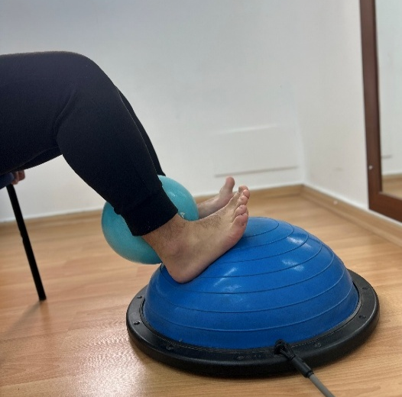  Tibialis anterior strengthening | The participant was instructed to squeeze the ball on the BOSU ball while performing ankle dorsiflexion and to hold the position for 5 seconds. | 1: 1x10 rep;  2: 2x10 rep;  3: 3x10 rep;
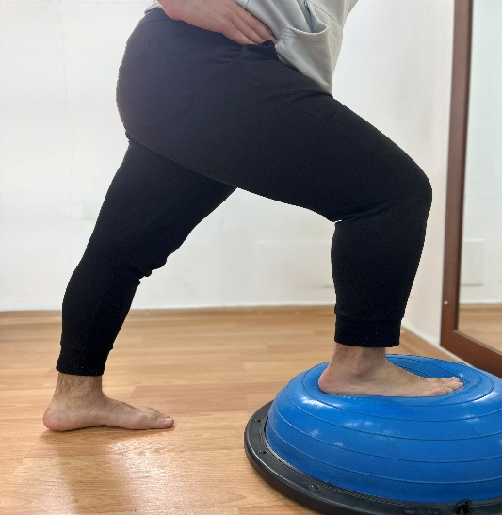  Gastrocnemius stretching | While performing a gastrocnemius–soleus stretch on the BOSU ball, the participant was instructed to keep both feet parallel, ensure that the heel of the rear foot remained in contact with the ground, and to hold the end position for 10 seconds. | 1: 1x10 rep;  2: 2x10 rep;  3: 3x10 rep;
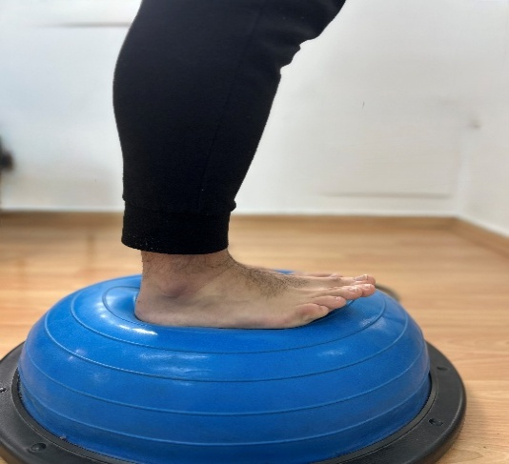  Standing on Bosuball | The participants were instructed to maintain their balance while standing on the Bosuball. The time elapsed until the balance is lost is considered 1 repetition. | 1: 1x10 rep;  2: 2x10 rep;  3: 3x10 rep;
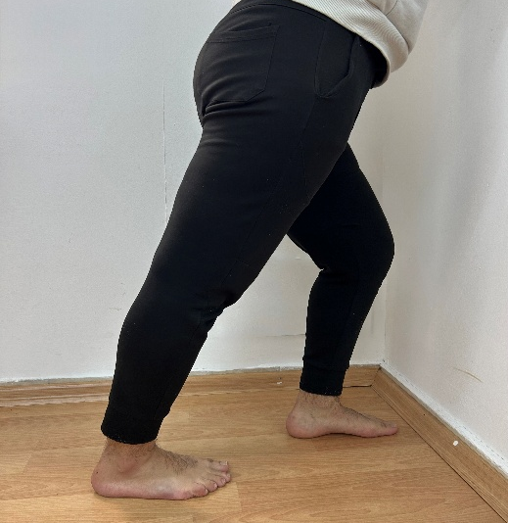  Static Gastrocnemius stretching | While performing a static gastrocnemius–soleus stretch against the wall, the participant was instructed to keep both feet parallel, ensure that the heel of the rear foot remained in contact with the ground, and to hold the end position for 10 seconds. | 1: 1x10 rep;  2: 2x10 rep;  3: 3x10 rep;

