Optimal Exercise Modality and Dose for Reducing Visceral Adipose Tissue in Overweight or Obese Adults: A Network Meta-Analysis and Dose-Response Study

Supplementary materials | Page
Appendix 1 Search Strategy | P1-P4
Appendix 2 Definitions of Exercise Training Interventions | P5
Appendix 3 Basic Characteristics and Exercise Intervention Details of the Included Studies | P6-P10
Appendix 4 Risk of Bias Assessment with the RoB 2.0 Tool | P11
Appendix 5 Contribution of Direct and Indirect Comparisons to the Network Meta-Analysis (NMA) and the Number of Studies in Each Direct Comparison | P13
Appendix 6 Inconsistency Analysis Using Loop, Global, and Local Inconsistency Tests | P14
Appendix 7 Results of Pairwise Comparison | P15
Appendix 8 Results of the GRADE Assessment of the Quality of Evidence | P16-P17
Appendix 9 Key Assumptions of Bayesian Dose-Response Analysis | P18-P21
Appendix 10 Model Selection in Bayesian Dose-Response Analysis | P22-P24
Appendix 11 Bayesian Dose-Response Relationship | P25-P27
Appendix 12 References of Included Studies | P28-P32

Appendix 1 Search Strategy
Table S1 PubMed
Search procedure | Query | Results
#11 | (((("Exercise"[Mesh]) OR (((((((((((((Physical Exercise[Title/Abstract]) OR (Aerobic Exercise[Title/Abstract])) OR (Physical Activity[Title/Abstract])) OR (walking[Title/Abstract])) OR (running[Title/Abstract])) OR (cycling[Title/Abstract])) OR (resistance training[Title/Abstract])) OR (treadmill[Title/Abstract])) OR (strength training[Title/Abstract])) OR (resistance exercise[Title/Abstract])) OR (Combined Aerobic[Title/Abstract] AND Resistance Training[Title/Abstract])) OR (mixed exercise program[Title/Abstract])) OR (High-intensity interval training[Title/Abstract]))) AND (("Obesity"[Mesh]) OR ("Overweight"[Mesh]))) AND (("Intra-Abdominal Fat"[Mesh]) OR ((((((((((Intra Abdominal Fat[Title/Abstract]) OR (Intra-Abdominal Adipose Tissue[Title/Abstract])) OR (Adipose Tissue, Intra-Abdominal[Title/Abstract])) OR (Visceral Fat[Title/Abstract])) OR (Fat, Visceral[Title/Abstract])) OR (Visceral Adipose Tissue[Title/Abstract])) OR (Abdominal Visceral Fat[Title/Abstract])) OR (Fat, Abdominal Visceral[Title/Abstract])) OR (Retroperitoneal Fat[Title/Abstract])) OR (Retroperitoneal Adipose Tissue[Title/Abstract])))) AND ((((randomized controlled trial[Title/Abstract]) OR (randomized[Title/Abstract])) OR (placebo[Title/Abstract])) OR (RCT[Title/Abstract])) | 180
#10 | (((randomized controlled trial[Title/Abstract]) OR (randomized[Title/Abstract])) OR (placebo[Title/Abstract])) OR (RCT[Title/Abstract]) | 959230
#9 | ("Intra-Abdominal Fat"[Mesh]) OR ((((((((((Intra Abdominal Fat[Title/Abstract]) OR (Intra-Abdominal Adipose Tissue[Title/Abstract])) OR (Adipose Tissue, Intra-Abdominal[Title/Abstract])) OR (Visceral Fat[Title/Abstract])) OR (Fat, Visceral[Title/Abstract])) OR (Visceral Adipose Tissue[Title/Abstract])) OR (Abdominal Visceral Fat[Title/Abstract])) OR (Fat, Abdominal Visceral[Title/Abstract])) OR (Retroperitoneal Fat[Title/Abstract])) OR (Retroperitoneal Adipose Tissue[Title/Abstract])) | 22095
#8 | (((((((((Intra Abdominal Fat[Title/Abstract]) OR (Intra-Abdominal Adipose Tissue[Title/Abstract])) OR (Adipose Tissue, Intra-Abdominal[Title/Abstract])) OR (Visceral Fat[Title/Abstract])) OR (Fat, Visceral[Title/Abstract])) OR (Visceral Adipose Tissue[Title/Abstract])) OR (Abdominal Visceral Fat[Title/Abstract])) OR (Fat, Abdominal Visceral[Title/Abstract])) OR (Retroperitoneal Fat[Title/Abstract])) OR (Retroperitoneal Adipose Tissue[Title/Abstract]) | 20066
#7 | "Intra-Abdominal Fat"[Mesh] | 8008
#6 | ("Obesity"[Mesh]) OR ("Overweight"[Mesh]) | 304629
#5 | "Overweight"[Mesh] | 304629
#4 | "Obesity"[Mesh] | 292444
#3 | ("Exercise"[Mesh]) OR (((((((((((((Physical Exercise[Title/Abstract]) OR (Aerobic Exercise[Title/Abstract])) OR (Physical Activity[Title/Abstract])) OR (walking[Title/Abstract])) OR (running[Title/Abstract])) OR (cycling[Title/Abstract])) OR (resistance training[Title/Abstract])) OR (treadmill[Title/Abstract])) OR (strength training[Title/Abstract])) OR (resistance exercise[Title/Abstract])) OR (Combined Aerobic[Title/Abstract] AND Resistance Training[Title/Abstract])) OR (mixed exercise program[Title/Abstract])) OR (High-intensity interval training[Title/Abstract])) | 639251
#2 | ((((((((((((Physical Exercise[Title/Abstract]) OR (Aerobic Exercise[Title/Abstract])) OR (Physical Activity[Title/Abstract])) OR (walking[Title/Abstract])) OR (running[Title/Abstract])) OR (cycling[Title/Abstract])) OR (resistance training[Title/Abstract])) OR (treadmill[Title/Abstract])) OR (strength training[Title/Abstract])) OR (resistance exercise[Title/Abstract])) OR (Combined Aerobic[Title/Abstract] AND Resistance Training[Title/Abstract])) OR (mixed exercise program[Title/Abstract])) OR (High-intensity interval training[Title/Abstract]) | 520252
#1 | "Exercise"[Mesh] | 283369

Table S2 Embase
Search procedure | Query | Results
#10 | #3 AND #4 AND #5 AND #8 AND #9 | 412
#9 | 'randomized controlled trial':ab,ti OR 'randomized':ab,ti OR 'placebo':ab,ti OR 'rct':ab,ti | 1592185
#8 | #6 OR #7 | 40539
#7 | 'intra abdominal fat':ab,ti OR 'adipose tissue, intra-abdominal':ab,ti OR 'intra-abdominal adipose tissue':ab,ti OR 'visceral fat':ab,ti OR 'fat, visceral':ab,ti OR 'visceral adipose tissue':ab,ti OR 'abdominal visceral fat':ab,ti OR 'fat, abdominal visceral':ab,ti OR 'retroperitoneal fat':ab,ti OR 'fats, retroperitoneal':ab,ti OR 'retroperitoneal adipose tissue':ab,ti | 31173
#6 | 'intra-abdominal fat'/exp | 32702
#5 | 'adult'/exp | 13621546
#4 | 'obesity'/exp | 830488
#3 | #1 OR #2 | 1056018
#2 | 'physical exercise':ab,ti OR 'aerobic exercise':ab,ti OR 'physical activity':ab,ti OR 'walking':ab,ti OR 'running':ab,ti OR 'cycling':ab,ti OR 'resistance training':ab,ti OR 'treadmill':ab,ti OR 'strength training':ab,ti OR 'resistance exercise':ab,ti OR 'combined aerobic and resistance training':ab,ti OR 'mixed exercise program':ab,ti OR 'high-intensity interval training':ab,ti | 681134
#1 | 'exercise'/exp | 570439

Table S3 Cochrane Library
Search procedure | Query | Results
#11 | #3 and #6 and #7 and #10 | 568
#10 | #8 or #9 | 4226
#9 | (Intra Abdominal Fat):ti,ab,kw or (Intra-Abdominal Adipose Tissue):ti,ab,kw or (Adipose Tissue, Intra-Abdominal):ti,ab,kw or (Visceral Fat):ti,ab,kw or (Fat, Visceral):ti,ab,kw or (Visceral Adipose Tissue):ti,ab,kw or (Abdominal Visceral Fat):ti,ab,kw or (Fat, Abdominal Visceral):ti,ab,kw or (Retroperitoneal Fat):ti,ab,kw or (Fats, Retroperitoneal):ti,ab,kw or (Retroperitoneal Adipose Tissue):ti,ab,kw | 4226
#8 | MeSH descriptor: [Intra-Abdominal Fat] explode all trees | 476
#7 | MeSH descriptor: [Adult] explode all trees | 642782
#6 | #4 or #5 | 26703
#5 | MeSH descriptor: [Overweight] explode all trees | 26703
#4 | MeSH descriptor: [Obesity] explode all trees | 22903
#3 | #1 or #2 | 1427789
#2 | (Physical Exercise):ti,ab,kw or (Aerobic Exercise):ti,ab,kw or (Physical Activity):ti,ab,kw or (walking):ti,ab,kw or (running):ti,ab,kw or (cycling):ti,ab,kw or (resistance training):ti,ab,kw or (treadmill):ti,ab,kw or (strength training):ti,ab,kw or (resistance exercise):ti,ab,kw or (Combined Aerobic and Resistance Training):ti,ab,kw or (mixed exercise program):ti,ab,kw or (High-intensity interval training):ti,ab,kw | 164515
#1 | MeSH descriptor: [Exercise] explode all trees | 42079

Table S4 Web of Science
Search procedure | Query | Results
#6 | #1 AND #2 AND #3 AND #4 AND #5 | 169
#5 | randomized controlled trial (Topic) OR randomized (Topic) OR placebo (Topic) OR RCT (Topic) | 1416751
#4 | Obesity (Topic) OR Overweight (Topic) | 580864
#3 | Adult (Topic) | 2321532
#2 | Intra-Abdominal Fat (Topic) OR Intra Abdominal Fat (Topic) OR Intra-Abdominal Adipose Tissue (Topic) OR Adipose Tissue, Intra-Abdominal (Topic) OR Visceral Fat (Topic) OR Fat, Visceral (Topic) OR Visceral Adipose Tissue (Topic) OR Abdominal Visceral Fat (Topic) OR Fat, Abdominal Visceral (Topic) OR Retroperitoneal Fat (Topic) OR Fats, Retroperitoneal (Topic) OR Retroperitoneal Adipose Tissue (Topic) | 34540
#1 | Exercise (Topic) OR Physical Exercise (Topic) OR Aerobic Exercise (Topic) OR Physical Activity (Topic) OR running (Topic) OR walking (Topic) OR cycling (Topic) OR resistance training (Topic) OR treadmill (Topic) OR strength training (Topic) OR resistance exercise (Topic) OR Combined Aerobic and Resistance Training (Topic) OR mixed exercise program (Topic) OR High-intensity interval training (Topic) | 4092466

Appendix 2 Definitions of Exercise Training Interventions
Exercise | Description
Aerobic exercise | Activities in which the body’s large muscle groups move rhythmically and continuously over a prolonged period, typically performed to improve cardiorespiratory fitness and endurance.  Examples: walking, jogging, cycling, swimming.
Resistance training | Exercise performed by having a specific muscle or muscle group work against an external resistance to improve muscular fitness, such as strength, endurance, and muscle mass.
Combined aerobic and resistance training | An integrated program that delivers both aerobic and resistance components within the same training period (same session or on alternate days).
High-intensity interval training | High-intensity interval training is characterized by brief, intermittent bouts of vigorous activity interspersed with rest periods or lower-intensity recovery; exercise intensity is commonly described as 85–95% of maximal heart rate (HRmax) or 80–100% of peak power/output (or workload).

Appendix 3 Basic Characteristics and Exercise Intervention Details of the Included Studies
Study | Country | Number | Age | Type of exercise | BMI | BF% | Intervention duration (weeks) | Time  (minutes) | Frequency  ( times/week) | Exact dose | Dose | Residual dose | Outcome measure
Mohammadi¹ 2022 | Iran | IG1:9 | ≥50 | RT | 28.8±2.1 | 31.4±1.8 | 12 | 25 | 3 | 360 | 250 | 110 | calculated via  formula, index
Mohammadi¹ 2022 | Iran | IG2:10 | ≥50 | AE | 29.2±2.4 | 32.0±2.5 | 12 | 25 | 3 | 450 | 500 | 50 | calculated via  formula, index
Mohammadi¹ 2022 | Iran | CG:9 | ≥50 | CON | 28.8±2.3 | 31.0±2.2 |  |  |  |  |  |  | calculated via  formula, index
Hyun² 2021 | Korea | IG:8 | 37.8±2.8 | AE | 25.4±2.3 | 37.5±2.3 | 8 | 40 | 3 | 816 | 750 | 66 | InBody
Hyun² 2021 | Korea | CG:8 | 39.1±2.4 | HIIT | 25.8±2.0 | 38.6±5.0 | 8 | 20 | 3 | 420 | 500 | 80 | InBody
Jamka³ 2021 | Poland | IG:44 | 55.0±7.0 | AE | 35.9±4.4 |  | 12 | 50 | 3 | 1020 | 1000 | 20 | DXA
Jamka³ 2021 | Poland | CG:41 | 55.0±7.0 | COM | 36.0±5.1 |  | 12 | 50 | 3 | 750 | 750 | 0 | DXA
Rashidi⁴ 2021 | Iran | IG:13 | 44.3±4.7 | RT | 33.1±4.5 | 45.6±3.0 | 8 | 40 | 3 | 420 | 500 | 80 | calculated via  formula, index
Rashidi⁴ 2021 | Iran | CG:13 | 45.2±3.9 | CON | 33.1±3.6 | 43.9±2.7 |  |  |  |  |  |  | calculated via  formula, index
Valsdottir⁵ 2021 | Norway | IG:12 | 40.5±3.7 | HIIT | 30.7±2.3 | 41.8±3.5 | 10 | 28 | 3 | 739.2 | 750 | 10.8 | DXA
Valsdottir⁵ 2021 | Norway | CG:15 | 38.6±3.7 | CON | 30.8±2.3 | 43.3±5.0 |  |  |  |  |  |  | DXA
Abdelbasset⁶ 2020 | Saudi Arabia | IG1:15 | 54.9±4.7 | AE | 36.7±3.5 |  | 8 | 35 | 3 | 714 | 750 | 36 | MRI
Abdelbasset⁶ 2020 | Saudi Arabia | IG2:16 | 54.4±5.8 | HIIT | 36.3±4.5 |  | 8 | 12 | 3 | 316.8 | 250 | 66.8 | MRI
Abdelbasset⁶ 2020 | Saudi Arabia | CG:16 | 55.2±4.3 | CON | 35.9±5.3 |  |  |  |  |  |  |  | MRI
Gripp⁷ 2021 | Brazil | IG:11 | 39.0±5.0 | AE | 28.7±3.1 | 29.3±3.2 | 8 | 30 | 3 | 702 | 750 | 48 | DXA
Gripp⁷ 2021 | Brazil | CG:11 | 38.0±6.0 | HIIT | 27.2±1.3 | 28.3±3.7 | 8 | 18 | 3 | 594 | 500 | 94 | DXA
Lee⁸ 2020 | Australia | IG:12 | 40.5±10.0 | HIIT | 29.0±2.1 | 37.8±5.7 | 12 | 16 | 3 | 422.4 | 500 | 77.6 | DXA
Lee⁸ 2020 | Australia | CG:15 | 46.1±10.5 | CON | 31.6±3.4 | 37.2±6.3 |  |  |  |  |  |  | DXA
Mendham⁹ 2020 | South Africa | IG:20 | 22.4±2.4 | COM | 34.1±2.8 |  | 12 | 45 | 4 | 900 | 1000 | 100 | MRI
Mendham⁹ 2020 | South Africa | CG:15 | 23.7±4.9 | CON | 33.4±2.7 |  |  |  |  |  |  |  | MRI
Ramos¹⁰ 2020 | Australia | IG:10 | 54.0±9.0 | AE | 34.0±6.5 | 43.4±8.4 | 16 | 30 | 5 | 720 | 750 | 30 | DEXA
Ramos¹⁰ 2020 | Australia | CG:13 | 54.0±10.0 | HIIT | 32.1±4.9 | 40.5±6.7 | 16 | 16 | 3 | 422.4 | 500 | 77.6 | DEXA
Ballin¹¹ 2019 | Sweden | IG:36 | 70.7±0.3 | HIIT | 29.8±3.1 | 39.6±6.6 | 10 | 25 | 3 | 660 | 750 | 90 | DXA
Ballin¹¹ 2019 | Sweden | CG:36 | 70.7±0.2 | CON | 29.0±3.5 | 39.6±5.8 |  |  |  |  |  |  | DXA
Zhang¹² 2020 | China | IG1:12 | 19.7±1.1 | HIIT | 26.0±2.9 | 44.6±5.0 | 12 | 30 | 3 | 792 | 750 | 42 | CT
Zhang¹² 2020 | China | IG2:11 | 21.0±2.4 | AE | 25.1±3.0 | 44.1±4.5 | 12 | 45 | 3 | 675 | 750 | 75 | CT
Zhang¹² 2020 | China | CG:13 | 21.2±2.2 | CON | 25.2±1.8 | 43.5±4.0 |  |  |  |  |  |  | CT
Smidt¹³ 2020 | South Africa | IG:20 | 22.3±2.4 | COM | 34.1±2.8 | 50.3±2.4 | 12 | 45 | 4 | 900 | 1000 | 100 | DXA
Smidt¹³ 2020 | South Africa | CG:13 | 23.7±4.9 | CON | 33.4±2.7 | 50.3±5.7 |  |  |  |  |  |  | DXA
Boutcher¹⁴ 2019 | Australia | IG:20 | 54.1±3.6 | HIIT | 28.3±3.7 | 36.9±4.3 | 8 | 20 | 3 | 528 | 500 | 28 | DXA
Boutcher¹⁴ 2019 | Australia | CG:20 | 53.3±3.4 | CON | 27.3±4.1 | 36.5±5.1 |  |  |  |  |  |  | DXA
Cho¹⁵ 2019 | Korea | IG:9 | 38.6±8.2 | COM | 26.9±3.9 | 31.3±7.2 | 8 | 60 | 3 | 900 | 1000 | 100 | CT
Cho¹⁵ 2019 | Korea | CG:5 | 42.6±10.6 | CON | 25.8±3.4 | 29.9±3.4 |  |  |  |  |  |  | CT
Hagovska¹⁶ 2020 | Slovak Republic | IG:36 | 26.7±4.8 | COM | 25.0±0.6 | 34.0±1.5 | 12 | 60 | 2 | 600 | 500 | 100 | InBody
Hagovska¹⁶ 2020 | Slovak Republic | CG:34 | 26.9±4.9 | CON | 25.1±0.6 | 32.0±1.2 |  |  |  |  |  |  | InBody
Dupuit¹⁷ 2020 | France | IG1:8 | 67.1±7.2 | AE | 31.2±3.0 | 37.9±4.0 | 12 | 40 | 3 | 816 | 750 | 66 | DXA
Dupuit¹⁷ 2020 | France | IG2:10 | 59.9±5.9 | HIIT | 31.5±4.3 | 33.7±11.6 | 12 | 20 | 3 | 528 | 500 | 28 | DXA
Nunes¹⁸ 2019 | Brazil | IG:13 | 62.9±8.8 | HIIT | 31.4±6.1 | 46.2±5.3 | 12 | 28 | 3 | 739.2 | 750 | 10.8 | DEXA
Nunes¹⁸ 2019 | Brazil | CG:13 | 62.3±6.9 | COM | 30.6±3.9 | 44.5±3.1 | 12 | 60 | 3 | 900 | 1000 | 100 | DEXA
Ratajczak¹⁹ 2019 | Poland | IG:22 | 51.0±8.0 | AE | 35.9±5.2 |  | 12 | 50 | 3 | 1020 | 1000 | 20 | calculated via  formula, index
Ratajczak¹⁹ 2019 | Poland | CG:17 | 49.0±10.0 | COM | 35.0±3.9 |  | 12 | 50 | 3 | 750 | 750 | 0 | calculated via  formula, index
Bairapareddy²⁰ 2018 | India | IG:66 | 20–45 | AE | 29.2±2.7 | 32.0±5.3 | 12 | 40 | 5 | 1160 | 1250 | 90 | InBody
Bairapareddy²⁰ 2018 | India | CG:64 | 20–45 | CON | 29.0±2.4 | 31.5±4.3 |  |  |  |  |  |  | InBody
Wedell Neergaard²¹ 2019 | Denmark | IG:14 | 50.7±7.5 | AE | 31.7±4.0 |  | 12 | 35 | 3 | 714 | 750 | 36 | MRI
Wedell Neergaard²¹ 2019 | Denmark | CG:12 | 47.9±7.5 | CON | 31.2±3.8 |  |  |  |  |  |  |  | MRI
Holliday²² 2018 | UK | IG:16 | 41.0±2.0 | AE | 29.2±3.4 |  | 24 | 30 | 5 | 645 | 750 | 105 | DXA
Holliday²² 2018 | UK | CG:20 | 41.0±2.0 | CON | 29.2±3.4 |  |  |  |  |  |  |  | DXA
Roy²³ 2018 | New Zealand | IG:69 | 43.0±10.2 | HIIT | 32.9±4.2 | 38.1±7.0 | 48 | 15 | 3 | 396 | 500 | 104 | DXA
Roy²³ 2018 | New Zealand | CG:94 | 43.9±11.5 | AE | 33.1±4.5 | 40.0±7.7 | 48 | 30 | 5 | 825 | 750 | 75 | DXA
Tong²⁴ 2018 | China  (Hong Kong) | IG:16 | 21.3±1.0 | HIIT |  | 38.2±2.4 | 12 | 30 | 4 | 1056 | 1000 | 56 | CT
Tong²⁴ 2018 | China  (Hong Kong) | CG:14 | 20.7±1.5 | CON |  | 40.5±2.6 |  |  |  |  |  |  | CT
Chen²⁵ 2017 | China  (Taiwan) | IG1:15 | 69.3±3.0 | AE | 26.8±3.8 | 40.0±4.4 | 8 | 60 | 2 | 576 | 500 | 76 | InBody
Chen²⁵ 2017 | China  (Taiwan) | IG2:15 | 68.9±4.4 | RT | 28.3±4.4 | 39.7±5.6 | 8 | 60 | 2 | 420 | 500 | 80 | InBody
Chen²⁵ 2017 | China  (Taiwan) | IG3:15 | 68.5±2.7 | COM | 27.2±2.9 | 39.7±5.8 | 8 | 60 | 2 | 600 | 500 | 100 | InBody
Chen²⁵ 2017 | China  (Taiwan) | CG:15 | 68.6±3.1 | CON | 29.0±3.9 | 39.8±4.5 |  |  |  |  |  |  | InBody
Oh²⁶ 2017 | Japan | IG1:19 | 51.2±8.3 | RT | 27.2±3.9 |  | 12 | 30 | 3 | 315 | 250 | 65 | MRI
Oh²⁶ 2017 | Japan | IG2:20 | 48.6±8.1 | HIIT | 28.4±4.0 |  | 12 | 13 | 3 | 343.2 | 250 | 93.2 | MRI
Oh²⁶ 2017 | Japan | CG:13 | 48.2±8.3 | AE | 28.8±4.0 |  | 12 | 40 | 3 | 600 | 500 | 100 | MRI
Keating²⁷ 2017 | Australia | IG:11 | 45.4±6.3 | RT | 32.2±4.0 |  | 8 | 35 | 3 | 504 | 500 | 4 | MRI
Keating²⁷ 2017 | Australia | CG:14 | 44.2±10.5 | CON | 30.8±3.7 |  |  |  |  |  |  |  | MRI
Wu²⁸ 2017 | USA | IG:6 | 25.8±5.3 | AE | 36.1±2.3 | 41.3±2.5 | 12 | 35 | 4 | 812 | 750 | 62 | DXA
Wu²⁸ 2017 | USA | CG:6 | 28.8±5.5 | CON | 32.2±2.5 | 40.3±2.5 |  |  |  |  |  |  | DXA
Houghton²⁹ 2016 | UK | IG:12 | 54.0±12.0 | COM | 33.0±5.0 |  | 12 | 45 | 3 | 675 | 750 | 75 | MRI
Houghton²⁹ 2016 | UK | CG:12 | 51.0±16.0 | CON | 33.0±7.0 |  |  |  |  |  |  |  | MRI
Zhang³⁰ 2017 | China | IG1:15 | 21.5±1.7 | HIIT | 38.1±2.3 |  | 12 | 35 | 3 | 924 | 1000 | 76 | CT
Zhang³⁰ 2017 | China | IG2:15 | 20.9±1.4 | AE | 38.0±2.1 |  | 12 | 60 | 3 | 900 | 1000 | 100 | CT
Zhang³⁰ 2017 | China | CG:13 | 20.8±1.1 | CON | 40.9±2.9 |  |  |  |  |  |  |  | CT
Cooper³¹ 2016 | Australia | IG1:15 | 49.1±5.3 | HIIT | 29.7±4.0 | 25.0±5.3 | 12 | 18 | 3 | 475.2 | 500 | 24.8 | CT
Cooper³¹ 2016 | Australia | IG2:15 | 51.1±5.7 | AE | 30.6±3.4 | 27.3±6.5 | 12 | 55 | 3 | 1122 | 1000 | 122 | CT
Cooper³¹ 2016 | Australia | CG:14 | 51.2±7.0 | CON | 28.7±3.6 | 25.1±5.4 |  |  |  |  |  |  | CT
Maillard³² 2016 | France | IG:8 | 70.1±6.8 | AE | 29.7±3.4 | 37.9±3.7 | 16 | 40 | 2 | 544 | 500 | 44 | DEXA
Maillard³² 2016 | France | CG:8 | 68.2±5.4 | HIIT | 32.6±4.8 | 36.2±4.8 | 16 | 20 | 2 | 352 | 250 | 102 | DEXA
Keating³³ 2015 | Australia | IG:12 | 45.6±12.8 | AE | 32.2±4.9 |  | 8 | 35 | 3 | 577.5 | 500 | 77.5 | MRI
Keating³³ 2015 | Australia | CG:12 | 39.1±10.1 | CON | 31.3±2.8 |  |  |  |  |  |  |  | MRI
Arad³⁴ 2015 | USA | IG:9 | 29.0±4.0 | HIIT | 32.5±3.6 | 45.4±3.7 | 14 | 24 | 3 | 633.6 | 750 | 116.4 | MRI
Arad³⁴ 2015 | USA | CG:11 | 30.0±7.0 | CON | 32.1±3.2 | 45.4±5.0 |  |  |  |  |  |  | MRI
Baria³⁵ 2014 | Brazil | IG:10 | 52.1±11.4 | AE | 30.8±5.1 |  | 12 | 45 | 3 | 513 | 500 | 13 | CT
Baria³⁵ 2014 | Brazil | CG:9 | 53.4±9.6 | CON | 29.6±1.9 |  |  |  |  |  |  |  | CT
Bacchi³⁶ 2013 | Italy | IG:13 | 55.6±7.2 | AE | 30.5±3.6 | 31.8±5.0 | 12 | 50 | 3 | 750 | 750 | 0 | MRI
Bacchi³⁶ 2013 | Italy | CG:17 | 56.0±7.8 | RT | 28.8±4.5 | 29.8±7.8 | 12 | 30 | 3 | 540 | 500 | 40 | MRI
Zhang³⁷ 2015 | China | IG1:12 | 21.0±1.0 | HIIT | 25.8±2.7 | 31.3±3.6 | 12 | 16 | 4 | 704 | 750 | 46 | CT
Zhang³⁷ 2015 | China | IG2:12 | 20.6±1.2 | AE | 26.0±1.6 | 32.0±2.4 | 12 | 33 | 4 | 897.6 | 1000 | 102.4 | CT
Zhang³⁷ 2015 | China | CG:11 | 20.9±1.0 | CON | 25.4±1.5 | 32.0±2.4 |  |  |  |  |  |  | CT
Herzig³⁸ 2014 | Finland | IG:33 | 58.1±9.9 | AE | 32.6±5.7 | 40.0±7.6 | 12 | 45 | 3 | 378 | 500 | 122 | InBody
Herzig³⁸ 2014 | Finland | CG:35 | 59.5±10.8 | CON | 30.9±4.8 | 38.6±9.0 |  |  |  |  |  |  | InBody
Bouchonville³⁹ 2014 | USA | IG:22 | 70.0±4.0 | COM | 36.9±5.4 | 40.2±10.5 | 48 | 60 | 3 | 900 | 1000 | 100 | MRI
Bouchonville³⁹ 2014 | USA | CG:23 | 69.0±4.0 | CON | 37.3±4.7 | 43.4±6.7 |  |  |  |  |  |  | MRI
Dobrosielski⁴⁰ 2012 | USA | IG:51 | 57.0±6.0 | COM | 33.0±4.3 | 38.2±7.5 | 24 | 60 | 3 | 900 | 1000 | 100 | MRI
Dobrosielski⁴⁰ 2012 | USA | CG:63 | 56.0±6.0 | CON | 33.6±4.8 | 38.4±7.5 |  |  |  |  |  |  | MRI
Jung⁴¹ 2012 | Korea | IG:8 | 48.4±6.1 | AE | 25.9±1.6 |  | 12 | 30 | 5 | 870 | 750 | 120 | CT
Jung⁴¹ 2012 | Korea | CG:12 | 55.5±7.6 | CON | 27.7±3.4 |  |  |  |  |  |  |  | CT
Donges⁴² 2013 | Australia | IG1:13 | 45.4±6.1 | AE | 32.0±4.9 | 27.8±4.7 | 12 | 50 | 3 | 870 | 750 | 120 | CT
Donges⁴² 2013 | Australia | IG2:13 | 45.4±6.1 | RT | 29.7±3.2 | 27.6±5.0 | 12 | 25 | 3 | 450 | 500 | 50 | CT
Donges⁴² 2013 | Australia | IG3:13 | 46.2±5.0 | COM | 30.2±2.5 | 27.6±5.0 | 12 | 50 | 3 | 750 | 750 | 0 | CT
Donges⁴² 2013 | Australia | CG:8 | 49.5±7.4 | CON | 29.6±5.4 | 23.9±6.2 |  |  |  |  |  |  | CT
Heydari⁴³ 2012 | Australia | IG:20 | 24.7±4.8 | HIIT | 28.4±2.2 | 34.8±4.1 | 12 | 20 | 3 | 528 | 500 | 28 | CT
Heydari⁴³ 2012 | Australia | CG:18 | 25.1±3.9 | CON | 29.0±3.1 | 36.3±5.9 |  |  |  |  |  |  | CT
Moghadasi⁴⁴ 2013 | Iran | IG:8 | 35–50 | AE | 30.3±2.1 | 30.0±3.4 | 12 | 30 | 4 | 696 | 750 | 54 | MRI
Moghadasi⁴⁴ 2013 | Iran | CG:8 | 35–50 | CON | 32.0±5.3 | 31.4±5.5 |  |  |  |  |  |  | MRI
Kim⁴⁵ 2012 | Korea | IG:15 | 54.5±2.8 | AE | 25.0±1.3 | 36.0±3.0 | 16 | 60 | 3 | 1440 | 1500 | 60 | InBody
Kim⁴⁵ 2012 | Korea | CG:15 | 54.5±2.8 | CON | 25.1±1.5 | 36.6±1.7 |  |  |  |  |  |  | InBody
Slentz⁴⁶ 2011 | USA | IG1:52 | 49.7±11.4 | RT | 30.5±3.4 |  | 24 | 40 | 3 | 420 | 500 | 80 | CT
Slentz⁴⁶ 2011 | USA | IG2:48 | 49.5±9.8 | AE | 30.4±3.2 |  | 24 | 40 | 3 | 816 | 750 | 66 | CT
Slentz⁴⁶ 2011 | USA | CG:44 | 46.9±10.0 | COM | 30.4±3.2 |  | 24 | 75 | 3 | 1125 | 1000 | 125 | CT
Hallsworth⁴⁷ 2011 | UK | IG:11 | 52.0±13.3 | RT | 32.3±4.9 | 37.0±8.0 | 8 | 40 | 3 | 696 | 750 | 54 | MRI
Hallsworth⁴⁷ 2011 | UK | CG:8 | 62.0±7.4 | CON | 32.3±4.8 | 41.0±6.0 |  |  |  |  |  |  | MRI
Friedenreich⁴⁸ 2011 | Canada | IG:155 | 61.2±5.4 | AE | 29.1±4.5 | 42.2±4.9 | 48 | 45 | 5 | 1530 | 1500 | 30 | CT
Friedenreich⁴⁸ 2011 | Canada | CG:156 | 60.6±5.7 | CON | 29.2±4.3 | 42.4±5.7 |  |  |  |  |  |  | CT
Ku⁴⁹ 2010 | Korea | IG1:13 | 55.7±6.2 | RT | 27.1±2.3 | 35.2±5.6 | 12 | 35 | 5 | 875 | 750 | 125 | CT
Ku⁴⁹ 2010 | Korea | IG2:15 | 55.7±7.0 | AE | 27.1±2.4 | 36.4±6.0 | 12 | 60 | 5 | 1440 | 1500 | 60 | CT
Ku⁴⁹ 2010 | Korea | CG:16 | 57.8±8.1 | CON | 27.1±2.4 | 35.1±6.5 |  |  |  |  |  |  | CT
Kwon⁵⁰ 2010 | Korea | IG:13 | 55.5±7.5 | AE | 27.0±2.5 | 37.3±5.5 | 12 | 60 | 5 | 1200 | 1250 | 50 | CT
Kwon⁵⁰ 2010 | Korea | CG:14 | 57.5±8.6 | CON | 27.5±3.0 | 37.5±6.2 |  |  |  |  |  |  | CT
Barone⁵¹ 2009 | USA | IG:51 | 64.6±5.7 | COM | 29.4±3.8 | 38.0±9.0 | 24 | 60 | 3 | 900 | 1000 | 100 | MRI
Barone⁵¹ 2009 | USA | CG:53 | 64.6±5.7 | CON | 29.7±5.0 | 38.0±10.0 |  |  |  |  |  |  | MRI
Schmitz⁵² 2007 | USA | IG:70 | 36.0±5.0 | RT | 29.4±3.3 | 44.3±5.0 | 48 | 60 | 2 | 420 | 500 | 80 | CT
Schmitz⁵² 2007 | USA | CG:63 | 36.0±6.0 | CON | 29.4±3.2 | 43.5±4.8 |  |  |  |  |  |  | CT
Slentz⁵³ 2005 | USA | IG:46 | 53.0±7.0 | AE | 29.7±3.1 |  | 24 | 60 | 3 | 864 | 750 | 114 | CT
Slentz⁵³ 2005 | USA | CG:47 | 52.3±7.7 | CON | 29.8±3.0 |  |  |  |  |  |  |  | CT
Cuff⁵⁴ 2003 | Canada | IG1:10 | 63.4±7.0 | COM | 33.3±4.7 |  | 16 | 65 | 3 | 975 | 1000 | 25 | CT
Cuff⁵⁴ 2003 | Canada | IG2:9 | 59.4±6.6 | AE | 32.5±4.2 |  | 16 | 65 | 3 | 1072.5 | 1000 | 72.5 | CT
Cuff⁵⁴ 2003 | Canada | CG:9 | 60.0±5.7 | CON | 36.7±6.0 |  |  |  |  |  |  |  | CT
McTiernan⁵⁵ 2007 | USA | IG:48 | 56.2±6.7 | AE | 29.7±3.7 | 31.5±6.4 | 48 | 60 | 6 | 1728 | 1500 | 228 | CT
McTiernan⁵⁵ 2007 | USA | CG:51 | 56.6±7.6 | CON | 30.1±4.8 | 29.7±5.9 |  |  |  |  |  |  | CT
Donnelly⁵⁶ 2003 | USA | IG:16 | 22.0±4.0 | AE | 29.7±2.9 | 28.3±4.6 | 64 | 40 | 5 | 960 | 1000 | 40 | CT
Donnelly⁵⁶ 2003 | USA | CG:15 | 24.0±4.0 | CON | 29.0±3.0 | 26.8±4.6 |  |  |  |  |  |  | CT
Waters⁵⁷ 2022 | USA | IG1:35 | 70.0±4.0 | AE | 35.9±4.4 |  | 26 | 60 | 3 | 1224 | 1250 | 26 | MRI
Waters⁵⁷ 2022 | USA | IG2:35 | 70.0±5.0 | RT | 36.7±5.8 |  | 26 | 60 | 3 | 1080 | 1000 | 80 | MRI
Waters⁵⁷ 2022 | USA | IG3:35 | 70.0±5.0 | COM | 35.8±4.5 |  | 26 | 60 | 3 | 900 | 1000 | 100 | MRI
Waters⁵⁷ 2022 | USA | CG:36 | 70.0±5.0 | CON | 36.7±5.0 |  |  |  |  |  |  |  | MRI
Haganes⁵⁸ 2022 | Norway | IG:26 | 34.9±7.0 | HIIT | 32.5±4.5 | 38.6±10.5 | 7 | 16 | 3 | 528 | 500 | 28 | InBody
Haganes⁵⁸ 2022 | Norway | CG:29 | 36.4±6.2 | CON | 33.1±4.2 | 39.5±10.1 |  |  |  |  |  |  | InBody
Lehmann⁵⁹ 2024 | Germany | IG:56 | 43.5±10.7 | RT | 37.1±5.2 | 43.2±5.4 | 48 | 40 | 2 | 464 | 500 | 36 | MRI
Lehmann⁵⁹ 2024 | Germany | CG:56 | 45.0±11.1 | AE | 37.1±4.8 | 43.6±6.5 | 48 | 40 | 2 | 320 | 250 | 70 | MRI
Chang⁶⁰ 2025 | China  (Taiwan) | IG:58 | 57.4±6.0 | AE | ≥25% in males and ≥30% in females |  | 8 | 30 | 3 | 612 | 500 | 112 | ACCUNIQ BC300
Chang⁶⁰ 2025 | China  (Taiwan) | CG:58 | 56.8±6.6 | HIIT |  |  | 8 | 20 | 3 | 660 | 750 | 90 | ACCUNIQ BC300
①AE = Aerobic exercise, ②RT = Resistance training, ③CON = Control, ④COM = Combined aerobic and resistance training, ⑤HIIT = High-intensity interval training, ⑥IG = Intervention group, ⑦CG = Comparison group, ⑧DEXA/DXA = Dual-energy X-ray absorptiometry, ⑨MRI = Magnetic resonance imaging, ⑩InBody = a bioelectrical impedance analysis (BIA) device, ⑪CT = Computed tomography, ⑫BMI = Body mass index, ⑬BF% = Body fat percentage, ⑭MET = Metabolic equivalent of task

Appendix 4 Risk of Bias Assessment with the RoB 2.0 Tool
Study | Randomization process | Deviations from intended interventions | Missing outcome data | Measurement of the outcome | Selection of the reported result | Overall Bias
Mohammadi 2022 | some concerns | Low | some concerns | High | Low | High
Hyun 2021 | Low | Low | Low | Low | Low | Low
Jamka 2021 | Low | some concerns | Low | some concerns | Low | some concerns
Rashidi 2021 | Low | Low | some concerns | Low | some concerns | some concerns
Valsdottir 2021 | Low | Low | Low | Low | Low | Low
Abdelbasset 2020 | Low | Low | High | Low | Low | High
Gripp 2021 | Low | some concerns | some concerns | Low | Low | some concerns
Lee 2020 | Low | some concerns | some concerns | Low | Low | some concerns
Mendham 2020 | Low | Low | Low | Low | Low | Low
Ramos 2020 | Low | some concerns | Low | Low | some concerns | some concerns
Ballin 2019 | Low | Low | Low | Low | Low | Low
Zhang 2020 | Low | Low | Low | Low | Low | Low
Smidt 2020 | Low | Low | Low | Low | Low | Low
Boutcher 2019 | Low | Low | Low | Low | Low | Low
Cho 2019 | Low | Low | Low | some concerns | Low | some concerns
Hagovska 2020 | Low | Low | Low | Low | Low | Low
Dupuit 2020 | Low | Low | Low | Low | Low | Low
Nunes 2019 | some concerns | Low | some concerns | Low | Low | some concerns
Ratajczak 2019 | Low | Low | Low | Low | Low | Low
Bairapareddy 2018 | Low | Low | some concerns | High | some concerns | High
Wedell Neergaard 2019 | Low | Low | Low | Low | Low | Low
Holliday 2018 | Low | Low | some concerns | some concerns | Low | some concerns
Roy 2018 | Low | Low | Low | some concerns | Low | some concerns
Tong 2018 | Low | Low | Low | Low | Low | Low
Chen 2017 | Low | Low | Low | Low | Low | Low
Oh 2017 | Low | some concerns | some concerns | High | Low | High
Keating 2017 | Low | Low | Low | some concerns | Low | some concerns
Wu 2017 | Low | some concerns | some concerns | Low | Low | some concerns
Houghton 2016 | Low | Low | Low | Low | Low | Low
Zhang 2017 | Low | Low | Low | Low | Low | Low
Cooper 2016 | Low | Low | Low | Low | Low | Low
Maillard 2016 | Low | Low | some concerns | Low | Low | some concerns
Keating 2015 | Low | Low | Low | Low | Low | Low
Arad 2015 | Low | Low | Low | some concerns | Low | some concerns
Baria 2014 | Low | some concerns | some concerns | Low | Low | some concerns
Bacchi 2013 | Low | Low | Low | Low | Low | Low
Zhang 2015 | Low | Low | Low | Low | Low | Low
Herzig 2014 | Low | some concerns | High | Low | Low | High
Bouchonville 2014 | Low | Low | Low | Low | Low | Low
Dobrosielski 2012 | Low | some concerns | Low | some concerns | Low | some concerns
Jung 2012 | Low | Low | Low | Low | Low | Low
Donges 2013 | Low | Low | Low | Low | Low | Low
Heydari 2012 | Low | Low | Low | Low | Low | Low
Moghadasi 2013 | Low | Low | Low | Low | Low | Low
Kim 2012 | Low | Low | Low | Low | Low | Low
Slentz 2011 | Low | Low | Low | Low | Low | Low
Hallsworth 2011 | Low | Low | Low | Low | Low | Low
Friedenreich 2011 | Low | Low | Low | Low | Low | Low
Ku 2010 | Low | Low | some concerns | Low | Low | some concerns
Kwon 2010 | Low | Low | some concerns | Low | Low | some concerns
Barone 2009 | Low | Low | Low | Low | Low | Low
Schmitz 2007 | Low | Low | Low | Low | Low | Low
Slentz 2005 | Low | Low | some concerns | some concerns | Low | some concerns
Cuff 2003 | Low | Low | Low | Low | Low | Low
McTiernan 2007 | Low | Low | Low | Low | Low | Low
Donnelly 2003 | some concerns | Low | some concerns | High | Low | High
Waters 2022 | Low | Low | Low | Low | Low | Low
Haganes 2022 | Low | Low | Low | Low | Low | Low
Lehmann 2024 | Low | Low | some concerns | some concerns | Low | some concerns
Chang 2025 | Low | Low | Low | Low | Low | Low

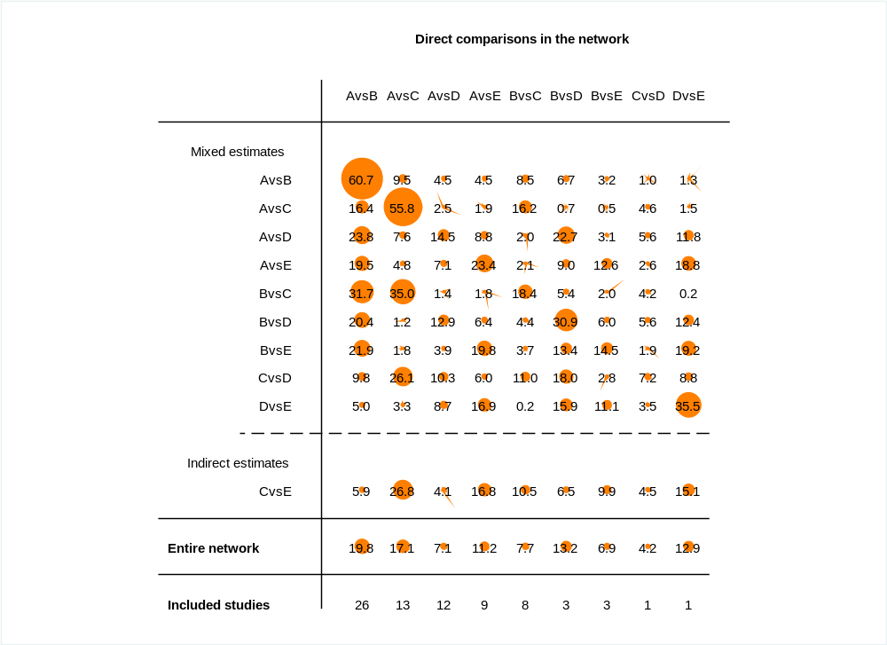
Appendix 5 Contribution of Direct and Indirect Comparisons to the Network Meta-Analysis (NMA) and the Number of Studies in Each Direct Comparison
A: Control, B: Aerobic exercise, C: High-intensity interval training, D: Combined aerobic and resistance training, E: Resistance training

Appendix 6 Inconsistency Analysis Using Loop, Global, and Local Inconsistency Tests
Table S5 Results of the Loop Inconsistency Test
Loop | IF | seIF | z_value | p_value | CI_95 | Loop_Heterog_tau2
AE-COM-RT | 0.654 | 0.511 | 1.28 | 0.2 | (0.00,1.66) | 0.094
CON-HIIT-COM | 0.485 | 0.82 | 0.592 | 0.554 | (0.00,2.09) | 0.397
CON-AE-HIIT | 0.444 | 0.254 | 1.748 | 0.08 | (0.00,0.94) | 0.111
CON-AE-COM | 0.345 | 0.42 | 0.821 | 0.411 | (0.00,1.17) | 0.251
CON-COM-RT | 0.345 | 0.921 | 0.374 | 0.708 | (0.00,2.15) | 0.551
AE-HIIT-COM | 0.315 | 0.751 | 0.419 | 0.675 | (0.00,1.79) | 0.155
CON-AE-RT | 0.025 | 0.371 | 0.067 | 0.947 | (0.00,0.75) | 0.148
CON = Control, AE = Aerobic exercise, RT = Resistance training, COM = Combined aerobic and resistance training, HIIT = High-intensity interval training

Table S6 Fitting the Inconsistency Model
Fitting the Inconsistency Model
chi2 | 4.47
Prob > chi2 | 0.4837

Table S7 Results of the Local Inconsistency Test
Side | Direct |  | Indirect |  | Difference
 | Coef. | Std. Err. | Coef. | Std. Err. | Coef. | Std. Err. | P>z
A B | -0.7223239 | 0.1228422 | -0.5726075 | 0.1958136 | -0.1497164 | 0.2314239 | 0.518
A C | -0.5581772 | 0.1691423 | -1.079938 | 0.2329719 | 0.5217604 | 0.2873016 | 0.069
A D | -0.7991803 | 0.1755607 | -0.5461799 | 0.2672322 | -0.2530004 | 0.3197572 | 0.429
A E | -0.665005 | 0.2115744 | -0.5393259 | 0.3013121 | -0.125679 | 0.3679051 | 0.733
B C | -0.3401065 | 0.2233791 | 0.1600351 | 0.1967559 | -0.5001417 | 0.2973291 | 0.093
B D | 0.2689289 | 0.3165386 | -0.1556523 | 0.1905002 | 0.4245811 | 0.3694506 | 0.25
B E | 0.0277079 | 0.3380416 | 0.0688078 | 0.2238983 | -0.0410999 | 0.4051803 | 0.919
C D | 0.2588882 | 0.6322585 | -0.0061405 | 0.2025552 | 0.2650287 | 0.6639122 | 0.69
D E | 0.4403623 | 0.5363059 | 0.0350431 | 0.2337022 | 0.4053192 | 0.5850135 | 0.488
A: Control, B: Aerobic exercise, C: High-intensity interval training, D: Combined aerobic and resistance training, E: Resistance training

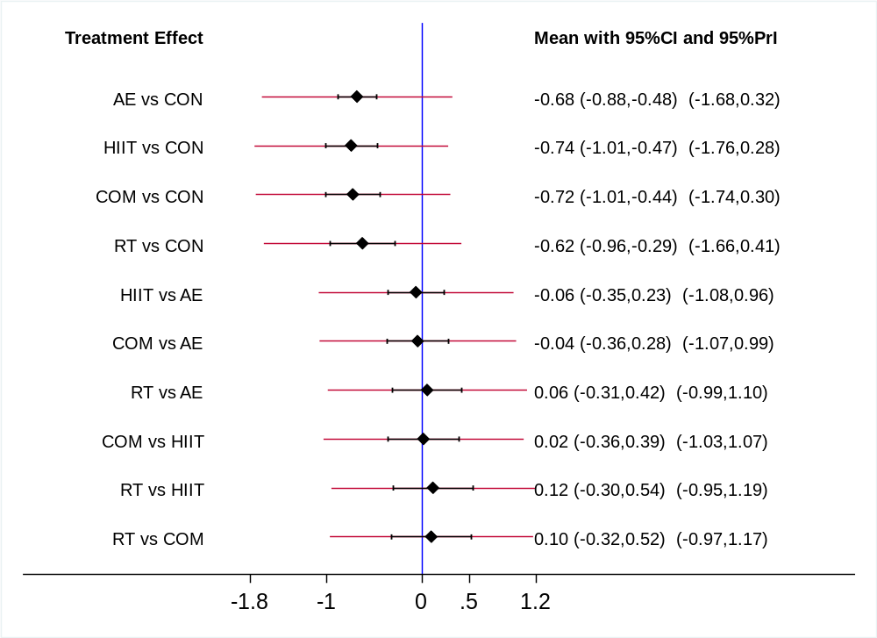
Appendix 7 Results of Pairwise Comparison
CON = Control, AE = Aerobic exercise, RT = Resistance training, COM = Combined aerobic and resistance training, HIIT = High-intensity interval training

Appendix 8 Results of the GRADE Assessment of the Quality of Evidence

Figure S1 Overview of Limitations in the Studies
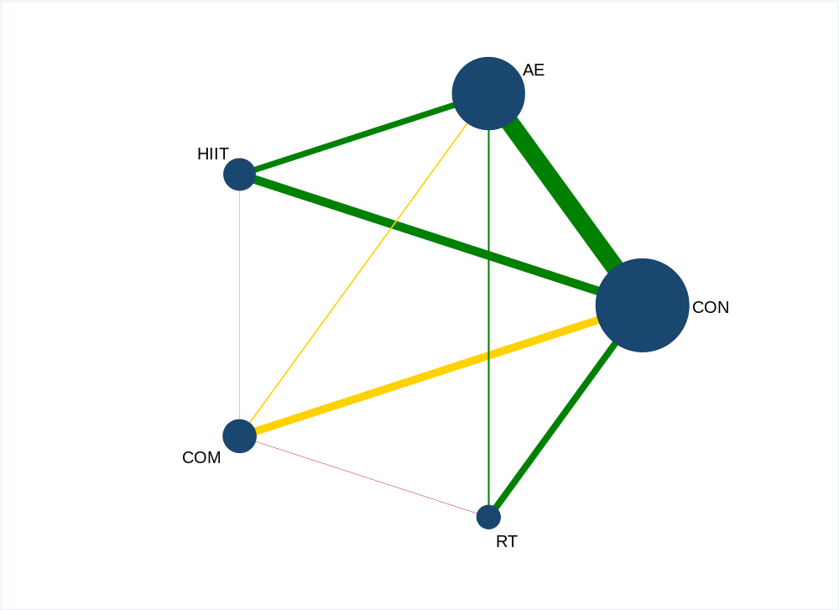
The color of the lines represents the overall risk-of-bias judgement for the comparison between the corresponding interventions, derived from the RoB 2.0 assessments of the included studies: green = low risk of bias; yellow = some concerns; red = high risk of bias.
CON = Control, AE = Aerobic exercise, RT = Resistance training, COM = Combined aerobic and resistance training, HIIT = High-intensity interval training

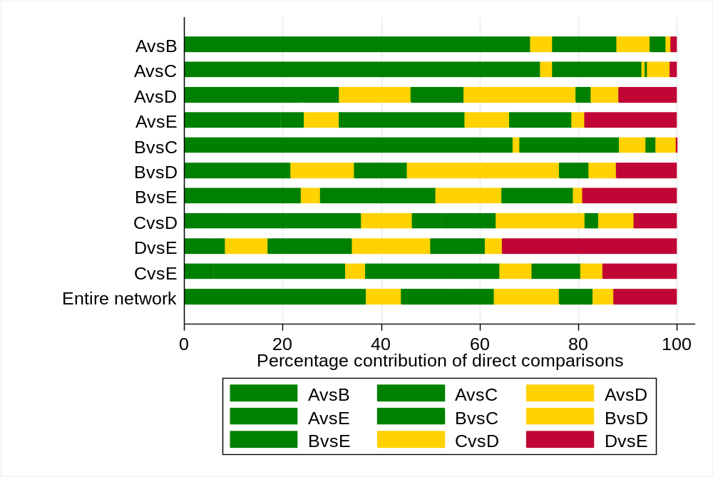
Figure S2 Contribution of Risk-of-Bias Judgements (RoB 2.0) to Each Network Estimate
A: Control, B: Aerobic exercise, C: High-intensity interval training, D: Combined aerobic and resistance training, E: Resistance training, green: low risk, yellow: some concerns, red: high risk

Table S8 Reasons for Downgrading in the GRADE Assessment of the Quality of Evidence

(1) Study Limitations
Each network estimate was rated according to the Grading of Recommendations, Assessment, Development, and Evaluation (GRADE) framework. Study limitations were assessed based on the risk-of-bias (RoB 2.0) judgments for each direct comparison, with the following scoring: low risk (green) = 0; some concerns (yellow) = −1; high risk (red) = −2. Based on these ratings, we calculated a weighted risk score for each comparison and the surface under the cumulative ranking curve (SUCRA) rankings, reflecting the impact of RoB 2.0 scores in direct comparisons on the corresponding network estimate. If the risk score was between −1.5 and −0.6, the certainty was downgraded by one level, labeled as "Study limitations"; if the risk score was less than −1.6, it was downgraded by two levels, labeled as "Study limitations²".

(2) Indirectness
Downgrading for indirectness was determined by evaluating whether the contribution plot (Appendix 5) was informed solely by indirect evidence.

(3) Heterogeneity and Inconsistency
For heterogeneity in direct comparisons, we determined whether the prediction intervals between interventions in the prediction interval plot (Appendix 7) crossed the line of no effect; if they did (i.e., the red solid line intersected the blue solid line), the comparison was classified as highly heterogeneous (labeled as "Heterogeneity"). Inconsistency between direct and indirect evidence was assessed using loop-specific heterogeneity estimates and node-splitting analyses (labeled as "Inconsistency").

(4) Imprecision
When the total sample size is less than 400, an overall downgrade of one level is applied. Imprecision in ranking results was assessed by the magnitude of differences between interventions' SUCRA values; when the differences were small, the corresponding intervention was downgraded by one level.

(5) Publication Bias
Assessed for downgrading by analyzing the funnel plot (Figure 5 in the main text).
Comparison | Nature of the evidence | Confidence | Downgrading due to
AvsB | Mixed | Moderate | Heterogeneity
AvsC | Mixed | Moderate | Heterogeneity
AvsD | Mixed | Low | Study limitations, Heterogeneity
AvsE | Mixed | Low | Study limitations, Heterogeneity
BvsC | Mixed | Moderate | Publication bias
BvsD | Mixed | Moderate | Study limitations
BvsE | Mixed | Moderate | Study limitations
CvsD | Mixed | Moderate | Imprecision
DvsE | Mixed | Moderate | Study limitations
CvsE | Indirect | Moderate | Indirectness
Ranking of treatments |  | Moderate | Publication Bias
A: Control, B: Aerobic exercise, C: High-intensity interval training, D: Combined aerobic and resistance training, E: Resistance training

Appendix 9 Key Assumptions of Bayesian Dose-Response Analysis

(1) Connectivity
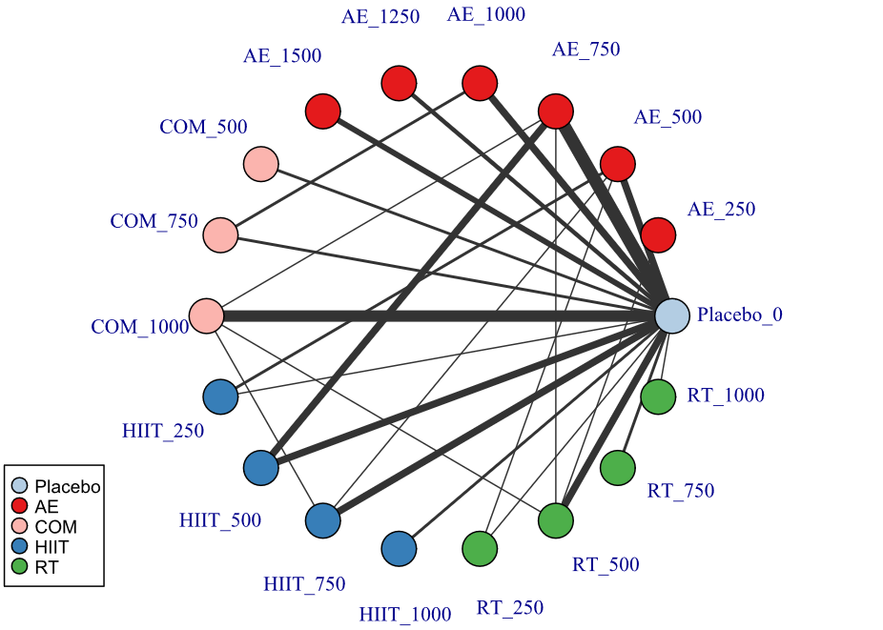
Within the theoretical framework of network meta-analysis (NMA), network connectivity is a fundamental prerequisite for valid comparisons. Insufficient connectivity may not only reduce statistical power but also increase the risk of bias, thereby raising the likelihood of erroneous conclusions. In this study, we systematically assessed network connectivity at two levels: exercise modality and exercise dose. The results (Figure S3) showed no evidence of network disconnection, indicating that the network structure remained overall connected.
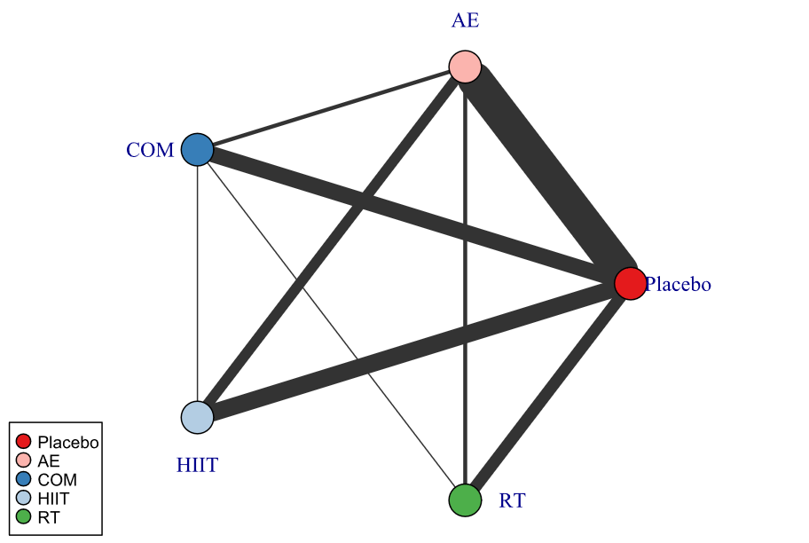
Figure S3 Treatment-level network
Figure S4 Agent-level network
AE = Aerobic exercise, RT = Resistance training, COM = Combined aerobic and resistance training, HIIT = High-intensity interval training, Placebo = Control

(2) Consistency
Data consistency was assessed by comparing the results from the network consistency model with those from an unrelated mean effects model. In this study, we compared the deviance values, the number of estimated parameters in the network, and the deviance information criterion (DIC) between the two models to evaluate model fit, as shown in Table S9.
Table S9 Comparison of fit between the consistency and UME models
Model | pV | Residual deviance | DIC | SD
Consistent | 155.5 | 153.387 | 891.5 | 0.583
UME | 150.1 | 152.682 | 887.4 | 0.711
UME = Unrelated Mean Effects, pV = Number of estimated parameters, DIC = Deviance Information Criterion, SD = Standard Deviation

(3) Transitivity
In this study, we applied a node-splitting approach within a multivariate network meta-analysis (MBNMA) framework to assess consistency by partitioning the contribution of a given treatment contrast into direct and indirect components and comparing the corresponding estimates; when the two estimates were similar, the evidence was considered consistent, as shown in Table S10 and Figure S5.
Table S10 Node-splitting analysis of inconsistency
Comparison | p-value | Median | 2.50% | 97.50%
RT_500 vs COM_1000 | 0.575
-> direct |  | 0.451 | -0.953 | 1.902
-> indirect |  | 0.244 | -0.356 | 0.818
-> MBNMA |  | 0.27 | -0.258 | 0.814
HIIT_750 vs COM_1000 | 0.545
-> direct |  | -0.272 | -1.897 | 1.394
-> indirect |  | 0.005 | -0.612 | 0.578
-> MBNMA |  | -0.021 | -0.593 | 0.52
COM_750 vs AE_1000 | 0.446
-> direct |  | 0.33 | -0.747 | 1.417
-> indirect |  | -0.097 | -0.528 | 0.32
-> MBNMA |  | -0.135 | -0.53 | 0.264
RT_500 vs AE_750 | 0.442
-> direct |  | 0.235 | -1.435 | 1.803
-> indirect |  | 0.036 | -0.408 | 0.478
-> MBNMA |  | 0.051 | -0.372 | 0.466
HIIT_500 vs AE_750 | 0.107
-> direct |  | -0.679 | -1.387 | 0.003
-> indirect |  | 0.158 | -0.178 | 0.503
-> MBNMA |  | 0.005 | -0.308 | 0.339
COM_1000 vs AE_750 | 0.503
-> direct |  | 0.166 | -1.406 | 1.688
-> indirect |  | 0.263 | -0.219 | 0.736
-> MBNMA |  | 0.22 | -0.224 | 0.681
RT_250 vs AE_500 | 0.189
-> direct |  | -0.612 | -2.251 | 0.918
-> indirect |  | 0.12 | -0.108 | 0.342
-> MBNMA |  | 0.111 | -0.114 | 0.337
HIIT_750 vs AE_500 | 0.27
-> direct |  | 0.387 | -1.064 | 1.831
-> indirect |  | -0.503 | -0.934 | -0.06
-> MBNMA |  | -0.418 | -0.833 | -0.004
HIIT_250 vs AE_500 | 0.166
-> direct |  | -0.61 | -1.764 | 0.547
-> indirect |  | 0.105 | -0.078 | 0.28
-> MBNMA |  | 0.088 | -0.09 | 0.28
RT_500 vs AE_250 | 0.298
-> direct |  | 0.36 | -1.139 | 1.818
-> indirect |  | -0.357 | -0.753 | 0.027
-> MBNMA |  | -0.294 | -0.672 | 0.089
RT_1000 vs Placebo_0 | 0.622
-> direct |  | -1.311 | -2.77 | 0.271
-> indirect |  | -0.833 | -1.706 | 0.019
-> MBNMA |  | -0.934 | -1.705 | -0.157
RT_750 vs Placebo_0 | 0.445
-> direct |  | -0.194 | -1.364 | 0.976
-> indirect |  | -0.866 | -1.539 | -0.211
-> MBNMA |  | -0.701 | -1.278 | -0.118
HIIT_1000 vs Placebo_0 | 0.582
-> direct |  | -0.691 | -1.772 | 0.442
-> indirect |  | -1.128 | -1.746 | -0.492
-> MBNMA |  | -1.016 | -1.567 | -0.473
COM_500 vs Placebo_0 | 0.009
-> direct |  | -1.924 | -2.891 | -0.874
-> indirect |  | -0.311 | -0.511 | -0.102
-> MBNMA |  | -0.366 | -0.582 | -0.159
AE_1500 vs Placebo_0 | 0.822
-> direct |  | -1.003 | -1.777 | -0.263
-> indirect |  | -1.052 | -1.559 | -0.51
-> MBNMA |  | -1.029 | -1.441 | -0.624
AE_1250 vs Placebo_0 | 0.623
-> direct |  | -0.888 | -1.743 | -0.045
-> indirect |  | -0.847 | -1.239 | -0.456
-> MBNMA |  | -0.857 | -1.201 | -0.52
AE = Aerobic exercise, RT = Resistance training, COM = Combined aerobic and resistance training, HIIT = High-intensity interval training, Placebo = Control
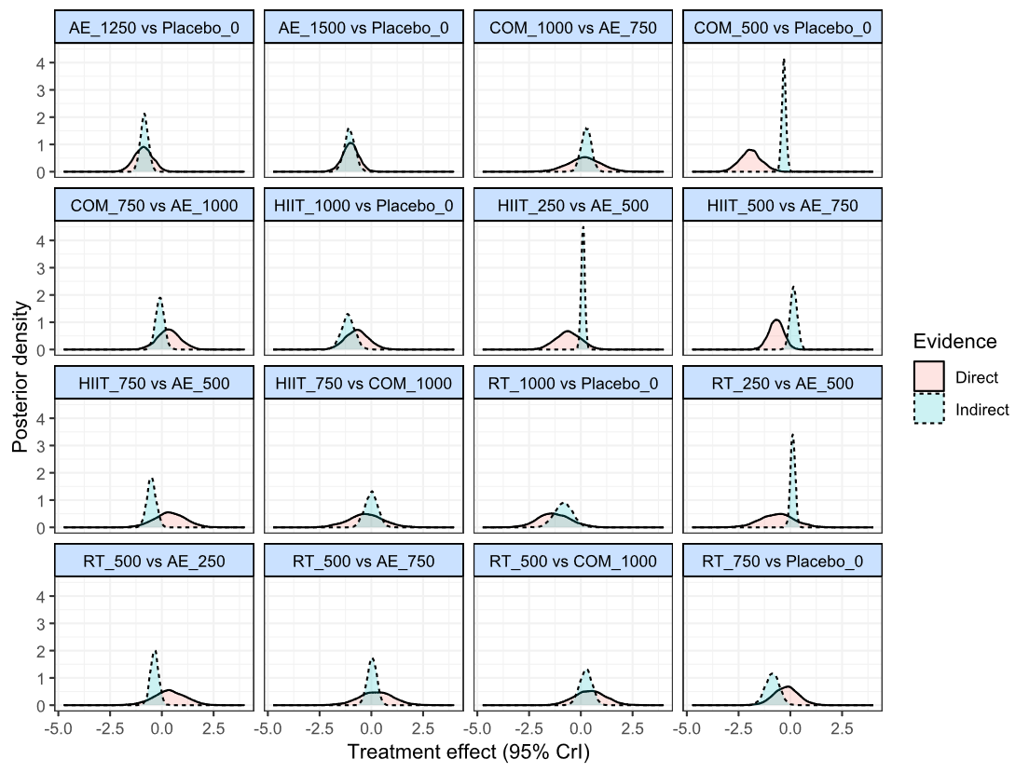
Figure S5 Node-splitting analysis
AE = Aerobic exercise, RT = Resistance training, COM = Combined aerobic and resistance training, HIIT = High-intensity interval training, Placebo = Control

Appendix 10 Model Selection in Bayesian Dose-Response Analysis

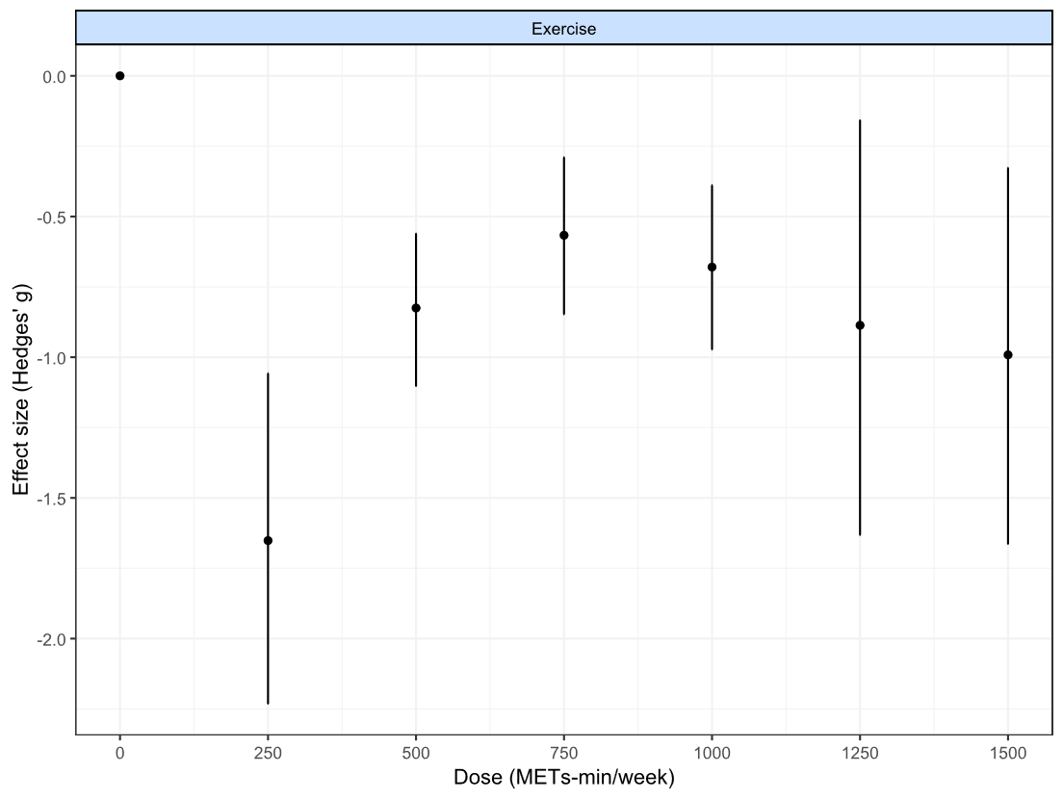
(1) Comparison of Nonlinear Functions and Model Fit
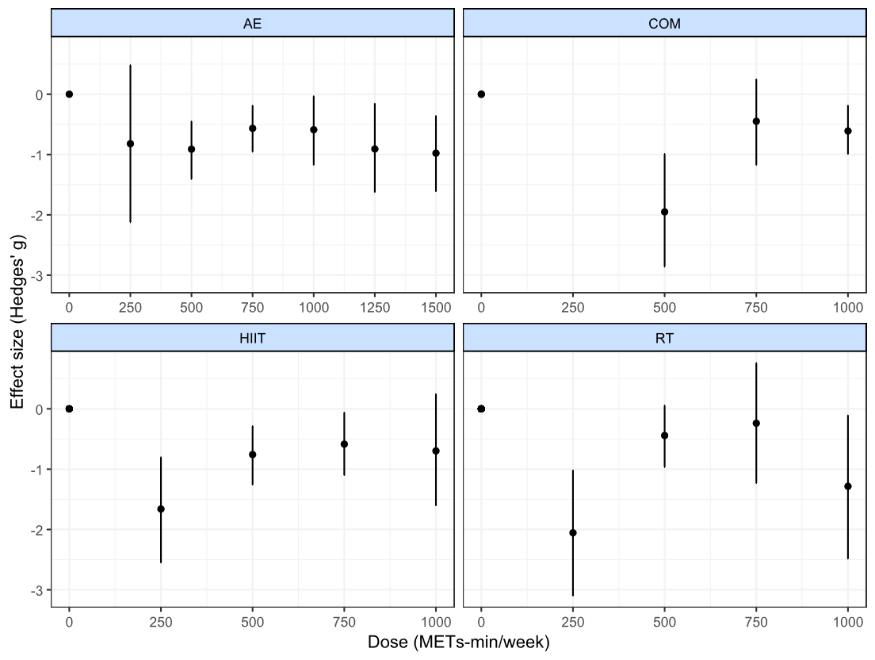
Figure S6 “Split” NMA of overall exercise
Figure S7 “Split” NMA of different exercise agents
AE = Aerobic exercise, RT = Resistance training, COM = Combined aerobic and resistance training, HIIT = High-intensity interval training

(2) Model Selection
Table S11 Model fit comparison
Model | DIC | SD | Deviance | Residual deviance | pV
Emax (common treatment effects) | 1114.8 | NA | 1034.249 | 450.652 | 80.5
Emax (random treatment effects) | 887.8 | 0.648 | 736.238 | 152.641 | 151.5
Restricted cubic spline  (common treatment effects; 3 knots) | 1006.2 | NA | 910.085 | 326.488 | 96.1
Restricted cubic spline  (random treatment effects; 3 knots) | 885.2 | 0.571 | 736.888 | 153.291 | 148.3
Quadratic  (2nd degree polynomial, common  treatment effects) | 1111.5 | NA | 1027.041 | 443.444 | 84.5
Quadratic  (2nd degree polynomial, random  treatment effects) | 874.8 | 0.678 | 737.106 | 153.509 | 137.6
Non-parametric monotonically up (common treatment effects) | 1130.2 | NA | 1030.727 | 447.130 | 99.4
DIC = Deviance Information Criterion, SD = Between-study Standard Deviation, pV = Number of estimated parameters,
NA = Not Applicable

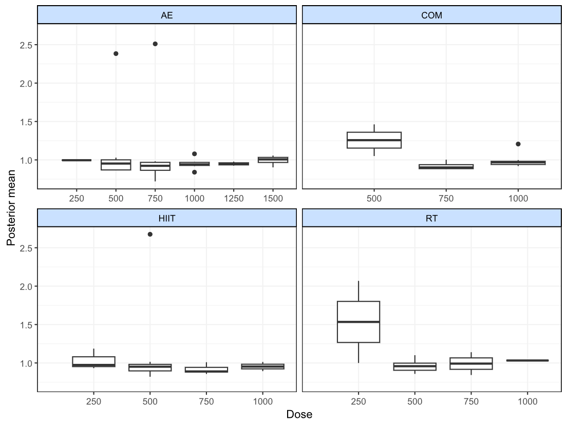
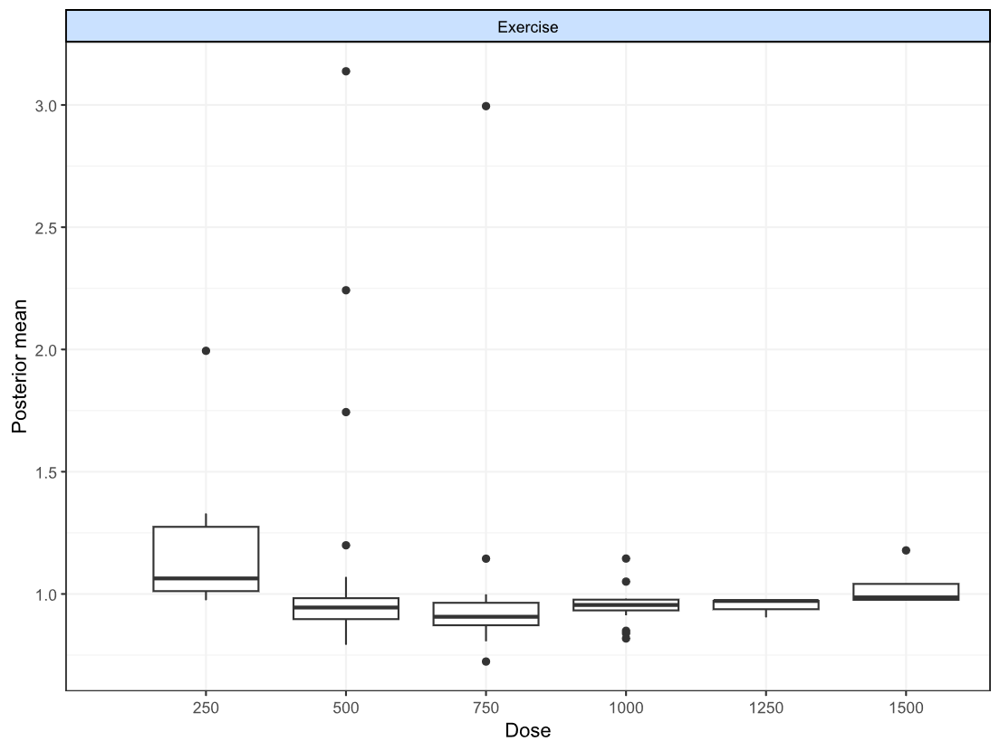
Figure S8 Deviance plot at overall exercise
Figure S9 Deviance plots at treatment-level
AE = Aerobic exercise, RT = Resistance training, COM = Combined aerobic and resistance training, HIIT = High-intensity interval training

Appendix 11 Bayesian Dose-Response Relationship
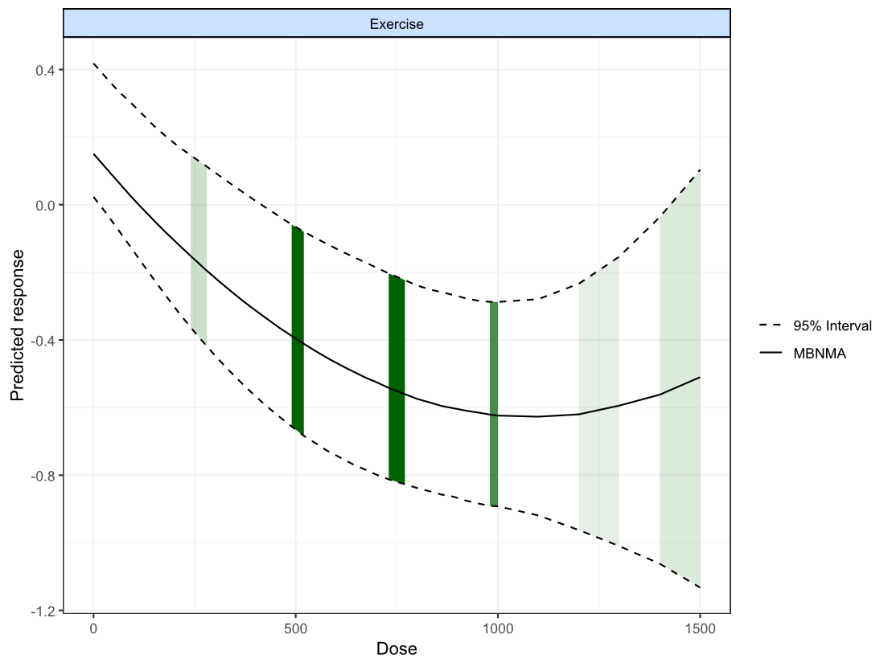
(1) Bayesian Dose-Response Relationship Between Exercise Dose and Visceral Adipose Tissue in Adults With Overweight or Obesity
Figure S10 Bayesian Dose-Response Relationship Between Exercise Dose and Visceral Adipose Tissue
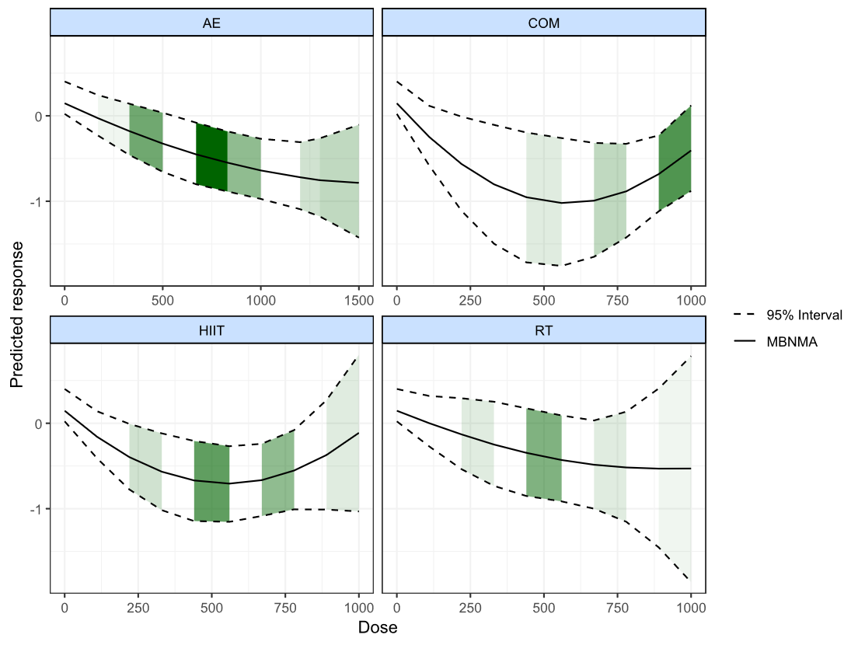
Figure S11 Bayesian Dose-Response Relationships for Four Exercise Modalities
AE = Aerobic exercise, RT = Resistance training, COM = Combined aerobic and resistance training, HIIT = High-intensity interval training

(2) Ranking of the Effectiveness of the Four Interventions
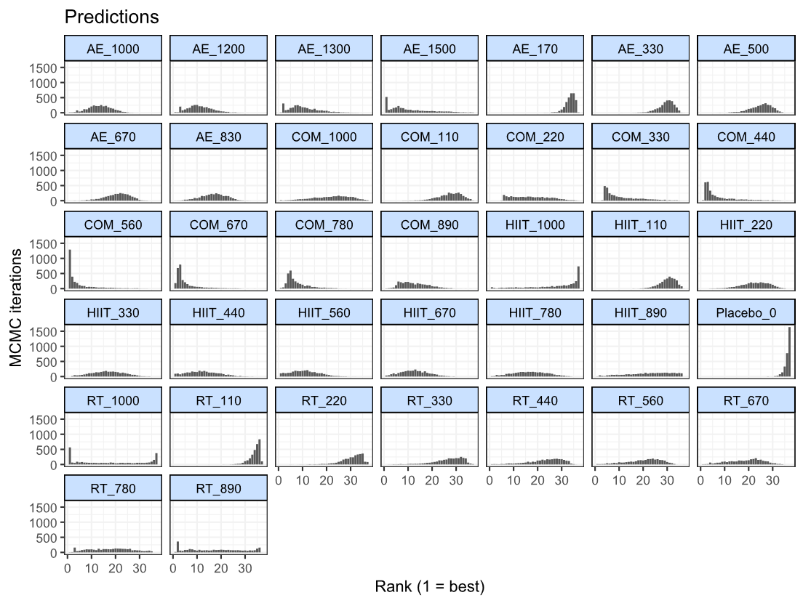
Figure S12 shows the probability of the four interventions being ranked from best to worst (estimated after up to 5000 iterations).
Figure S12 Effectiveness Ranking of the Four Exercise Interventions
AE = Aerobic exercise, RT = Resistance training, COM = Combined aerobic and resistance training, HIIT = High-intensity interval training, Placebo = Control

Table S12 Predictions ranking (from best to worst)
Treatment | Mean | Median | 2.50% | 97.50%
COM_560 | 4.81 | 2 | 1 | 23
COM_670 | 5.33 | 3 | 1 | 21
COM_440 | 7.27 | 4 | 2 | 26
COM_780 | 7.67 | 6 | 3 | 20.03
AE_1300 | 10.45 | 9 | 2 | 25
AE_1500 | 10.61 | 8 | 1 | 31
HIIT_560 | 10.83 | 11 | 1 | 23
COM_330 | 11.04 | 8 | 4 | 29
AE_1200 | 11.09 | 11 | 3 | 22
HIIT_440 | 12.37 | 12 | 1 | 25
HIIT_670 | 12.57 | 12 | 2 | 24
COM_890 | 12.64 | 12 | 4 | 25
AE_1000 | 13.44 | 13 | 4 | 23
HIIT_330 | 16.62 | 17 | 4 | 29
HIIT_780 | 16.76 | 17 | 3 | 30
AE_830 | 16.82 | 17 | 6 | 26
COM_220 | 17.26 | 17 | 6 | 32
RT_890 | 17.68 | 17 | 2 | 36
RT_780 | 17.81 | 18 | 3 | 34
RT_1000 | 18.14 | 17 | 1 | 37
RT_670 | 18.71 | 20 | 4 | 31
RT_560 | 20.4 | 22 | 5 | 31
AE_670 | 20.76 | 21 | 10 | 29
COM_1000 | 22.01 | 23 | 6 | 35
HIIT_890 | 22.52 | 24 | 4 | 36
HIIT_220 | 22.74 | 23 | 11 | 32
RT_440 | 23.29 | 24 | 7 | 33
AE_500 | 25.16 | 26 | 15 | 32
RT_330 | 26.8 | 28 | 11 | 35
COM_110 | 27.42 | 28 | 17 | 35
HIIT_1000 | 27.86 | 32 | 3.98 | 37
AE_330 | 29.59 | 30 | 22 | 35
HIIT_110 | 30.2 | 31 | 22 | 36
RT_220 | 30.55 | 32 | 19 | 37
AE_170 | 33.52 | 34 | 29 | 36
RT_110 | 34.07 | 35 | 28 | 37
Placebo_0 | 36.2 | 37 | 33 | 37

Appendix 12 References of Included Studies
1. Mohammadi, A., Bijeh, N., Moazzami, M., Kazem Khodaei, & Rahimi, N. (2022). Effect of exercise training on spexin level, appetite, lipid accumulation product, visceral adiposity index, and body composition in adults with type 2 diabetes. Biological Research For Nursing, 24(2), 152–162. https://doi.org/10.1177/10998004211050596
2. Hyun, A. (2021). Effect of real-time online high-intensity interval training on physiological and physical parameters for abdominally obese women: A randomized pilot study. Applied Sciences, 11(24), 12129. https://doi.org/10.3390/app112412129
3. Jamka, M., Mądry, E., Krzyżanowska-Jankowska, P., Skrypnik, D., Szulińska, M., Mądry, R., Lisowska, A., Batyrova, G., Duś-Żuchowska, M., Gotz-Więckowska, A., Bogdański, P., & Walkowiak, J. (2021). The effect of endurance and endurance-strength training on body composition and cardiometabolic markers in abdominally obese women: A randomised trial. Scientific Reports, 11(1), 12339. https://doi.org/10.1038/s41598-021-90526-7
4. Rashidi, Z., Beigi, R., Mardaniyan Ghahfarrokhi, M., Faramarzi, M., Banitalebi, E., Jafari, T., Earnest, C. P., & Baker, J. S. (2021). Effect of elastic band resistance training with green coffee extract supplementation on adiposity indices and TyG-related indicators in obese women. Obesity Medicine, 24, 100351. https://doi.org/10.1016/j.obmed.2021.100351
5. Valsdottir, T. D., Øvrebø, B., Falck, T. M., Litleskare, S., Johansen, E. I., Henriksen, C., & Jensen, J. (2021). Low-carbohydrate high-fat diet and exercise: Effect of a 10-week intervention on body composition and CVD risk factors in overweight and obese women—a randomized controlled trial. Nutrients, 13(1), 110. https://doi.org/10.3390/nu13010110
6. Abdelbasset, W. K., Tantawy, S. A., Kamel, D. M., Alqahtani, B. A., Elnegamy, T. E., Soliman, G. S., & Ibrahim, A. A. (2020). Effects of high-intensity interval and moderate-intensity continuous aerobic exercise on diabetic obese patients with nonalcoholic fatty liver disease: A comparative randomized controlled trial. Medicine, 99(10), e19471. https://doi.org/10.1097/MD.0000000000019471
7. Gripp, F., Nava, R. C., Cassilhas, R. C., Esteves, E. A., Magalhães, C. O. D., Dias-Peixoto, M. F., De Castro Magalhães, F., & Amorim, F. T. (2021). HIIT is superior than MICT on cardiometabolic health during training and detraining. European Journal of Applied Physiology, 121(1), 159–172. https://doi.org/10.1007/s00421-020-04502-6
8. Lee, A. S., Johnson, N. A., McGill, M. J., Overland, J., Luo, C., Baker, C. J., Martinez-Huenchullan, S., Wong, J., Flack, J. R., & Twigg, S. M. (2020). Effect of high-intensity interval training on glycemic control in adults with type 1 diabetes and overweight or obesity: A randomized controlled trial with partial crossover. Diabetes Care, 43(9), 2281–2288. https://doi.org/10.2337/dc20-0342
9. Mendham, A. E., Larsen, S., George, C., Adams, K., Hauksson, J., Olsson, T., Fortuin-de Smidt, M. C., Nono Nankam, P. A., Hakim, O., Goff, L. M., Pheiffer, C., & Goedecke, J. H. (2020). Exercise training results in depot-specific adaptations to adipose tissue mitochondrial function. Scientific Reports, 10(1), 3785. https://doi.org/10.1038/s41598-020-60286-x
10. Ramos, J. S., Dalleck, L. C., Stennett, R. C., Mielke, G. I., Keating, S. E., Murray, L. S., Hasnain, S. Z., Fassett, R. G., McGuckin, M., Croci, I., & Coombes, J. S. (2020). Effect of different volumes of interval training and continuous exercise on interleukin-22 in adults with metabolic syndrome: A randomized trial. Diabetes, Metabolic Syndrome and Obesity: Targets and Therapy, 13, 2443–2453. https://doi.org/10.2147/DMSO.S251567
11. Ballin, M., Lundberg, E., Sörlén, N., Nordström, P., Hult, A., & Nordström, A. (2019). Effects of interval training on visceral adipose tissue in centrally obese 70‐year‐old individuals: A randomized controlled trial. Journal of the American Geriatrics Society, 67(8), 1625–1631. https://doi.org/10.1111/jgs.15919
12. Zhang, H., Tong, T. K., Kong, Z., Shi, Q., Liu, Y., & Nie, J. (2021). Exercise training‐induced visceral fat loss in obese women: The role of training intensity and modality. Scandinavian Journal of Medicine & Science in Sports, 31(1), 30–43. https://doi.org/10.1111/sms.13803
13. Fortuin-de Smidt, M. C., Mendham, A. E., Hauksson, J., Hakim, O., Stefanovski, D., Clamp, L., Phiri, L., Swart, J., Goff, L. M., Micklesfield, L. K., Kahn, S. E., Olsson, T., & Goedecke, J. H. (2020). Effect of exercise training on insulin sensitivity, hyperinsulinemia and ectopic fat in black south african women: A randomized controlled trial. European Journal of Endocrinology, 183(1), 51–61. https://doi.org/10.1530/EJE-19-0957
14. Boutcher, Y. N., Boutcher, S. H., Yoo, H. Y., & Meerkin, J. D. (2019). The effect of sprint interval training on body composition of postmenopausal women. Medicine & Science in Sports & Exercise, 51(7), 1413–1419. https://doi.org/10.1249/MSS.0000000000001919
15. Cho, A.-R., Moon, J.-Y., Kim, S., An, K.-Y., Oh, M., Jeon, J. Y., Jung, D.-H., Choi, M. H., & Lee, J.-W. (2019). Effects of alternate day fasting and exercise on cholesterol metabolism in overweight or obese adults: A pilot randomized controlled trial. Metabolism, 93, 52–60. https://doi.org/10.1016/j.metabol.2019.01.002
16. Hagovska, M., Švihra, J., Buková, A., Dračková, D., Horbacz, A., & Nagyová, I. (2020). Effect of an exercise programme for reducing abdominal fat on overactive bladder symptoms in young overweight women. International Urogynecology Journal, 31(5), 895–902. https://doi.org/10.1007/s00192-019-04157-8
17. Dupuit, M., Rance, M., Morel, C., Bouillon, P., Pereira, B., Bonnet, A., Maillard, F., Duclos, M., & Boisseau, N. (2020). Moderate-intensity continuous training or high-intensity interval training with or without resistance training for altering body composition in postmenopausal women. Medicine & Science in Sports & Exercise, 52(3), 736–745. https://doi.org/10.1249/MSS.0000000000002162
18. Nunes, P. R. P., Martins, F. M., Souza, A. P., Carneiro, M. A. S., Orsatti, C. L., Michelin, M. A., Murta, E. F. C., De Oliveira, E. P., & Orsatti, F. L. (2019). Effect of high-intensity interval training on body composition and inflammatory markers in obese postmenopausal women: A randomized controlled trial. Menopause, 26(3), 256–264. https://doi.org/10.1097/GME.0000000000001207
19. Ratajczak, M., Skrypnik, D., Bogdański, P., Mądry, E., Walkowiak, J., Szulińska, M., Maciaszek, J., Kręgielska-Narożna, M., & Karolkiewicz, J. (2019). Effects of endurance and endurance–strength training on endothelial function in women with obesity: A randomized trial. International Journal of Environmental Research and Public Health, 16(21), 4291. https://doi.org/10.3390/ijerph16214291
20. Bairapareddy, K. C., Maiya, A. G., Kumar, P., Nayak, K., Guddattu, V., & Nayak, V. (2018). Effect of aerobic exercise on echocardiographic epicardial adipose tissue thickness in overweight individuals. Diabetes, Metabolic Syndrome and Obesity: Targets and Therapy, 11, 303–312. https://doi.org/10.2147/DMSO.S145862
21. Wedell-Neergaard, A.-S., Lang Lehrskov, L., Christensen, R. H., Legaard, G. E., Dorph, E., Larsen, M. K., Launbo, N., Fagerlind, S. R., Seide, S. K., Nymand, S., Ball, M., Vinum, N., Dahl, C. N., Henneberg, M., Ried-Larsen, M., Nybing, J. D., Christensen, R., Rosenmeier, J. B., Karstoft, K., … Krogh-Madsen, R. (2019). Exercise-induced changes in visceral adipose tissue mass are regulated by IL-6 signaling: A randomized controlled trial. Cell Metabolism, 29(4), 844-855.e3. https://doi.org/10.1016/j.cmet.2018.12.007
22. Holliday, A., Burgin, A., Fernandez, E. V., Fenton, S. A. M., Thielecke, F., & Blannin, A. K. (2018). Points-based physical activity: A novel approach to facilitate changes in body composition in inactive women with overweight and obesity. BMC Public Health, 18(1), 261. https://doi.org/10.1186/s12889-018-5125-2
23. Roy, M., Williams, S. M., Brown, R. C., Meredith-Jones, K. A., Osborne, H., Jospe, M., & Taylor, R. W. (2018). High-intensity interval training in the real world: Outcomes from a 12-month intervention in overweight adults. Medicine & Science in Sports & Exercise, 50(9), 1818–1826. https://doi.org/10.1249/MSS.0000000000001642
24. Tong, T. K., Zhang, H., Shi, H., Liu, Y., Ai, J., Nie, J., & Kong, Z. (2018). Comparing Time Efficiency of Sprint vs. High-Intensity Interval Training in Reducing Abdominal Visceral Fat in Obese Young Women: A Randomized, Controlled Trial. Frontiers in Physiology, 9, 1048. https://doi.org/10.3389/fphys.2018.01048
25. Chen, H., Chung, Y., Chen, Y., Ho, S., & Wu, H. (2017). Effects of different types of exercise on body composition, muscle strength, and IGF‐1 in the elderly with sarcopenic obesity. Journal of the American Geriatrics Society, 65(4), 827–832. https://doi.org/10.1111/jgs.14722
26. Oh, S., So, R., Shida, T., Matsuo, T., Kim, B., Akiyama, K., Isobe, T., Okamoto, Y., Tanaka, K., & Shoda, J. (2017). High-Intensity Aerobic Exercise Improves Both Hepatic Fat Content and Stiffness in Sedentary Obese Men with Nonalcoholic Fatty Liver Disease. Scientific Reports, 7(1), 43029. https://doi.org/10.1038/srep43029
27. Keating, S. E., Hackett, D. A., Parker, H. M., Way, K. L., O’Connor, H. T., Sainsbury, A., Baker, M. K., Chuter, V. H., Caterson, I. D., George, J., & Johnson, N. A. (2017). Effect of resistance training on liver fat and visceral adiposity in adults with obesity: A randomized controlled trial. Hepatology Research, 47(7), 622–631. https://doi.org/10.1111/hepr.12781
28. Wu, S., Park, K.-S., & McCormick, J. B. (2017). Effects of exercise training on fat loss and lean mass gain in mexican-American and korean premenopausal women. International Journal of Endocrinology, 2017, 1–7. https://doi.org/10.1155/2017/5465869
29. Houghton, D., Thoma, C., Hallsworth, K., Cassidy, S., Hardy, T., Burt, A. D., Tiniakos, D., Hollingsworth, K. G., Taylor, R., Day, C. P., McPherson, S., Anstee, Q. M., & Trenell, M. I. (2017). Exercise reduces liver lipids and visceral adiposity in patients with nonalcoholic steatohepatitis in a randomized controlled trial. Clinical Gastroenterology and Hepatology, 15(1), 96-102.e3. https://doi.org/10.1016/j.cgh.2016.07.031
30. Zhang, H., Tong, T. K., Qiu, W., Zhang, X., Zhou, S., Liu, Y., & He, Y. (2017). Comparable Effects of High-Intensity Interval Training and Prolonged Continuous Exercise Training on Abdominal Visceral Fat Reduction in Obese Young Women. Journal of Diabetes Research, 2017, 1–9. https://doi.org/10.1155/2017/5071740
31. Cooper, J. H. F., Collins, B. E. G., Adams, D. R., Robergs, R. A., & Donges, C. E. (2016). Limited effects of endurance or interval training on visceral adipose tissue and systemic inflammation in sedentary middle-aged men. Journal of Obesity, 2016, 1–10. https://doi.org/10.1155/2016/2479597
32. Maillard, F., Rousset, S., Pereira, B., Traore, A., De Pradel Del Amaze, P., Boirie, Y., Duclos, M., & Boisseau, N. (2016). High-intensity interval training reduces abdominal fat mass in postmenopausal women with type 2 diabetes. Diabetes & Metabolism, 42(6), 433–441. https://doi.org/10.1016/j.diabet.2016.07.031
33. Keating, S. E., Hackett, D. A., Parker, H. M., O’Connor, H. T., Gerofi, J. A., Sainsbury, A., Baker, M. K., Chuter, V. H., Caterson, I. D., George, J., & Johnson, N. A. (2015). Effect of aerobic exercise training dose on liver fat and visceral adiposity. Journal of Hepatology, 63(1), 174–182. https://doi.org/10.1016/j.jhep.2015.02.022
34. Arad, A. D., DiMenna, F. J., Thomas, N., Tamis-Holland, J., Weil, R., Geliebter, A., & Albu, J. B. (2015). High-intensity interval training without weight loss improves exercise but not basal or insulin-induced metabolism in overweight/obese African American women. Journal of Applied Physiology, 119(4), 352–362. https://doi.org/10.1152/japplphysiol.00306.2015
35. Baria, F., Kamimura, M. A., Aoike, D. T., Ammirati, A., Leister Rocha, M., De Mello, M. T., & Cuppari, L. (2014). Randomized controlled trial to evaluate the impact of aerobic exercise on visceral fat in overweight chronic kidney disease patients. Nephrology Dialysis Transplantation, 29(4), 857–864. https://doi.org/10.1093/ndt/gft529
36. Bacchi, E., Negri, C., Targher, G., Faccioli, N., Lanza, M., Zoppini, G., Zanolin, E., Schena, F., Bonora, E., & Moghetti, P. (2013). Both resistance training and aerobic training reduce hepatic fat content in type 2 diabetic subjects with nonalcoholic fatty liver disease (the RAED2 randomized trial). Hepatology, 58(4), 1287–1295. https://doi.org/10.1002/hep.26393
37. Zhang, H., Tong, T. K., Qiu, W., Wang, J., Nie, J., & He, Y. (2015). Effect of high-intensity interval training protocol on abdominal fat reduction in overweight Chinese women: A randomized controlled trial. Kinesiology, 47(1), 57–66.
38. Herzig, K.-H., Ahola, R., Leppäluoto, J., Jokelainen, J., Jämsä, T., & Keinänen-Kiukaanniemi, S. (2014). Light physical activity determined by a motion sensor decreases insulin resistance, improves lipid homeostasis and reduces visceral fat in high-risk subjects: PreDiabEx study RCT. International Journal of Obesity, 38(8), 1089–1096. https://doi.org/10.1038/ijo.2013.224
39. Bouchonville, M., Armamento-Villareal, R., Shah, K., Napoli, N., Sinacore, D. R., Qualls, C., & Villareal, D. T. (2014). Weight loss, exercise or both and cardiometabolic risk factors in obese older adults: Results of a randomized controlled trial. International Journal of Obesity, 38(3), 423–431. https://doi.org/10.1038/ijo.2013.122
40. Dobrosielski, D. A., Gibbs, B. B., Ouyang, P., Bonekamp, S., Clark, J. M., Wang, N.-Y., Silber, H. A., Shapiro, E. P., & Stewart, K. J. (2012). Effect of Exercise on Blood Pressure in Type 2 Diabetes: A Randomized Controlled Trial. Journal of General Internal Medicine, 27(11), 1453–1459. https://doi.org/10.1007/s11606-012-2103-8
41. Jung, J. Y., Han, K. A., Ahn, H. J., Kwon, H. R., Lee, J. H., Park, K. S., & Min, K. W. (2012). Effects of aerobic exercise intensity on abdominal and thigh adipose tissue and skeletal muscle attenuation in overweight women with type 2 diabetes mellitus. Diabetes & Metabolism Journal, 36(3), 211–221. https://doi.org/10.4093/dmj.2012.36.3.211
42. Donges, C. E., Duffield, R., Guelfi, K. J., Smith, G. C., Adams, D. R., & Edge, J. A. (2013). Comparative effects of single-mode vs. Duration-matched concurrent exercise training on body composition, low-grade inflammation, and glucose regulation in sedentary, overweight, middle-aged men. Applied Physiology, Nutrition, and Metabolism, 38(7), 779–788. https://doi.org/10.1139/apnm-2012-0443
43. Heydari, M., Freund, J., & Boutcher, S. H. (2012). The effect of high-intensity intermittent exercise on body composition of overweight young males. Journal of Obesity, 2012, 1–8. https://doi.org/10.1155/2012/480467
44. Moghadasi, M., Mohebbi, H., Rahmani‐Nia, F., Hassan‐Nia, S., & Noroozi, H. (2013). Effects of short‐term lifestyle activity modification on adiponectin mRNA expression and plasma concentrations. European Journal of Sport Science, 13(4), 378–385. https://doi.org/10.1080/17461391.2011.635701
45. Kim, J.-W., & Kim, D.-Y. (2012). Effects of Aerobic Exercise Training on Serum Sex Hormone Binding Globulin, Body Fat Index, and Metabolic Syndrome Factors in Obese Postmenopausal Women. Metabolic Syndrome and Related Disorders, 10(6), 452–457. https://doi.org/10.1089/met.2012.0036
46. Slentz, C. A., Bateman, L. A., Willis, L. H., Shields, A. T., Tanner, C. J., Piner, L. W., Hawk, V. H., Muehlbauer, M. J., Samsa, G. P., Nelson, R. C., Huffman, K. M., Bales, C. W., Houmard, J. A., & Kraus, W. E. (2011). Effects of aerobic vs. Resistance training on visceral and liver fat stores, liver enzymes, and insulin resistance by HOMA in overweight adults from STRRIDE AT/RT. American Journal of Physiology-Endocrinology and Metabolism, 301(5), E1033–E1039. https://doi.org/10.1152/ajpendo.00291.2011
47. Hallsworth, K., Fattakhova, G., Hollingsworth, K. G., Thoma, C., Moore, S., Taylor, R., Day, C. P., & Trenell, M. I. (2011). Resistance exercise reduces liver fat and its mediators in non-alcoholic fatty liver disease independent of weight loss. Gut, 60(9), 1278–1283. https://doi.org/10.1136/gut.2011.242073
48. Friedenreich, C. M., Woolcott, C. G., McTiernan, A., Terry, T., Brant, R., Ballard-Barbash, R., Irwin, M. L., Jones, C. A., Boyd, N. F., Yaffe, M. J., Campbell, K. L., McNeely, M. L., Karvinen, K. H., & Courneya, K. S. (2011). Adiposity changes after a 1-year aerobic exercise intervention among postmenopausal women: A randomized controlled trial. International Journal of Obesity, 35(3), 427–435. https://doi.org/10.1038/ijo.2010.147
49. Ku, Y., Han, K., Ahn, H., Kwon, H., Koo, B., Kim, H., & Min, K. (2010). Resistance Exercise Did Not Alter Intramuscular Adipose Tissue but Reduced Retinol-binding Protein-4 Concentration in Individuals with Type 2 Diabetes Mellitus. Journal of International Medical Research, 38(3), 782–791. https://doi.org/10.1177/147323001003800305
50. Kwon, H. R., Min, K. W., Ahn, H. J., Seok, H. G., Koo, B. K., Kim, H. C., & Han, K. A. (2010). Effects of aerobic exercise on abdominal fat, thigh muscle mass and muscle strength in type 2 diabetic subject. Korean Diabetes Journal, 34(1), 23–31. https://doi.org/10.4093/kdj.2010.34.1.23
51. Barone, B. B., Wang, N.-Y., Bacher, A. C., & Stewart, K. J. (2009). Decreased exercise blood pressure in older adults after exercise training: Contributions of increased fitness and decreased fatness. British Journal of Sports Medicine, 43(1), 52–56. https://doi.org/10.1136/bjsm.2008.050906
52. Schmitz, K. H., Hannan, P. J., Stovitz, S. D., Bryan, C. J., Warren, M., & Jensen, M. D. (2007). Strength training and adiposity in premenopausal women: Strong, Healthy, and Empowered study. The American Journal of Clinical Nutrition, 86(3), 566–572. https://doi.org/10.1093/ajcn/86.3.566
53. Slentz, C. A., Aiken, L. B., Houmard, J. A., Bales, C. W., Johnson, J. L., Tanner, C. J., Duscha, B. D., & Kraus, W. E. (2005). Inactivity, exercise, and visceral fat. STRRIDE: A randomized, controlled study of exercise intensity and amount. Journal of Applied Physiology, 99(4), 1613–1618.https://doi.org/10.1152/japplphysiol.00124.2005
54. Cuff, D. J., Meneilly, G. S., Martin, A., Ignaszewski, A., Tildesley, H. D., & Frohlich, J. J. (2003). Effective Exercise Modality to Reduce Insulin Resistance in Women With Type 2 Diabetes. Diabetes Care, 26(11), 2977–2982. https://doi.org/10.2337/diacare.26.11.2977
55. McTiernan, A., Sorensen, B., Irwin, M. L., Morgan, A., Yasui, Y., Rudolph, R. E., Surawicz, C., Lampe, J. W., Lampe, P. D., Ayub, K., & Potter, J. D. (2007). Exercise effect on weight and body fat in men and women. Obesity, 15(6), 1496–1512. https://doi.org/10.1038/oby.2007.178
56. Donnelly, J. E., Hill, J. O., Jacobsen, D. J., Potteiger, J., Sullivan, D. K., Johnson, S. L., Heelan, K., Hise, M., Fennessey, P. V., Sonko, B., Sharp, T., Jakicic, J. M., Blair, S. N., Tran, Z. V., Mayo, M., Gibson, C., & Washburn, R. A. (2003). Effects of a 16-month randomized controlled exercise trial on body weight and composition in young, overweight men and women: The midwest exercise trial. Archives of Internal Medicine, 163(11), 1343–1350. https://doi.org/10.1001/archinte.163.11.1343
57. Waters, D. L., Aguirre, L., Gurney, B., Sinacore, D. R., Fowler, K., Gregori, G., Armamento-Villareal, R., Qualls, C., & Villareal, D. T. (2022). Effect of aerobic or resistance exercise, or both, on intermuscular and visceral fat and physical and metabolic function in older adults with obesity while dieting. The Journals of Gerontology: Series A, 77(1), 131–139. https://doi.org/10.1093/gerona/glab111
58. Haganes, K. L., Silva, C. P., Eyjólfsdóttir, S. K., Steen, S., Grindberg, M., Lydersen, S., Hawley, J. A., & Moholdt, T. (2022). Time-restricted eating and exercise training improve HbA1c and body composition in women with overweight/obesity: A randomized controlled trial. Cell Metabolism, 34(10), 1457-1471.e4. https://doi.org/10.1016/j.cmet.2022.09.003
59. Lehmann, S., Retschlag, U., Oberbach, A., Morgenroth, R., Linder, N., Schaudinn, A., Garnov, N., Busse, H., Solty, K., Prettin, C., Köppe‐Bauernfeind, N., Flehmig, G., Selig, L., Trips, E., Stumvoll, M., Petroff, D., & Blüher, M. (2024). Visceral fat mass dynamics in a 2‐year randomized STrength versus ENdurance training trial in people with obesity. Diabetes, Obesity and Metabolism, 26(9), 4087–4099. https://doi.org/10.1111/dom.15767
60. Chang, Y.-H., Lee, Y.-H., Wu, K. L., Hsu, W.-L., Hung, H., & Shun, S.-C. (2025). Exercise strategy for reducing visceral adipose tissue in community residents with obesity: A sequential multiple assignment randomized trial. Journal of Nursing Research, 33(2), e385. https://doi.org/10.1097/jnr.0000000000000662

PRISMA NMA Checklist
Section/Topic | Item # | Checklist Item | Reported on Page #
TITLE
Title | 1 | Identify the report as a systematic review incorporating a network meta-analysis (or related form of meta-analysis). | P1
ABSTRACT
Structured summary | 2 | Provide a structured summary including, as applicable:  Background: main objectives  Methods: data sources; study eligibility criteria, participants, and interventions; study appraisal; and synthesis methods, such as network meta-analysis.  Results: number of studies and participants identified; summary estimates with corresponding confidence/credible intervals; treatment rankings may also be discussed. Authors may choose to summarize pairwise comparisons against a chosen treatment included in their analyses for brevity.  Discussion/Conclusions: limitations; conclusions and implications of findings.  Other: primary source of funding; systematic review registration number with registry name. | P1
INTRODUCTION
Rationale | 3 | Describe the rationale for the review in the context of what is already known, including mention of why a network meta-analysis has been conducted. | P2
Objectives | 4 | Provide an explicit statement of questions being addressed, with reference to participants, interventions, comparisons, outcomes, and study design (PICOS). | P2-P3
METHODS
Protocol and registration | 5 | Indicate whether a review protocol exists and if and where it can be accessed (e.g., Web address); and, if available, provide registration information, including registration number. | P3
Eligibility criteria | 6 | Specify study characteristics (e.g., PICOS, length of follow-up) and report characteristics (e.g., years considered, language, publication status) used as criteria for eligibility, giving rationale. Clearly describe eligible treatments included in the treatment network, and note whether any have been clustered or merged into the same node (with justification). | P3-P4
Information sources | 7 | Describe all information sources (e.g., databases with dates of coverage, contact with study authors to identify additional studies) in the search and date last searched. | P3
Search | 8 | Present full electronic search strategy for at least one database, including any limits used, such that it could be repeated. | P3  Appendix 1
Study selection | 9 | State the process for selecting studies (i.e., screening, eligibility, included in systematic review, and, if applicable, included in the meta-analysis). | P4
Data collection process | 10 | Describe method of data extraction from reports (e.g., piloted forms, independently, in duplicate) and any processes for obtaining and confirming data from investigators. | P4-P5
Data items | 11 | List and define all variables for which data were sought (e.g., PICOS, funding sources) and any assumptions and simplifications made. | P3-P4
Geometry of the network | S1 | Describe methods used to explore the geometry of the treatment network under study and potential biases related to it. This should include how the evidence base has been graphically summarized for presentation, and what characteristics were compiled and used to describe the evidence base to readers. | P5-P6
Risk of bias within individual studies | 12 | Describe methods used for assessing risk of bias of individual studies (including specification of whether this was done at the study or outcome level), and how this information is to be used in any data synthesis. | P5
Summary measures | 13 | State the principal summary measures (e.g., risk ratio, difference in means). Also describe the use of additional summary measures assessed, such as treatment rankings and surface under the cumulative ranking curve (SUCRA) values, as well as modified approaches used to present summary findings from meta-analyses. | P5
Planned methods of analysis | 14 | Describe the methods of handling data and combining results of studies for each network meta-analysis. This should include, but not be limited to:  Handling of multi-arm trials;  Selection of variance structure;  Selection of prior distributions in Bayesian analyses; and  Assessment of model fit. | P4-P5
Assessment of Inconsistency | S2 | Describe the statistical methods used to evaluate the agreement of direct and indirect evidence in the treatment network(s) studied. Describe efforts taken to address its presence when found. | P5-P6
Risk of bias across studies | 15 | Specify any assessment of risk of bias that may affect the cumulative evidence (e.g., publication bias, selective reporting within studies). | P5
Additional analyses | 16 | Describe methods of additional analyses if done, indicating which were pre-specified. This may include, but not be limited to, the following:  Sensitivity or subgroup analyses;  Meta-regression analyses;  Alternative formulations of the treatment network; and  Use of alternative prior distributions for Bayesian analyses (if applicable). | Not Applicable
RESULTS†
Study selection | 17 | Give numbers of studies screened, assessed for eligibility, and included in the review, with reasons for exclusions at each stage, ideally with a flow diagram. | P6-7  Figure 1
Presentation of network structure | S3 | Provide a network graph of the included studies to enable visualization of the geometry of the treatment network. | P8  Figure 2
Summary of network geometry | S4 | Provide a brief overview of characteristics of the treatment network. This may include commentary on the abundance of trials and randomized patients for the different interventions and pairwise comparisons in the network, gaps of evidence in the treatment network, and potential biases reflected by the network structure. | P8
Study characteristics | 18 | For each study, present characteristics for which data were extracted (e.g., study size, PICOS, follow-up period) and provide the citations. | P7  Appendix 3
Risk of bias within studies | 19 | Present data on risk of bias of each study and, if available, any outcome level assessment. | P8  Appendix 4
Results of individual studies | 20 | For all outcomes considered (benefits or harms), present, for each study: 1) simple summary data for each intervention group, and 2) effect estimates and confidence intervals. Modified approaches may be needed to deal with information from larger networks. | Not Applicable
Synthesis of results | 21 | Present results of each meta-analysis done, including confidence/credible intervals. In larger networks, authors may focus on comparisons versus a particular comparator (e.g., placebo or standard care), with full findings presented in an appendix. League tables and forest plots may be considered to summarize pairwise comparisons. If additional summary measures were explored (such as treatment rankings), these should also be presented. | P9-P10  Figure 3  Figure 4  Table 1
Exploration for inconsistency | S5 | Describe results from investigations of inconsistency. This may include such information as measures of model fit to compare consistency and inconsistency models, P values from statistical tests, or summary of inconsistency estimates from different parts of the treatment network. | P9  Appendix 6
Risk of bias across studies | 22 | Present results of any assessment of risk of bias across studies for the evidence base being studied. | P8  Appendix 8
Results of additional analyses | 23 | Give results of additional analyses, if done (e.g., sensitivity or subgroup analyses, meta-regression analyses, alternative network geometries studied, alternative choice of prior distributions for Bayesian analyses, and so forth). | P11-P13
DISCUSSION
Summary of evidence | 24 | Summarize the main findings, including the strength of evidence for each main outcome; consider their relevance to key groups (e.g., healthcare providers, users, and policy-makers). | P13-P15
Limitations | 25 | Discuss limitations at study and outcome level (e.g., risk of bias), and at review level (e.g., incomplete retrieval of identified research, reporting bias). Comment on the validity of the assumptions, such as transitivity and consistency. Comment on any concerns regarding network geometry (e.g., avoidance of certain comparisons). | P15-P16
Conclusions | 26 | Provide a general interpretation of the results in the context of other evidence, and implications for future research. | P16
FUNDING
Funding | 27 | Describe sources of funding for the systematic review and other support (e.g., supply of data); role of funders for the systematic review. This should also include information regarding whether funding has been received from manufacturers of treatments in the network and/or whether some of the authors are content experts with professional conflicts of interest that could affect use of treatments in the network. | Not Applicable
PICOS = population, intervention, comparators, outcomes, study design.
* Text in italics indicate wording specific to reporting of network meta-analyses that has been added to guidance from the PRISMA statement.
† Authors may wish to plan for use of appendices to present all relevant information in full detail for items in this section

