Figures Legend:
Fig.S1 Network diagram of intervention comparisons for Timed Up and Go (TUG) performance
Fig.S2 Network diagram of intervention comparisons for Berg Balance Scale (BBS)
Fig.S3 Network diagram of intervention comparisons for 6-Minute Walk Test (6MWT)
Fig.S4 Network diagram of intervention comparisons for 2-Minute Walk Test (2MWT)
Fig.S5 Network diagram of intervention comparisons for 10 Meter Walk Test (10MWT)
Fig.S6 Network diagram of intervention comparisons for Fatigue Severity Scale (FSS)
Fig.S7 Network diagram of intervention comparisons for Modified Fatigue Impact Scale (MFIS)
Fig.S8 Network diagram of intervention comparisons for MSQOL-54 Physical Health
Fig.S9 Network diagram of intervention comparisons for MSQOL-54 Mental Health
Fig.S10 Forest Plot of MSQOL-54 Physical Health
Fig.S11 Forest Plot of MSQOL-54 Mental Health
Fig.S12 Forest Plot of 2-Minute Walk Test
Fig.S13 Forest Plot of 10-Meter Walk Test

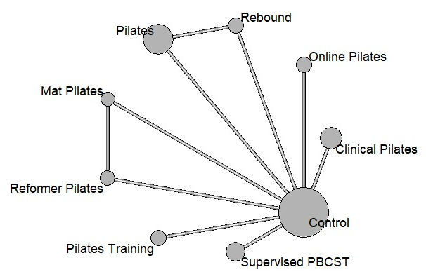
Fig.S1 Network diagram of intervention comparisons for Timed Up and Go (TUG) performance

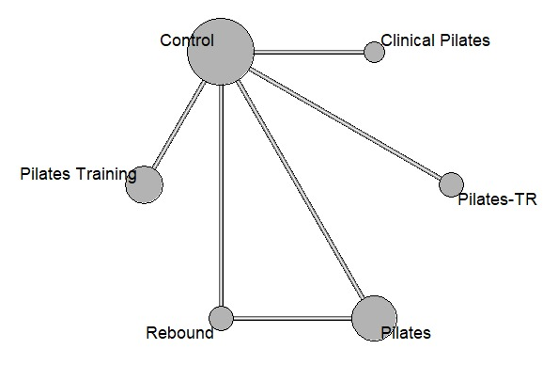
Fig.S2 Network diagram of intervention comparisons for Berg Balance Scale (BBS)

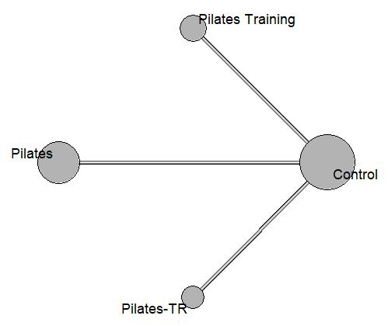
Fig.S3 Network diagram of intervention comparisons for 6-Minute Walk Test (6MWT)

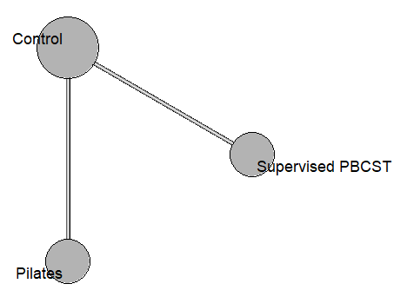
Fig.S4 Network diagram of intervention comparisons for 2-Minute Walk Test (2MWT)

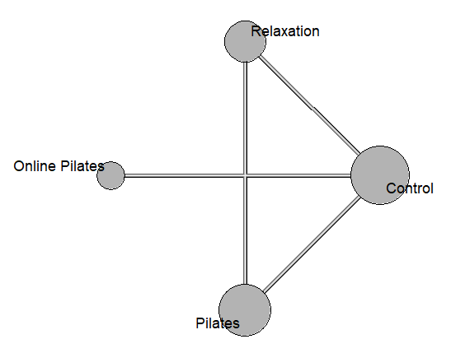
Fig.S5 Network diagram of intervention comparisons for 10 Meter Walk Test (10MWT)

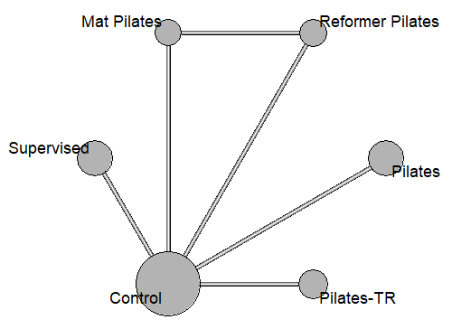
Fig.S6 Network diagram of intervention comparisons for Fatigue Severity Scale (FSS)

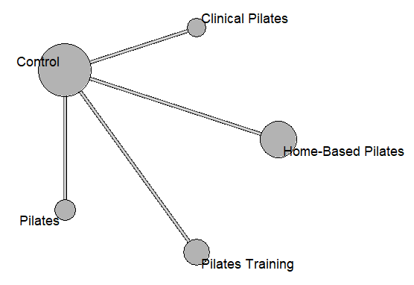
Fig.S7 Network diagram of intervention comparisons for Modified Fatigue Impact Scale (MFIS)

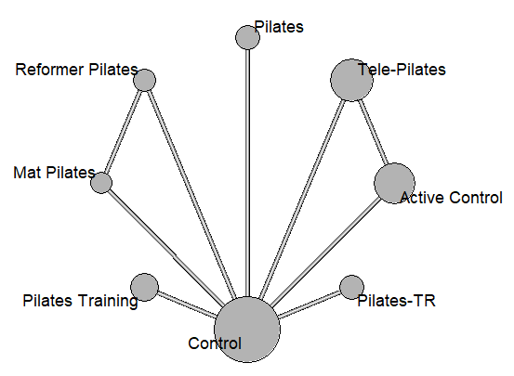
Fig.S8 Network diagram of intervention comparisons for MSQOL-54 Physical Health

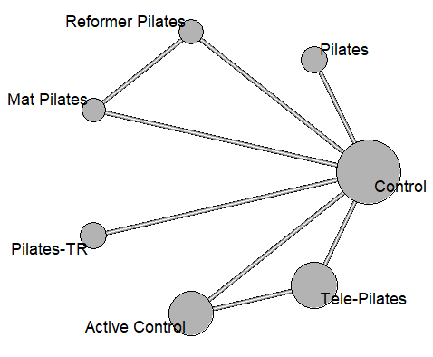
Fig.S9 Network diagram of intervention comparisons for MSQOL-54 Mental Health

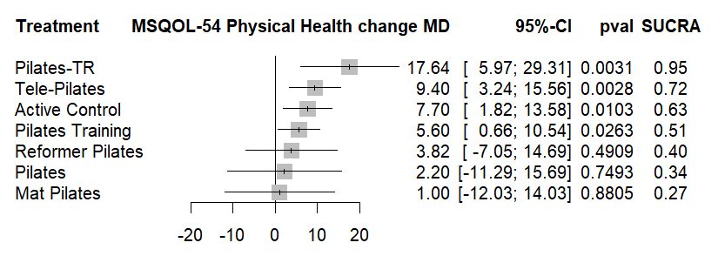
Fig.S10 Forest Plot of MSQOL-54 Physical Health

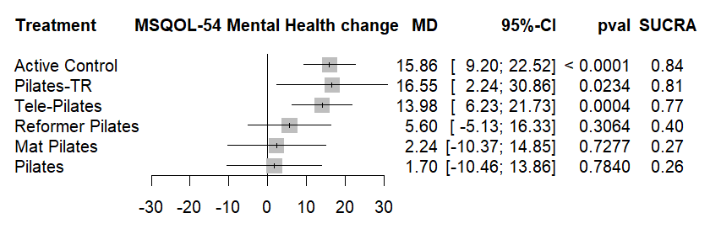
Fig.S11 Forest Plot of MSQOL-54 Mental Health

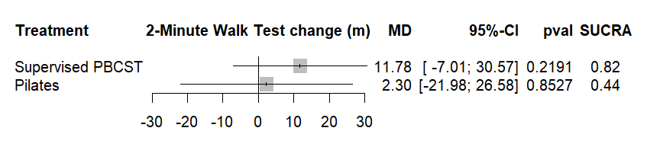
Fig.S12 Forest Plot of 2-Minute Walk Test

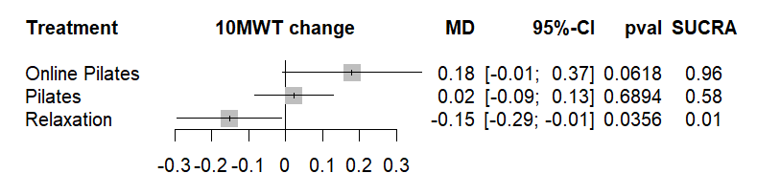
Fig.S13 Forest Plot of 10-Meter Walk Test

