Supplementary Material

Supplementary Table 1. Primary Model-Based Contrasts 2
Supplementary Table 2. PPT Trial Stability and Sensitivity Analyses 3
Supplementary Table 2A. PPT Trial Stability 3
Supplementary Table 2B. Sensitivity Analysis Including All Four Trials 3
Supplementary Table 2C. Trial-Level Sensitivity Analysis Retaining Trials 2–4 3
Supplementary Table 3. Measurement Location Contrasts 5
Supplementary Table 4. CONSORT 2010 Checklist 6
Supplementary Figure 1. Experimental apparatus and measurement procedures. 7
Supplementary Figure 2. Model diagnostic plots for the primary linear mixed-effects model. 8

Supplementary Table 1. Primary Model-Based Contrasts
Contrast | Estimate, N | SE | 95% CI | p-value
Overall EIH: Post − Pre | 2.85 | 0.52 | 1.83 to 3.87 | <0.001
Healthy EIH: Post − Pre | 5.55 | 0.69 | 4.20 to 6.90 | <0.001
Pain EIH: Post − Pre | 0.15 | 0.78 | -1.39 to 1.69 | 0.848
Group difference in EIH: Healthy − Pain | 5.40 | 1.04 | 3.36 to 7.45 | <0.001
Overall additional BFR effect: ΔBFR − ΔNon-BFR | -0.14 | 1.04 | -2.18 to 1.91 | 0.894
Healthy additional BFR effect | -0.07 | 1.38 | -2.77 to 2.62 | 0.958
Pain additional BFR effect | -0.21 | 1.57 | -3.28 to 2.87 | 0.896
Group difference in additional BFR effect | 0.13 | 2.09 | -3.96 to 4.22 | 0.949
Primary analyses were based on the mean of PPT Trials 2–4. Estimates were derived from model-based marginal contrasts from the linear mixed-effects model. Additional BFR effect was defined as ΔPPT_BFR − ΔPPT_Non-BFR.

Supplementary Table 2. PPT Trial Stability and Sensitivity Analyses

Supplementary Table 2A. PPT Trial Stability
Comparison | Estimate, N | p-value | Interpretation
Trial 2 vs Trial 1 | -1.01 | 0.030 | Trial 1 was significantly higher
Trial 3 vs Trial 1 | -1.35 | 0.004 | Trial 1 was significantly higher
Trial 4 vs Trial 1 | -1.55 | <0.001 | Trial 1 was significantly higher

Supplementary Table 2B. Sensitivity Analysis Including All Four Trials
Contrast | Estimate, N | 95% CI | p-value
Overall EIH | 2.41 | 1.38 to 3.45 | <0.001
Healthy EIH | 5.21 | 3.84 to 6.57 | <0.001
Pain EIH | -0.38 | -1.94 to 1.17 | 0.629
Group difference in EIH | 5.59 | 3.52 to 7.66 | <0.001
Overall additional BFR effect | 0.42 | -1.65 to 2.49 | 0.689

Supplementary Table 2C. Trial-Level Sensitivity Analysis Retaining Trials 2–4
Contrast | Estimate, N | 95% CI | p-value
Overall EIH | 2.85 | 1.83 to 3.87 | <0.001
Healthy EIH | 5.55 | 4.20 to 6.90 | <0.001
Pain EIH | 0.15 | -1.39 to 1.69 | 0.848
Group difference in EIH | 5.40 | 3.36 to 7.45 | <0.001
Overall additional BFR effect | -0.14 | -2.18 to 1.91 | 0.894
The all-four-trial sensitivity analysis used the mean of Trials 1–4. The trial-level sensitivity analysis retained Trials 2–4 as repeated technical measurements and accounted for clustering within Subject × Condition × Time × Location cells.

Supplementary Table 3. Measurement Location Contrasts
Location contrast | Estimate, N | SE | 95% CI | p-value
Suprapatellar − Patellar Tendon | 2.40 | 0.64 | 1.15 to 3.65 | <0.001
Suprapatellar − Lateral Leg | 4.94 | 0.64 | 3.69 to 6.20 | <0.001
Patellar Tendon − Lateral Leg | 2.54 | 0.64 | 1.29 to 3.80 | <0.001
Positive estimates indicate higher PPT values at the first listed site. Estimates were averaged across group, condition, and time.

Supplementary Table 4. CONSORT 2010 Checklist
Note: The CONSORT 2010 checklist was completed as applicable to a single-session split-body intervention study. Items that were not applicable to this design are marked as such in the page-number column.
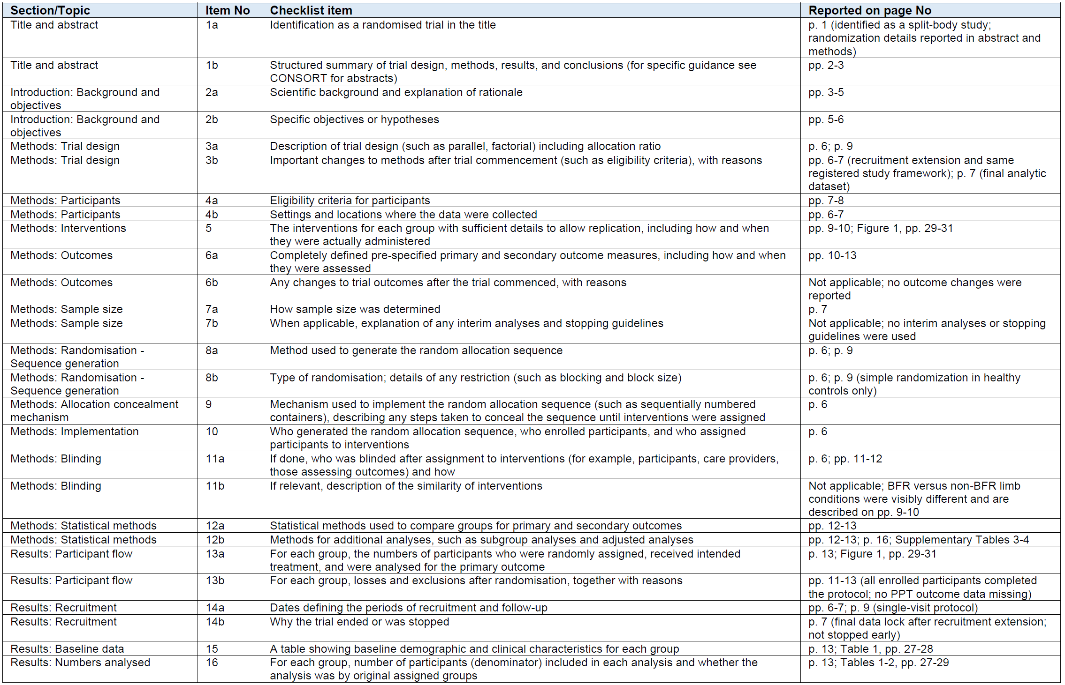
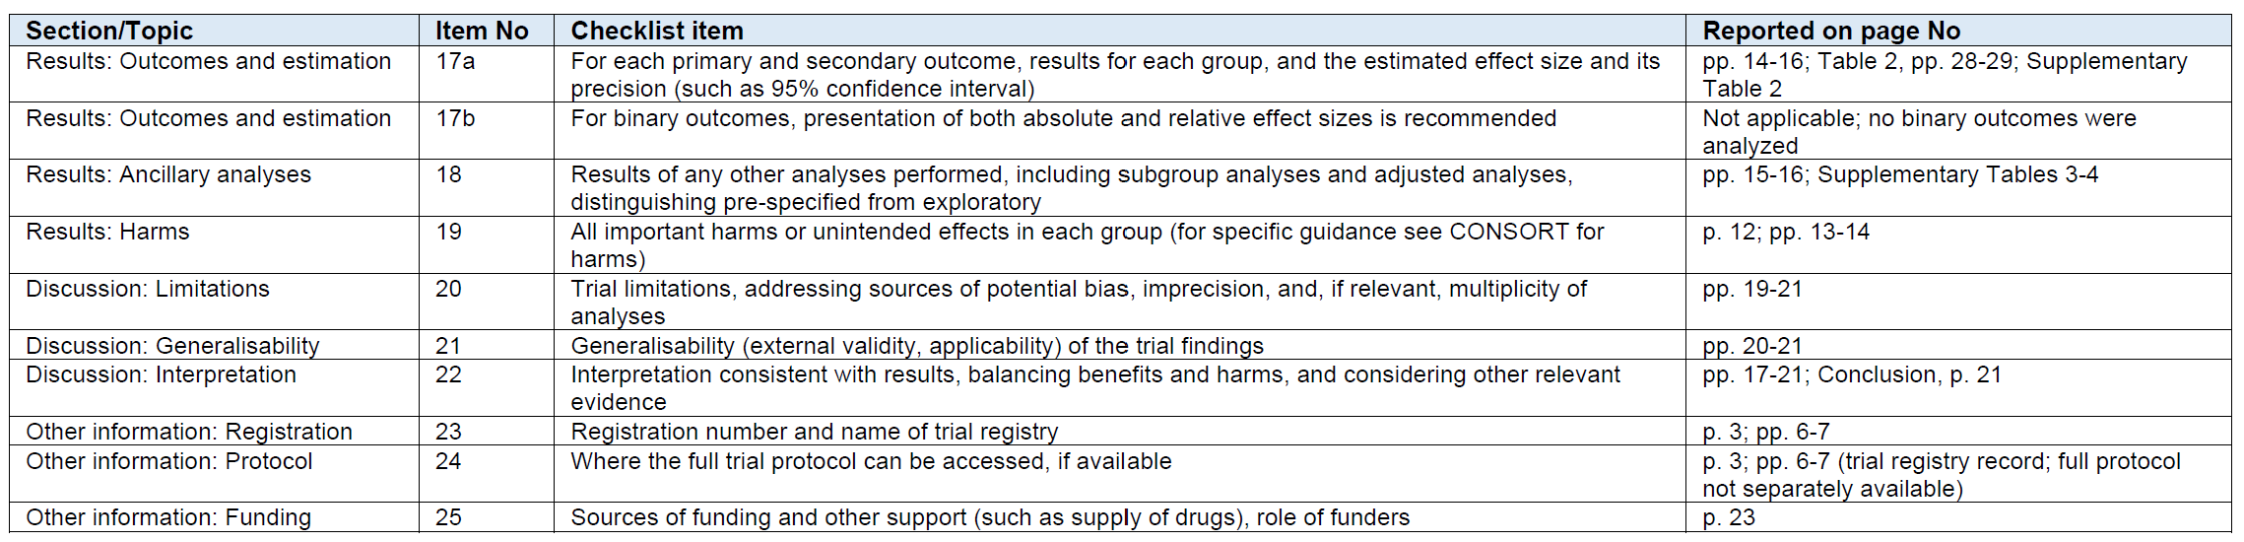

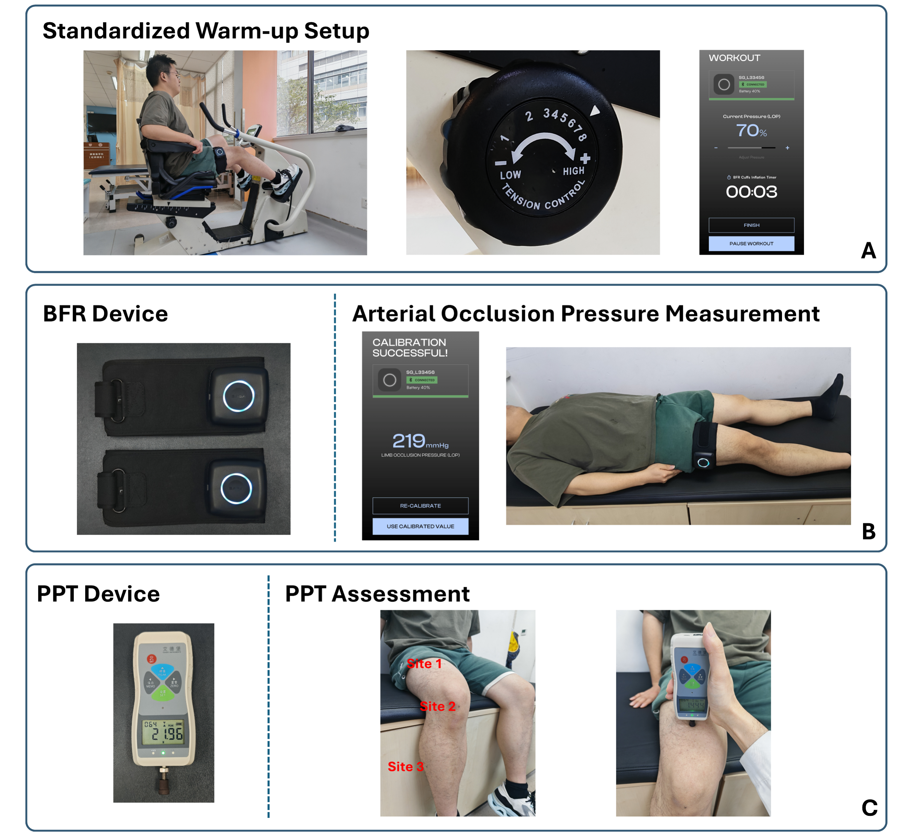

Supplementary Figure 1. Experimental apparatus and measurement procedures.
(A) Standardized warm-up setup showing a participant performing the 5-minute low-intensity cycling warm-up on a stationary ergometer. (B) BFR device and arterial occlusion pressure measurement using wireless pneumatic cuffs and a mobile application interface. (C) PPT assessment using a digital handheld algometer applied perpendicular to the skin at the peri-patellar measurement sites. BFR, blood flow restriction; PPT, pressure pain threshold.
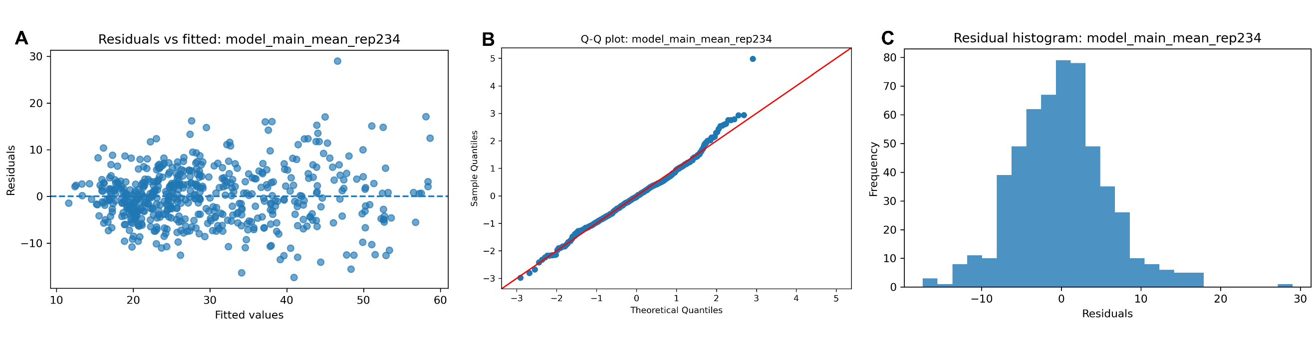

Supplementary Figure 2. Model diagnostic plots for the primary linear mixed-effects model.
(A) Residuals versus fitted values showed no clear pattern suggesting major heteroscedasticity. (B) The Q-Q plot showed acceptable residual distribution with only mild tail deviation. (C) The residual histogram showed an approximately centered residual distribution. Together, these diagnostic plots did not indicate major violations of model assumptions.

