Supplemental Table 1. Dose-Response Relationship between the Count of Menstrual-Related Conditions and Reporting "Post-Menstruation" as the Optimal Timing.
Variable | AOR | 95% CI | P-Value
Count of Menstrual-related Conditions (Reference: NC group)
1 condition | 2.370 | (2.130 - 2.639) | <0.001
2 conditions | 3.308 | (2.891 - 3.785) | <0.001
3 conditions (ATC group) | 3.541 | (2.838 - 4.419) | <0.001
Covariates
Age (per 1-year increase) | 1.013 | (1.003 - 1.022) | 0.011
BMI (per 1 kg/m² increase) | 0.996 | (0.977 - 1.015) | 0.659
AOR: Adjusted Odds Ratio; CI: 95% Confidence Interval. Results are from a multivariate logistic regression model. The outcome variable was 'Optimal Timing = Post-Menstruation' (1=Yes, 0=Other valid responses). The primary predictor was the count of menstrual-related conditions, with '0 conditions' (NC Group) as the reference category. AORs are adjusted for Sport Category (Reference: Ball Games) in addition to the covariates listed in the table (Age, BMI).

Supplemental Table 2. Temporal Trends in Self-Reported Optimal Timing (2008-2021) by Menstrual-Related Condition Group
Optimal Timing | Group | AOR per Year | 95% CI | P-Value
During Menstruation | Overall | 0.979 | (0.953 - 1.006) | 0.130
 | ATC | 0.946 | (0.846 - 1.057) | 0.325
 | NC | 0.991 | (0.932 - 1.054) | 0.777
 | Other | 0.990 | (0.959 - 1.022) | 0.526
Post-Menstruation | Overall | 0.875 | (0.863 - 0.887) | <0.001
 | ATC | 0.919 | (0.863 - 0.979) | 0.009
 | NC | 0.848 | (0.826 - 0.871) | <0.001
 | Other | 0.894 | (0.879 - 0.910) | <0.001
Premenstrual Phase | Overall | 0.991 | (0.962 - 1.020) | 0.530
 | ATC | 0.976 | (0.865 - 1.101) | 0.695
 | NC | 0.951 | (0.903 - 1.002) | 0.061
 | Other | 1.009 | (0.971 - 1.049) | 0.631
No Relation | Overall | 1.155 | (1.138 - 1.172) | <0.001
 | ATC | 1.148 | (1.054 - 1.251) | 0.002
 | NC | 1.171 | (1.141 - 1.202) | <0.001
 | Other | 1.129 | (1.107 - 1.151) | <0.001
Mid-cycle Phase | Overall | 1.253 | (1.186 - 1.323) | <0.001
 | ATC | 1.284 | (1.070 - 1.541) | 0.007
 | NC | 1.281 | (1.124 - 1.460) | <0.001
 | Other | 1.257 | (1.179 - 1.341) | <0.001
AOR = Adjusted Odds Ratio; CI = 95% Confidence Interval. Results are from multivariate logistic regression models. Each analysis block (e.g., 'During Menstruation') used that specific optimal timing response as the outcome variable (1=Yes, 0=Other valid responses). The AOR per Year represents the odds ratio for a one-year increase in time, adjusted for Age, BMI, and Sport Category (Reference: Ball Games). 'Overall' models include all participants. 'NC' (No Conditions), 'ATC' (All Three Conditions), and 'Other' models represent subgroup analyses restricted to participants in that specific condition group.

Supplemental Table 3. Sensitivity Analysis: Multivariate Logistic Regression Analysis of Factors Associated with Reporting "Post-Menstruation" as Optimal Timing (First-Visit Records Only)
Variable | AOR | 95% CI | P-Value
Menstrual-related Conditions (Reference: Condition-free)
PMS (Condition Present) | 2.432 | (2.086 - 2.834) | <0.001
Heavy Menstrual Bleeding (HMB) (Condition Present) | 1.593 | (1.281 - 1.981) | <0.001
Dysmenorrhea (Condition Present) | 1.177 | (0.979 - 1.415) | 0.082
Sport Category (Reference: Ball Games)
Scoring Sports | 1.107 | (0.883 - 1.387) | 0.38
Record Sports | 1.098 | (0.898 - 1.343) | 0.361
Racket Sports | 1.055 | (0.778 - 1.432) | 0.729
Combat Sports | 1.051 | (0.795 - 1.389) | 0.727
Endurance Sports | 0.936 | (0.674 - 1.300) | 0.692
Aesthetic Sports | 0.909 | (0.627 - 1.318) | 0.615
Covariates (Demographics)
Age (Standardized) | 1.137 | (1.051 - 1.229) | 0.001
BMI (Standardized) | 0.939 | (0.867 - 1.017) | 0.121
AOR = Adjusted Odds Ratio; CI = 95% Confidence Interval. Results are from a multivariate logistic regression model restricted to the first-visit record of each unique individual to ensure statistical independence (Valid N = 3,079, after excluding records with missing data in covariates or invalid optimal timing responses). The outcome variable was 'Optimal Timing = Post-Menstruation' (1=Yes, 0=Other valid responses). Sport Category reference was 'Ball Games', and the reference for each condition variable was '0 (condition-free)'. Age and BMI are standardized variables (mean = 0, SD = 1).

Supplemental Table 4. Sensitivity Analysis: Generalized Estimating Equations (GEE) Analysis of Factors Associated with Reporting "Post-Menstruation" as Optimal Timing (Full Longitudinal Dataset)
Variable | AOR | 95% CI | P-Value
Menstrual-related Conditions (Reference: Condition-free)
PMS | 2.017 | (1.823 – 2.230) | <0.001
HMB | 1.506 | (1.302 – 1.742) | <0.001
Dysmenorrhea | 1.195 | (1.059 – 1.348) | 0.004
Sport Category (Reference: Ball Games)
Aesthetic Sports | 1.040 | (0.808 – 1.338) | 0.761
Combat Sports | 1.227 | (0.986 – 1.527) | 0.066
Endurance Sports | 1.239 | (0.974 – 1.576) | 0.081
Racket Sports | 1.036 | (0.824 – 1.301) | 0.764
Record Sports | 1.309 | (1.124 – 1.526) | <0.001
Scoring Sports | 1.318 | (1.105 – 1.571) | 0.002
Covariates (Demographics)
Age (Standardized) | 1.047 | (0.986 – 1.112) | 0.133
BMI (Standardized) | 0.978 | (0.921 – 1.038) | 0.468
AOR = Adjusted Odds Ratio; CI = 95% Confidence Interval. Results are from a generalized estimating equation (GEE) model applied to the full longitudinal dataset to account for within-individual correlations resulting from repeated measurements (Valid N = 8,298 from 3,458 unique athletes). The outcome variable was 'Optimal Timing = Post-Menstruation' (1=Yes, 0=Other valid responses). All three menstrual-related conditions were entered simultaneously into the model to determine the strongest predictor. Age and BMI are standardized variables (mean = 0, SD = 1). HMB: Heavy Menstrual Bleeding; PMS: Premenstrual Syndrome.

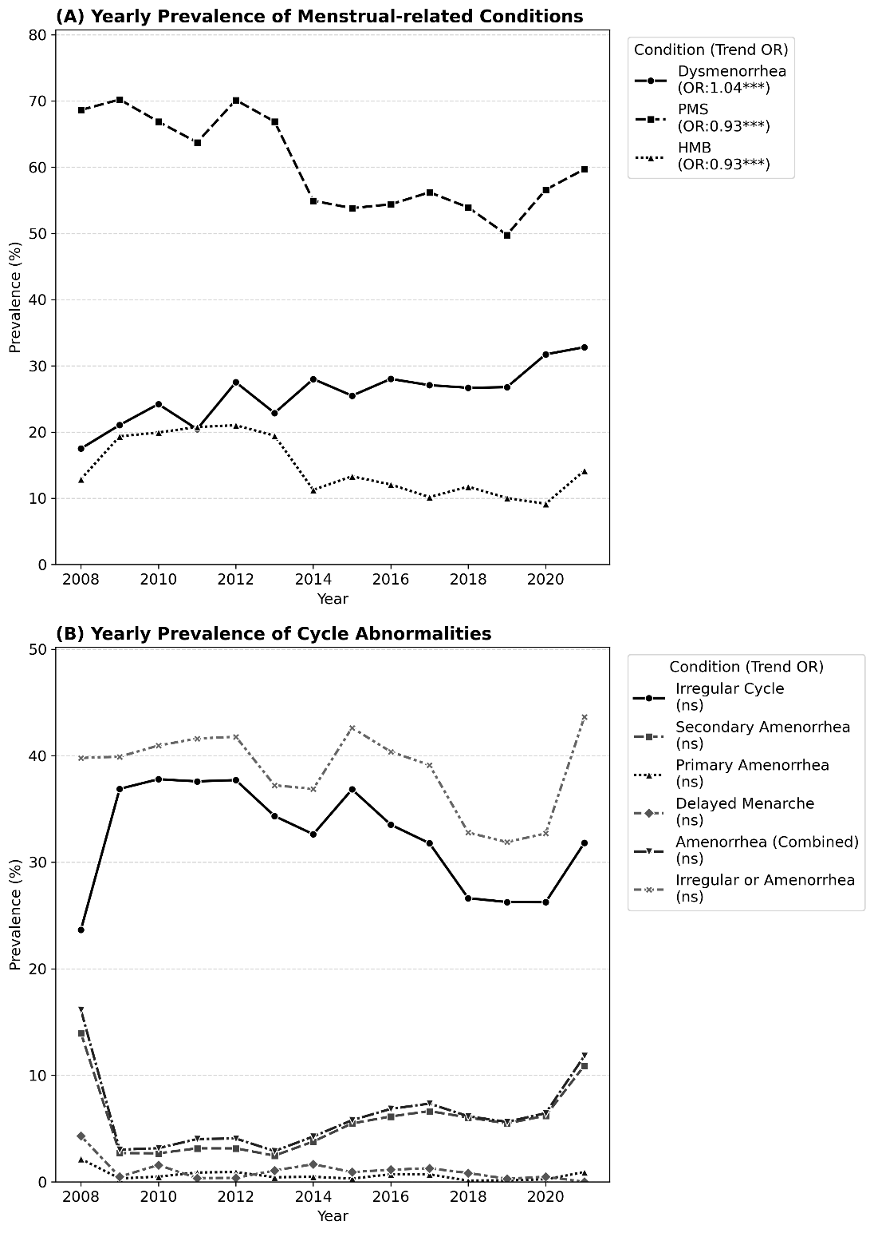
Supplemental Figure 1. Temporal trends in the prevalence of menstrual-related conditions and cycle abnormalities (2008–2021).
(A) Annual prevalence of menstrual-related conditions. While premenstrual syndrome (PMS) and heavy menstrual bleeding (HMB) significantly decreased, dysmenorrhea showed an increasing trend.
(B) Annual prevalence of menstrual cycle abnormalities. A divergent trend was observed: irregular cycle prevalence decreased over the 15 years, whereas secondary amenorrhea prevalence significantly increased, indicating a rise in severe dysfunction despite a reduction in milder irregularities.

