Appendix 1 Search strategy
Table 1 Search strategy in PubMed
Step | Search strategy
#1 | Search: (("Neoplasms"[Mesh]) OR (Tumors) OR (Neoplasia) OR (Cancer) OR (Malignant Neoplasm) OR (Malignancy) OR (Malignancies) OR (Benign Neoplasms))
#2 | Search: ((Exercise) OR (Resistance training) OR (Weight lift) OR (Strength training) OR (Strength exercise) OR (Weight training))
#3 | Search: ("Randomized Controlled Trial" [Publication Type]) OR (RCT)
#4 | #1 AND #2 AND #3
#5 | Search:((Quality of life)) OR (Life Quality)) OR (Health-Related Quality Of Life)) OR (HRQOL))
#6 | Search:((Fatigue) OR (Lassitude))
#7 | #5 OR #6
#8 | #4 AND #7

The Cochrane Library
(cancer OR tumour OR Neoplasia OR Neoplasms OR chemotherapy ) AND (exercise OR "Resistance training" OR Weight lift OR resistance OR Strength training OR Strength exercise OR Weight training ) AND ("Quality of life" OR "Life Quality" OR "Health-Related Quality Of Life" OR "HRQOL" OR "life quality") AND ("Fatigue" OR "Lassitude" )in Record Title
Web of Science
(TI=(Neoplasms OR Tumors OR Neoplasia OR Cancer OR "Malignant Neoplasm" OR Malignancy) AND TI=(exercise OR "Resistance training" OR "Weight lift*" OR "Strength training" OR "Strength exercise" OR "Weight training") AND TI=("Quality of life" OR "Life Quality" OR "Health-Related Quality Of Life" OR HRQOL) AND TI=( Fatigue OR Lassitude))
Embase
( ABS ( ( Neoplasms OR Tumors OR Neoplasia OR Cancer ) ) AND ABS ( ( exercise OR "Resistance training" OR Weight lift OR Strength training OR Strength exercise OR Weight training ) ) AND ABS ( ( "quality of life" OR "Life Quality" OR "health related quality of life" OR "HRQOL" ) ) AND ABS ( ( "Fatigue" OR "Lassitude" ) ) )

Appendix 2 Risk of bias assessment
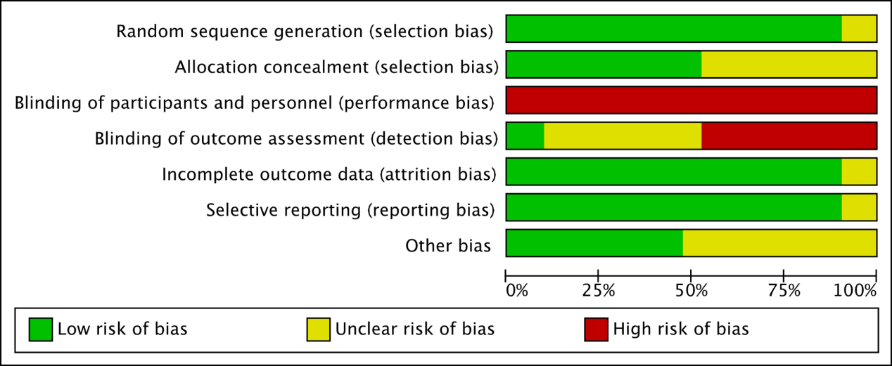

Figure1 The overall risk of bias for all included studies

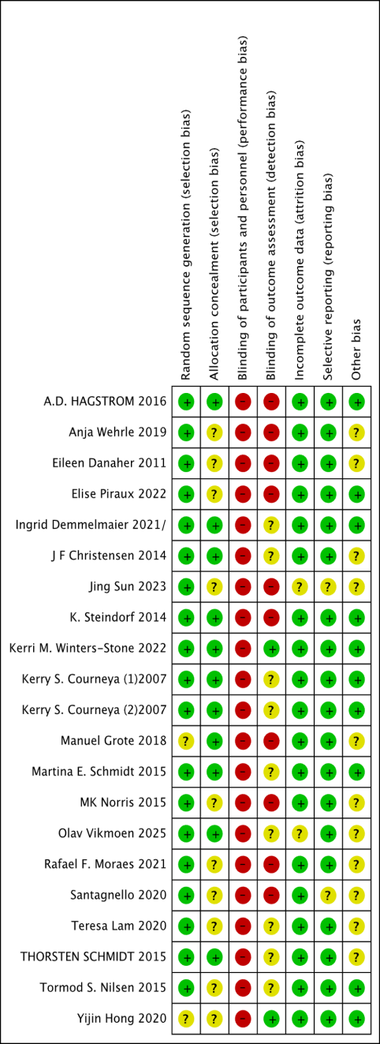

Figure 2 The risk of bias for each study

Appendix 3 Certainy of evidence

Resistance training compared with usual care for improving quality of life and reducing fatigue in cancer patients
Bibliography: Mei J, Li X, Chen K, Zhang W, Wang R. Effects of Different Resistance Training Programs on Quality of Life and Fatigue in Cancer Patients: A Network Meta-Analysis. [Year], Issue [Issue].
Quality assessment
Participants  (studies)  Follow up | Risk of bias | Inconsistency | Indirectness | Imprecision | Publication bias | Overall quality of evidence
Quality of Life (Better indicated by high values)
1635  (20 studies) | very serious^{1,2,3} | no serious inconsistency | no serious  indirectness | no serious | undetected | ⊕⊕⊝⊝  LOW^{1,2,3}  Due to risk of bias,
Fatigue (Better indicated by lower values)
1511  (17 studies) | very serious^{1,2,3} | serious⁴ | no serious indirectness | no serious | undetected | ⊕⊝⊝⊝  VERY LOW^{1,2,3,4}  Due to risk of bias, Inconsistency
GRADE Working Group grades of evidence
High quality: Further research is very unlikely to change our confidence in the estimate of effect.
Moderate quality: Further research is likely to have an important impact on our confidence in the estimate of effect and may change the estimate.
Low quality: Further research is very likely to have an important impact on our confidence in the estimate of effect and is likely to change the estimate.
Very low quality: We are very uncertain about the estimate.
The grade of evidence was downgraded：
publication bias：More than 25% of included studies were at high risk of bias or more than 50% unclear risk of bias（No Randomly assigned ；no concealment of allocation scheme, no blinding, too many subjects lost to follow-up, selective reporting of results）
indirectness：There were differences between included studies in methodological factors such as intervention types and length, included age ranges, and included study populations
Consistency of effect：Heterogeneity was statistically significant
imprecision：small sample sizes
publication bias. There was direct evidence of publication bias.
¹ High risk for selective outcome reporting
² Don't blinding researchers and participants in experiments or provided insufficient information
³ Provide insufficient information on blinding of outcome assessment or high risk for blinding of outcome assessment
⁴ Significant level of heterogeneity observed
⁵ There was direct evidence of publication bias
⁶ The sample size is low
⁷ No explanation was provided

Appendix 4 The analysis

Quality of life

1.1 The node splitting
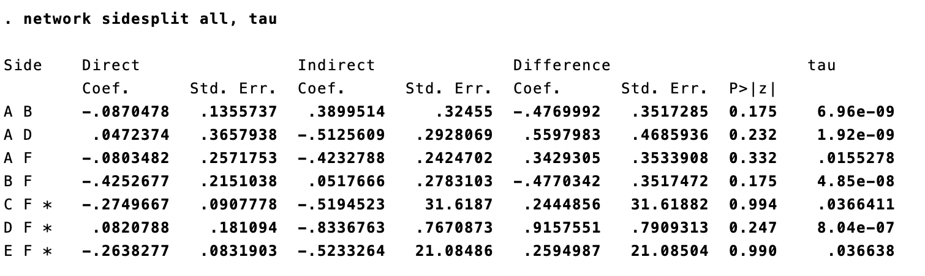

Figure 3 Detection of Local Inconsistencies for inattention
A=HI-LF, B=LI-LF, C=MI-LF, D=HI-HF, E=MI-HF, F=UC

1.2 Forest plot
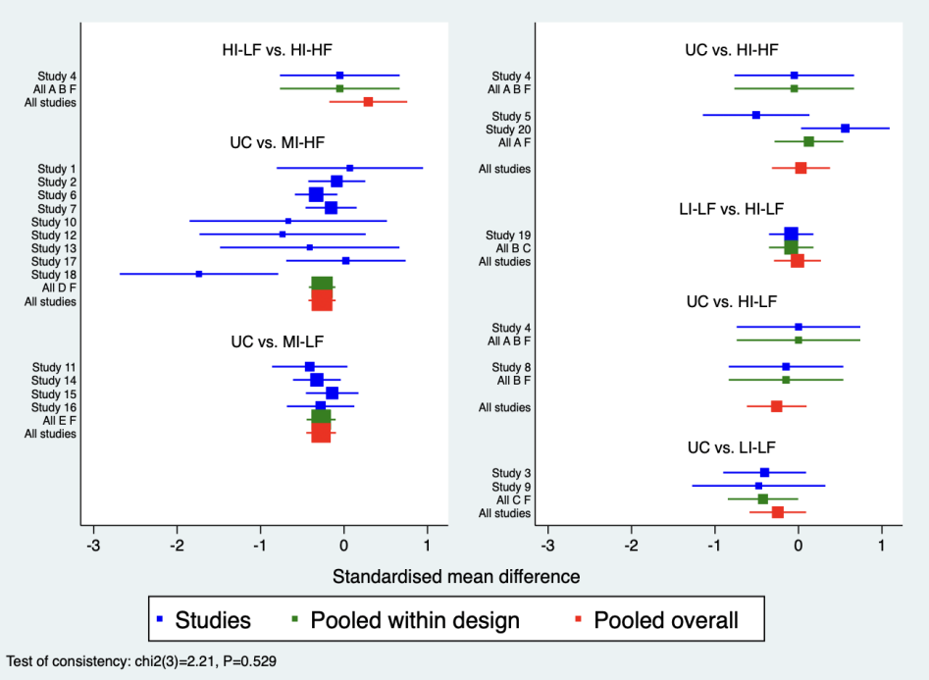

Figure 4 Pairwise comparison of digital cognitive interventions for inattention.
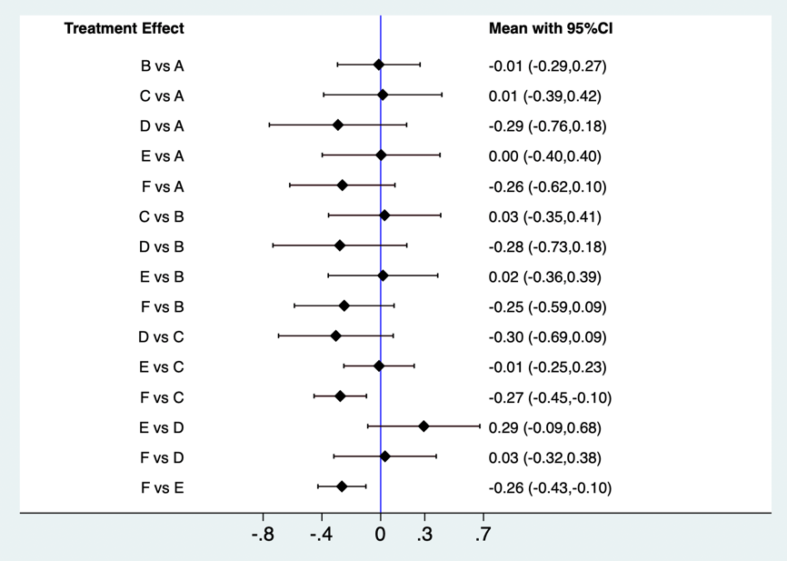

Figure 5 Interval Plot for the Network Meta-Analysis of inattention
A=HI-LF, B=LI-LF, C=MI-LF, D=HI-HF, E=MI-HF, F=UC

1. 3 Cumulative ranking probability plots
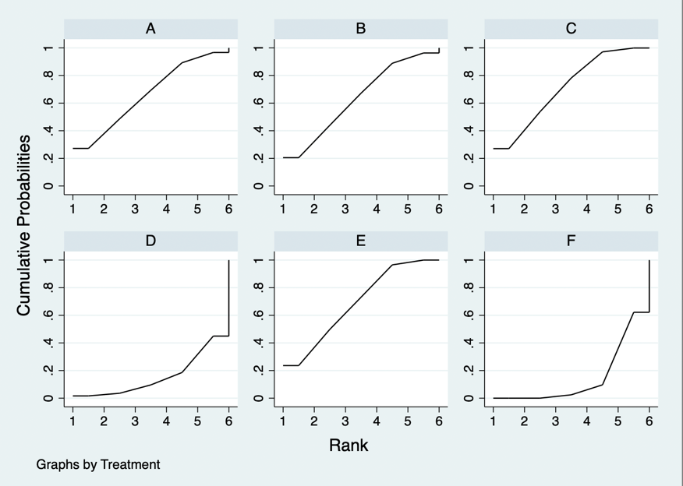

Figure 6 Cumulative ranking probability plots for inattention.The horizontal axis represents the possible rank of each treatment (from best to worst according to the outcome). The vertical axis represents the cumulative probability for each treatment to be the best option, the best of 2 options, the best of 3 options, and so on.

1.4 Comparative effectiveness
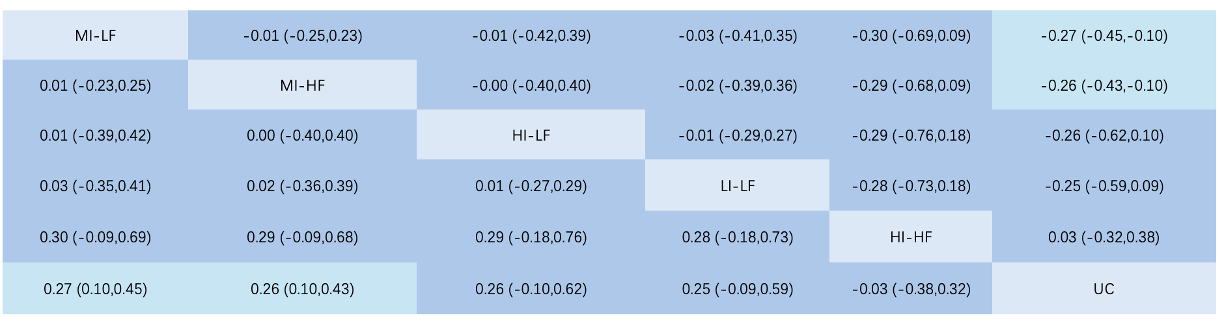
Figure 7 Comparative Efficacy Results for inattention. Each cell displays the standardized mean difference (SMD) and its 95% confidence interval (CI).

1.5 Funnel plot
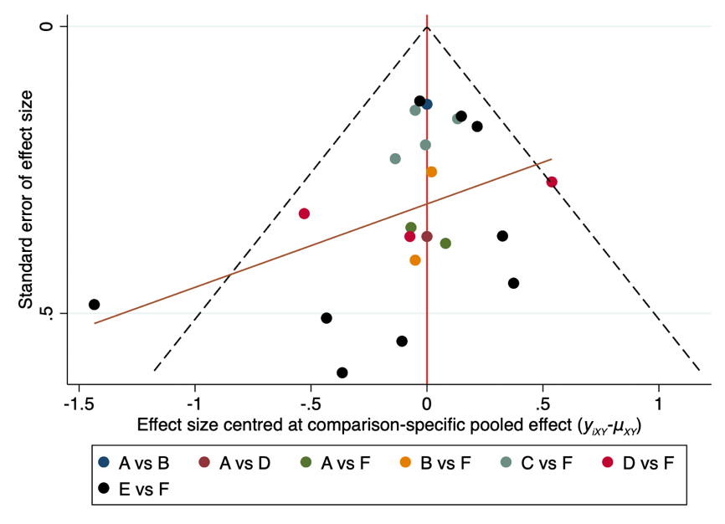

Figure 8 Funnel plot of included literature for inattention.
A=HI-LF, B=LI-LF, C=MI-LF, D=HI-HF, E=MI-HF, F=UC

Fatigue

2.1 The node splitting
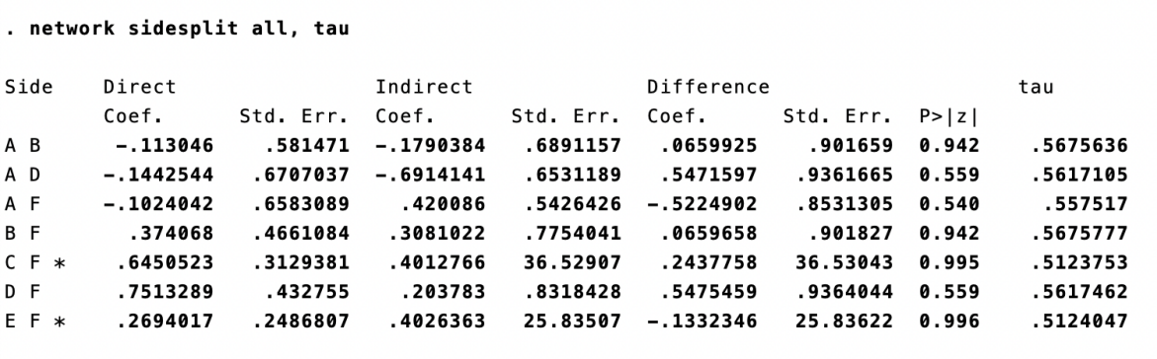

Figure 9 Detection of Local Inconsistencies for hyperactive impulse.
A=HI-LF, B=LI-LF, C=MI-LF, D=HI-HF, E=MI-HF, F=UC

2.2 Forest plot
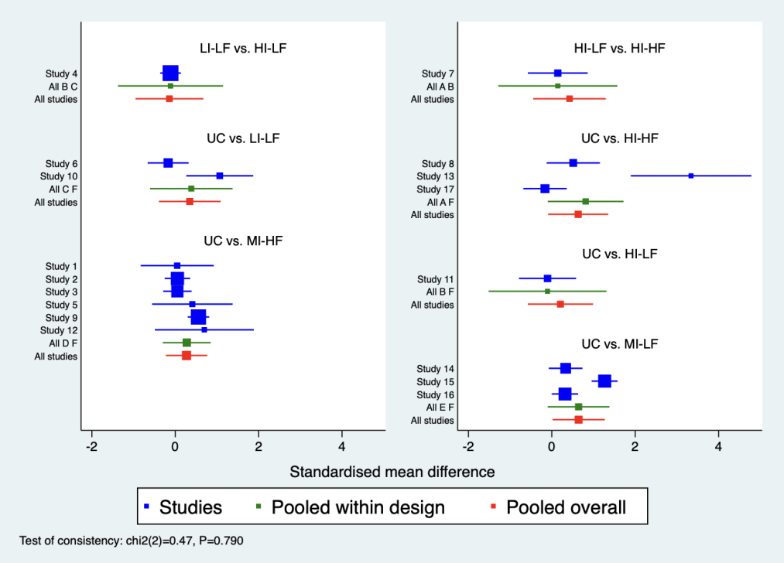

Figure 10 Pairwise comparison of digital cognitive interventions for hyperactive impulse.
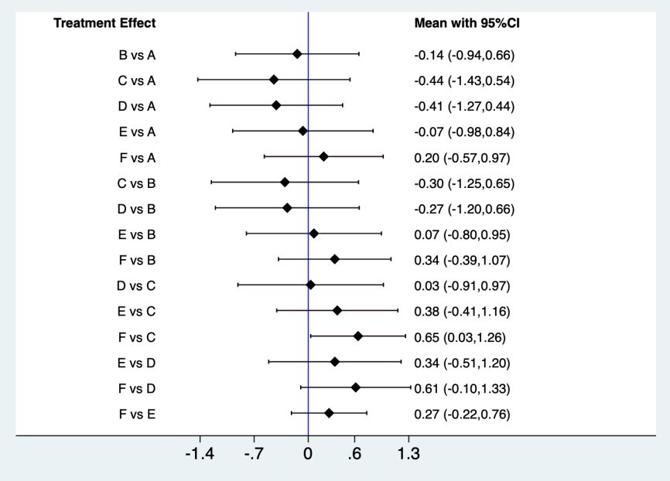

Figure 11 Interval Plot for the Network Meta-Analysis of hyperactive impulse
A=HI-LF, B=LI-LF, C=MI-LF, D=HI-HF, E=MI-HF, F=UC

2.3 Cumulative ranking probability plots
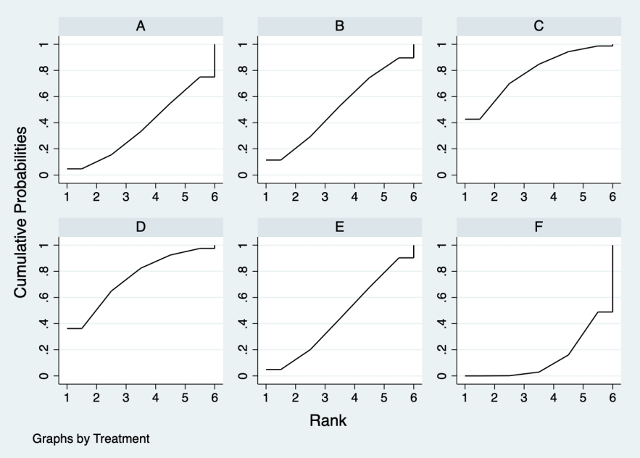

Figure 12 Cumulative ranking probability plots for hyperactive impulse. The horizontal axis represents the possible rank of each treatment (from best to worst according to the outcome). The vertical axis represents the cumulative probability for each treatment to be the best option, the best of 2 options, the best of 3 options, and so on.
2.4 Comparative effectiveness
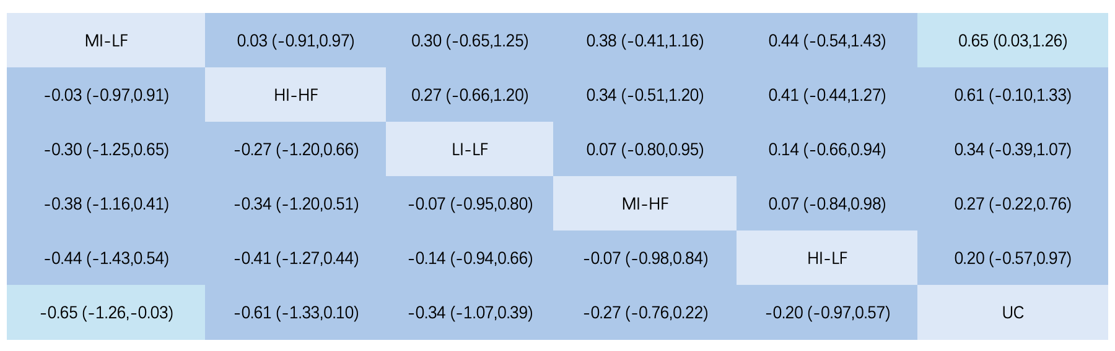
Figure 13 Comparative efficacy results for hyperactive impulse. Each cell displays the standardized mean difference (SMD) and its 95% confidence interval (CI).

2.5 Funnel plot
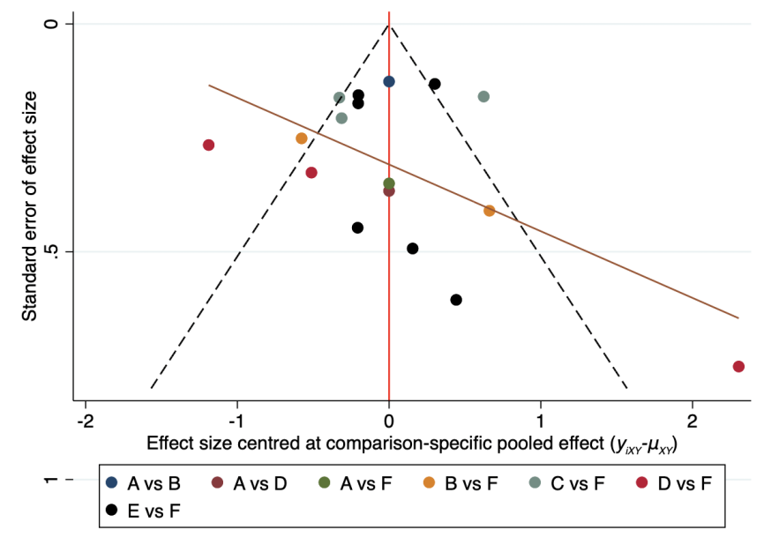
Figure 14 Funnel plot of included literature for hyperactive impulse.
A=HI-LF, B=LI-LF, C=MI-LF, D=HI-HF, E=MI-HF, F=UC

3 Subgroup Analysis of Quality of Life
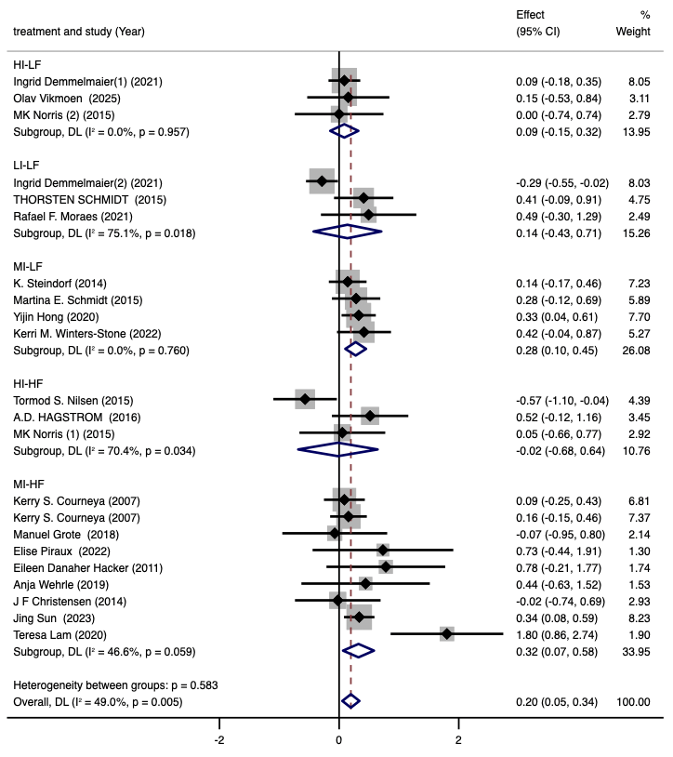
Figure 15. Meta-analysis forest plot for subgroup analysis of intervention measures
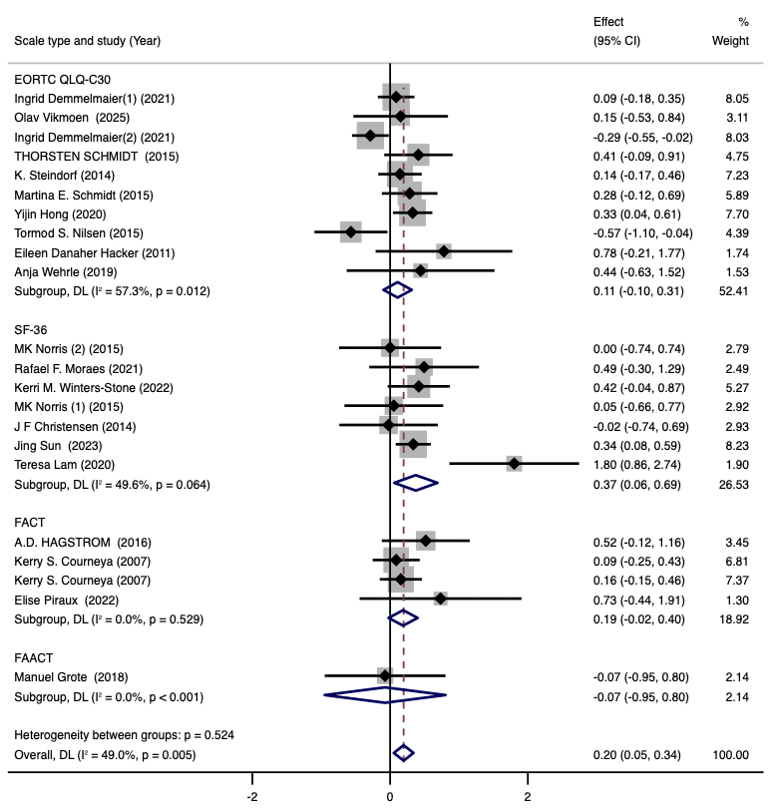
Figure 16: Meta-analysis forest plot for assessment scale subgroups

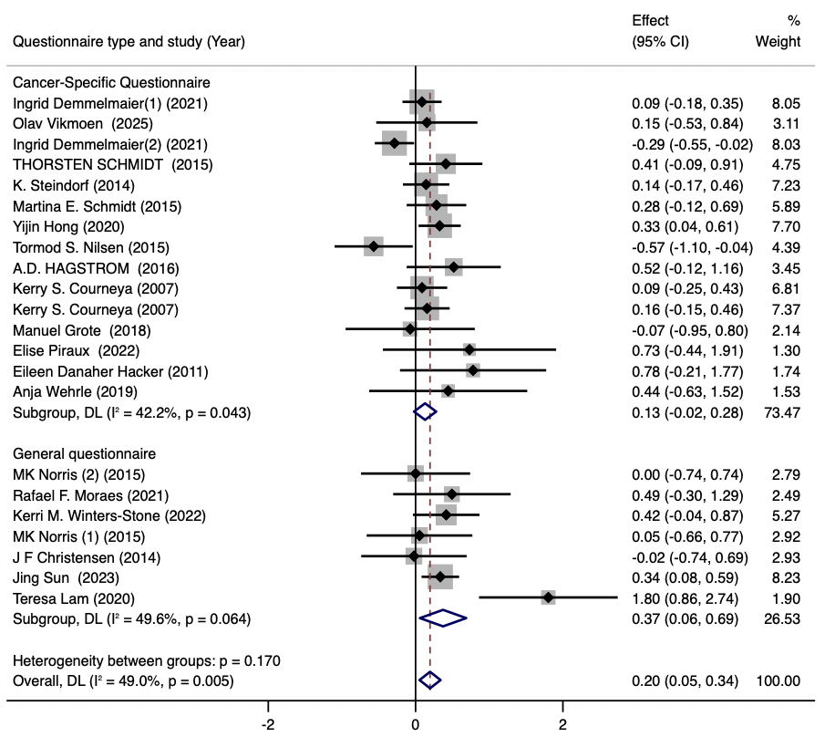
Figure 17: Meta-analysis forest plot for questionnaire type subgroups

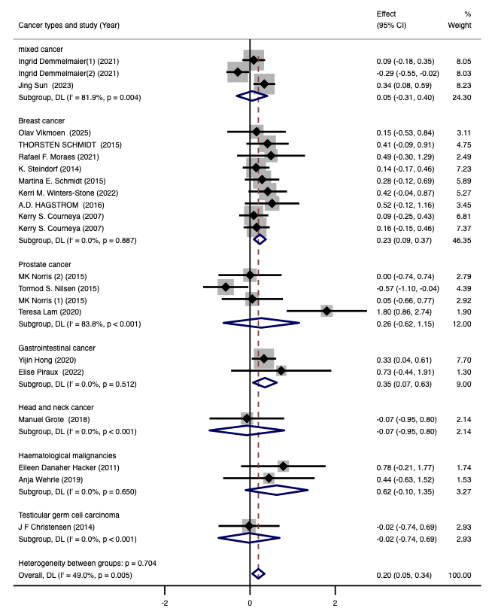
Figure 18. Meta-analysis forest plot for subgroup analysis of Cancer types
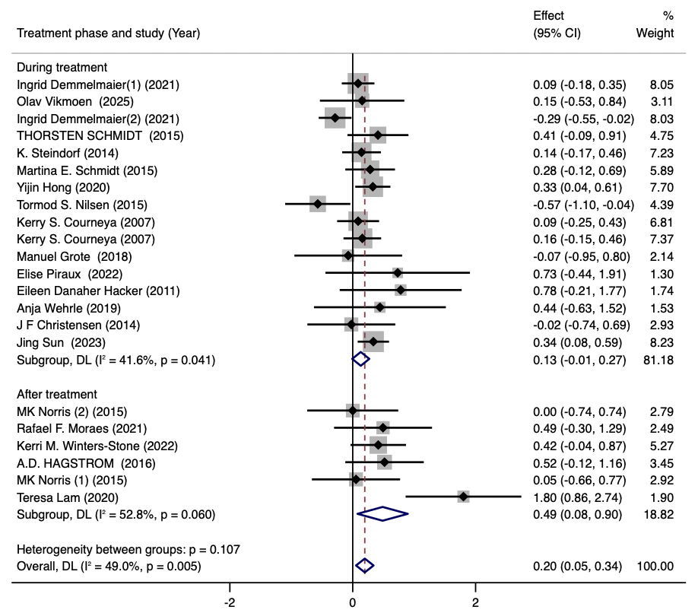
Figure 19: Meta-analysis forest plot for the treatment phase subgroup

4 Subgroup Analysis of Fatigue
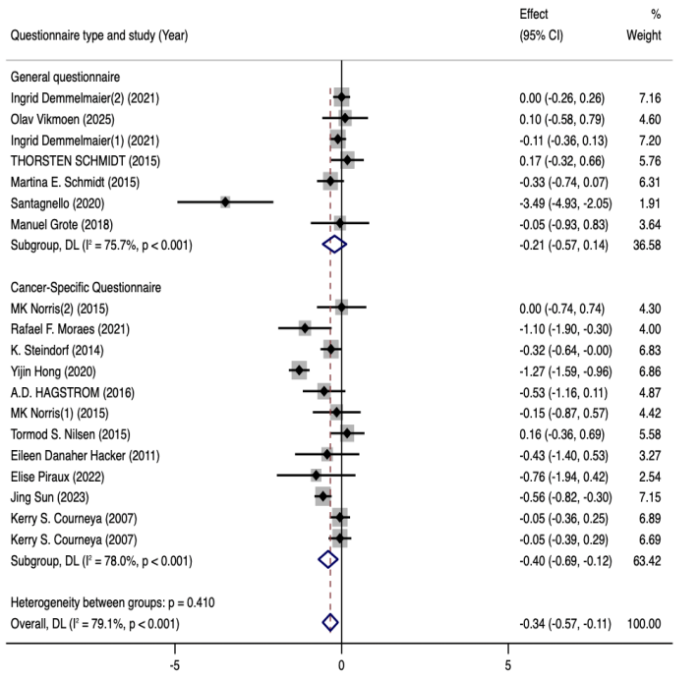
Figure 20: Meta-analysis forest plot for questionnaire type subgroups

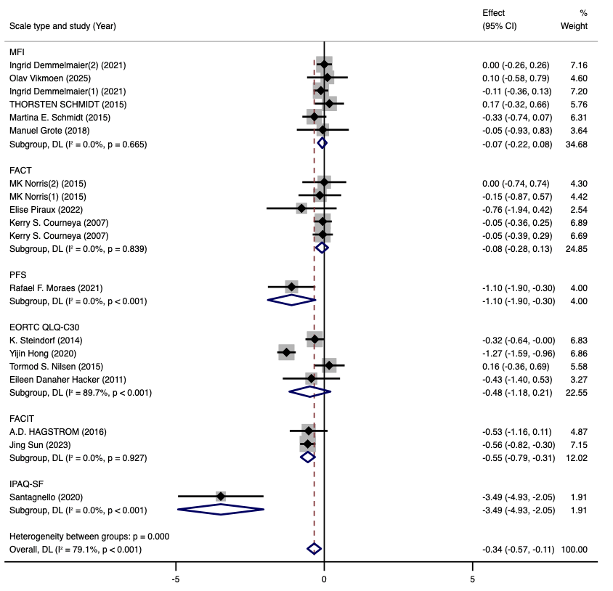
Figure 21: Meta-analysis forest plot for assessment scale subgroups
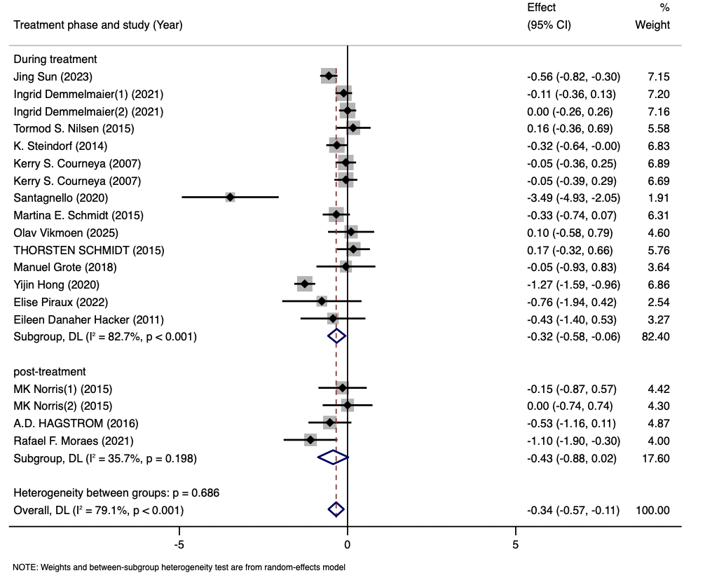
Figure 22: Meta-analysis forest plot for the treatment phase subgroup

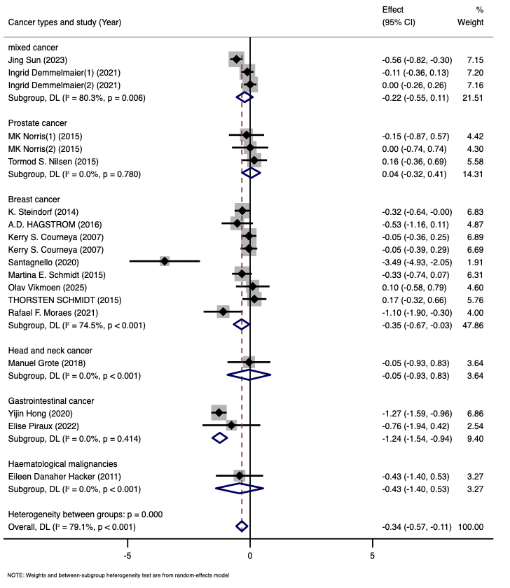
Figure 23. Meta-analysis forest plot for subgroup analysis of Cancer types
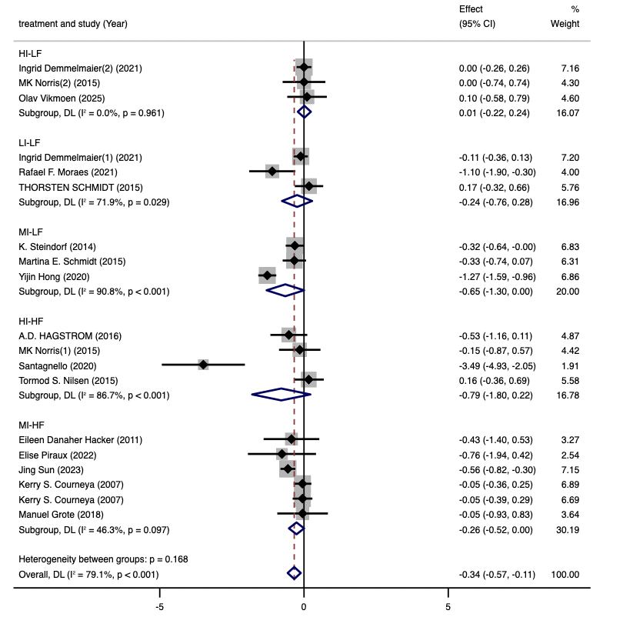
Figure 24. Meta-analysis forest plot for subgroup analysis of intervention measures

Appendix 5 The Preferred Reporting Items for Systematic reviews and Meta-Analysis (PRISMA) 2020 Main Checklist.

Topic | No. | Item | Location where item is reported
TITLE
Title | 1 | Identify the report as a systematic review. | Page 1
ABSTRACT
Abstract | 2 | See the PRISMA 2020 for Abstracts checklist | Page 1-3
INTRODUCTION
Rationale | 3 | Describe the rationale for the review in the context of existing knowledge. | Page 3-4
Objectives | 4 | Provide an explicit statement of the objective(s) or question(s) the review addresses. | Page 4
METHODS
Eligibility criteria | 5 | Specify the inclusion and exclusion criteria for the review and how studies were grouped for the syntheses. | Page 5-6
Information sources | 6 | Specify all databases, registers, websites, organizations, reference lists and other sources searched or consulted to identify studies. Specify the date when each source was last searched or consulted. | Page 5
Search strategy | 7 | Present the full search strategies for all databases, registers and websites, including any filters and limits used. | Appendix1
Selection process | 8 | Specify the methods used to decide whether a study met the inclusion criteria of the review, including how many reviewers screened each record and each report retrieved, whether they worked independently, and if applicable, details of automation tools used in the process. | Page 7
Data collection process | 9 | Specify the methods used to collect data from reports, including how many reviewers collected data from each report, whether they worked independently, any processes for obtaining or confirming data from study investigators, and if applicable, details of automation tools used in the process. | Page 9
Data items | 10a | List and define all outcomes for which data were sought. Specify whether all results that were compatible with each outcome domain in each study were sought (e.g. for all measures, time points, analyses), and if not, the methods used to decide which results to collect. | Page 7
 | 10b | List and define all other variables for which data were sought (e.g. participant and intervention characteristics, funding sources). Describe any assumptions made about any missing or unclear information. | Page 7
Study risk of bias assessment | 11 | Specify the methods used to assess risk of bias in the included studies, including details of the tool(s) used, how many reviewers assessed each study and whether they worked independently, and if applicable, details of automation tools used in the process. | Page 8
Effect measures | 12 | Specify for each outcome the effect measure(s) (e.g. risk ratio, mean difference) used in the synthesis or presentation of results. | Page 9-10
Synthesis methods | 13a | Describe the processes used to decide which studies were eligible for each synthesis (e.g. tabulating the study intervention characteristics and comparing against the planned groups for each synthesis (item 5)). | Page 5-7
 | 13b | Describe any methods required to prepare the data for presentation or synthesis, such as handling of missing summary statistics, or data conversions. | Page 9
 | 13c | Describe any methods used to tabulate or visually display results of individual studies and syntheses. | Page 9,Figure 2
 | 13d | Describe any methods used to synthesize results and provide a rationale for the choice(s). If meta-analysis was performed, describe the model(s), method(s) to identify the presence and extent of statistical heterogeneity, and software package(s) used. | Page 9
 | 13e | Describe any methods used to explore possible causes of heterogeneity among study results (e.g. subgroup analysis, meta-regression). | Page 9
 | 13f | Describe any sensitivity analyses conducted to assess robustness of the synthesized results. | Page 9
Reporting bias assessment | 14 | Describe any methods used to assess risk of bias due to missing results in a synthesis (arising from reporting biases). | Page 8
Certainty assessment | 15 | Describe any methods used to assess certainty (or confidence) in the body of evidence for an outcome. | Page 8
RESULTS
Study selection | 16a | Describe the results of the search and selection process, from the number of records identified in the search to the number of studies included in the review, ideally using a flow diagram. | Page 10,  Figure 1
 | 16b | Cite studies that might appear to meet the inclusion criteria, but which were excluded, and explain why they were excluded. | Page 10
Study characteristics | 17 | Cite each included study and present its characteristics. | Page 11  Table 1
Risk of bias in studies | 18 | Present assessments of risk of bias for each included study. | Page 12
Results of individual studies | 19 | For all outcomes, present, for each study: (a) summary statistics for each group (where appropriate) and (b) an effect estimates and its precision (e.g. confidence/credible interval), ideally using structured tables or plots. | Table 1
Results of syntheses | 20a | For each synthesis, briefly summaries the characteristics and risk of bias among contributing studies. | Page 11-12
 | 20b | Present results of all statistical syntheses conducted. If meta-analysis was done, present for each the summary estimate and its precision (e.g. confidence/credible interval) and measures of statistical heterogeneity. If comparing groups, describe the direction of the effect. | Page 13-19
 | 20c | Present results of all investigations of possible causes of heterogeneity among study results. | Page 13-17
 | 20d | Present results of all sensitivity analyses conducted to assess the robustness of the synthesized results. | Page N/A
Reporting biases | 21 | Present assessments of risk of bias due to missing results (arising from reporting biases) for each synthesis assessed. | Page 20
Certainty of evidence | 22 | Present assessments of certainty (or confidence) in the body of evidence for each outcome assessed. | Page 13
DISCUSSION
Discussion | 23a | Provide a general interpretation of the results in the context of other evidence. | Page 21-30
 | 23b | Discuss any limitations of the evidence included in the review. | Page 30
 | 23c | Discuss any limitations of the review processes used. | Page 30
 | 23d | Discuss implications of the results for practice, policy, and future research. | Page 31
OTHER INFORMATION
Registration and protocol | 24a | Provide registration information for the review, including register name and registration number, or state that the review was not registered. | Page 4-5
 | 24b | Indicate where the review protocol can be accessed, or state that a protocol was not prepared. | Page 5
 | 24c | Describe and explain any amendments to information provided at registration or in the protocol. | Page N/A
Support | 25 | Describe sources of financial or non-financial support for the review, and the role of the funders or sponsors in the review. | Page 32
Competing interests | 26 | Declare any competing interests of review authors. | Page 32
Availability of data, code and other materials | 27 | Report which of the following are publicly available and where they can be found template data collection forms; data extracted from included studies; data used for all analyses; analytic code; any other materials used in the review. | Page 33

