Electronic Supplementary Material Contents
Number | Material
1 | Electronic Supplementary Material Appendix S1 (PRISMA 2020 checklist)
2 | Electronic Supplementary Material Appendix S2 (Search strategie)
3 | Electronic Supplementary Material Appendix S3 (Detailed intervention characteristics)
3 | Electronic Supplementary Material Appendix S4 (Forest plot results)
4 | Electronic Supplementary Material Appendix S5 (PEDro score)
5 | Electronic Supplementary Material Appendix S6 (Sensitivity analysis)
6 | Electronic Supplementary Material Appendix S7 (Grade)

Electronic Supplementary Material Appendix S1（PRISMA 2020）
Section/topic | # | Checklist item | Reported on page #
Effects of Combined Training on Inflammatory Biomarkers in Middle-Aged and Older Adults: A systematic review and meta-analysis
Title | 1 | Identify the report as a systematic review, meta-analysis, or both. | 1
Structured summary | 2 | Provide a structured summary including, as applicable: background; objectives; data sources; study eligibility criteria, participants, and interventions; study appraisal and synthesis methods; results; limitations; conclusions and implications of key findings; systematic review registration number. | 2,3
INTRODUCTION
Rationale | 3 | Describe the rationale for the review in the context of what is already known. | 3,4
Objectives | 4 | Provide an explicit statement of questions being addressed with reference to participants, interventions, comparisons, outcomes, and study design （PICOS）. | 3-5
METHODS
Protocol and registration | 5 | Indicate if a review protocol exists, if and where it can be accessed （e.g., Web address）, and, if available, provide registration information including registration number. | 5
Eligibility criteria | 6 | Specify study characteristics （e.g., PICOS, length of follow-up） and report characteristics （e.g., years considered, language, publication status） used as criteria for eligibility, giving rationale. | 7
Information sources | 7 | Describe all information sources （e.g., databases with dates of coverage, contact with study authors to identify additional studies） in the search and date last searched. | 5,6
Search | 8 | Present full electronic search strategy for at least one database, including any limits used, such that it could be repeated. | 6
Study selection | 9 | State the process for selecting studies （i.e., screening, eligibility, included in systematic review, and, if applicable, included in the meta-analysis）. | 6
Data collection process | 10 | Describe method of data extraction from reports （e.g., piloted forms, independently, in duplicate） and any processes for obtaining and confirming data from investigators. | 7,8
Data items | 11 | List and define all variables for which data were sought （e.g., PICOS, funding sources） and any assumptions and simplifications made. | 7,8
Risk of bias in individual studies | 12 | Describe methods used for assessing risk of bias of individual studies （including specification of whether this was done at the study or outcome level）, and how this information is to be used in any data synthesis. | 8,9
Summary measures | 13 | State the principal summary measures （e.g., risk ratio, difference in means）. | 9,10
Synthesis of results | 14 | Describe the methods of handling data and combining results of studies, if done, including measures of consistency （e.g., I²） for each meta-analysis. | 9,10

Section/topic | # | Checklist item | Reported on page #
Risk of bias across studies | 15 | Specify any assessment of risk of bias that may affect the cumulative evidence （e.g., publication bias, selective reporting within studies）. | 10,11
Additional analyses | 16 | Describe methods of additional analyses （e.g., sensitivity or subgroup analyses, meta-regression）, if done, indicating which were pre-specified. | 11
RESULTS
Study selection | 17 | Give numbers of studies screened, assessed for eligibility, and included in the review, with reasons for exclusions at each stage, ideally with a flow diagram. | 11,12
Study characteristics | 18 | For each study, present characteristics for which data were extracted （e.g., study size, PICOS, follow-up period） and provide the citations. | 12-18
Risk of bias within studies | 19 | Present data on risk of bias of each study and, if available, any outcome level assessment （see item 12）. | 23,24
Results of individual studies | 20 | For all outcomes considered （benefits or harms）, present, for each study: （a） simple summary data for each intervention group （b） effect estimates and confidence intervals, ideally with a forest plot. | 19,20
Synthesis of results | 21 | Present results of each meta-analysis done, including confidence intervals and measures of consistency. | 20-24
Risk of bias across studies | 22 | Present results of any assessment of risk of bias across studies （see Item 15）. | 23,24
Additional analysis | 23 | Give results of additional analyses, if done （e.g., sensitivity or subgroup analyses, meta-regression [see Item 16]）. | 25-27
DISCUSSION
Summary of evidence | 24 | Summarize the main findings including the strength of evidence for each main outcome; consider their relevance to key groups （e.g., healthcare providers, users, and policy makers）. | 27-32
Limitations | 25 | Discuss limitations at study and outcome level （e.g., risk of bias）, and at review-level （e.g., incomplete retrieval of identified research, reporting bias）. | 32,33
Conclusions | 26 | Provide a general interpretation of the results in the context of other evidence, and implications for future research. | 33
FUNDING
Funding | 27 | Describe sources of funding for the systematic review and other support （e.g., supply of data）; role of funders for the systematic review. | 35

Electronic Supplementary Material Appendix S2 (Search strategies)
Data | Query | Results
PUBMED | ("combined exercise" OR "combined training" OR "concurrent training" OR "aerobic-resistance training" OR "aerobic-resistance exercise" OR "combined aerobic and resistance exercise" OR "combined aerobic and resistance training" OR "aerobic and resistance training" OR "aerobic and strength training" OR "hybrid training" OR "integrated training" OR "High Intensity Interval Training" OR "HIIT" ) AND ("inflammatory" OR "inflammation" OR "inflammatory mediators" OR "systemic inflammation" OR "C-reactive protein" OR "CRP" OR "interleukin-6" OR "IL-6" OR "interleukin-1 beta" OR "IL-1β" OR "tumor necrosis factor alpha" OR "TNF-α" OR "cytokines" OR "interleukins") in All Fields | 859
Cochrane Library | ("combined exercise" OR "combined training" OR "concurrent training" OR "aerobic-resistance training" OR "aerobic-resistance exercise" OR "combined aerobic and resistance exercise" OR "combined aerobic and resistance training" OR "aerobic and resistance training" OR "aerobic and strength training" OR "hybrid training" OR "integrated training" OR "High Intensity Interval Training" OR "HIIT" ) AND ("inflammatory" OR "inflammation" OR "inflammatory mediators" OR "systemic inflammation" OR "C-reactive protein" OR "CRP" OR "interleukin-6" OR "IL-6" OR "interleukin-1 beta" OR "IL-1β" OR "tumor necrosis factor alpha" OR "TNF-α" OR "cytokines" OR "interleukins") in the Title Abstract Keywords fields, and the language was restricted to English. | 851
Web of Science | ("combined exercise" OR "combined training" OR "concurrent training" OR "aerobic-resistance training" OR "aerobic-resistance exercise" OR "combined aerobic and resistance exercise" OR "combined aerobic and resistance training" OR "aerobic and resistance training" OR "aerobic and strength training" OR "hybrid training" OR "integrated training" OR "High Intensity Interval Training" OR "HIIT" ) AND ("inflammatory" OR "inflammation" OR "inflammatory mediators" OR "systemic inflammation" OR "C-reactive protein" OR "CRP" OR "interleukin-6" OR "IL-6" OR "interleukin-1 beta" OR "IL-1β" OR "tumor necrosis factor alpha" OR "TNF-α" OR "cytokines" OR "interleukins") in All Fields | 1307
EBSCOhost | ("combined exercise" OR "combined training" OR "concurrent training" OR "aerobic-resistance training" OR "aerobic-resistance exercise" OR "combined aerobic and resistance exercise" OR "combined aerobic and resistance training" OR "aerobic and resistance training" OR "aerobic and strength training" OR "hybrid training" OR "integrated training" OR "High Intensity Interval Training" OR "HIIT" ) AND ("inflammatory" OR "inflammation" OR "inflammatory mediators" OR "systemic inflammation" OR "C-reactive protein" OR "CRP" OR "interleukin-6" OR "IL-6" OR "interleukin-1 beta" OR "IL-1β" OR "tumor necrosis factor alpha" OR "TNF-α" OR "cytokines" OR "interleukins") in All Fields | 1089

Electronic Supplementary Material Appendix S3 (Detailed intervention characteristics)
First author, year | Int | d/wk | Dur | dropout rates (%) | ITTA | Biomarker assay
Magalhães et al,2020 | HIIT+RT | 3 | 52 | 24.0% | yes | ELISA
Magalhães et al,2020 | MCT+RT | 3 | 52 | 17.9% | yes | ELISA
Magalhães et al,2020 | No structured exercise | 3 | 52 | 11.1% | yes | ELISA
Jorge et al,2011 | Stretching exercises | 3 | 12 | 0% | No | ELISA
Jorge et al,2011 | Cycling | 3 | 12 | 0% | No | ELISA
Jorge et al,2011 | RT | 3 | 12 | 0% | No | ELISA
Jorge et al,2011 | AT+RT | 3 | 12 | 0% | No | ELISA
Park et al,2015 | AT+RT | 3 | 12 | 0% | No | ELISA
Park et al,2015 | NR | NR | 12 | 0% | No | ELISA
Birjandi et al,2023 | NR | NR | 8 | 0% | No | Elisa
Birjandi et al,2023 | AT+RT+BE | 3 | 8 | 0% | No | Elisa
Theodorou et al, 2016 | AE | 3 | 32 | 0% | No | Cobas Integra Plus 400 chemistry analyser
Theodorou et al, 2016 | RT | 3 | 32 | 0% | No | Cobas Integra Plus 400 chemistry analyser
Theodorou et al, 2016 | AT+RT | 3 | 32 | 0% | No | Cobas Integra Plus 400 chemistry analyser
Theodorou et al, 2016 | NR | 3 | 32 | 0% | No | Cobas Integra Plus 400 chemistry analyser
Parhampour et al, 2019 | RT | 3 | 6 | 0% | No | ELISA
Parhampour et al, 2019 | AT | 3 | 6 | 0% | No | ELISA
Parhampour et al, 2019 | AT+RT | 3 | 6 | 0% | No | ELISA
Parhampour et al, 2019 | NR | NR | 6 | 0% | No | ELISA
Parent-Roberge et al, 2020 | AT+RT | 3 | 12 | 0% | No | ELISA
Parent-Roberge et al, 2020 | Stretching exercises | 3 | 12 | 0% | No | ELISA
Liu et al,2015 | NR | NR | 12 | 0% | No | ELISA
Liu et al,2015 | AT+RT | 3 | 12 | 0% | No | ELISA
Liu et al,2015 | NR | NR | 12 | 0% | No | ELISA
Lima et al,2015 | Treadmill | 3 | 10 | 0% | No | ELISA
Lima et al,2015 | AT+RT | 3 | 10 | 0% | No | ELISA
Lima et al,2015 | NR | NR | NR | 0% | No | ELISA
Libardi et al, 2011 | RT | 3 | 16 | 0% | No | ELISA
Libardi et al, 2011 | AT+RT | 3 | 16 | 0% | No | ELISA
Libardi et al, 2011 | NR | NR | NR | 0% | No | ELISA
Libardi et al, 2012 | RT | 3 | 16 | 0% | No | ELISA
Libardi et al, 2012 | Walking or running | 3 | 16 | 0% | No | ELISA
Libardi et al, 2012 | AT+RT | 3 | 16 | 0% | No | ELISA
Libardi et al, 2012 | NR | 3 | 16 | 0% | No | ELISA
Kim et al,2018 | NR | NR |  | 33% | yes | ELISA
Kim et al,2018 | RT | NR | 6 | 25% | yes | ELISA
Kim et al,2018 | AT+RT | NR | 6 | 19% | yes | ELISA
Guariglia et al, 2018 | Recreational activities | 2 | 16 | 54% | yes | ELISA
Guariglia et al, 2018 | AT+RT | 3 | 16 | 50% | yes | ELISA
Dieli-Conwright et al, 2018 | AT+RT | 3 | 16 | 0% | No | Vitros 4600 Analyzer (Ortho Clinical Diagnostics, Rochester, NY)
Dieli-Conwright et al, 2018 | NR | NR | 16 | 0% | No
Da Silva et al, 2020 | RT+MICT | 3 | 12 | 0% | No | Beckman Coulter AU 400 (Brea, United States) commercial kits.
Da Silva et al, 2020 | RT+HIIT | 3 | 12 | 0% | No
Da Silva et al, 2020 | NR | 3 | 12 | 0% | No
Annibalini et al, 2017 | NR | NR | NR | 0% | No | ELISA
Annibalini et al, 2017 | AT+RT | 3 | 16 | 0% | No | ELISA
Nathalie Deckx et al, 2015 | AT+RT | 3 | 12 | 24% | yes | ELISA
Nathalie Deckx et al, 2015 | NR | NR | 12 | 26% | yes | ELISA
Banitalebi et al, 2018 | Cycle ergometers | 3 | 10 | 0% | No | ELISA
Banitalebi et al, 2018 | AT+RT | 3 | 10 | 0% | No | ELISA
Banitalebi et al, 2018 | NR | NR | NR | 0% | No | ELISA
Brunelli et al, 2015 | AT+RT | 3 | 24 | 0% | No | ELISA
Note: ELISA, enzyme-linked immunosorbent assay; ITTA, Intention-to-treat analysis; Int, intervention; Wk, week; Dur, Duration
Electronic Supplementary Material Appendix S4 (Forest Plots)

IL6
IL6 Subgroup(health status)  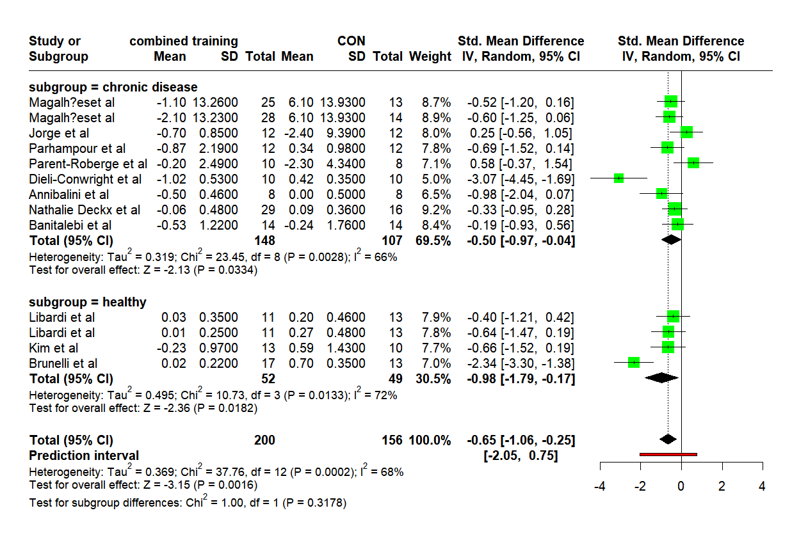 | IL6 Subgroup(gender)  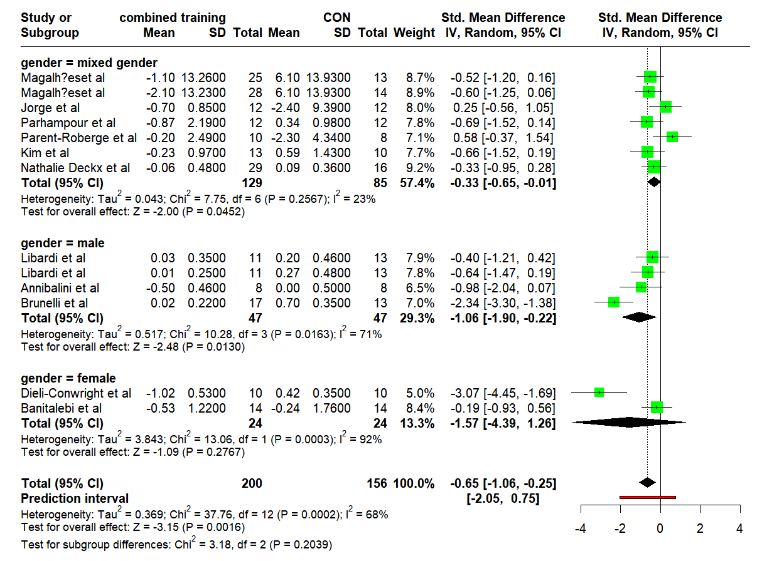 | IL6 Meta-regression(Age)  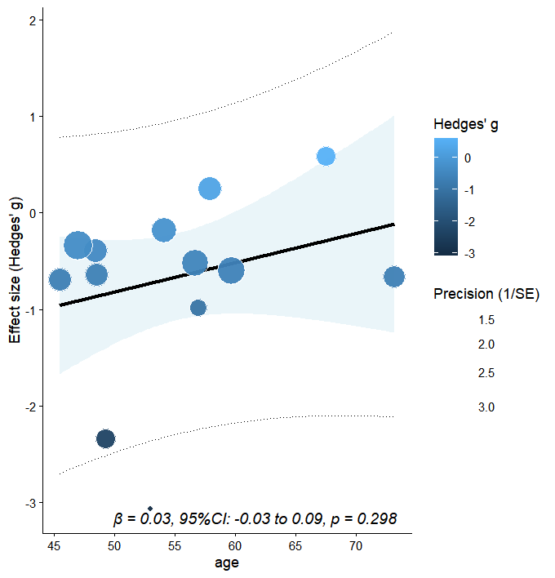
IL6 Meta-regression(intervention duration)  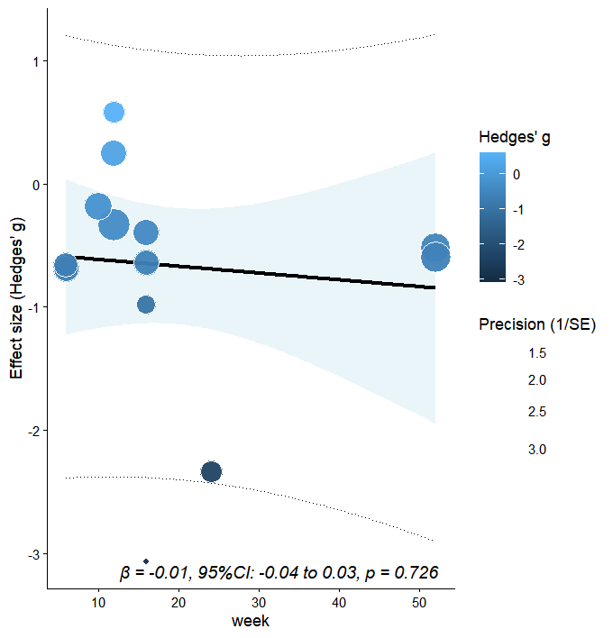 | IL6 Meta-regression(BMI)  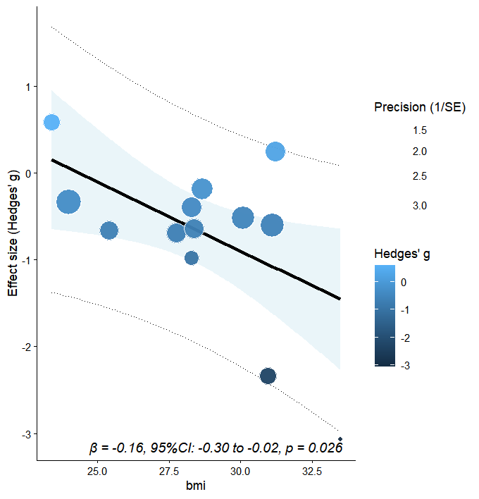 | The effect of CT on IL-6 (primary outcome)  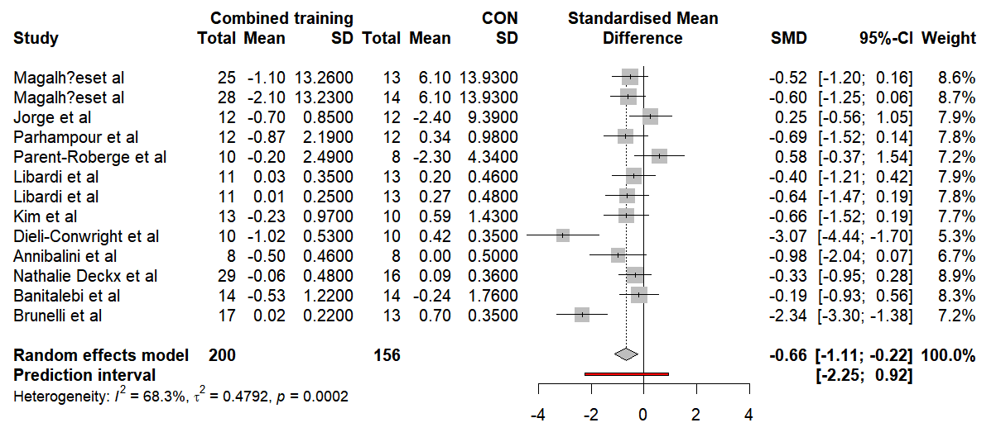

TNF-α Subgroup(health status)  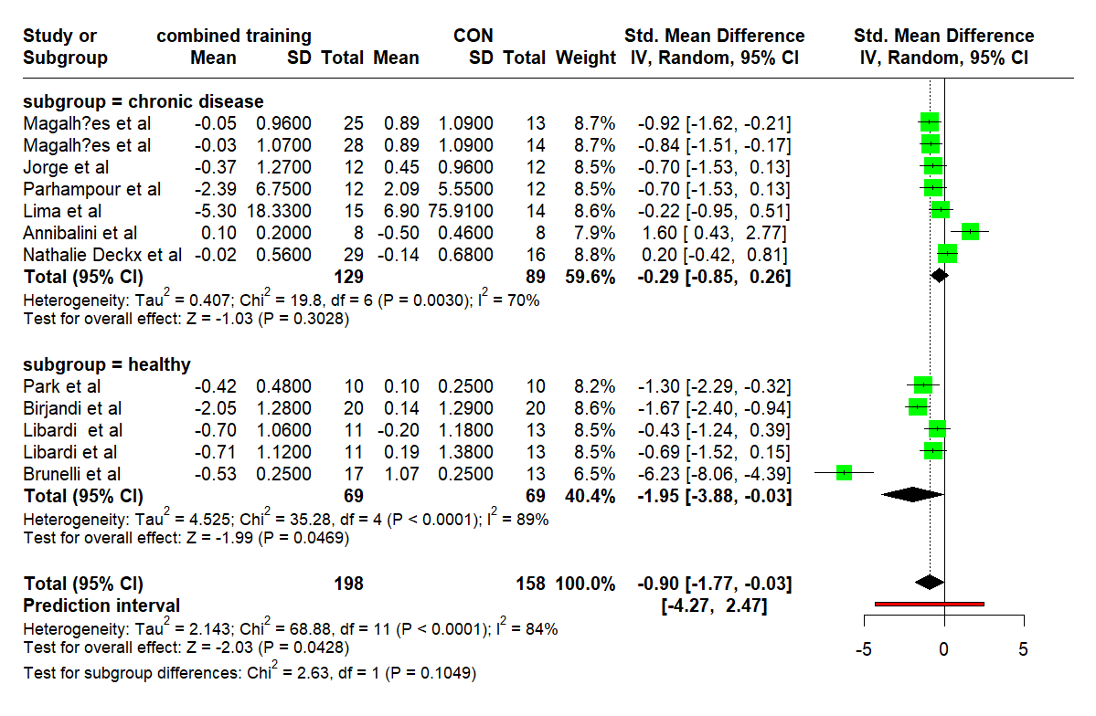 | TNF-α Subgroup(gender)  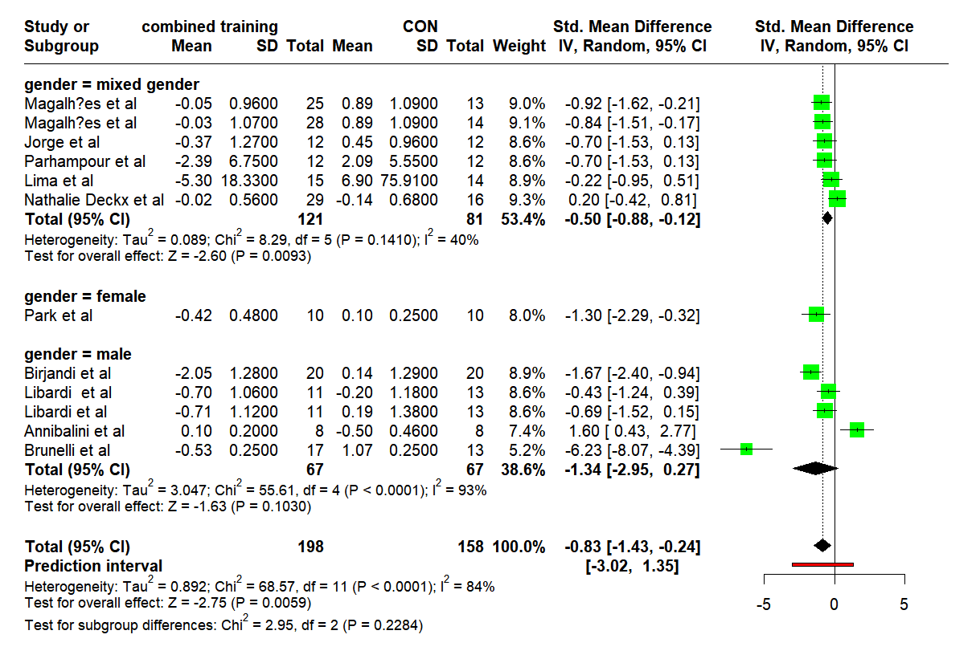 | TNF-α Meta-regression(Age)  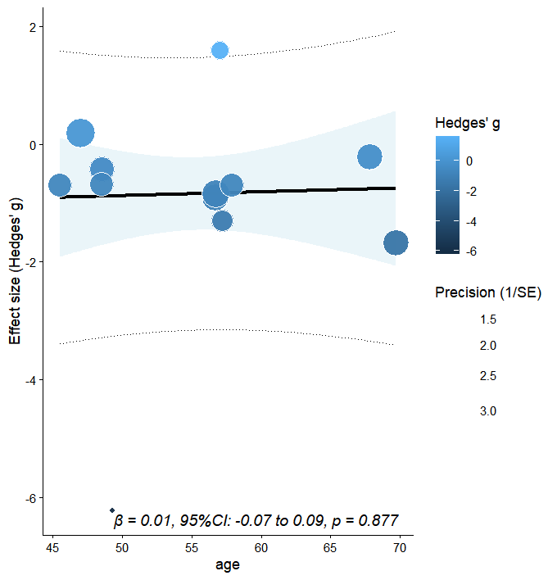
TNF-α Meta-regression(intervention duration)  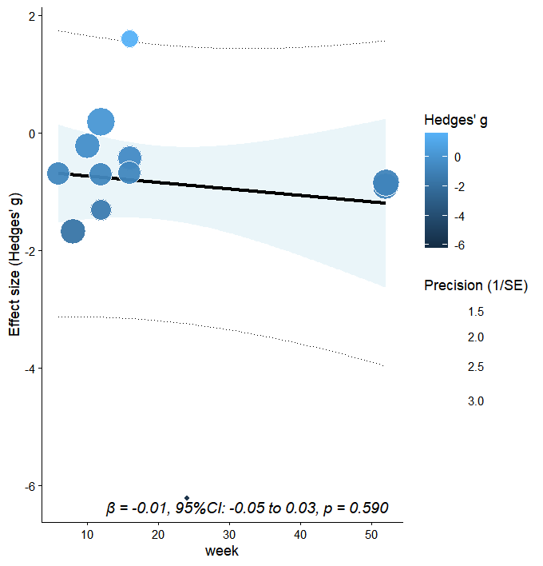 | TNF-α Meta-regression(BMI)  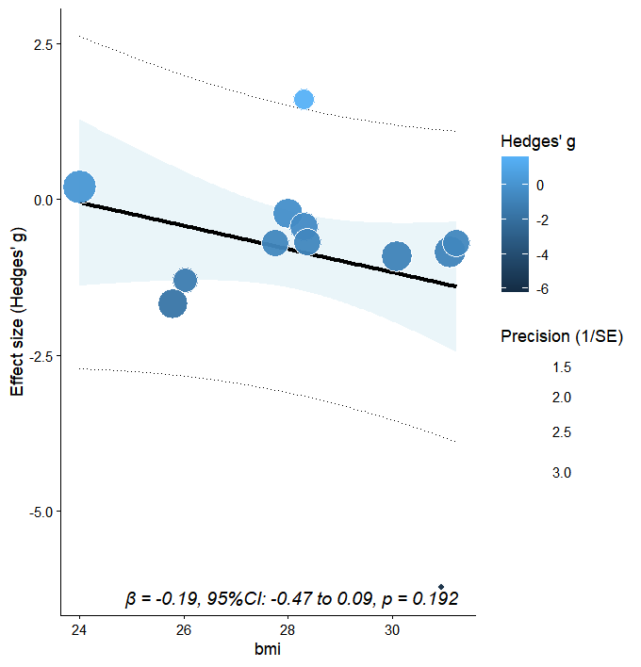 | 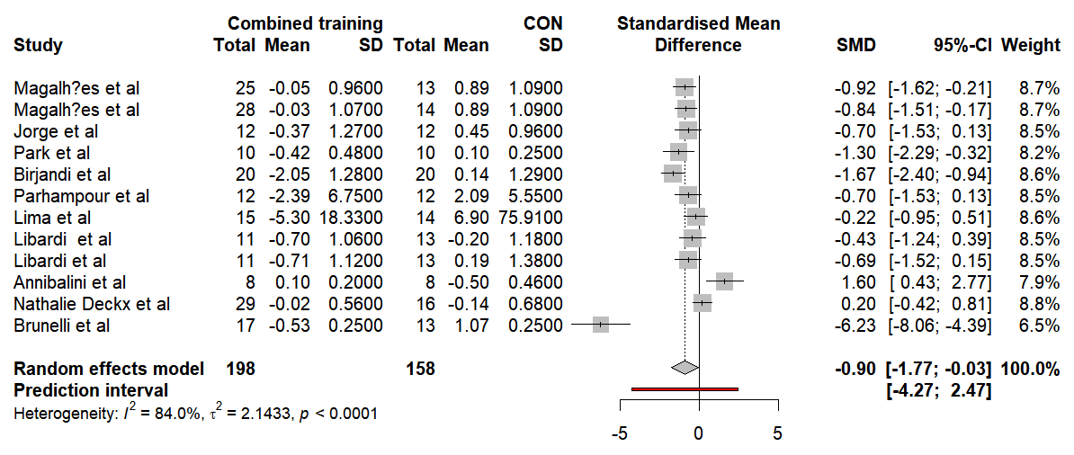
TNF-α

IL-10
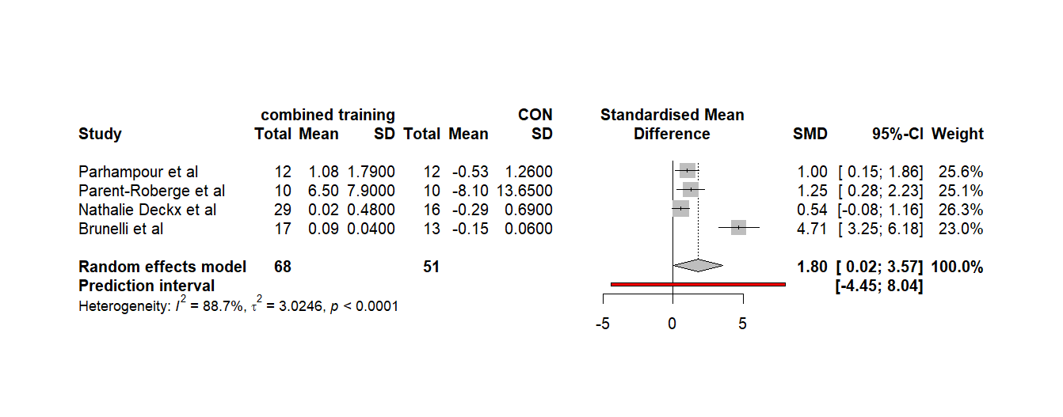
The effect of CT on IL-10 (primary outcome)

CRP
CRP Subgroup(health status)  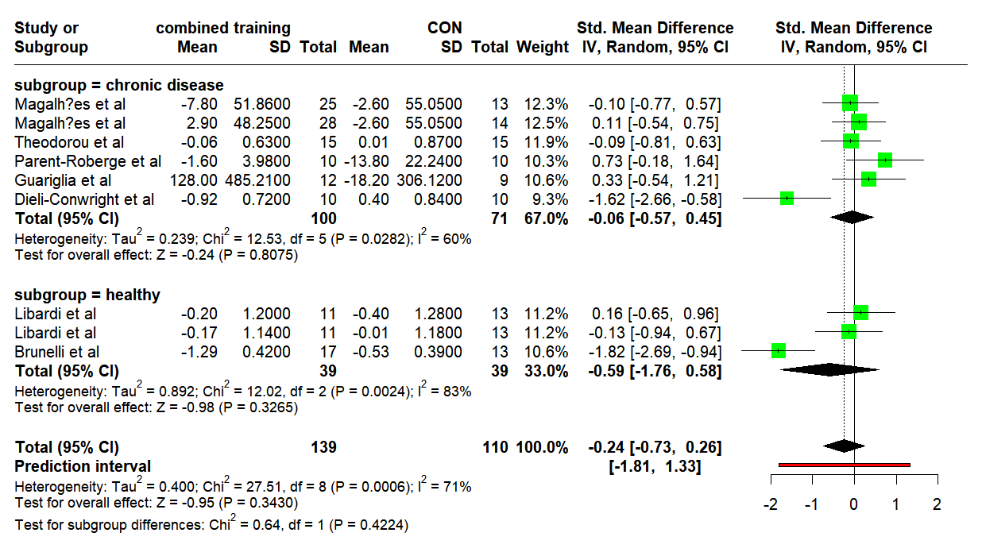 | CRP Subgroup(gender)  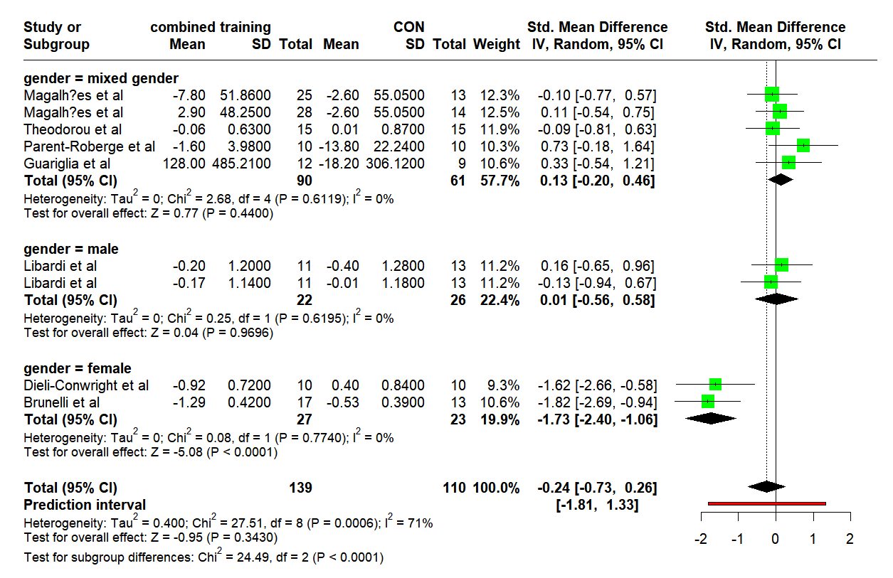
CRP Subgroup(BMI)  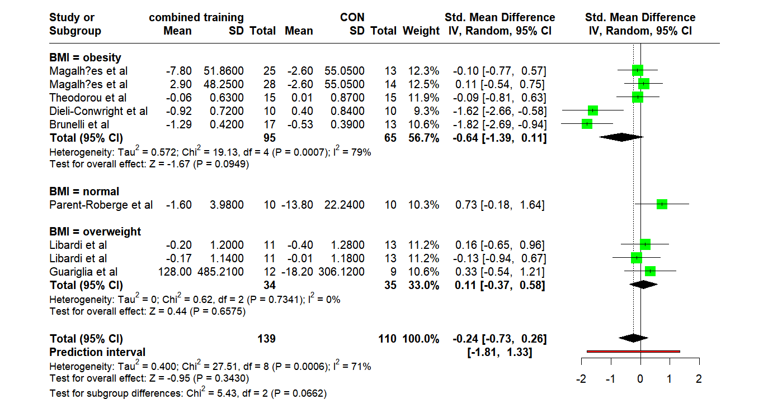 | The effect of CT on CRP (primary outcome)  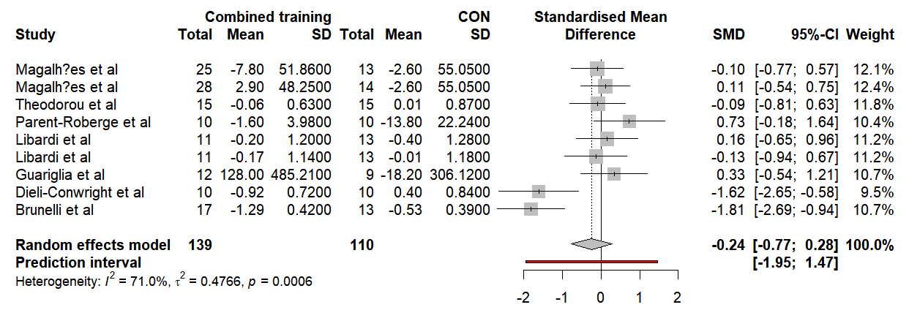

hs-CRP Subgroup(health status)  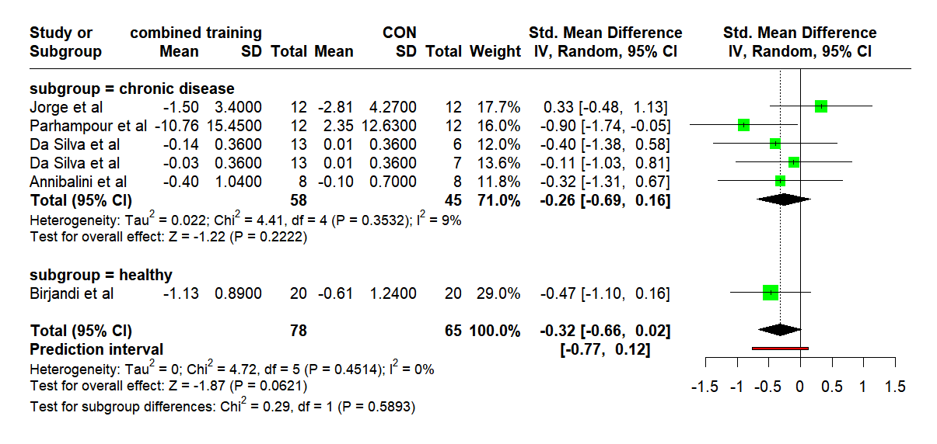 | hs-CRP Subgroup(gender)  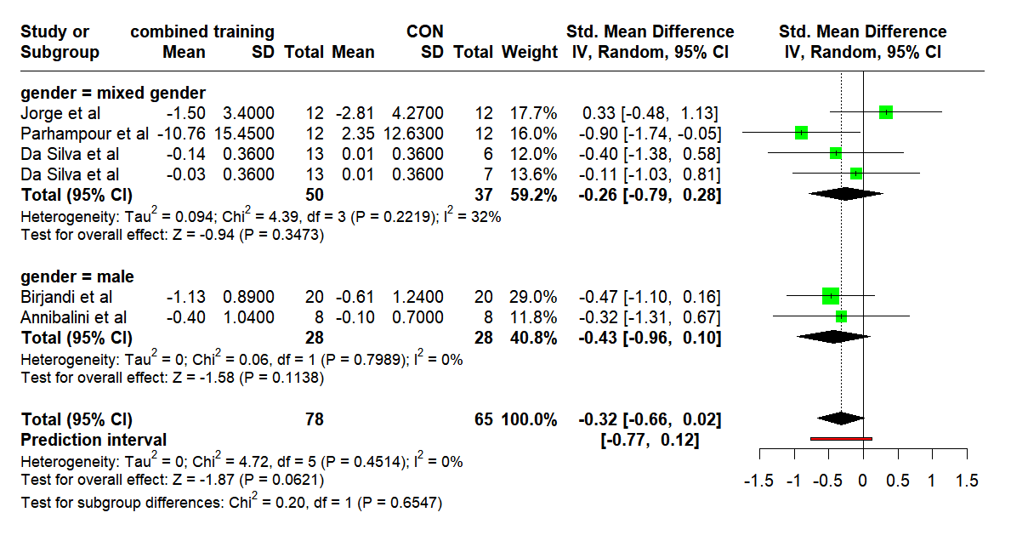
hs-CRP Subgroup(BMI)  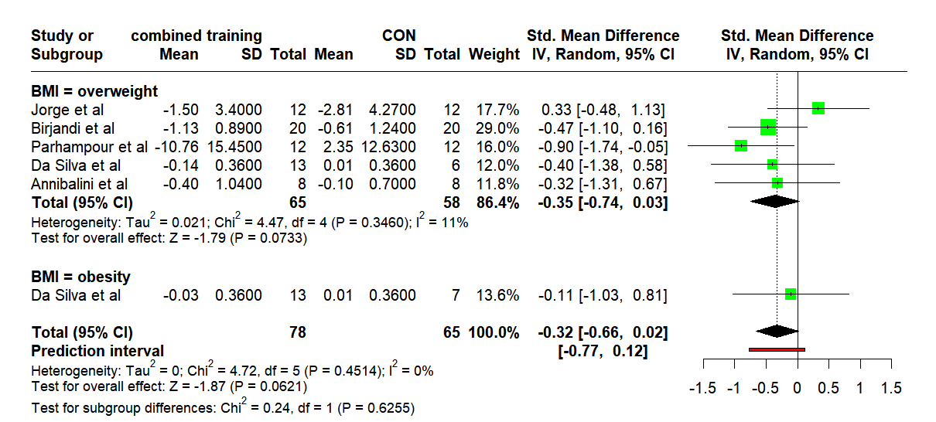 | The effect of CT on hs-CRP (primary outcome)  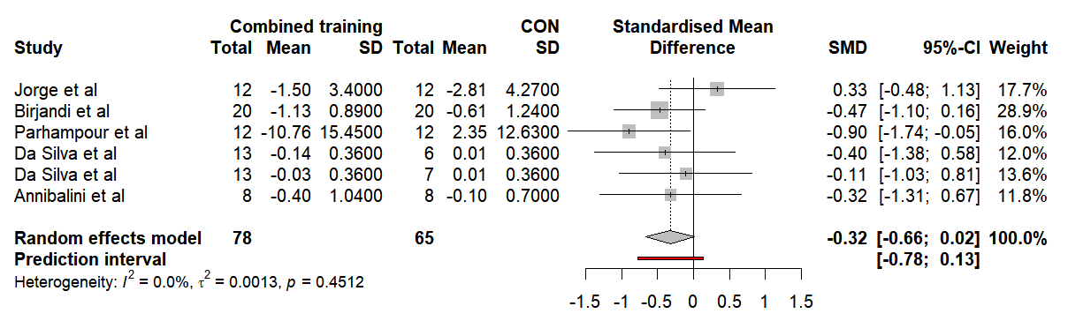

hs-CRP

Electronic Supplementary Material Appendix S5 (Methodological quality assessment [PEDro])
Author, year | D1 | D2 | D3 | D4 | D5 | D6 | D7 | D8 | D9 | D10 | D11 | Total
Magalhães et al, 2020 | Y | 1 | 1 | 1 | 0 | 1 | 0 | 1 | 1 | 1 | 1 | 8
Jorge et al, 2011 | Y | 1 | 0 | 1 | 0 | 0 | 0 | 1 | 1 | 1 | 1 | 6
Park et al, 2015 | Y | 1 | 0 | 0 | 0 | 0 | 0 | 1 | 1 | 1 | 1 | 5
Birjandi et al, 2023 | Y | 1 | 0 | 1 | 0 | 0 | 0 | 1 | 1 | 1 | 1 | 6
Theodorou et al, 2016 | Y | 1 | 0 | 1 | 0 | 0 | 0 | 1 | 1 | 1 | 1 | 6
Parhampour et al, 2019 | Y | 1 | 0 | 0 | 0 | 0 | 0 | 1 | 1 | 1 | 1 | 5
Parent-Roberge et al, 2020 | Y | 1 | 0 | 1 | 0 | 0 | 1 | 1 | 1 | 1 | 1 | 7
Liu el al, 2015 | Y | 1 | 0 | 1 | 0 | 0 | 0 | 1 | 1 | 1 | 1 | 6
Lima et al, 2015 | Y | 1 | 0 | 0 | 0 | 0 | 0 | 1 | 1 | 1 | 1 | 5
Libardi et al, 2011 | Y | 1 | 0 | 1 | 0 | 0 | 0 | 1 | 1 | 1 | 1 | 6
Libardi et al, 2012 | Y | 1 | 0 | 1 | 0 | 0 | 0 | 1 | 1 | 1 | 1 | 6
Kim et al, 2018 | Y | 1 | 0 | 0 | 0 | 0 | 0 | 1 | 1 | 1 | 1 | 5
Guariglia et al, 2018 | Y | 1 | 1 | 0 | 0 | 1 | 1 | 0 | 1 | 1 | 1 | 7
Dieli-Conwright et al, 2018 | Y | 1 | 1 | 0 | 0 | 0 | 1 | 1 | 1 | 1 | 1 | 7
Da Silva et al, 2020 | Y | 1 | 0 | 1 | 0 | 0 | 0 | 1 | 1 | 1 | 1 | 6
Annibalini et al, 2017 | Y | 1 | 0 | 1 | 0 | 0 | 0 | 1 | 1 | 1 | 1 | 6
Nathalie Deckx et al, 2015 | Y | 1 | 1 | 1 | 0 | 0 | 0 | 1 | 1 | 1 | 1 | 7
Banitalebi et al, 2018 | Y | 1 | 1 | 1 | 0 | 0 | 1 | 1 | 1 | 1 | 1 | 8
Brunelli et al, 2015 | Y | 1 | 0 | 0 | 0 | 0 | 0 | 0 | 1 | 1 | 1 | 4

Note: studies scoring ≥6 are considered high quality, those scoring 4-5 are considered moderate quality, and those scoring ≤3 are considered low quality.
1. eligibility criteria were specified (not included in the total score)
2. subjects were randomly allocated to groups (in a crossover study, subjects were randomly allocated an order in which treatments were received)
3. allocation was concealed
4. the groups were similar at baseline regarding the most important prognostic indicators
5. there was blinding of all subjects
6. there was blinding of all therapists who administered the therapy
7. there was blinding of all assessors who measured at least one key outcome
8. measures of at least one key outcome were obtained from more than 85% of the subjects initially allocated to groups
9. all subjects for whom outcome measures were available received the treatment or control condition as allocated or, where this was not the case, data for at least one key outcome was analysed by “intention to treat”
10. the results of between-group statistical comparisons are reported for at least one key outcome
11. the study provides both point measures and measures of variability for at least one key outcome

Electronic Supplementary Material Appendix S6（Sensitivity analysis）
IL6(Sensitivity analysis)  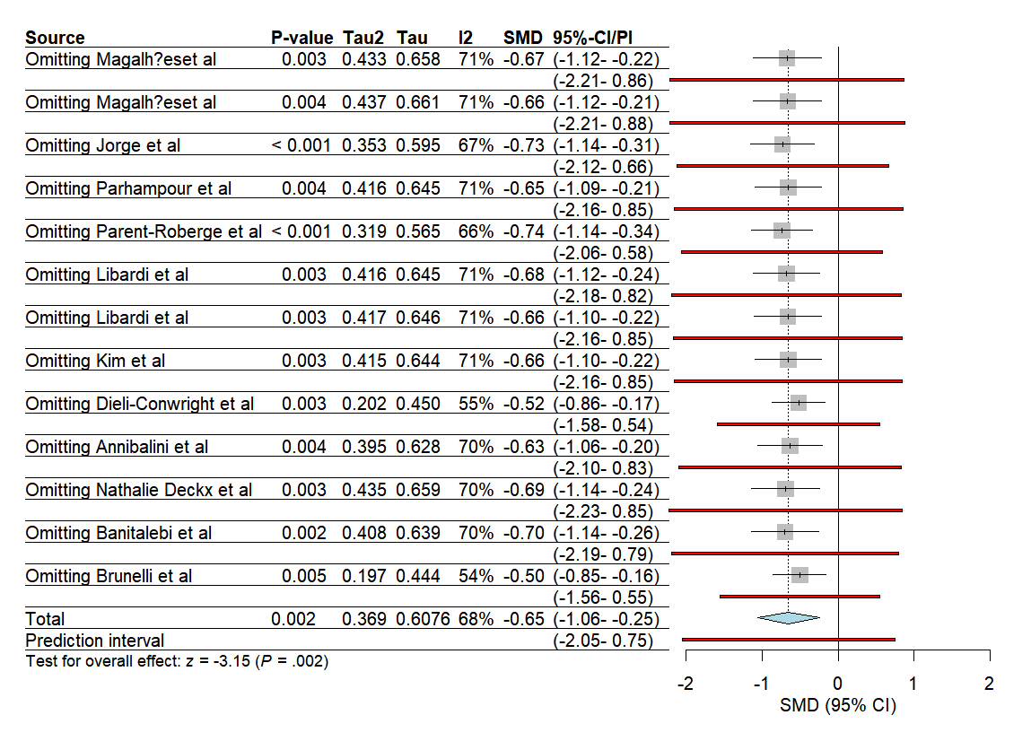 | TNF-α(Sensitivity analysis)  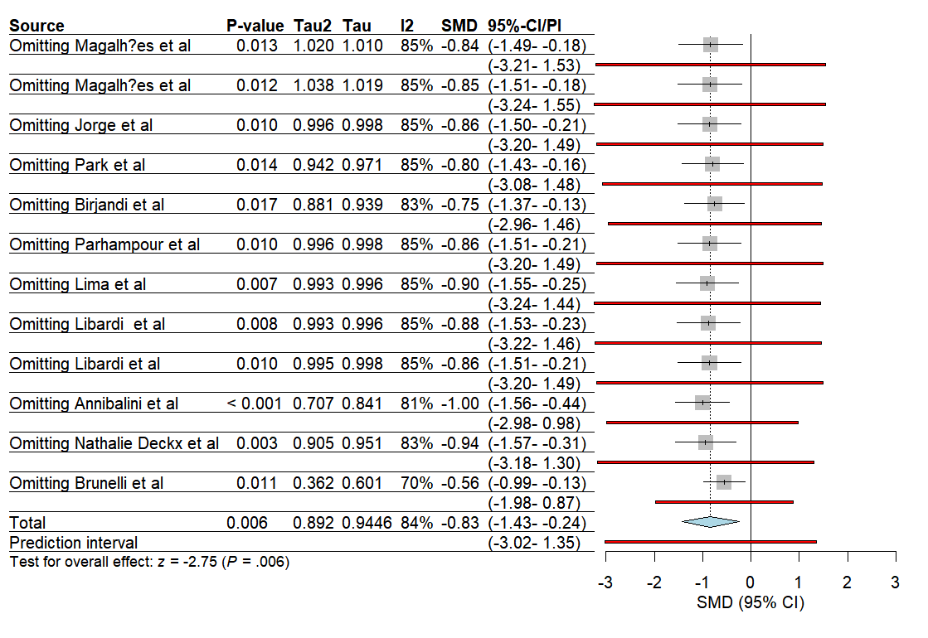 | CRP(Sensitivity analysis)  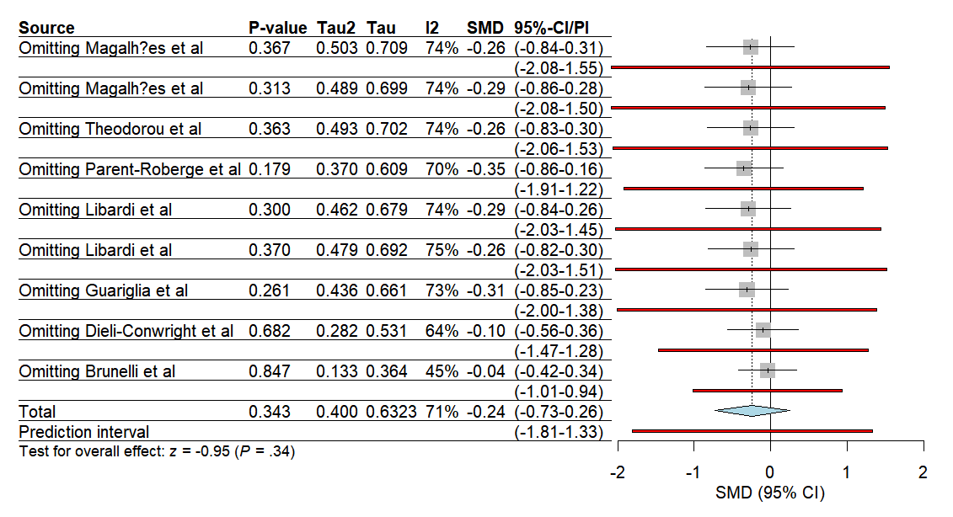
hs-CRP(Sensitivity analysis)  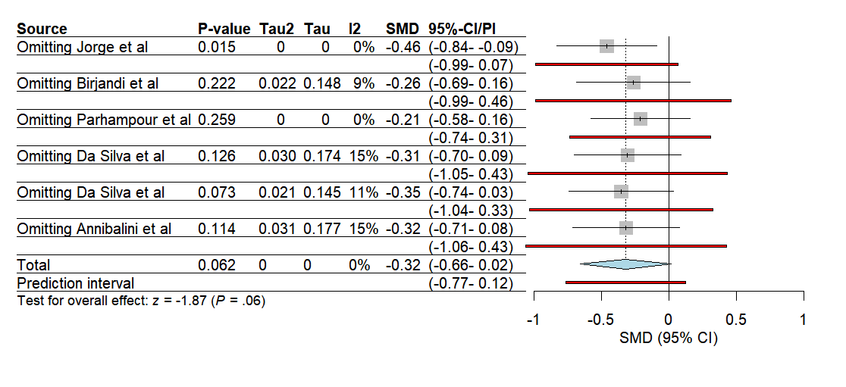 | IL10(Sensitivity analysis)  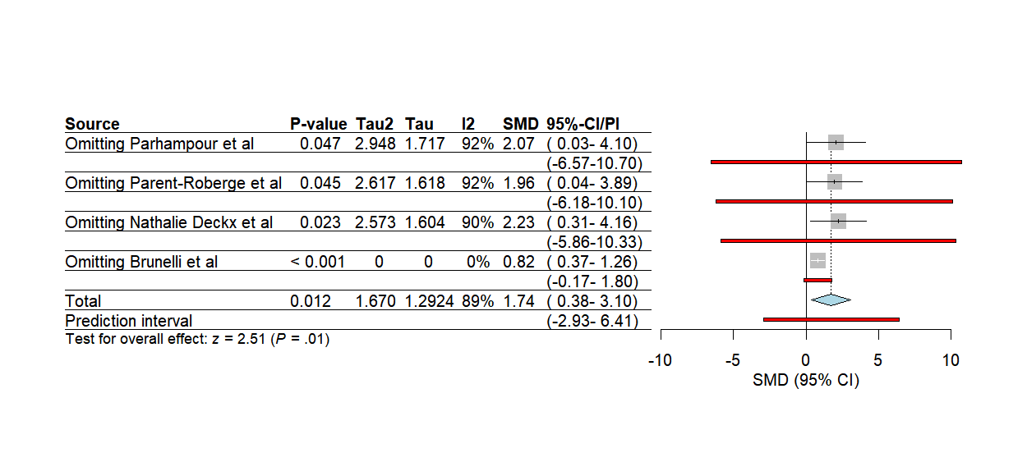

Electronic Supplementary Material Appendix 7(GRADE)

Outcome | No of participants (studies) | Certainty Assessment |  |  |  |  | Hedge’s g † (95% CI) | Grade*
Outcome | No of participants (studies) | Risk of bias | Inconsistency | Indirectness | Imprecision | Other | Hedge’s g † (95% CI) | Grade*
Combined training
IL-6 | 356  (12 RCT) | Some serious | Not serious | Not serious | Not serious | None | -0.66 (-1.11，-0.22) | ⨁⨁◯◯  Low
TNF-α | 356  (11 RCT) | Some serious | Serious | Not serious | Not serious | None | -0.90(-1.77，-0.03) | ⨁⨁◯◯  Low
CRP | 265  (8RCT) | Some serious | Serious | Not serious | Not Serious | None | -0.24(-0.77，0.28) | ⨁⨁◯◯  Low
hs-crp | 143  (5 RCT) | Some serious | Not serious | Not serious | Serious | None | -0.32(-0.66，0.02) | ⨁⨁◯◯  Low
IL-10 | 119  (4 RCT) | Some serious | Serious | Not serious | Serious | None | 1.80(0.02，3.57) | ⨁◯◯◯  Very Low
Corints of evidence according to Gradine of Recommcadations, Assessment, Derclopment, and Exalentions (GRADE).
Hish: We are very confident in the estimated effect
Moderate: Our confidence in the estimated effect is moderate
Low: We have limited confidence in the estimated effect
Very low: We have very little confidence in the estimated etteet
No of participants: Total number of participants with pooled effecte

