Testing carryover effect on LDL-c outcome
Design: Crossover design
4 sequence (AR; RA; BR; RB)
A= Pravastatin 40 mg; B= Phytosterols 2 g; R=Reference (combination group)
Period: 2; Drug: A, B, R
Response to reviewer (carryover effect on LDL-c)
We tested the carryover effect between Drug A and Combination and Drug B and Combination. Mixed linear regression model with lm4 package in r program was used to test the effect. We found that there was no statistical difference of carryover effect between sequence AR and RA (P value: 0.977). The statistical difference of carryover effect between sequence BR and RB was not observed as well (P value: 0.659). So in this study we could conclud that no carryover effect was observed.
Statistical modeling for testing carryover effect as follow:

$y_{ijk}=μ+b_{ij}+π_{k}+ϕ_{m}+λ_{m}+ε_{ijk}$ Equation (1)

Where i = sequence, j = patient, k = period and m = treatment
$μ$ : Overall mean
$b_{ij}$: Effect of j^{th} patient with i^{th} sequence
$π_{k}$: Effect of k^{th} period
$ϕ_{m}$: Effect of m^{th} drug treatment
$λ_{m}$: Residual effect of m^{th} drug treatment
$ε_{ijk}$: Random error

We tested two hypothesis of carryover effect that is AR|RA and BR | RB.
Hypothesis I, we tested for sequence AR|RA (group 1 vs 2)

Ho: there was no difference average of ldl between sequence AR and RA ($b_{ij}$ = 0)
Ha: there was difference average of ldl between sequence AR and RA ($b_{ij}$ ≠ 0)

Hypothesis II, we tested for sequence BR|RB (group 3 vs 4)

Ho: there was no difference average of ldl between sequence BR and RB ($b_{ij}$ = 0)
Ha: there was difference average of ldl between sequence BR and RB ($b_{ij}$ ≠ 0)

If P value of sequence from modelling was no statistical significant (P value >0.05), we could concluded that no carryover effect.
Table 1 show the effect of carryover among sequence (AR | RA, BR | RB)
 | Coefficient | SE | t value | p-value
LDL (outcome)
$b_{ij}$ : Sequence (AR vs RA) | 0.25 | 8.53 | 0.029 | 0.977
$π_{k}$ : Period (1 vs 2) | 11.73 | 8.53 | 1.375 | 0.169
$ϕ_{m}$: Drug (A vs R) | -5.18 | 8.53 | -0.607 | 0.544
LDL (outcome)
$b_{ij}$ : Sequence (BR vs RB) | 4.28 | 9.69 | 0.442 | 0.659
$π_{k}$ : Period (1 vs 2) | 5.41 | 9.46 | 0.572 | 0.567
$ϕ_{m}$: Drug (B vs R) | 31.59 | 9.46 | 3.339 | 0.001

From table 1, the sequence effect was not statistical difference both sequence AR|AR (P value = 0.977) and BR | RB (P value=0.659).

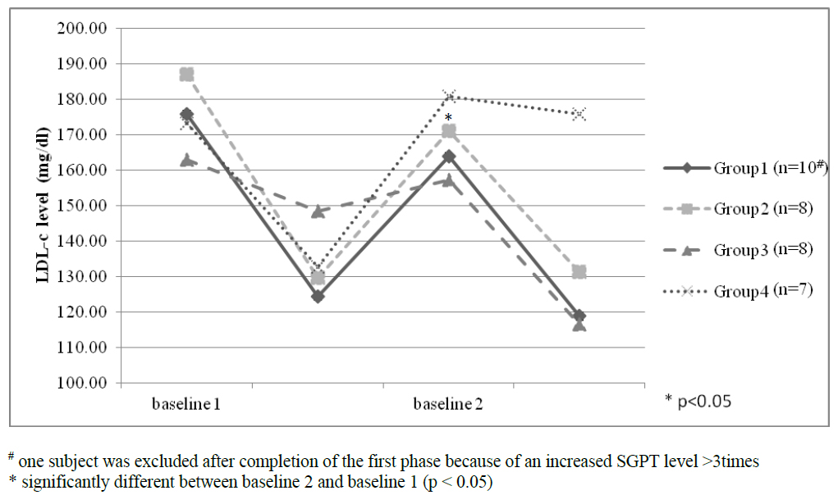
From this graph, we seen that, at the period II sequence 4 (baseline 2, group 4), the value of LDL-c level was higher than baseline 1. It might be that this results occurred by participant status or a tendency of participants to have a high LDL-c level after period 1.

Reference
Dieter H, Volker S, Iris P. 2007. Bioequivalence Studies in Drug Development: Methods and Applications. 1st. New York: John Wiley & Sons Inc

