PanFP: Pangenome-based functional profiles for microbial communities
Se-Ran Jun, Michael S. Robeson, Loren J. Hauser, Christopher W. Schadt, Andrey A. Gorin

Figure S1. Flow diagram of PanFP.

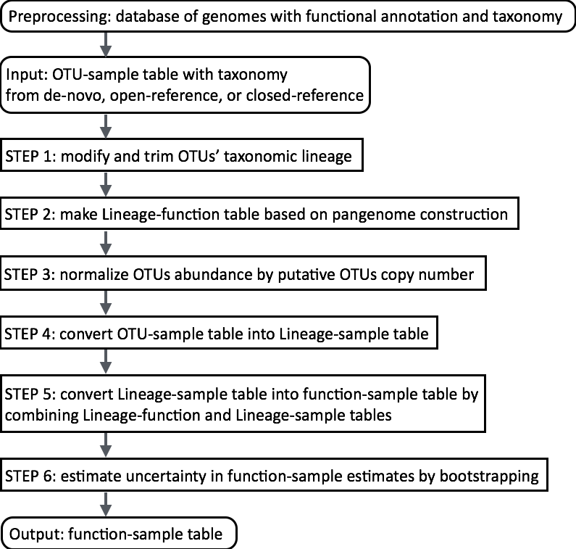

Figure S2. Figure S1. Functional coverage. The X-axis represents the functional coverage, which is defined as the number of proteins with functional annotations by KO terms divided by the total number of proteins for each organism. The Y-axis represents the number of organisms whose complete proteomes have the given functional annotation percentage. The functional profiles of samples by PanFP depend on pangenome construction. Therefore, the occurrence of functional terms is related to the number of genomes included in pangenome construction. But, the number of genomes involved in different pangenomes varies greatly. Therefore, we normalized occurrence of functional terms by the number of genomes pooled for pangenome construction. We filtered out genomes with poor functional annotation to avoid the underestimation of frequency of functional terms, and excluded 252 complete prokaryotes with a 30% cutoff for KEGG Orthology. However, with a 10% cutoff, we excluded 253 complete prokaryotes for KEGG Orthology, indicating that we employed almost all annotated genomes of complete prokaryotes.
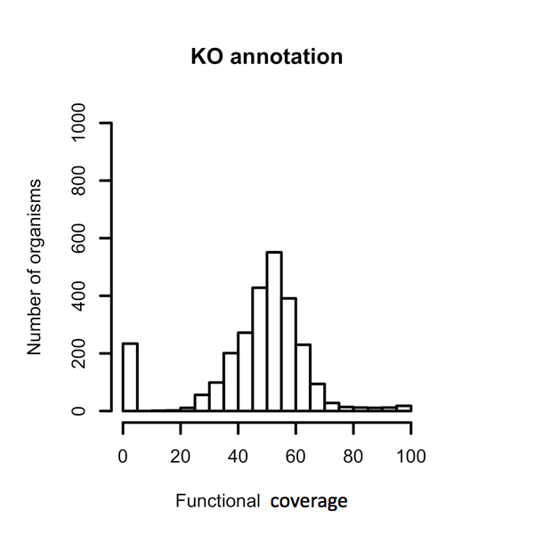

Figure S3. Figure S2. Spearman rank correlation between PanFP and PICRUSt.
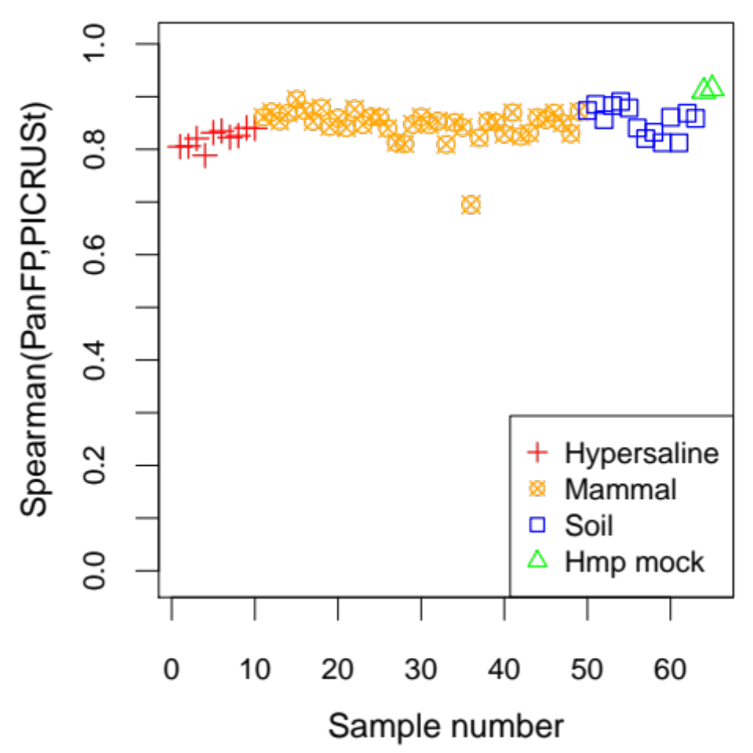

Table S1. Summary of the number of KO terms with positive estimates in functional profiles. The table summarizes the number of KO terms with positive estimates in functional terms by sequenced metagenome, PanFP, and PICRUSt for 65 samples. Summary of the number of KO terms in functional profiles by sequenced metagenome, PanFP and PICRUSt.
Hypersaline  sampleID | Meta  genome | PanFP | PICRUSt | PanFP  vs  Meta  genome | PICRUSt  vs  Meta  genome | PanFP  vs  PICRUSt | Corr  PanFP  vs  Meta  genome | Corr  PICRUSt  vs  Meta  genome | Corr  PanFP  vs PICRUSt
4440968.3 | 167 | 6247 | 3948 | 165 | 162 | 3718 | 0.122 | 0.151 | 0.805
4440972.3 | 178 | 6888 | 4198 | 177 | 177 | 4000 | 0.160 | 0.097 | 0.806
4440970.3 | 182 | 6444 | 3952 | 181 | 179 | 3737 | 0.125 | 0.086 | 0.820
4440971.3 | 190 | 6322 | 3933 | 190 | 187 | 3732 | 0.140 | 0.161 | 0.788
4440969.3 | 198 | 6305 | 3951 | 197 | 197 | 3746 | 0 | 0.039 | 0.832
4440964.3 | 556 | 6195 | 3970 | 553 | 549 | 3828 | 0.212 | 0.2 | 0.835
4440967.3 | 172 | 5614 | 3909 | 171 | 169 | 3679 | 0.135 | 0.106 | 0.823
4440966.3 | 263 | 6328 | 3926 | 262 | 258 | 3727 | 0.049 | 0.061 | 0.826
4440965.3 | 301 | 6320 | 3866 | 300 | 289 | 3754 | 0.06 | 0.051 | 0.841
4440963.3 | 424 | 6606 | 4196 | 421 | 420 | 3997 | 0.117 | 0.103 | 0.84
Soil  sampleID | Meta  genome | PanFP | PICRUSt | PanFP  vs  Meta  genome | PICRUSt  vs  Meta  genome | PanFP  vs  PICRUSt | Corr  PanFP  vs  Meta  genome | Corr  PICRUSt  vs  Meta  genome | Corr  PanFP  vs  PICRUSt
SV1 | 4966 | 6054 | 4672 | 4034 | 3835 | 4418 | 0.770 | 0.761 | 0.874
TL1 | 4325 | 6222 | 4438 | 3801 | 3589 | 4253 | 0.783 | 0.764 | 0.885
SF2 | 4497 | 6497 | 4858 | 3892 | 3787 | 4658 | 0.760 | 0.753 | 0.856
BZ1 | 4723 | 6195 | 4593 | 3824 | 3679 | 4347 | 0.772 | 0.767 | 0.883
PE6 | 4873 | 6928 | 5130 | 4367 | 4179 | 4986 | 0.785 | 0.789 | 0.891
CL1 | 4609 | 6463 | 4657 | 3893 | 3757 | 4522 | 0.757 | 0.758 | 0.878
EB026 | 4114 | 5936 | 4441 | 3700 | 3566 | 4283 | 0.766 | 0.749 | 0.841
EB021 | 3476 | 6280 | 3643 | 3170 | 2845 | 3528 | 0.705 | 0.689 | 0.820
AR3 | 4047 | 6517 | 4614 | 3728 | 3519 | 4432 | 0.695 | 0.686 | 0.832
EB020 | 3892 | 6300 | 4327 | 3518 | 3319 | 4140 | 0.721 | 0.694 | 0.813
KP1 | 4183 | 6850 | 4981 | 3846 | 3746 | 4776 | 0.747 | 0.755 | 0.860
EB024 | 4105 | 6379 | 4513 | 3697 | 3498 | 4323 | 0.726 | 0.715 | 0.812
MD3 | 4484 | 6478 | 4890 | 3819 | 3702 | 4685 | 0.768 | 0.757 | 0.869
DF1 | 4293 | 6454 | 4523 | 3710 | 3603 | 4377 | 0.740 | 0.74 | 0.859
Mammal  sampleID | Meta  genome | PanFP | PICRUSt | PanFP  vs  Meta  genome | PICRUSt  vs  Meta  genome | PanFP  Vs  PICRUSt | Corr  PanFP  vs  Meta  genome | Corr  PICRUSt  vs  Meta  genome | Corr  PanFP  vs  PICRUSt
Capybara | 1333 | 5737 | 3653 | 1258 | 1260 | 3459 | 0.590 | 0.609 | 0.861
GorillaSTL | 662 | 5736 | 3531 | 637 | 631 | 3447 | 0.370 | 0.382 | 0.871
Hyena2 | 1455 | 5930 | 3683 | 1434 | 1405 | 3595 | 0.549 | 0.57 | 0.854
BaboonSTL | 728 | 5462 | 3274 | 710 | 704 | 3181 | 0.393 | 0.384 | 0.869
Echidna | 1868 | 6138 | 4659 | 1849 | 1845 | 4537 | 0.767 | 0.76 | 0.894
PolarBr2 | 3145 | 5868 | 4350 | 3122 | 3088 | 4250 | 0.502 | 0.469 | 0.873
Saki | 1603 | 6062 | 4055 | 1480 | 1451 | 3972 | 0.576 | 0.587 | 0.853
Orang1 | 747 | 5785 | 4054 | 715 | 702 | 3955 | 0.456 | 0.459 | 0.879
BushDog1 | 1421 | 4334 | 2931 | 1388 | 1362 | 2758 | 0.553 | 0.566 | 0.843
VWPig | 932 | 5204 | 3152 | 916 | 897 | 3017 | 0.454 | 0.458 | 0.860
Okapi1 | 656 | 6004 | 3569 | 646 | 636 | 3472 | 0.382 | 0.377 | 0.841
Horse1 | 976 | 6358 | 4839 | 941 | 944 | 4601 | 0.476 | 0.466 | 0.876
AfElphSD3 | 991 | 5264 | 2926 | 938 | 897 | 2846 | 0.448 | 0.433 | 0.847
BigHornSD | 743 | 5873 | 3562 | 729 | 722 | 3453 | 0.379 | 0.396 | 0.862
ZebraSTL1 | 605 | 6324 | 3337 | 600 | 593 | 3273 | 0.301 | 0.331 | 0.861
Kroo3 | 549 | 5646 | 3453 | 547 | 543 | 3326 | 0.269 | 0.245 | 0.840
Callimicos | 1214 | 4941 | 2968 | 1201 | 1169 | 2864 | 0.512 | 0.478 | 0.813
BaboonW | 609 | 5094 | 2727 | 600 | 588 | 2632 | 0.392 | 0.35 | 0.810
HyraxSD | 986 | 5543 | 3840 | 959 | 947 | 3734 | 0.490 | 0.462 | 0.847
BlackRhino1 | 1050 | 4671 | 2923 | 1024 | 1008 | 2783 | 0.510 | 0.518 | 0.861
Urial2 | 697 | 5650 | 3260 | 669 | 661 | 3156 | 0.418 | 0.391 | 0.847
Chimp2 | 499 | 5384 | 3074 | 482 | 470 | 2975 | 0.336 | 0.326 | 0.853
BlackBr2 | 2975 | 5381 | 3502 | 2942 | 2836 | 3452 | 0.610 | 0.646 | 0.809
SpgbkW | 1238 | 6381 | 3678 | 1219 | 1199 | 3593 | 0.490 | 0.496 | 0.851
SpecBr2 | 1858 | 5136 | 2206 | 1838 | 1386 | 2174 | 0.772 | 0.69 | 0.842
Squirrel | 1361 | 4444 | 2791 | 1348 | 1334 | 2671 | 0.453 | 0.677 | 0.695
Colobus | 954 | 5585 | 3187 | 925 | 905 | 3094 | 0.453 | 0.455 | 0.822
HyraxSTL | 1122 | 5490 | 3243 | 1077 | 1069 | 3162 | 0.472 | 0.507 | 0.853
Gazelle3 | 929 | 5347 | 3110 | 886 | 872 | 3006 | 0.435 | 0.433 | 0.851
BigHornW3 | 1191 | 5702 | 3364 | 1100 | 983 | 3276 | 0.387 | 0.361 | 0.829
Chimp1 | 1192 | 5689 | 3355 | 1106 | 1068 | 3257 | 0.512 | 0.527 | 0.869
Lion2 | 3031 | 5719 | 4015 | 2984 | 2918 | 3915 | 0.462 | 0.46 | 0.825
Rabbit | 912 | 4766 | 2708 | 902 | 886 | 2599 | 0.435 | 0.413 | 0.831
Okapi2 | 554 | 5747 | 3241 | 536 | 533 | 3149 | 0.293 | 0.311 | 0.861
Armadillo | 1066 | 5634 | 4198 | 1056 | 1055 | 4076 | 0.487 | 0.506 | 0.856
Giraffe2 | 905 | 6242 | 3836 | 876 | 862 | 3752 | 0.502 | 0.491 | 0.869
RTLemur | 1136 | 6263 | 3706 | 1125 | 1114 | 3622 | 0.470 | 0.511 | 0.850
Lion1 | 1273 | 5414 | 4069 | 1261 | 1254 | 3943 | 0.464 | 0.488 | 0.830
BlackLemur | 1245 | 4813 | 3024 | 1215 | 1201 | 2880 | 0.540 | 0.515 | 0.872
HMP mock  sampleID | Meta  genome | PanFP | PICRUSt | PanFP  vs  Meta  genome | PICRUSt  vs  Meta  genome | PanFP  Vs  PICRUSt | Corr  PanFP  vs  Meta  genome | Corr  PICRUSt  vs  Meta  genome | Corr  PanFP  vs  PICRUSt
even | 6111 | 6550 | 5432 | 5152 | 5020 | 5279 | 0.894 | 0.885 | 0.910
staggered | 5991 | 6678 | 5485 | 5109 | 4984 | 5345 | 0.872 | 0.847 | 0.914

