Additional Table 2: FDA approved drugs against Leishmania mexicana selected for the study
Sodium stibogluconate:  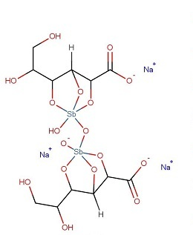 | Sitamaquine  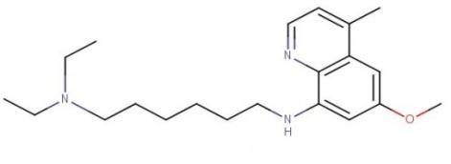
Quinacrine  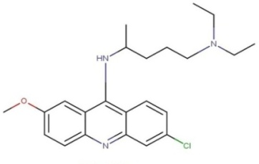 | Pentamidine  