Supplementary file 1: Examples of clinical oral wound healing
- Fresh punch biopsy (baseline) b) Healing after 2 days
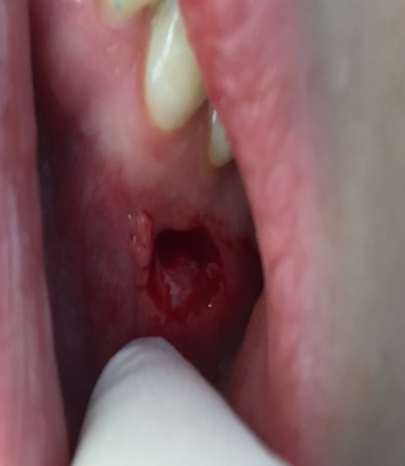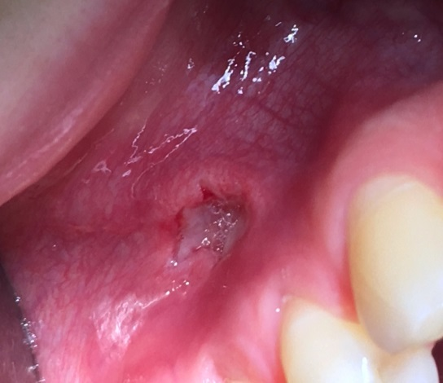
- Healing after 5 days d) Healing after 8 days
