File name: Additional file 1
Title of data: DPPH radical scavenging activities of the tested Matricaria recutita L. extract.
Description of data: The percentage inhibitions of DPPH scavenging activity of the extract.

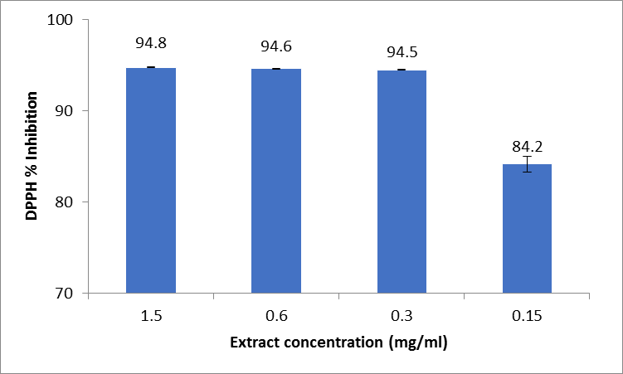
Additional file 1. DPPH radical scavenging activities of the tested Matricaria recutita L. extract.

