Additional file 3:
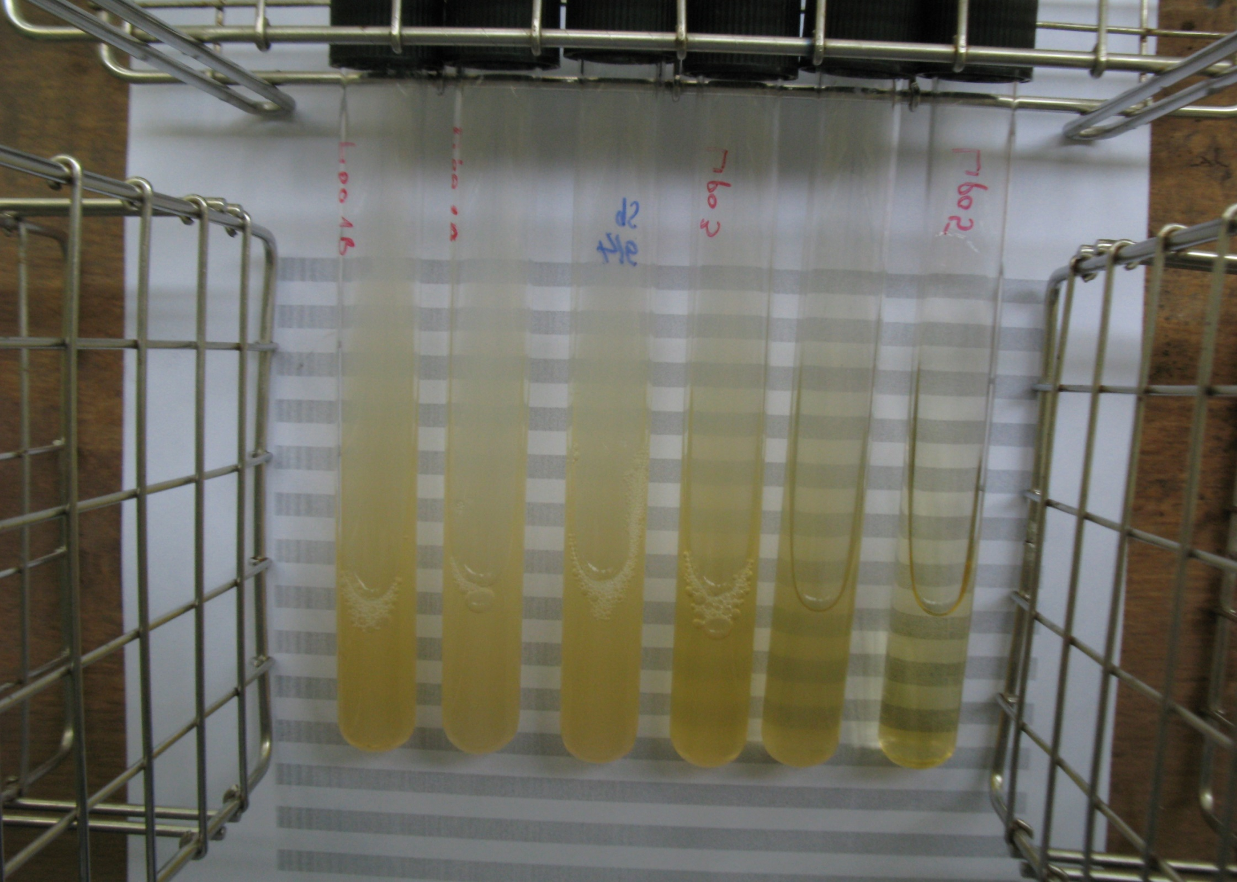
A
B
C
D
E
F
Figure S1.

