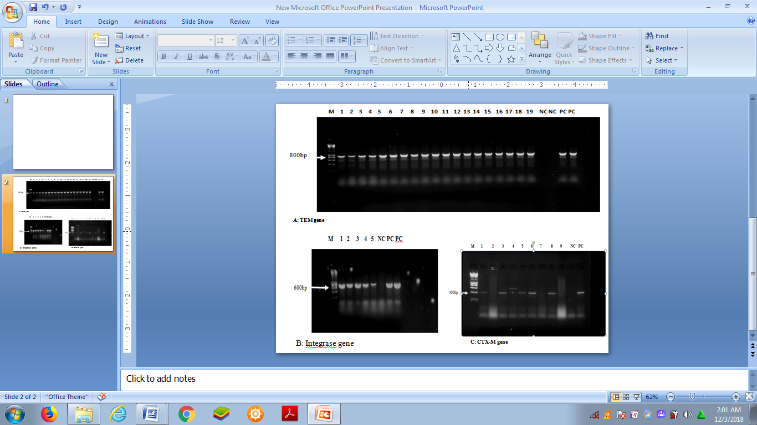

Key=M: 1 Kb DNA ladder, 1-19 isolates from chicken droppings, NC: Negative controls PC: Positive controls, A: TEM, B: Integrase, C: CTX-M

