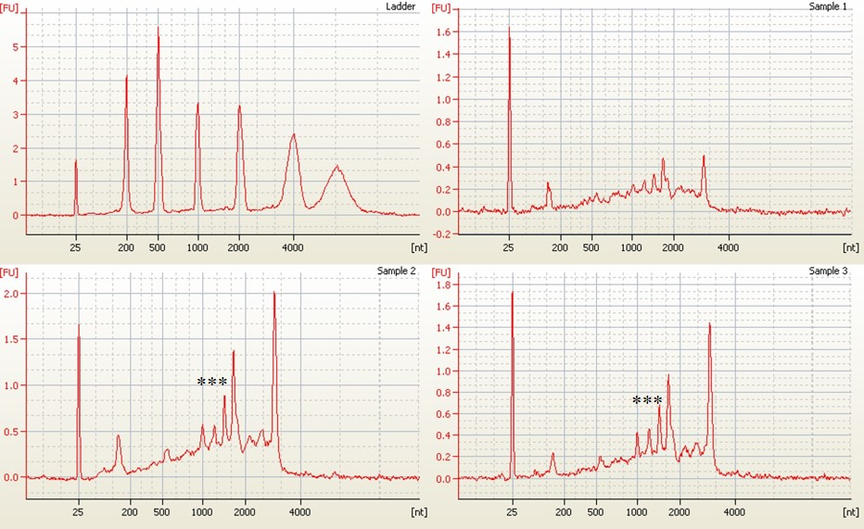
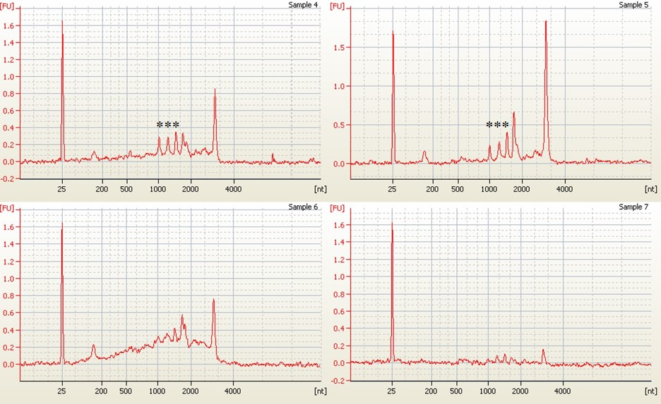

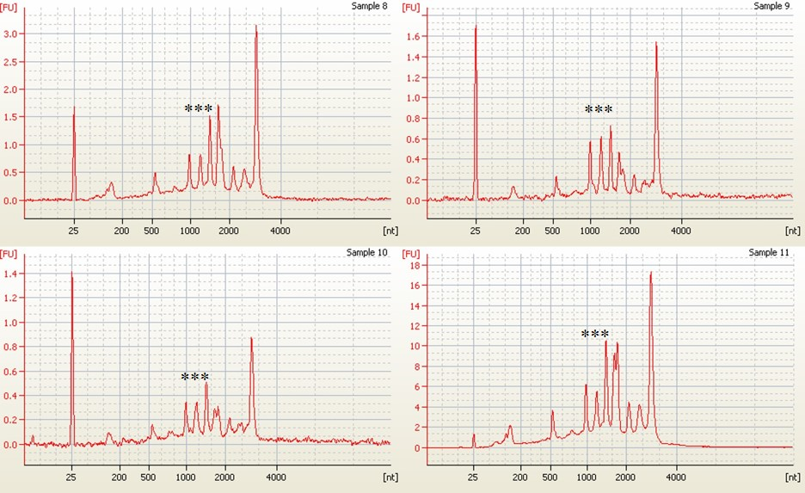
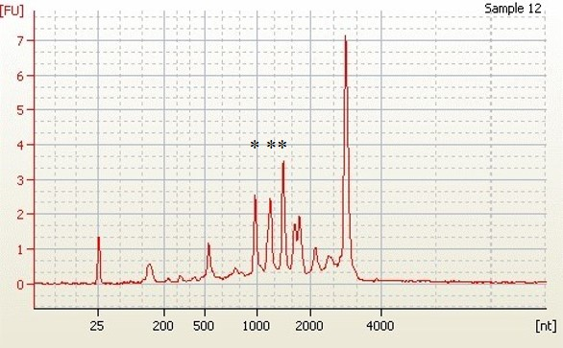
Figure S1 Electropherogram of kiwifruit total RNA samples. The visual assessment showed the presence of prominent 25S and 18S rRNA peaks on RNA samples 2, 3, 5, 8, 9, 11 and 12.*** corresponds to three chloroplast RNA peaks [32]. Some pictures are not marked with *** because the chloroplast peaks are not prominent enough.

Figure S2 Gel electrophoresis of kiwifruit ds cDNA synthesis. Lane L - Kb plus ladder (Invitrogen, Cat. No. 10787018); Lanes 1, 2 - Kiwifruit ds cDNA; Lane 3 - Mouse liver ds cDNA.

Table S1 Gene specific primers used in this study
S.no | Primers name | Nucleotide sequence
1 | AcHIPP26 forward primer | ATGGGGGCTTTGGATCATCT
2 | AcHIPP26 reverse primer | TCACATGACAACACAAGCGG
3 | AcATPase forward primer | ATGCCGACGGAACATGCTGA
4 | AcATPase reverse primer | TTAAGCCTGCAAAAAGCTCG
5 | AcPRP forward primer | ATGGGGATTAATTCCCTTTG
6 | AcPRP reverse primer | CTAAGGATGATGGTAAGGAG
7 | Psa avrPto5 forward primer | ATGGGAAACGTATGCGTTGG
8 | Psa avrPto5 reverse primer | CTAGCCGTTGCGGGGAGCGA
Bold letters are the start and stop codons of the primer

