Figure S5 Y2H analysis of Psa AvrPto5 and three prey clones. Plates I - SDA/-Leu-Trp medium; Plate II - SDA/-Leu-Trp-His medium; 1 - Positive interaction control (Murine p53 (bait) + SV40 large T-antigen (prey); Clontech, USA); 2 - Negative interaction control (Lamin (bait) + SV40 large T-antigen (prey); Clontech, USA); 3 - Negative self-activation control (Empty bait and prey vectors); 4 - Bait self-activation control (Psa AvrPto5 (bait) + empty prey vector); 5 - True positive interaction control [33] (Pgy AvrB (bait) + AtRIN4 (prey)); 6 - Prey self-activation control (Empty bait vector + AcATPase (prey)); 7 - Psa AvrPto5 (bait) + AcATPase (prey); 8 - Prey self-activation control (Empty bait vector + AcHIPP26 (prey)); 9 - Psa AvrPto5 (bait) + AcHIPP26 (prey); 10 - Prey self-activation control (Empty bait vector + AcPRP (prey)); 11 - Psa AvrPto5 (bait) + AcPRP (prey).

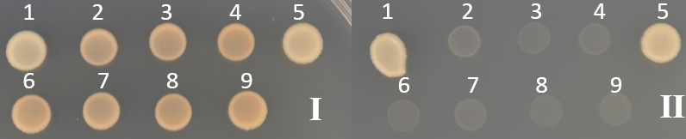
Figure S6 Y2H analysis of Psa AvrPto5 (bait) and full length AcATPase, AcPRP proteins. Plate I - SDA/-Leu-Trp medium; Plate II - SDA/-Leu-Trp-His medium. 1 - Positive interaction control (Murine p53 (bait) + SV40 large T-antigen (prey); Clontech, USA); 2 - Negative interaction control (Lamin (bait) + SV40 large T-antigen (prey); Clontech, USA); 3 - Negative self-activation control (Empty bait and prey vectors); 4 - Bait self-activation control (Psa AvrPto5 (bait) + Empty prey vector); 5 - True positive interaction control [33] (Pgy AvrB (bait) + AtRIN4 (prey)); 6 - Prey self-activation control (Empty bait vector + AcATPase (prey)); 7 - Psa AvrPto5 (bait) + AcATPase (prey); 8 - Prey self-activation control (Empty bait vector + AcPRP (prey)); 9 - Psa AvrPto5 (bait) + AcPRP (prey).

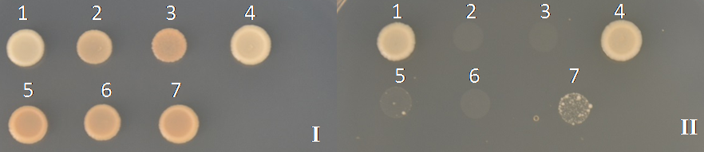
Figure S7 Y2H analysis of AcHIPP26 (bait) and Psa AvrPto5 (prey). Plate I - SDA/-Leu-Trp medium; Plate II - SDA/-Leu-Trp-His + 3-AT 4 mM medium; 1 - Positive interaction control (Murine p53 (bait) + SV40 large T-antigen (prey); Clontech, USA); 2 - Negative interaction control (Lamin (bait) + SV40 large T-antigen (prey); Clontech, USA); 3 - Negative self-activation control (Empty bait and prey vectors); 4 - True positive interaction control [33] (Pgy AvrB (bait) + AtRIN4 (prey)); 5 - Bait self-activation control (AcHIPP26 (bait) + empty prey vector); 6 - Prey self-activation control (Empty bait vector + Psa AvrPto5 (prey)); 7 - AcHIPP26 (bait) + Psa AvrPto5 (prey).

