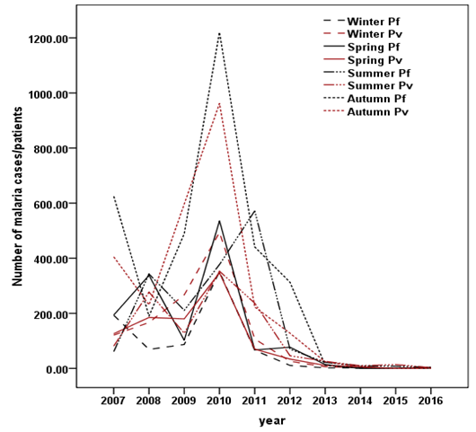
Note: Pf = Plasmodium falciparum, Pv = Plasmodium vivax,

Figure S1 Prevalence of plasmodium species with respect to seasonal variation at Asendabo Health Center, (January, 2007-August, 2016)

