Additional file
Amplification of K13 and PfAtpase was done in a 15 μl reaction mix using 7.5 μl Q5 master mix, 0.75 μl of primer (10 µM), 4.5 µl of nuclease free water and 1.5 μl of template. The following cyclic parameters were used: 98 ºC initial denaturation for 10 minutes, 35 cycles of 98 ºC for 30 seconds, 60 ºC for 30 seconds and 72 ºC for 1 minute, final extension at 72 ºC for 2 minutes 30 seconds. 6 μl of product was taken for electrophoresis on 1 % agarose gel (40 min at 100 v) stained with ethidium bromide and then visualised with ultraviolet light.
The Pfcrt and Pfmdr1 genes were amplified using nested PCR method. Amplification was done in a 15 μɭ reaction mix using 1.5 μl 10x thermopol reaction buffer, 0.25 μl of dNTPs (10 mM), 0.5 μl of primer (10 µM), 11.8 μl of nuclease free water, 0.15 μl of Taq DNA Polymerase and 1.0 μl of template. The following cyclic parameters were used: 94 ºC initial denaturation for 3 minutes, 30 cycles of 94 ºC for 30 seconds, 60 ºC for 30 seconds and 72 ºC for 1 minute, final extension at 72 ºC for 5 minutes. One μl of the PCR product will be re-amplified with specified primers, using the following parameters: 3 minutes at 94 ºC 30 cycles of 94 ºC for 30 seconds, 56 ºC for 30 seconds and 65 ºC ,1 minute, final extension at 65 ºC for 5 minutes. Six microlitres of product was used for electrophoresis. All primers and cycling conditions are listed in Table S1.
All PCR amplifications generating a single product were incubated with ExoSAP-ITR (USB, Cleveland, OH, USA) to remove excess primers and nucleotides according to the manufacturer’s protocol and then sequenced.

Additional file 1: Table 1. List of primers and cycling conditions for amplification
K13 propeller domain | Forward: 5'GCT GGC GTA TGT GTA CAC CTA TG3’  Reverse: 5’ATC TCT CAC CAT TAG TTC CAC CAA T3’ | 98ºC for 10 min, {98ºC 30 s, 60ºC 30 s, 72ºC 60 s}x 35 cycles, 72ºC 2 min 30 s
PfATPase6 | Forward: 5'ATTATATCTTTGTCATTCGTG3'  Reverse: 5'TTGTAAAGGTGTTTGAGTATC3' | 94ºC for 3 mins, {94ºC 30 s, 60ºC 30 s, 72ºC 60 s}x 30 cycles, 72ºC 5 min 30 s
Pfcrt | Forward Nest 1: 5'-CCG TTA ATA ATA AAT ACA CGC AG-3'  Reverse Nest 1: 5'-CGG ATG TTA CAA AAC TAT AGT TAC C-3'  Forward Nest 2: 5'-AGG TTC TTG TCT TGG TAA ATT TGC-3'  Reverse Nest 2: 5'-CAA AAC TAT AGT TAC CAA TTT TG-3' | 94ºC for 3 mins, {94ºC 30 s, 56ºC 30 s, 62ºC 60 s}x 35 cycles, 62ºC 5 min  94ºC for 3 mins, {94ºC 30 s, 56ºC 30 s, 65ºC 60 s}x 30 cycles, 65ºC 5 min
Pfmdr1 | Forward Nest 1: 5'-AGG TTG AAA AAG AGT TGA AC-3'  Reverse Nest 1: 5'-ATG ACA CCA CAA ACA TAA AT-3'  Forward Nest 2: 5'-ACA AAA AGA GTA CCG CTG AAT-3'  Reverse Nest 2: 5'-AAA CGC AAG TAA TAC ATA AAG TC-3' | 94ºC for 3 mins, {94ºC 30 s, 60ºC 30 s, 72ºC 60 s}x 30 cycles, 72ºC 5 min  94ºC for 3 mins, {94ºC 30 s, 60ºC 30 s, 72ºC 60 s}x 30 cycles, 72ºC 5 min

Additional file 1: Table 2. Taqman primers and probes
Gene | Primer/Probe | Sequences (5’-3’)
K13 | 580For | GGTGGCACCTTTGAATACCC
 | 580Rev | ATCTCTCACCATTAGTTCCACCAAT
 | 580C | FAM-5’-AGCTATGTGTGTTGCTT-3’-MGB
 | 580Y | VIC-5’-CAGCTATGTATGTTGCTTT-3’-MGB
 | 493For | CAACAATGCTGGCGTATGTG
 | 493Rev | AACGATCATACACCTCAGTTTCAA
 | 493Y | FAM-5'-ACCAAAAACGTATAAGAAA-3'-MGB
 | 493H | VIC-5'-CCAAAAACGTGTAAGAAA-3'-MGB
 | 539For | CCTAGAAGAAATAATTGTGGTGTTACG
 | 539-Rev | GTGCCACCTCTACCCATGCT
 | 539R | FAM-5'-CAAATGGTAGAATTTATTG-3'-MGB
 | 539T | VIC-5'-CAAATGGTACAATTTATTG-3'-MGB
 | 543For | TTGTGGTGTTACGTCAAATGGT
 | 543Rev | GTGCCACCTCTACCCATGCT
 | 543I | FAM-5'-ATCCCCCAATACAATAA-3'-MGB
 | 543T | VIC-5'-ATCCCCCAGTACAATAA-3'-MGB
 | 402For | GGT-TTG-AAT-GAATTA-GAA-GTA-GAA-AAG-AAG
 | 402Rev | ACA-GAA-TAC-CAA-CTA-TGT-CAAAAA-GGG-GAT
 | 402L | FAM-5'-ACCTAAATTCATGTTCTTT-3'-MGB
 | 402V | VIC-5'-CACCTAAATACATGTTCTT-3'-MGB

Additional file 1: Table 3. Demographics of respondents
Characteristics | Badagry N (%) | Alajue N (%)
Age group
≤ 5 | 6 (12) | 0
6 to 19 | 21 (42) | 13 (39.4)
20 to 35 | 14 (28) | 11 (33.3)
36 to 61 | 9 (18) | 9 (27.3)
Sex
Male | 28 (56) | 8 (24.2)
Female | 22 (44) | 25 (75.8)
Occupation
Student | 36 (72) | 5 (15.2)
Business/Trade | 10 (20) | 6 (18.2)
Farming | 2 (4) | 14 (42.4)
Unemployed | 2 (4) | 8 (24.2)

Additional file 1: Table 4. Description of Pfk13, PfATPase and Pfmdr1 polymorphisms
Gene | Codon Position (SNPs) | Reference AA | Reference Nucleotide | Mutant AA | Mutant Nucleotide | N | Prevalence (%)
Pfk13 | 496 | G | ggt | S | tca | 1 | 1.2
 | 539 | R | aga | F | ttt | 1 | 1.2
 | 543 | I | att | V | gta | 1 | 1.2
 | 557 | A | gca | ? | -aa | 3 | 3.61
 | 566 | V | gta | K | aaa | 1 | 1.2
 | 578 | A | gct | K | aaa | 2 | 2.41
 | 584 | D | gat | I | att | 1 | 1.2
 | 580 | C | tgt | Y | tat | 1 | 1.2
PfATPase | 679 | S | tct | S | tcc | 7 | 8.43
 | 699 | M | atg | V | gtt | 8 | 9.63
 | 769 | S | agt | M | atg | 3 | 3.61
Pfmdr1 | 86 | N | aat | K | aaa | 47 | 56.63
 | 184 | Y | tat | F | taa | 11 | 13.25
SNP= Single Nucleotide Polymorphism, pfk13=kelch 13, pfmdr1= multidrug resistance gene1, pfATPase
N= Number of SNPs
-= Nucleotide deletion
? = Not an amino acid

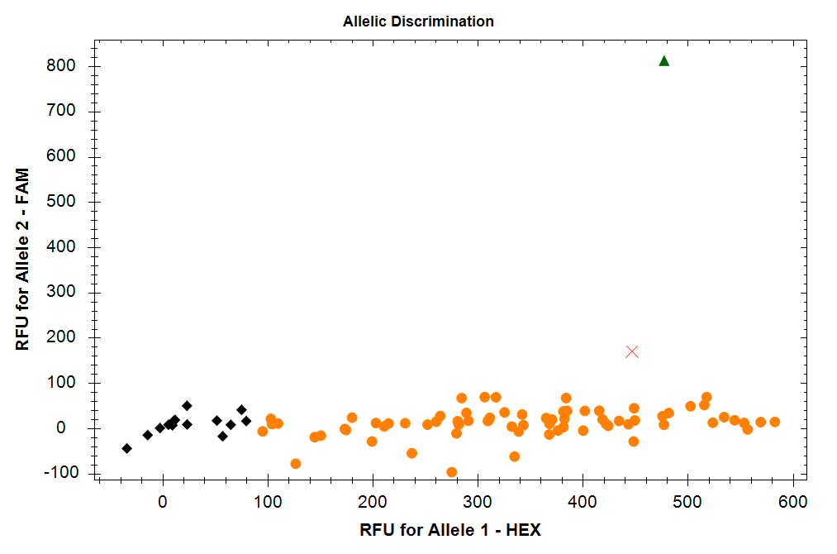
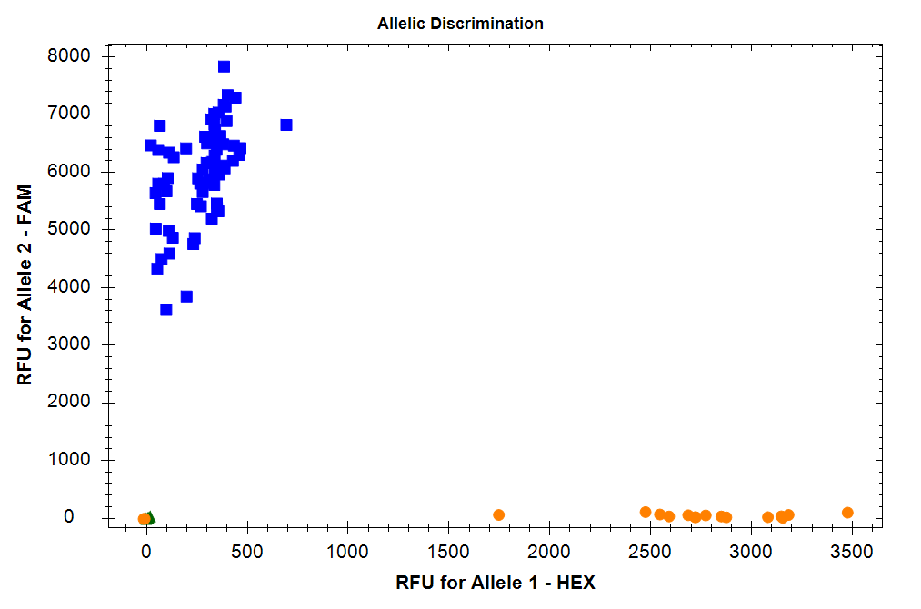
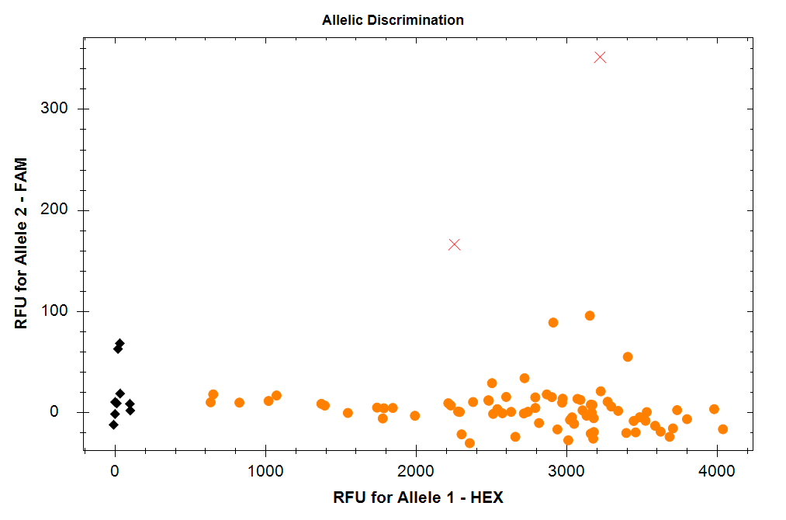
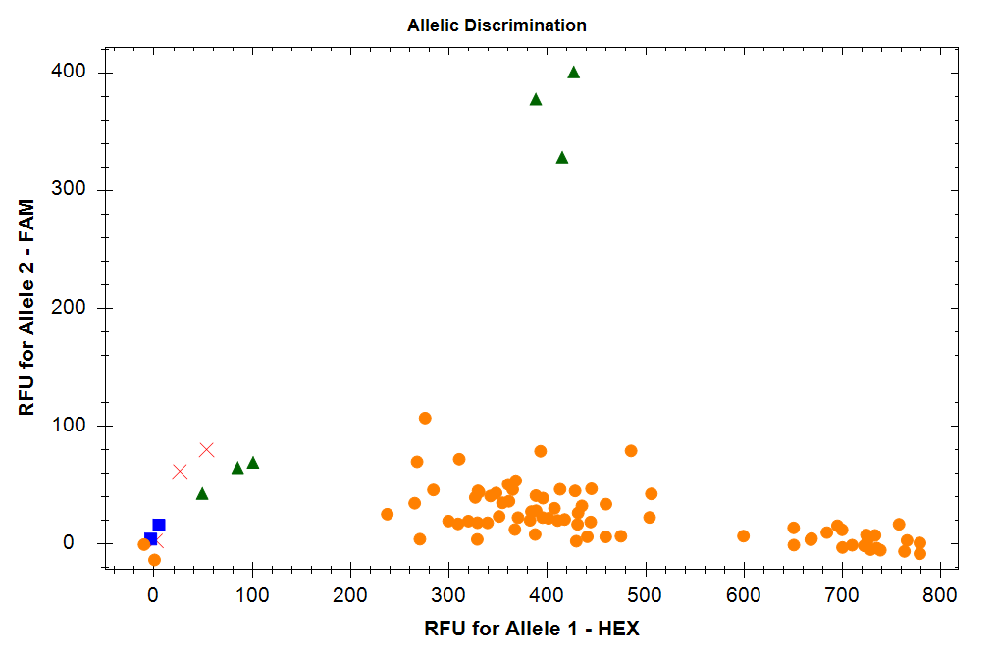
K13 SNP493 SNP493
K13 SNP539 SNP539
K13 SNP543 SNP543 543
K13 SNP580
A
B
C
D

Additional file 1: Figure 1. Allelic discrimination of K13 single nucleotide polymorphisms (SNPs)

