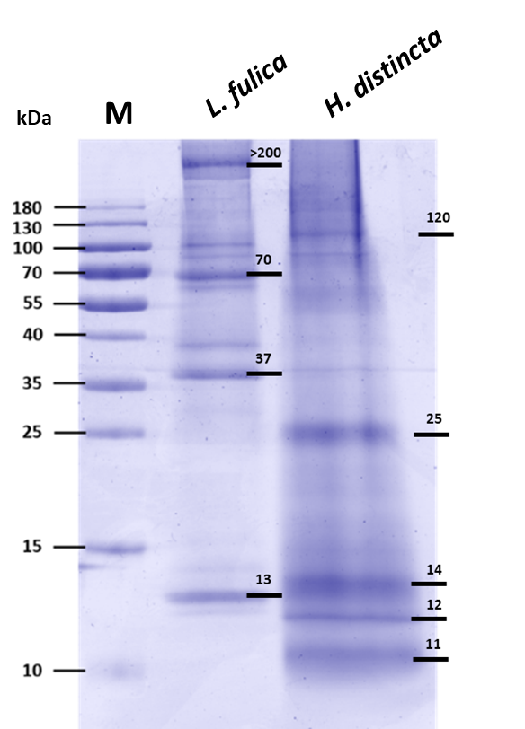

Additional file 2: Figure S2. Analysis of the main proteins in total snail mucus from L. fulica and H. distincta by SDS-PAGE. M; Prestain marker PageRuler. Mucus (25 µg/lane) was resolved by SDS-PAGE and then stained with Coomassie Brilliant Blue. Black lines indicate the major protein bands.

