Additional file
Table S1: BLAST result of 16S rRNA gene: Sequencing ID in a gene bank, and compatibility of DNA sequences obtained from National Center Biotechnology Information (NCBI).
GenBank Accession Number | country | Source | Compatibility
ID: LC_508802 | Japan | Staphylococcus aureus | 99%
ID: MN_611106 | Pakistan | Staphylococcus aureus | 99%
ID: MN_606199 | Nigeria | Staphylococcus aureus | 99%
ID: MN_611246 | Bangladesh | Staphylococcus aureus | 99%
ID_ MN556575 | Egypt | Staphylococcus aureus | 99%
ID_ MN555444 | Iraq | Staphylococcus aureus | 99%
ID_ MN652637 | China | Staphylococcus aureus | 99%
ID_ MF664194 | Germany | Staphylococcus aureus | 99%

Figure: S1. (A): Base pair substitution at position 249 from A to G which illustrated by arrows. Chromatograms edited using Finch TV software (B): Sequence alignment of 16S rRNA gene
.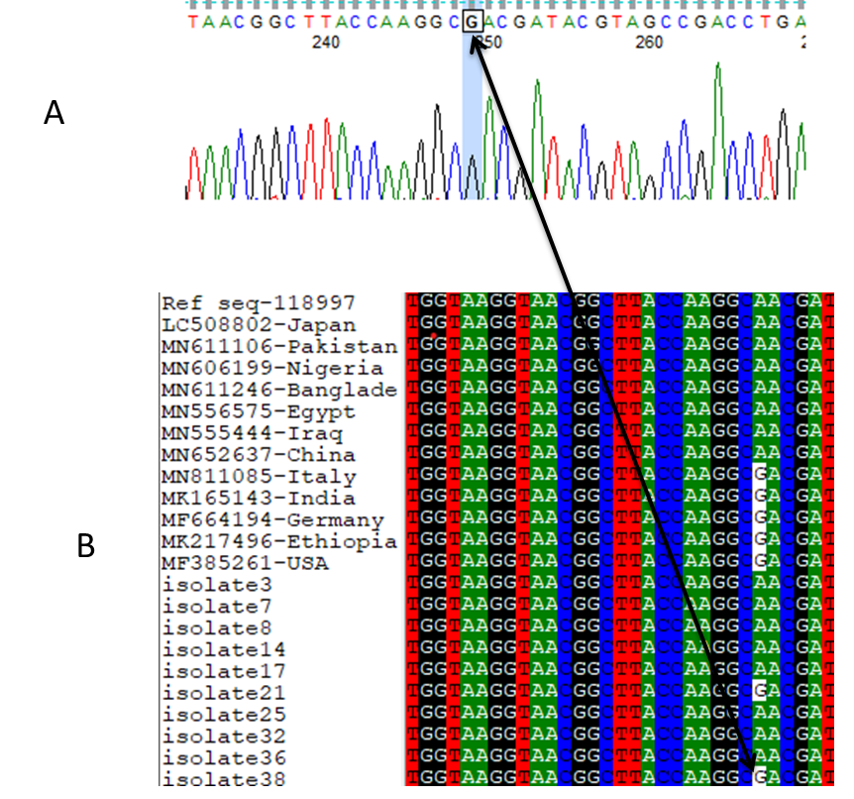
Figure S2: Neighbour-joining and Maximum Parsimony trees based on the concatenated sequences of the 16S rRNA gene among S.aureus clinical isolates

