Figure S1. Study enrollment diagram
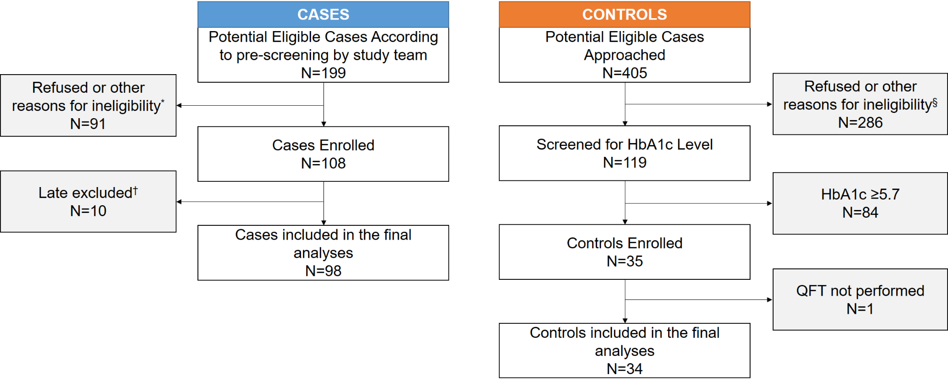
*Including 1 patient who self-reported the use of steroids and 1 patient who was part of another diabetes study
†Reasons for late exclusion: 7 had been diagnosed with T2DM for > 3 years (according to medical chart review), 2 were later confirmed as patients with pre-diabetes, and 1 self-reported history of active TB disease during questionnaire interview
§Reasons for exclusion among controls (N=286):
- 176 (61.5%) refused
- 36 (12.6%) were not Fulton/DeKalb counties residents
- 35 (12.2%) self-reported prior T2DM/pre-diabetes diagnosis
- 11 (3.8%) were non-English speakers
- 7 (2.4%) were less than 21 years old at the time of encounter
- 4 (1.4%) were HIV positive
- 17 (5.9%) were not enrolled due to other reasons (e.g., were on steroids or other invasive therapy, patients at the sickle cells clinic

