Fig. S1 Morbidity in patients with COPD according to the Spanish guidelines GesEPOC 2021 risk groups

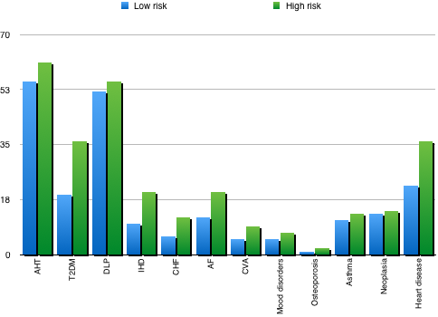

Abbreviations: AHT: arterial hypertension; AF: atrial fibrilation; CHF: chronic heart failure; CVA: cerebrovascular accidents; DLP: dyslipidemia; IHD: ischeamic heart disease; T2DM: type 2 diabetes mellitus

