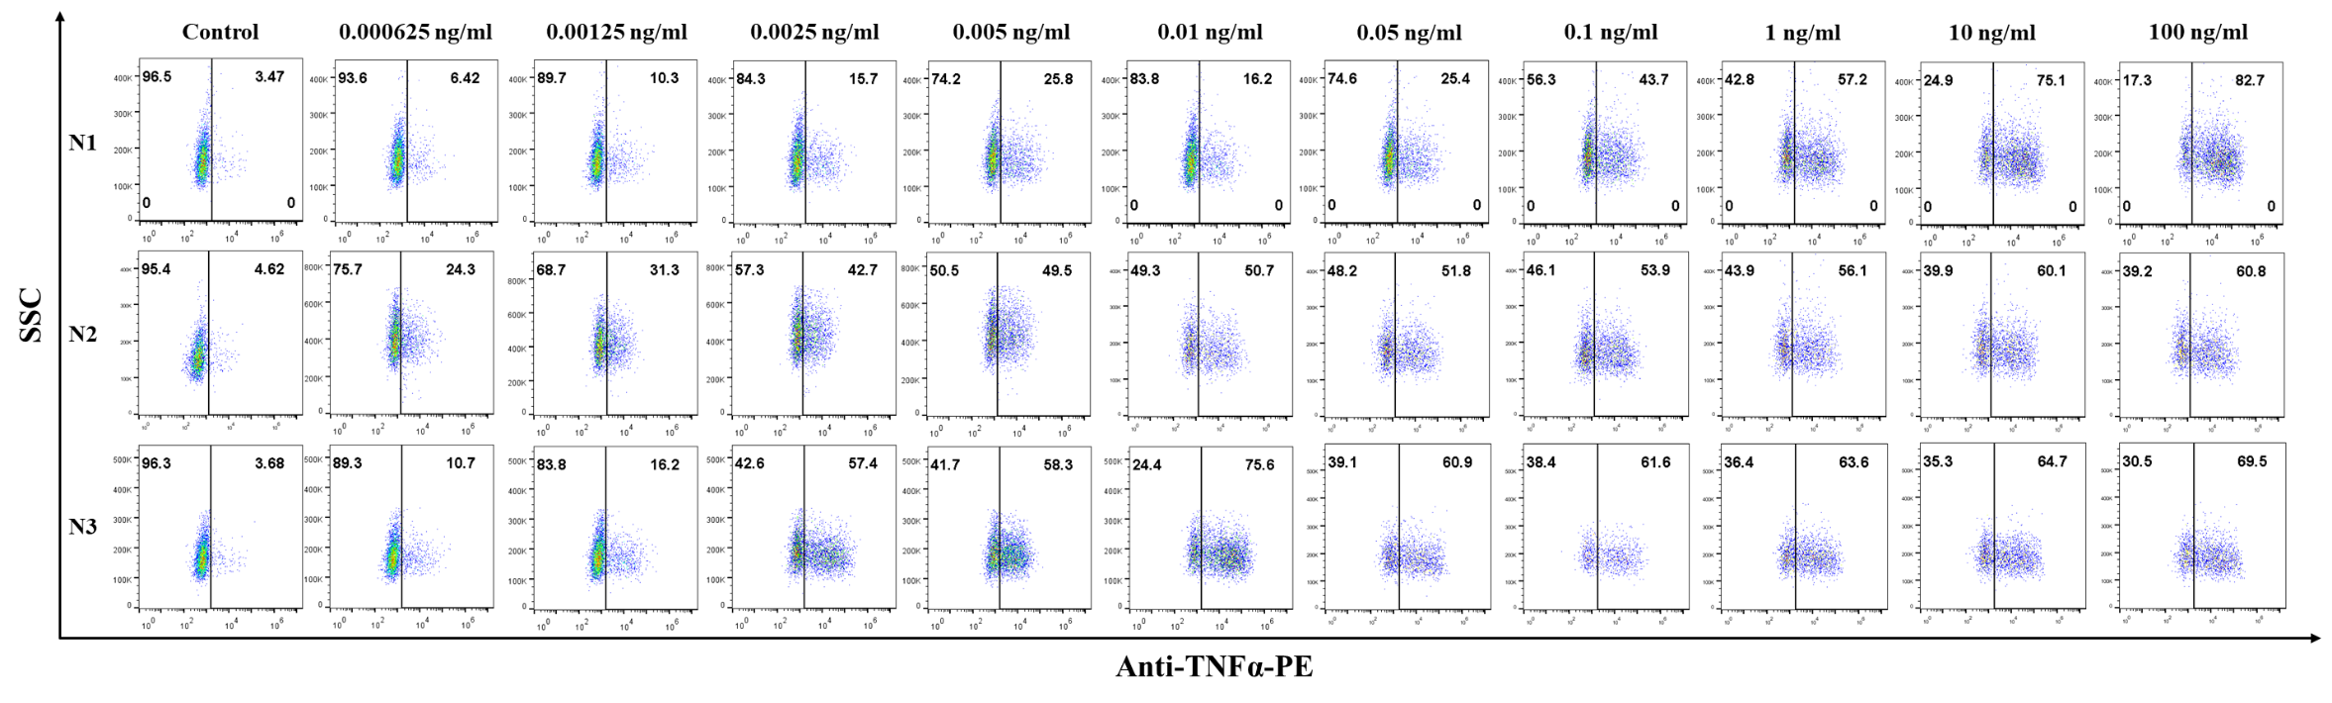

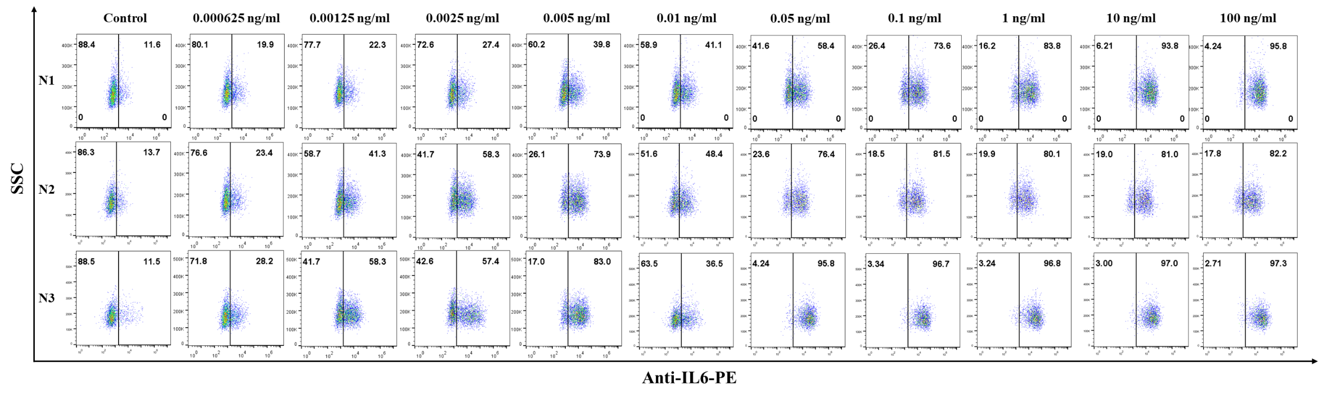

Figure S4. Flow cytometric profiles of each subject (According to figure 3 in the paper):
Lipopolysaccharide induces the production of TNF-α and IL-6 in monocytes. PBMCs were stimulated with the indicated concentrations of LPS or in the absence of LPS (Control). The intracellular TNF-α and IL-6 were determined by flow cytometry. CD14+ monocyte population of the three individuals (as indicated) were gated and dot plotted on the expression of the indicated cytokines are shown (numbers indicate the % cells).

