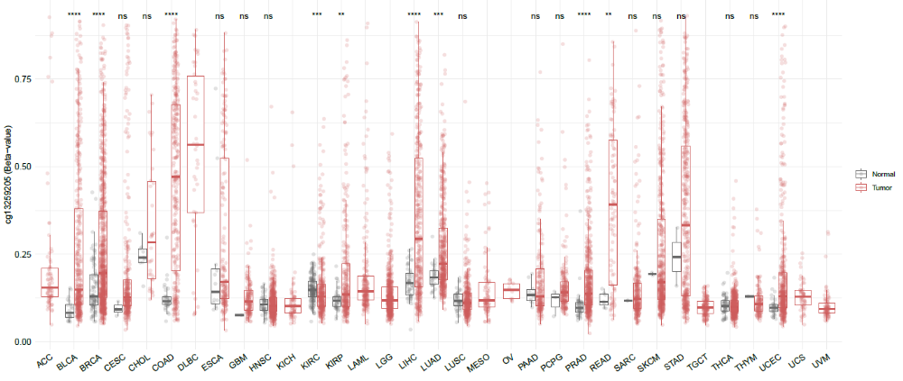
Figure S1. The β-value [methylated/(methylated+unmethylated cytosine)] in cg13259205 is shown across each type of cancer (red) compared with each normal tissue (green). TCGA data were downloaded from http://www.bioinfo-zs.com/smartapp/, and box plots were generated. ACC, adrenocortical carcinoma; BLCA, bladder urothelial carcinoma; BRCA, breast invasive carcinoma; CESC, cervical squamous cell carcinoma and endocervical adenocarcinoma; CHOL, cholangiocarcinoma; COAD, colon adenocarcinoma; DLBC, diffuse large B-cell lymphoma; ESCA, esophageal carcinoma; GBM, glioblastoma multiforme; HNSC, head and neck squamous cell carcinoma; KICH, kidney chromophobe; KIRC, kidney renal clear cell carcinoma; KIRP, kidney renal papillary cell carcinoma; LAML, acute myeloid leukemia; LGG, brain lower grade glioma; LIHC, liver hepatocellular carcinoma; LUAD, lung adenocarcinoma; LUSC, lung squamous cell carcinoma; DLBC, lymphoid neoplasm diffuse large B-cell lymphoma; MESO, mesothelioma; OV, ovarian serous cystadenocarcinoma; PAAD, pancreatic adenocarcinoma; PCPG; pheochromocytoma and paraganglioma; PRAD, Prostate adenocarcinoma; READ; rectum adenocarcinoma; SARC, sarcoma; SKCM, skin cutaneous melanoma; STAD, stomach adenocarcinoma; TGCT, testicular germ cell tumors; THYM, thymoma; THCA, thyroid carcinoma; UCS, uterine carcinosarcoma; UCEC, uterine corpus endometrial carcinoma; UVM, uveal melanoma; TCGA, The Cancer Genome Atlas.

