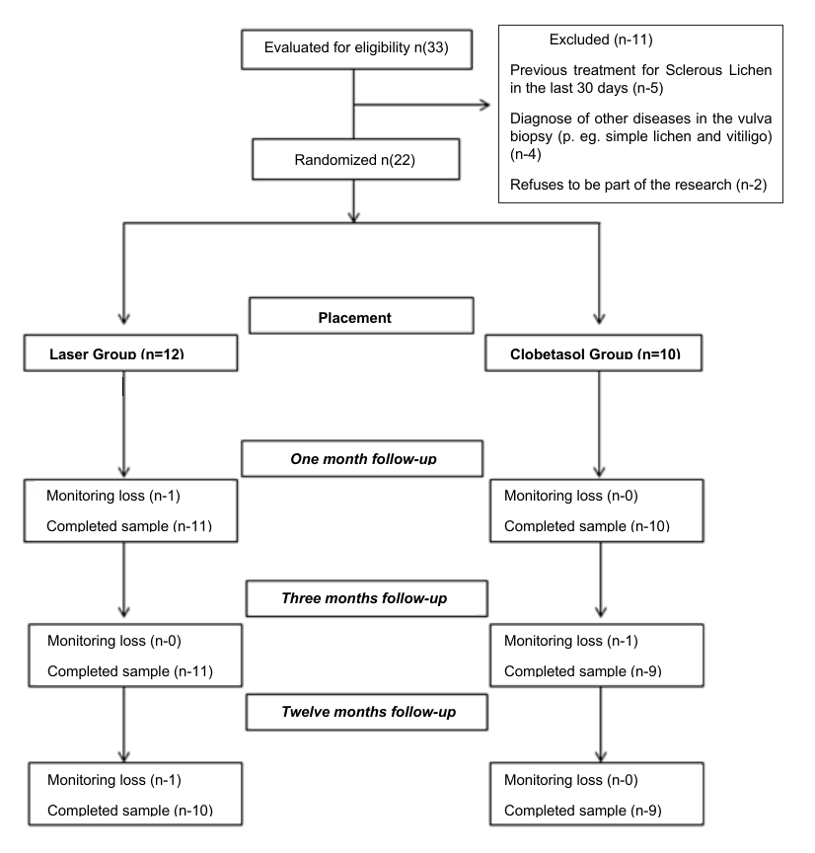
Figure 1 – Monitoring Flowchart
Reasons for patients’ loss: Laser Group - occurrence of acute pulmonary edema, with discontinuation of treatment in one of the patients (after 1 month of follow-up) and impossibility of telephone contact with the number provided in medical records by another patient (after 12 months of follow-up). / Clobetasol Group – quit participating in the research, without any specific reason, wishing only to maintain the proposed treatment.
Source: The authors (2020).

