Figure 2 - Comparison before and after the institution of treatment with three sessions of fractionated CO₂ laser for Vulvar Lichen Sclerosus
A)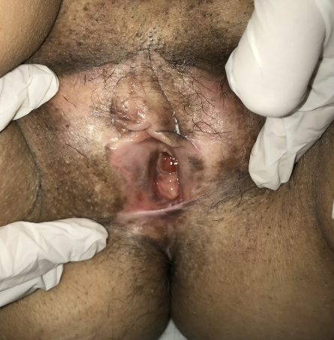B)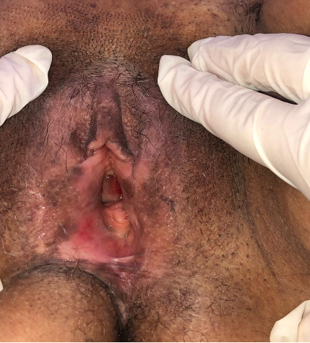
Legend: A) Patient with Vulvar Lichen Sclerosus before the institution of treatment. B) Aspect of the vulva after 3 sessions of Fractional CO2 Laser, being identified improvement of hypochromia, skin atrophy and hyperkeratosis areas.
Source: Author's personal file (2020).

