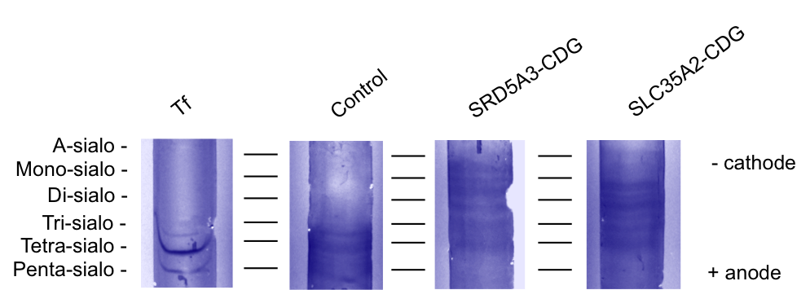

Fig. S1 Isoelectric focusing (IEF) of serum transferrin. Standard Tf (lane 1), control (lane 2), SRD5A3-CDG patient (lane 3), and SLC35A2-CDG patient (lane 4). Strips were stained with Coomassie Blue.

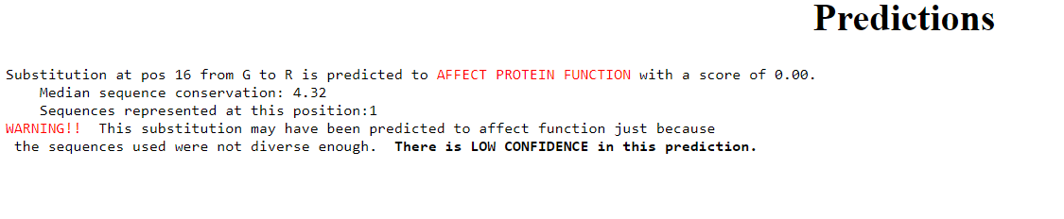
Fig. S2 SIFT tool prediction score for SLC35A2 variant, c.46G>A p. (G16R).

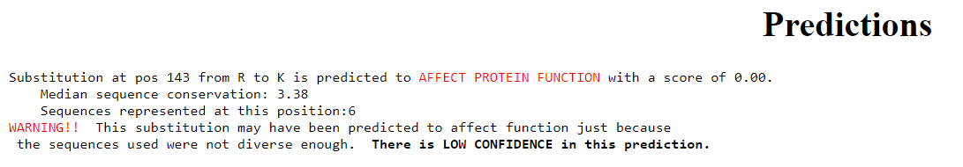
Fig. S3 PolyPhen-2 v2.2 prediction score for SRD5A3, variant, c.428G>A p.(R143K).

Fig. S4 Histogram chart represents the quantified intensities of LAMP2 in total leukocytes bands obtained by western blot. The values were measured by image J software.

Fig. S5 Histogram chart represents the quantified intensities of CTN in total leukocytes bands obtained by western blot. The values were measured by image J software.

Fig. S6 Histogram chart represents the quantified intensities of bands of the activation products of CSTC enzyme in plasma obtained by western blot. The values were measured by image J software.

Control
SLC35A2-CDG
SRD5A3-CDG

The original blot of figure 5 showing LAMP2 protein expression profiles in a cohort of CDG patients. The red box is denoting the studied cases in our work. The blot was cut and the beta actin was detected for only the studied cases.

CTN
Control
SRD5A3-CDG
SLC35A2-CDG
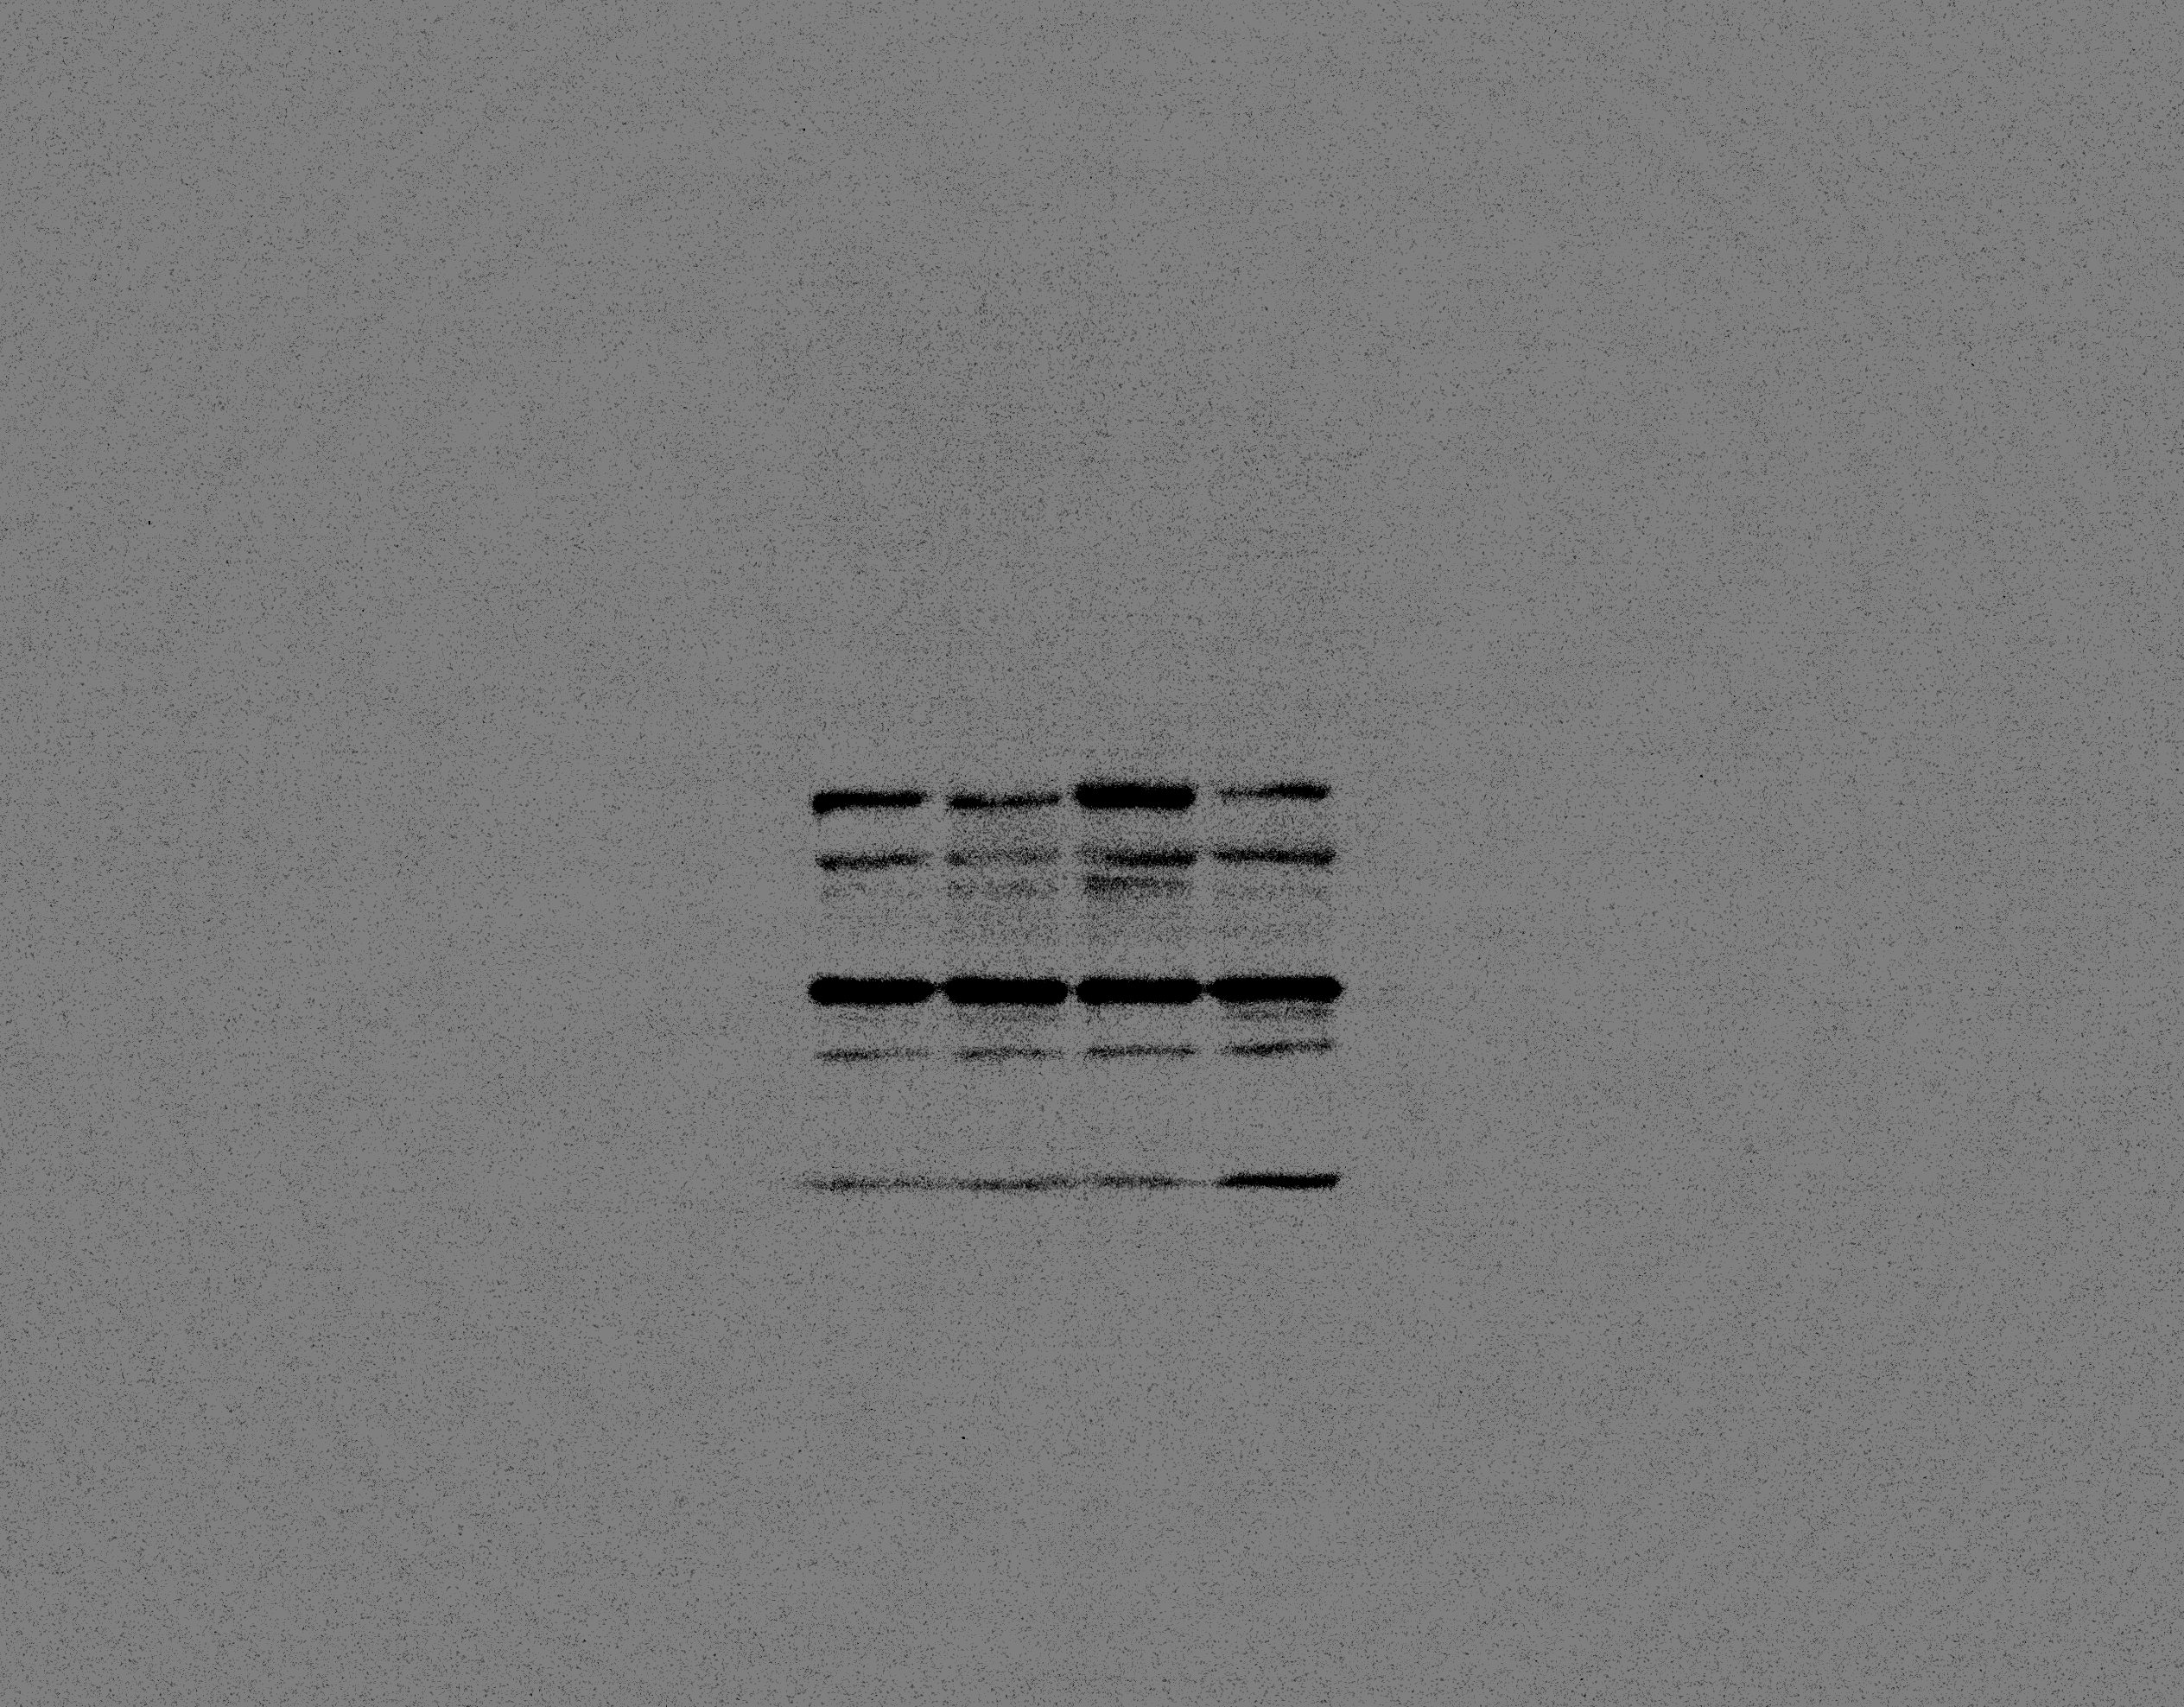
GAPDH

The original blot of figure 6 showing CTN protein expression profiles in CDG patients. The red box is denoting the studied cases in our work.

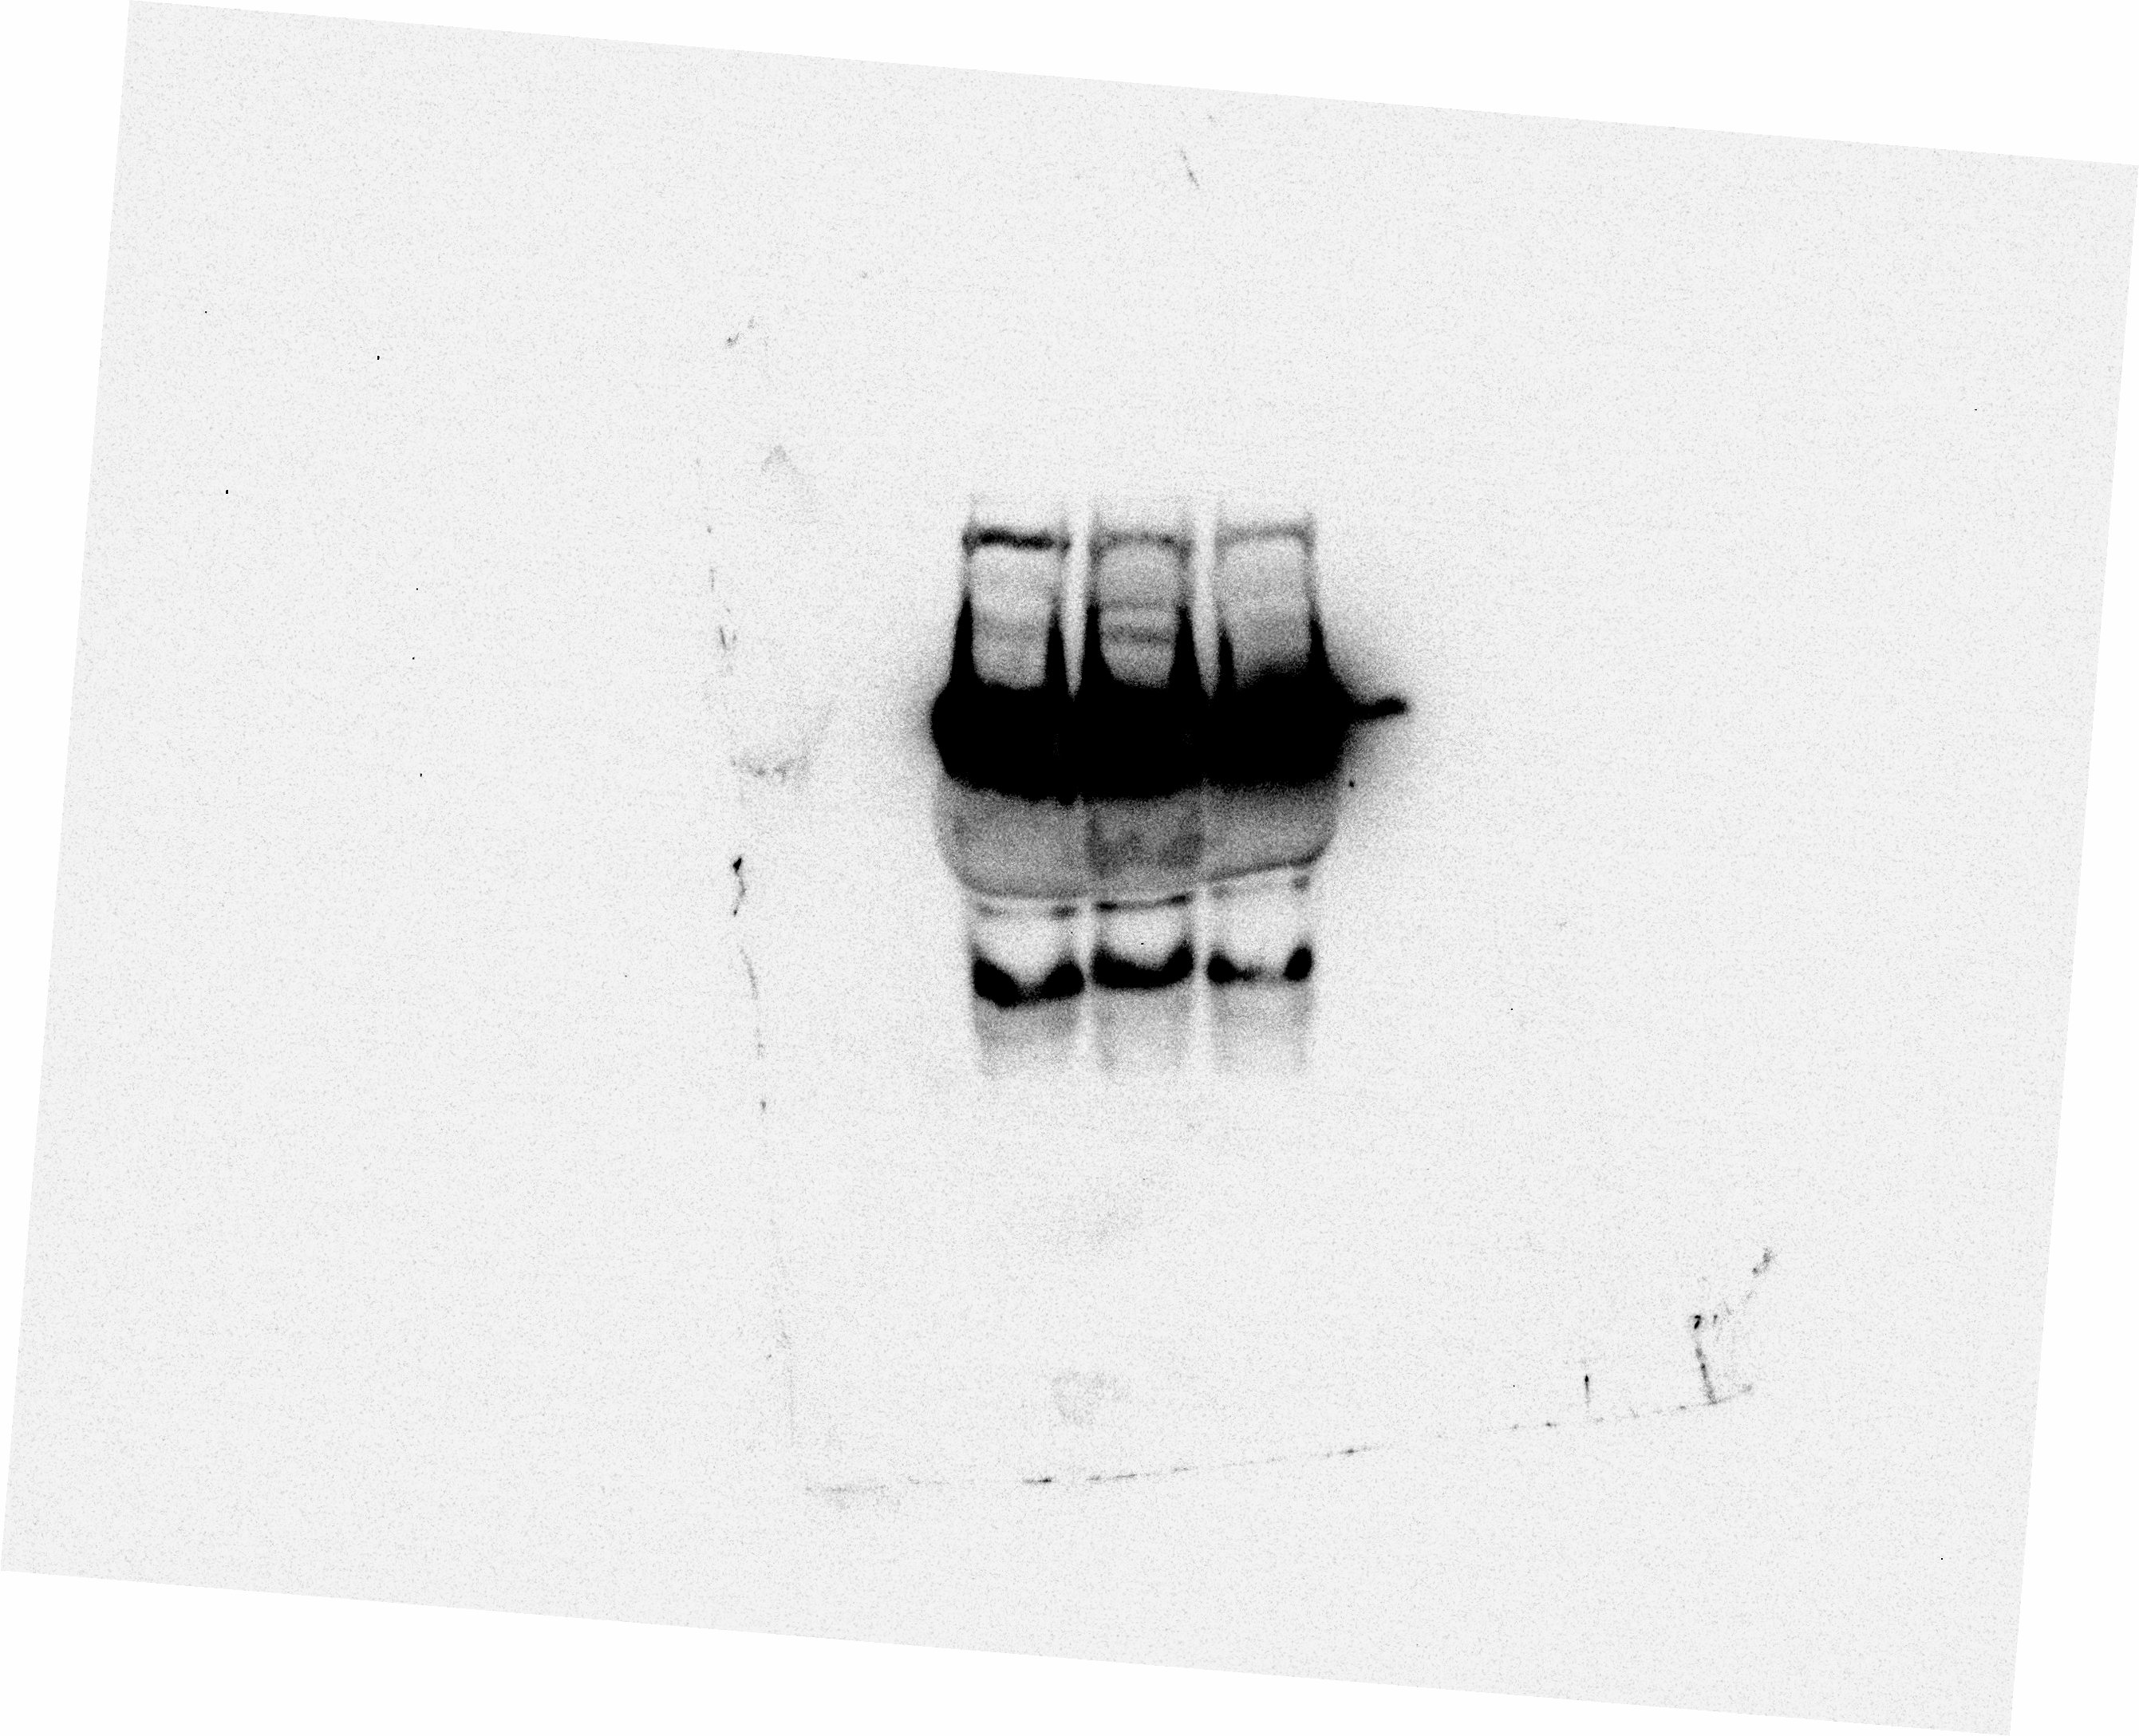
SLC35A2-CDG
Control
SRD5A3-CDG

The original blot of CTSC in plasma

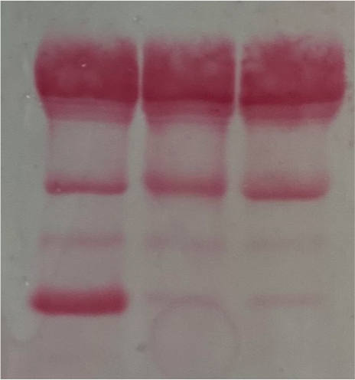
SRD5A3-CDG
SLC35A2-CDG
Control

The original blot of figure 7 showing nitrocellulose membrane stained with ponceau S as a loading marker for CSTC in plasma.

