Supplementary Files

Additional file 1. Overview of the plasmid used in transfection of R. communis protoplasts.
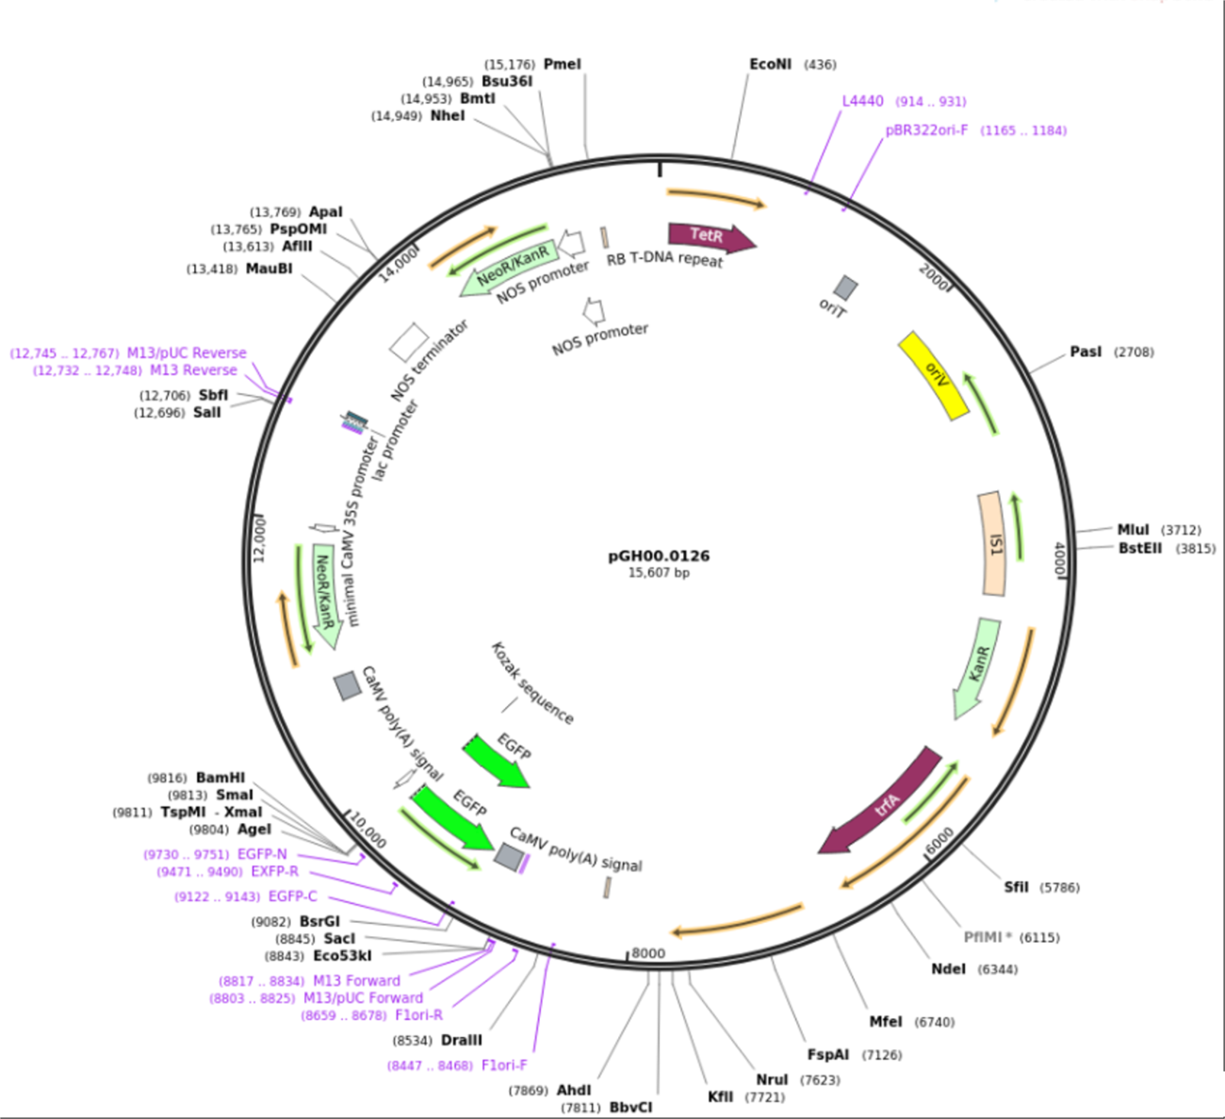
The 15,607 bp-long plasmid: the EGFP gene under the E12-omega promotor; the neomycin phosphotransferase II gene under E12-omega promotor; the promoter consists of two repeated copies of the cauliflower mosaic virus (CaMV) 35S promoter, followed by one copy of the P35S.

