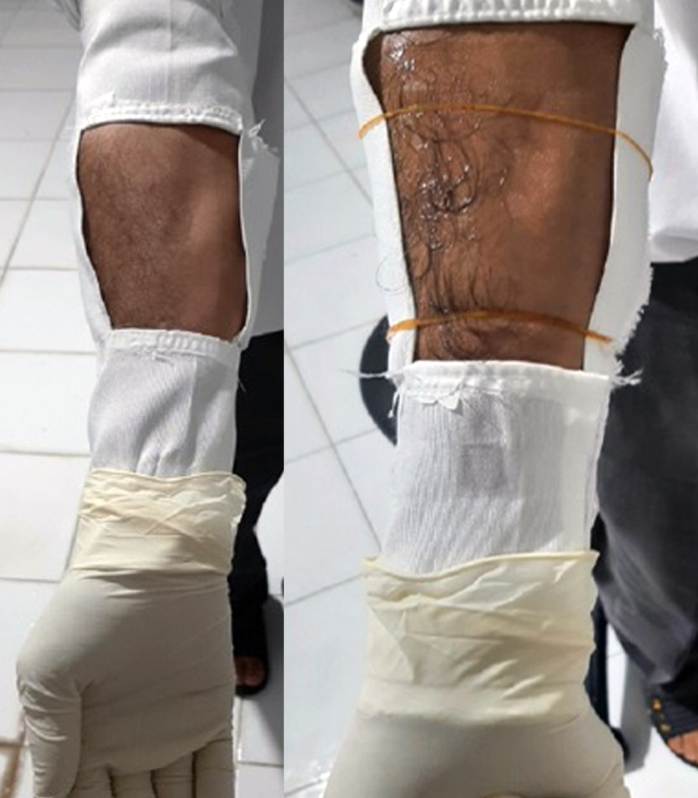
S2: Left: an exposed area with mosquitoes before treatment, Right: exposed area after treatment with nanogel or DEET

