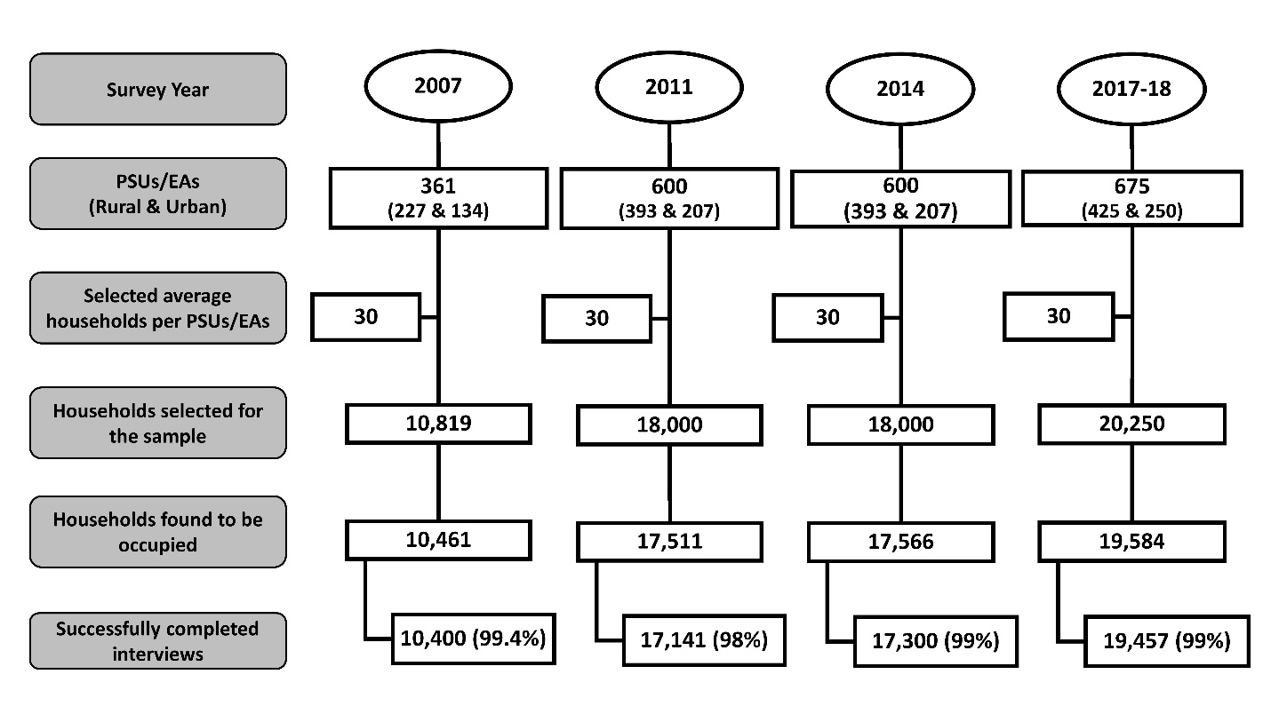
Supplementary Figure 1: Sampling flowchart for the selection of households for BDHS 2007, 2011, 2014 and 2017-18

Supplementary Table 1: Measure of inequality (Concentration Index and 95% Confidence Interval) by survey year
Year | Concentration Index (CI) | Standard Error | P value
2007 | 0.404 | 0.007 | <0.001
2011 | 0.333 | 0.005 | <0.001
2014 | 0.227 | 0 .004 | <0.001
2017-18 | 0 .271 | 0.004 | <0.001

