Supplementary Materials
Supplementary Table 1
Demographic and clinical characteristics of TCGA-LUAD and Shedden cohorts
Characteristic | TCGA-LUAD  (n=483) | Shedden  (n=346)
Age - median (range) | 66 (33, 88) | 65 (35, 87)
Sex - no.(%)
Female | 263 (54.5) | 186 (53.8)
Male | 220 (45.5) | 160 (46.2)
Tumor Stage - no.(%)
I | 333 (68.9) | 298 (86.1)
II | 150 (31.1) | 48 (13.9
III and IV
Smoking Status - no.(%) | 263 (54.5) | 217 (62.7)
Smoker | 116 (24.0) | 80 (23.1)
Non-smoker | 104 (21.5) | 49 (14.2)

Supplementary Table 2
A summary of parameters for clustering method. Only parameters different from the default values are presented.
Algorithm | Parameters changed from default
k-means (sklearn.cluster.KMeans) | n_clusters = 2
Gaussian Mixture (sklearn.mixture.GaussianMixture) | n_components = 2
Agglomerative Clustering (sklearn.cluster.AgglomerativeClustering) | n_clusters = 2
Random Survival Forest  (var.select) | method = "md"  nrep = 100
Cox Regression  (CoxPHFitter) | penalizer = 0.1
Cox Regression  (CoxPHFitter.fit) | step_size = 0.5
survClust  (cv.survclust) | k = 2

Supplementary Table 3
Overall results of different clustering methods based on TCGA-LUAD dataset with all the original features.
Type | Method | Mean P-value | Standard Deviation | 95% CI
Unsupervised | KM | 0.685 | 0.173 | (0.401, 0.958)
 | GM | 0.683 | 0.240 | (3.83E-02, 0.990)
 | AC | 0.124 | 2.78E-17 | (0.124, 0.124)
 | Consensus | 0.481 | 0.311 | (7.46E-02, 0.988)
Semi-Supervised | RF-KM | 0.561 | 0.276 | (4.33E-03, 0.873)
 | RF-GM | 8.40E-03 | 5.79E-02 | (4.90E-16, 2.53E-02)
 | RF-AC | 0.569 | 0.265 | (0.325, 0.873)
 | RF-Consensus | 0.279 | 0.321 | (2.99E-06, 0.873)
 | Cox-KM | 3.96E-16 | 6.95E-16 | (1.35E-16, 2.50E-15)
 | Cox-GM | 1.19E-09 | 3.57E-10 | (1.93E-11, 1.29E-09)
 | Cox-AC | 8.58E-14 | 0 | (8.58E-14, 8.58E-14)
 | Cox-Consensus | 3.44E-10 | 7.33E-11 | (3.01E-15, 3.60E-10)

Note: This table displays the overall clustering results, providing p-values, standard deviations for p-values, and 95% confidence intervals. Methods are organized by type (unsupervised, semi-supervised, and supervised). Results are summarized from 200 trials for each method. Agglomerative clustering results, except for RF-AC, do not have a standard deviation or confidence interval, as they are not affected by random initial values and thus are the same across 200 trials. The 95% CI was calculated based on the 2.5 and 97.5 percentile of p-values from 200 trials.

Supplementary Figure 1
Survival curves for different clustering methods based on TCGA-LUAD data with PC features.
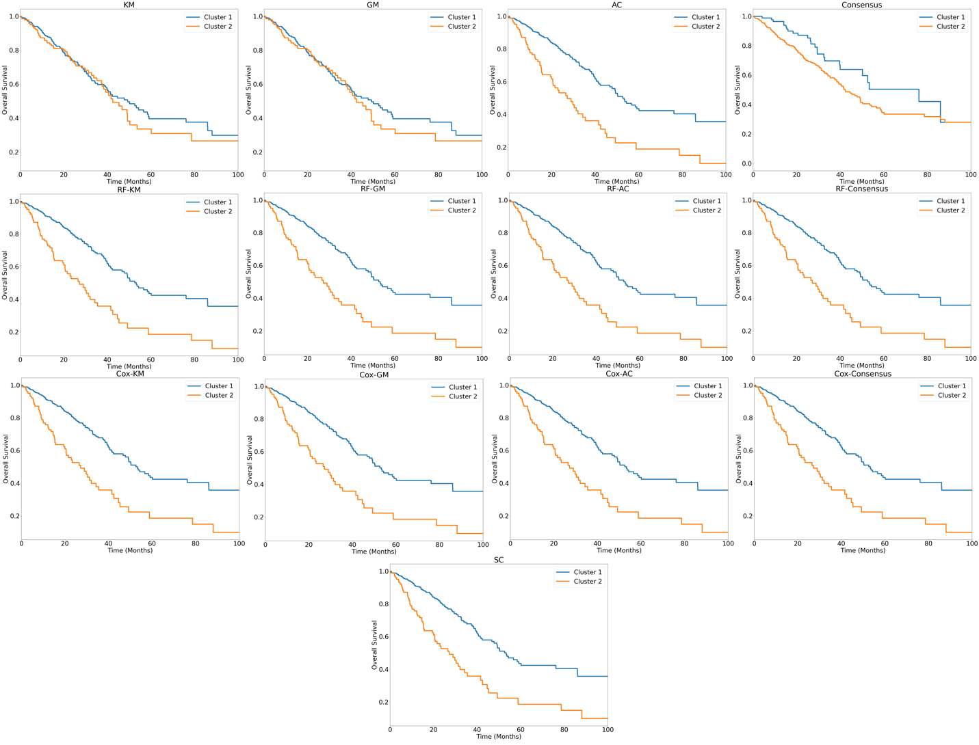
Note: These graphs display Kaplan-Meier survival curves for the two clusters identified by each of the clustering methods. One representative trial from each clustering method is presented.

Supplementary Figure 2
Survival curves for different clustering methods based on Shedden data with PC features.
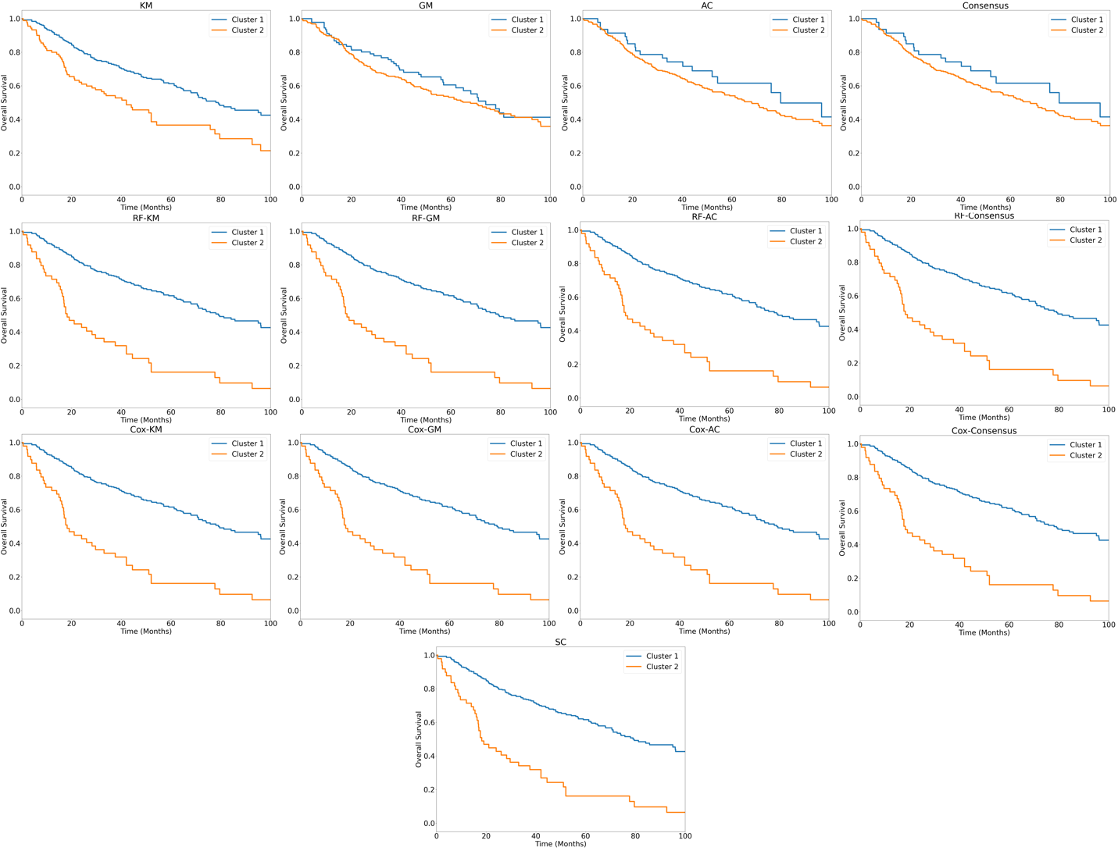
Note: These graphs display Kaplan-Meier survival curves for the two clusters identified by each of the clustering methods. One representative trial from each clustering method is presented.

Supplementary Figure 3
Survival curves for different clustering methods based on TCGA-LUAD data with all the original features.
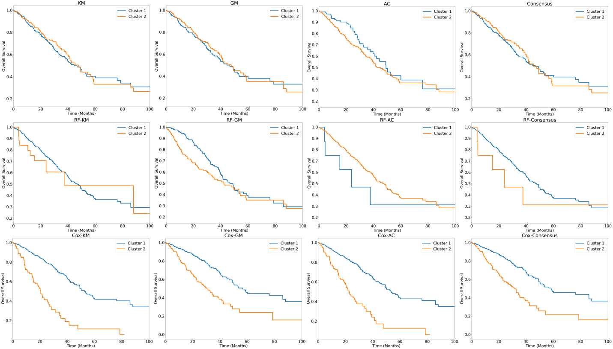
Note: These graphs display Kaplan-Meier survival curves for the two clusters identified by each of the clustering methods. One representative trial from each clustering method is presented.

Supplementary Figure 4
Comparison of p-values from different clustering methods based on TCGA-LUAD data with all the original features
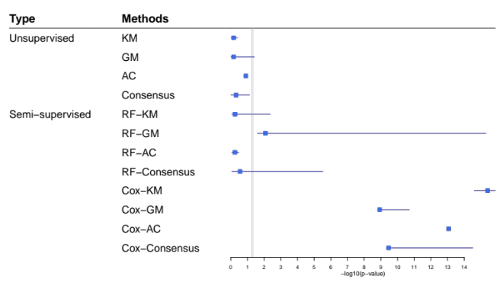
Note: This forest plot displays -log₁₀ p-value for comparing survival distribution between the two clusters identified by each clustering method based on TCGA-LUAD data with all the original features. The methods are grouped based on clustering algorithms, with unsupervised methods on top, semi-supervised methods in the center, and survClust (SC), the supervised method, on the bottom. Cox-AC, Cox-KM, and SC present the best performance of all the methods. The solid square indicates -log₁₀(mean p-value) and horizonal line indicates the corresponding 95% CI over 200 trials for each method. The significance threshold of p=0.05 is marked with a vertical line, with significant values to the right of the line.
Supplementary Figure 5
Evaluation of the consistency of clustering results from different clustering methods based on TCGA-LUAD data with all the original features
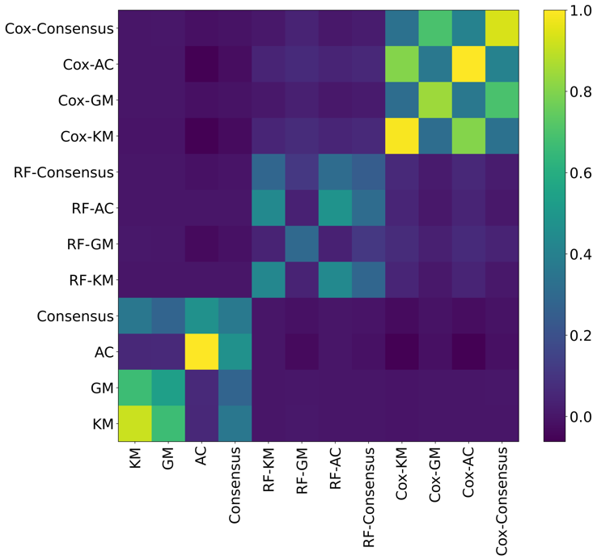
Note: The heatmap presents the ARI for each pair of clustering methods based on TCGA-LUAD data with all the original features.

