SUPPLEMENTARY MATERIALS

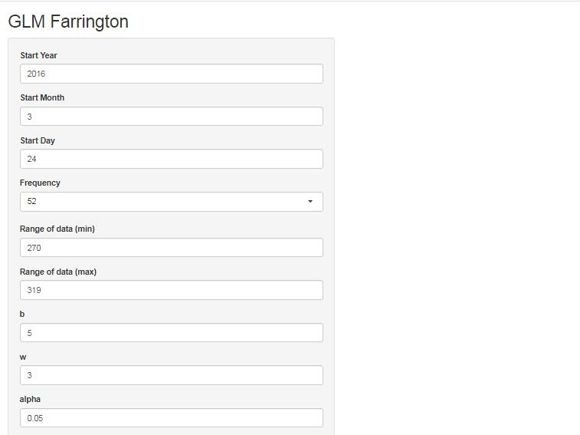
S1: The user panel in the implementation section of GLM Farrington algorithm

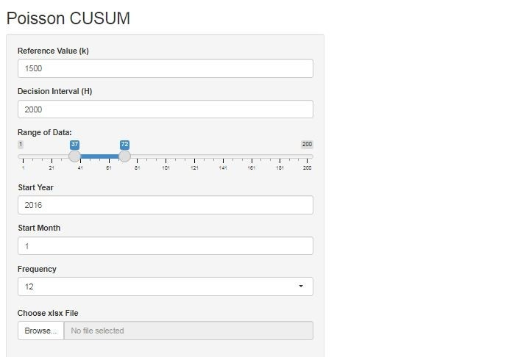
S2: The user panel in the implementation section of Poisson CUSUM algorithm

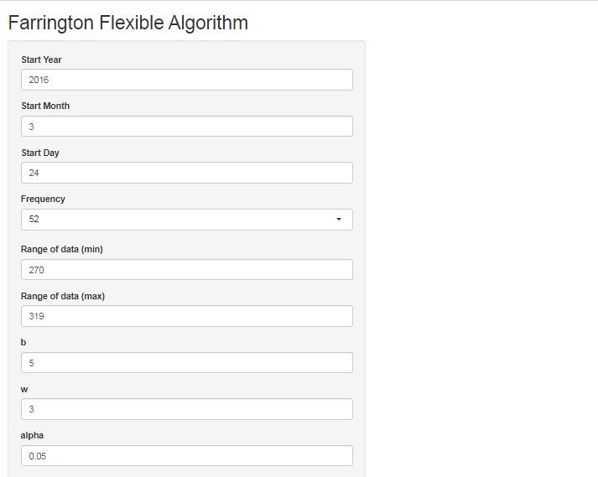
S3: The user panel in the implementation section of Farrington Flexible algorithm

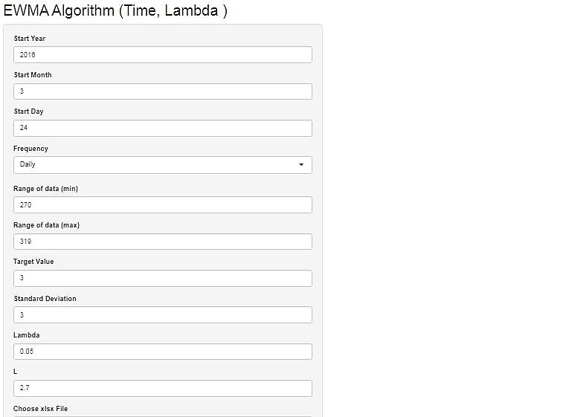

S4: The user panel in the implementation section of EWMA algorithm

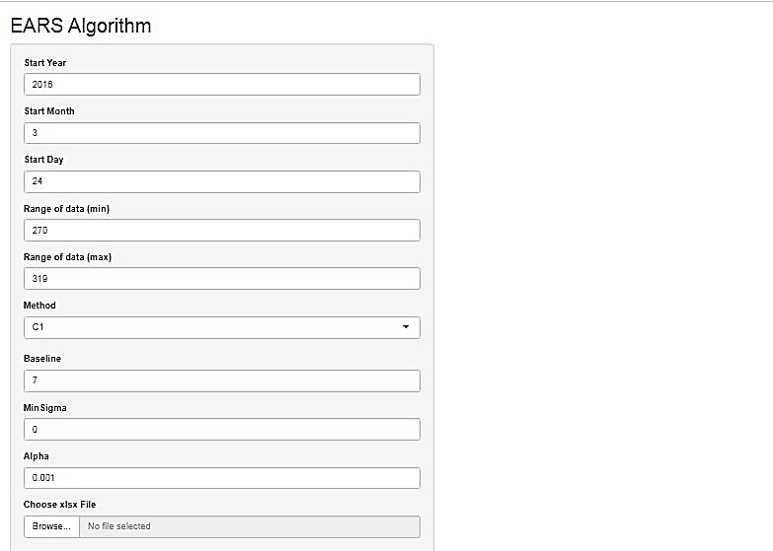
S5: The user panel in the implementation section of EARS algorithm

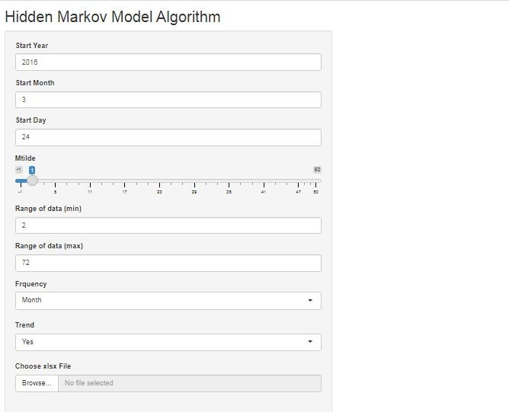
S6: The user panel in the implementation section of Hidden Markov Model algorithm

