Supplemental Figures Legends

Figure S1

Multidimensional scaling plot (MDS) of raw count data for all samples. Text color represents whether samples were in the HgCl₂ (red) or control (blue) treatment group.

Figure S2

Heatmap of gene expression in whole female D. melanogaster exposed to HgCl₂ or control treatments. The color gradient represents variation in log₂-transformed read counts for each of 150 genes that showed significant differential gene expression between treatments (P_{FDR} < 0.01, |log₂ fold-change| > 2). The column marginal color annotation reflects whether samples were in the HgCl₂ (gray) or control (blue) treatment group.

Figure S3

Plot of the top 15 enriched Biological Process categories for 119 genes that exhibited higher expression in HgCl₂-treated D. melanogaster (log₂ fold-change > 2, P_{FDR} < 0.01). Color reflects variation in significance of enrichment measured as a Benjamini–Hochberg FDR-adjusted P-value.

Figure S4

Plot of the top 15 enriched Biological Process categories for 31 genes that exhibited lower expression in HgCl₂-treated D. melanogaster (log₂ fold-change < -2, P_{FDR} < 0.01). Color reflects variation in significance of enrichment measured as a Benjamini–Hochberg FDR-adjusted P-value.
Figure S1
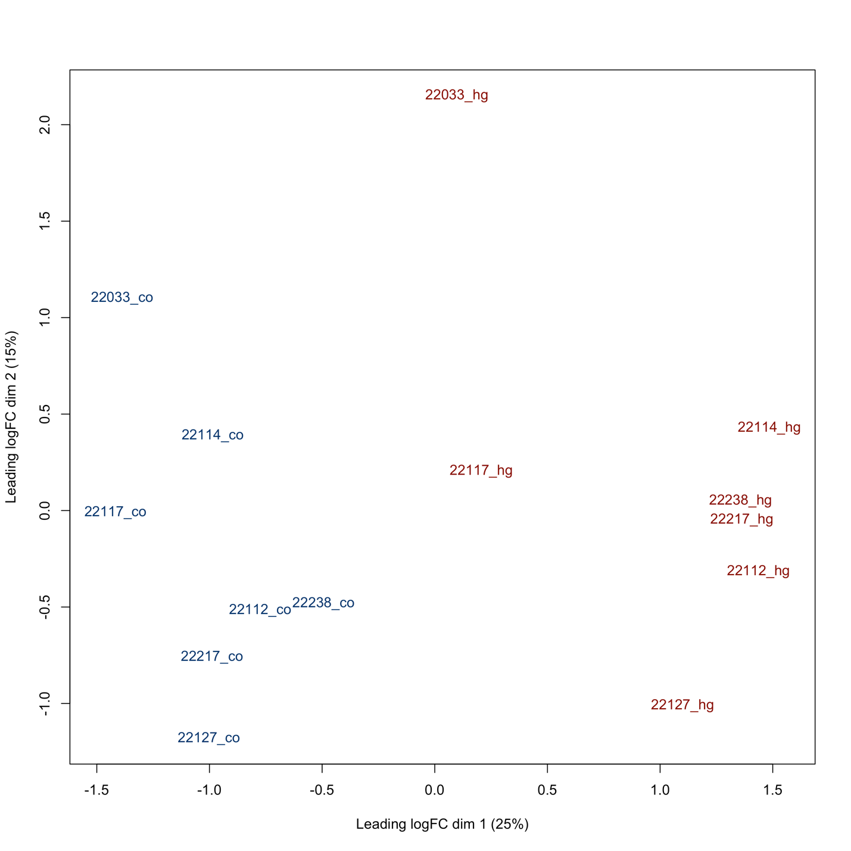

Figure S2

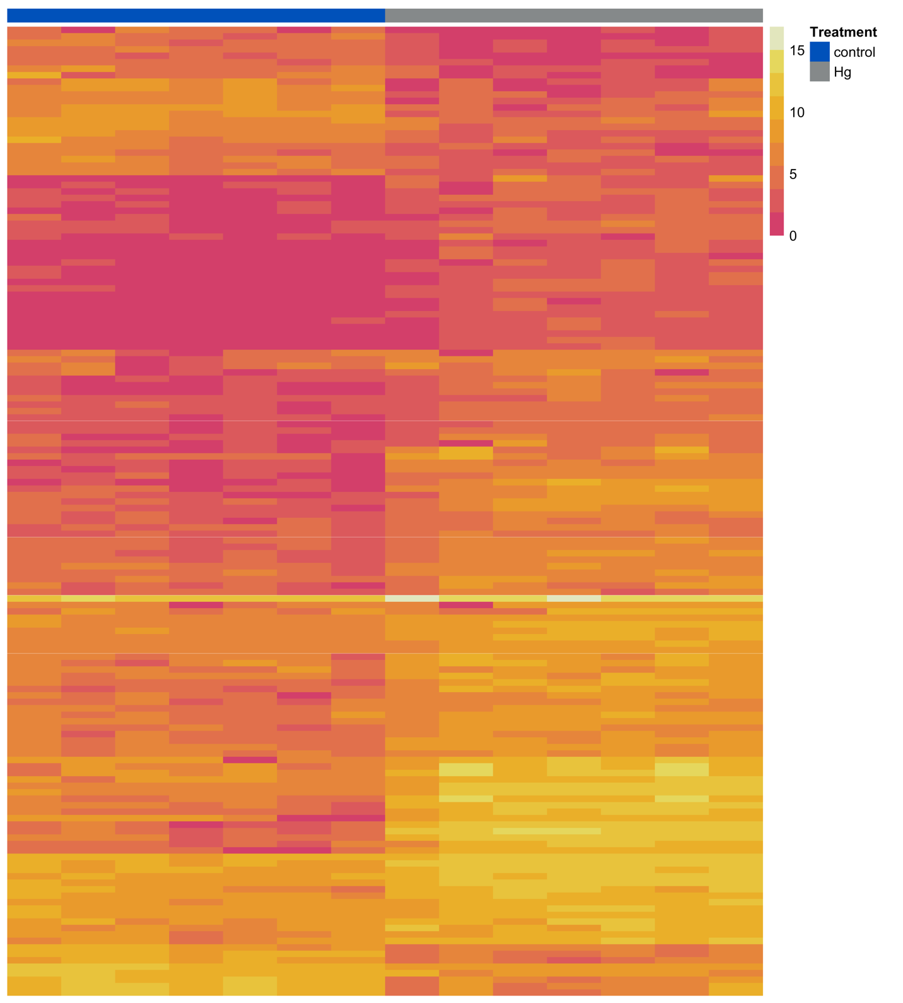
Figure S3

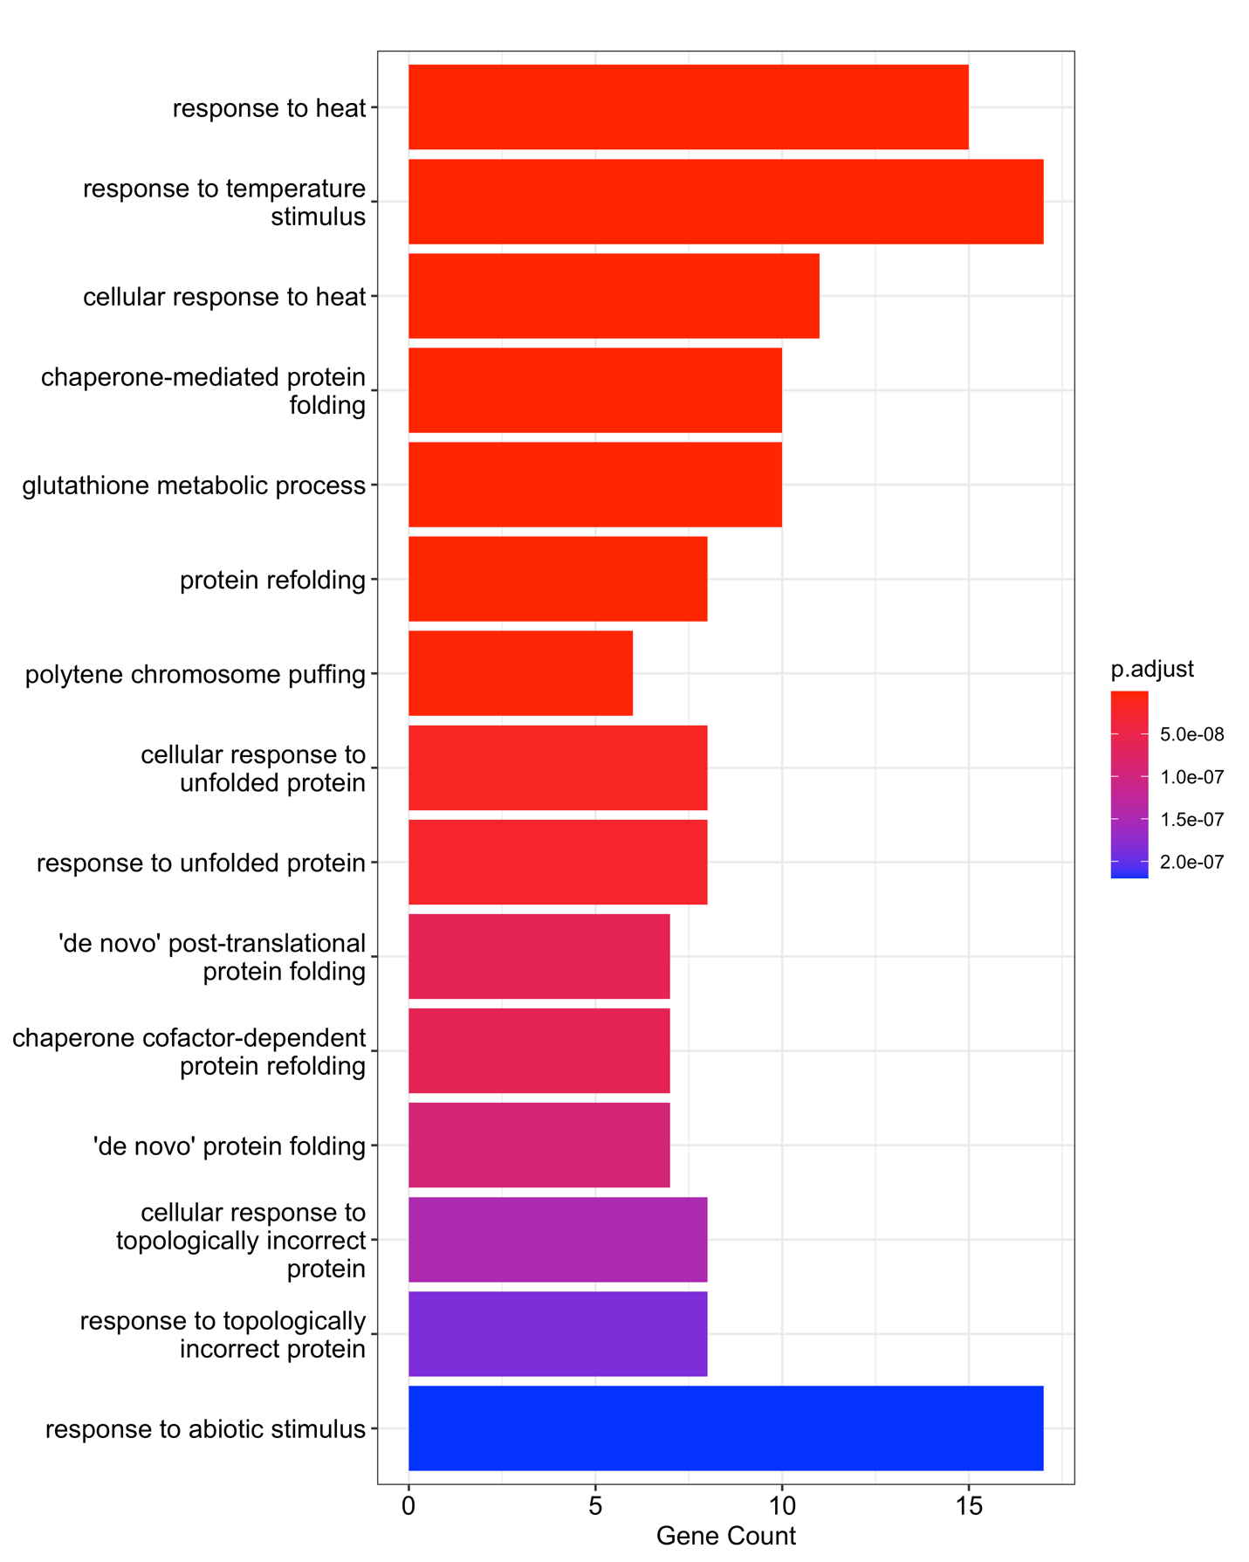

Figure S4

