Table of contents
1.0 Background 3
1.1 Adapter trimming algorithms 3
Fig. S1: Trimming algorithms implemented by the adapter and quality trimming software programs compared in this study. 3
1.1.1 Sequence-matching algorithm 3
1.1.2 Sequence overlapping algorithm 4
1.1.3 Probabilistic overlapping algorithm 5
1.1.4 K-mer based algorithm. 5
1.1.5 A bit-masked k-difference matching 6
2.0 Supplementary Methods 7
2.1 Parameter selection and optimization for adapter trimming 7
2.1.1 Adapter-to-read alignment 7
2.1.2 Forward-to-reverse read alignment 7
Table S2: Standardized parameters used for quality and adapter trimming for the six trimmers compared. 9
2.2 Poliovirus, severe acute respiratory syndrome coronavirus 2, and norovirus sequencing on Illumina platforms 10
2.2.1 Viral RNA extraction 10
2.2.2 Reverse transcription and random amplification of poliovirus RNA 10
2.2.3 Reverse transcription and targeted amplification of norovirus & SARS-CoV-2 RNA 11
2.2.4 Library construction and sequencing 11
2.3 Read assembly and assembly statistics 12
2.4 SNP calling 12
2.5 Calculating SNPs Concordance 13
3.0 Supplementary Results 14
Table S3: Statistical differences in percentage residual adapters between iSeq versus MiSeq reads, grouped by trimmer and virus analyzed. 14
Table S4: Statistical differences between iSeq versus MiSeq poliovirus, SARS-CoV-2, and norovirus read metrics before and after processing with different trimmers. 15
Table S5: Statistical differences among poliovirus raw and trimmed read metrics, grouped by trimmer and sequencing platform. 16
Table S6: Statistical differences among SARS-CoV-2 raw and trimmed read metrics, grouped by trimmer and sequencing platform. 18
Table S7: Statistical differences among norovirus raw and trimmed read metrics, grouped by trimmer and sequencing platform. 20
Fig. S8: Differences between poliovirus raw (as reference, Ref) and trimmed read metrics, grouped by sequencing platform. Metrics which are statistically different compared to raw data are indicated with a black asterisk *. Abbreviations: polio is for poliovirus, noro for norovirus, and SC2 for severe acute respiratory syndrome coronavirus 2. 22
Fig. S9: Differences between severe acute respiratory syndrome coronavirus 2 raw (as reference, Ref) and trimmed read metrics, grouped by sequencing platform. Metrics which are statistically different compared to raw data are indicated with a black asterisk *. Abbreviations: SC2 for severe acute respiratory syndrome coronavirus 2. 23
Table S11: Mean percentage of high-quality bases (Q≥30) for poliovirus, SARS-CoV-2, and norovirus reads grouped by sequencing platform and trimmer. Date in blue highlights the highest and red the lowest Q≥30 for trimmed reads for a given virus/platform. 25
Table S13: Statistical differences in maximum contig length (maxContig) between trimmers, grouped by virus and sequencing platform. 27
Table S14: Statistical differences in N50, maximum contig length, and SNP quality for iSeq versus MiSeq assemblies from raw and trimmed reads, grouped by virus and trimmer. 28
Table S15: Statistical differences in SNP quality between trimmers, grouped by virus and sequencing platform. 29
Fig. S16: Multi-venn diagram showing concordant SNPs among iSeq and MiSeq poliovirus, severe acute respiratory syndrome coronavirus 2, and norovirus assemblies from raw and trimmed reads. Shapes vary to enable visualization of shared SNPs or overlaps between the different trimmer sets.Abbreviations: polio is for poliovirus, noro for norovirus and SC2 for severe acute respiratory syndrome coronavirus 2. 30
Differences in runtime and memory usage between trimmers. 32
References 32

Background

Adapter trimming algorithms

Fig. S1: Trimming algorithms implemented by the adapter and quality trimming software programs compared in this study.
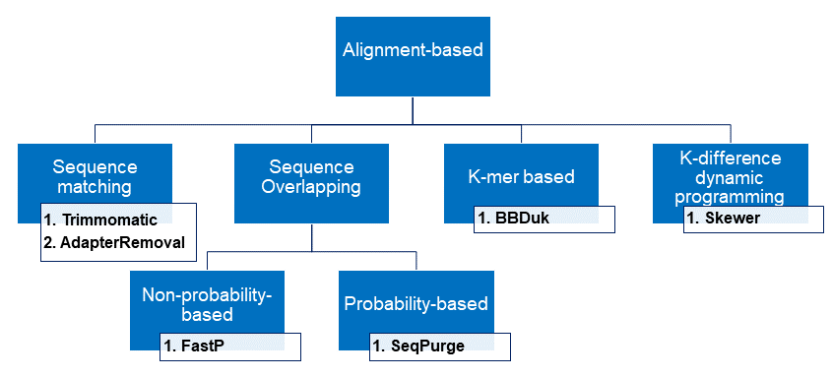

Sequence-matching algorithm
Sequence-matching uses global alignment to match the 5’ ends of suspected adapters to 3’ ends of sequenced reads with no gaps. If a match is found, the unmatched 3’ ends of the reads are trimmed (1–3). We selected two sequence-matching software programs for this comparison study: Trimmomatic v0.39 (1) and AdapterRemoval v2.2.2 (3).
Trimmomatic operates using two modes, “simple” and “palindrome”, simultaneously. In the simple mode, Trimmomatic scans each read from the 5’ to 3’ end and locally aligns reads and a user-supplied suspected adapter sequence (adapter-read matching). The palindrome mode, also known as the ‘adapter read-through’ or “insert matching”, is when the forward (R1) and reverse (R2) reads are matched (globally aligned) and any sequence beyond the aligned regions are trimmed (1). The palindrome mode simultaneously tests if two reads (R1 and R2) contain the same number of valid bases, the valid bases are reverse compliments, and contain contaminating adapter sequences at opposite sides, which increases its specificity and sensitivity. Specifically, under the palindrome mode, Trimmomatic first aligns adapters to their respective read, then the adapter-to-read combination for each read pair are aligned against each other by a “seed and extend” approach like the simple mode (1). This global alignment ensures end-to-end match between R1 and R2.
AdapterRemoval v2 also performs single and paired read trimming simultaneously. For single reads, it uses the semiglobal Needleman–Wunsch Alignment to align the read and adapter sequence which match the 5’ ends of suspected adapters to 3’ ends of sequenced reads (either R1 or R2) with no gaps and trimming the matching region. For paired reads, AdapterRemoval v2 tests the R1 and reverse compliment for overlap (no gaps). It then prefixes the adapter sequence of reverse complement reverse read (R2) to R1 and adapter sequence of R1 to reverse complement of R2 before doing a pairwise global alignment between R1 and R2 (2,3).

Sequence overlapping algorithm
The overlapping algorithm aligns forward and reverse reads allowing mismatched bases but no gaps; sequences that fall beyond the overlapped regions are trimmed.
The trimmer evaluated in this study which uses the overlapping algorithm is FastP v0.20.1 (4,5). FastP identifies adapters based on two assumptions: 1) that the reads have one adapter sequence, and 2) the adapter sequences are only at the tails of the reads. FastP independently trims single reads by assembling the high frequency read tails. It computes the 10-mer for the first one million reads. If this k-mer occurs at high frequencies in reads (>0.0001), then it is used as seed to detect the whole (extended) adapter forward and backward using a tree-based algorithm.
For paired reads, FastP finds the optimal overlap between forward and reverse reads based on the edit distance (number of different bases between reads) and the overlapped length (5). Any bases past the overlapping region are trimmed, hence FastP can trim very short sequences (at least one base) at read tails.

Probabilistic overlapping algorithm
With this trimming algorithm, the overlapping region between forward-reverse reads or adapter-read sequences with the highest probability is identified before trimming the unaligned bases. An example trimmer which was evaluated in this study is SeqPurge v2022_07 (6).
SeqPurge combines the adapter-matching and insert-matching approaches. For paired reads, SeqPurge tests different offsets (number of bases) to insert match between R1 and R2. When the best offset (match with the lowest probability of being random) is found, the read sequences are matched and bases outside the matching region (insert) are trimmed as adapters. The probability of the insert match is calculated based on the binomial distribution formula below:
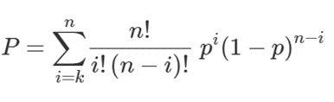
Given two sequences (R1 and R2) of length n, SeqPurge starts by counting the number of matching bases k between the sequences. Assuming a fixed match probability of p= 0.25 for each base (A, C, G, T), it uses the binomial distribution to calculate the probability (P) of observing k or more matching bases. If P is below a given threshold, the sequences are considered a non-random match. This threshold is the parameter balancing sensitivity/specificity of the algorithm.
If SeqPurge finds no matches between R1 and R2, it matches adapter sequences to R1 and R2 separately (adapter-read matching). If an adapter-read match is detected, the read is trimmed starting at the offset position to the end. If the adapter matched one read of the pair, both paired reads are trimmed at the offset position (6).

K-mer based algorithm.
The k-mer based algorithm involves matching the suspected k-mer adapter sequence to individual reads, and all bases on the right of the read-adapter matched region are trimmed. The adapter trimmer evaluated in this study using this algorithm is BBDuk v38.90, a tool for the BBMap/BBTools package of fast, multithreaded bioinformatics tools for DNA and RNA sequence data analysis (https://sourceforge.net/projects/bbmap/, https://jgi.doe.gov/data-and-tools/software-tools/bbtools/). BBDuk, where ‘Duk’ means Decontamination Using Kmers.
BBDuk implements right or left trimming or masking (7). BBDuk only performs adapter-read matching, and by default discards any read that matches the suspected k-mer adapter sequence. To counteract this behavior, we used the ktrim=r and qtrim=rl parameters. When the suspected k-mer matches the read, ktrim=r allows the kmer and all the bases to the right of the read to be trimmed, leaving only the bases to the left. The qtrim=rl allows trimming of low-quality bases on both the right and left sides of the read. To prevent BBDuk from filtering out reads based on quality after trimming, we set the minavgquality=0.

A bit-masked k-difference matching
The bit-masked k-difference algorithm finds read and adapter pairs that have k-differences, allows mismatches, insertions and indels (gaps) in the read-adapter matching. An example a of trimmer implementing this algorithm which was evaluated in this study is Skewer v0.2.2 (8).
Skewer matches adapter sequences of length n to reads with length m and builds a k-difference (m+1) by (n+1) matrix using dynamic programming. Then, the algorithm searches the last row of the matrix and reports pairs with no greater than k differences. For paired reads, Skewer first finds all k-difference occurrences of adapters in both forward and reverse reads before trimming and then checks for adapter occurrences on the reverse-complements of each of the paired sequences. The algorithm scores the occurrence of adapters in the paired reads and the alignment of their reverse compliments. This scoring scheme finds the ideal starting point for trimming that meets the k-difference requirement and has the maximum score. Details on the trimming algorithm and mathematical equations employed can be found here: https://bmcbioinformatics.biomedcentral.com/articles/10.1186/1471-2105-15-182 (8).
- Supplementary Methods

Parameter selection and optimization for adapter trimming
We followed the Trimmomatic scoring scheme ( http://www.usadellab.org/cms/uploads/supplementary/Trimmomatic/TrimmomaticManual_V0.32.pdf) to standardize key parameters common to all selected trimmers. These parameters included thresholds for sequence matching or overlapping, quality trimming based on quality scores (Q), and allowed mismatches for paired reads (forward read-to-reverse read) and single-reads (adapter-to-read) alignments.

Adapter-to-read alignment
To calculate the full alignment score, each matching base increases the alignment score by 0.6, while each mismatch reduces the alignment score by Q/10. By considering the quality of the base calls, mismatches caused by read errors have less impact. The Trimmomatic developers recommend a Q score between 7 and 15 as the threshold value for simple alignment mode. Our longest adapter was 34 bases long, which gives a maximum score of 34×0.6 = 20.4. We choose a minimum of 12 bases of adapter matching with the read resulting in a minimum score of 12×0.6 = 7.2.
The minimum read to adapter precent match for SeqPurge was determined using the parameter ‘match_perc’. Since we set at least 12 bases of the adapter to match the read, the minimum match length for the longest adapter is 12/34×100=35%; and for the shortest adapter is 12/19×100= 63%. Therefore, we used the minimum percentage of the shortest adapter (19 bases).

Forward-to-reverse read alignment
The maximum length of both forward (R1) and reverse (R2) reads is 151, therefore the maximum score for perfectly matched R1 and R2 reads would be 151×0.6 =90.6. Allowing at least 50 bases to match between R1 and R2 results in a minimum paired end (PE) score of 50×0.6 =30. This corresponds to up to 101 mismatches over the total read length (101/151=67% mismatch rate (-mm) =0.67).
Example: Parameters used for Trimmomatic
Match score = 0.6
Mismatch score = reduce Q/10
- A perfect match of a 12 bases = 0.6×12 = 7
- A perfect match of a 25 bases = 0.6×25 = 15
- Recommend values of between 7⎼15 for single end (SE)
- Our longest adapter was 34 bases= maximum score of 34×0.6 = 20.4.
- So, we choose a minimum of 12 bases of adapter matching with the read gives the min Q score as 12×0.6 = 7 for SE
- For PE, minimum score = 50 bases ×0.6 = 30
- For PE, mismatches allowed 101/151= 67%

Table S2: Standardized parameters used for quality and adapter trimming for the six trimmers compared.
Task | Parameter | Trimmomatic | AdapterRemoval | FastP | SeqPurge | BBDuk | Skewer
Adapter Identification and Trimming | PE match Q score threshold  (R1-to-R2) | 30  (at least 50 bases match between R1 and R2, mm=101/151) | _ | _ | _ | _ | _
Adapter Identification and Trimming | SE match Q score threshold  (Adapter-to-Read) | 7  (at least 12 bases match between read and adapter) | _ | _ | _ | _ | _
Adapter Identification and Trimming | PE (%) mismatchrate  (R1-to-R2) | _ | 0.67  (101/151) | 67 (101/151×100 | 35 (50/151×100, match) | _ | _
Adapter Identification and Trimming | SE:  Min bases for adapter-to-Read overlap | _ | 12 | _ | _ | _ | 12
Adapter Identification and Trimming | PE:  Number of bases overlap required.  (R1-to-R2) | _ | _ | 50 | _ | 50 | _
Adapter Identification and Trimming | Max number of mismatching bases in seed | 4 | _ | 4 | _ | _ | 4  (Max error rate=0.21)
Adapter Identification and Trimming | minAdapter length to detect/trim | 8 | _ | _ | _ | 8 | _
Quality Trimming  (Read/low quality base clipping) | Window size  (Number of bases to compute average Q score) | 4 |  |  |  | _ | _
Quality Trimming  (Read/low quality base clipping) | Average Q score below which bases are trimmed | 15
Read Filtering | minLength of reads after trimming | 50
PE: Paired End, SE: Single End, minAdapter: minimum length (in bases) of adapter sequence to detect and trim; minLength; minimum length of reads (in bases) to retain after trimming.

Poliovirus, severe acute respiratory syndrome coronavirus 2, and norovirus sequencing on Illumina platforms
    - Viral RNA extraction
Thirteen poliovirus clinical isolates, eight severe acute respiratory syndrome coronavirus 2 (SARS-CoV-2) nasopharyngeal (NP) swabs, and seven norovirus stool samples were collected, and viral RNA was extracted for each sample type according to their laboratory-optimized procedure as follows:
Norovirus RNA was extracted using the MagMax-96 Viral RNA Isolation kit (Applied Biosystem, Waltham MA USA) with KingFisher Flex Purification System according to manufacturer’s instruction (Thermo Scientific, Waltham MA USA). The extracted RNA was then treated with dsDNase (Thermo Scientific) to remove genomic dsDNA for 2 min at 37°C, and 0.1M DTT for 5 min at 55°C to inactivate the dsDNase.
Poliovirus RNA was extracted from Flinders Technology Associates (FTA) cards using a previously detailed process (https://www.train.org/main/course/1048222/). Total RNA was extracted from FTA resuspensions using the QIAamp Viral RNA Mini kit (Qiagen, Germantown MD USA) and eluted with 50µl AVE buffer solution. No carrier RNA was used for this extraction.
SARS-CoV-2 RNA was extracted from NP swab buffer using EZ1 DSP Virus Kit on the EZ1 Advanced XL (Qiagen) automated extraction system following the manufacturer’s instructions.
    - Reverse transcription and random amplification of poliovirus RNA
Poliovirus RNA was reverse transcribed using the qScript One-Step RT-qPCR kit (QuantaBio, Beverly, MA USA). Samples were denatured by adding viral RNA to random primers and oligo dT and incubated for 5 min at 65°C, then 2 min at 4°C. The samples were then added to a master mix containing qScript reverse transcriptase and Vent (exo-) DNA polymerase (NEB, Ipswich MA USA) and incubated under the following conditions: 5 min at 25°C, 30 min at 42°C, 10 min at 95°C, 2 min at 4°C, and 30 min at 72°C. The resulting cDNA was then cleaned using ExoSAP-IT PCR Product Cleanup Kit (Applied Biosystems).
    - Reverse transcription and targeted amplification of norovirus & SARS-CoV-2 RNA
Norovirus RNA was first denatured in a reaction containing reverse primer TX30SXN [3], dsDNase-treated RNA, and dNTP for 5 min at 64°C then for 2 min at 4°C. cDNA was generated using Maxima H Minus First Strand cDNA Synthesis Kit (Thermo Fisher) under the following conditions: 1 hour at 50°C, 5 min at 85°C, and 2 min at 4°C. Full genome amplicons were generated using SequelPrep Long PCR Kit (Applied Biosystems) using the TX30SXN primer (GACTAGTTCTAGATCGCGAGCGGCCGCCC(T)₃₀) (9), and GII_1-35 primer (GTGAATGAAGATGGCGTCTAACGACGCTTCCGCTG) (10), under the following conditions: 94°C for 2 min, 9 cycles [94°C for 10 sec, 55° for 30 sec, 68°C for 9 min], 29 cycles [94°C for 10 sec, 55°C for 30 sec, 68°C for 9 min 20 sec, with a 20 second extension per cycle], 72°C for 5 min, and hold at 11°C. Amplicons were pooled and purified using the ExoSAP-IT PCR Product Cleanup kit (Applied Biosystems).
SARS-CoV-2 samples were processed using a previously published protocol adapted to a four-pool PCR design to generate tiled SARS-CoV-2 amplicons (11). First strand cDNA was generated using Superscript IV reverse transcriptase and random hexamer primers under the following PCR conditions: 10 min at 25°C, 10 min at 50°C, and 10 min at 80°C. SARS-CoV-2 cDNA was used as input for the four-pool primal scheme; the cDNA was added to each primal pool set including NEBNext Q5 Hot Start HiFi PCR Master Mix and incubated under the following PCR conditions: 30 seconds at 98°C and 40 cycles of [98°C for 15 seconds and 65°C for 5 minutes]. PCR amplicons were pooled and purified using 1.8x AMPure XP bead cleanup, and concentrations were determined using the Quant-IT 1x dsDNA HS kit (Invitrogen).
    - Library construction and sequencing
For all samples, libraries were constructed on a Zephyr G3 NGS workstation (PerkinElmer, Waltham MA) with an initial input of 40 ng using the DNA Library Prep Kit (Illumina, San Diego CA USA) with halved reactions following the manufacturer’s protocol. Libraries were purified with AMPure XP beads at 1.8x ratio. The purified samples were quantified on the Biotek Synergy LX plate reader (Agilent Technologies, Santa Clara, CA) using the Quant-IT 1x dsDNA HS kit and visualized using the HS D1000 TapeStation assay (Agilent Technologies). Sequencing was split into two library pools; the first pool contained norovirus and SARS-CoV-2 libraries, and the second pool contained the poliovirus libraries. Pooled libraries were sequenced on both MiSeq and iSeq platforms using 300-cycle (2 x 150 bp, paired end) MiSeq v2 Micro Kits and iSeq i1 reagent v2 cartridges, respectively.

Read assembly and assembly statistics
Raw and total (paired and single) trimmed reads output by each trimmer for each virus type were assembled de novo using SPAdes v3.15.3 (12) with the following parameters: -k 21,33,55,77,99,121 --only-assembler --isolate -t 30 --cov-cutoff 10. The ‘--only-assembler’ and ‘--careful’ flags served to run the assemblies without error correction and reduce the number of mismatches and indels, respectively. The resultant assemblies were used to calculate contig statistics and identify single nucleotide polymorphisms (SNPs). We reported two statistics for contig size, N50 and maximum contig length (maxContig), where N50 represents the length of the shortest contig where contigs the same size or longer span half or more of the total genome analyzed. We further calculated the “genome coverage”, which was calculated as Maximum Contig Length (bp)/Viral Genome Length (bp) ×100. Significances of difference in N50, maxContig, and genome coverage were calculated using the Wilcoxon signed-rank test (function “wilcox.test()” in R).

SNP calling
To call SNPs, a custom workflow was implemented in nextflow version 21.04.3 ((Di Tommaso et al., 2017), https://github.com/darlenewagner/nextflowViral). First, reads were mapped to their respective references using bowtie2 version 2.3.5.1 with settings ‘--no-unal’ and ‘--local’ (Langmead and Salzberg, 2012). Norovirus samples Noro_sample_1, Noro_sample_3, Noro_sample_4, Noro_sample_5, and Noro_sample_6 were mapped to Norovirus GII isolate, accession number OL913976 using Geneious R11 v11.1.5 (Biomatters) and re-mapped to their corresponding consensus references. Norovirus samples Noro_sample_2 and Noro_sample_7 were mapped directly to OL913976 without creating a custom reference. Poliovirus samples, Polio_sample_1, Polio_sample_2, Polio_sample_3, and Polio_sample_4, were mapped to the custom reference of Polio_sample_3 reads assembled in Geneious R11 v11.1.5. Sample Polio_sample_5 was similarly assembled in Geneious R11 v11.1.5 using itself as the reference. The remaining eight poliovirus samples (Polio_samples_6-13) were mapped to a custom reference constructed of Polio_sample_6 reads mapped to Human poliovirus 2 strain Sabin 2, accession number AY184220 using Geneious R11 v11.1.5. All SARS-CoV-2 samples were mapped to MN908947. Compression, sorting, and indexing of bowtie2 output was performed using samtools version 1.15.1 (Danecek et al., 2021) while mapping depth was computed using BEDTools version 2.26.0 (Quinlan and Hall, 2010). The mpileup function of bcftools (Danecek et al., 2021) was employed to call SNPs using parameters -d 35000, -Ob, -Q 20, -q 20, and --annotate FORMAT/AD,FORMAT/DP. Here, ‘-d’ indicates maximum mapping depth, ‘-Ob’ indicates output as .bam file, ‘-Q’ indicates minimum base quality, ‘-q’ indicates minimum mapping quality for an alignment, and ‘-annotate FORMAT/AD,FORMAT/DP’ ensures output of allele fraction and depth of SNPs calls. BCFtools assigns SNP quality up to 228, where the value signifies the log odds of an erroneous SNP call.

Calculating SNPs Concordance
The concordance of SNP positions for the three viral datasets analyzed were determined across all adapter trimming datasets plus the untrimmed dataset using the following formula:
Equation 1:

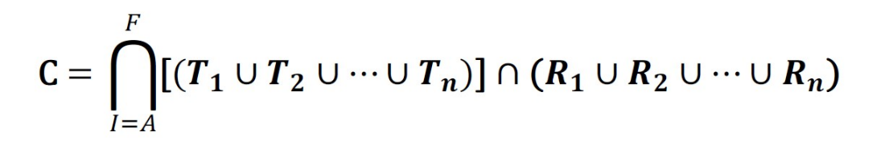

Here, to compute the set of concordant SNPs, C, the intersection is taken across the unions of SNPs positions in samples, T, 1 through n, within each of the six adapter trimmed sets, A through F for a given virus type. The intersection with the union for the raw (untrimmed) set, R, is taken with the resulting six adapter trimmed sets.

Supplementary Results

Table S3: Statistical differences in percentage residual adapters between iSeq versus MiSeq reads, grouped by trimmer and virus analyzed.
Differences between iSeq vs MiSeq residual adapters
Trimmer | p | p.adjusted
Poliovirus

Raw  AdapterRemv2  FastP  Skewer | 4.03×10⁻¹⁵  7.37×10⁻⁵  0.263  0.27 | 1.61×10⁻¹⁴  2.95×10⁻⁴  1  1
SARS-CoV-2

Raw  AdapterRemv2  FastP  SeqPurge  Skewer | 3.33×10⁻⁹  0.003  0.128  1  0.01 | 1.67×10⁻⁸  0.015  0.64  1  0.05
Norovirus

Raw  AdapterRemv2  FastP  Skewer | 3.38×10⁻⁴  0.017  0.019  0.083 | 1.35 ×10⁻³  0.068  0.076  0.332

Table S4: Statistical differences between iSeq versus MiSeq poliovirus, SARS-CoV-2, and norovirus read metrics before and after processing with different trimmers.
Differences between iSeq vs MiSeq read metrics

Trimmer | Poliovirus |  | SARS-CoV-2 |  | Norovirus
 | p | p.adjusted | p | p.adjusted | p | p.adjusted
Total Read Count
Raw  Trimmomatic  AdapterRemv2  FastP  SeqPurge  BBDuk  Skewer | 0.65  0.545  0.801  0.545  0.762  0.579  0.762 | 1  1  1  1  1  1  1 | 0.005  0.442  0.13  0.442  0.13  0.505  0.161 | 0.035  1  0.91  1  0.91  1  1 | 0.209  0.62  0.456  0.62  0.535  0.71  0.535 | 1  1  1  1  1  1  1
Paired Read Count
Raw  Trimmomatic  AdapterRemv2  FastP  SeqPurge  BBDuk  Skewer | 0.65  0.479  0.801  0.511  0.762  0.579  0.762 | 1  1  1  1  1  1  1 | 0.005  0.574  0.105  0.505  0.161  0.442  0.161 | 0.035  1  0.735  1  1  1  1 | 0.209  0.71  0.383  0.71  0.535  0.71  0.535 | 1  1  1  1  1  1  1
Base Count
Raw  Trimmomatic  AdapterRemv2  FastP  SeqPurge  BBDuk  Skewer | 0.65  0.264  0.336  0.264  0.336  0.287  0.362 | 1  1  1  1  1  1  1 | 0.005  0.442  0.798  0.505  0.645  0.721  0.645 | 0.035  1  1  1  1  1  1 | 0.209  1  0.805  1  0.805  0.71  0.902 | 1  1  1  1  1  1  1
Read Length
Trimmomatic  AdapterRemv2  FastP  SeqPurge  BBDuk  Skewer | 1.63×10⁻⁵  1.64×10⁻⁵  1.63×10⁻⁵  1.63×10⁻⁵  1.61×10⁻⁵  1.64×10⁻⁵ | 9.78×10⁻⁵  9.84×10⁻⁵  9.78×10⁻⁵  9.78×10⁻⁵  9.66×10⁻⁵  9.84×10⁻⁵ | 9.31×10⁻⁴  9.23×10⁻⁴  9.23×10⁻⁴  9.31×10⁻⁴  9.31×10⁻⁴  9.23×10⁻⁴ | 5.59×10⁻³  5.54×10⁻³  5.54×10⁻³  5.59×10⁻³  5.59×10⁻³  5.54×10⁻³ | 0.021  0.018  0.021  0.018  0.018  0.084 | 0.126  0.108  0.126  0.108  0.108  0.504
Percent Of Bases With Q≥20
Raw  Trimmomatic  AdapterRemv2  FastP  SeqPurge  BBDuk  Skewer | 1.92×10⁻⁷  1.63×10⁻⁵  1.64×10⁻⁵  1.64×10⁻⁵  1.64×10⁻⁵  1.64×10⁻⁵  1.92×10⁻⁷ | 1.34×10⁻⁶  1.14×10⁻⁴  1.15×10⁻⁴  1.15×10⁻⁴  1.15×10⁻⁴  1.15×10⁻⁴  1.34×10⁻⁶ | 9.31×10⁻⁴  9.31×10⁻⁴  9.31×10⁻⁴  9.31×10⁻⁴  9.31×10⁻⁴  9.31×10⁻⁴  1.55×10⁻⁴ | 6.52×10⁻³  6.52×10⁻³  6.52×10⁻³  6.52×10⁻³  6.52×10⁻³  6.52×10⁻³  1.09×10⁻³ | 5.83×10⁻⁴  5.83×10⁻⁴  0.002  5.83×10⁻⁴  0.128  0.002  0.209 | 4.08×10⁻³  4.08×10⁻³  0.014  4.08×10⁻³  0.896  0.014  1
Percent Of Bases With Q≥30
Raw  Trimmomatic  AdapterRemv2  FastP  SeqPurge  BBDuk  Skewer | 3.84×10⁻⁴  0.663  0.012  0.614  0.204  0.758  0.682 | 2.69×10⁻³  1  0.084  1  1  1  1 | 1.55×10⁻⁴  9.31×10⁻⁴  1×10⁻³  1.55×10⁻⁴  0.038  1.55×10⁻⁴  0.4 | 1.09×10⁻³  6.52×10⁻³  7. ×10⁻³  1.09×10⁻³  0.266  1.09×10⁻³  1 | 0.128  5.83×10⁻⁴  5×10⁻³  5.83×10⁻⁴  0.318  5.83×10⁻⁴  1 | 0.896  4.08×10⁻³  0.035  4.08×10⁻³  1  4.08×10⁻³  1

Table S5: Statistical differences among poliovirus raw and trimmed read metrics, grouped by trimmer and sequencing platform.
Poliovirus
 | Trimmer | Raw | Trimmomatic | AdapterRemv2 | FastP | SeqPurge | BBDuk
Platform
 | Total Read Count
iSeq | Trimmomatic  AdapterRemv2  FastP  SeqPurge  BBDuk  Skewer | 0.06  0.06  0.06  0.108  0.199  0.108 | ⎼  0.841  0.841  0.758  0.758  0.758 | ⎼  ⎼  0.92  0.758  0.758  0.758 | ⎼  ⎼  ⎼  0.758  0.758  0.758 | ⎼  ⎼  ⎼  ⎼  0.758  0.841 | ⎼  ⎼  ⎼  ⎼  ⎼  0.758
MiSeq | Trimmomatic  AdapterRemv2  FastP  SeqPurge  BBDuk  Skewer | 0.583  0.583  0.583  0.583  0.744  0.583 | ⎼  0.762  0.762  0.762  0.743  0.762 | ⎼  ⎼  0.762  0.762  0.65  0.762 | ⎼  ⎼  ⎼  0.762  0.744  0.762 | ⎼  ⎼  ⎼  ⎼  0.744  0.762 | ⎼  ⎼  ⎼  ⎼  ⎼  0.744
 | Paired Read Count
iSeq | Trimmomatic  AdapterRemv2  FastP  SeqPurge  BBDuk  Skewer | 0.027  0.027  0.027  0.089  0.027  0.089 | ⎼  0.762  0.762  0.673  0.673  0.673 | ⎼  ⎼  0.762  0.673  0.673  0.673 | ⎼  ⎼  ⎼  0.673  0.673  0.673 | ⎼  ⎼  ⎼  ⎼  0.534  0.762 | ⎼  ⎼  ⎼  ⎼  ⎼  0.534
MiSeq | Trimmomatic  AdapterRemv2  FastP  SeqPurge  BBDuk  Skewer | 0.426  0.355  0.426  0.486  0.355  0.486 | ⎼  0.672  0.8  0.716  0.672  0.716 | ⎼  ⎼  0.672  0.672  0.879  0.672 | ⎼  ⎼  ⎼  0.716  0.672  0.716 | ⎼  ⎼  ⎼  ⎼  0.672  0.8 | ⎼  ⎼  ⎼  ⎼  ⎼  0.672
 | Base Count
iSeq | Trimmomatic  AdapterRemv2  FastP  SeqPurge  BBDuk  Skewer | 4.71×10⁻⁶  4.71×10⁻⁶  4.71×10⁻⁶  4.71×10⁻⁶  4.71×10⁻⁶  4.71×10⁻⁶ | ⎼  0.762  0.762  0.715  0.212  0.715 | ⎼  ⎼  0.762  0.715  0.216  0.715 | ⎼  ⎼  ⎼  0.715  0.216  0.715 | ⎼  ⎼  ⎼  ⎼  0.149  0.762 | ⎼  ⎼  ⎼  ⎼  ⎼  0.149
MiSeq | Trimmomatic  AdapterRemv2  FastP  SeqPurge  BBDuk  Skewer | 9.79×10⁻⁵  6.06×10⁻⁵  9.79×10⁻⁵  2.2×10⁻⁴  4.04×10⁻⁶  2.51×10⁻⁴ | ⎼  0.678  0.762  0.678  0.169  0.678 | ⎼  ⎼  0.678  0.678  0.293  0.678 | ⎼  ⎼  ⎼  0.678  0.17  0.678 | ⎼  ⎼  ⎼  ⎼  0.102  0.762 | ⎼  ⎼  ⎼  ⎼  ⎼  0.102
 | Read Length
iSeq | Trimmomatic  AdapterRemv2  FastP  SeqPurge  BBDuk  Skewer | 1.45×10⁻⁵  1.45×10⁻⁵  1.45×10⁻⁵  1.45×10⁻⁵  1.45×10⁻⁵  1.45×10⁻⁵ | ⎼  0.558  0.739  0.049  3.12×10⁻⁵  0.017 | ⎼  ⎼  0.657  0.019  3.12×10⁻⁵  6.53×10⁻³ | ⎼  ⎼  ⎼  0.036  3.12×10⁻⁵  0.011 | ⎼  ⎼  ⎼  ⎼  3.12×10⁻⁵  0.497 | ⎼  ⎼  ⎼  ⎼  ⎼  3.12×10⁻⁵
MiSeq | Trimmomatic  AdapterRemv2  FastP  SeqPurge  BBDuk  Skewer | 1.45×10⁻⁵  1.45×10⁻⁵  1.45×10⁻⁵  1.45×10⁻⁵  1.45×10⁻⁵  1.45×10⁻⁵ | ⎼  0.175  0.463  0.031  3.09×10⁻⁵  0.011 | ⎼  ⎼  0.323  1.25×10⁻³  3.09×10⁻⁵  9.32×10⁻⁴ | ⎼  ⎼  ⎼  0.011  3.09×10⁻⁵  3.99×10⁻³ | ⎼  ⎼  ⎼  ⎼  3.09×10⁻⁵  0.472 | ⎼  ⎼  ⎼  ⎼  ⎼  3.09×10⁻⁵
 | Percent of bases with Q≥20
iSeq | Trimmomatic  AdapterRemv2  FastP  SeqPurge  BBDuk  Skewer | 3.45×10⁻⁵  3.45×10⁻⁵  3.45×10⁻⁵  3.45×10⁻⁵  3.45×10⁻⁵  4.04×10⁻⁶ | ⎼  7.746×10⁻³  0.411  3.45×10⁻⁵  4.15×10⁻⁴  3.31×10⁻⁴ | ⎼  ⎼  1.69×10⁻³  3.45×10⁻⁵  3.49×10⁻⁵  3.61×10⁻⁵ | ⎼  ⎼  ⎼  3.45×10⁻⁵  1.05×10⁻³  4.77×10⁻⁴ | ⎼  ⎼  ⎼  ⎼  3.45×10⁻⁵  1.57×10⁻⁴ | ⎼  ⎼  ⎼  ⎼  ⎼  0.057
MiSeq | Trimmomatic  AdapterRemv2  FastP  SeqPurge  BBDuk  Skewer | 1.35×10⁻⁶  1.35×10⁻⁶  1.35×10⁻⁶  9.69×10⁻⁶  1.14×10⁻⁴  2.02×10⁻⁶ | ⎼  0.274  0.841  0.339  0.339  0.841 | ⎼  ⎼  0.274  0.102  0.102  0.362 | ⎼  ⎼  ⎼  0.339  0.339  0.841 | ⎼  ⎼  ⎼  ⎼  0.878  0.339 | ⎼  ⎼  ⎼  ⎼  ⎼  0.34
 | Percent of bases with Q≥30
iSeq | Trimmomatic  AdapterRemv2  FastP  SeqPurge  BBDuk  Skewer | 8.08×10⁻⁷  3.45×10⁻⁵  8.08×10⁻⁷  8.08×10⁻⁷  3.45×10⁻⁵  3.45×10⁻⁵ | ⎼  0.196  0.857  8.08×10⁻⁷  3.64×10⁻⁴  0.672 | ⎼  ⎼  0.196  3.45×10⁻⁵  7.68×10⁻⁵  0.551 | ⎼  ⎼  ⎼  8.08×10⁻⁷  3.54×10⁻⁴  0.676 | ⎼  ⎼  ⎼  ⎼  3.77×10⁻⁴  3.45×10⁻⁵ | ⎼  ⎼  ⎼  ⎼  ⎼  2.05×10⁻⁴
MiSeq | Trimmomatic  AdapterRemv2  FastP  SeqPurge  BBDuk  Skewer | 1.01×10⁻⁶  1.01×10⁻⁶  1.01×10⁻⁶  1.35×10⁻⁶  1.35×10⁻⁶  1.01×10⁻⁶ | ⎼  0.292  0.841  0.292  0.292  0.841 | ⎼  ⎼  0.292  0.089  0.088  0.384 | ⎼  ⎼  ⎼  0.292  0.292  0.841 | ⎼  ⎼  ⎼  ⎼  0.918  0.292 | ⎼  ⎼  ⎼  ⎼  ⎼  0.292

Table S6: Statistical differences among SARS-CoV-2 raw and trimmed read metrics, grouped by trimmer and sequencing platform.
SARS-CoV-2
 | Trimmer | Raw | Trimmomatic | AdapterRemv2 | FastP | SeqPurge | BBDuk
Platform
 | Total Read Count
iSeq | Trimmomatic  AdapterRemv2  FastP  SeqPurge  BBDuk  Skewer | 0.012  0.012  0.012  0.012  0.175  0.012 | ⎼  0.797  1  0.797  0.245  0.797 | ⎼  ⎼  0.922  0.797  0.245  0.797 | ⎼  ⎼  ⎼  0.797  0.245  0.797 | ⎼  ⎼  ⎼  ⎼  0.409  0.797 | ⎼  ⎼  ⎼  ⎼  ⎼  0.448
MiSeq | Trimmomatic  AdapterRemv2  FastP  SeqPurge  BBDuk  Skewer | 0.174  0.174  0.174  0.174  0.753  0.174 | ⎼  0.753  1  0.971  0.174  0.753 | ⎼  ⎼  0.753  0.753  0.174  0.753 | ⎼  ⎼  ⎼  1  0.174  0.753 | ⎼  ⎼  ⎼  ⎼  0.174  0.753 | ⎼  ⎼  ⎼  ⎼  ⎼  0.174
 | Paired Read Count
iSeq | Trimmomatic  AdapterRemv2  FastP  SeqPurge  BBDuk  Skewer | 9.79×10⁻³  9.79×10⁻³  9.79×10⁻³  0.01  9.79×10⁻³  0.01 | ⎼  0.798  0.757  0.624  0.624  0.624 | ⎼  ⎼  0.757  0.624  0.624  0.624 | ⎼  ⎼  ⎼  0.624  0.624  0.624 | ⎼  ⎼  ⎼  ⎼  0.421  0.757 | ⎼  ⎼  ⎼  ⎼  ⎼  0.391
MiSeq | Trimmomatic  AdapterRemv2  FastP  SeqPurge  BBDuk  Skewer | 0.29  0.29  0.29  0.29  0.147  0.29 | ⎼  0.678  0.721  0.678  0.492  0.678 | ⎼  ⎼  0.678  0.678  0.678  0.678 | ⎼  ⎼  ⎼  0.678  0.492  0.678 | ⎼  ⎼  ⎼  ⎼  0.492  0.678 | ⎼  ⎼  ⎼  ⎼  ⎼  0.492
 | Base Count
iSeq | Trimmomatic  AdapterRemv2  FastP  SeqPurge  BBDuk  Skewer | 5.44×10⁻⁴  5.44×10⁻⁴  5.44×10⁻⁴  5.44×10⁻⁴  5.44×10⁻⁴  5.44×10⁻⁴ | ⎼  0.757  0.878  0.709  0.022  0.708 | ⎼  ⎼  0.757  0.708  0.028  0.708 | ⎼  ⎼  ⎼  0.709  0.022  0.708 | ⎼  ⎼  ⎼  ⎼  0.018  0.753 | ⎼  ⎼  ⎼  ⎼  ⎼  8.86×10⁻³
MiSeq | Trimmomatic  AdapterRemv2  FastP  SeqPurge  BBDuk  Skewer | 5.44×10⁻⁴  5.44×10⁻⁴  5.44×10⁻⁴  5.44×10⁻⁴  5.44×10⁻⁴  5.44×10⁻⁴ | ⎼  0.709  0.721  0.721  0.016  0.709 | ⎼  ⎼  0.709  0.709  0.072  0.709 | ⎼  ⎼  ⎼  0.713  0.022  0.709 | ⎼  ⎼  ⎼  ⎼  0.016  0.713 | ⎼  ⎼  ⎼  ⎼  ⎼  0.016
 | Read Length
iSeq | Trimmomatic  AdapterRemv2  FastP  SeqPurge  BBDuk  Skewer | 1.08×10⁻³  1.08×10⁻³  1.08×10⁻³  1.08×10⁻³  1.08×10⁻³  1.08×10⁻³ | ⎼  0.264  0.916  0.324  1.08×10⁻³  0.044 | ⎼  ⎼  0.191  0.081  1.78×10⁻³  4.76×10⁻³ | ⎼  ⎼  ⎼  0.333223  1.78×10⁻³  0.046 | ⎼  ⎼  ⎼  ⎼  1.08×10⁻³  0.185 | ⎼  ⎼  ⎼  ⎼  ⎼  1.78×10⁻³
MiSeq | Trimmomatic  AdapterRemv2  FastP  SeqPurge  BBDuk  Skewer | 1.42×10⁻³  1.42×10⁻³  1.42×10⁻³  1.42×10⁻³  1.42×10⁻³  1.42×10⁻³ | ⎼  0.305  0.429  0.323  1.76×10⁻³  0.305 | ⎼  ⎼  0.314  0.033  1.76×10⁻³  0.017 | ⎼  ⎼  ⎼  0.305  1.76×10⁻³  0.137 | ⎼  ⎼  ⎼  ⎼  1.76×10⁻³  0.429 | ⎼  ⎼  ⎼  ⎼  ⎼  1.76×10⁻³
 | Percent Of Bases With Q≥20
iSeq | Trimmomatic  AdapterRemv2  FastP  SeqPurge  BBDuk  Skewer | 1.09×10⁻³  1.09×10⁻³  1.09×10⁻³  1.09×10⁻³  1.09×10⁻³  1.09×10⁻³ | ⎼  1.09×10⁻³  1.09×10⁻³  1.09×10⁻³  0.752  1.09×10⁻³ | ⎼  ⎼  1.09×10⁻³  1.09×10⁻³  1.09×10⁻³  1.09×10⁻³ | ⎼  ⎼  ⎼  1.09×10⁻³  7.99×10⁻³  1.09×10⁻³ | ⎼  ⎼  ⎼  ⎼  1.09×10⁻³  0.420126 | ⎼  ⎼  ⎼  ⎼  ⎼  1.09×10⁻³
MiSeq | Trimmomatic  AdapterRemv2  FastP  SeqPurge  BBDuk  Skewer | 5.44×10⁻⁴  5.44×10⁻⁴  5.44×10⁻⁴  5.44×10⁻⁴  5.44×10⁻⁴  5.44×10⁻⁴ | ⎼  0.087  1  0.342  0.342  0.241 | ⎼  ⎼  0.087  0.016  8.86×10⁻³  0.423 | ⎼  ⎼  ⎼  0.342  0.342  0.241 | ⎼  ⎼  ⎼  ⎼  0.757  0.087 | ⎼  ⎼  ⎼  ⎼  ⎼  0.087
 | Percent Of Bases With Q≥30
iSeq | Trimmomatic  AdapterRemv2  FastP  SeqPurge  BBDuk  Skewer | 1.63×10⁻³  4.08×10⁻⁴  4.08×10⁻⁴  4.08×10⁻⁴  4.08×10⁻⁴  4.08×10⁻⁴ | ⎼  7.49×10⁻³  0.086  1.63×10⁻³  0.081  0.081 | ⎼  ⎼  4.08×10⁻⁴  4.08×10⁻⁴  7.25×10⁻⁴  1.31×10⁻³ | ⎼  ⎼  ⎼  4.08×10⁻⁴  0.875  0.38 | ⎼  ⎼  ⎼  ⎼  1.81×10⁻³  2.8×10⁻⁴ | ⎼  ⎼  ⎼  ⎼  ⎼  0.401
MiSeq | Trimmomatic  AdapterRemv2  FastP  SeqPurge  BBDuk  Skewer | 5.44×10⁻⁴  5.44×10⁻⁴  5.44×10⁻⁴  5.44×10⁻⁴  5.44×10⁻⁴  5.44×10⁻⁴ | ⎼  0.114  1  0.342  0.256  0.241 | ⎼  ⎼  0.114  0.016  8.86×10⁻³  0.757 | ⎼  ⎼  ⎼  0.342  0.256  0.241 | ⎼  ⎼  ⎼  ⎼  0.757  0.096 | ⎼  ⎼  ⎼  ⎼  ⎼  0.066

Table S7: Statistical differences among norovirus raw and trimmed read metrics, grouped by trimmer and sequencing platform.
Norovirus
 | Trimmer | Raw | Trimmomatic | AdapterRemv2 | FastP | SeqPurge | BBDuk
Platform
 | Total Read Count
iSeq | Trimmomatic  AdapterRemv2  FastP  SeqPurge  BBDuk  Skewer | 0.184  0.184  0.184  0.278  0.449  0.409 | ⎼  0.746  0.746  0.746  0.487  0.684 | ⎼  ⎼  0.805  0.702  0.487  0.684 | ⎼  ⎼  ⎼  0.702  0.487  0.684 | ⎼  ⎼  ⎼  ⎼  0.684  0.746 | ⎼  ⎼  ⎼  ⎼  ⎼  0.684
MiSeq | Trimmomatic  AdapterRemv2  FastP  SeqPurge  BBDuk  Skewer | 0.723  0.723  0.723  0.723  1  0.723 | ⎼  0.723  0.746  0.723  0.723  0.723 | ⎼  ⎼  0.723  0.723  0.723  0.723 | ⎼  ⎼  ⎼  0.723  0.723  0.723 | ⎼  ⎼  ⎼  ⎼  0.723  0.746 | ⎼  ⎼  ⎼  ⎼  ⎼  0.723
 | Paired Read Count
iSeq | Trimmomatic  AdapterRemv2  FastP  SeqPurge  BBDuk  Skewer | 0.138  0.122  0.122  0.223  0.122  0.337 | ⎼  0.746  1  0.563  0.563  0.556 | ⎼  ⎼  0.746  0.556  0.563  0.556 | ⎼  ⎼  ⎼  0.563  0.563  0.556 | ⎼  ⎼  ⎼  ⎼  0.337  0.746 | ⎼  ⎼  ⎼  ⎼  ⎼  0.337
MiSeq | Trimmomatic  AdapterRemv2  FastP  SeqPurge  BBDuk  Skewer | 0.661  0.661  0.661  0.661  0.661  0.661 | ⎼  0.661  0.785  0.661  0.902  0.661 | ⎼  ⎼  0.661  0.661  0.661  0.661 | ⎼  ⎼  ⎼  0.661  0.902  0.661 | ⎼  ⎼  ⎼  ⎼  0.661  0.785 | ⎼  ⎼  ⎼  ⎼  ⎼  0.661
 | Base Count
iSeq | Trimmomatic  AdapterRemv2  FastP  SeqPurge  BBDuk  Skewer | 0.052  0.052  0.052  0.052  0.052  0.052 | ⎼  0.591  0.902  0.258  0.245  0.258 | ⎼  ⎼  0.591  0.258  0.245  0.258 | ⎼  ⎼  ⎼  0.258  0.245  0.258 | ⎼  ⎼  ⎼  ⎼  0.069  0.651 | ⎼  ⎼  ⎼  ⎼  ⎼  0.052
MiSeq | Trimmomatic  AdapterRemv2  FastP  SeqPurge  BBDuk  Skewer | 0.278  0.275  0.278  0.409  0.147  0.545 | ⎼  0.685  0.71  0.59  0.574  0.574 | ⎼  ⎼  0.685  0.545  0.661  0.545 | ⎼  ⎼  ⎼  0.598  0.574  0.574 | ⎼  ⎼  ⎼  ⎼  0.545  0.71 | ⎼  ⎼  ⎼  ⎼  ⎼  0.545
 | Read Length
iSeq | Trimmomatic  AdapterRemv2  FastP  SeqPurge  BBDuk  Skewer | 2.22×10⁻³  2.22×10⁻³  2.22×10⁻³  2.22×10⁻³  2.22×10⁻³  2.22×10⁻³ | ⎼  0.478  0.522  0.023  2.22×10⁻³  0.018 | ⎼  ⎼  0.478  0.023  2.22×10⁻³  0.018 | ⎼  ⎼  ⎼  0.026  4.09×10⁻³  0.023 | ⎼  ⎼  ⎼  ⎼  2.22×10⁻³  0.447 | ⎼  ⎼  ⎼  ⎼  ⎼  2.22×10⁻³
MiSeq | Trimmomatic  AdapterRemv2  FastP  SeqPurge  BBDuk  Skewer | 2.776×10⁻³  2.776×10⁻³  2.776×10⁻³  2.776×10⁻³  2.776×10⁻³  2.776×10⁻³ | ⎼  0.489  0.847  0.026  4.49×10⁻³  0.026 | ⎼  ⎼  0.489  0.026  7.64×10⁻³  0.026 | ⎼  ⎼  ⎼  0.026  4.495×10⁻³  0.026 | ⎼  ⎼  ⎼  ⎼  2.78×10⁻³  0.506 | ⎼  ⎼  ⎼  ⎼  ⎼  2.78×10⁻³
 | Percent Of Bases With Q≥20
iSeq | Trimmomatic  AdapterRemv2  FastP  SeqPurge  BBDuk  Skewer | 2.04×10⁻³  2.89×10⁻³  2.04×10⁻³  0.287  2.89×10⁻³  0.535 | ⎼  2.89×10⁻³  0.015  2.04×10⁻³  0.383  2.04×10⁻³ | ⎼  ⎼  2.89×10⁻³  2.89×10⁻³  2.89×10⁻³  2.89×10⁻³ | ⎼  ⎼  ⎼  2.04×10⁻³  0.172  2.04×10⁻³ | ⎼  ⎼  ⎼  ⎼  2.89×10⁻³  0.243 | ⎼  ⎼  ⎼  ⎼  ⎼  2.89×10⁻³
MiSeq | Trimmomatic  AdapterRemv2  FastP  SeqPurge  BBDuk  Skewer | 1.75×10⁻³  1.75×10⁻³  1.75×10⁻³  0.114  1.75×10⁻³  0.182 | ⎼  0.01  0.787  4.45×10⁻³  0.024  4.45×10⁻³ | ⎼  ⎼  0.01  1.75×10⁻³  1.75×10⁻³  1.75×10⁻³ | ⎼  ⎼  ⎼  4.45×10⁻³  0.01  4.45×10⁻³ | ⎼  ⎼  ⎼  ⎼  0.049  1 | ⎼  ⎼  ⎼  ⎼  ⎼  0.089
 | Percent Of Bases With Q≥30
iSeq | Trimmomatic  AdapterRemv2  FastP  SeqPurge  BBDuk  Skewer | 2.04×10⁻³  3.75×10⁻³  2.04×10⁻³  0.243  2.04×10⁻³  0.798 | ⎼  0.015  0.651  2.04×10⁻³  0.096  3.75×10⁻³ | ⎼  ⎼  0.011  3.75×10⁻³  7.9×10⁻³  3.75×10⁻³ | ⎼  ⎼  ⎼  2.04×10⁻³  0.136  3.75×10⁻³ | ⎼  ⎼  ⎼  ⎼  2.04×10⁻³  0.651 | ⎼  ⎼  ⎼  ⎼  ⎼  3.75×10⁻³
MiSeq | Trimmomatic  AdapterRemv2  FastP  SeqPurge  BBDuk  Skewer | 1.75×10⁻³  1.75×10⁻³  1.75×10⁻³  0.182  1.75×10⁻³  0.182 | ⎼  0.024  0.89  2.72×10⁻³  0.024  7.79×10⁻³ | ⎼  ⎼  0.024  1.75×10⁻³  1.75×10⁻³  1.75×10⁻³ | ⎼  ⎼  ⎼  0.72×10⁻³  0.024  7.79×10⁻³ | ⎼  ⎼  ⎼  ⎼  0.089  1 | ⎼  ⎼  ⎼  ⎼  ⎼  0.089

Fig. S8: Differences between poliovirus raw (as reference, Ref) and trimmed read metrics, grouped by sequencing platform. Metrics which are statistically different compared to raw data are indicated with a black asterisk *. Abbreviations: polio is for poliovirus, noro for norovirus, and SC2 for severe acute respiratory syndrome coronavirus 2.
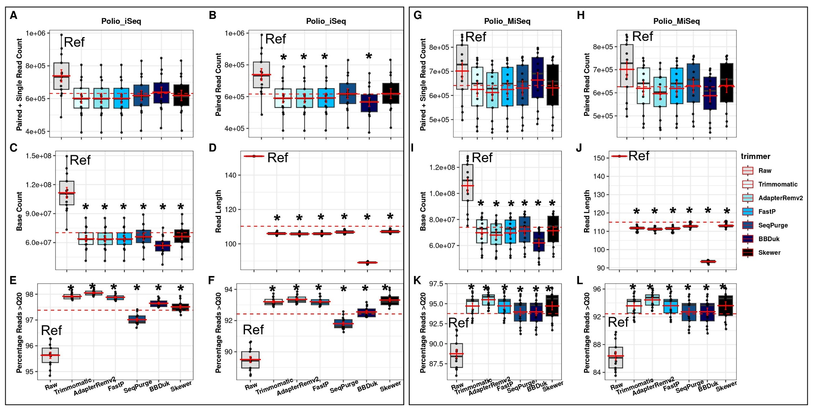

Fig. S9: Differences between severe acute respiratory syndrome coronavirus 2 raw (as reference, Ref) and trimmed read metrics, grouped by sequencing platform. Metrics which are statistically different compared to raw data are indicated with a black asterisk *. Abbreviations: SC2 for severe acute respiratory syndrome coronavirus 2.
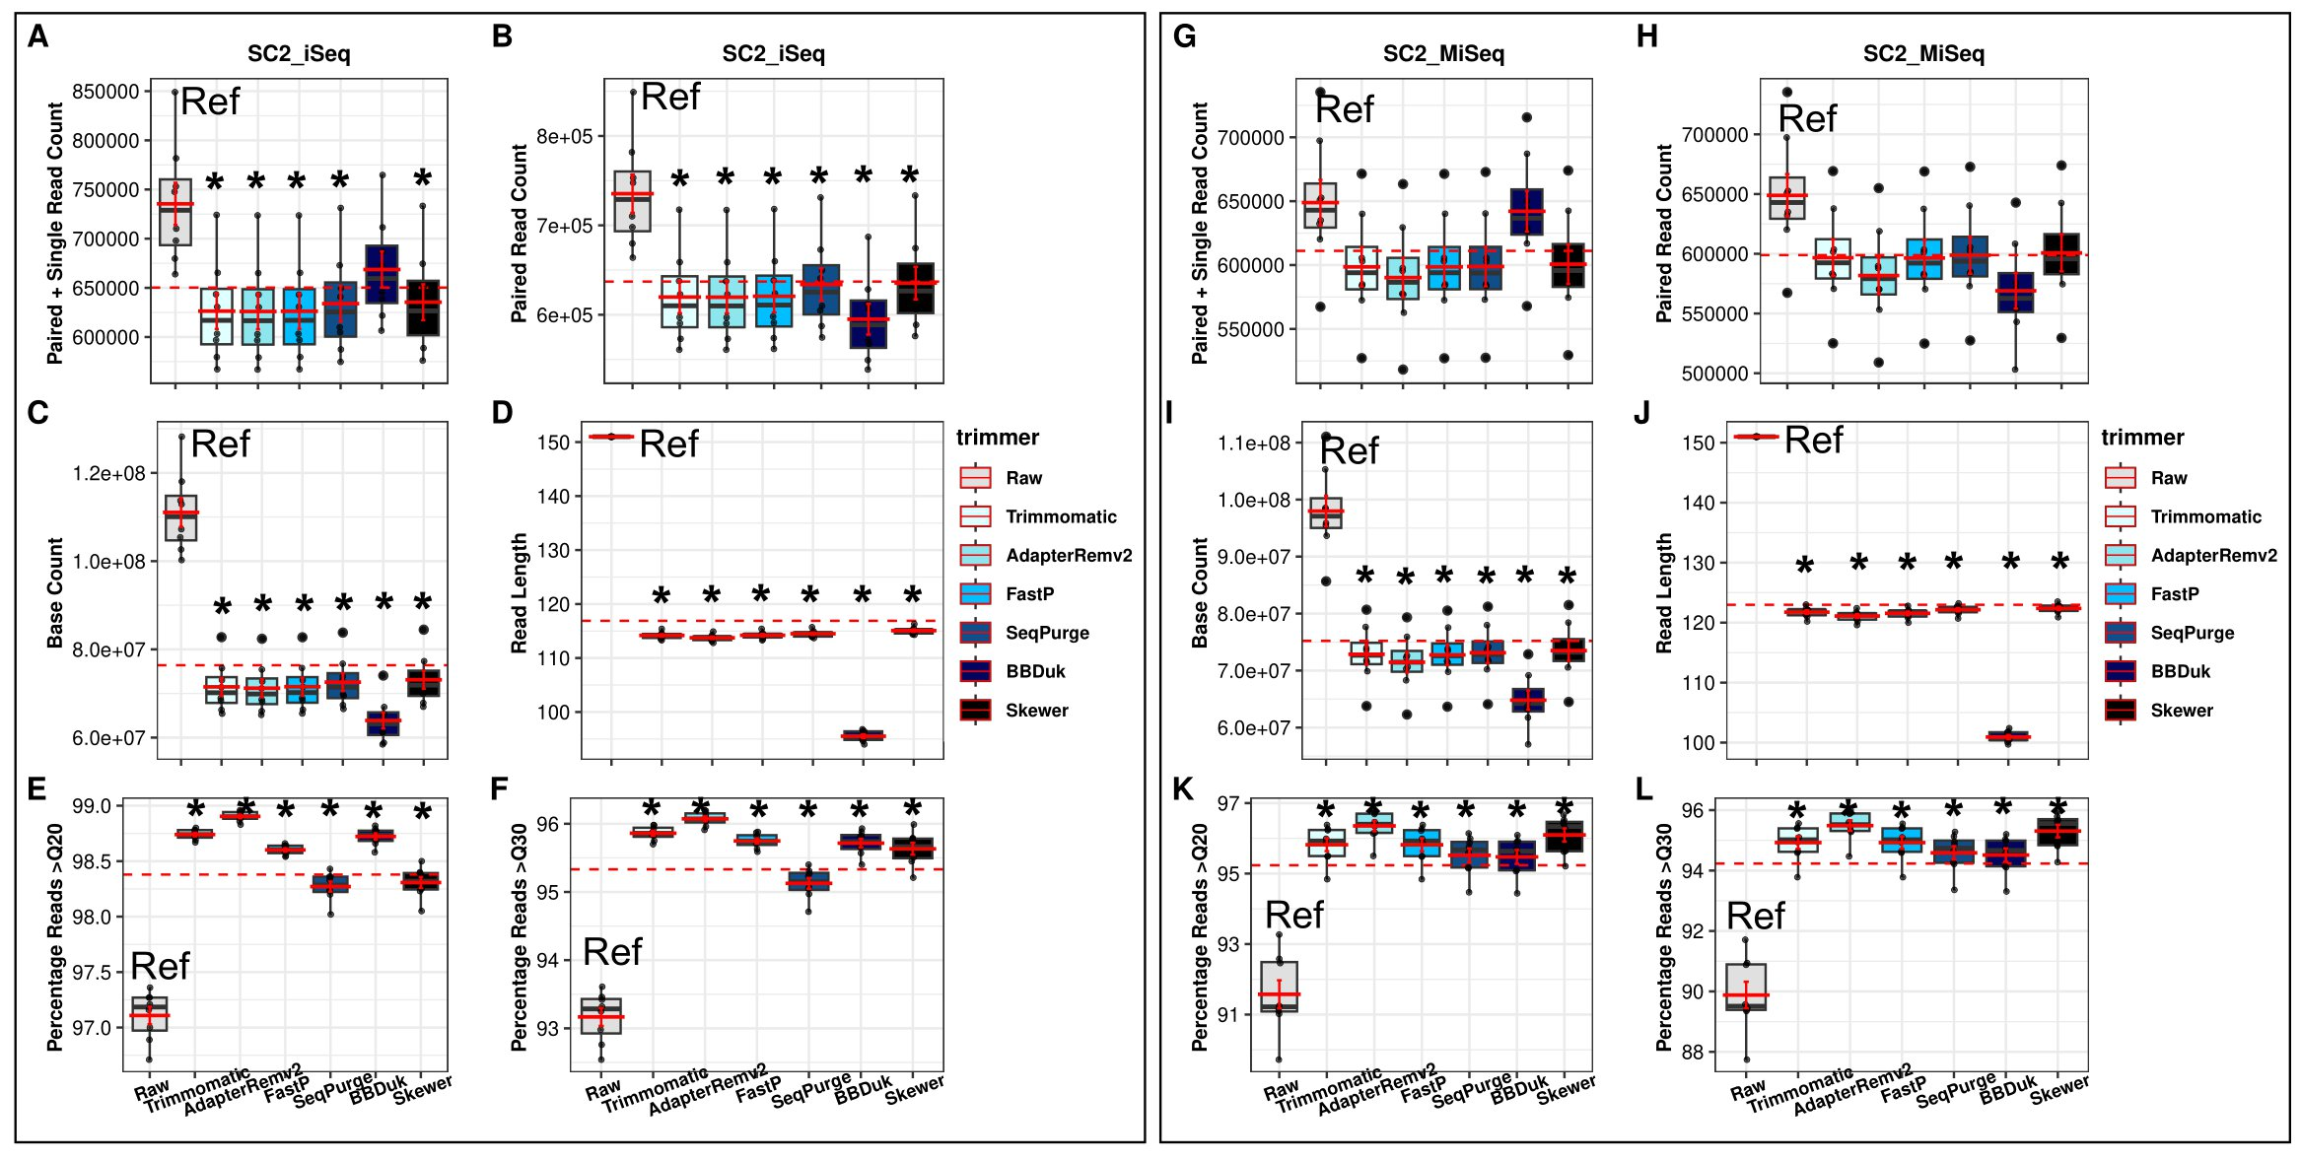
Fig. S10: Differences between norovirus raw (as reference, Ref) and trimmed read metrics, grouped by sequencing platform. Metrics which are statistically different compared to raw data are indicated with a black asterisk *. Abbreviations: noro for norovirus.
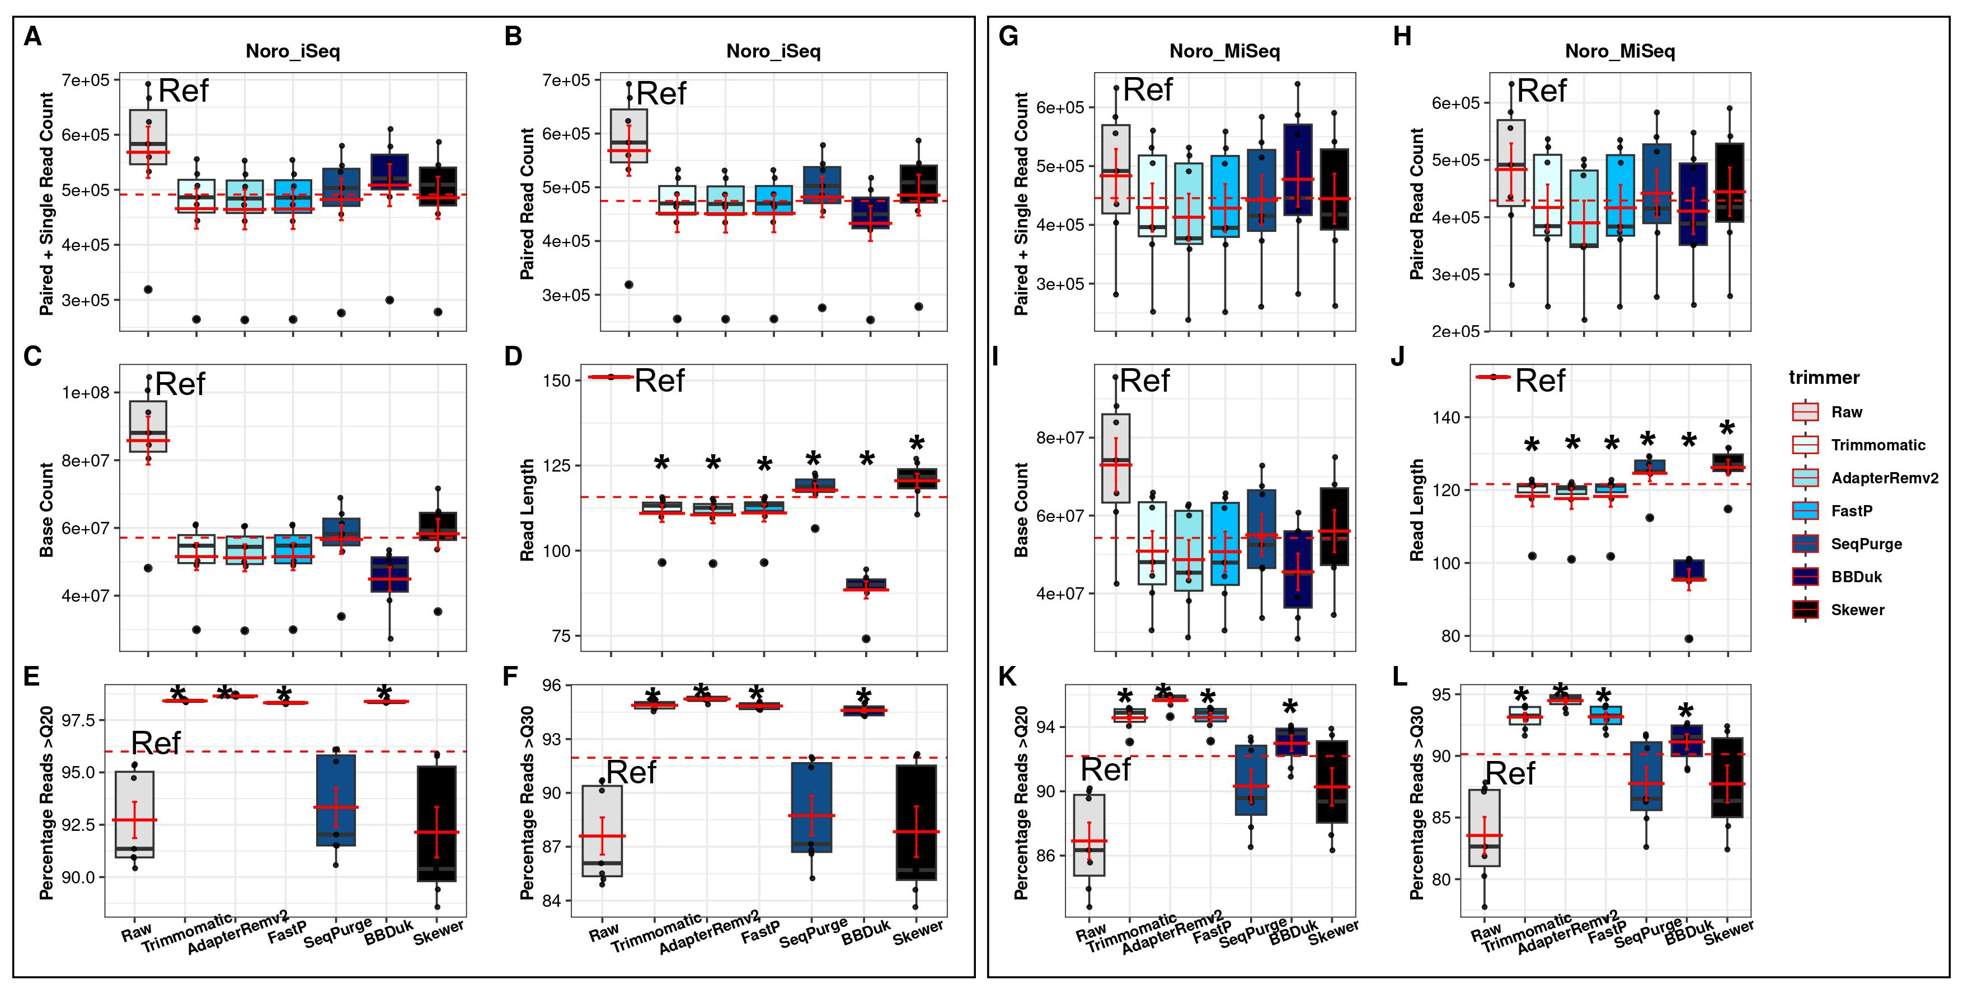

Table S11: Mean percentage of high-quality bases (Q≥30) for poliovirus, SARS-CoV-2, and norovirus reads grouped by sequencing platform and trimmer. Date in blue highlights the highest and red the lowest Q≥30 for trimmed reads for a given virus/platform.
Percentage of high-quality (Q≥30) raw and trimmed reads

Platform | Virus | Raw (ref) | Trimmomatic | AdapterRemoval | FastP | SeqPurge | BBDuk | Skewer
iSeq | Poliovirus | 89.51 | 93.21 | 93.36 | 93.21 | 91.8 | 92.56 | 93.32
iSeq | SARS-CoV-2 | 93.17 | 95.86 | 96.07 | 95.75 | 95.13 | 95.72 | 95.63
iSeq | Noro | 87.6 | 94.88 | 95.23 | 94.84 | 88.73 | 94.6 | 87.84
MiSeq | Polio | 86.37 | 93.58 | 94.43 | 93.6 | 92.72 | 92.73 | 93.6
MiSeq | SARS-CoV-2 | 89.88 | 94.93 | 95.49 | 94.93 | 94.59 | 94.51 | 95.31
MiSeq | Noro | 83.55 | 93.15 | 94.48 | 93.17 | 87.76 | 91.13 | 87.73

Table S12: Statistical differences in N50 between trimmers, grouped by virus and sequencing platform.
N50
 | Trimmer | Raw | Trimmomatic | AdapterRemv2 | FastP | SeqPurge | BBDuk
Platform
Poliovirus
iSeq | Trimmomatic  AdapterRemv2  FastP  SeqPurge  BBDuk  Skewer | 6.81×10⁻⁵  6.81×10⁻⁵  6.81×10⁻⁵  8.05×10⁻⁵  0.944  8.05×10⁻⁵ | ⎼  1  9.57×10⁻³  0.944  6.81×10⁻⁵  0.944 | ⎼  ⎼  9.57×10⁻³  0.944  6.81×10⁻⁵  0.944 | ⎼  ⎼  ⎼  9.57×10⁻³  6.81×10⁻⁵  9.57×10⁻³ | ⎼  ⎼  ⎼  ⎼  6.81×10⁻⁵  1 | ⎼  ⎼  ⎼  ⎼  ⎼  6.81×10⁻⁵
MiSeq | Trimmomatic  AdapterRemv2  FastP  SeqPurge  BBDuk  Skewer | 0.544  0.45  1  0.827  8.7×10⁻⁴  1 | ⎼  0.85  0.558  0.45  2.04×10⁻⁴  0.625 | ⎼  ⎼  0.45  0.329  2.04×10⁻⁴  0.468 | ⎼  ⎼  ⎼  0.827  8.7×10⁻⁴  1 | ⎼  ⎼  ⎼  ⎼  0.012  0.827 | ⎼  ⎼  ⎼  ⎼  ⎼  2.0×10⁻³
SARS-CoV-2
iSeq | Trimmomatic  AdapterRemv2  FastP  SeqPurge  BBDuk  Skewer | 4.57×10⁻³  4.57×10⁻³  4.57×10⁻³  4.57×10⁻³  0.158  4.57×10⁻³ | ⎼  1  0.739  0.739  9.79×10⁻³  0.881 | ⎼  ⎼  0.739  0.739  7.75×10⁻³  0.739 | ⎼  ⎼  ⎼  1  7.75×10⁻³  1 | ⎼  ⎼  ⎼  ⎼  7.75×10⁻³  1 | ⎼  ⎼  ⎼  ⎼  ⎼  9.79×10⁻³
MiSeq | Trimmomatic  AdapterRemv2  FastP  SeqPurge  BBDuk  Skewer | 0.099  0.084  0.972  0.084  0.573  0.084 | ⎼  0.972  0.184  1  0.037  1 | ⎼  ⎼  0.184  0.972  0.037  0.972 | ⎼  ⎼  ⎼  0.184  0.211  0.184 | ⎼  ⎼  ⎼  ⎼  0.037  1 | ⎼  ⎼  ⎼  ⎼  ⎼  0.037
Norovirus
iSeq | Trimmomatic  AdapterRemv2  FastP  SeqPurge  BBDuk  Skewer | 0.285  0.285  0.285  0.527  0.638  0.527 | ⎼  0.814  0.814  0.638  0.527  0.638 | ⎼  ⎼  1  0.531  0.527  0.531 | ⎼  ⎼  ⎼  0.53  0.527  0.531 | ⎼  ⎼  ⎼  ⎼  0.814  1 | ⎼  ⎼  ⎼  ⎼  ⎼  0.889
MiSeq | Trimmomatic  AdapterRemv2  FastP  SeqPurge  BBDuk  Skewer | 0.495  0.495  0.495  0.545  0.992  0.495 | ⎼  0.84  0.992  1  0.495  0.992 | ⎼  ⎼  0.976  0.976  0.495  0.978 | ⎼  ⎼  ⎼  1  0.495  0.992 | ⎼  ⎼  ⎼  ⎼  0.545  0.992 | ⎼  ⎼  ⎼  ⎼  ⎼  0.545

Table S13: Statistical differences in maximum contig length (maxContig) between trimmers, grouped by virus and sequencing platform.
maxContig length
 | Trimmer | Raw | Trimmomatic | AdapterRemv2 | FastP | SeqPurge | BBDuk
Platform
Poliovirus
iSeq | Trimmomatic  AdapterRemv2  FastP  SeqPurge  BBDuk  Skewer | 6.43×10⁻⁵  6.43×10⁻⁵  6.43×10⁻⁵  6.43×10⁻⁵  0.902  6.43×10⁻⁵ | ⎼  1  9.57×10⁻³  0.944  6.43×10⁻⁵  0.944 | ⎼  ⎼  9.57×10⁻³  0.944  6.43×10⁻⁵  0.944 | ⎼  ⎼  ⎼  9.57×10⁻³  6.43×10⁻⁵  9.57×10⁻³ | ⎼  ⎼  ⎼  ⎼  6.43×10⁻⁵  1 | ⎼  ⎼  ⎼  ⎼  ⎼  6.43×10⁻⁵
MiSeq | Trimmomatic  AdapterRemv2  FastP  SeqPurge  BBDuk  Skewer | 0.567  0.471  0.967  0.827  1.33×10⁻⁴  0.979 | ⎼  0.85  0.579  0.471  1.33×10⁻⁴  0.671 | ⎼  ⎼  0.471  0.346  1.33×10⁻⁴  0.51 | ⎼  ⎼  ⎼  0.788  1.33×10⁻⁴  0.979 | ⎼  ⎼  ⎼  ⎼  7.07×10⁻³  0.766 | ⎼  ⎼  ⎼  ⎼  ⎼  1.33×10⁻⁴
SARS-CoV-2
iSeq | Trimmomatic  AdapterRemv2  FastP  SeqPurge  BBDuk  Skewer | 4.57×10⁻³  3.26×10⁻³  3.26×10⁻³  3.26×10⁻³  0.627  3.26×10⁻³ | ⎼  0.924  0.785  0.785  6.2×10⁻³  0.785 | ⎼  ⎼  0.691  0.691  6.2×10⁻³  0.691 | ⎼  ⎼  ⎼  1  6.2×10⁻³  1 | ⎼  ⎼  ⎼  ⎼  6.2×10⁻³  1 | ⎼  ⎼  ⎼  ⎼  ⎼  6.2×10⁻³
MiSeq | Trimmomatic  AdapterRemv2  FastP  SeqPurge  BBDuk  Skewer | 0.079  0.074  0.079  0.074  0.488  0.074 | ⎼  0.924  1  0.601  7.83×10⁻³  1 | ⎼  ⎼  0.879  0.647  7.83×10⁻³  0.879 | ⎼  ⎼  ⎼  0.599  7.83×10⁻³  1 | ⎼  ⎼  ⎼  ⎼  7.83×10⁻³  0.372 | ⎼  ⎼  ⎼  ⎼  ⎼  7.83×10⁻³
Norovirus
iSeq | Trimmomatic  AdapterRemv2  FastP  SeqPurge  BBDuk  Skewer | 0.524  0.524  0.558  0.814  0.996  0.749 | ⎼  0.928  0.928  0.605  0.513  0.605 | ⎼  ⎼  1  0.605  0.513  0.605 | ⎼  ⎼  ⎼  0.605  0.513  0.605 | ⎼  ⎼  ⎼  ⎼  0.605  0.996 | ⎼  ⎼  ⎼  ⎼  ⎼  0.605
MiSeq | Trimmomatic  AdapterRemv2  FastP  SeqPurge  BBDuk  Skewer | 0.256  0.208  0.253  0.253  0.995  0.269 | ⎼  0.7  0.996  0.996  0.253  0.996 | ⎼  ⎼  0.7  0.908  0.208  0.909 | ⎼  ⎼  ⎼  0.996  0.253  0.996 | ⎼  ⎼  ⎼  ⎼  0.208  1 | ⎼  ⎼  ⎼  ⎼  ⎼  0.253

Table S14: Statistical differences in N50, maximum contig length, and SNP quality for iSeq versus MiSeq assemblies from raw and trimmed reads, grouped by virus and trimmer.
Differences in N50, maximum contig length, and SNP quality for iSeq versus MiSeq reads
 | N50 |  | Max Contig length |  | SNP Quality
Trimmer | p | p.adjusted | p | p.adjusted | p | p.adjusted
Poliovirus
Raw  Trimmomatic  AdapterRemv2  FastP  SeqPurge  BBDuk  Skewer | 1.65×10⁻⁴  0.917  0.874  0.002  0.139  0.006  0.295 | 1.16×10⁻³  1  1  0.014  0.973  0.042  1 | 1.34×10⁻⁴  0.917  0.874  0.002  0.113  0.022  0.26 | 9.38×10⁻⁴  1  1  0.014  0.791  0.154  1 | 0.224  0.253  0.556  0.247  0.492  0.438  0.303 | 1  1  1  1  1  1  1
SARS-CoV-2
Raw  Trimmomatic  AdapterRemv2  FastP  SeqPurge  BBDuk  Skewer | 0.01  0.528  0.269  0.115  0.958  0.442  0.916 | 0.07  1  1  0.805  1  1  1 | 0.028  0.599  0.293  1  0.344  0.528  0.958 | 0.196  1  1  1  1  1  1 | 0.102  0.37  0.44  0.227  0.187  0.445  0.297 | 0.714  1  1  1  1  1  1
Norovirus
Raw  Trimmomatic  AdapterRemv2  FastP  SeqPurge  BBDuk  Skewer | 0.902  0.52  1  0.517  0.949  0.209  0.701 | 1  1  1  1  1  1  1 | 0.337  0.48  1  0.517  0.654  0.62  0.7 | 1  1  1  1  1  1  1 | 0.709  0.948  0.906  0.948  0.525  0.26  0.656 | 1  1  1  1  1  1  1

Table S15: Statistical differences in SNP quality between trimmers, grouped by virus and sequencing platform.
 |  | Raw | Trimmomatic | AdapterRemv2 | FastP | SeqPurge | BBDuk
Polio
iSeq | Trimmomatic  AdapterRemv2  FastP  SeqPurge  BBDuk  Skewer | 0.895  0.895  0.895  0.895  4.67×10⁻⁴  0.895 | ⎼  0.895  0.895  0.895  1.99×10⁻⁴  0.895 | ⎼  ⎼  0.895  0.895  9.58×10⁻⁵  0.895 | ⎼  ⎼  ⎼  0.895  1.35×10⁻⁴  0.895 | ⎼  ⎼  ⎼  ⎼  5.18×10⁻⁵  0.895 | ⎼  ⎼  ⎼  ⎼  ⎼  9.45×10⁻⁵
MiSeq | Trimmomatic  AdapterRemv2  FastP  SeqPurge  BBDuk  Skewer | 0.972  0.972  0.972  0.972  1.47×10⁻⁴  0.972 | ⎼  0.972  0.972  0.972  7.70×10⁻⁵  0.972 | ⎼  ⎼  0.972  0.972  1.61×10⁻⁴  0.972 | ⎼  ⎼  ⎼  0.972  4.66×10⁻⁵  0.972 | ⎼  ⎼  ⎼  ⎼  4.66×10⁻⁵  0.972 | ⎼  ⎼  ⎼  ⎼  ⎼  4.66×10⁻⁵
SARS-CoV-2
iSeq | Trimmomatic  AdapterRemv2  FastP  SeqPurge  BBDuk  Skewer | 0.922  0.91  0.91  0.944  0.276  0.91 | ⎼  0.91  0.944  0.91  0.298  0.91 | ⎼  ⎼  0.91  0.91  0.55  0.771 | ⎼  ⎼  ⎼  0.91  0.298  0.91 | ⎼  ⎼  ⎼  ⎼  0.276  0.91 | ⎼  ⎼  ⎼  ⎼  ⎼  0.276
MiSeq | Trimmomatic  AdapterRemv2  FastP  SeqPurge  BBDuk  Skewer | 0.915  0.915  0.915  0.915  0.379  0.807 | ⎼  0.915  0.915  0.915  0.245  0.915 | ⎼  ⎼  0.988  0.915  0.295  0.807 | ⎼  ⎼  ⎼  0.915  0.295  0.807 | ⎼  ⎼  ⎼  ⎼  0.269  0.915 | ⎼  ⎼  ⎼  ⎼  ⎼  0.153
Norovirus
iSeq | Trimmomatic  AdapterRemv2  FastP  SeqPurge  BBDuk  Skewer | 0.683  0.809  0.683  0.599  0.683  0.886 | ⎼  0.893  1  0.893  0.183  0.893 | ⎼  ⎼  0.893  0.893  0.243  0.923 | ⎼  ⎼  ⎼  0.893  0.183  0.893 | ⎼  ⎼  ⎼  ⎼  0.183  0.886 | ⎼  ⎼  ⎼  ⎼  ⎼  0.315
MiSeq | Trimmomatic  AdapterRemv2  FastP  SeqPurge  BBDuk  Skewer | 0.998 | ⎼  0.998  1  0.998  0.998  0.998 | ⎼  ⎼  0.998  0.998  0.998  0.998 | ⎼  ⎼  ⎼  0.998  0.998  0.998 | ⎼  ⎼  ⎼  ⎼  0.998  0.998 | ⎼  ⎼  ⎼  ⎼  ⎼  0.998

Fig. S16: Multi-venn diagram showing concordant SNPs among iSeq and MiSeq poliovirus, severe acute respiratory syndrome coronavirus 2, and norovirus assemblies from raw and trimmed reads. Shapes vary to enable visualization of shared SNPs or overlaps between the different trimmer sets.Abbreviations: polio is for poliovirus, noro for norovirus and SC2 for severe acute respiratory syndrome coronavirus 2.
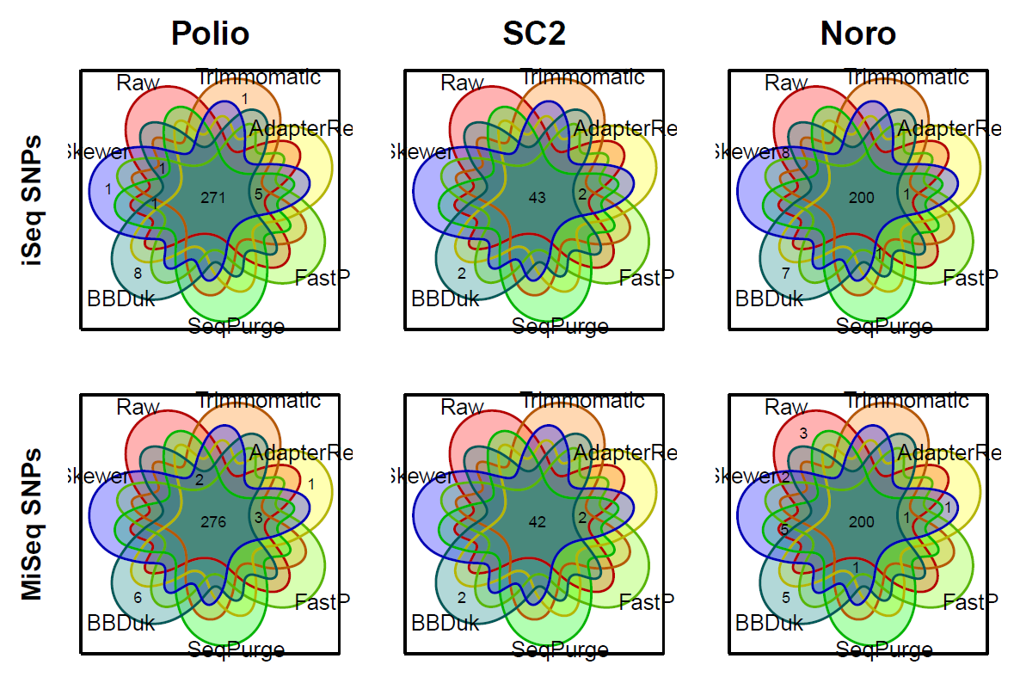

Differences in runtime and memory usage between trimmers.
Using the largest poliovirus dataset (n=13), All trimmers except SeqPurge processed the 13 poliovirus samples in under one minute (<50 seconds). Specifically, FastP was the fastest, taking only 12.75 seconds while SeqPurge took the longest average time of 3.9 minutes to process 13 samples. AdapterRemoval, Skewer, and SeqPurge used less than 0.7GB memory, FastP and BBDuk used approximately 1.5GB, while Trimmomatic used the largest memory of 4.4GB for processing 13 samples.

References
1. Bolger AM, Lohse M, Usadel B. Trimmomatic: a flexible trimmer for Illumina sequence data. Bioinformatics. 2014 Aug;30(15):2114–20.
2. Lindgreen S. AdapterRemoval: easy cleaning of next-generation sequencing reads. BMC Res Notes. 2012 Jul 2;5(1):337.
3. Schubert M, Lindgreen S, Orlando L. AdapterRemoval v2: rapid adapter trimming, identification, and read merging. BMC Res Notes [Internet]. 2016 [cited 2022 Dec 21];9. Available from: https://www.ncbi.nlm.nih.gov/pmc/articles/PMC4751634/
4. Chen S, Huang T, Zhou Y, Han Y, Xu M, Gu J. AfterQC: automatic filtering, trimming, error removing and quality control for fastq data. BMC Bioinformatics. 2017 Mar 14;18(3):80.
5. Chen S, Zhou Y, Chen Y, Gu J. fastp: an ultra-fast all-in-one FASTQ preprocessor. Bioinformatics. 2018 Sep 1;34(17):i884–90.
6. Sturm M, Schroeder C, Bauer P. SeqPurge: highly-sensitive adapter trimming for paired-end NGS data. BMC Bioinformatics. 2016 May 10;17:208.
7. Brian Bushnell. BBMap download | SourceForge.net [Internet]. 2014 [cited 2023 Mar 21]. Available from: https://sourceforge.net/projects/bbmap/
8. Jiang H, Lei R, Ding SW, Zhu S. Skewer: a fast and accurate adapter trimmer for next-generation sequencing paired-end reads. BMC Bioinformatics. 2014 Jun 12;15(1):182.
9. Katayama K, Shirato-Horikoshi H, Kojima S, Kageyama T, Oka T, Hoshino F, et al. Phylogenetic analysis of the complete genome of 18 Norwalk-like viruses. Virology. 2002 Aug 1;299(2):225–39.
10. Parra GI, Squires RB, Karangwa CK, Johnson JA, Lepore CJ, Sosnovtsev SV, et al. Static and Evolving Norovirus Genotypes: Implications for Epidemiology and Immunity. PLoS Pathog. 2017 Jan;13(1):e1006136.
11. Paden CR, Tao Y, Queen K, Zhang J, Li Y, Uehara A, et al. Rapid, Sensitive, Full-Genome Sequencing of Severe Acute Respiratory Syndrome Coronavirus 2. Emerg Infect Dis. 2020 Oct;26(10):2401–5.
12. Prjibelski A, Antipov D, Meleshko D, Lapidus A, Korobeynikov A. Using SPAdes De Novo Assembler. Curr Protoc Bioinforma. 2020;70(1):e102.

