SUPPLEMENTARY MATERIAL

Reducing DNA Extraction Costs Through Factorial Design for the DNAdvance Kit

Carson J. Neal¹ (carsonn@uark.edu),
Zachery D. Zbinden^{1,2*} (zach.zbinden@umces.edu),
Michael E. Douglas¹ (med1@uark.edu),
Marlis R. Douglas¹ (mrd1@uark.edu)

¹Department of Biological Sciences, University of Arkansas, Fayetteville, AR, USA
²Current address: Appalachian Laboratory, University of Maryland Center for Environmental Science, Frostburg, MD, USA

*Corresponding author: Zachery D. Zbinden

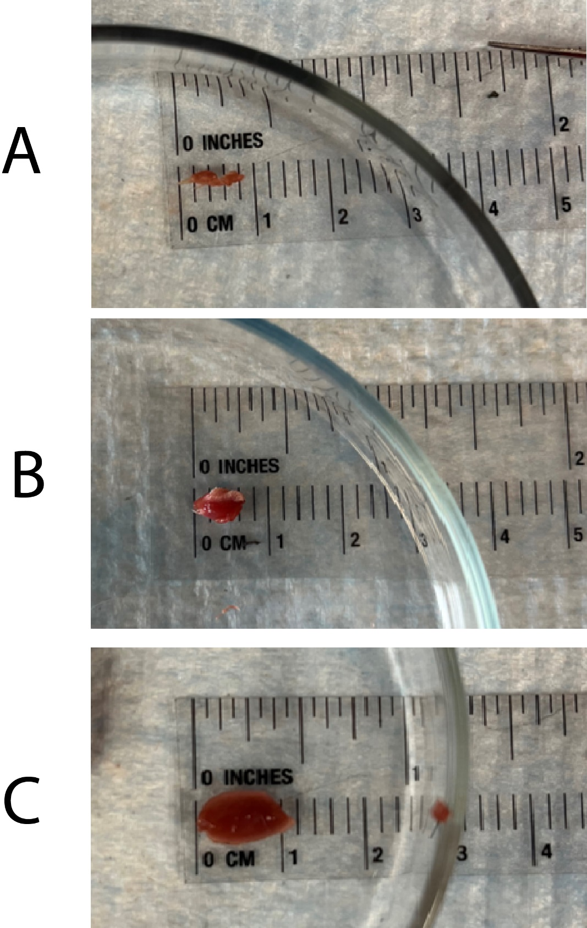
Figure S1: Three masses of White-tailed Deer tongue tissue from which DNA was extracted: A) 10mg, B) 50mg, and C) 100mg.

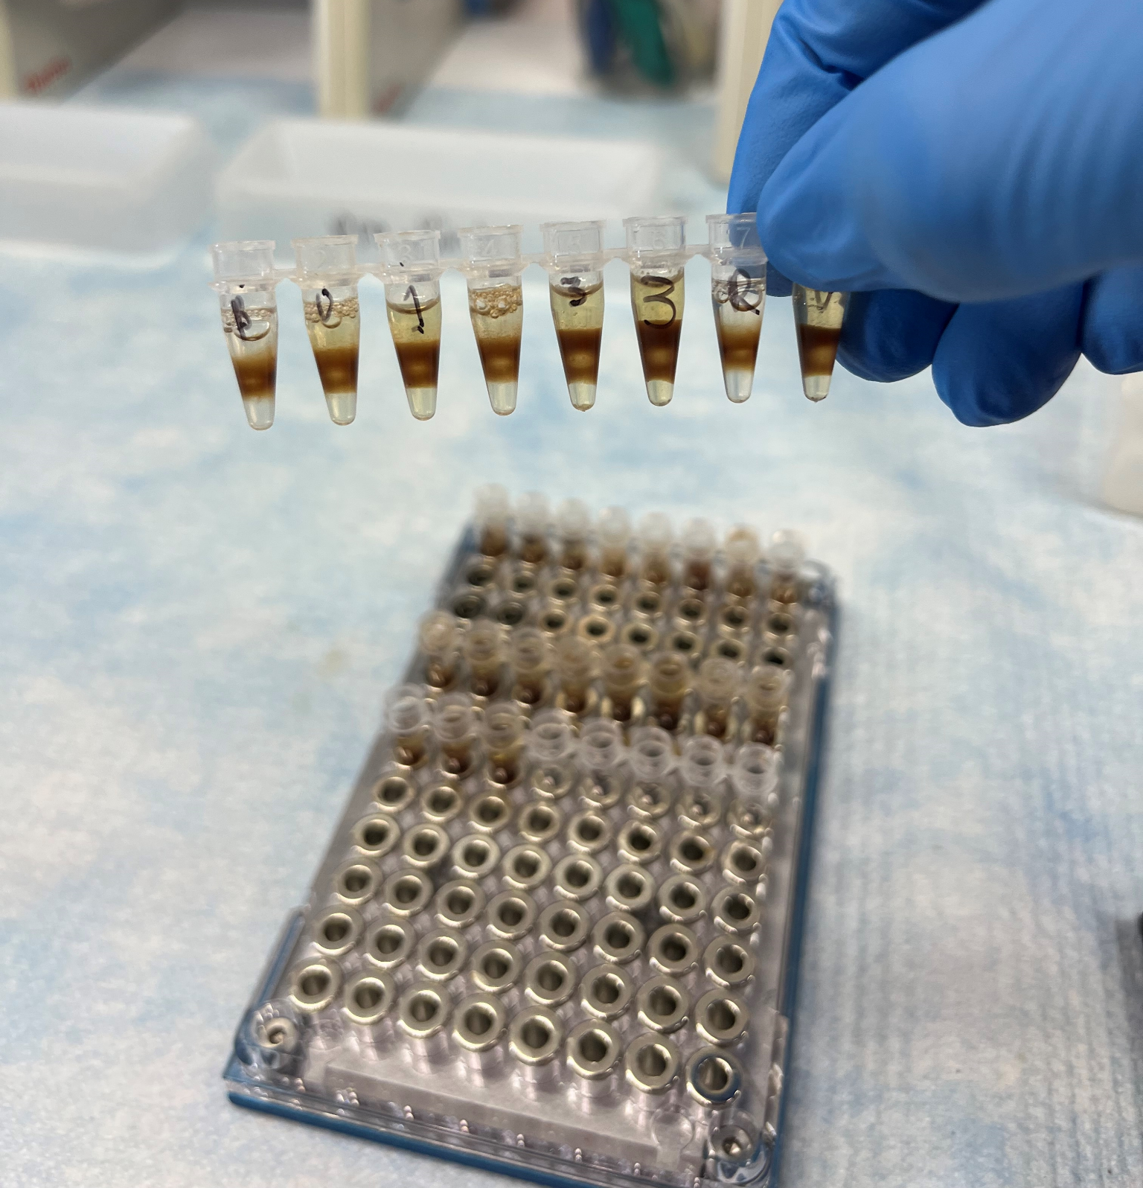
Figure S2: DNA bound to magnetic beads, which are attached to the sides of the tubes. During this step, the slightly yellow supernatant was removed without disturbing beads on the side, ideally leaving only DNA and magnetic beads.

Table S1: DNA concentration data collected for N=81 samples of White-tail Deer tissue across N=9 experimental treatment groups and three weekly blocks. Sample ID is a unique identifier for each sample. The week represents the weekly block in which the samples were extracted. The mass of the tissue is given in grams, and the volume of DNAdvance kit lysis reagent used is given as the percentage of the manufacturer's protocol. The final DNA Concentration is given in ng/μl.

Sample ID | Week | Mass (g) | Volume (%) | DNA Concentration (ng/μl)
B01V25M10A | 1 | 10 | 0.25 | 3.93
B01V25M10B | 1 | 10 | 0.25 | 3.22
B01V25M10C | 1 | 10 | 0.25 | 8
B02V25M10D | 2 | 10 | 0.25 | 2.45
B02V25M10E | 2 | 10 | 0.25 | 3.31
B02V25M10F | 2 | 10 | 0.25 | 6.42
B03V25M10G | 3 | 10 | 0.25 | 30.7
B03V25M10H | 3 | 10 | 0.25 | 4.26
B03V25M10I | 3 | 10 | 0.25 | 6.53
B01V25M50A | 1 | 50 | 0.25 | 65.9
B01V25M50B | 1 | 50 | 0.25 | 192
B01V25M50C | 1 | 50 | 0.25 | 102
B02V25M50D | 2 | 50 | 0.25 | 25.8
B02V25M50E | 2 | 50 | 0.25 | 33.4
B02V25M50F | 2 | 50 | 0.25 | 68.9
B03V25M50G | 3 | 50 | 0.25 | 62
B03V25M50H | 3 | 50 | 0.25 | 62.6
B03V25M50I | 3 | 50 | 0.25 | 62.8
B01V25M100A | 1 | 100 | 0.25 | 183
B01V25M100B | 1 | 100 | 0.25 | 68.1
B01V25M100C | 1 | 100 | 0.25 | 74.8
B02V25M100D | 2 | 100 | 0.25 | 34.6
B02V25M100E | 2 | 100 | 0.25 | 49.3
B02V25M100F | 2 | 100 | 0.25 | 21.6
B03V25M100G | 3 | 100 | 0.25 | 35.6
B03V25M100H | 3 | 100 | 0.25 | 47.5
B03V25M100I | 3 | 100 | 0.25 | 29.3
B01V33M10A | 1 | 10 | 0.33 | 47.8
B01V33M10B | 1 | 10 | 0.33 | 17.6
B01V33M10C | 1 | 10 | 0.33 | 19.1
B02V33M10D | 2 | 10 | 0.33 | 35.4
B02V33M10E | 2 | 10 | 0.33 | 19.2
B02V33M10F | 2 | 10 | 0.33 | 16.7
B03V33M10G | 3 | 10 | 0.33 | 24.7
B03V33M10H | 3 | 10 | 0.33 | 1.56
B03V33M10I | 3 | 10 | 0.33 | 6.24
B01V33M50A | 1 | 50 | 0.33 | 189
B01V33M50B | 1 | 50 | 0.33 | 63.3
B01V33M50C | 1 | 50 | 0.33 | 132
B02V33M50D | 2 | 50 | 0.33 | 44.1
B02V33M50E | 2 | 50 | 0.33 | 62
B02V33M50F | 2 | 50 | 0.33 | 92.6
B03V33M50G | 3 | 50 | 0.33 | 115
B03V33M50H | 3 | 50 | 0.33 | 24.8
B03V33M50I | 3 | 50 | 0.33 | 154
B01V33M100A | 1 | 100 | 0.33 | 91.3
B01V33M100B | 1 | 100 | 0.33 | 163
B01V33M100C | 1 | 100 | 0.33 | 143
B02V33M100D | 2 | 100 | 0.33 | 97.7
B02V33M100E | 2 | 100 | 0.33 | 50.7
B02V33M100F | 2 | 100 | 0.33 | 38
B03V33M100G | 3 | 100 | 0.33 | 269
B03V33M100H | 3 | 100 | 0.33 | 60.7
B03V33M100I | 3 | 100 | 0.33 | 90.3
B01V50M10A | 1 | 10 | 0.5 | 85
B01V50M10B | 1 | 10 | 0.5 | 48.6
B01V50M10C | 1 | 10 | 0.5 | 33.4
B02V50M10D | 2 | 10 | 0.5 | 136
B02V50M10E | 2 | 10 | 0.5 | 102
B02V50M10F | 2 | 10 | 0.5 | 25.9
B03V50M10G | 3 | 10 | 0.5 | 55
B03V50M10H | 3 | 10 | 0.5 | 17
B03V50M10I | 3 | 10 | 0.5 | 18
B01V50M50A | 1 | 50 | 0.5 | 6.3
B01V50M50B | 1 | 50 | 0.5 | 63.9
B01V50M50C | 1 | 50 | 0.5 | 24.9
B02V50M50D | 2 | 50 | 0.5 | 10.4
B02V50M50E | 2 | 50 | 0.5 | 142
B02V50M50F | 2 | 50 | 0.5 | 35.6
B03V50M50G | 3 | 50 | 0.5 | 16.1
B03V50M50H | 3 | 50 | 0.5 | 112
B03V50M50I | 3 | 50 | 0.5 | 30.6
B01V50M100A | 1 | 100 | 0.5 | 172
B01V50M100B | 1 | 100 | 0.5 | 124
B01V50M100C | 1 | 100 | 0.5 | 239
B02V50M100D | 2 | 100 | 0.5 | 91.7
B02V50M100E | 2 | 100 | 0.5 | 117
B02V50M100F | 2 | 100 | 0.5 | 64.5
B03V50M100G | 3 | 100 | 0.5 | 51.5
B03V50M100H | 3 | 100 | 0.5 | 110
B03V50M100I | 3 | 100 | 0.5 | 278

