Supplementary information S1
Figures in S1 show examples of ratio images obtained under no sound or control. The ratio images were calculated as the ratio of OCT signals obtained under no sound; therefore, no changes should be observed. As can be seen, there was only some activity at the surface, which is prone to high noise levels. Other than that there were no changes could be observed across the depth of the leaf demonstrating the sensitivity of the functional OCT in plant studies.
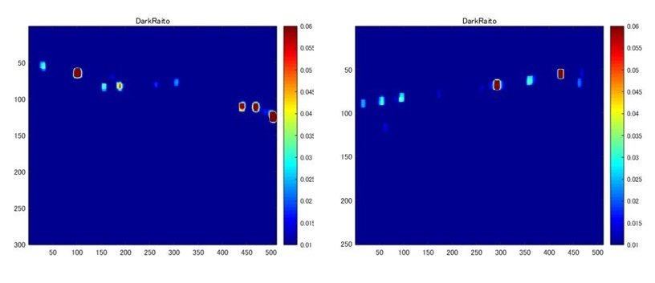
Supplementary information S2
Results obtained with rock and classical music are given in Figure S2. The images were obtained from the rear side of the arugula leaf, which is supposed to contain more stomata. Stomata are believed to change during the sound stimuli, as demonstrated in our previous work [6]. For rock music, ‘The Jimi Hendrix Experience - Purple Haze’ was used. As classical music, Mozart’s Eine kleine Nachtmusik (Karajan Vienna Philharmony recording of 1949) was used. The sound pressure level was set to 100dB for both cases. The top and bottom rows of images correspond, respectively, to classical and rock music. The leftmost, middle, and rightmost in both rows correspond to before, after, and ratio images, respectively.
For classical music, there is more uniform variation across the depth, while for rock music, there was a general reduction. Red Encircled regions show representative stomata and its variation in size with respect to different musical sounds. These results further demonstrate the effectiveness of functional OCT in sound studies in plants.
